BPC Financial Data Upload Instructions
Step-by-step guide for uploading Income Statement
and Balance Sheet data to the dashboard

Overview
This guide walks you through the complete process of uploading financial data to the BPC Dashboard. The upload process involves five main steps:
- Navigate to the Upload page
- Download and fill in the Excel template
- Upload the completed Excel file
- Review and submit the Income Statement
- Review and submit the Balance Sheet

IMPORTANT
The Income Statement and Balance Sheet must be submitted separately. After clicking each Submit button, you must wait for the green success message and confetti animation before proceeding.

Step 1: Navigate to Upload
From the main dashboard, locate the Admin section in the left sidebar. Click the "Upload" button (purple gradient button) to open the data upload page.
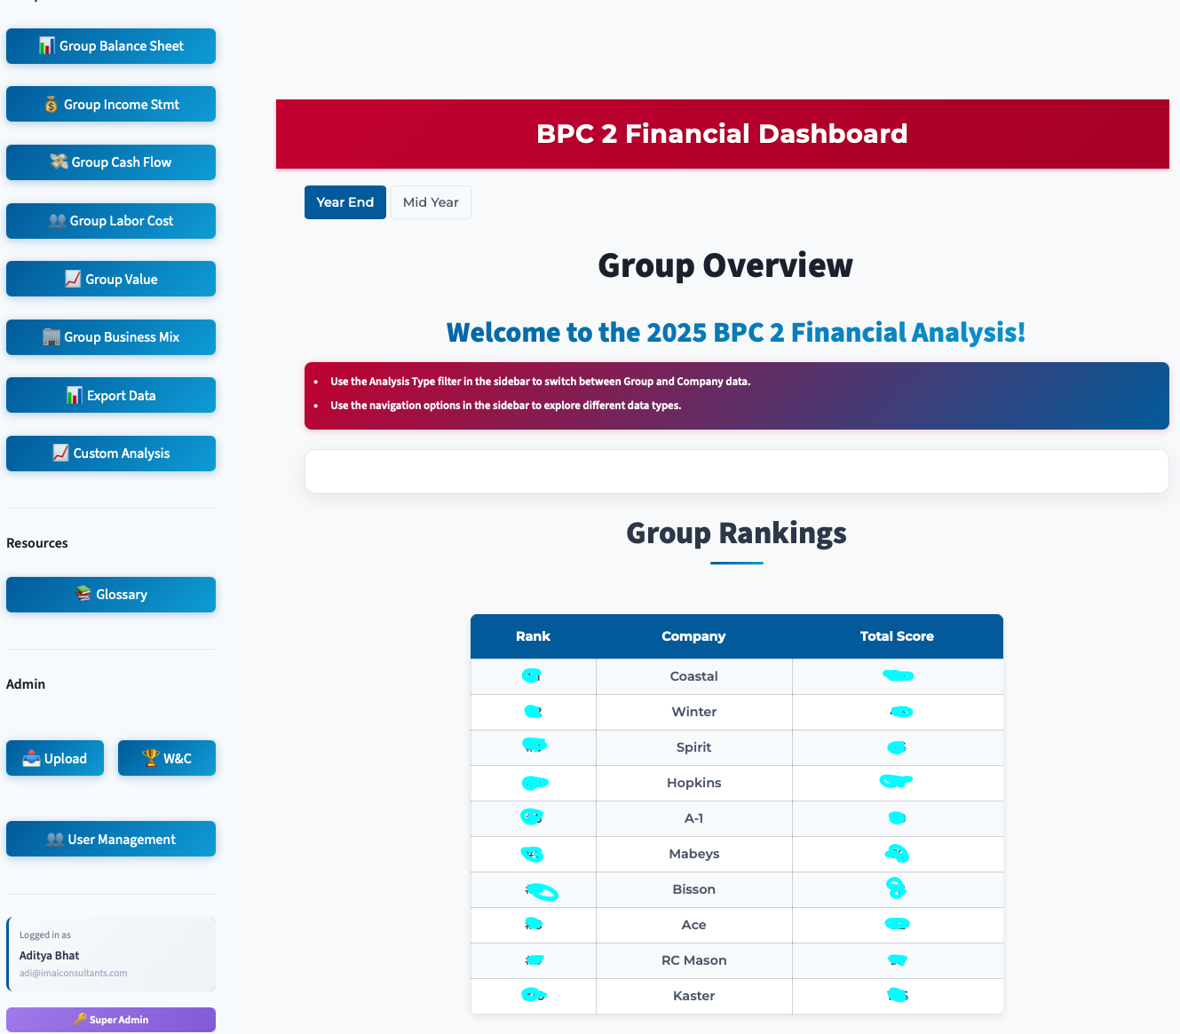
Dashboard home page with Upload button in the sidebar Admin section

Step 2: Download & Fill Template
On the Upload page, the sidebar contains both the Download Template and Upload Data sections. Click "Download Excel Template" to get the official BPC template file. The template contains two sheets:
- Income Statement: Revenue, expenses, and profit line items
- Balance Sheet: Assets, liabilities, and equity line items
Fill in your company's financial data in the appropriate cells. Only enter values in the white (unprotected) cells. Gray cells contain formulas and will be calculated automatically.
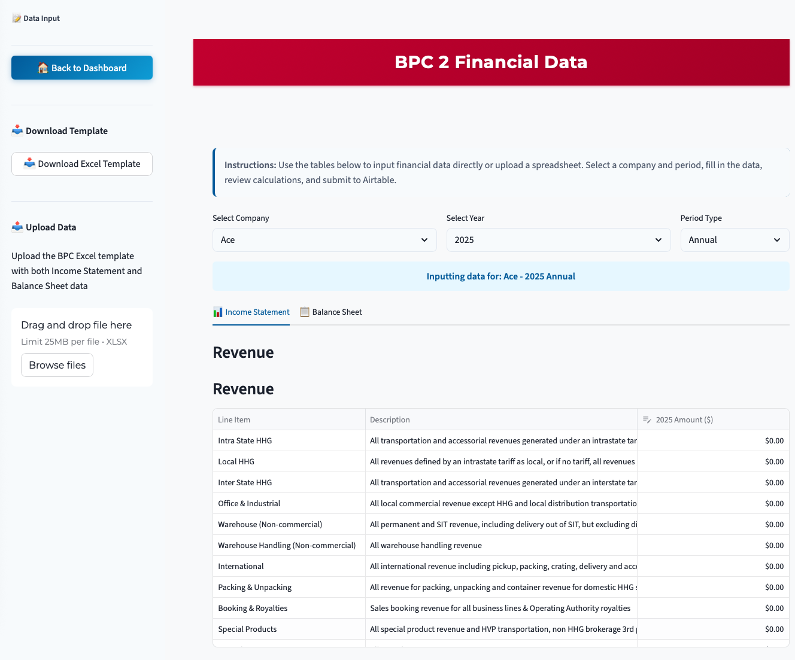

Upload page with Download Template and Upload Data in the sidebar
Note: The template includes an Instructions sheet with guidance on each field.

Step 3: Upload the Excel File
After filling in the template, upload it using the file uploader in the sidebar. Click "Browse files" or drag and drop your completed Excel file. The system will automatically parse both the Income Statement and Balance Sheet sheets and load the data into the form.
You will see confirmation messages showing how many items were loaded from each sheet.
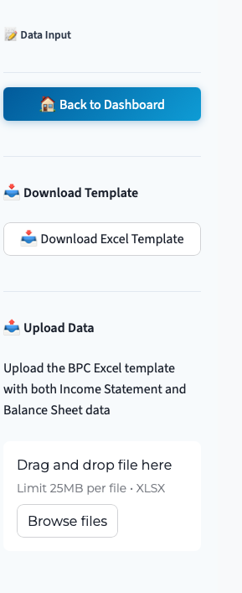
Sidebar with Download Template and file uploader
Note: Both Income Statement and Balance Sheet data are loaded from a single file upload.

Step 4: Review & Submit Income Statement
On the Income Statement tab, review all values in the data tables. You can edit any value directly in the table if corrections are needed.
When you are satisfied with the data, scroll to the bottom and click "Submit Income Statement to Airtable".
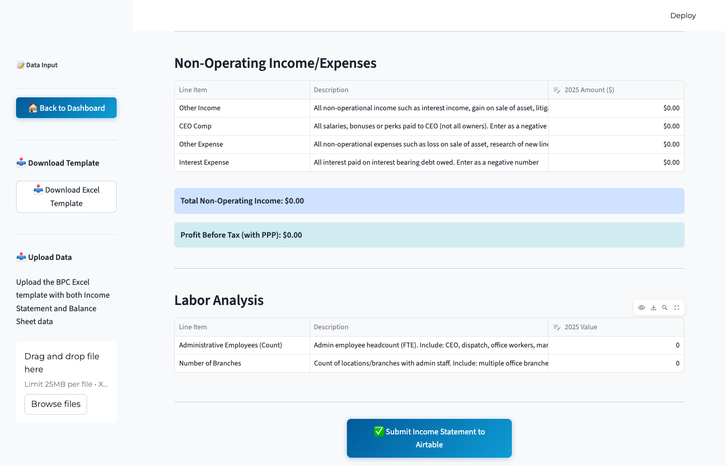
Income Statement tab with the Submit button at the bottom

IMPORTANT
After clicking Submit, WAIT for the green success message and confetti animation to appear. This confirms your data was saved successfully. Do NOT click the button again or navigate away until you see the confirmation.

Step 5: Submit Balance Sheet
Switch to the Balance Sheet tab. Review all values, paying special attention to the balance check at the bottom of the page. The system will show whether your Balance Sheet balances (Total Assets = Total Liabilities & Equity).
Click "Submit Balance Sheet to Airtable" to save your data.
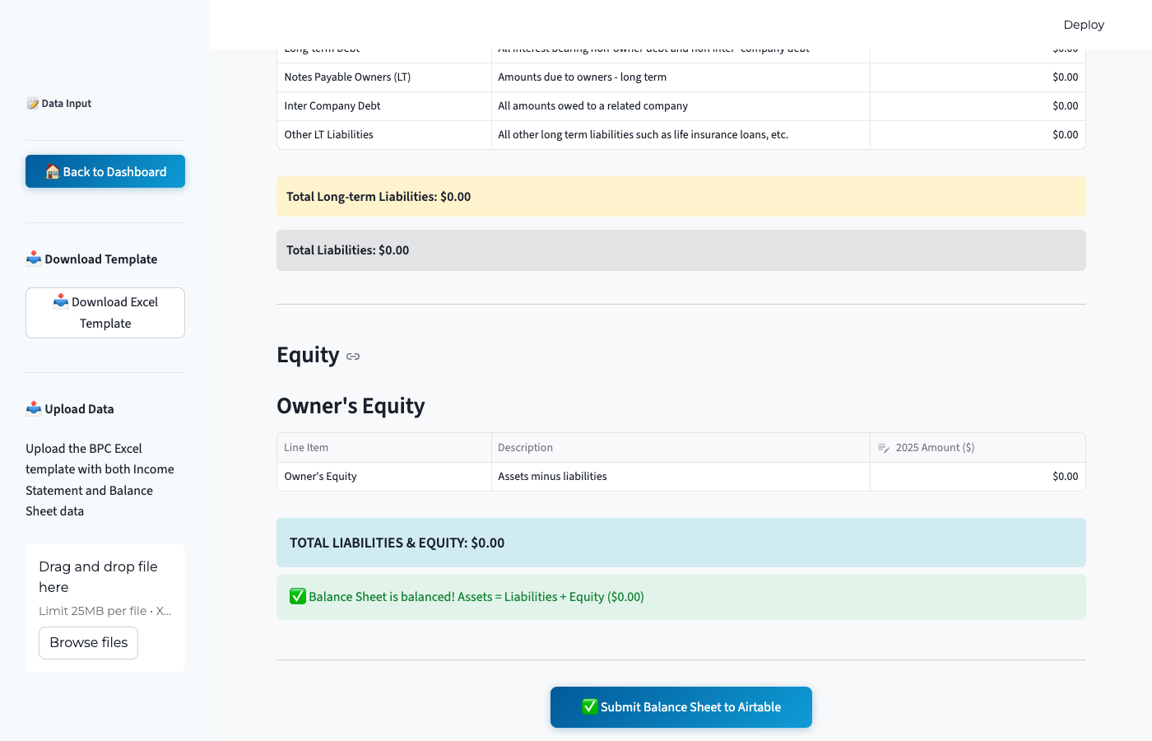
Balance Sheet tab with balance check and Submit button

IMPORTANT
Both sheets must be submitted separately. Submitting the Income Statement does NOT submit the Balance Sheet, and vice versa. Make sure you submit both.

Note: The Submit button will be disabled if the Balance Sheet does not balance. Correct any discrepancies before submitting.

Quick Reference Checklist
- Navigate to the Upload page via the sidebar Admin section
- Download the Excel template and fill in both sheets
- Upload the completed Excel file using the sidebar uploader
- Review the Income Statement tab and click "Submit Income Statement to Airtable"
- Wait for the green success message and confetti animation
- Switch to the Balance Sheet tab and click "Submit Balance Sheet to Airtable"
- Wait for the green success message and confetti animation

Troubleshooting
Q: Balance Sheet won't submit?
A: The Balance Sheet must balance (Total Assets = Total Liabilities & Equity) before the submit button is enabled. Check your values and correct any discrepancies.
Q: Submit button is grayed out?
A: If you already submitted data, the button will be disabled. Edit a value in the table or upload a new file to re-enable the submit button.
Q: Data still showing after submission?
A: This is normal Streamlit behavior. The form data remains visible after submission until the page is refreshed. Your data has been saved if you saw the success message.
Q: Uploaded file shows errors?
A: Make sure you are using the official BPC Upload Template. The parser expects specific sheet names (Income Statement, Balance Sheet) and row labels.
Q: Need Further Help?
A: If you encounter any issues that you are unable to resolve using the steps above, please feel free to reach out for assistance at adi@imaiconsultants.com Include a brief description of the issue and any error messages you see on screen.

