PULSE
HR Management Tool
Business Requirements Document
Prepared by: Aditya Kulkarni
Prepared for: CortexCraft Innovation Labs Pvt Ltd — Technical Assessment, Round 1
Date: 21 July 2026

1. Introduction & Purpose
This document defines the business requirements for Pulse, a lightweight HR Management Tool built as a proof-of-concept for the technical assessment. The goal is to demonstrate a working, end-to-end system covering the core needs of a small-to-mid-sized organization's HR function: maintaining an employee directory and managing the leave request lifecycle.
The scope is deliberately narrow so it can be delivered as a working prototype within the assessment window, while the architecture is designed to extend cleanly toward a production-grade system (see Section 4).

2. Key User Personas
Persona | Description | Primary Goals
HR Admin | Manages the employee lifecycle and adjudicates leave requests. Has organization-wide visibility. | Onboard/offboard employees; keep records accurate; approve or reject leave fairly and quickly.
Employee | An individual contributor or manager who is a member of the organization. | View colleagues in the directory; apply for leave; track the status of their own requests.

3. Core Features

3.1 Employee Directory
- Onboarding: HR Admin can add a new employee with name, email, department, designation, and joining date.
- Directory view: All employees can browse a read-only, searchable list of everyone in the organization.
- Offboarding: HR Admin can remove an employee record.
- Record editing: HR Admin can update an employee's department, designation, or status as roles change.

3.2 Leave Management
- Apply for leave: Employees submit a leave request with type (Casual/Sick/Earned), date range, and reason.
- Review queue: HR Admin sees all pending requests in one place.
- Approve / Reject: HR Admin actions a request; the employee's view updates to reflect the decision.
- Personal history: Employees can see the status of their own past and pending requests.

3.3 Dashboard
- Organization snapshot: Total and active employee counts, pending leave requests, and approved-leave counts.
- Department breakdown: A quick view of which departments exist and how the org is composed.

4. Primary Functional Workflows

4.1 Onboarding an Employee
- HR Admin opens the Employee Directory and selects “Add employee”.
- HR Admin enters the employee's details and submits the form.
- The system generates a unique employee ID and adds the record to the directory.
- The new employee immediately appears for all users and is available for leave assignment.

4.2 Applying for and Resolving a Leave Request
- Employee opens Leave Management and selects “Apply for leave.”
- Employee specifies leave type, date range, and an optional reason, then submits.
- The request enters the queue with status “Pending” and is visible to HR Admin.
- HR Admin reviews the request and either approves or rejects it.
- The employee sees the updated status reflected against their request immediately.

5. Out of Scope (for this prototype)
- Payroll processing, tax computation, and statutory compliance.
- Performance review cycles and goal tracking.
- Multi-level approval chains (e.g., manager → HR → finance).
- Real authentication/SSO — role selection is simulated for demonstration purposes.

6. System Architecture (Overview)
Pulse follows a simple three-layer architecture: a browser-based client, a Node.js application server, and a JSON-file data layer standing in for a database. Full design rationale is provided in the accompanying System Architecture document; a summary diagram is included below.
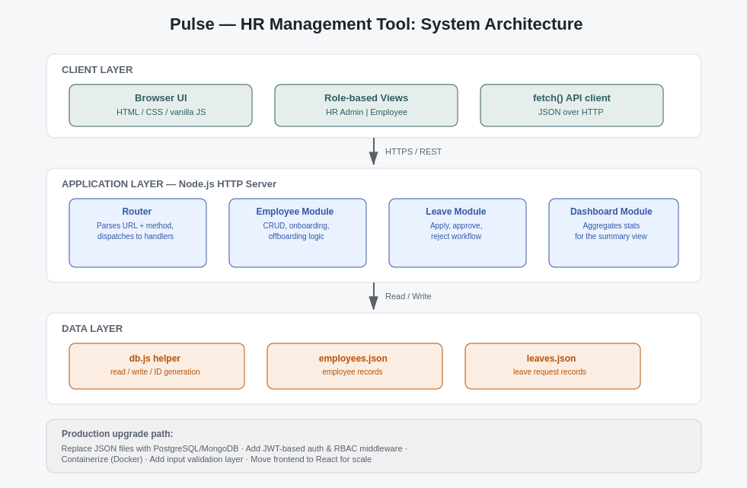
Key design choices, at a glance:
- Zero-dependency backend: built on Node's native http module so the prototype runs with a single command and no package installation.
- JSON file storage: readable, inspectable, and sufficient for prototype-scale data; swapped for a real database before production (see Section 4 of the Architecture doc).
- Role-based UI: a single frontend renders different capabilities depending on whether the signed-in user is HR Admin or Employee.

7. Deliverables Summary
Deliverable | Description
Business Requirements Document | This document — features, personas, and workflows.
System Architecture | Diagram and design-choice rationale (separate document).
Working Model | Functional prototype: Node.js backend + JSON file database + HTML/CSS/JS frontend.

