A PRELIMENERY REPORT ON

EARLY DETECTION OF ALZHEIMER’S DISEASE USING CNN DEEP LEARNING

SUBMITTED TO THE VISHWAKARMA INSTITUTE OF INFORMATION TECHNOLOGY, PUNE
IN THE PARTIAL FULFILLMENT OF THE REQUIREMENTS
FOR THE AWARD OF THE DEGREE

OF

BACHELOR OF TECHNOLOGY (COMPUTER ENGINEERING)

SUBMITTED BY

HIMANSHU SURYAWANSHI 22110300
ADITYA ROKAMWAR 22110765
SUYASH PHAPALE 22110445
SARVESH HAJARE 22110702



DEPARTMENT OF COMPUTER ENGINEERING

BRACT’S
VISHWAKARMA INSTITUTE OF INFORMATION TECHNOLOGY

SURVEY NO. 3/4, KONDHWA (BUDRUK), PUNE – 411048, MAHARASHTRA (INDIA).

Sr. No. |  |  |  | Title of Chapter |  | Page No.
01 |  |  |  | Introduction
 | 1.1 |  |  | Overview
 | 1.2 |  |  | Motivation
 | 1.3 |  |  | Problem Definition and Objectives
 | 1.4 |  |  | Project Scope & Limitations
 | 1.5 |  |  | Methodologies of Problem solving
02 |  |  |  | Literature Survey
03 |  |  |  | System Design
 |  | 3.1 |  | System Architecture
04 |  |  |  | Project Implementation
 |  |  | 4.1 | Overview of Project Modules
 |  |  | 4.2 | Tools and Technologies Used
 |  |  | 4.3 | Algorithm Details
 |  |  |  | 4.3.1 | Algorithm 1
 |  |  |  | 4.3.2 | Algorithm 2
 |  |  |  | 4.3.3 | …
05 |  |  |  | Results
 |  |  | 5.1 | Outcomes
 |  |  | 5.2 | Screen Shots
 |  |  | 5.3 | Confusion Matrix, Precision ,Recall,Accuracy,Specificity ,Sensitivity All Graph
06 |  |  |  | Conclusions
 |  | 9.1 |  | Conclusions
 |  | 9.2 |  | Future Work
 |  | 9.3 |  | Applications
07 |  |  |  | References

1. INTRODUCTION

Alzheimer’s disease (AD) is a chronic neurodegenerative disease mainly occurring in the elderly. As per WHO statistics, around 55 million people will be affected by dementia worldwide in 2025. It is anticipated to double every 20 years, reaching 78 million by 2030 and 139 million by 2050. AD is the leading cause of dementia and contributes to 60–70% of cases. It deteriorates cognitive function and causes memory impairment. It is a progressive disease in which, at its late stage, they lose the complete cognitive ability and memory and depend on others for daily activities. AD has no cure but can be delayed by taking necessary medications if known at earlier stages. Changes in the brain can begin years before the first symptoms appear. Mild Cognitive Impairment (MCI) is the precursor of AD, and it is crucial to know the disease at this stage to prevent further progression. Structural MRI is an excellent biomarker to predict AD, especially in the MCI stage, since it gives the anatomic structure of atrophy regions. Even though SMRI gives the structural details, identifying the MCI stage is challenging since only subtle changes exist between AD, MCI, and NC. Ternary classification can classify three classes since only a single algorithm is required to classify them. It also has the added advantage of training with both MCI and AD, which helps to learn the atrophy features common to both classes. Often, Alzheimer’s disease symptoms are dismissed as part of the normal aging process. We can see the difference between regular aging changes and Alzheimer’s patients in the MRI slices by including Normal Control (NC). Coronal studies of MRI images can reveal the role of the amygdala and hippocampus in early disease detection. Also, it can bring forth other regions of the disease.

Deep learning is an end-to-end learning model where the feature extraction and classification are automated by the network itself. The primary advantage of end-to-end learning is optimizing all steps in the processing pipeline, leading to optimal performance. Early deep learning models needed feature extraction before feeding the one dimensional feature vector to the network. Also, it may flatten 2 Dimensional (2D) and 3 Dimensional (3D) images into one single vector to learn and classify. Handcrafted feature extraction leads to data scarcity and high dimensionality, and the need for feature selection throws off many features. Convolutional Neural Networks (CNN) is an end-to-end, powerful deep learning method where spatial relationships of the image are utilized, and features are learned automatically from the image.

2. LITERATURE SURVEY

AD is a fast-growing disease occurring worldwide. It mostly affects the aged population.
AD is incurable and is a neurodegenerative disease that mostly affects the brain. People are
facing problems associated with AD due to a lack of early diagnosis due to no or minor
symptoms in the early stages of the disease. Gaudiuso et al. (2020) proposed a technique
using machine learning integrated with Laser-Induced Breakdown Spectroscopy (LIBS).
Micro drop plasmas were diagnosed for AD patients and healthy controls (HCs). The
classiﬁcation was also performed using machine learning algorithms. The dataset used for
the evaluation of the model had 31 AD patients and 36 HCs. The proposed technique
successfully diagnosed late-onset AD, with a better diagnosis for patients greater than 65
years of age. The total classiﬁcation accuracy between AD and HC was 80%, which
indicates that it is better than other approaches.
Bilal et al. (2020) proposed a technique for the accurate diagnosis of AD. This study
proposed nanotechnologies to overcome the limitations in treatment for early diagnosis
and analysis. The neurodegenerative disease was treated with nanocarriers delivering bio-
actives. Using nanocarriers with bio-actives is a very fruitful way to treat
neurodegenerative disease compared to common therapies. This review came after
studying nanocarriers, nanoparticles, and nanotubes which are helpful for early-stage
diagnosis in large volumes of data. This study conducted a few experiments to ﬁnd an
optimum solution for early diagnosis for aged people to overcome AD. The results of this
AD is a fast-growing disease occurring worldwide. It mostly affects the aged population.
AD is incurable and is a neurodegenerative disease that mostly affects the brain. People are
facing problems associated with AD due to a lack of early diagnosis due to no or minor
symptoms in the early stages of the disease. Gaudiuso et al. (2020) proposed a technique
using machine learning integrated with Laser-Induced Breakdown Spectroscopy (LIBS).
Micro drop plasmas were diagnosed for AD patients and healthy controls (HCs). The
classiﬁcation was also performed using machine learning algorithms. The dataset used for
the evaluation of the model had 31 AD patients and 36 HCs. The proposed technique
successfully diagnosed late-onset AD, with a better diagnosis for patients greater than 65
years of age. The total classiﬁcation accuracy between AD and HC was 80%, which
indicates that it is better than other approaches.
Bilal et al. (2020) proposed a technique for the accurate diagnosis of AD. This study
proposed nanotechnologies to overcome the limitations in treatment for early diagnosis
and analysis. The neurodegenerative disease was treated with nanocarriers delivering bio-
actives. Using nanocarriers with bio-actives is a very fruitful way to treat
neurodegenerative disease compared to common therapies. This review came after
studying nanocarriers, nanoparticles, and nanotubes which are helpful for early-stage
diagnosis in large volumes of data. This study conducted a few experiments to ﬁnd an
optimum solution for early diagnosis for aged people to overcome AD. The results of this
AD is a fast-growing disease occurring worldwide. It mostly affects the aged population.AD is incurable and is a neurodegenerative disease that mostly affects the brain. People are facing problems associated with AD due to a lack of early diagnosis due to no or minor symptoms in the early stages of the disease. Gaudiuso et al. (2020) proposed a technique using machine learning integrated with Laser-Induced Breakdown Spectroscopy (LIBS). Micro drop plasmas were diagnosed for AD patients and healthy controls (HCs). The classiﬁcation was also performed using machine learning algorithms. The dataset used for the evaluation of the model had 31 AD patients and 36 HCs. The proposed technique successfully diagnosed late-onset AD, with a better diagnosis for patients greater than 65years of age. The total classiﬁcation accuracy between AD and HC was 80%, which indicates that it is better than other approaches.

Bilal et al. (2020) proposed a technique for the accurate diagnosis of AD. This study proposed nanotechnologies to overcome the limitations in treatment for early diagnosis and analysis. The neurodegenerative disease was treated with nanocarriers delivering bio-actives. Using nanocarriers with bio-actives is a very fruitful way to treat neurodegenerative disease compared to common therapies. This review came after studying nanocarriers, nanoparticles, and nanotubes which are helpful for early-stage diagnosis in large volumes of data. This study conducted a few experiments to ﬁnd an optimum solution for early diagnosis for aged people to overcome AD. The results of this study perform better than the open-source dataset and suggest how to treat patients in the early stages.

3. SYSTEM ARCHITECTURE

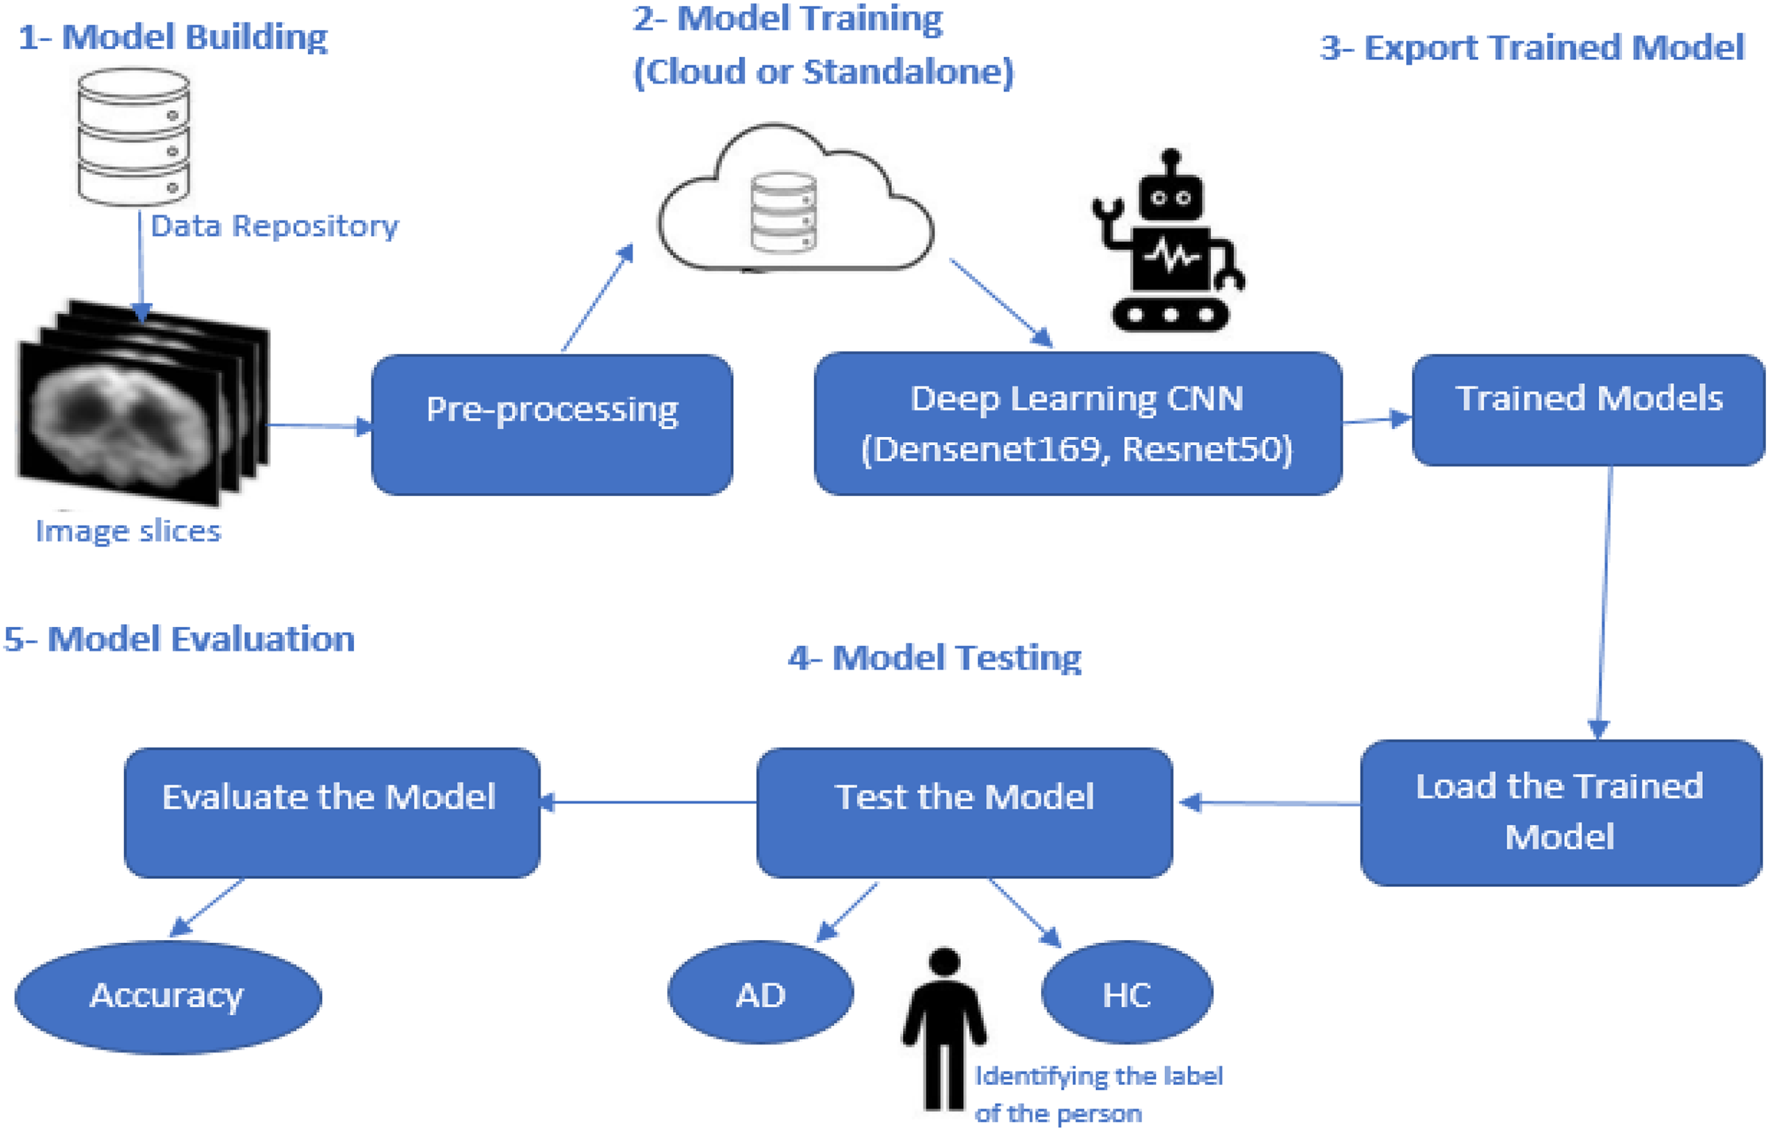
EffNetB0, InceptionV3

4. PROJECT IMPLEMENTATION

PROPOSED METHODOLOGY

This proposed research methodology addresses the problems discussed in the Introduction. Various techniques based on deep learning were discussed earlier, but these approaches are lacking in the early diagnosis of AD when symptoms are minor or non-existent. This research study focused on the CNN-based deep learning models known as EfficientNetB0, InceptionV3 and Custom CNN, which are used for diagnosing and classifying AD.

Pre-processing

Several steps are performed in this stage of model development. The first is loading the image dataset into the model. The dataset is insufficient to train the deep learning models to meet the required data volume. Here data augmentation techniques are applied in which a few parameters are set such that the images are rescaled, rotated, zoomed, flipped horizontally and vertically, and split. Validation is performed for the whole image dataset. After applying these steps, sufficient data volume was generated based on the previous dataset. This dataset had four classes: Non-Dementia, Very Mild-Dementia, Mild Dementia, and Moderate Dementia. Each image was individually labelled for analysis purposes. After applying these steps, the dataset was available for further processing.

Model building

The proposed model was based on the EfficientNetB0, InceptionV3 and Custom CNN models. CNN is a deep learning model used for the classification of features. A CNN model contains several different layers. A few common layers in CNN architectures are discussed below.

- The input layer
The first CNN layer is the input layer which defines the image size used in the dataset as 128x128x3(width height channels). Shuffling the images is unnecessary because each training epoch will be shuffled automatically.

- The convolutional layer
The convolutional layer is the core of the CNN architecture. It is the basic master layer which contains required parameters and feature maps. These layers are key to performance via the selection of a kernel. Padding is used in the feature maps and the convolutional layer to match the sizes of the input and output layers. By default, padding is assigned preset values of one.

- Batch normalization layer
Network training is a time-consuming process. Batch normalization of the training data is an easy optimization. Gradients are normalized and help move forward or trigger the network propagation. Batch normalization layers are used between the non-linearity and convolutional layers.

- ReLU layer
Rectified linear unit (ReLU) is the activation function mostly used in neural network architectures. ReLU layer is used after the batch normalization layer.

- Max-pooling layer
Spatial features are large. This layer helps to reduce the feature map size and to remove redundancy from the spatial information. Sample reduction helps to reduce the computation cost and to move meaningful information into the feature maps.

- Fully connected layer
These layers are described by their name. All the previous layers are connected here. At this stage, all the previous learning layers are merged. The final layer provides the classification of the model. The number of outputs equals the number of classes identified in the image dataset. In this study, there are four classes.

- Softmax layer
The output obtained from the fully connected layer is not normalized. Normalization is performed using an output Softmax layer. The output obtained from this layer is a positive integer and can be used for classification.

- Classification layer
The classification layer is the last in the CNN architecture. The Softmax layer uses it for classification. Probabilities are returned for each input image to authenticate the manually labelled classes. It also calculates the loss values.

Model training

After successfully developing the deep learning model architecture, it needs to be trained. The whole dataset is shuffled in each training epoch for 100. In this study, both architectures, DenseNet169 and ResNet50, were used separately for training purposes. We used 70% of the data for training the model and the rest of the 30% was used to test the model.

Testing model

The trained model is tested using various images. This model diagnoses AD and classification between these four different classes. The values output from the model are compared with the true values for the input images. The comparison of output values with true values for the testing dataset is used to evaluate the model.

Model evaluation

The model is evaluated based on the training model and testing dataset. The evaluation measure is computed by comparing calculated values from the model and true values known for each image in the testing dataset. The evaluation measures are used as proof of whether the model is performing well or not. Accuracy is the evaluation measure used to check the model’s significance. Accuracy is used for the performance analysis of the proposed model. The computation of accuracy is defined below:

Accuracy = Aa/ Ac * 100

where Aa is the number of accurately classified results and Ac is the total number of results.

Algorithm

- EfficientNetB0

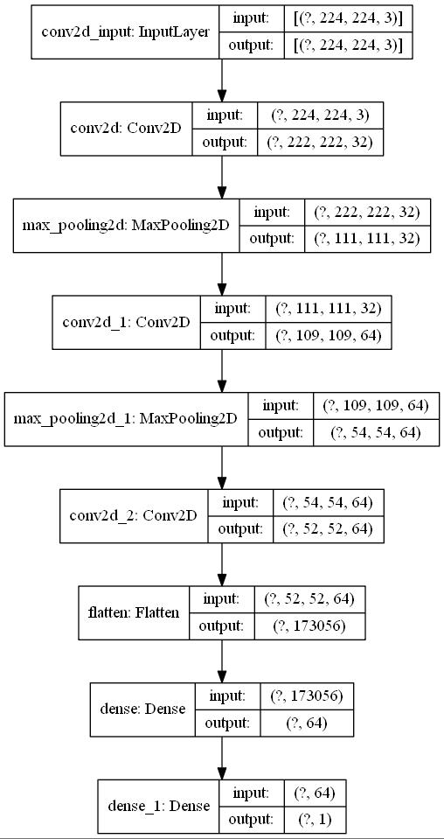

- InceptionV3

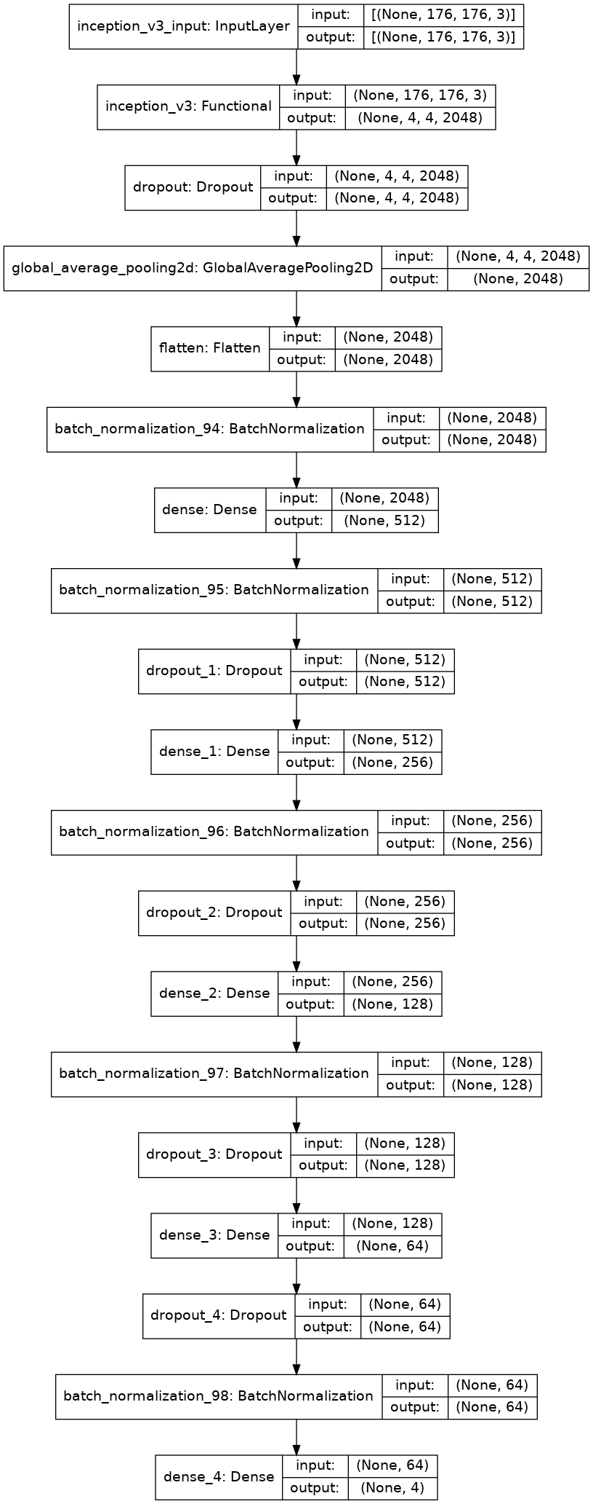

- Custom CNN

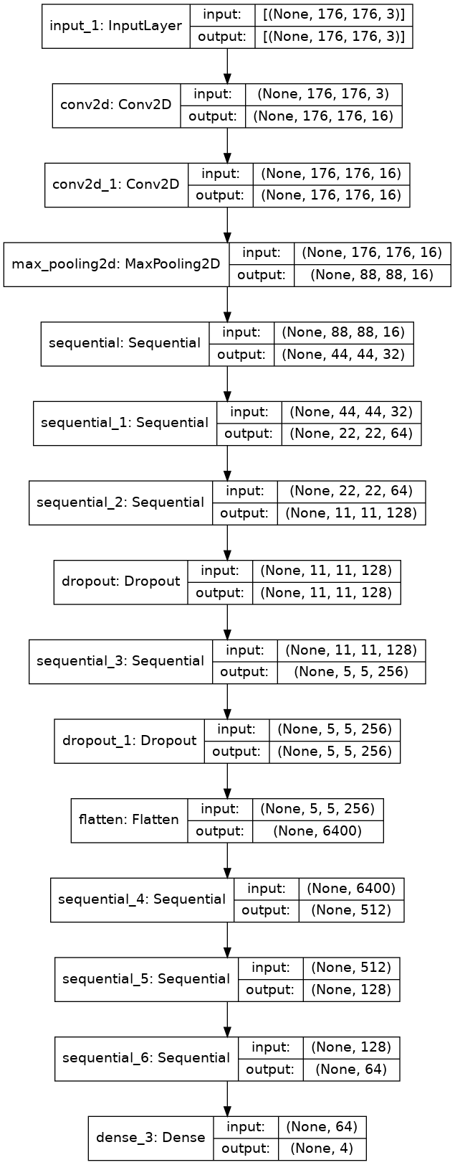

5. RESULT

Outcome

Model | Accuracy (%)
EfficientNetB0 | 85.46
InceptionV3 | 89.06
Custom CNN | 94.84

Screenshots

Confusion Matrix, Precision , Recall, Accuracy, All Graphs

- EfficientNetB0

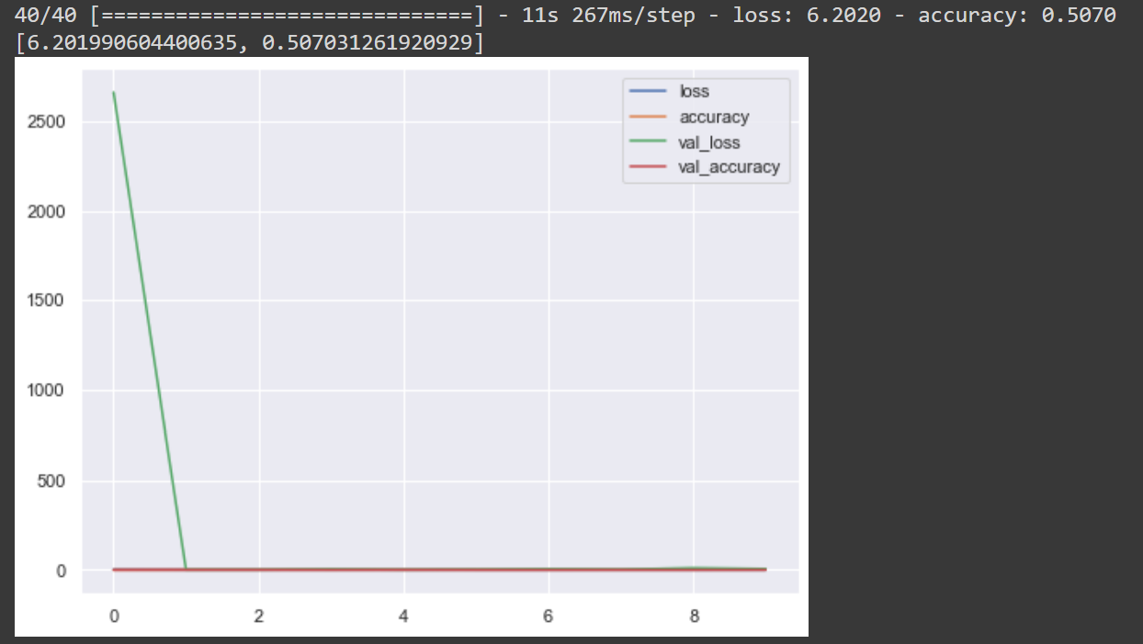

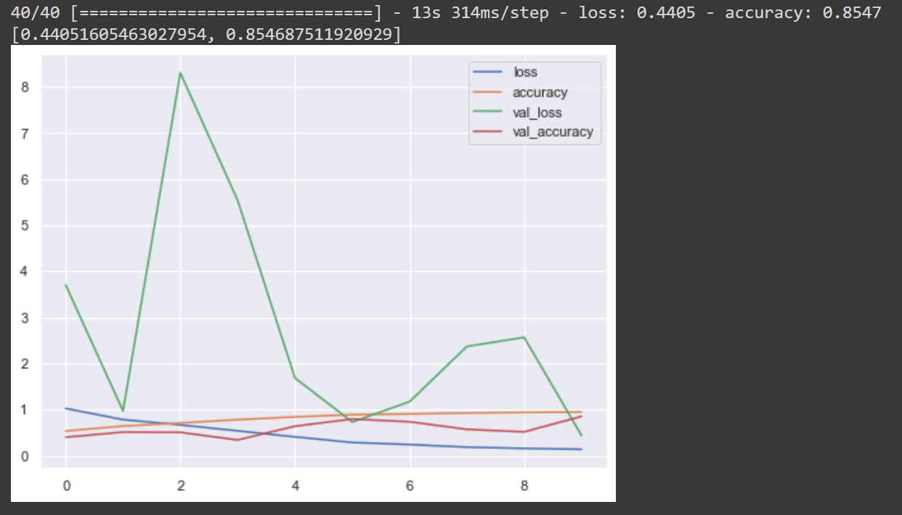

- InceptionV3

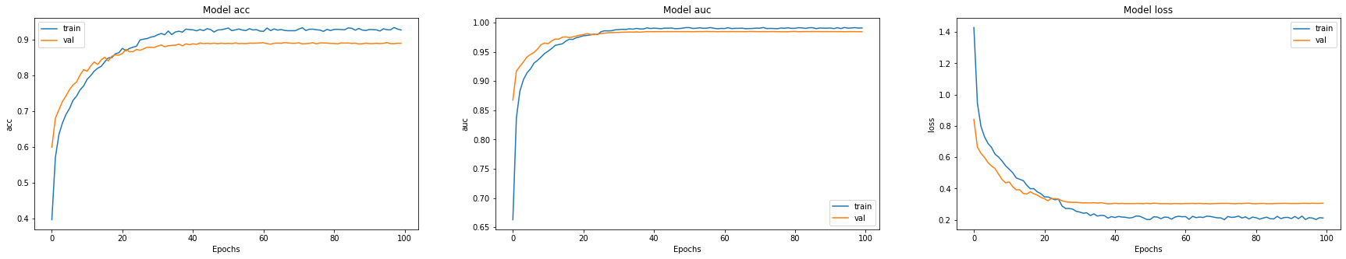

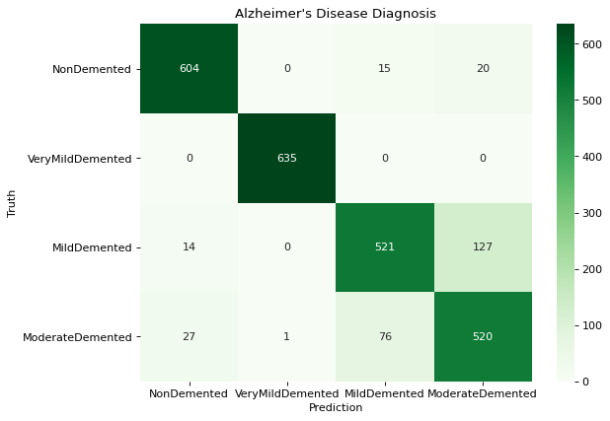

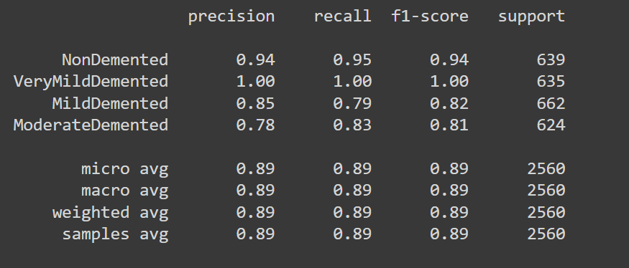

- Custom CNN

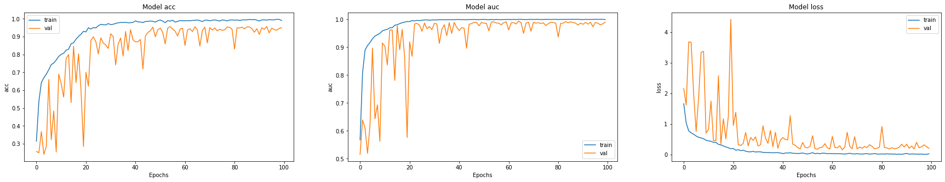

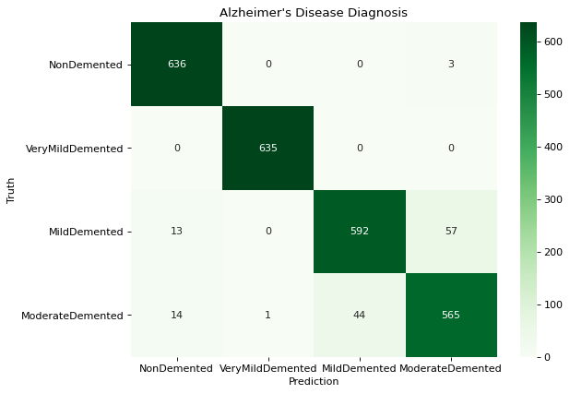

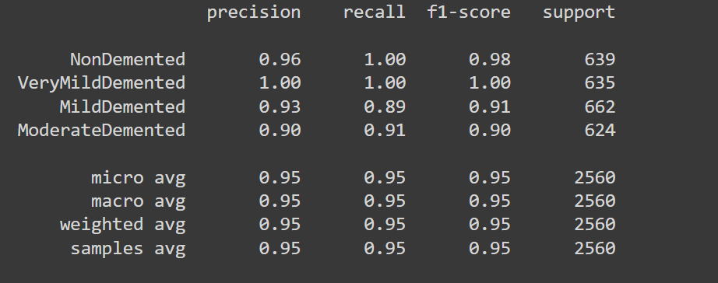

6. CONCLUSION AND FUTURE WORK

It has been determined that Alzheimer’s disease is an incurable neurodegenerative disease that affects brain memory, particularly in the elderly. Owing to the enormous number of patients, it is impossible to perform manual diagnosis efficiently and health specialists make errors during evaluation due to time constraints and the difficulty of the process. Various procedures are used to diagnose and characterize Alzheimer’s, but an accurate and timely diagnostic solution is required. The proposed model suggests a deep learning-based method for diagnosing and classifying Alzheimer’s disease utilizing the EfficientNetB0, InceptionV3 and Custom CNN architectures. Non-Dementia, Very Mild-Dementia, Mild Dementia, and Moderate Dementia were the four classifications of Alzheimer’s Disease in this model. During the training and testing stages, the Custom CNN method outperformed all other. This suggested approach may be used to do real-time analysis and classification of Alzheimer’s disease. In the future, we plan to extend the disease detection with more data sets and use different measures to detect the system’s accuracy.

7. REFERENCES

- Kumar A, Sidhu J, Goyal A, Tsao JW. 2018. Alzheimer disease. StatPearls.1–27. Available at http://europepmc.org/books/NBK499922 (accessed 4 December 2022).

- Kundaram SS, Pathak KC. 2021. Deep learning-based alzheimer disease detection. In: Proceedings of the Fourth International Conference on Microelectronics, Computing and Communication Systems. Singapore: Springer, 587–597.

- NawazH,MaqsoodM,AfzalS,AadilF,MehmoodI,RhoS.2021.Adeepfeature-based real-time system for Alzheimer disease stage detection. Multimedia Tools and Applications 80(28):35789 35807 DOI 10.1007/s11042-020-09087-y.

- Salehi AW, Baglat P, Gupta G. 2020. Alzheimer’s disease diagnosis using deep learning techniques. International Journal of Engineering and Advanced Technology 9(3):874–880 DOI 10.35940/ijeat.C5345.029320.

- Sharma G, Vijayvargiya A, Kumar R. 2021. Comparative assessment among different convolutional neural network architectures for Alzheimer’s disease detection. In: 2021 IEEE 8th Uttar Pradesh Section International Conference on Electrical, Electronics and Computer Engineering (UPCON). Piscataway: IEEE, 1–6.

