MAHA INVENTORY
Final Workflow, Platform Explanation & Step-by-Step Build Plan
A digital agricultural inventory intelligence system for Maharashtra

1. The project in simple words
Maha Inventory collects stock movement records from participating large private godowns and wholesale vendors across Maharashtra. Vendors record what they purchase from farmers, what they sell or dispatch, what they transfer to another godown, and any stock that spoils. The platform turns these records into district-wise inventory visibility and uses historical records and seasonal patterns to estimate future requirements.
Main principle: Farmers do not need accounts on Maha Inventory. The main data-entry users are godown owners and wholesale vendors. Government users review aggregated information and use it for planning; Gram Panchayats, farmer communities and NGOs can help communicate or coordinate priorities.

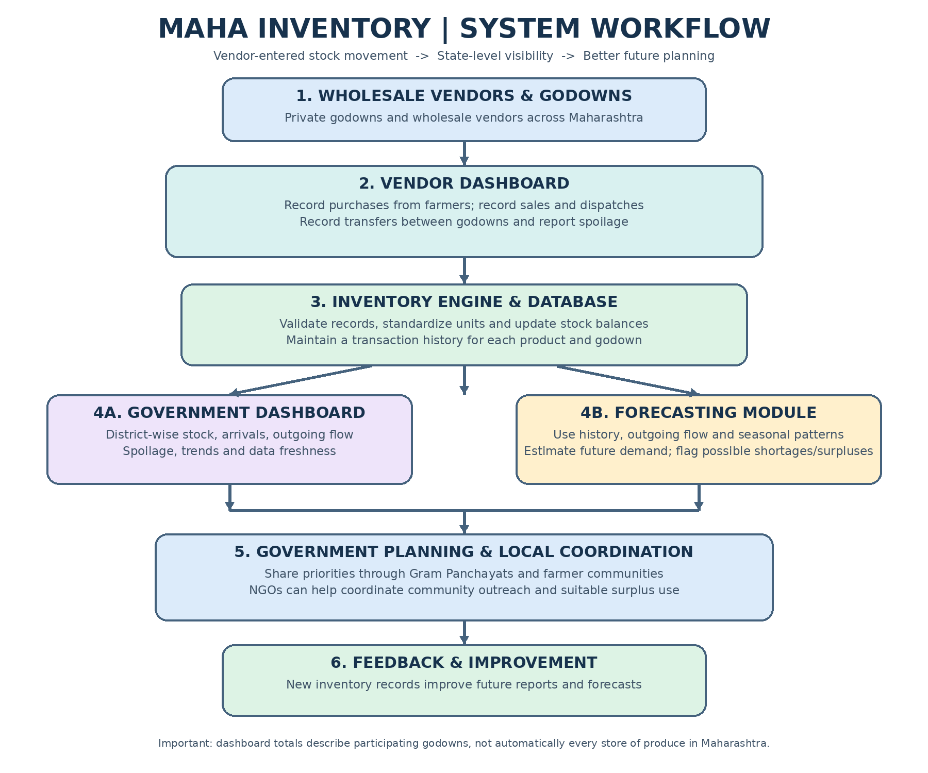
Coverage note: totals are only as complete as the participating vendors and the quality/timeliness of their records.

2. Final operating workflow: step by step
Step 1 — Approve a vendor and register each godown
An administrator verifies the business and creates a vendor account. The vendor adds each godown, its district/taluka/village or address, and contact details needed for operations. One vendor may manage multiple godowns.
Step 2 — Vendor records a purchase from a farmer
When produce arrives, the vendor selects the product (for example, tomatoes), enters received weight and unit (kg, quintal or tonne), purchase date, purchase amount if required, and the godown receiving it. The farmer does not need to log in. A receipt or internal reference can be retained for checking.
Step 3 — Maha Inventory adds incoming stock
The system converts quantities to a standard internal unit (recommended: kilograms for weight-based goods), validates the entry and increases that godown’s stock balance. The user interface can still display kg, quintals or tonnes.
Step 4 — Vendor records every outgoing movement
When produce is sold or dispatched, the vendor records the product, quantity, date and movement type. The system reduces the source godown’s stock. It is best to record outgoing movements promptly, so the dashboard does not keep showing stock that is no longer there.
Step 5 — Vendor records transfers between godowns
If 100 kg of tomatoes moves from Godown A to Godown B, the system reduces 100 kg at A and adds 100 kg at B. A transfer inside the participating network should not be counted as new stock for Maharashtra overall.
Step 6 — Vendor records spoilage or damage
If stock spoils after purchase or during storage, the vendor enters the product, quantity, date and reason. Spoiled stock is removed from usable inventory and separately tracked for reporting.
Step 7 — System calculates current usable stock
For each product and godown, the system calculates opening stock plus purchases and transfers in, minus sales/dispatches, transfers out and spoilage, plus or minus any approved correction. It preserves a movement history instead of silently deleting old records.
Step 8 — Government reviews the state-level picture
Authorized government users see inventory by district, taluka, product and date, with indicators for incoming volume, outgoing volume, remaining usable stock, spoilage and how recently each vendor updated records.
Step 9 — Forecast possible future needs
The forecasting module studies historical purchases, outgoing movement, stock trends and seasonal patterns. It estimates which products may face a shortage or surplus and shows the confidence or limitations of each estimate.
Step 10 — Coordinate planning through local partners
Government teams can share priorities through Gram Panchayats and farmer communities. NGOs may support outreach, local coordination or finding suitable uses for surplus. The platform informs planning; it does not directly order farmers to grow a crop.
Step 11 — Compare estimates with what actually happened
As more records arrive, the system compares prior estimates with actual stock movement and adjusts its forecasts. Administrators monitor data completeness and follow up on inactive or inconsistent vendor accounts.

3. Inventory rules and a worked example
The inventory engine is the core of the platform. Every record must change stock in a predictable way and leave a trace that can be checked later.
Event | Effect on source godown | Effect on destination / state total
Purchase received from farmer | Increase stock | State total increases by received amount
Sale / dispatch to a buyer outside tracked godowns | Decrease stock | State total decreases by dispatched amount
Transfer from one tracked godown to another | Decrease source stock | Increase destination stock; state total stays unchanged
Spoilage / damage | Decrease usable stock | Usable state inventory decreases; spoilage is separately reported
Approved correction / stock count adjustment | Increase or decrease with reason and approver | Reflects corrected figure; audit trail retained

Worked example: tomatoes in one godown
Movement | Quantity
Purchase received | +500 kg
Sold / dispatched | -300 kg
Spoiled and reported | -20 kg
Remaining usable stock | = 180 kg
Calculation: 500 kg - 300 kg - 20 kg = 180 kg. If another 100 kg is transferred to a second participating godown, the first godown shows 80 kg and the second increases by 100 kg. The statewide total does not increase merely because of that transfer.

Recommended standard rules
- Use a consistent product catalogue, including common names and regional-language labels where useful. Avoid treating spelling variants as different products.
- Store weight-based quantities in one standard unit internally; 1 quintal = 100 kg and 1 tonne = 1,000 kg. Show the vendor-friendly unit on the screen.
- Do not allow negative stock without an authorized correction workflow. Warn users when a movement exceeds available stock.
- Do not silently erase stock events. Correct mistakes through a reversal or approved adjustment with a reason, user and timestamp.
- Keep product, unit, date, godown and movement type mandatory. Make price optional for the first release if cost reporting is not essential.
- Mark records with last-updated time and, where practical, a verification status so government users can distinguish fresh data from stale data.

4. Who uses the platform?
User role | What they can do | What they should not automatically see
Vendor / godown operator | Enter purchases, sales/dispatches, transfers, spoilage and view their own stock | Other vendors’ private transaction details
Maha Inventory administrator | Approve vendor accounts, manage products/units/locations, review errors and audit changes | Should not change records without leaving an audit trail
Government analyst / authorized official | View aggregated inventory, regional trends, data freshness and forecasts | Private business-level details unless access is explicitly authorized
Planning / coordination partner | View approved needs or surplus summaries relevant to their work | Unnecessary commercial or personal data

5. Main application modules
A. Login and role permissions
Different screens and permissions for vendors, administrators and government users. Protect accounts and prevent a vendor from viewing another vendor’s private ledger.
B. Vendor and godown registration
Business approval, godown location, district/taluka, status and assigned users.
C. Product catalogue
Standard names for vegetables, fruits and flowers; category; supported unit; optional grade or variety.
D. Stock movement entry
Forms for purchase/inward, sale or dispatch/outward, transfer, spoilage and approved adjustment.
E. Inventory ledger
Chronological history of every movement; current usable stock by product and godown; alerts for unusual or inconsistent values.
F. Government dashboard
Filters for date, product, district and taluka; charts and tables for current stock, inflow, outflow, spoilage and freshness of data.
G. Forecast and planning
Historical trends and seasonal analysis; probable future requirements; possible shortages/surpluses; evidence and limitations displayed alongside forecasts.
H. Local coordination
A later module for publishing approved planning priorities or surplus summaries for Gram Panchayats, farmer communities and NGOs.
I. Audit and reporting
Record who entered or changed data, when it changed and why; exports and summary reports for authorized users.

6. What data should be stored?
Record type | Minimum fields
Vendor / account | Vendor ID, business name, verified status, assigned users, contact for operations
Godown | Godown ID, vendor ID, location, district/taluka, active status
Product catalogue | Product ID, standard name, category, supported unit, optional variety/grade
Stock movement | Movement ID, product, quantity, unit, normalized quantity, movement type, date/time, source godown, destination godown if transfer, user ID, reference, reason if adjustment/spoilage
Forecast result | Product, region, forecast period, estimated range, method/version, creation date, key data limitations

7. How forecasting should work
Do not begin by promising that AI can tell the state exactly what farmers must produce. The first goal is a transparent estimate that improves as the records improve. Current stock alone cannot prove future demand; outgoing movements and, later, market-demand information are important signals.
- First release: show historical stock and movement charts, month-by-month patterns and simple moving averages.
- Next release: estimate future demand using purchase and outgoing trends, seasonality and regional differences. Use several previous seasons when reliable data exists.
- Later release: consider adding public market arrivals/prices, crop calendars, weather or other approved datasets, if integration and data quality permit.
- Present forecasts as estimates with the period, assumptions and confidence/uncertainty. Flag districts or products with too little data rather than creating false precision.
- Compare forecasts with actual outcomes regularly and report forecast error to administrators.

8. Step-by-step plan to build the app
Phase 1 — Confirm requirements
Agree on the first product categories, required vendor fields, movement types, location hierarchy, user roles and what government users may see. Prepare sample records from 2-3 realistic godowns.
Phase 2 — Design the screens
Create simple wireframes for vendor login, purchase entry, outgoing entry, transfer, spoilage, stock list and government dashboard. Test forms with one or two vendor representatives before coding.
Phase 3 — Build user access
Implement sign-in, role-based permissions, vendor approval and godown registration. Add secure password handling and account recovery.
Phase 4 — Build catalogue and movement records
Create product/unit lists and forms for purchases, outgoing movements, transfers, spoilage and corrections. Validate required fields and units.
Phase 5 — Build inventory calculation
Implement the stock ledger and automatic stock balance. Add transfer pairing, duplicate-entry warnings, negative-stock checks and audit history.
Phase 6 — Build government reports
Add filters and summaries by product, district, taluka and date. Show available stock, inflow, outflow, spoilage and last-updated time.
Phase 7 — Add baseline forecasting
Start with understandable historical charts and seasonal averages. Test against past periods before presenting the forecast to decision-makers.
Phase 8 — Pilot with a small group
Recruit a limited group of godowns in selected areas. Compare dashboard balances with actual stock checks, identify missing entries and improve the forms.
Phase 9 — Secure and launch
Test access controls, backups, recovery, performance, audit records and export permissions. Train vendors and define support for data-entry questions.
Phase 10 — Expand across Maharashtra
Add districts and vendors gradually. Monitor coverage, record freshness and inventory discrepancies before relying on statewide conclusions.

9. Suggested practical technology
Build a responsive web application first, so vendors can use it on a laptop, tablet or phone without installing a separate app. A possible stack is React/Next.js for the interface, Python (Django or FastAPI) or Node.js for the backend, and PostgreSQL for the database. These are options, not requirements; a team can use its familiar supported stack. Keep stock calculations on the server so the same rules apply to every screen and report.

10. Minimum launch checklist
- An approved vendor can create and manage only their assigned godowns.
- A purchase increases stock by the correct amount after unit conversion.
- A sale or dispatch reduces stock; spoilage reduces usable stock.
- A transfer decreases source stock and increases destination stock without inflating statewide total.
- The dashboard can filter inventory by product, location and date, and shows when records were last updated.
- Corrections are traceable, and vendors cannot silently erase movement history.
- Government users see only data allowed by their role.
- The pilot compares reported balances with physical checks and documents discrepancies.
- Forecasts are labelled as estimates and are not presented as guaranteed production instructions.
Most important recommendation: Build the reliable vendor-entry and stock-ledger system first. Forecasting and government planning will only be as useful as the accuracy and coverage of the inventory data.

