1. Create own resume in JSON format

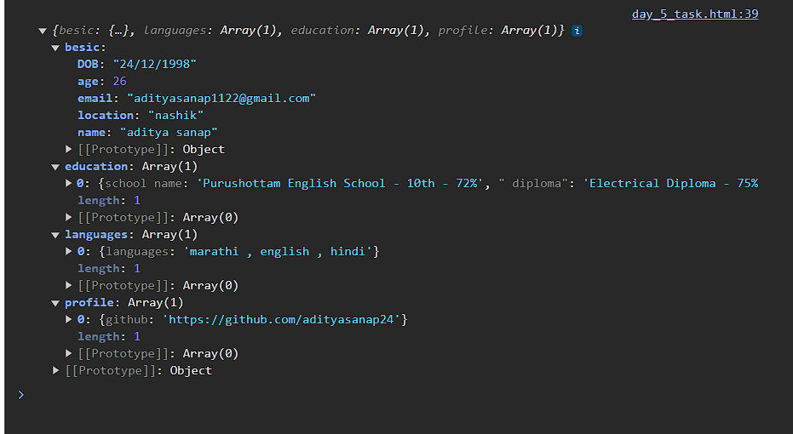

1. Use the (For, for in , for of, for each)

