**Assignment 1: Basic SQL**

**Name: Aditya Sharad Deshmukh**

**MIS: 612203036**

**CS Div 1 Batch T2**

**Statement**: Write the simple SQL queries on the given schema.

1. Write the following simple SQL Queries on the University Schema.

* Find the names of all the students whose total credits are greater than 100 .

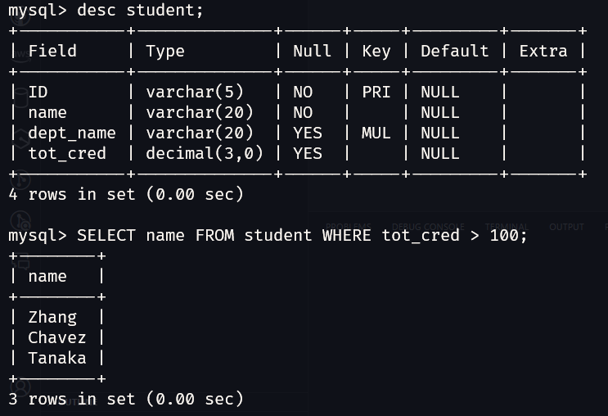

* Find the course id and grades of all courses taken by any student named 'Tanaka'.

SELECT course_id, grade FROM takes WHERE ID = (SELECT ID FROM student WHERE name = 'Tanaka');

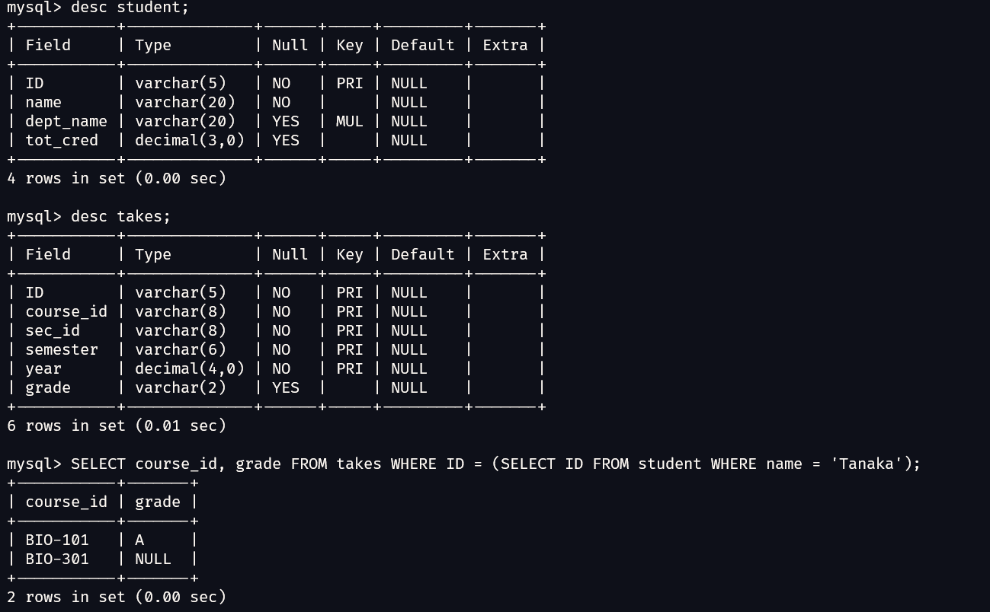

* Find the courses which are offered in both 'Fall' and 'Spring' semester (not necessarily in the same year).

select distinct title from course c JOIN takes t on t.course_id = c.course_id where t.semester = 'Fall' or t.semester = 'Spring';

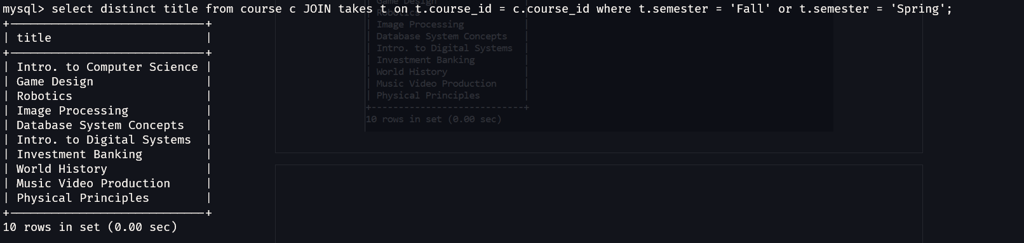

* Find the names of all the instructors from Comp. Sci. department.

SELECT name FROM instructor WHERE dept_name = 'Comp. Sci.';

* 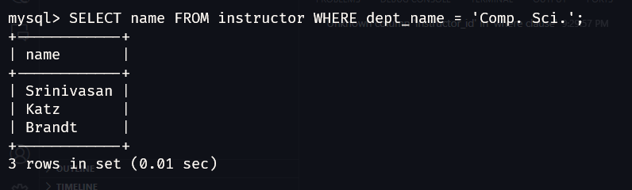
* Find the course id and titles of all courses taught by an instructor named 'Srinivasan'

select course_id, title from course where course_id in (select course_id from teaches where id in (select id from instructor where name = 'Srinivasan'));

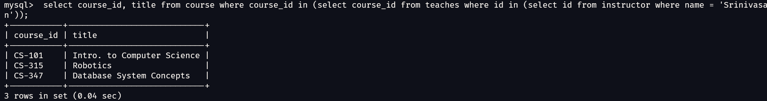

* Find the names of instructors who have taught at least one course in Spring 2009.

select name from instructor where id in (select id from teaches where semester = 'Spring' and year = 2009);

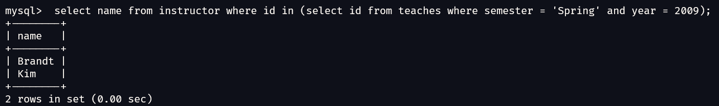

1. Create the Railway schema using the commands in the [Railway DDL](http://www.it.iitb.ac.in/moodle/pluginfile.php/77066/mod_assign/intro/RailwayDDL.sql)script; The DDL script also contains a description of the railway Schema. Insert sample data using the command in the file [SampleRailwayData](http://www.it.iitb.ac.in/moodle/pluginfile.php/77066/mod_assign/intro/railwayInsertFile.sql).

Write the following Queries for Railway Schema.

* Find pairs of stations (station codes) that have a track (direct connection) with distance less than 20Kms between them.

select stcode1, stcode2 from track where distance < 20;  
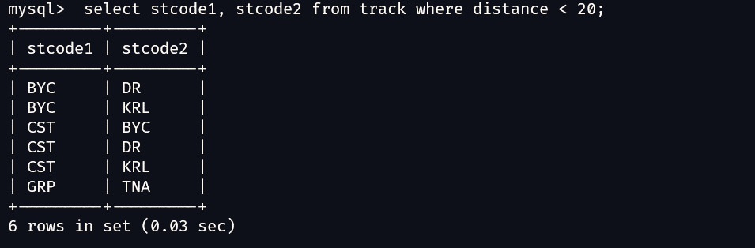

* Find the IDs of all the trains which have a stop at THANE

select id from trainhalts where stcode in (select stcode from station where name = 'THANE');

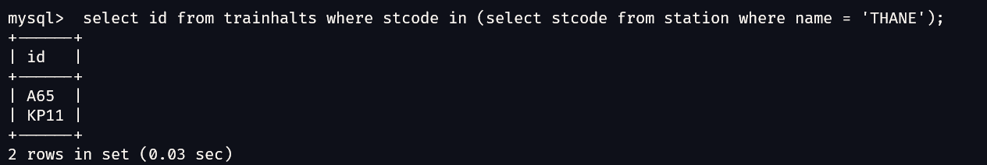

* Find the names of all trains that start at MUMBAI.

select name from train where id in (select id from trainhalts where stcode in (select stcode from station where name = 'MUMBAI'));

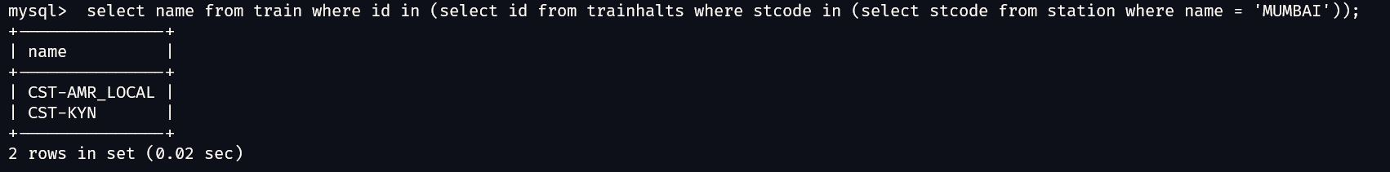

* List all the stations in order of visit by the train 'CST-AMR_LOCAL'.  
  select name from station where stcode in (select stcode from trainhalts where id in (select id from train where name = 'CST-AMR_LOCAL'));

