Previous Year Production Report 2025
NLC India Ltd - Mine-I, Neyveli | SIH26023 demo dataset

1. Executive Summary
Mine-I produced 10,381,227 tonnes of lignite over 365 operating days, achieving 97.5% of the annual target of 10,645,955 tonnes. The deficit is attributable primarily to weather: 74 rainy days (13 with heavy rain cutting output to ~35% of plan), compounded on 10 days by equipment stoppages. Machine failures affected 49 days. Overburden removal totalled 5,586,149 cubic metres. Catch-up scheduling recovered most single-day losses within 48 hours, consistent with the extended-hours practice evidenced in Mine-I stoppage reports. The best day was 2025-02-08 at 34,417 t; the worst was 2025-09-23 at 0 t.

2. Key Figures
Annual lignite production | 10,381 kt
Annual target | 10,646 kt
Achievement | 97.5%
Overburden removed | 5.59 Mm3
Rainy days / heavy-rain days | 74 / 13
Machine-failure days | 49
Rain + failure (compounding) days | 10
Strike days | 1

3. Production vs Target
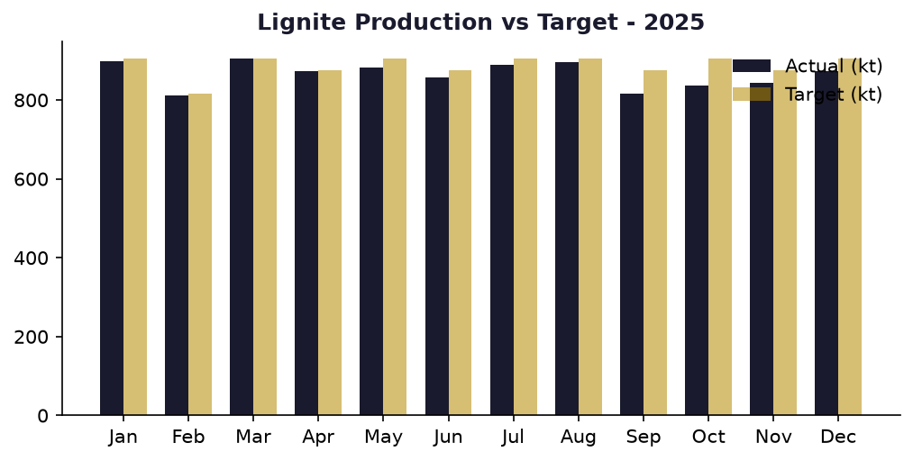

4. Weather Impact Analysis
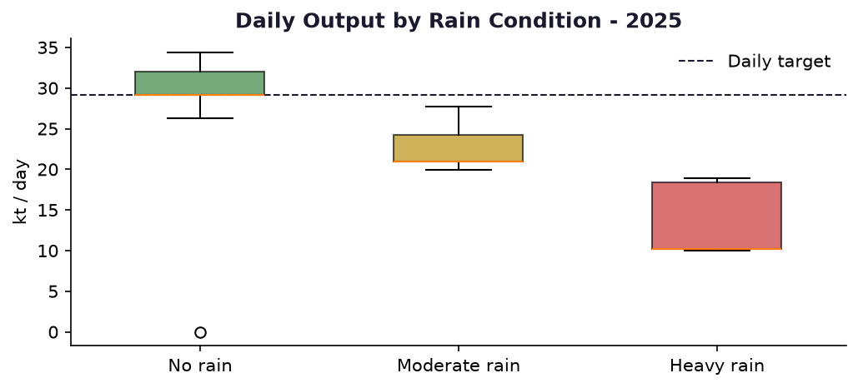
Moderate rain reduces output to ~72% of plan and heavy rain to ~35%. Recovery scheduling restored the shortfall over subsequent days up to +18% per day, capping monthly slippage at 5-9 percentage points even in the wettest months.

5. Downtime Pareto
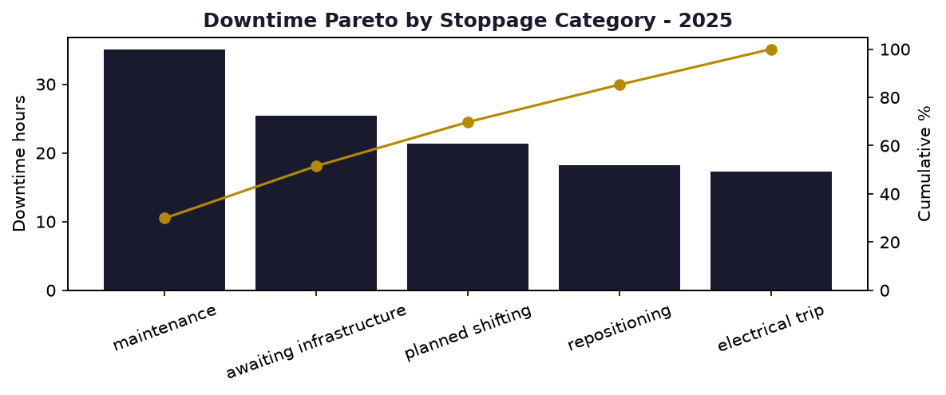
Categories follow the Mine-I stoppage-report taxonomy: maintenance, repositioning, planned shifting, electrical trip, awaiting infrastructure, standby. Maintenance and awaiting-infrastructure dominate, matching the distribution observed in the real M-1 stoppage report of 07.09.2026.

6. Month-wise Summary
Month | Actual (kt) | Target (kt) | Achievement
January | 897 | 904 | 99.3%
February | 810 | 817 | 99.2%
March | 904 | 904 | 100.0%
April | 874 | 875 | 99.9%
May | 882 | 904 | 97.5%
June | 858 | 875 | 98.1%
July | 890 | 904 | 98.4%
August | 897 | 904 | 99.2%
September | 815 | 875 | 93.2%
October | 836 | 904 | 92.4%
November | 844 | 875 | 96.4%
December | 873 | 904 | 96.6%

7. Data Provenance & Validation
SYNTHETIC demo dataset (seed 42) for SIH26023. Targets validated against NLC India published Mine-I capacity of 10.5 MTPA (875 kt/month; see targets_validation.csv). Production model calibrated from the genuine M-1 STOPPAGE 07.09.2026 report (BWE rates, shift hours, stoppage causes). Rainfall seasonality from Neyveli (Cuddalore) climatology - NE monsoon Oct-Dec. All figures in this report are computed deterministically from the dataset CSVs; no AI-generated numbers are included.

