[College / Institute Name]
Department of Computer Engineering
SELF-LEARNING ACTIVITY (SLA)
IMPLEMENTATION & GUI DESIGN NOTE
on
“DINING PHILOSOPHER PROBLEM”
Implementation Details and GUI Design – Companion Note to the Review 1 Report
Subject: Operating System
Submitted by
[Student Name 1] (Roll No: [____])
[Student Name 2] (Roll No: [____])
Under the guidance of
[Guide / Faculty Name]
Academic Year: [20XX – 20XX]

TABLE OF CONTENTS
1. Implementation 3
1.1 Technology Stack 3
1.2 Engine Architecture 3
1.3 Core Data Model 4
1.4 Tick-Based Execution Model 5
1.5 Synchronization Strategies Implemented 5
Table 1: Synchronization Strategies Implemented 6
1.6 Deadlock Detection 6
1.7 Testing 7
2. GUI Design 8
2.1 Design Concept 8
2.2 Screen / Route Structure 8
Table 2: Implemented Screens 10
2.3 Core Visual Components 10
2.4 HUD Elements 10
2.5 Interaction Design per Level 11
2.6 Mapping Back to OS Concepts 12
Table 3: Game-to-OS Concept Mapping 12
3. References 13

1. Implementation
This section documents a working, browser-playable simulation named “Pixel Diner”. Rather than a console program, the implementation is a small Next.js web application in which the Dining Philosophers engine is a pure, framework-free TypeScript module and the user interface is a thin rendering layer on top of it. This separation keeps the synchronization logic testable and independent of how it is displayed.

1.1 Technology Stack
- Next.js 15 (App Router) – page routing and the overall application shell.
- TypeScript – the simulation engine and all components are fully typed.
- Tailwind CSS v4 – utility-based styling for the pixel-art interface.
- Framer Motion – animates state transitions (a philosopher becoming hungry, a chopstick changing hands).
- Vitest – unit tests for the engine's core logic.
- No backend and no database: the application is fully static, and sound is generated from WebAudio square waves rather than audio files.

1.2 Engine Architecture
The engine lives entirely under an engine/ folder, independent of React, and is organised into three cooperating modules:
- simulation.ts – owns the simulation state and exposes the operations createSim, tick, manualToggle, ringBell and preempt.
- strategies/ – defines the three selectable acquisition policies (naive, hierarchy, waiter), each expressed purely as a fork-acquisition order plus a flag.
- deadlock.ts – builds the wait-for graph for the current state and detects cycles in it.
A React hook, useSimulation, wraps this engine with a clock (play / pause / step / speed) and feeds the resulting state down to the table and HUD components, which only render it; user actions (clicking a philosopher, pressing Play) flow back up as calls into the engine's pure functions. Figure 1 shows this layered architecture.
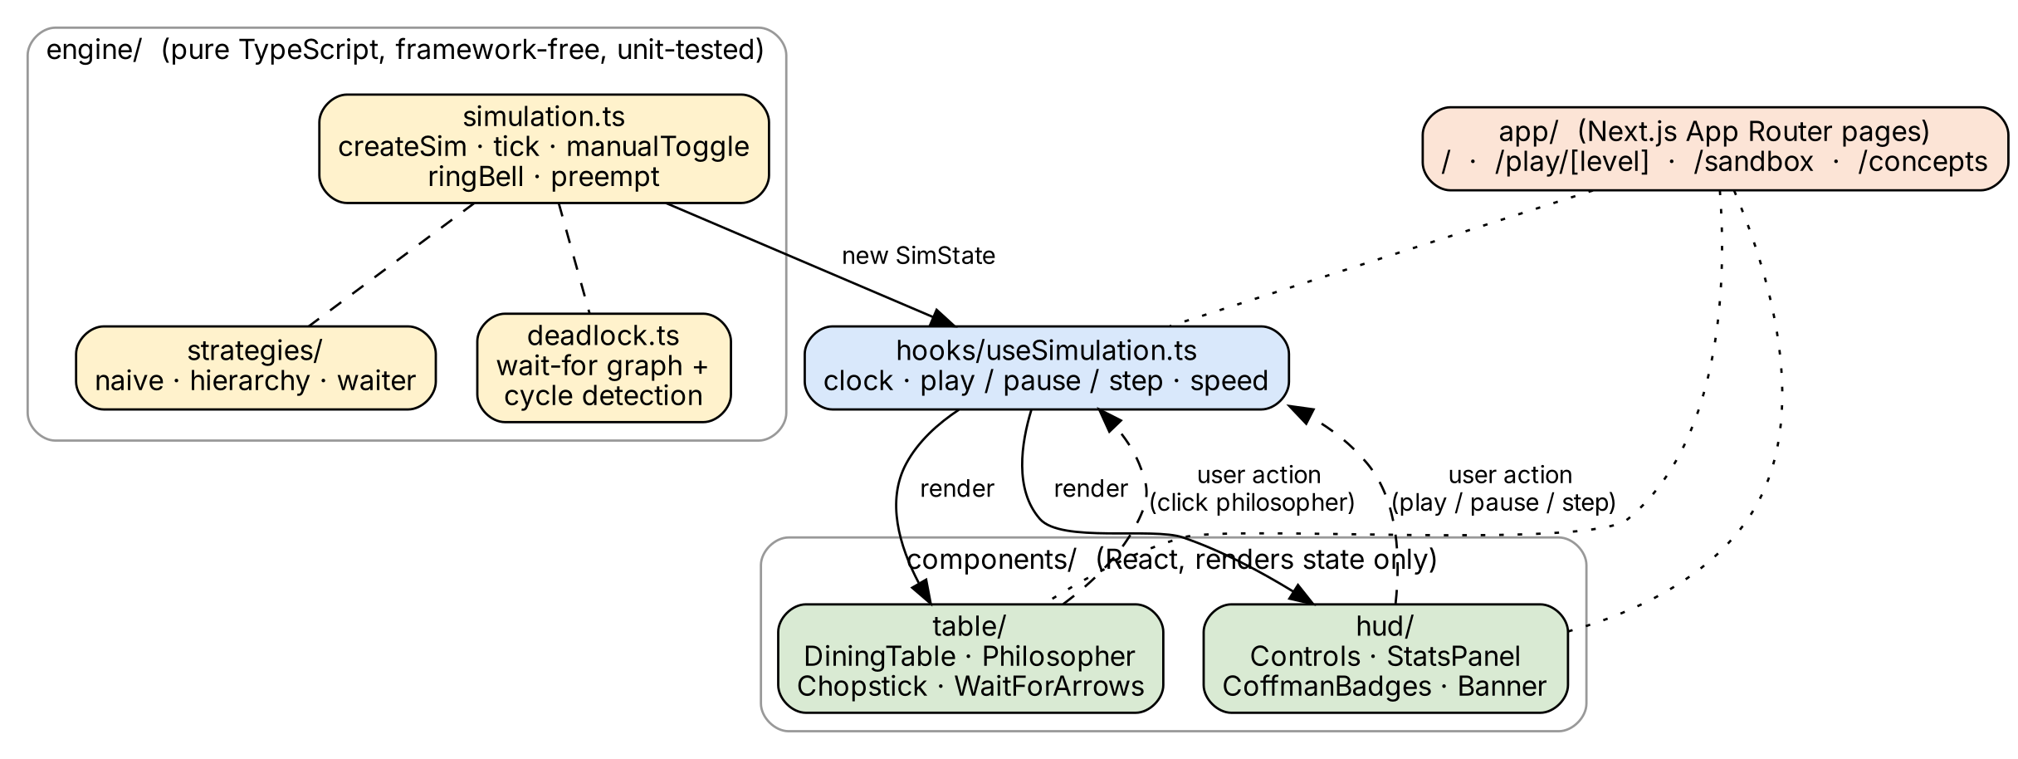
Figure 1: Implementation Architecture – Engine, Hook and UI Layers

1.3 Core Data Model
Each philosopher is represented by a small record carrying its current state (thinking / hungry / eating), a countdown timer, how long it has been waiting, how many meals it has eaten, and whether it has ever crossed the starvation threshold:
interface Philosopher {
id: number;
state: "thinking" | "hungry" | "eating";
timer: number; // ticks left in this phase
wait: number; // ticks spent hungry so far
meals: number; // total meals eaten
maxWait: number; // longest wait ever recorded
seated: boolean; // waiter strategy only
starved: boolean; // ever crossed the starvation threshold
}
The overall simulation state (SimState) additionally holds the current tick count, the chosen strategy, a chopsticks array (chopsticks[i] records which philosopher, if any, is holding chopstick i), a deterministic seeded random-number generator (so runs are reproducible), and the most recently detected deadlock cycle, if one exists. Chopstick i is defined to be shared between philosopher (i−1) and philosopher i, directly matching the shared-resource adjacency described above.

1.4 Tick-Based Execution Model
The simulation advances in discrete ticks. On every tick, each philosopher is visited once (in a rotating order, so no seat is permanently favoured) and its state machine is advanced by one step:
for each philosopher p (rotated order):
if p.state == THINKING:
if p.timer-- <= 0: p.state = HUNGRY
else if p.state == EATING:
if p.timer-- <= 0:
release both chopsticks; p.meals++
p.state = THINKING
else: // HUNGRY
p.wait++; if p.wait >= starveAt: p.starved = true
(a, b) = strategy.order(p) // acquisition order
target = the one of (a, b) not yet held by p
if chopstick[target] is free:
chopstick[target] = p // grab ONE stick this tick
if p holds both a and b:
p.state = EATING
Crucially, a hungry philosopher acquires at most one chopstick per tick rather than both at once. This is a deliberate design choice: it makes the hold-and-wait condition – a philosopher holding one chopstick while waiting for the other – directly observable on screen, instead of happening invisibly inside a single atomic step. The engine's own unit tests assert this behaviour explicitly.

1.5 Synchronization Strategies Implemented
Three acquisition policies are implemented behind a common Strategy interface, so the simulation, deadlock detector and GUI all work identically regardless of which one is active:

Table 1 Synchronization Strategies Implemented
Strategy | Acquisition Rule | Coffman Condition Broken | Deadlock-Free?
Naive (Grab Left First) | wait(left); wait(right) – the baseline, unsynchronized rule. | None | No
Resource Hierarchy (Numbered Sticks) | Always grab the lower-numbered chopstick first, regardless of left/right. | Circular Wait | Yes
Waiter (counting semaphore = N−1) | At most N−1 philosophers may be seated/trying to eat at once. | Hold and Wait | Yes
Preempt (Sandbox recovery action) | Forces one deadlocked philosopher to drop its chopsticks. | No Preemption | Recovery, not prevention
Table 1: Synchronization Strategies Implemented

1.6 Deadlock Detection
Because every strategy lets a hungry philosopher wait on at most one chopstick at a time, the wait-for graph of the whole system is a functional graph (every node has out-degree at most one). The deadlock detector therefore does not need a general-purpose cycle-detection algorithm: for each philosopher with an outstanding wait, it simply follows the chain of “waiting for” edges and checks whether it revisits a node already seen. If it does, that revisited sequence is exactly the circular-wait cycle, and it is reported as the active deadlock. Because each node has at most one outgoing edge, this walk is bounded by N (the number of philosophers), giving an O(N) check that re-runs after every tick and after every manual action.
function findCycle(state):
next = { p -> philosopher p is waiting for for each blocked p }
for each start in next.keys():
seen = []
cur = start
while cur is defined and cur not in seen:
seen.append(cur); cur = next[cur]
if cur is defined:
return seen starting from cur // the cycle
return null // no deadlock
When a cycle is found, the affected philosophers and the chopsticks between them are highlighted (red wait-for arrows in the GUI, described in Section 2), and the Sandbox screen additionally offers a Preempt action that forcibly releases one deadlocked philosopher's chopsticks – a direct, interactive demonstration of deadlock recovery by breaking the No-Preemption condition rather than by prevention.

1.7 Testing
The engine is covered by unit tests (Vitest) that exercise it independently of the UI: that the naive strategy can be driven into a genuine deadlock, that the hierarchy and waiter strategies never deadlock under the same adversarial sequence of ticks, and that the one-chopstick-per-tick rule is respected. Keeping the engine framework-free made it straightforward to test it in isolation before any GUI work began, in line with the design set out above.

2. GUI Design
This section documents the GUI that was built: the interface, titled “Pixel Diner”, is an 8-bit, playable explainer of the Dining Philosophers Problem rather than a static diagram – the user feeds philosophers by hand, watches a deadlock happen, and then picks a strategy that fixes it.

2.1 Design Concept
The GUI follows a retro pixel-art visual language: a dining table and philosopher sprites drawn as inline SVG, a dark background, a limited high-contrast colour palette (one colour per philosopher's robe), and a monospace pixel font for all HUD text. This style was chosen because it reads clearly at a glance, keeps every philosopher visually distinct, and gives the simulation a game-like, approachable feel appropriate for an educational tool rather than a dry diagnostic dashboard.

2.2 Screen / Route Structure
The application is organised into five routes, summarised in Figure 2. Each route targets a specific stage of understanding, from free manual exploration to guided failure to guided recovery:
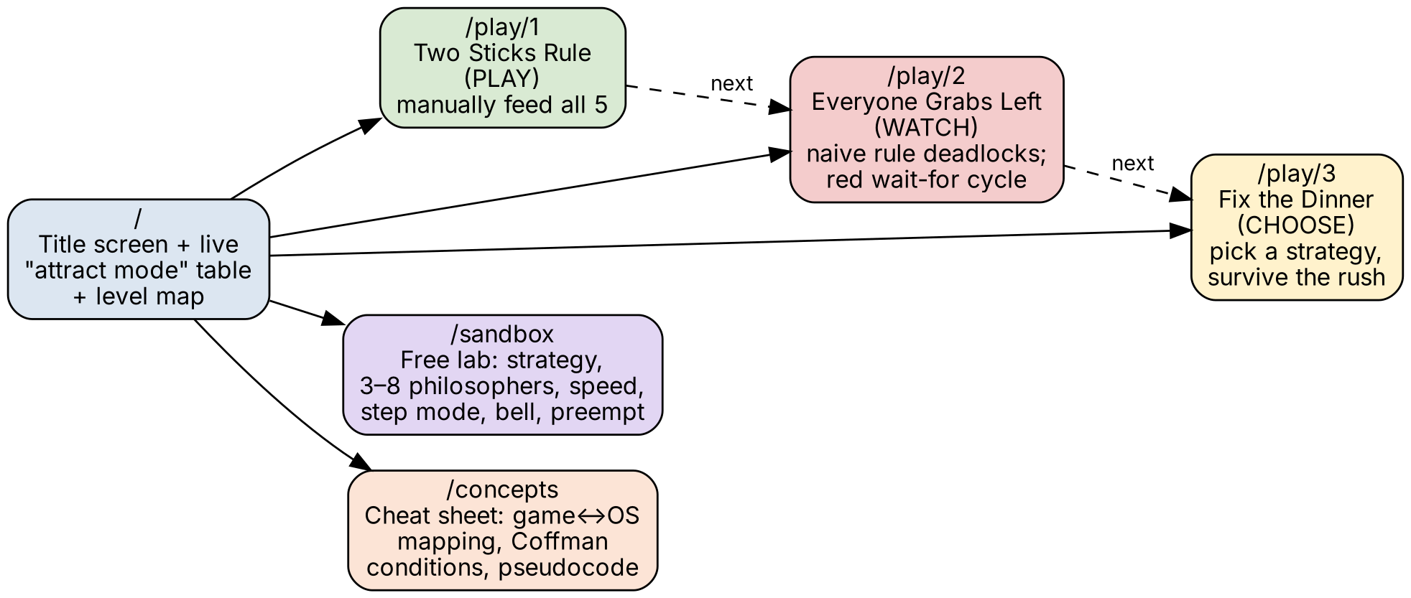
Figure 2: Implemented Screen Navigation Map

Table 2 Implemented Screens
Route | Mode | What the Player Does
/ | – | Title screen, a live “attract mode” table, and the level map with star progress.
/play/1 | PLAY | Two Sticks Rule: tap philosophers to grab chopsticks and feed all 5 by hand (manual strategy).
/play/2 | WATCH | Everyone Grabs Left: the naive strategy deadlocks in seconds – a red wait-for cycle, skull icons, and the four Coffman conditions are shown.
/play/3 | CHOOSE | Fix the Dinner: pick a strategy (Waiter / Numbered Sticks / preempt) and survive a dinner rush.
/sandbox | FREE | Free lab: choose strategy, 3–8 philosophers, speed, step mode, dinner bell, preempt, live stats.
/concepts | REFERENCE | One-screen cheat sheet: game↔OS mapping, Coffman conditions, and strategy pseudocode.
Table 2: Implemented Screens

2.3 Core Visual Components
- DiningTable – the circular pixel-art table and bowl at the centre of the screen.
- Philosopher – one sprite per philosopher, coloured by id, labelled with its current state (thinking / hungry / eating) directly beneath it.
- Chopstick – drawn between adjacent philosophers; its colour and position reflect whether it is free or held.
- WaitForArrows – drawn only while a deadlock cycle is active; red arrows trace the circular-wait relationship between the stuck philosophers, making the abstract wait-for graph of Section 1.6 directly visible.

2.4 HUD Elements
- Controls – Play / Pause, Step (advance exactly one tick, useful for close observation), a x1 / x2 / x4 speed selector, and Reset.
- StatsPanel – a live bar chart of meals eaten per philosopher (fairness at a glance), plus numeric readouts for the current tick, throughput (meals per 100 ticks), the longest wait recorded, how many philosophers are currently starving, and the running deadlock count.
- CoffmanBadges – the four necessary conditions for deadlock (Mutual Exclusion, Hold-and-Wait, No Preemption, Circular Wait), highlighted according to which ones the active strategy actually breaks.
- Banner / SpeechBubble – a short narrator line that reacts to what is happening (for example, prompting the player to tap a hungry philosopher, or announcing a deadlock).
Figure 3 shows these elements together as they appear on the Level 1 (“Two Sticks Rule”) play screen: the table and philosopher sprites on the left, the control bar and Coffman badges beneath it, and the stats panel with the narrator bubble on the right.
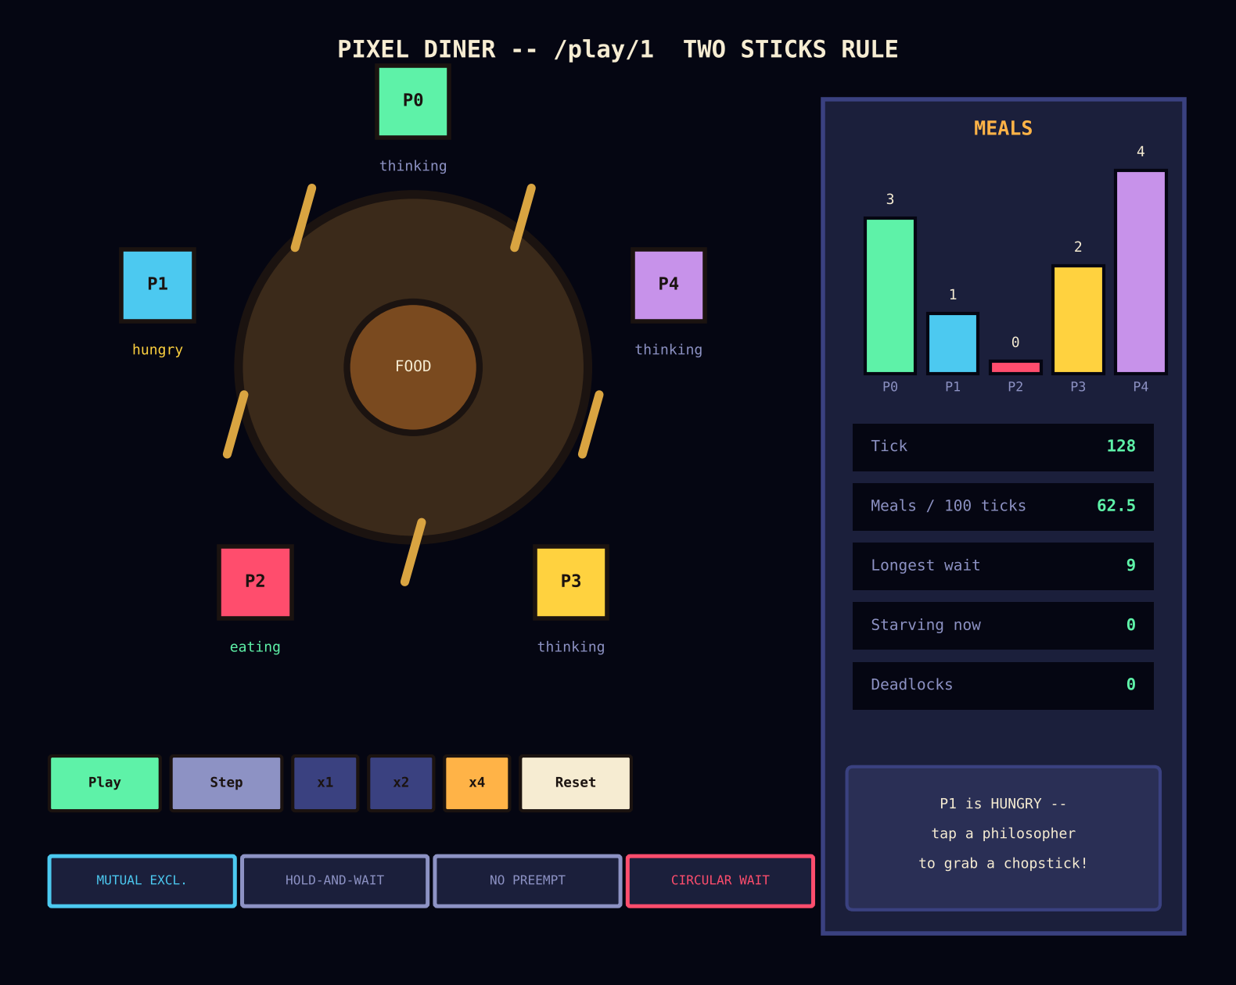
Figure 3: Implemented GUI – Dining Table and HUD (Level 1, “Two Sticks Rule”)

2.5 Interaction Design per Level
The three levels intentionally give the player three different relationships with the synchronization logic, so that each OS concept is learned through a different mode of engagement rather than through text alone:
- Level 1 – PLAY: the player directly clicks philosophers to grab chopsticks by hand (the manual strategy). This lets the player discover, through their own actions, that neighbours cannot eat together and that they themselves can accidentally deadlock the table – resource-sharing and circular-wait failures described in Section 1.
- Level 2 – WATCH: the naive strategy runs automatically and reliably deadlocks within seconds; the player observes the red wait-for cycle, the skull icons marking starvation, and the Coffman badges lighting up, connecting the visual failure directly back to the four necessary conditions.
- Level 3 – CHOOSE: the player selects a fix – the Waiter strategy, Numbered Sticks (resource hierarchy), or a preemption “trap card” – and must keep the table running (“survive the dinner rush”) for a fixed number of ticks, directly experiencing the trade-offs of each solution from Section 1.5.
- Sandbox – a free-form lab exposing every control at once: choice of strategy, philosopher count from 3 to 8, speed, single-step mode, a dinner-bell action that makes every philosopher hungry at once, and a preempt action for manual deadlock recovery.
- Concepts – a one-screen cheat sheet listing the game-to-OS mapping (table below), the four Coffman conditions, and the pseudocode for each strategy, for quick reference while playing.

2.6 Mapping Back to OS Concepts
Every visual element in the GUI is deliberately traceable back to a specific Operating System concept, so that the game never drifts away from the material it is meant to teach. The table below reproduces the mapping shown on the application's own Concepts screen.

Table 3 Game-to-OS Concept Mapping
Game Element | Operating System Concept
Philosopher | Process / thread
Chopstick | Resource guarded by a mutex
Eating | Critical section (needs both resources)
Thinking | Non-critical work
Hunger bar / wait | Waiting time
Skull icon | Starvation
Lock + red wait-for arrows | Deadlock (a cycle in the wait-for graph)
Table 3: Game-to-OS Concept Mapping

3. References
[1] Ben-David, N. and Blelloch, G. E. (2022). Fast and Fair Randomized Wait-Free Locks. In Proceedings of the 2022 ACM Symposium on Principles of Distributed Computing (PODC ’22), Salerno, Italy, pp. 1–12. https://doi.org/10.1145/3519270.3538448
[2] Dijkstra, E. W. (1971). Hierarchical Ordering of Sequential Processes. Acta Informatica, 1, pp. 115–138.
[3] Silberschatz, A., Galvin, P. B., and Gagne, G. Operating System Concepts (10th ed.). Wiley. – Chapter on Process Synchronization and the Dining-Philosophers Problem.
[4] GeeksforGeeks. Dining Philosopher Problem Using Semaphores. Retrieved from https://www.geeksforgeeks.org/operating-systems/dining-philosopher-problem-using-semaphores/
[5] Project source – “Pixel Diner: The Dining Philosophers Problem”, team implementation (Next.js 15, TypeScript, Tailwind CSS v4, Framer Motion, Vitest), local repository README.md.

