[College / Institute Name]
Department of Computer Engineering
SELF-LEARNING ACTIVITY (SLA)
REVIEW 1 REPORT
on
“DINING PHILOSOPHER PROBLEM”
A Synchronization Problem in Operating Systems
Subject: Operating System
Submitted by
[Student Name 1] (Roll No: [____])
[Student Name 2] (Roll No: [____])
Under the guidance of
[Guide / Faculty Name]
Academic Year: [20XX – 20XX]

TABLE OF CONTENTS
1. Project Selection 4
2. Traditional Concept / Algorithm Explanation 5
2.1 Problem Definition 5
2.2 System Model 5
2.3 Resource Sharing 5
2.4 Synchronization 5
2.5 Deadlock 6
2.6 Starvation 6
2.7 Traditional Solution 6
Table 1: Philosopher States 7
3. Research Paper Study 8
3.1 – 3.6 Title / Authors / Year / Problem / Approach / Findings 8
3.7 Relevance to Our Project 9
Table 2: Research Paper Summary 10
4. Proposed Methodology 11
5. Proposed GUI Framework (Design Proposal) 12
5.1 Initial GUI Prototype (Wireframe) 13
6. Flow Diagram / Block Diagram / Initial Prototype 15
6.1 Overall System Flowchart 15
6.2 System Block Diagram 16
6.3 Initial GUI Prototype 17
7. Implementation 18
7.1 Technology Stack 18
7.2 Engine Architecture 18
7.3 Core Data Model 19
7.4 Tick-Based Execution Model 20
7.5 Synchronization Strategies Implemented 20
Table 3: Synchronization Strategies Implemented 21
7.6 Deadlock Detection 21
7.7 Testing 22
8. GUI Design 23
8.1 Design Concept 23
8.2 Screen / Route Structure 23
Table 4: Implemented Screens 25
8.3 Core Visual Components 25
8.4 HUD Elements 25
8.5 Interaction Design per Level 26
8.6 Mapping Back to OS Concepts 27
Table 5: Game-to-OS Concept Mapping 27
9. References 28

1. Project Selection
The topic selected for this Self-Learning Activity is the Dining Philosopher Problem, one of the most widely studied classical synchronization problems in Operating Systems. It was originally formulated by Edsger W. Dijkstra to illustrate the difficulties that arise when multiple concurrent processes compete for a limited set of shared resources.
The Operating System concept involved is process synchronization, specifically the coordination of concurrent processes that must share exclusive-access resources without violating correctness. The problem addressed by this project is the safe and efficient allocation of shared resources among concurrently executing entities so that two undesirable outcomes – deadlock and starvation – are avoided while still permitting the maximum possible concurrency.
In the classical formulation, five philosophers sit around a circular table. Between every pair of adjacent philosophers lies a single fork, giving five forks in total for five philosophers. A philosopher alternates between thinking, being hungry, and eating; to eat, a philosopher must obtain both the fork on the left and the fork on the right. Since a fork is shared between two neighbouring philosophers, only one of the two may hold it at any given time.
In terms of Operating System abstractions, each philosopher represents a concurrent process or thread, and each fork represents a shared resource that must be accessed under mutual exclusion. The region of code in which a philosopher holds one or both forks corresponds to the critical section, and the overall problem is therefore an exercise in critical-section management and resource allocation.
Synchronization is required because, without a coordinating mechanism, all philosophers could simultaneously pick up the fork on their left and then wait indefinitely for the fork on their right (or vice versa). This produces a circular-wait condition, which is one of the four necessary conditions for deadlock. Even when deadlock is avoided, an unfair scheduling of fork access can cause a particular philosopher to be perpetually bypassed by neighbours who are served first – a condition known as starvation.
The Dining Philosopher Problem is therefore selected because it compactly demonstrates several core Operating System issues – mutual exclusion, critical sections, deadlock, and starvation – in a single, easily visualised scenario, making it well suited for a simulation-based SLA project.

2. Traditional Concept / Algorithm Explanation

2.1 Problem Definition
The classical Dining Philosopher Problem considers five philosophers seated around a circular table, each alternating between two states – thinking and eating. A bowl of food lies at the centre of the table, and a single fork is placed between every pair of adjacent philosophers. To eat, a philosopher must pick up both the fork to their immediate left and the fork to their immediate right. Because each fork is shared between two neighbours, the philosophers must coordinate their access to these forks so that no two adjacent philosophers use the same fork at the same time.

2.2 System Model
The system consists of two categories of entities: philosophers (processes) and forks (shared resources). Each philosopher can be in exactly one of three states at any instant:
- Thinking – the philosopher is not requesting any resource and is executing independently.
- Hungry – the philosopher wishes to eat and is waiting to acquire both adjacent forks.
- Eating – the philosopher has successfully acquired both forks and is using the shared resource.
Each fork can be modelled as a binary resource (available or held) or, more generally, as a binary semaphore that permits only one holder at a time.

2.3 Resource Sharing
Every fork is shared between exactly two neighbouring philosophers. This adjacency creates a resource-sharing graph that is structurally a cycle: philosopher i shares one fork with philosopher (i−1) and another fork with philosopher (i+1). Because access to a fork must be mutually exclusive, at most two philosophers who are not adjacent can eat at the same time out of the five, and no two adjacent philosophers can eat simultaneously.

2.4 Synchronization
Synchronization is required to ensure that (i) two neighbouring philosophers never hold the same fork at the same time (mutual exclusion), and (ii) every hungry philosopher is eventually able to eat (progress and fairness). A synchronization primitive such as a semaphore, mutex lock, or monitor is used to guard access to each fork so that a philosopher's request to pick up a fork is granted only when that fork is currently free.

2.5 Deadlock
Deadlock arises in the naive solution where every philosopher simultaneously picks up the fork on one fixed side (say, the left fork) before attempting to pick up the other. If all five philosophers execute this step at the same time, every fork is held by exactly one philosopher, and each philosopher is left waiting indefinitely for the second fork, which is held by a neighbour who is equally blocked. This is a circular-wait condition: philosopher 0 waits for a fork held by philosopher 1, who waits for a fork held by philosopher 2, and so on back to philosopher 0. Since none of the four necessary conditions for deadlock (mutual exclusion, hold-and-wait, no pre-emption, circular wait) is broken, the system reaches a permanent standstill.

2.6 Starvation
Even when deadlock is prevented, a philosopher can still be starved of resources. For example, if scheduling consistently favours two non-adjacent philosophers, their shared neighbour may repeatedly find at least one of its two forks unavailable and may therefore never get to eat, even though the system as a whole continues to make progress. Starvation is a liveness problem rather than a safety problem: the system does not deadlock, but fairness to individual processes is violated.

2.7 Traditional Solution
A widely taught traditional solution uses one counting/binary semaphore per fork together with a mutex or an asymmetric ordering rule to break the circular-wait condition. Two common variants are commonly discussed in the traditional treatment of this problem:
- Resource ordering (asymmetric acquisition): forks are numbered, and every philosopher is required to pick up the lower-numbered fork before the higher-numbered one. This removes circular wait because at least one philosopher (the one whose left fork has the higher number) will attempt to acquire the shared low-numbered fork first, breaking the symmetry that causes deadlock.
- Limiting concurrent diners: an additional counting semaphore restricts the number of philosophers who may attempt to pick up forks simultaneously to at most four (one fewer than the total). This guarantees that at least one philosopher can always obtain both forks, preventing the all-hold-one-and-wait scenario.
Both variants preserve mutual exclusion on each fork while eliminating the circular-wait condition that causes deadlock; additional fairness policies, such as a waiter/monitor arbitrator or FIFO queuing per fork, are layered on top of these to further reduce the risk of starvation.

Table 1 Philosopher States
State | Description
Thinking | Philosopher is not requesting any resource and is not competing for forks.
Hungry | Philosopher wishes to eat and is requesting/waiting for the left and right forks.
Eating | Philosopher has acquired both required forks and is using the shared resource.
Table 1: Philosopher States and Descriptions

3. Research Paper Study

3.1 Title
Fast and Fair Randomized Wait-Free Locks.

3.2 Authors
Naama Ben-David (VMware Research) and Guy E. Blelloch (Carnegie Mellon University).

3.3 Year of Publication
2022 – published in Proceedings of the 2022 ACM Symposium on Principles of Distributed Computing (PODC ’22), Salerno, Italy. DOI: https://doi.org/10.1145/3519270.3538448.

3.4 Problem Addressed
The paper addresses the general problem of designing fine-grained locks for concurrent, asynchronous systems that guarantee both wait-freedom (every operation completes in a bounded number of steps) and fairness (every competing process has a reasonable probability of acquiring the locks it needs), even when an adversarial scheduler can delay any process arbitrarily. The authors explicitly use the Dining Philosophers Problem as their running example, treating forks as locks, philosophers as competing processes, and eating as the execution of a critical section.

3.5 Proposed Approach
The authors propose a randomized tryLock algorithm in which every attempt to acquire a set of locks is assigned a uniformly random priority only after the process has first “helped” complete the pending attempts of all currently competing processes. This helping step prevents an adversarial scheduler from biasing which processes a given process ends up competing against. A process's random priority then determines whether it wins access to all of its requested locks (forks); the process with the highest priority among its active competitors on every requested lock succeeds, while the others are marked as having lost and must retry. Fixed step-count delays are additionally introduced before and after a process reveals its priority, which prevents the scheduler from exploiting timing variation to skew the fairness guarantees.

3.6 Major Findings
The paper proves that, given an upper bound κ on how many competing attempts can exist on any single lock at once and an upper bound L on the number of locks requested per attempt, every tryLock attempt completes in O(κ²L²T) steps (T being the maximum length of the critical section) and succeeds with probability at least 1/(κL), independent of the scheduler's choices. As a direct corollary for the Dining Philosophers Problem, where each philosopher contends for exactly two forks (κ = L = 2), each attempt to eat completes in O(1) expected steps and succeeds with probability at least 1/4 per attempt, giving the first algorithm of its kind with these constant-factor guarantees against a fully adversarial, asynchronous scheduler.

3.7 Relevance to Our Project
This paper is directly relevant because it studies the same underlying resource-contention structure that our simulation implements – competing processes that must acquire a small, fixed set of shared resources (forks/locks) to proceed. It reinforces two points that this project's traditional-algorithm discussion also makes: that naive fork acquisition leads to deadlock through circular wait, and that avoiding starvation requires an explicit fairness mechanism rather than relying on scheduling alone.
It is important to distinguish what the paper proposes from what our Review 1 project implements. The paper proposes a randomized, provably wait-free and fairness-bounded locking protocol intended for general fine-grained concurrent data structures, analysed against a fully adversarial scheduler – a research-level contribution well beyond the scope of an undergraduate SLA simulation. Our project, as built (see Section 7, Implementation), uses three concrete acquisition strategies – naive, resource-hierarchy and a waiter/semaphore arbitrator – which cover the deterministic side of this same design space. What could potentially be incorporated later is the core intuition of randomized priority assignment among contending philosophers, as a fourth selectable strategy in the Sandbox screen, to let students directly compare deterministic and randomized fairness.

Table 2 Research Paper Summary
Parameter | Details
Paper Title | Fast and Fair Randomized Wait-Free Locks
Authors | Naama Ben-David (VMware Research) and Guy E. Blelloch (Carnegie Mellon University)
Year | 2022 (PODC ’22)
Problem | Designing fair, wait-free fine-grained locks for asynchronous concurrent systems, using the Dining Philosophers Problem as the running example.
Approach | Randomized tryLock with mutual helping before priority assignment, plus fixed step delays to prevent adversarial scheduling bias.
Findings | O(κ²L²T) worst-case steps per attempt; success probability at least 1/(κL); O(1)-step, 1/4-probability solution for the classical 5-philosopher case.
Relevance | Confirms deadlock/starvation risks of naive fork acquisition and motivates a fairness-aware alternative for future extension of this project.
Table 2: Research Paper Summary

4. Proposed Methodology
The methodology for the Dining Philosopher simulation follows a straightforward pipeline in which the user configures the simulation, the system executes philosopher behaviour under a chosen synchronization algorithm, and the results are continuously reflected back to the user through the interface. The overall workflow, as carried through into the implementation described in Section 7, is as follows:
User Input → Select Algorithm → Initialize Philosophers & Forks → Execute Synchronization → Update Philosopher States → Detect Deadlock/Waiting → Display Results.
The system is organised into the following major components, each with a distinct responsibility:
- Philosopher module – models each philosopher as an independent logical unit that cycles through the Thinking, Hungry, and Eating states and issues requests for the forks on either side.
- Fork/resource module – represents each fork as a mutually exclusive resource with an owner field, exposing acquire and release operations to the philosopher module.
- Synchronization module – implements the chosen concurrency-control strategy (naive, resource-ordering/hierarchy, or a waiter/semaphore arbitrator) that governs how fork-acquisition requests from the philosopher module are granted or queued.
- Simulation module – drives the overall time-stepped execution, advancing philosopher states and invoking the synchronization module on every tick.
- GUI module – renders the circular table, the current state of each philosopher and fork, and exposes the user-facing controls described in Section 5.
- Result/monitoring module – observes the running simulation to detect deadlock conditions (a cycle in the wait-for graph among philosophers) and to compute fairness statistics, such as the number of times each philosopher has eaten and the longest waiting time observed.
This modular separation allows the synchronization algorithm to be swapped or extended (for instance, to later add the randomized approach discussed in Section 3.5) without requiring changes to the GUI or monitoring modules. Section 7 (Implementation) and Section 8 (Proposed GUI Framework) describe, respectively, how this methodology was carried into a working codebase and how its modules surface through the interface.

5. Proposed GUI Framework
The project proposes a simple, visually intuitive GUI-based simulation rather than a purely textual or console-based demonstration, so that synchronization behaviour, resource allocation, and the onset of deadlock or starvation can be observed directly rather than inferred from log output alone.
The proposed GUI is organised around a central circular table view, on which the five philosophers and five forks are arranged exactly as in the classical formulation, together with a control panel that lets the user drive and configure the simulation. The GUI is proposed to include the following elements:
- Five philosophers arranged around a circular table, each shown at a fixed position corresponding to its seat.
- Five forks/chopsticks placed between adjacent philosopher positions, matching the classical resource layout.
- Colour-coded philosopher states – Thinking, Hungry, and Eating – updated live as the simulation progresses.
- Start, Pause, and Reset buttons to control simulation execution.
- A simulation speed control, allowing the user to slow down or speed up state transitions for closer observation.
- An algorithm selection control, allowing the user to switch between the traditional resource-ordering solution and any alternative strategy.
- A basic execution log panel, printing a short, timestamped trace of significant events such as fork requests, acquisitions, and releases.
- Basic performance information, such as a live count of philosophers currently eating and waiting, and a deadlock-status indicator.
By presenting the state of every philosopher and fork simultaneously and updating it in real time, the GUI is intended to help a student viewer directly observe how synchronization decisions affect concurrency – for instance, seeing forks change ownership, seeing a philosopher remain in the Hungry state for an extended period (illustrating potential starvation), or seeing every philosopher freeze in the Hungry state simultaneously (illustrating deadlock). The design is deliberately kept minimal, avoiding additional dashboards or configuration options beyond what is necessary to demonstrate these core Operating System concepts, since this is a college-level SLA project rather than a production monitoring tool.

5.1 Initial GUI Prototype (Wireframe)
Figure 3 shows a conceptual wireframe of the proposed interface, illustrating the circular table with the five philosophers and forks, the control panel on the right, and the execution log at the bottom. Section 8 (Proposed GUI Framework – Implemented Design) shows how this proposal was realised in the actual application.
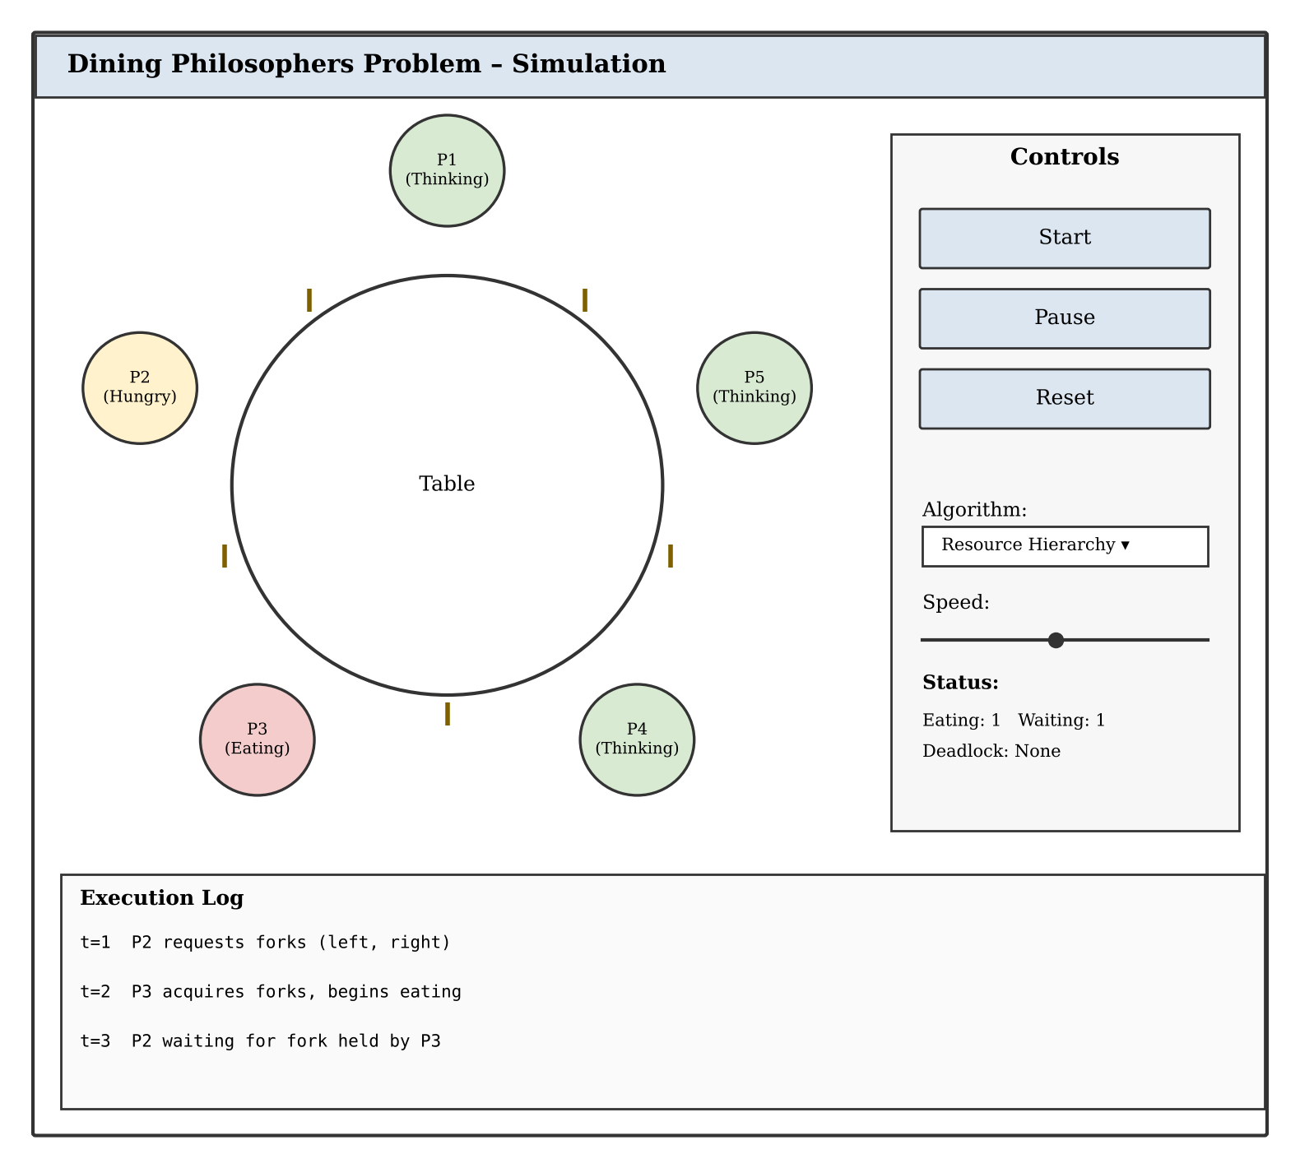
Figure 3: Initial GUI Prototype – Conceptual Wireframe

6. Flow Diagram / Block Diagram / Initial Prototype

6.1 Overall System Flowchart
Figure 1 presents the overall control flow of a single philosopher's lifecycle within the simulation, from initialization through the repeated think–request–eat cycle, including the wait path taken when the required forks are not both available.
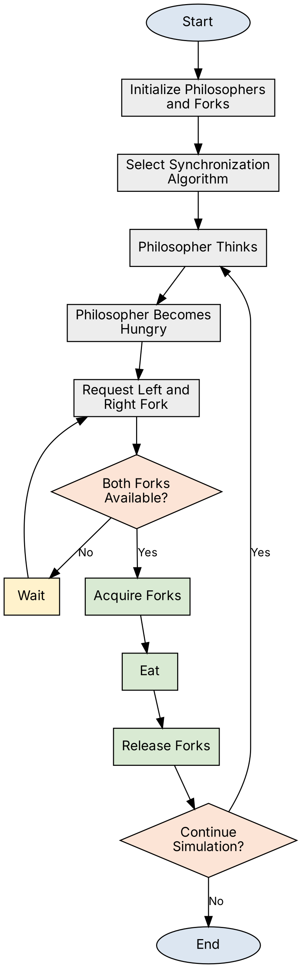
Figure 1: Overall System Flowchart

6.2 System Block Diagram
Figure 2 shows the high-level architectural relationship between the major components proposed in Section 4 – the user, the GUI layer, the simulation controller, the synchronization algorithm module, the philosopher and fork objects, and the monitoring/results module that feeds status information back to the GUI.
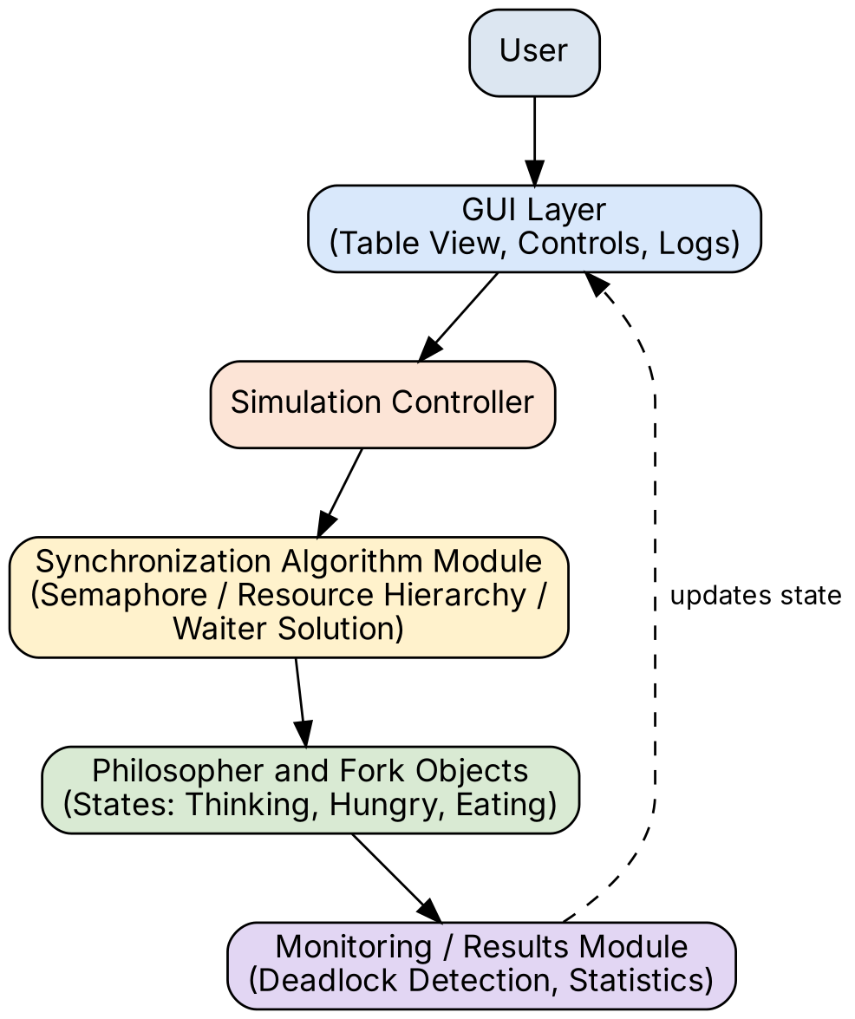
Figure 2: System Block Diagram

6.3 Initial GUI Prototype
The initial GUI prototype/wireframe has already been presented as Figure 3 in Section 5.1, alongside the description of the proposed interface elements, to keep the GUI discussion and its visual reference together. Section 7 and Section 8 below describe how this proposal was carried through into a working implementation.

7. Implementation
The proposed methodology of Section 4 was carried through into a working, browser-playable simulation named “Pixel Diner”. Rather than a console program, the implementation is a small Next.js web application in which the Dining Philosophers engine is a pure, framework-free TypeScript module and the user interface is a thin rendering layer on top of it. This separation keeps the synchronization logic testable and independent of how it is displayed.

7.1 Technology Stack
- Next.js 15 (App Router) – page routing and the overall application shell.
- TypeScript – the simulation engine and all components are fully typed.
- Tailwind CSS v4 – utility-based styling for the pixel-art interface.
- Framer Motion – animates state transitions (a philosopher becoming hungry, a chopstick changing hands).
- Vitest – unit tests for the engine's core logic.
- No backend and no database: the application is fully static, and sound is generated from WebAudio square waves rather than audio files.

7.2 Engine Architecture
The engine lives entirely under an engine/ folder, independent of React, and is organised into three cooperating modules:
- simulation.ts – owns the simulation state and exposes the operations createSim, tick, manualToggle, ringBell and preempt.
- strategies/ – defines the three selectable acquisition policies (naive, hierarchy, waiter), each expressed purely as a fork-acquisition order plus a flag.
- deadlock.ts – builds the wait-for graph for the current state and detects cycles in it.
A React hook, useSimulation, wraps this engine with a clock (play / pause / step / speed) and feeds the resulting state down to the table and HUD components, which only render it; user actions (clicking a philosopher, pressing Play) flow back up as calls into the engine's pure functions. Figure 4 shows this layered architecture.
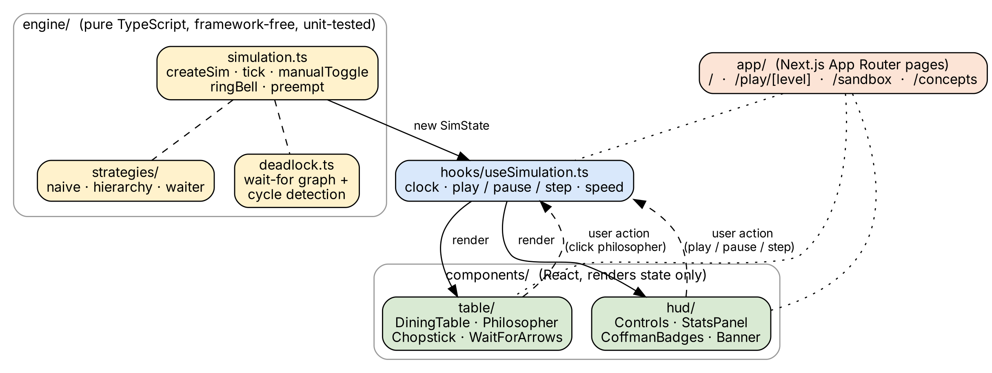
Figure 4: Implementation Architecture – Engine, Hook and UI Layers

7.3 Core Data Model
Each philosopher is represented by a small record carrying its current state (thinking / hungry / eating), a countdown timer, how long it has been waiting, how many meals it has eaten, and whether it has ever crossed the starvation threshold:
interface Philosopher {
id: number;
state: "thinking" | "hungry" | "eating";
timer: number; // ticks left in this phase
wait: number; // ticks spent hungry so far
meals: number; // total meals eaten
maxWait: number; // longest wait ever recorded
seated: boolean; // waiter strategy only
starved: boolean; // ever crossed the starvation threshold
}
The overall simulation state (SimState) additionally holds the current tick count, the chosen strategy, a chopsticks array (chopsticks[i] records which philosopher, if any, is holding chopstick i), a deterministic seeded random-number generator (so runs are reproducible), and the most recently detected deadlock cycle, if one exists. Chopstick i is defined to be shared between philosopher (i−1) and philosopher i, directly matching the circular adjacency described in Section 2.3.

7.4 Tick-Based Execution Model
The simulation advances in discrete ticks. On every tick, each philosopher is visited once (in a rotating order, so no seat is permanently favoured) and its state machine is advanced by one step:
for each philosopher p (rotated order):
if p.state == THINKING:
if p.timer-- <= 0: p.state = HUNGRY
else if p.state == EATING:
if p.timer-- <= 0:
release both chopsticks; p.meals++
p.state = THINKING
else: // HUNGRY
p.wait++; if p.wait >= starveAt: p.starved = true
(a, b) = strategy.order(p) // acquisition order
target = the one of (a, b) not yet held by p
if chopstick[target] is free:
chopstick[target] = p // grab ONE stick this tick
if p holds both a and b:
p.state = EATING
Crucially, a hungry philosopher acquires at most one chopstick per tick rather than both at once. This is a deliberate design choice: it makes the hold-and-wait condition – a philosopher holding one chopstick while waiting for the other – directly observable on screen, instead of happening invisibly inside a single atomic step. The engine's own unit tests assert this behaviour explicitly.

7.5 Synchronization Strategies Implemented
Three acquisition policies are implemented behind a common Strategy interface, so the simulation, deadlock detector and GUI all work identically regardless of which one is active:

Table 3 Synchronization Strategies Implemented
Strategy | Acquisition Rule | Coffman Condition Broken | Deadlock-Free?
Naive (Grab Left First) | wait(left); wait(right) – the baseline, unsynchronized rule. | None | No
Resource Hierarchy (Numbered Sticks) | Always grab the lower-numbered chopstick first, regardless of left/right. | Circular Wait | Yes
Waiter (counting semaphore = N−1) | At most N−1 philosophers may be seated/trying to eat at once. | Hold and Wait | Yes
Preempt (Sandbox recovery action) | Forces one deadlocked philosopher to drop its chopsticks. | No Preemption | Recovery, not prevention
Table 3: Synchronization Strategies Implemented

7.6 Deadlock Detection
Because every strategy lets a hungry philosopher wait on at most one chopstick at a time, the wait-for graph of the whole system is a functional graph (every node has out-degree at most one). The deadlock detector therefore does not need a general-purpose cycle-detection algorithm: for each philosopher with an outstanding wait, it simply follows the chain of “waiting for” edges and checks whether it revisits a node already seen. If it does, that revisited sequence is exactly the circular-wait cycle, and it is reported as the active deadlock. Because each node has at most one outgoing edge, this walk is bounded by N (the number of philosophers), giving an O(N) check that re-runs after every tick and after every manual action.
function findCycle(state):
next = { p -> philosopher p is waiting for for each blocked p }
for each start in next.keys():
seen = []
cur = start
while cur is defined and cur not in seen:
seen.append(cur); cur = next[cur]
if cur is defined:
return seen starting from cur // the cycle
return null // no deadlock
When a cycle is found, the affected philosophers and the chopsticks between them are highlighted (red wait-for arrows in the GUI, described in Section 8), and the Sandbox screen additionally offers a Preempt action that forcibly releases one deadlocked philosopher's chopsticks – a direct, interactive demonstration of deadlock recovery by breaking the No-Preemption condition rather than by prevention.

7.7 Testing
The engine is covered by unit tests (Vitest) that exercise it independently of the UI: that the naive strategy can be driven into a genuine deadlock, that the hierarchy and waiter strategies never deadlock under the same adversarial sequence of ticks, and that the one-chopstick-per-tick rule is respected. Keeping the engine framework-free made it straightforward to test it in isolation before any GUI work began, in line with the modular methodology proposed in Section 4.

8. GUI Design
Section 5 set out the proposed GUI framework before implementation began. This section documents how that proposal was realised: the interface that was actually built, titled “Pixel Diner”, is an 8-bit, playable explainer of the Dining Philosophers Problem rather than a static diagram – the user feeds philosophers by hand, watches a deadlock happen, and then picks a strategy that fixes it.

8.1 Design Concept
The GUI follows a retro pixel-art visual language: a dining table and philosopher sprites drawn as inline SVG, a dark background, a limited high-contrast colour palette (one colour per philosopher's robe), and a monospace pixel font for all HUD text. This style was chosen because it reads clearly at a glance, keeps every philosopher visually distinct, and gives the simulation a game-like, approachable feel appropriate for an educational tool rather than a dry diagnostic dashboard.

8.2 Screen / Route Structure
The application is organised into five routes, summarised in Figure 5. Each route targets a specific stage of understanding, from free manual exploration to guided failure to guided recovery:
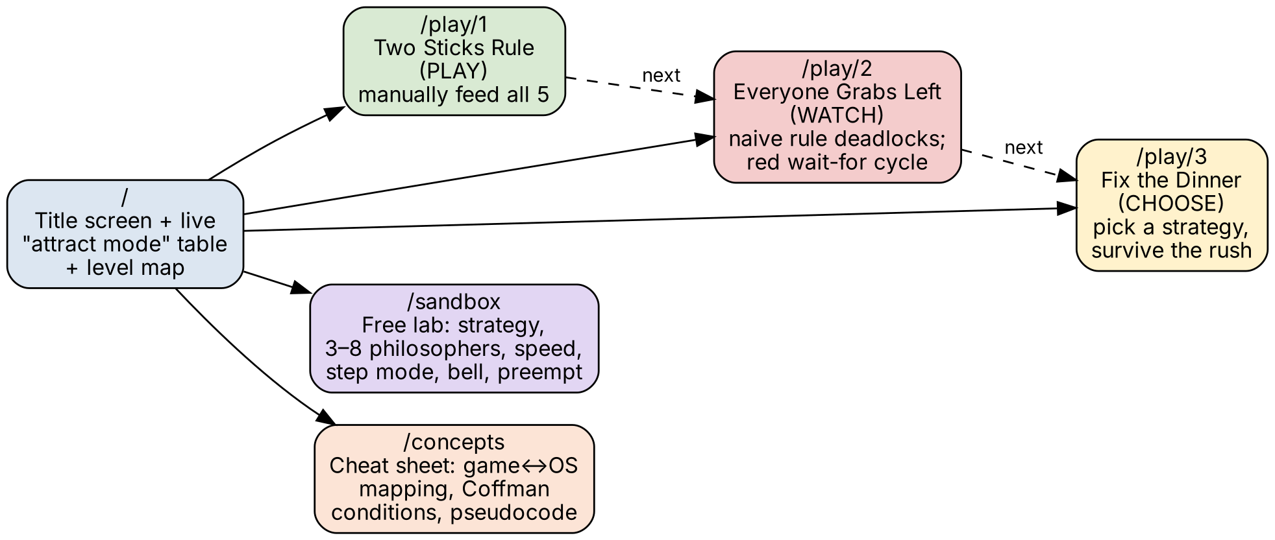
Figure 5: Implemented Screen Navigation Map

Table 4 Implemented Screens
Route | Mode | What the Player Does
/ | – | Title screen, a live “attract mode” table, and the level map with star progress.
/play/1 | PLAY | Two Sticks Rule: tap philosophers to grab chopsticks and feed all 5 by hand (manual strategy).
/play/2 | WATCH | Everyone Grabs Left: the naive strategy deadlocks in seconds – a red wait-for cycle, skull icons, and the four Coffman conditions are shown.
/play/3 | CHOOSE | Fix the Dinner: pick a strategy (Waiter / Numbered Sticks / preempt) and survive a dinner rush.
/sandbox | FREE | Free lab: choose strategy, 3–8 philosophers, speed, step mode, dinner bell, preempt, live stats.
/concepts | REFERENCE | One-screen cheat sheet: game↔OS mapping, Coffman conditions, and strategy pseudocode.
Table 4: Implemented Screens

8.3 Core Visual Components
- DiningTable – the circular pixel-art table and bowl at the centre of the screen.
- Philosopher – one sprite per philosopher, coloured by id, labelled with its current state (thinking / hungry / eating) directly beneath it.
- Chopstick – drawn between adjacent philosophers; its colour and position reflect whether it is free or held.
- WaitForArrows – drawn only while a deadlock cycle is active; red arrows trace the circular-wait relationship between the stuck philosophers, making the abstract wait-for graph of Section 7.6 directly visible.

8.4 HUD Elements
- Controls – Play / Pause, Step (advance exactly one tick, useful for close observation), a x1 / x2 / x4 speed selector, and Reset.
- StatsPanel – a live bar chart of meals eaten per philosopher (fairness at a glance), plus numeric readouts for the current tick, throughput (meals per 100 ticks), the longest wait recorded, how many philosophers are currently starving, and the running deadlock count.
- CoffmanBadges – the four necessary conditions for deadlock (Mutual Exclusion, Hold-and-Wait, No Preemption, Circular Wait), highlighted according to which ones the active strategy actually breaks.
- Banner / SpeechBubble – a short narrator line that reacts to what is happening (for example, prompting the player to tap a hungry philosopher, or announcing a deadlock).
Figure 6 shows these elements together as they appear on the Level 1 (“Two Sticks Rule”) play screen: the table and philosopher sprites on the left, the control bar and Coffman badges beneath it, and the stats panel with the narrator bubble on the right.
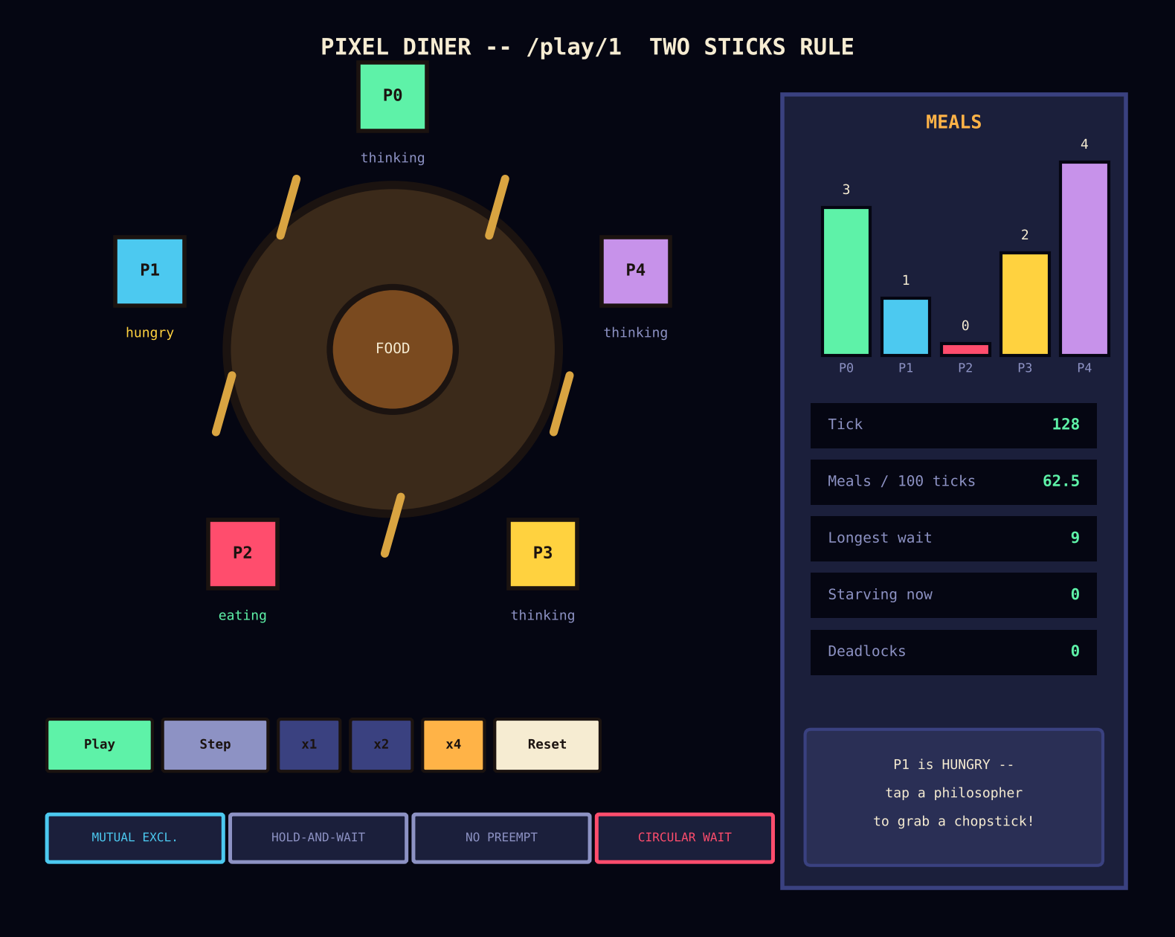
Figure 6: Implemented GUI – Dining Table and HUD (Level 1, “Two Sticks Rule”)

8.5 Interaction Design per Level
The three levels intentionally give the player three different relationships with the synchronization logic, so that each OS concept is learned through a different mode of engagement rather than through text alone:
- Level 1 – PLAY: the player directly clicks philosophers to grab chopsticks by hand (the manual strategy). This lets the player discover, through their own actions, that neighbours cannot eat together and that they themselves can accidentally deadlock the table – the same circular-wait failure explained abstractly in Section 2.5.
- Level 2 – WATCH: the naive strategy runs automatically and reliably deadlocks within seconds; the player observes the red wait-for cycle, the skull icons marking starvation, and the Coffman badges lighting up, connecting the visual failure directly back to the four necessary conditions.
- Level 3 – CHOOSE: the player selects a fix – the Waiter strategy, Numbered Sticks (resource hierarchy), or a preemption “trap card” – and must keep the table running (“survive the dinner rush”) for a fixed number of ticks, directly experiencing the trade-offs of each solution from Section 2.7 and Section 7.5.
- Sandbox – a free-form lab exposing every control at once: choice of strategy, philosopher count from 3 to 8, speed, single-step mode, a dinner-bell action that makes every philosopher hungry at once, and a preempt action for manual deadlock recovery.
- Concepts – a one-screen cheat sheet listing the game-to-OS mapping (table below), the four Coffman conditions, and the pseudocode for each strategy, for quick reference while playing.

8.6 Mapping Back to OS Concepts
Every visual element in the GUI is deliberately traceable back to a specific Operating System concept, so that the game never drifts away from the material it is meant to teach. The table below reproduces the mapping shown on the application's own Concepts screen.

Table 5 Game-to-OS Concept Mapping
Game Element | Operating System Concept
Philosopher | Process / thread
Chopstick | Resource guarded by a mutex
Eating | Critical section (needs both resources)
Thinking | Non-critical work
Hunger bar / wait | Waiting time
Skull icon | Starvation
Lock + red wait-for arrows | Deadlock (a cycle in the wait-for graph)
Table 5: Game-to-OS Concept Mapping

9. References
[1] Ben-David, N. and Blelloch, G. E. (2022). Fast and Fair Randomized Wait-Free Locks. In Proceedings of the 2022 ACM Symposium on Principles of Distributed Computing (PODC ’22), Salerno, Italy, pp. 1–12. https://doi.org/10.1145/3519270.3538448
[2] Dijkstra, E. W. (1971). Hierarchical Ordering of Sequential Processes. Acta Informatica, 1, pp. 115–138.
[3] Silberschatz, A., Galvin, P. B., and Gagne, G. Operating System Concepts (10th ed.). Wiley. – Chapter on Process Synchronization and the Dining-Philosophers Problem.
[4] GeeksforGeeks. Dining Philosopher Problem Using Semaphores. Retrieved from https://www.geeksforgeeks.org/operating-systems/dining-philosopher-problem-using-semaphores/
[5] Project source – “Pixel Diner: The Dining Philosophers Problem”, team implementation (Next.js 15, TypeScript, Tailwind CSS v4, Framer Motion, Vitest), local repository README.md.

