AN ASSIGNMENT
ON
INTERVAL ESTIMATION
&
HYPOTHESIS TESTING
BY

2023A7PS0265U Aditya Sharma
Instructor IN-Charge DR. Maneesha

prepared for assignment 1 fulfillment of the course
MATH F432 APPLIED STATISTICAL METHODS

BITS PILANI, DUBAI CAMPUS
DUBAI INTERNATIONAL ACADEMIC CITY, DUBAI
UAE

Table of Contents
1.0 Introduction to Dataset and Tasks 3
2.0 Objective and Hypothesis 3
3.0 Descriptive Statistics 4
4.0 Inferential Calculations 4
A. Critical Value and Test Statistic 4
B. Interval Estimation (95% Confidence Interval) 5
5.0 Outputs using python code 6
6.0 Conclusion 7
7.0 Python Code 8

1.0 Introduction to Dataset and Tasks
The dataset used is the healthcare-dataset-stroke-data.csv, which contains various health and demographic indicators for patients, including their Body Mass Index (BMI) and stroke status. You are required to determine the following:
(a) 95% confidence interval for the true mean BMI of stroke patients based on the given dataset.
(b) At a 5% level of significance, test the hypothesis that the mean BMI of stroke patients is equal to national average 28.5 kg/m².
Clearly state the null and alternative hypotheses, compute the test statistic (t-statistic), determine the critical value, and decide using the critical region approach.

2.0 Objective and Hypothesis
This analysis investigates whether the mean Body Mass Index (BMI) of stroke patients differs significantly from a hypothesized national average.
Null Hypothesis (H₀): The mean BMI (μ) of stroke patients is equal to 28.5 kg/m².
Alternative Hypothesis (Hₐ): The mean BMI (μ) is not equal to 28.5 kg/m² (μ ≠ 28.5).
Test Used: One-Sample T-Test.
Why? A T-test is used because the true population standard deviation (σ) is unknown, and we are comparing a single sample mean to a hypothesized value. The T-distribution is used to account for the additional uncertainty introduced by estimating σ with the sample standard deviation.

3.0 Descriptive Statistics
Metric | Symbol | Value
Sample Size | n | 209
Sample Mean | x̄ | 30.47
Sample Standard Deviation | s | 6.33
Hypothesized Mean | μ | 28.50
Significance Level | α | 0.05

4.0 Inferential Calculations
All calculations were executed using Python code.

A. Critical Value and Test Statistic
Standard error (SE):
$$SE =\frac{s}{\sqrt{n}}$$
Substituting values:
SE = $\frac{6.33}{\sqrt{209}}=0.44$
Test Statistic (t - Test):
$t = \frac{\tilde{x}-μ}{SE}$
Substituting values:
$$t = \frac{30.47-28.5}{0.44}=4.503$$
$t_{critical}= ±1.97$1

B. Interval Estimation (95% Confidence Interval)
Margin of Error (ME):
$$ME = t_{\left\{critical\right\}}×SE$$
Substituting values:
ME = 1.971 × 0.44 = 0.863
Confidence Interval (CI) :
$$CI = \tilde{x}± ME$$
Substituting values:
95% CI : $29.61≤μ≤31.33$

5.0 Outputs using python code
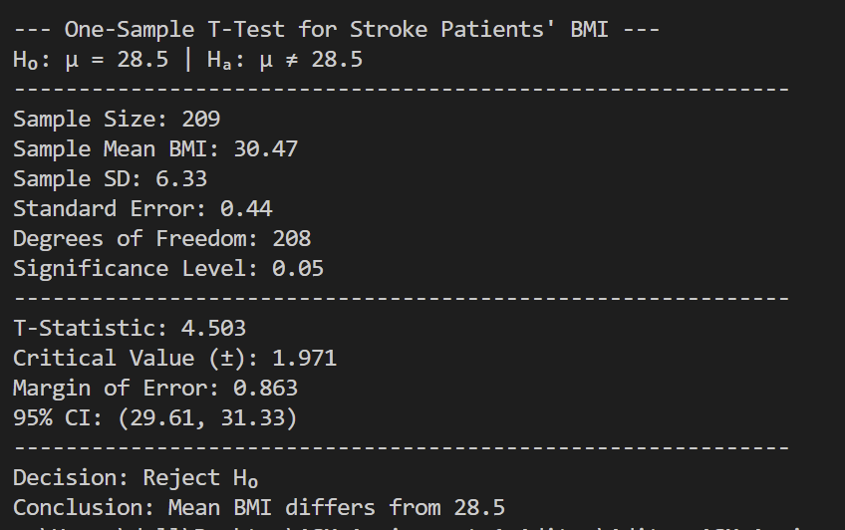
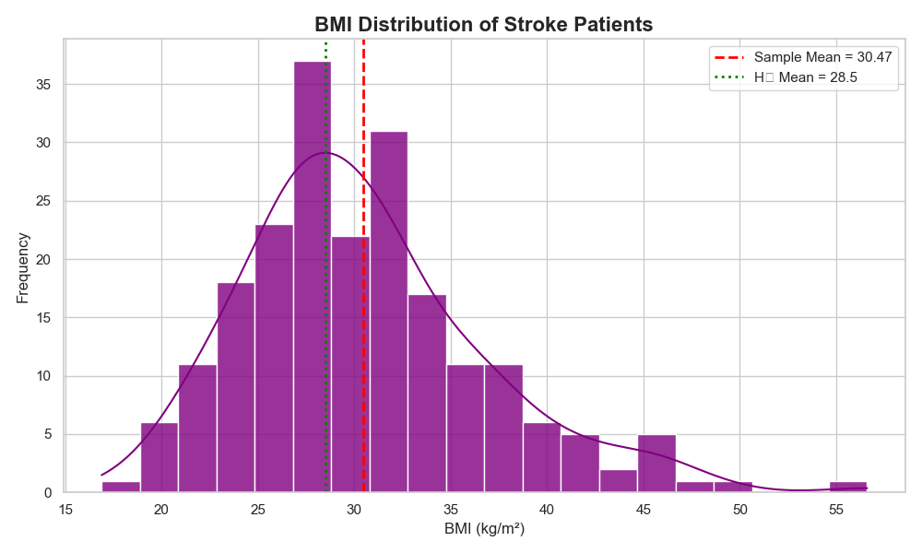

6.0 Conclusion
Decision (Critical Region Approach):
The calculated Test Statistic (t=4.503) falls outside the critical region bounded by ±1.97, as |4.503| > 1.97.
Conclusion: Reject H₀. There is statistically significant evidence to conclude that the mean BMI of stroke patients is different from the hypothesized national average of 28.5 kg/m².
Confidence Interval Interpretation: The 95% CI for the true mean BMI is (29.61, 31.33). Since the hypothesized mean of 28.5 is not contained within this interval, this confirms the decision to reject the null hypothesis.

7.0 Python Code
import pandas as pd
import numpy as np
import matplotlib.pyplot as plt
import seaborn as sns
from scipy import stats

sns.set(style="whitegrid")

file_path = r"C:\Users\dell\Desktop\ASM_Assignment_1_Aditya\healthcare-dataset-stroke-data.csv"

try:
df = pd.read_csv(file_path)
except FileNotFoundError:
print(f"Error: File not found at '{file_path}'")
exit()

bmi = df[df['stroke'] == 1].dropna(subset=['bmi'])['bmi']

if bmi.empty:
print("Error: No data for stroke patients with valid BMI")
exit()

n = len(bmi)
sample_mean = bmi.mean()
sample_std = bmi.std(ddof=1)
pop_mean = 28.5
alpha = 0.05
std_error = sample_std / np.sqrt(n)

t_stat = (sample_mean - pop_mean) / std_error
df_val = n - 1
t_crit = stats.t.ppf(1 - alpha / 2, df=df_val)
margin = t_crit * std_error
ci = (sample_mean - margin, sample_mean + margin)

print(f"\n--- One-Sample T-Test for Stroke Patients' BMI ---")
print(f"H₀: μ = {pop_mean} | Hₐ: μ ≠ {pop_mean}")
print("-" * 60)
print(f"Sample Size: {n}")
print(f"Sample Mean BMI: {sample_mean:.2f}")
print(f"Sample SD: {sample_std:.2f}")
print(f"Standard Error: {std_error:.2f}")
print(f"Degrees of Freedom: {df_val}")
print(f"Significance Level: {alpha}")
print("-" * 60)
print(f"T-Statistic: {t_stat:.3f}")
print(f"Critical Value (±): {t_crit:.3f}")
print(f"Margin of Error: {margin:.3f}")
print(f"95% CI: ({ci[0]:.2f}, {ci[1]:.2f})")
print("-" * 60)

reject = abs(t_stat) > t_crit
decision = "reject" if reject else "fail to reject"
print(f"Decision: {decision.capitalize()} H₀")
print(f"Conclusion: Mean BMI {'differs from' if reject else 'does not differ from'} {pop_mean}")

plt.figure(figsize=(10, 6))
sns.histplot(data=bmi, kde=True, color='purple', bins=20, alpha=0.8)
plt.axvline(sample_mean, color='red', linestyle='--', linewidth=2,
label=f'Sample Mean = {sample_mean:.2f}')
plt.axvline(pop_mean, color='green', linestyle=':', linewidth=2,
label=f'H₀ Mean = {pop_mean}')
plt.title('BMI Distribution of Stroke Patients', fontsize=16, fontweight='bold')
plt.xlabel('BMI (kg/m²)', fontsize=12)
plt.ylabel('Frequency', fontsize=12)
plt.legend()
plt.tight_layout()
plt.show()

8.0 Additional Robustness Checks (Extension)
The BMI distribution for stroke patients is noticeably right-skewed (skewness = 0.887, kurtosis = 1.181), and a Shapiro–Wilk test rejects the assumption of normality (W = 0.9564, p = 5.24 × 10⁻⁶). This section checks whether the t-test conclusion in Section 6.0 still holds once that assumption is questioned.
Why the t-test is still reasonable: with n = 209, the Central Limit Theorem means the sampling distribution of the mean is approximately normal even though the underlying BMI values are skewed, so the one-sample t-test remains a valid approach here. The checks below confirm this empirically rather than just by appeal to theory.
Effect size (Cohen's d): d = (x̄ − μ) / s = (30.47 − 28.50) / 6.33 = 0.311. By Cohen's (1988) convention (0.2 = small, 0.5 = medium, 0.8 = large), this is a small-to-medium effect: the difference from the national average is statistically significant but modest in absolute size (about 2 kg/m²).
Non-parametric check (Wilcoxon signed-rank test): this test does not assume normality. Testing the sample against μ = 28.5 gives W = 7604.5, p = 3.60 × 10⁻⁴. At α = 0.05, this also rejects H₀, agreeing with the t-test.
Bootstrap 95% CI (10,000 resamples, percentile method, seed = 42): (29.63, 31.33), essentially identical to the parametric CI of (29.61, 31.33) and still excluding 28.5.
Conclusion of the robustness check: the parametric t-test, the non-parametric Wilcoxon signed-rank test, and the bootstrap resampling CI all agree in rejecting H₀. The conclusion in Section 6.0 is robust to the non-normality of the underlying BMI distribution.

