AN ASSIGNMENT
ON
MULTIPLE LINEAR REGRESSION & ONE-WAY ANOVA
(with a Classification Extension)
BY
2023A7PS0265U Aditya Sharma
Instructor In-Charge: Dr. Maneesha
prepared for assignment 2 fulfillment of the course
MATH F432 APPLIED STATISTICAL METHODS
BITS PILANI, DUBAI CAMPUS
DUBAI INTERNATIONAL ACADEMIC CITY, DUBAI
UAE

PART A — Multiple Linear Regression: Advertising Spend and Sales

1.0 Introduction to Dataset and Tasks
The dataset used is advertising.csv (200 observations), containing advertising spend (in thousands of dollars) across three media -- TV, Radio, and Newspaper -- and the resulting Sales (in thousands of units) for a product. You are required to determine the following:
(a) Fit a multiple linear regression model predicting Sales from TV, Radio, and Newspaper spend.
(b) Test overall model significance (F-test) and each predictor's individual significance (t-tests), and report 95% confidence intervals for each coefficient.
(c) Check the regression assumptions: normality of residuals, homoscedasticity, and multicollinearity among predictors.

2.0 Objective and Hypotheses
This analysis investigates which advertising channels are significant predictors of sales, and how much of the variation in sales the three channels jointly explain.
Overall model (F-test):
H0: β(TV) = β(Radio) = β(Newspaper) = 0 (none of the predictors explain sales)
Ha: at least one β(j) ≠ 0
Each coefficient (t-test):
H0: β(j) = 0 vs. Ha: β(j) ≠ 0, for j ∈ {TV, Radio, Newspaper}, at α = 0.05.

3.0 Descriptive Statistics
Variable | Mean | Std. Dev. | Min | Median | Max
TV | 147.04 | 85.85 | 0.70 | 149.75 | 296.40
Radio | 23.26 | 14.85 | 0.00 | 22.90 | 49.60
Newspaper | 30.55 | 21.78 | 0.30 | 25.75 | 114.00
Sales | 15.13 | 5.28 | 1.60 | 16.00 | 27.00

4.0 Correlation Analysis
TV spend is strongly correlated with Sales (r = 0.901); Radio shows a moderate correlation (r = 0.350); Newspaper is weakly correlated (r = 0.158). Radio and Newspaper are themselves moderately correlated (r = 0.354), which is checked for multicollinearity in Section 6.0.
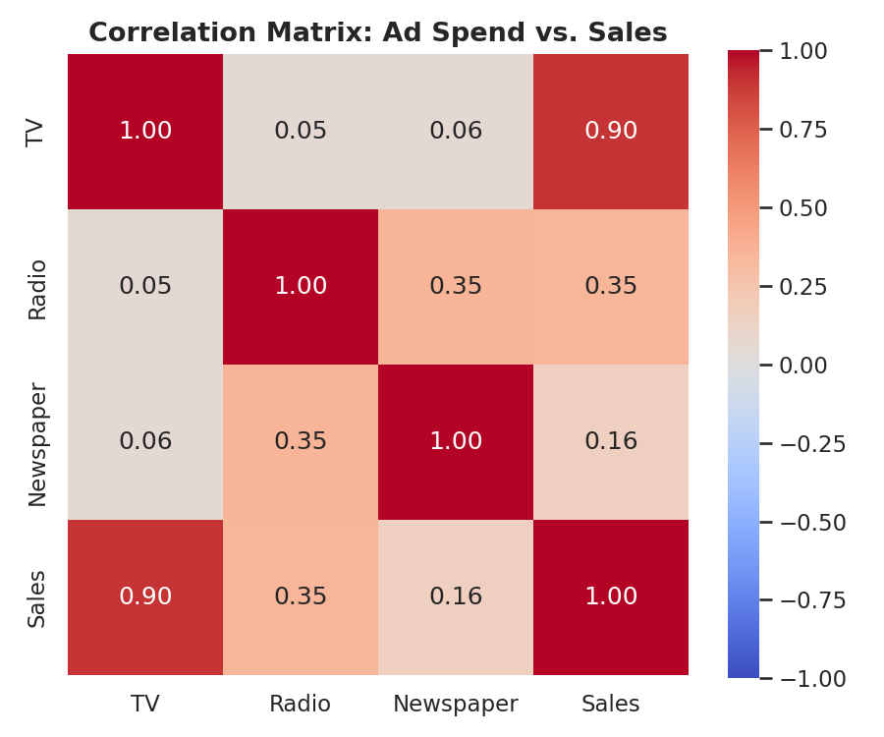
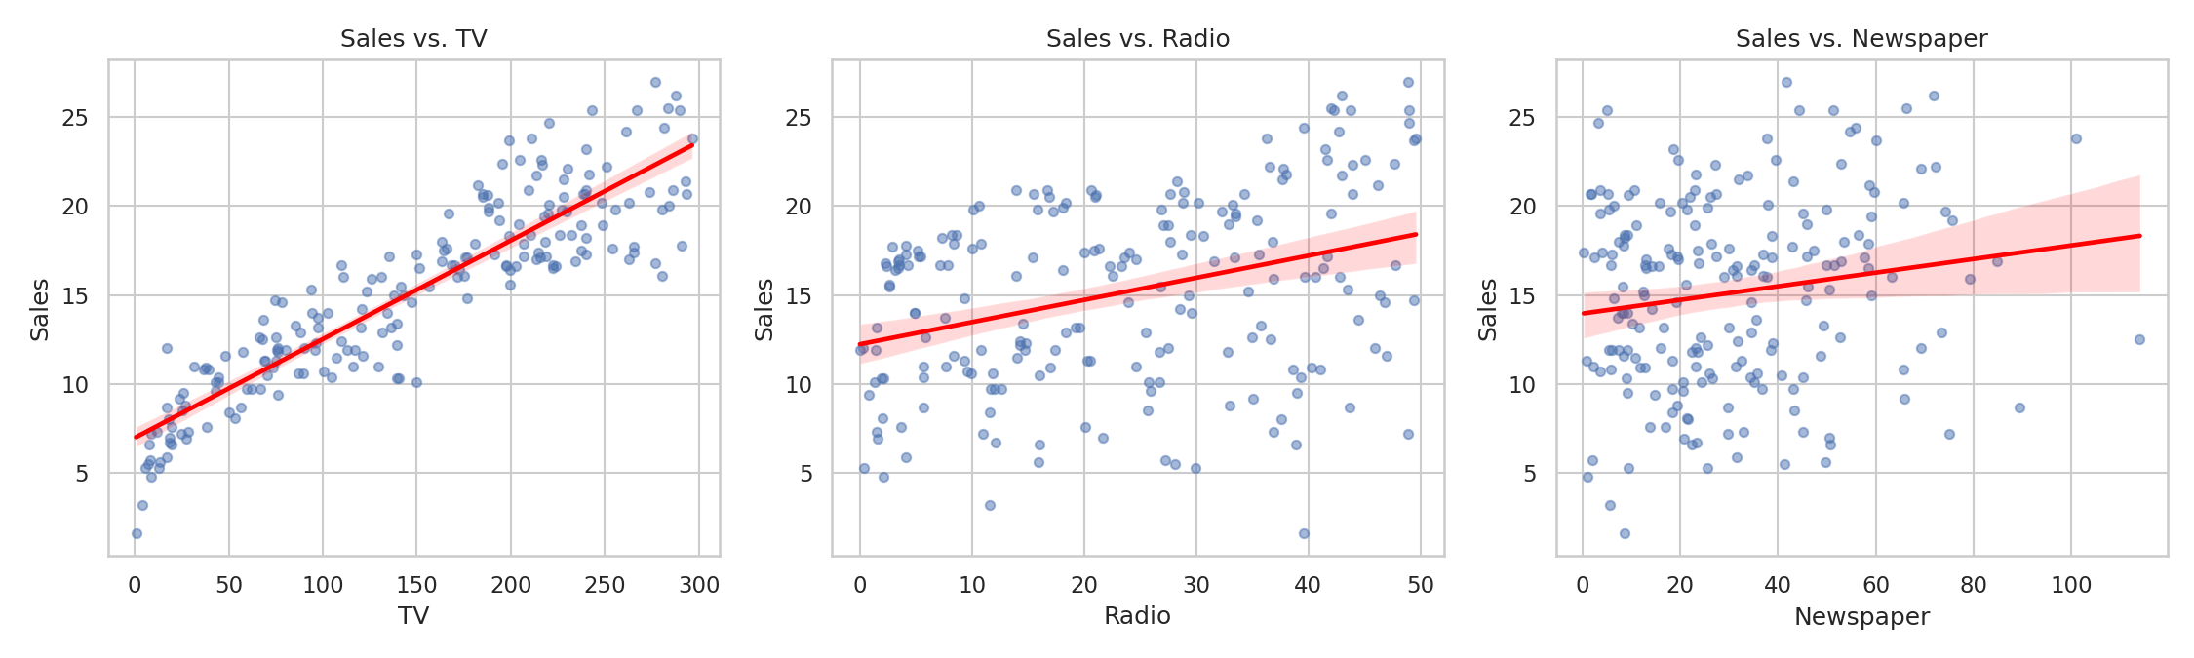

5.0 Regression Results
Fitted model: Sales = 4.6251 + 0.0544 × TV + 0.1070 × Radio + 0.0003 × Newspaper
Predictor | Coefficient | Std. Error | t | p-value | 95% CI
Intercept | 4.6251 | 0.308 | 15.041 | < 0.001 | (4.019, 5.232)
TV | 0.0544 | 0.001 | 39.592 | < 0.001 | (0.052, 0.057)
Radio | 0.1070 | 0.008 | 12.604 | < 0.001 | (0.090, 0.124)
Newspaper | 0.0003 | 0.006 | 0.058 | 0.954 | (-0.011, 0.012)
Overall F-test: F(3, 196) = 605.4, p = 8.13 × 10⁻⁹⁹ — the model as a whole is highly statistically significant.
R² = 0.903, Adjusted R² = 0.901 — the model explains about 90% of the variance in Sales.
Decision on individual predictors: TV and Radio are statistically significant predictors of Sales (p < 0.001 each). Newspaper is NOT statistically significant (p = 0.954) — its 95% CI for the coefficient, (-0.011, 0.012), contains 0.

6.0 Model Diagnostics
Multicollinearity (Variance Inflation Factor):
Predictor | VIF
TV | 2.487
Radio | 3.285
Newspaper | 3.055
All VIF values are well below the common threshold of 5, so multicollinearity is not a concern.
Normality of residuals (Shapiro-Wilk):
W = 0.9758, p = 0.0016 — normality is formally rejected at α = 0.05 (the residuals are slightly left-skewed with a few heavy-tailed points, skew = -0.431, kurtosis = 4.605), but with n = 200 the F- and t-tests remain reasonably robust to mild non-normality by the Central Limit Theorem.
Homoscedasticity (Breusch-Pagan test):
LM statistic = 3.979, p = 0.264 — homoscedasticity holds; there is no evidence that residual variance changes with the fitted values.
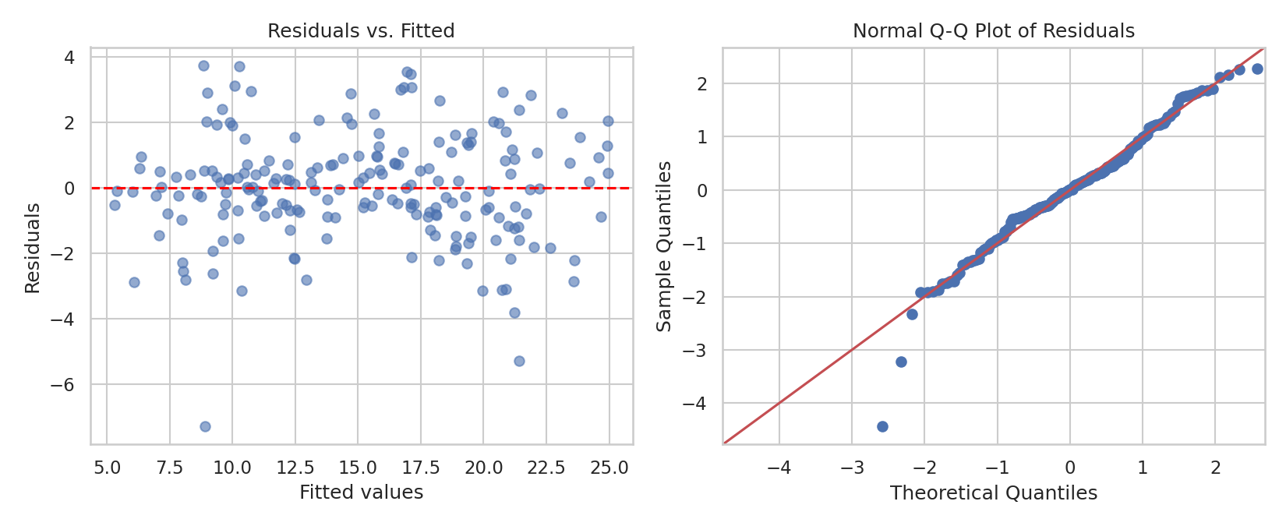

7.0 Conclusion
TV and Radio advertising spend are statistically significant, positive predictors of Sales; Newspaper spend shows no significant relationship with Sales once TV and Radio are accounted for. The model explains 90.3% of the variance in Sales (R² = 0.903) and passes the homoscedasticity and multicollinearity checks; residuals show only mild non-normality, which is not a serious concern at this sample size. Practically, this suggests that of the three channels studied, advertising budget is better allocated to TV and Radio than to Newspaper.

8.0 Python Code (Part A)
"""
MATH F432 Applied Statistical Methods -- Assignment 2, Part A
Multiple Linear Regression: Sales ~ TV + Radio + Newspaper (advertising.csv)
Tasks:
(a) Fit a multiple linear regression model predicting Sales from TV, Radio,
and Newspaper advertising spend.
(b) Test overall model significance (F-test) and each coefficient's
significance (t-tests), report 95% CIs for each coefficient.
(c) Check regression assumptions: normality of residuals, homoscedasticity
(Breusch-Pagan), and multicollinearity (VIF).
"""
import os
import numpy as np
import pandas as pd
import matplotlib.pyplot as plt
import seaborn as sns
import statsmodels.api as sm
from scipy import stats
from statsmodels.stats.diagnostic import het_breuschpagan
from statsmodels.stats.outliers_influence import variance_inflation_factor
sns.set(style="whitegrid")
BASE_DIR = os.path.dirname(os.path.abspath(__file__))
FILE_PATH = os.path.join(BASE_DIR, "advertising.csv")
FIG_CORR = os.path.join(BASE_DIR, "fig_correlation_heatmap.png")
FIG_DIAG = os.path.join(BASE_DIR, "fig_regression_diagnostics.png")
FIG_SCATTER = os.path.join(BASE_DIR, "fig_sales_vs_predictors.png")
ALPHA = 0.05
try:
df = pd.read_csv(FILE_PATH)
except FileNotFoundError:
print(f"Error: File not found at '{FILE_PATH}'")
raise SystemExit(1)
predictors = ["TV", "Radio", "Newspaper"]
X = df[predictors]
y = df["Sales"]
n = len(df)
print("--- Descriptive Statistics ---")
print(df[predictors + ["Sales"]].describe().round(2))
print("\n--- Correlation Matrix ---")
corr = df[predictors + ["Sales"]].corr()
print(corr.round(3))
Xc = sm.add_constant(X)
model = sm.OLS(y, Xc).fit()
print("\n--- Multiple Linear Regression: Sales ~ TV + Radio + Newspaper ---")
print(model.summary())
print("\n--- Variance Inflation Factors (multicollinearity check) ---")
vif = pd.DataFrame({
"feature": predictors,
"VIF": [variance_inflation_factor(X.values, i) for i in range(X.shape[1])],
})
print(vif.round(3).to_string(index=False))
resid = model.resid
fitted = model.fittedvalues
sh_stat, sh_p = stats.shapiro(resid)
print(f"\nShapiro-Wilk on residuals: W={sh_stat:.4f}, p={sh_p:.4f}")
print(" -> Residuals are", "NOT normal" if sh_p < ALPHA else "approximately normal", f"at alpha={ALPHA}")
bp_stat, bp_p, _, _ = het_breuschpagan(resid, Xc)
print(f"Breusch-Pagan test for homoscedasticity: LM stat={bp_stat:.4f}, p={bp_p:.4f}")
print(" ->", "Heteroscedasticity detected" if bp_p < ALPHA else "Homoscedasticity holds", f"at alpha={ALPHA}")
print("\n--- Conclusion ---")
overall_p = model.f_pvalue
print(f"Overall F-test: F={model.fvalue:.1f}, p={overall_p:.3e} "
f"-> model is {'statistically significant' if overall_p < ALPHA else 'not significant'}")
for pred in predictors:
p = model.pvalues[pred]
sig = "significant" if p < ALPHA else "NOT significant"
print(f" {pred}: coef={model.params[pred]:.4f}, p={p:.4f} -> {sig}")
print(f"R-squared = {model.rsquared:.3f} (Adj. R-squared = {model.rsquared_adj:.3f})")
# ---------------------------------------------------------------------------
# Figures
# ---------------------------------------------------------------------------
plt.figure(figsize=(6, 5))
sns.heatmap(corr, annot=True, fmt=".2f", cmap="coolwarm", vmin=-1, vmax=1, square=True)
plt.title("Correlation Matrix: Ad Spend vs. Sales", fontsize=13, fontweight="bold")
plt.tight_layout()
plt.savefig(FIG_CORR, dpi=150)
plt.close()
fig, axes = plt.subplots(1, 3, figsize=(15, 4.5))
for ax, pred in zip(axes, predictors):
sns.regplot(data=df, x=pred, y="Sales", ax=ax, scatter_kws={"alpha": 0.5, "s": 20},
line_kws={"color": "red"})
ax.set_title(f"Sales vs. {pred}")
plt.tight_layout()
plt.savefig(FIG_SCATTER, dpi=150)
plt.close()
fig, axes = plt.subplots(1, 2, figsize=(11, 4.5))
axes[0].scatter(fitted, resid, alpha=0.6)
axes[0].axhline(0, color="red", linestyle="--")
axes[0].set_xlabel("Fitted values")
axes[0].set_ylabel("Residuals")
axes[0].set_title("Residuals vs. Fitted")
sm.qqplot(resid, line="45", fit=True, ax=axes[1])
axes[1].set_title("Normal Q-Q Plot of Residuals")
plt.tight_layout()
plt.savefig(FIG_DIAG, dpi=150)
plt.close()
print(f"\nFigures saved: {FIG_CORR}, {FIG_SCATTER}, {FIG_DIAG}")

PART B — One-Way ANOVA and Classification: Iris Dataset

9.0 Introduction to Dataset and Tasks
The dataset used is iris.csv (150 observations, Fisher's classic Iris dataset), containing four measurements -- Sepal Length, Sepal Width, Petal Length, and Petal Width, in cm -- for 50 flowers from each of 3 species: setosa, versicolor, and virginica. You are required to determine the following:
(a) Test whether mean Petal Length differs across the three species using a one-way ANOVA.
(b) Check the ANOVA assumptions (normality per group, homogeneity of variance) and apply appropriate post-hoc and robustness checks.
(c) Extension: build a classifier that predicts species from all four measurements, and evaluate it on held-out data.

10.0 Objective and Hypotheses
This analysis investigates whether Petal Length -- the single most discriminative measurement in this dataset -- differs meaningfully across the three iris species.
H0: μ(setosa) = μ(versicolor) = μ(virginica)
Ha: at least one species mean differs from the others
Test used: one-way ANOVA (F-test), α = 0.05.

11.0 Descriptive Statistics
Species | n | Mean Petal Length | Std. Dev. | Min | Max
setosa | 50 | 1.464 | 0.174 | 1.0 | 1.9
versicolor | 50 | 4.260 | 0.470 | 3.0 | 5.1
virginica | 50 | 5.552 | 0.552 | 4.5 | 6.9
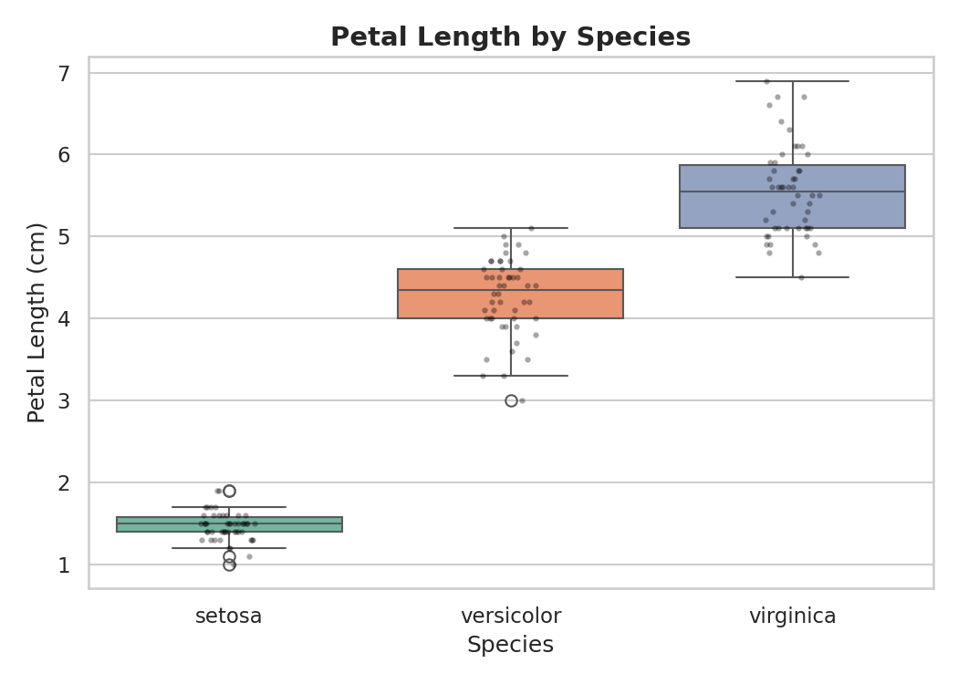

12.0 Assumption Checks
Check | Statistic | p-value | Conclusion
Shapiro-Wilk (setosa) | W = 0.9549 | 0.0547 | approx. normal
Shapiro-Wilk (versicolor) | W = 0.9660 | 0.1585 | approx. normal
Shapiro-Wilk (virginica) | W = 0.9622 | 0.1098 | approx. normal
Levene's test (equal variances) | stat = 19.72 | 2.59 × 10⁻⁸ | variances differ
All three groups pass the normality check individually, but Levene's test shows the assumption of equal variances across groups is violated (larger species have more variable petal lengths). Section 13.0 therefore also reports Welch's ANOVA, which does not assume equal variances, and the non-parametric Kruskal-Wallis test, which assumes neither normality nor equal variances.

13.0 ANOVA Results
Classical one-way ANOVA: F(2, 147) = 1179.03, p = 3.05 × 10⁻⁹¹ — reject H0. Eta-squared = 0.941, meaning species membership explains about 94% of the variance in petal length -- an extremely large effect.
Welch's ANOVA (robust to unequal variances): F(2, 78.05) = 1826.58, p = 2.85 × 10⁻⁶⁶ — same conclusion.
Kruskal-Wallis (non-parametric, robust to both normality and variance violations): H = 130.41, p = 4.80 × 10⁻²⁹ — same conclusion.
All three tests agree: mean petal length differs significantly across the three species.
Tukey HSD post-hoc (pairwise comparisons):
Group 1 | Group 2 | Mean Diff. | p (adj.) | 95% CI | Reject H0?
setosa | versicolor | 2.796 | < 0.001 | (2.592, 3.000) | Yes
setosa | virginica | 4.088 | < 0.001 | (3.884, 4.292) | Yes
versicolor | virginica | 1.292 | < 0.001 | (1.088, 1.496) | Yes
Every pairwise comparison is significant: all three species have distinct mean petal lengths.

14.0 Extension: LDA Classification
A Linear Discriminant Analysis (LDA) classifier was trained on all four measurements (Sepal Length, Sepal Width, Petal Length, Petal Width) using a stratified 70/30 train/test split (105 training, 45 test observations, seed = 42).
Species | Precision | Recall | F1-score | Support
setosa | 1.00 | 1.00 | 1.00 | 15
versicolor | 0.94 | 1.00 | 0.97 | 15
virginica | 1.00 | 0.93 | 0.97 | 15
Overall test accuracy: 97.8% (44/45 correct) — a single virginica flower was misclassified as versicolor, consistent with the small overlap visible between those two species in the pairplot below.
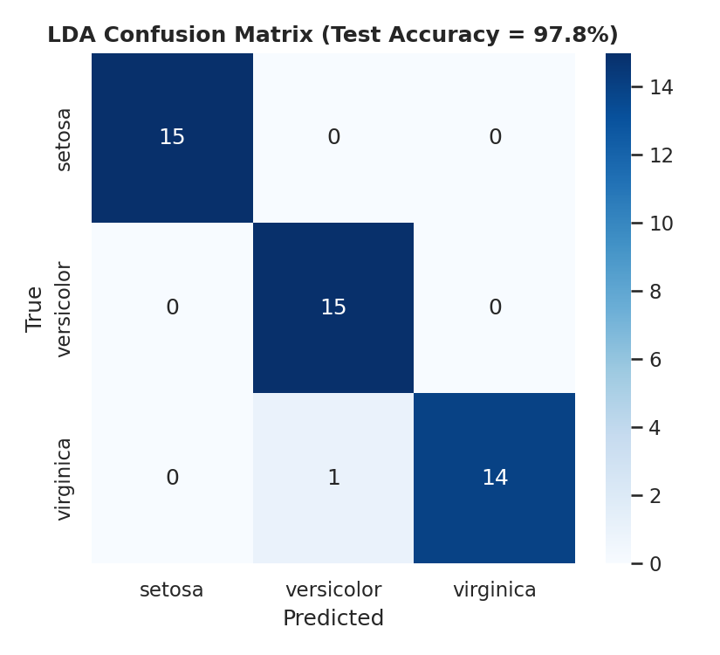
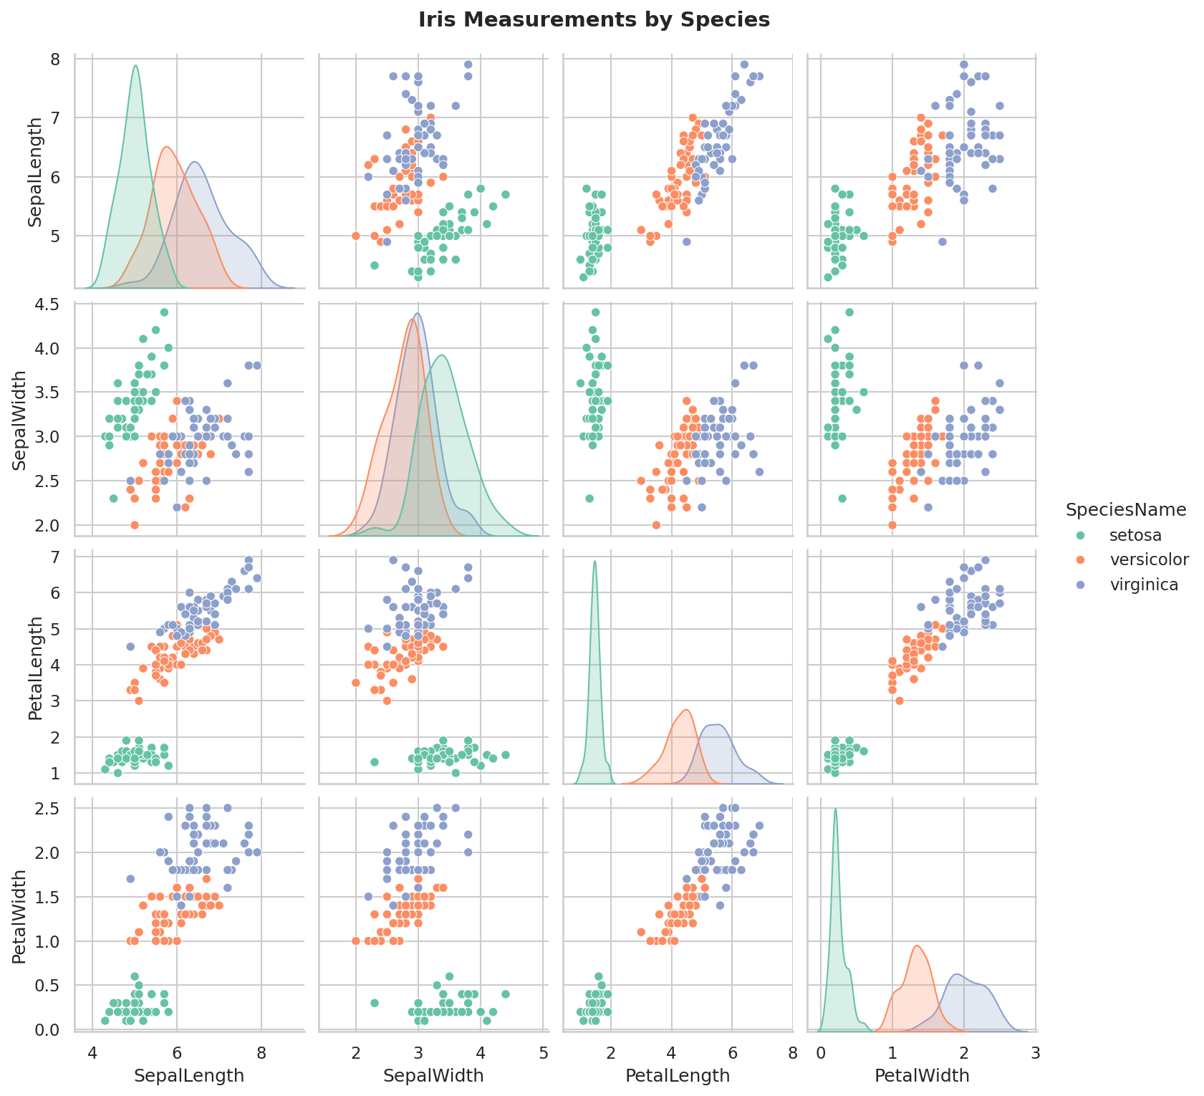

15.0 Conclusion
Mean petal length differs significantly across all three iris species (classical ANOVA, Welch's ANOVA, and Kruskal-Wallis all agree, with an extremely large effect size of η² = 0.941), and Tukey's post-hoc test confirms every pairwise difference is significant. This strong separation is also reflected in the LDA classifier, which predicts species from the four measurements with 97.8% test accuracy, misclassifying only a single borderline versicolor/virginica flower.

16.0 Python Code (Part B)
"""
MATH F432 Applied Statistical Methods -- Assignment 2, Part B
One-Way ANOVA + Classification on the Iris dataset (iris.csv).
Tasks:
(a) One-way ANOVA: does mean Petal Length differ across the 3 species
(setosa, versicolor, virginica)? H0: mu1 = mu2 = mu3, Ha: at least one differs.
(b) Check ANOVA assumptions: normality per group (Shapiro-Wilk) and
homogeneity of variance (Levene's test); if variances are unequal, also
run Welch's ANOVA and the non-parametric Kruskal-Wallis test as
robustness checks, and Tukey's HSD as the post-hoc test.
(c) Extension: a Linear Discriminant Analysis (LDA) classifier predicting
species from all four measurements, evaluated on a held-out test split.
"""
import os
import numpy as np
import pandas as pd
import matplotlib.pyplot as plt
import seaborn as sns
import pingouin as pg
from scipy import stats
from statsmodels.stats.multicomp import pairwise_tukeyhsd
from sklearn.discriminant_analysis import LinearDiscriminantAnalysis
from sklearn.model_selection import train_test_split
from sklearn.metrics import accuracy_score, confusion_matrix, classification_report
sns.set(style="whitegrid")
BASE_DIR = os.path.dirname(os.path.abspath(__file__))
FILE_PATH = os.path.join(BASE_DIR, "iris.csv")
FIG_BOX = os.path.join(BASE_DIR, "fig_petal_length_by_species.png")
FIG_PAIR = os.path.join(BASE_DIR, "fig_iris_pairplot.png")
FIG_CM = os.path.join(BASE_DIR, "fig_lda_confusion_matrix.png")
ALPHA = 0.05
SEED = 42
SPECIES_MAP = {0: "setosa", 1: "versicolor", 2: "virginica"}
FEATURES = ["SepalLength", "SepalWidth", "PetalLength", "PetalWidth"]
try:
df = pd.read_csv(FILE_PATH)
except FileNotFoundError:
print(f"Error: File not found at '{FILE_PATH}'")
raise SystemExit(1)
df["SpeciesName"] = df["Species"].map(SPECIES_MAP)
print("--- Descriptive Statistics: Petal Length by Species ---")
print(df.groupby("SpeciesName")["PetalLength"].describe().round(3))
groups = [g["PetalLength"].values for _, g in df.groupby("SpeciesName")]
species_order = sorted(df["SpeciesName"].unique(), key=lambda s: list(SPECIES_MAP.values()).index(s))
# ---------------------------------------------------------------------------
# Assumption checks
# ---------------------------------------------------------------------------
print("\n--- Assumption Checks ---")
for name, g in zip(species_order, groups):
sh_stat, sh_p = stats.shapiro(g)
print(f" Shapiro-Wilk ({name}): W={sh_stat:.4f}, p={sh_p:.4f} "
f"-> {'not normal' if sh_p < ALPHA else 'approx. normal'}")
lev_stat, lev_p = stats.levene(*groups)
print(f" Levene's test (equal variances): stat={lev_stat:.4f}, p={lev_p:.3e} "
f"-> {'variances differ' if lev_p < ALPHA else 'variances equal'} at alpha={ALPHA}")
# ---------------------------------------------------------------------------
# One-way ANOVA
# ---------------------------------------------------------------------------
print("\n--- One-Way ANOVA: PetalLength ~ Species ---")
f_stat, anova_p = stats.f_oneway(*groups)
grand_mean = df["PetalLength"].mean()
ss_between = sum(len(g) * (g.mean() - grand_mean) ** 2 for g in groups)
ss_total = ((df["PetalLength"] - grand_mean) ** 2).sum()
eta_sq = ss_between / ss_total
print(f" F({len(groups)-1}, {len(df)-len(groups)}) = {f_stat:.2f}, p = {anova_p:.3e}")
print(f" Eta-squared (effect size) = {eta_sq:.4f}")
print(f" Decision: {'Reject' if anova_p < ALPHA else 'Fail to reject'} H0 at alpha={ALPHA}")
print("\n--- Robustness Checks (variances were unequal per Levene's test) ---")
welch = pg.welch_anova(data=df, dv="PetalLength", between="SpeciesName")
print(welch.to_string(index=False))
kw_stat, kw_p = stats.kruskal(*groups)
print(f" Kruskal-Wallis (non-parametric): H={kw_stat:.2f}, p={kw_p:.3e}")
print("\n--- Tukey HSD Post-hoc Test ---")
tukey = pairwise_tukeyhsd(df["PetalLength"], df["SpeciesName"], alpha=ALPHA)
print(tukey)
# ---------------------------------------------------------------------------
# Extension: LDA classification
# ---------------------------------------------------------------------------
print("\n--- Extension: LDA Classification (Species ~ all 4 measurements) ---")
X = df[FEATURES]
y = df["SpeciesName"]
X_train, X_test, y_train, y_test = train_test_split(
X, y, test_size=0.3, random_state=SEED, stratify=y
)
lda = LinearDiscriminantAnalysis()
lda.fit(X_train, y_train)
y_pred = lda.predict(X_test)
acc = accuracy_score(y_test, y_pred)
print(f" Train/test split: {len(X_train)}/{len(X_test)} (stratified, seed={SEED})")
print(f" Test accuracy: {acc:.4f}")
print(classification_report(y_test, y_pred))
cm = confusion_matrix(y_test, y_pred, labels=species_order)
print("Confusion matrix (rows=true, cols=predicted):")
print(pd.DataFrame(cm, index=species_order, columns=species_order))
# ---------------------------------------------------------------------------
# Figures
# ---------------------------------------------------------------------------
plt.figure(figsize=(7, 5))
sns.boxplot(data=df, x="SpeciesName", y="PetalLength", order=species_order,
hue="SpeciesName", palette="Set2", legend=False)
sns.stripplot(data=df, x="SpeciesName", y="PetalLength", order=species_order,
color="black", alpha=0.35, size=3)
plt.title("Petal Length by Species", fontsize=14, fontweight="bold")
plt.xlabel("Species")
plt.ylabel("Petal Length (cm)")
plt.tight_layout()
plt.savefig(FIG_BOX, dpi=150)
plt.close()
g = sns.pairplot(df, vars=FEATURES, hue="SpeciesName", palette="Set2", diag_kind="kde")
g.fig.suptitle("Iris Measurements by Species", y=1.02, fontsize=14, fontweight="bold")
g.savefig(FIG_PAIR, dpi=150)
plt.close()
plt.figure(figsize=(5.5, 5))
sns.heatmap(cm, annot=True, fmt="d", cmap="Blues",
xticklabels=species_order, yticklabels=species_order)
plt.title(f"LDA Confusion Matrix (Test Accuracy = {acc:.1%})", fontsize=12, fontweight="bold")
plt.xlabel("Predicted")
plt.ylabel("True")
plt.tight_layout()
plt.savefig(FIG_CM, dpi=150)
plt.close()
print(f"\nFigures saved: {FIG_BOX}, {FIG_PAIR}, {FIG_CM}")

