PIE
PATENT INFORMATION EXTRACTION FORM
TOPIC: BunkBusters: Geo-Fenced and Device-Bound Smart Attendance System
SCHOOL: Chitkara University, Rajpura, Punjab
INVENTOR’S DETAIL WHO UPLOADED THE PATENT ON CHALKPAD
NAME: Isha Kansal
EMPLOYEE CODE: CET1001265
MOBILE NO: 9592842249
MAIL ID (UNIVERSITY): isha.kansal@chitkara.edu.in MAIL ID (PERSONAL): single.isha1@gmail.com
OTHER INVENTORS DETAIL

NAME | EMP CODE/ROLL | ADDRESS WITH EMAIL AND MOBILE NO.
Aditya Sharma | 2210991198 | Jujhar Singh Nagar Street No.-4(Left) House no.-D-1/261 Near Grewal Bypass Malerkotla,148023 ,Punjab, adityas191204@gmail.com  Ph. No: 6284376084
Nischay Bareja | 2210991987 | 934 sec 13/17 panipat Haryana  barejanischay5@gmail.com  7027634774
Chaitanya Chadha | 2210991451 | 2042 sec-7 Sonipat, Haryana,  chaitanyashantchadha@gmail.com  Ph. No: 9729857473
Dhruv Jain | 2210991508 | 473, Mota Singh Nagar Jalandhar Punjab 144001,  jdhruv90235@gmail.com  Ph. No: 9023551000
Isha Kansal | CET1001265 | DCSE, Chitkara University Punjab,  isha.kansal@chitkara.edu.in  Ph. No: 9592842249

Q1.What was the problem?
Ans. In most colleges, attendance systems are still not fully reliable. Some teachers take attendance manually by calling out names. Some colleges use biometric machines, QR codes, or simple mobile applications. Even though these methods are digital, they still have many problems. One of the biggest problems is proxy attendance. Students sometimes give their phone to a friend to mark attendance on their behalf. In some systems, a student can just enter the classroom for a few minutes, mark attendance, and then leave early. The system cannot check whether the student actually stayed for the full class duration or not. So attendance does not truly represent real presence. Another issue is that many mobile-based attendance systems only check login credentials. If someone knows the username and password, they can log in from another device. There is no strong verification to ensure that the phone being used actually belongs to that specific student. Some systems use location tracking, but they usually check location only once at the beginning. After that, the system does not monitor whether the student remained inside the classroom. Also, GPS alone may not be fully reliable inside buildings, and in some cases, it can be manipulated. There are also situations where the teacher cancels the class, ends it early, or changes the duration. Most attendance systems do not adjust automatically according to the teacher’s actual session time. Because of this, students may be unfairly marked absent even if they were present during the actual teaching time. There is no proper session control from the teacher’s side to define the real start and end time of the class.
Due to all these issues, current attendance systems fail to ensure that:
- The student’s own registered device is physically inside the classroom.
- The student stays for the required duration of the class.
- The real student (not someone else) is present.
- Attendance duration matches the actual session controlled by the teacher.
This creates unfairness and misuse. Some students attend honestly, while others take advantage of loopholes. There is a need for a smarter and more controlled system where attendance depends on real physical presence for the correct duration, and where the teacher has control over the session timing so that attendance is calculated fairly.
Q2.How did you solve it (Inventive Step)?
Ans. To solve the problems of proxy attendance, early leaving, and misuse of login-based systems, we designed a system called BunkBusters which works in a more controlled and layered way instead of depending on only one method like GPS or face recognition. Our main idea was that attendance should not be marked based on just one action. It should be based on a full session that is controlled by the teacher. First, the teacher starts the class session from their dashboard or application. This means attendance tracking only begins when the teacher officially starts the session. If the teacher cancels the class or ends it early, the system automatically adjusts the required duration for attendance. So the student’s presence is calculated only according to the actual teaching time, not the fixed timetable. This makes the system fair. Second, each student account is linked to a specific mobile device and the SIM card inside that device. During registration, the system stores the device details and SIM information. Attendance can only be recorded if the same registered device and SIM are being used. This reduces the chance of login from another phone or emulator. It makes sure that the phone used actually belongs to that student. Third, we introduced geo-fencing for the classroom. Each classroom is defined using latitude, longitude, and altitude so that even different floors of the same building can be differentiated. When the teacher starts the session, the system checks whether the student’s registered phone is physically inside that classroom boundary. But instead of checking location only once, our system continuously checks whether the phone remains inside the classroom for the required minimum duration. If the phone leaves the classroom for more than an allowed time, the attendance becomes invalid. This prevents students from entering the class for just a few minutes and leaving after marking attendance. Finally, at the end of the session, the student must take a live photograph inside the app. This photo is captured only during the session end window and is verified with the registered identity of the student. The system also checks whether the location at the time of capturing the photo matches the classroom location. This step ensures that the phone was not given to someone else.
Attendance is marked only if all conditions are satisfied:
- Teacher has started the session.
- The registered device and SIM are being used.
- The phone stays inside the classroom geo-fence for the required duration.
- The student verifies identity at the end of the class.
- The teacher has ended the session.
By combining session control, device binding, continuous location tracking, and end-of-class identity verification, we created a more secure and reliable attendance system that reduces proxy attendance and ensures real physical presence.

Q3.What were the other possible solutions and why they could not be done?
Ans. Before finalizing our idea, we also thought about other possible solutions that colleges are already using or could use. But when we analyzed them properly, we found that each one had some limitations and could not completely solve the real problem. One possible solution is manual attendance, where the teacher calls out names or passes a sheet for signatures. This method is very common but it takes time, especially in large classes. It also allows proxy attendance easily because students can answer for their friends or sign on their behalf. So this method is not reliable and also wastes teaching time. Another possible solution is biometric systems like fingerprint scanners installed at classroom entrances. These systems are more secure than manual attendance. However, they require expensive hardware installation in every classroom. Maintenance cost is also high. Sometimes machines do not work properly due to network issues or hardware failure. Also, during peak times, long queues can form outside classrooms, which waste time. We also considered QR code-based attendance systems. In this method, the teacher displays a QR code and students scan it to mark attendance. But this method is still easy to misuse. A student can take a picture of the QR code and send it to someone outside the class. That person can scan it and mark attendance without being physically present. So QR codes alone do not guarantee real presence.
Another solution is simple GPS-based attendance apps. These apps mark attendance if the student’s phone is within a certain location radius. But this is not fully reliable because GPS can sometimes be inaccurate indoors. Also, some students may use fake GPS applications to change their location. In many cases, the system only checks location once at the beginning and does not verify whether the student stayed for the full class duration. Face recognition systems were also considered. These systems verify the student’s identity using a camera. But most systems capture the face only once at the beginning of the class. After that, there is no tracking of whether the student remained inside. Also, installing camera-based systems in every classroom can raise privacy concerns and increase cost Another idea was to use login-based mobile applications without device binding. But this method is weak because students can log in from different phones. It does not ensure that the actual registered device is present in the classroom. Because of these limitations, none of the existing solutions alone could fully prevent proxy attendance, early exit, login misuse, and unfair marking when the teacher changes session timing. That is why we decided to combine multiple layers like teacher-controlled sessions, device-SIM binding, continuous geo-location tracking, and end-of-class identity verification to create a more secure and practical solution.

Q4.What are the advantages of the solution proposed by you?
Ans. The main advantage of our proposed system, BunkBusters, is that it makes attendance more fair, secure, and reliable compared to traditional systems. First, it reduces proxy attendance. Since the system links each student account to a specific device and SIM card, and also requires identity verification at the end of the session, it becomes very difficult for students to give their phone to someone else to mark attendance. This increases honesty in the attendance process. Second, it ensures real physical presence. Many systems only check attendance once at the beginning of the class. In our system, the student’s phone must remain inside the classroom geo-fenced area for a minimum required duration. If the student leaves early, attendance will not be marked. This ensures that students actually stay in the class instead of just entering for a few minutes. Another important advantage is teacher control over the session. The teacher starts and ends the class session from their side. If the teacher cancels the class or ends it early, the system automatically adjusts the required attendance time. This makes the system flexible and fair because students are not marked absent due to schedule differences.

The system also improves transparency. Since attendance is calculated automatically based on multiple conditions, there is less confusion and fewer disputes between students and teachers. Everything is recorded digitally, which makes the process more clear and organized. It also reduces manual work for teachers. Teachers do not need to call out names or manage attendance sheets. The system automatically calculates presence based on real-time data, which saves time and allows teachers to focus more on teaching.
Another advantage is scalability. Since the system works through a mobile application and backend server, it can be used across multiple classrooms and departments without needing heavy hardware installation like biometric machines in every room. The system also increases discipline among students. When students know that attendance depends on staying inside the class for the full session and verifying identity at the end, they are less likely to misuse the system.
Overall, our solution combines location tracking, device verification, session control, and identity confirmation in one structured process. This makes attendance more secure, reduces misuse, saves time, and ensures fairness for both students and teachers.

Q5.Explain the stepwise working of the innovation explaining all the components used in the invention and the specific function they are performing.
Ans. The BunkBusters system works in a step-by-step process where both teacher and student have specific roles. The system combines a mobile application, a backend server, location services, device verification, and identity confirmation to ensure proper attendance marking. The complete working of the system is explained below:
Step 1: Student Registration
When a student installs the application for the first time, they register using their college credentials.
During registration, the system stores:
- Student details (name, roll number, department)
- Device identification details
- SIM card information linked to that phone
- This step ensures that each account is permanently connected to one specific device and SIM. This prevents login from other phones later.
Step 2: Teacher Starts the Session
At the beginning of the class, the teacher logs into their dashboard and starts the session manually. This step is very important because:
- Attendance tracking begins only after the teacher starts the session.
- The system records the exact start time.
- If the teacher cancels or delays the class, no attendance is calculated.
- This gives full session control to the teacher.

Step 3: Classroom Geo-Fence Activation
- Each classroom is predefined in the system using: Latitude
Longitude
Altitude (to differentiate floors)
- When the teacher starts the session, the geo-fence for that classroom becomes active.
- The student’s phone must be physically inside this defined area to qualify for attendance tracking.
Step 4: Continuous Location Monitoring Once the session starts, the system checks:
- Whether the registered device is inside the classroom boundary.
- Whether it stays inside for the minimum required duration.
- The system does not check only once. It monitors presence continuously or at regular intervals.
- If the student leaves the classroom for more than the allowed time limit:
- The attendance becomes invalid.
- The required duration counter resets or fails.
- This ensures students cannot enter, mark attendance, and leave early.
Step 5: Device and SIM Verification During the session, the system verifies:
- The request is coming from the registered device.
- The registered SIM card is active in that phone.
- If the SIM or device does not match the stored registration data:
- Attendance tracking does not proceed.
- This prevents phone sharing and account misuse.

Step 6: Teacher Ends the Session
- When the class ends, the teacher manually ends the session.
- The system records the exact end time.
- If the teacher ends early:
- Required attendance duration is automatically adjusted according to actual session time.
- If the teacher cancels the class:
- Attendance is not calculated at all.
- This makes the system flexible and fair.

Step 7: End-of-Class Identity Verification

After the teacher ends the session, students are prompted to take a live photo inside the app within a limited time window.
This photo:
- Is captured in real time.
- Is compared with the student’s registered identity.
- Is checked for current classroom location.
- This step ensures that:
- The real student is present.
- The phone was not given to someone else.
- The student is still inside the classroom at the end.
Step 8: Final Attendance Decision
- The backend system checks all conditions:
- Teacher started and ended the session.
- Registered device and SIM were used.
- Student stayed inside the geo-fence for required duration.
- End-of-class identity verification was successful.
- If all conditions are satisfied:
- Attendance is marked as present.
- If any one condition fails:
- Attendance is marked absent.
Components Used in the System
- Mobile Application (Student App)
Used for registration, location tracking, and end-session photo capture.
- Teacher Dashboard
Used to start and end sessions and manage attendance records.
- Backend Server and Database
Stores student data, device details, session timing, and attendance logs.
- Geo-Location Services (GPS + Altitude)
Used to detect whether the student is physically inside the classroom.
- Device and SIM Verification Module
Ensures the account is used only from the registered device and SIM.
- Identity Verification Module
Used to verify the student’s face during the end-of-class confirmation.
In simple words, the system works like a controlled session where attendance depends on real presence, correct device usage, and identity confirmation. It combines multiple checks instead of relying on a single factor, which makes it more secure and practical for real classroom use.
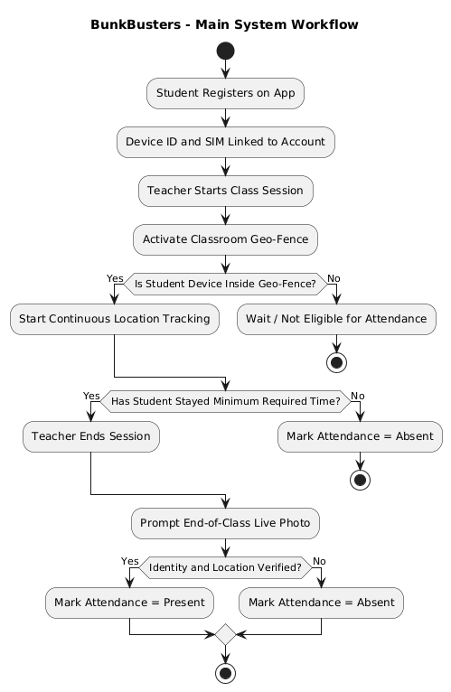

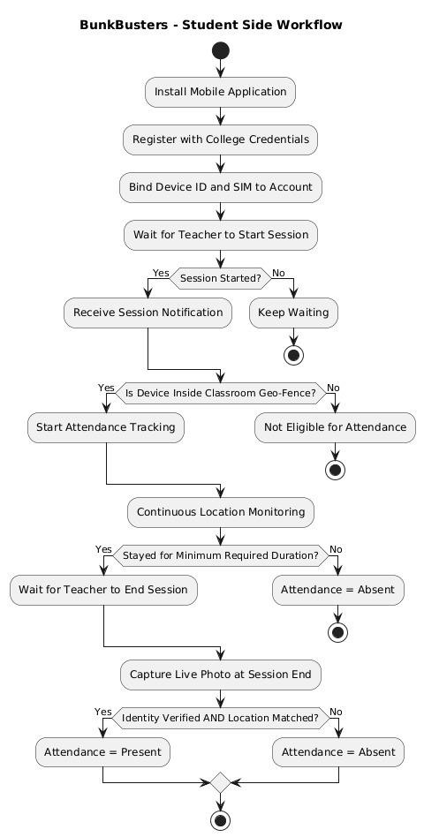

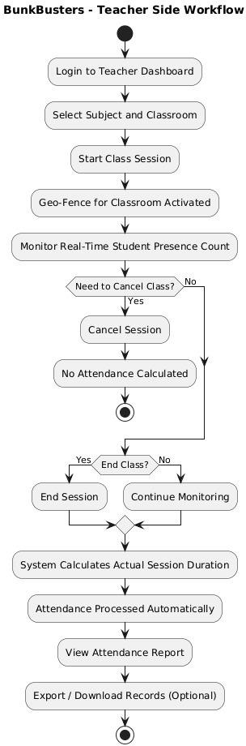
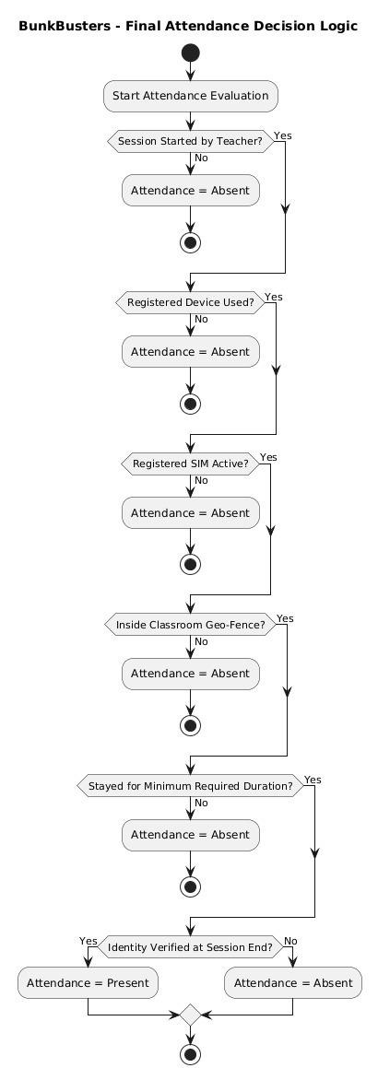

Work Flow

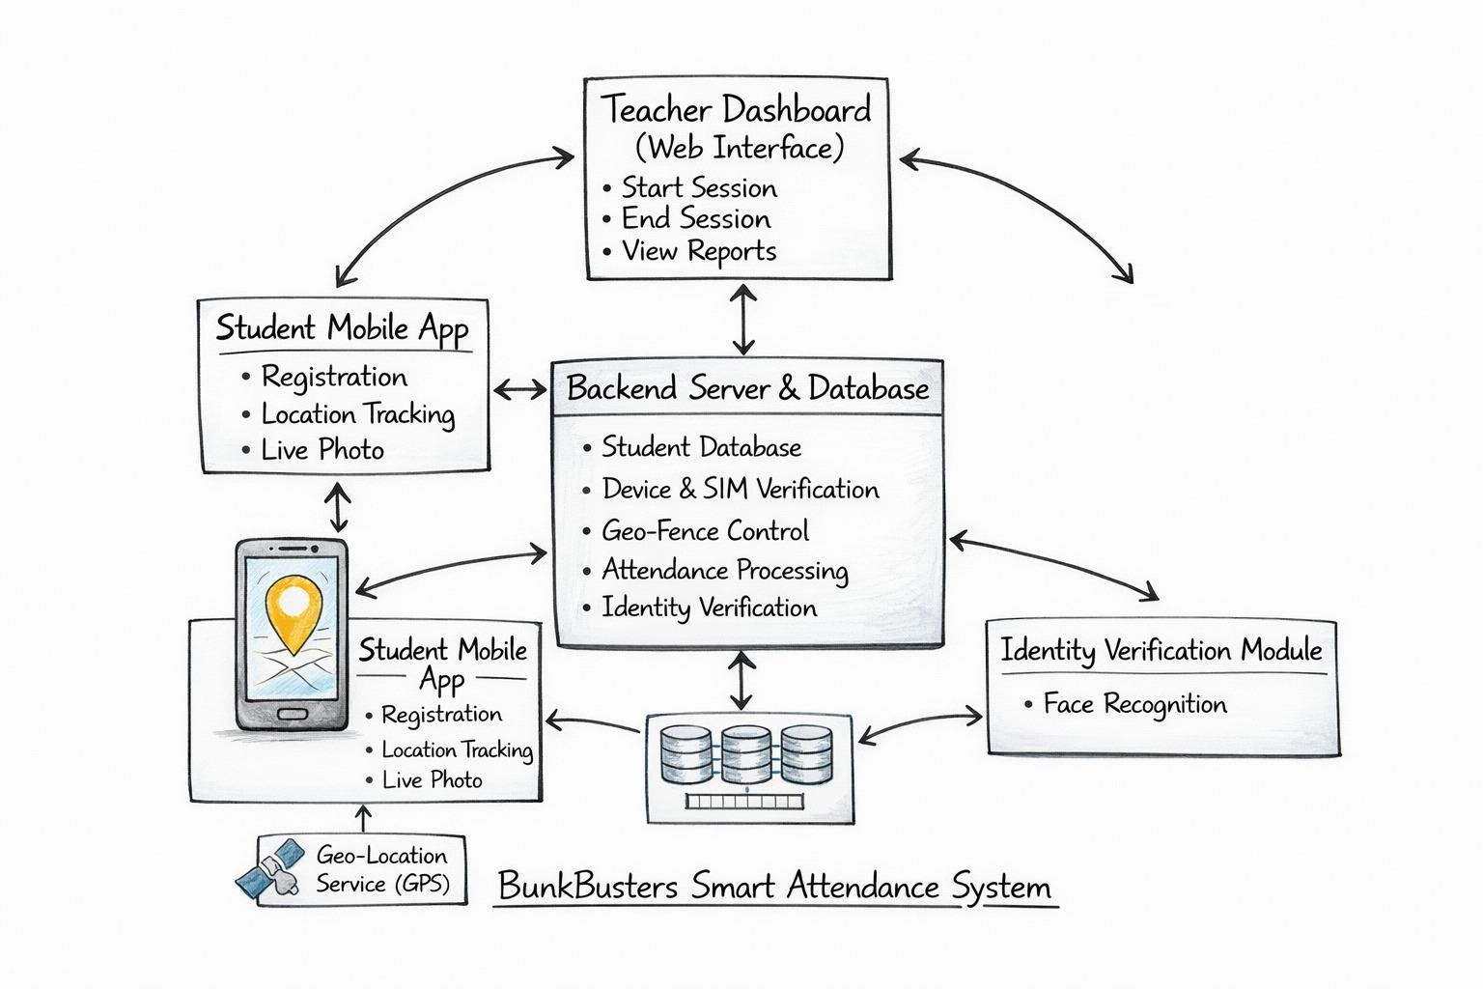

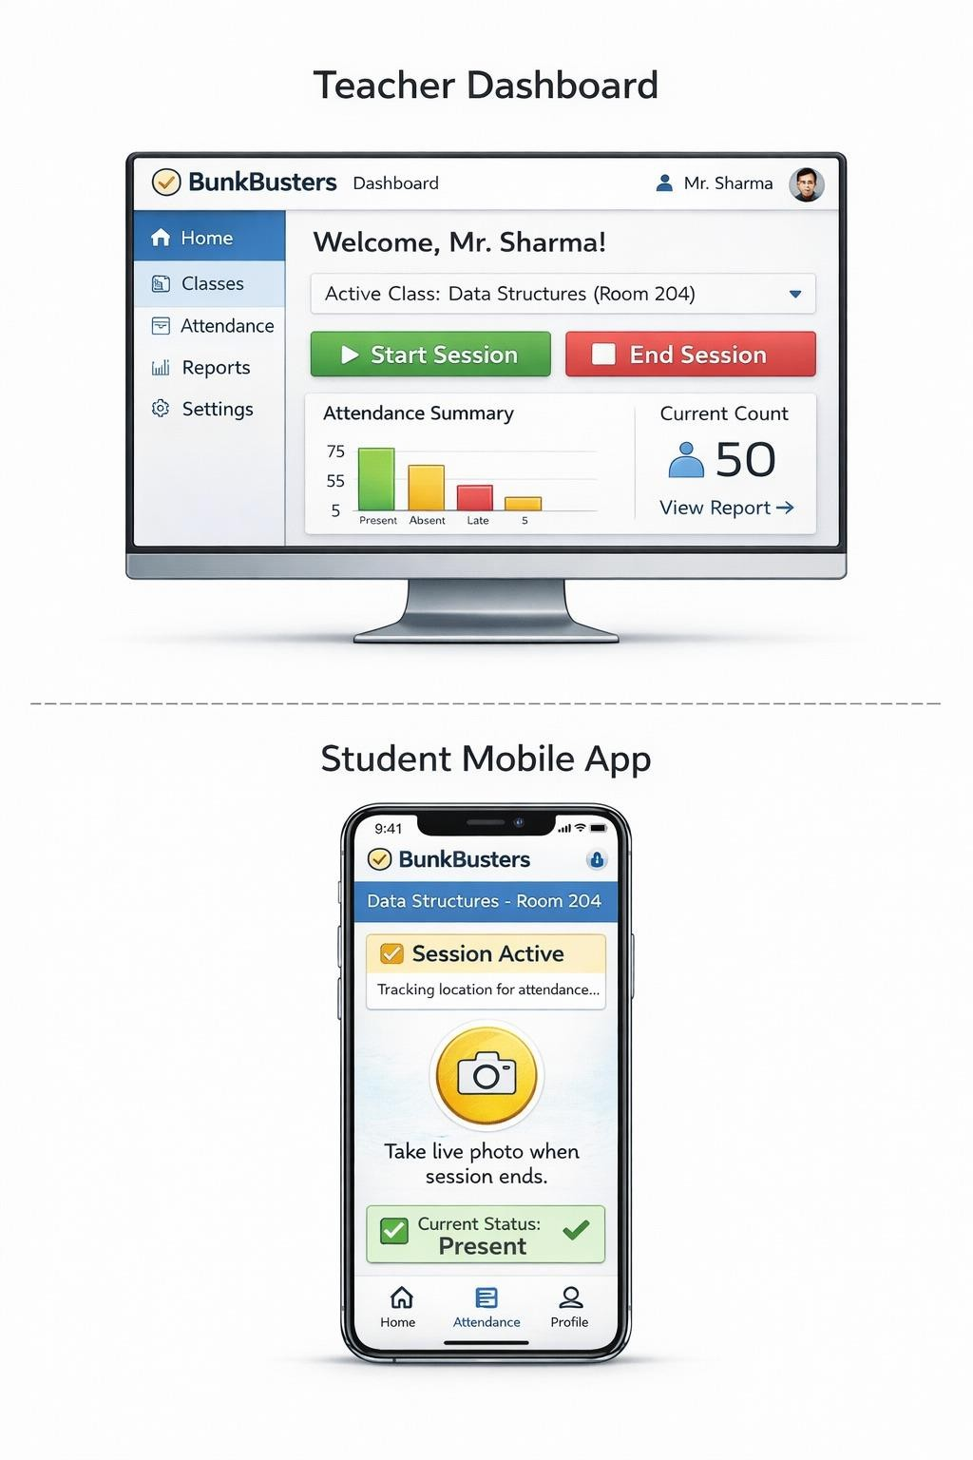
Design

Sr. No. | Keywords
1 | Smart Attendance System
2 | Geo-Fencing Based Classroom Monitoring
3 | Device and SIM Binding Authentication
4 | Proxy Attendance Prevention Technology
5 | Continuous Location Tracking
6 | Teacher-Controlled Session Management
7 | Real-Time Identity Verification
8 | Secure Mobile-Based Attendance
9 | Classroom Presence Validation
10 | Multi-Layer Authentication Framework
11 | Digital Education Monitoring System
12 | Automated Attendance Analytics

Relevant Key phrases relating to your invention

Sr. No. | Keywords
1 | Smart Attendance System
2 | Geo-Fencing Based Classroom Monitoring
3 | Device and SIM Binding Authentication
4 | Proxy Attendance Prevention Technology
5 | Continuous Location Tracking
6 | Teacher-Controlled Session Management
7 | Real-Time Identity Verification
8 | Secure Mobile-Based Attendance
9 | Classroom Presence Validation

