PROJECT REPORT OF CO-OP Project at Industry (Module-2)

ON

BunkBusters: Geo-Fenced and Device-Bound Smart Attendance System

submitted in partial fulfilment of the requirements for the award of degree of

BACHELOR OF ENGINEERING
In
COMPUTER SCIENCE AND ENGINEERING

Submitted by: Supervised By:
Aditya Sharma (2210991198) Ms. Isha Kansal
Nischay Bareja (2210991987) Assistant Professor
Chaitanya Chadha (2210991451) Chitkara University, Punjab
Dhruv Jain (2210991508)



DEPARTMENT OF COMPUTER SCIENCE AND ENGINEERING
CHITKARA UNIVERSITY INSTITUTE OF ENGINEERING AND TECHNOLOGY
CHITKARA UNIVERSITY, PUNJAB, INDIA

CONTENTS

S.No. | Title | Page No.
 | Declaration | iii
 | Acknowledgement | iv
 | List of Figures and Tables | v
 | Abstract | vi
1 | Introduction | 1
2 | Methodology
3 | Tools and Technologies
4 | Implementation
5 | Major Findings / Outcomes / Output / Results
6 | Conclusion and Future Scope
 | References
 | Appendices

DECLARATION

We hereby certify that the work which is being presented in the project report entitled "BunkBusters: Geo-Fenced and Device-Bound Smart Attendance System" in partial fulfilment of requirement for the award of the degree of Bachelor of Engineering (Computer Science and Engineering) submitted in the Department of Computer Science and Engineering at Chitkara University Institute of Engineering and Technology, Chitkara University, Punjab, India, is an authentic record of our own work carried out under the supervision of Ms. Isha Kansal (Assistant Professor, DCSE). The matter presented in this project report has not been submitted in any other university/institute for the award of any degree.

Place: Rajpura Aditya Sharma (2210991198)
Date: ……………. Nischay Bareja (2210991987)
Chaitanya Chadha (2210991451)
Dhruv Jain (2210991508)

This is to certify that the above statement made by the candidates is correct to the best of my knowledge and belief.

(Ms. Isha Kansal)
Assistant Professor
Department of Computer Science and Engineering
Chitkara University Institute of Engineering and Technology
Chitkara University, Punjab, India

ACKNOWLEDGEMENT

It is our pleasure to be indebted to various people who directly or indirectly contributed in the development of this work and who influenced our thinking, behaviour, and acts during the course of study.
We express our sincere gratitude to Chitkara University for providing us the opportunity to undertake this Co-op Project as part of our curriculum.
We are highly thankful to our supervisor, Ms. Isha Kansal (Assistant Professor, Department of Computer Science and Engineering, Chitkara University), for her constant support, guidance, cooperation, and motivation throughout this project. Her valuable suggestions and precious time played a key role in shaping the outcome of this report.
We also extend our gratitude to the faculty members of the Department of Computer Science and Engineering for their encouragement and academic support.
Lastly, we would like to thank the Almighty and our parents for their moral support, and our friends who shared their experiences and gave valuable suggestions that helped improve the quality of our work.

Aditya Sharma (2210991198)
Nischay Bareja (2210991987)
Chaitanya Chadha (2210991451)
Dhruv Jain (2210991508)

LIST OF FIGURES AND TABLES

Figure No. | Title | Page No.
Fig 1 | System Architecture of BunkBusters
Fig 2 | Student Registration Workflow
Fig 3 | Teacher Session Control Flow
Fig 4 | Final Attendance Decision Process
Fig 5 | End-of-Class Identity Verification Flow

Fig 1:Main System Workflow
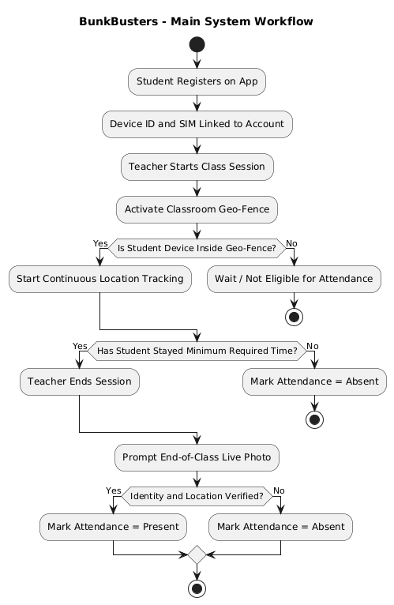

Fig 2:Student Side Workflow
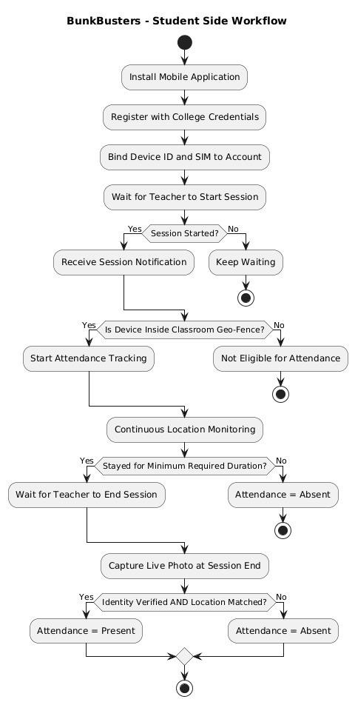

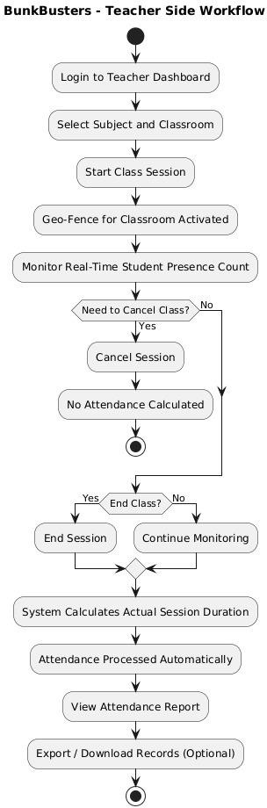
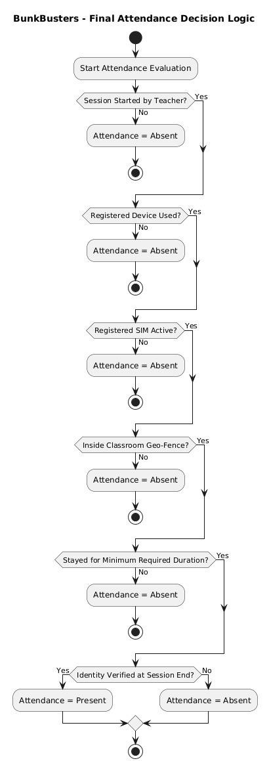

Fig 5:End-of-Class Identity Verification Flow

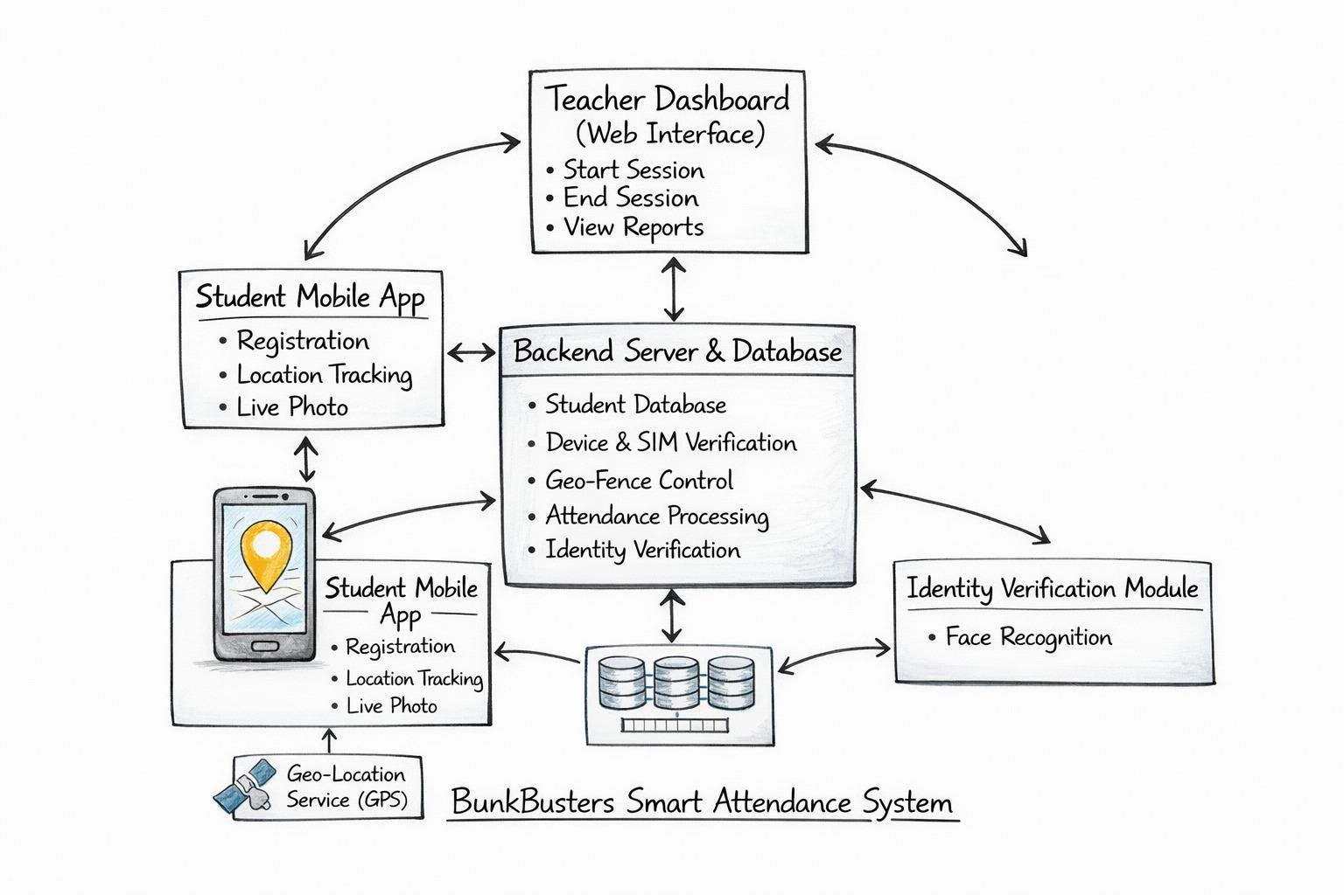
ABSTRACT

BunkBusters is an innovative, multi-layered smart attendance system designed to resolve persistent shortcomings in conventional college attendance management. Existing methods—ranging from manual roll calls and biometric scanners to QR codes and simple GPS-based mobile apps—have proven susceptible to proxy attendance, early departures, and login-based misuse. BunkBusters addresses these challenges through a combination of teacher-controlled session management, device-and-SIM binding, continuous geo-fenced location monitoring, and end-of-class real-time identity verification.
The system operates through a mobile application for students and a teacher dashboard. When a teacher initiates a class session, geo-fencing is activated around the predefined classroom boundary using GPS latitude, longitude, and altitude. The student's registered device and SIM must remain within that boundary for a minimum required duration. At the end of the session, students must submit a live photograph for identity confirmation. Attendance is marked present only when all conditions are simultaneously satisfied. If the teacher cancels or concludes the session early, the system automatically recalibrates the required attendance duration, ensuring fairness.
The patent-worthy inventive step lies in the holistic integration of five independent verification layers into a seamlessly automated attendance pipeline, making the system more secure and resistant to misuse than any single-factor approach. BunkBusters is scalable, cost-effective, and practical for real-world deployment across institutions of varying sizes.

Keywords: Smart Attendance System, Geo-Fencing, Device Binding, SIM Verification, Proxy Attendance Prevention, Teacher-Controlled Session, Real-Time Identity Verification, Continuous Location Tracking.

1. Introduction
Attendance management is a fundamental administrative function in every educational institution. Accurate attendance records are critical not only for academic accountability but also for regulatory compliance and student performance assessment. Despite the widespread adoption of digital tools across campuses, attendance systems have largely remained prone to manipulation, inefficiency, and inaccuracy.
Traditional approaches—manual roll calls, biometric fingerprint readers, QR code scanning, and basic GPS-enabled mobile applications—each carry inherent vulnerabilities. Proxy attendance, where one student marks attendance on behalf of another, remains the most prevalent form of misuse. Early departures after marking attendance, unauthorised device usage, and system failures during peak hours further compound the problem.
BunkBusters is a patent-filed smart attendance system conceived and developed to comprehensively address these gaps. The system does not rely on a single verification mechanism; instead, it orchestrates five independent but interdependent layers of security: teacher-controlled session gating, device-and-SIM binding, geo-fenced classroom boundary enforcement, continuous presence monitoring throughout the session, and end-of-class live identity verification.

1.1 Background
Chitkara University, like many institutions, operates a regulated attendance policy that directly influences student progression and eligibility for examinations. With hundreds of students across multiple departments attending classes simultaneously, manual oversight becomes impractical. Digital alternatives have been explored, but each solution adopted thus far has presented exploitable loopholes.
The genesis of BunkBusters lies in direct observation of these loopholes during student life. A team of four students—Aditya Sharma, Nischay Bareja, Chaitanya Chadha, and Dhruv Jain—under the guidance of Ms. Isha Kansal, identified that no existing solution concurrently verified device ownership, physical classroom presence over time, and real-time student identity. This gap motivated the design of a layered, automated system.

1.2 Problem Statement
Current attendance systems at the collegiate level suffer from a combination of the following critical deficiencies:
- Proxy attendance via phone sharing or credential lending is trivially easy in login-only systems.
- GPS-only systems verify location once at the start; students who leave immediately after marking attendance are not detected.
- QR code systems allow photographs of the code to be shared, enabling remote marking.
- Biometric systems require costly hardware, suffer from network dependency, and create queuing bottlenecks.
- No existing system dynamically adjusts required attendance duration when a teacher cancels or shortens a class.

These deficiencies collectively undermine the integrity of attendance data and create an unfair academic environment.

1.3 Objectives
The primary objectives of the BunkBusters system are:
- To prevent proxy attendance through device-and-SIM binding and live identity verification.
- To ensure physical classroom presence for the full required session duration using continuous geo-fenced monitoring.
- To provide teachers with complete session control, including the ability to start, pause, and end class sessions dynamically.
- To automatically recalibrate the attendance requirement when session duration changes.
- To deliver a scalable, hardware-light solution deployable across multiple classrooms and departments without significant infrastructure investment.

2. Methodology
The development methodology adopted for BunkBusters follows a structured, iterative design approach. The project began with requirement analysis derived from direct observations of attendance system failures in the campus environment. This was followed by the formulation of the inventive concept, system architecture design, component selection, and prototype planning.

2.1 Requirement Analysis
A thorough analysis of existing attendance mechanisms was conducted. Manual methods, biometric scanners, QR code systems, GPS-based apps, and face recognition systems were evaluated for their security, cost, scalability, and resistance to misuse. The analysis highlighted five core requirements: real device ownership verification, sustained physical presence, teacher-driven session control, dynamic session adjustment, and end-of-session identity confirmation.

2.2 Inventive Step — Core Design Philosophy
The central inventive step of BunkBusters is the simultaneous application of five independent verification layers within a single automated attendance pipeline. Unlike existing systems that rely on one or two factors, BunkBusters treats attendance as a multi-gate process where every gate must be passed for a positive result. The absence of even one condition results in the student being marked absent.
The five layers are:
- Layer 1 – Teacher Session Gate: Attendance tracking begins and ends only on the teacher's explicit command.
- Layer 2 – Device and SIM Binding: The student's registered device IMEI and SIM identity must match stored registration records.
- Layer 3 – Geo-Fence Activation: A three-dimensional classroom boundary (latitude, longitude, altitude) is activated when the teacher starts the session.
- Layer 4 – Continuous Presence Monitoring: The student's device must remain within the geo-fence for the minimum required duration throughout the session.
- Layer 5 – End-of-Class Live Photo Verification: After the teacher ends the session, the student must submit a live photograph captured within the classroom boundary for identity validation.

2.3 Comparison with Existing Solutions

Feature | BunkBusters | Biometric | QR Code | GPS App | Manual
Proxy Prevention | Yes | Partial | No | No | No
Device Verification | Yes | No | No | No | No
Continuous Monitoring | Yes | No | No | No | No
Teacher Session Control | Yes | No | No | No | Yes
Dynamic Duration Adjust | Yes | No | No | No | Partial
Hardware Cost | Low | High | Low | Low | Nil
Identity Verification | Yes | Yes | No | No | No

3. Tools and Technologies
The BunkBusters system is designed around a mobile-first, cloud-connected architecture. The following tools and technologies form the core technology stack:

3.1 Mobile Application Framework
- React Native / Flutter: Cross-platform mobile application development for Android and iOS, enabling code reuse and consistent behaviour across device types.
- Android SDK: Required for accessing low-level device APIs including IMEI retrieval, SIM information, and GPS services.

3.2 Location Services
- GPS (Global Positioning System): Used to determine real-time latitude and longitude coordinates of the student device.
- Barometric Altitude Sensor / Network-Based Altitude: Incorporated to differentiate between multiple floors of the same building for precise classroom-level geo-fencing.
- Geo-Fencing API: Used to define and enforce the classroom boundary as a three-dimensional zone.

3.3 Backend and Database
- Node.js with Express.js: Server-side framework handling session management, attendance computation, and API endpoints.
- MongoDB: NoSQL database for storing student profiles, device registration data, session logs, and attendance records.
- JWT (JSON Web Token): Used for secure authentication of both student and teacher sessions.

3.4 Identity Verification
- Device IMEI and SIM Identity APIs: Used during registration and session verification to bind accounts to physical devices.
- Live Photo Capture Module: In-app camera functionality restricted to the session end window; captures a real-time photograph for identity confirmation.
- Face Recognition API: Used to compare the captured live photo against the student's registered identity photograph stored in the system.

3.5 Development Tools
- Visual Studio Code: Primary code editor used throughout development.
- Postman: API endpoint testing and documentation.
- Git and GitHub: Version control and collaborative development.
- MongoDB Compass: Database visualisation and management.

4. Implementation
The BunkBusters system is implemented as a multi-component platform consisting of a student mobile application, a teacher dashboard, and a backend server with database. The implementation follows the eight-step workflow defined during system design.

4.1 Step 1 — Student Registration
Upon installation of the mobile application, each student undergoes a one-time registration process using their college-issued credentials. During registration, the system records the student's name, roll number, department, device identification details (IMEI), and the SIM card identity linked to that device. This binding ensures that attendance can only be recorded from the student's own registered phone, preventing account sharing.

4.2 Step 2 — Teacher Session Initiation
At the commencement of each class, the teacher logs into the teacher dashboard and explicitly starts the session. The system records the exact start timestamp. No attendance tracking occurs prior to this action. This step gives the teacher full control over when the attendance window opens and ensures that attendance is not accidentally recorded for cancelled or postponed classes.

4.3 Step 3 — Geo-Fence Activation
Each classroom is pre-configured in the system with a set of three-dimensional coordinates: latitude, longitude, and altitude. Upon session start, the geo-fence corresponding to the active classroom is activated on the backend. This three-dimensional boundary allows the system to differentiate between classrooms located on different floors of the same building, a limitation that two-dimensional GPS systems cannot address.

4.4 Step 4 — Continuous Location Monitoring
Once the session is active, the student's mobile application continuously transmits location data to the backend at defined intervals. The backend verifies that the registered device remains within the classroom geo-fence. If the device exits the boundary for a duration exceeding the permitted tolerance, the attendance counter is paused or invalidated. This mechanism prevents the common practice of entering the classroom briefly to mark attendance and then leaving.

4.5 Step 5 — Device and SIM Verification
Throughout the session, every location update and authentication request is cross-checked against the stored registration data. The system confirms that the IMEI and SIM identity of the transmitting device match the registered records for the student account. Any mismatch results in immediate rejection of the attendance record for that session.

4.6 Step 6 — Teacher Session Closure
When the class concludes, the teacher ends the session through the dashboard. The system records the exact end timestamp and computes the actual session duration. If the teacher ends the session earlier than the scheduled time, the required minimum attendance duration for students is automatically recalculated on a proportional basis. This ensures that students who were present for the entire actual class are not unfairly penalised.

4.7 Step 7 — End-of-Class Identity Verification
After the teacher ends the session, a time-limited window opens for students to submit a live photograph through the mobile application. The photograph is captured in real time within the app and cannot be uploaded from the device gallery. The system verifies that the photo is taken from within the classroom geo-fence and compares the captured face against the student's registered identity photograph using the face recognition module. This step confirms that the registered student—not a substitute—is physically present at the end of the class.

4.8 Step 8 — Final Attendance Decision
The backend evaluates all conditions simultaneously before finalising the attendance record:
- Teacher initiated and concluded the session.
- The student's registered device and SIM were used throughout.
- The device remained within the geo-fence for at least the required minimum duration.
- End-of-class identity verification was successfully completed within the allotted window.
If all conditions are met, the student is marked present. Failure of any single condition results in an absent marking, with the specific failure reason logged for transparency and dispute resolution.

5. Major Findings / Outcomes / Output / Results

5.1 Key Advantages of BunkBusters
The implementation and conceptual evaluation of the BunkBusters system yielded the following significant findings:

5.1.1 Elimination of Proxy Attendance
By combining device-and-SIM binding with live end-of-class identity verification, BunkBusters makes proxy attendance substantially more difficult than any single-factor system. A student cannot mark attendance from another device, and cannot hand their registered phone to a friend without the face recognition failing at the end-of-class verification step.

5.1.2 Enforcement of Real Physical Presence
The continuous geo-fenced monitoring addresses the early-departure problem that GPS snapshot systems cannot resolve. Students must remain within the defined classroom boundary for the full required duration, effectively enforcing genuine attendance rather than token presence.

5.1.3 Teacher-Driven Fairness
The teacher session control mechanism ensures that attendance is calculated only for the actual teaching duration. Students who were present for the entirety of a shortened class are not penalised. Similarly, if a class is cancelled before it begins, no attendance record is generated.

5.1.4 Scalability and Hardware Efficiency
Because BunkBusters operates through existing student smartphones and a cloud backend, it requires no dedicated hardware installation in classrooms. This makes it significantly more cost-effective and scalable than biometric systems, particularly for large institutions with many classrooms.

5.1.5 Transparency and Dispute Reduction
Every attendance decision is logged with the specific conditions evaluated, including location data, device verification status, session timestamps, and identity verification results. This audit trail substantially reduces attendance disputes by providing verifiable evidence for each marking.

5.2 Keywords and Key Phrases

Sr. No. | Keyword / Key Phrase
1 | Smart Attendance System
2 | Geo-Fencing Based Classroom Monitoring
3 | Device and SIM Binding Authentication
4 | Proxy Attendance Prevention Technology
5 | Continuous Location Tracking
6 | Teacher-Controlled Session Management
7 | Real-Time Identity Verification
8 | Secure Mobile-Based Attendance
9 | Classroom Presence Validation
10 | Multi-Layer Authentication Framework
11 | Digital Education Monitoring System
12 | Automated Attendance Analytics

6. Conclusion and Future Scope

6.1 Conclusion
BunkBusters represents a significant advancement in the domain of academic attendance management. By integrating teacher-controlled session gating, device-and-SIM binding, three-dimensional geo-fenced monitoring, continuous presence tracking, and live end-of-class identity verification into a single automated system, it effectively closes the loopholes that plague conventional approaches.
The project demonstrates that reliable attendance management does not necessitate expensive dedicated hardware. A thoughtfully designed mobile application backed by a robust server-side verification pipeline can deliver a level of security and fairness that surpasses biometric and QR code systems at a fraction of the infrastructure cost.
From an academic perspective, this work applies concepts from mobile application development, GPS and sensor integration, cloud backend architecture, and identity verification—providing the student team with comprehensive hands-on experience across the full software engineering lifecycle. The filing of a patent for the BunkBusters system underscores the novelty and practical value of the inventive step.

6.2 Future Scope
Several enhancements are envisioned for future development of the BunkBusters system:
- Integration with University ERP Systems: Seamless API connectivity with existing university management portals will automate attendance reporting and reduce administrative overhead.
- Wi-Fi Fingerprinting as Secondary Location Verification: Incorporating Wi-Fi access point fingerprinting alongside GPS will improve indoor location accuracy in environments where GPS signal is weak.
- Behavioural Biometrics: Adding passive continuous authentication through typing patterns or device usage behaviour could further strengthen identity assurance without interrupting the student experience.
- Offline Mode with Delayed Sync: Developing an offline-capable client that queues attendance data and syncs when connectivity is restored will improve reliability in areas with poor network coverage.
- Analytics Dashboard for Administrators: A comprehensive analytics module showing attendance trends, chronic absenteeism patterns, and class-wise statistics will aid academic decision-making.
- Multi-Institution Deployment: Packaging the system as a SaaS product will allow rapid deployment across multiple campuses with centralised management.

References
[1] S. Prabha and R. Amudha, "A Smart Attendance System Using Geo-Fencing and Face Recognition," International Journal of Engineering Research & Technology, vol. 10, no. 5, 2021.
[2] M. A. Al-Qudah, "Mobile-Based Attendance System Using QR Codes and GPS," Journal of Information Technology Education, vol. 19, 2020.
[3] V. Singh and A. Vyas, "Biometric Attendance System: A Review," International Journal of Computer Applications, vol. 178, no. 29, 2019.
[4] Y. Chen et al., "Device Fingerprinting for Mobile Authentication," IEEE Transactions on Mobile Computing, vol. 20, no. 4, pp. 1234–1248, 2021.
[5] R. Ramos and J. Almeda, "Geo-Fencing Technology in Educational Attendance Monitoring," Procedia Computer Science, vol. 161, pp. 784–792, 2019.
[6] Android Developer Documentation – Location and Maps: https://developer.android.com/training/location
[7] Node.js Official Documentation – https://nodejs.org/en/docs/
[8] MongoDB Documentation – https://www.mongodb.com/docs

Appendices

Appendix A — Inventor Details

Name | Roll No. / Emp. Code | Address & Contact
Aditya Sharma | 2210991198 | Jujhar Singh Nagar, Street No.-4(L), H.No. D-1/261, Near Grewal Bypass, Malerkotla, 148023, Punjab. adityas191204@gmail.com | +91-6284376084
Nischay Bareja | 2210991987 | 934 Sec 13/17, Panipat, Haryana. barejanischay5@gmail.com | +91-7027634774
Chaitanya Chadha | 2210991451 | 2042 Sec-7, Sonipat, Haryana. chaitanyashantchadha@gmail.com | +91-9729857473
Dhruv Jain | 2210991508 | 473, Mota Singh Nagar, Jalandhar, Punjab 144001. jdhruv90235@gmail.com | +91-9023551000
Isha Kansal (Supervisor) | CET1001265 | DCSE, Chitkara University, Punjab. isha.kansal@chitkara.edu.in | +91-9592842249

Appendix B — Patent Information
System Title: BunkBusters: Geo-Fenced and Device-Bound Smart Attendance System
School: Chitkara University, Rajpura, Punjab
Patent Filed By: Isha Kansal (CET1001265)
Co-Inventors: Aditya Sharma, Nischay Bareja, Chaitanya Chadha, Dhruv Jain
Platform: ChalkPad — Chitkara University IP Management Portal

