**Tour & Travel Website**

### PROJECT REPORT

### ON

### Web Technology

***Submitted* by**

**MEHAK SHARMA (**2110993810**)**

**ADITYA SHARMA** (2110993755)

**BE-CSE (Artificial Intelligence)**

***Guided by***

**Mr. Nitesh**

**CHITKARA UNIVERSITY INSITUTE OF ENGINEERING & TECHNOLOGY**

**CHITKARA UNIVERSITY, RAJPURA**

**Sept 2024**

# Table of Contents

1. Executive Summary  
2. Introduction  
3. Project Overview  
4. Technology Stack  
5. Design Process  
6. Implementation  
7. Tailwind CSS Integration  
8. User Experience (UX)  
0. Future Enhancements  
10. Conclusion

# Summary

**Purpose:** This project aims to create a comprehensive online platform for travelers to plan and book their trips. It provides essential information about destinations, accommodations, transportation, and activities, streamlining the travel planning process.

**Key Outcomes:**

* **User-Friendly Interface:** A visually appealing and intuitive website design that caters to both experienced and novice travelers.
* **Extensive Destination Database:** A vast collection of destinations, each with detailed information on attractions, climate, culture, and local experiences.
* **Accommodation Booking:** A seamless booking system that allows users to search, compare, and book various accommodations, from hotels and resorts to hostels and vacation rentals.
* **Transportation Options:** Information on flights, trains, buses, and rental cars, enabling users to plan their travel itineraries efficiently.
* **Activity Recommendations:** Suggestions for activities based on user preferences and interests, ensuring a personalized travel experience.

**Main Features:**

* **Destination Search:** A powerful search function to find destinations by name, location, or category.
* **Trip Planning Tools:** Itinerary builder, packing list generator, and currency converter to assist travelers in organizing their trips.
* **Customer Reviews and Ratings:** Authentic feedback from other travelers to help users make informed decisions.
* **Secure Payment Gateway:** A reliable payment system to ensure safe and convenient transactions.

**Technologies Used:**

* **React:** A JavaScript library for building user interfaces, providing a component-based architecture for efficient development.
* **JavaScript:** A versatile programming language that handles the website's logic and interactions.
* **Tailwind CSS:** A utility-first CSS framework that offers a rapid and customizable way to style web applications.

**Additional Libraries (if applicable):** Libraries like Axios for making API calls, React Router for handling navigation, and Mapbox for displaying maps.

Overall, this React, JavaScript, and Tailwind CSS-based tour and travel website offers a user-centric and informative platform for travelers to plan and book their adventures.

# Introduction

**Project Objectives:**

This project aims to develop a comprehensive online platform designed to simplify and enhance the travel planning experience for individuals and groups. The primary objectives are:

* **Centralized Travel Resource:** To provide a one-stop destination for travelers to discover, plan, and book various aspects of their trips, including flights, accommodations, activities, and transportation.
* **Personalized Recommendations:** To leverage user data and preferences to offer tailored suggestions for destinations, itineraries, and experiences, ensuring a more personalized and enjoyable journey.
* **Seamless Booking Experience:** To create a user-friendly booking process that allows travelers to easily reserve flights, accommodations, and activities with minimal hassle.
* **Informative Content:** To provide valuable travel information, tips, and destination guides to help users make informed decisions and maximize their travel experiences.

**Scope of the Website:**

The website will encompass the following key features:

* **Destination Search:** A robust search function to allow users to explore destinations based on various criteria, such as location, interests, budget, and travel style.
* **Trip Planning Tools:** Itinerary builders, packing list generators, and currency converters to assist travelers in organizing their trips efficiently.
* **Accommodation Booking:** A comprehensive platform for booking hotels, hostels, vacation rentals, and other accommodation options.
* **Flight and Transportation:** Integration with flight and transportation booking services to provide users with convenient options for travel.
* **Activity and Experience Booking:** A marketplace for booking tours, activities, and unique experiences at various destinations.
* **User Reviews and Ratings:** A system for travelers to share their experiences and rate destinations, accommodations, and activities.
* **Personalized Recommendations:** An algorithm that suggests destinations, itineraries, and activities based on user preferences and past behavior.

**Target Audience:**

The target audience for this website includes:

* **Leisure Travelers:** Individuals and families seeking enjoyable and memorable vacations.
* **Business Travelers:** Professionals who frequently travel for work and require efficient and convenient booking options.
* **Adventure Travelers:** Individuals seeking thrilling and off-the-beaten-path experiences.
* **Group Travelers:** Groups of friends, families, or colleagues planning trips together.

By addressing the needs and preferences of these target audiences, the website aims to become a go-to resource for planning and booking unforgettable travel experiences.

# Project Overview

**Project Goal:** To create a comprehensive online platform that simplifies and enhances the travel planning experience for individuals and groups.

**Key Features:**

* **Destination Search:** A robust search function to explore destinations based on various criteria.
* **Trip Planning Tools:** Itinerary builders, packing list generators, and currency converters.
* **Accommodation Booking:** A platform for booking hotels, hostels, vacation rentals, and more.
* **Flight and Transportation:** Integration with flight and transportation booking services.
* **Activity and Experience Booking:** A marketplace for booking tours, activities, and unique experiences.
* **User Reviews and Ratings:** A system for travelers to share their experiences and rate destinations, accommodations, and activities.
* **Personalized Recommendations:** An algorithm that suggests destinations, itineraries, and activities based on user preferences and past behavior.

**Technologies Used:**

* **React:** A JavaScript library for building user interfaces.
* **JavaScript:** A versatile programming language for handling website logic and interactions.
* **Tailwind CSS:** A utility-first CSS framework for rapid and customizable styling.
* **Vite:** A build tool for modern web applications.

**Project Structure:**

* **Components:** Reusable UI elements for building the website's interface.
* **Pages:** Individual pages like the homepage, destination search, trip planning, and booking.
* **API Integration:** Integration with external APIs for flight, accommodation, and activity data.
* **State Management:** Handling data and state within the application using tools like Redux or Context API.

**Benefits:**

* **User-Friendly Interface:** A visually appealing and intuitive design for easy navigation.
* **Personalized Experience:** Tailored recommendations based on user preferences.
* **Comprehensive Information:** A wealth of travel information, tips, and destination guides.
* **Seamless Booking:** A convenient and efficient booking process for flights, accommodations, and activities.
* **Community-Driven Content:** User reviews and ratings for valuable insights.

**Future Enhancements:**

* **Mobile Optimization:** Ensuring the website is fully responsive and optimized for mobile devices.
* **Social Media Integration:** Allowing users to share their travel experiences on social media.
* **Virtual Reality Tours:** Offering immersive virtual tours of popular destinations.
* **Offline Functionality:** Enabling users to access the website and plan trips without an internet connection.

This project aims to provide a valuable resource for travelers, making the planning and booking process more efficient, enjoyable, and personalized.

# Technology Stack

**Frontend:**

* **React:** A popular JavaScript library for building user interfaces, providing a component-based architecture for efficient development.
* **JavaScript:** The core programming language for web development, handling the website's logic and interactions.
* **Tailwind CSS:** A utility-first CSS framework that offers a rapid and customizable way to style web applications.
* **Vite:** A build tool that provides a fast development server and efficient bundling for modern web applications.

**Backend:**

* **Node.js:** A JavaScript runtime environment for building server-side applications, allowing you to use JavaScript for both frontend and backend development.
* **Express.js:** A popular Node.js web framework that provides a flexible and efficient way to build APIs and web applications.
* **Database:** A database system to store and manage data, such as MongoDB (NoSQL) or PostgreSQL (SQL).

**Additional Tools and Libraries:**

* **State Management:** Redux or Context API for managing application state and data flow.
* **API Integration:** Axios or Fetch API for making HTTP requests to external APIs (e.g., for flights, accommodations, activities).
* **Authentication and Authorization:** Passport.js or Firebase Authentication for user authentication and authorization.
* **Testing:** Jest or React Testing Library for unit and integration testing.
* **Deployment:** Vercel, Netlify, or Heroku for deploying the website to a production environment.

This technology stack provides a solid foundation for building a scalable, efficient, and maintainable tour and travel website. It combines the benefits of a modern frontend framework, a powerful backend environment, and essential tools for data management, API integration, and deployment.

# Design Process

## Design Process for a Tour and Travel Website

**1. User Research:**

* **Identify target audience:** Understand the needs, preferences, and behaviors of potential users.
* **Conduct interviews and surveys:** Gather feedback on existing travel websites and identify pain points.
* **Analyze user data:** Analyze user data to understand usage patterns and preferences.

**2. Information Architecture:**

* **Create sitemap:** Organize the website's content and structure.
* **Define navigation:** Determine how users will move through the website.
* **Develop wireframes:** Create low-fidelity visual representations of the website's layout.

**3. Visual Design:**

* **Create style guide:** Define the website's overall aesthetic, including colors, typography, and imagery.
* **Design UI elements:** Design buttons, forms, and other interactive elements.
* **Develop high-fidelity mockups:** Create detailed visual representations of the website's design.

**4. Prototyping:**

* **Build interactive prototypes:** Create clickable prototypes to test the user experience.
* **Conduct usability testing:** Gather feedback from users to identify areas for improvement.

**5. Development:**

* **Implement front-end:** Develop the website's front-end using React, JavaScript, and Tailwind CSS.
* **Integrate backend:** Connect the front-end to the backend API for data retrieval and processing.
* **Test and debug:** Thoroughly test the website for functionality and performance.

**6. Deployment:**

* **Choose hosting provider:** Select a hosting platform for the website.
* **Deploy website:** Upload the website's files to the hosting server.
* **Configure settings:** Set up domain name, SSL certificate, and other necessary settings.

**7. Ongoing Maintenance and Updates:**

* **Monitor performance:** Track website performance and identify any issues.
* **Implement updates:** Regularly update the website with new features and content.
* **Gather user feedback:** Continuously gather feedback from users to improve the website.

**Additional Considerations:**

* **Accessibility:** Ensure the website is accessible to users with disabilities.
* **Mobile optimization:** Design the website to be responsive and user-friendly on mobile devices.
* **SEO:** Optimize the website for search engines to improve visibility.
* **Security:** Implement security measures to protect user data and prevent unauthorized access.

By following this design process, you can create a tour and travel website that meets the needs of your target audience and provides a positive user experience.

# Implementation

### React Components

The website's user interface is built using React components, which are reusable building blocks that encapsulate specific functionality and UI elements. Key components might include:

* **DestinationCard:** Displays information about a destination, including name, image, description, and a link to view more details.
* **TripPlanner:** Handles the itinerary builder functionality, allowing users to add and remove destinations, activities, and accommodations.
* **BookingForm:** Processes booking requests for flights, accommodations, and activities, integrating with external APIs.
* **ReviewList:** Displays user reviews and ratings for destinations, accommodations, and activities.
* **Header:** The website's header, containing navigation links, a search bar, and possibly a user profile or login/signup options.
* **Footer:** The website's footer, containing contact information, social media links, and legal information.

### State Management

To manage the application's state, you can use either Redux or Context API. Both approaches provide ways to share data across components without prop drilling.

* **Redux:** A predictable state container for JavaScript applications. It centralizes state management, making it easier to reason about and debug.
* **Context API:** A built-in React feature for creating global state that can be accessed by any component within its context.

### Routing Strategies

React Router is commonly used to handle routing within React applications. It allows you to define different routes for different pages or components, enabling users to navigate between them.

* **Nested routes:** For complex hierarchies, nested routes can be used to create sub-routes within a parent route.
* **Dynamic routes:** To handle parameters in URLs, dynamic routes can be used, allowing for more flexible navigation.
* **Route guards:** To protect certain routes from unauthorized access, route guards can be implemented to check for authentication or authorization.

### Additional Considerations

* **API Integration:** Use tools like Axios or Fetch API to make HTTP requests to external APIs for data retrieval and processing.
* **Data Validation:** Implement data validation to ensure that user input is correct and consistent.
* **Error Handling:** Handle potential errors gracefully to provide a better user experience.
* **Accessibility:** Ensure the website is accessible to users with disabilities by following accessibility guidelines.
* **Performance Optimization:** Optimize the website's performance by minimizing file sizes, using efficient data structures, and optimizing code.

By carefully considering these implementation details, you can create a robust, scalable, and user-friendly tour and travel website.

# Tailwind CSS Integration

Tailwind CSS is a utility-first CSS framework that provides a set of pre-defined CSS classes for rapid and customizable styling. By using Tailwind, you can create visually appealing and responsive designs without writing custom CSS from scratch.

### Utility-First Approach

Tailwind's utility-first approach means that it provides a large number of low-level utility classes that can be combined to create custom styles. This approach offers several benefits:

* **Rapid development:** You can quickly style elements without having to write custom CSS rules.
* **Consistency:** Tailwind's classes help ensure consistency across your website's design.
* **Flexibility:** You can easily customize the look and feel of your website by combining different utility classes.

### Custom Styles

While Tailwind provides a wide range of utility classes, you may still need to create custom styles for specific elements or components. Tailwind allows you to define custom styles using a configuration file or by writing custom CSS rules.

Here are some examples of custom styles that you might create:

* **Theme variables:** Define variables for colors, fonts, and other design elements that can be used throughout your website.
* **Component-specific styles:** Create styles for specific components, such as buttons, cards, or navigation elements.
* **Responsive design:** Use Tailwind's responsive utilities to create responsive layouts that adapt to different screen sizes.

By effectively using Tailwind CSS, you can create a visually appealing and responsive tour and travel website without sacrificing development speed or flexibility.

# User Experience (UX)

**Key UX Considerations:**

* **Intuitive Navigation:**
  + Clear and logical navigation structure.
  + Breadcrumbs to indicate current location.
  + Prominent search bar for easy destination finding.
* **Personalized Recommendations:**
  + Algorithm-based suggestions tailored to user preferences.
  + Saved itineraries and preferences for future visits.
* **Seamless Booking Experience:**
  + Simplified booking process for flights, accommodations, and activities.
  + Secure payment gateways.
  + Clear confirmation and itinerary details.
* **Informative Content:**
  + Detailed destination information, including attractions, activities, and local culture.
  + Travel tips and advice for different types of travelers.
  + User reviews and ratings to help users make informed decisions.
* **Mobile Responsiveness:**
  + Optimize the website for mobile devices to cater to on-the-go travelers.
  + Ensure smooth navigation and easy-to-use features on smaller screens.
* **Accessibility:**
  + Adhere to accessibility standards (WCAG) to accommodate users with disabilities.
  + Provide alternative text for images.
  + Use sufficient color contrast.
* **Performance Optimization:**
  + Minimize page load times for a smooth user experience.
  + Optimize images and code for faster performance.
  + Implement caching mechanisms.

**UX Best Practices:**

* **User Testing:** Conduct regular user testing to gather feedback and identify areas for improvement.
* **Iterative Design:** Continuously refine the design based on user feedback and evolving trends.
* **Clear and Consistent Messaging:** Use clear and consistent language throughout the website.
* **Visual Appeal:** Ensure a visually appealing and engaging design.
* **Error Handling:** Provide informative and helpful error messages.

By focusing on these UX considerations and best practices, you can create a tour and travel website that provides a delightful and informative experience for users, leading to increased engagement, satisfaction, and conversions.

**ScreenShots**

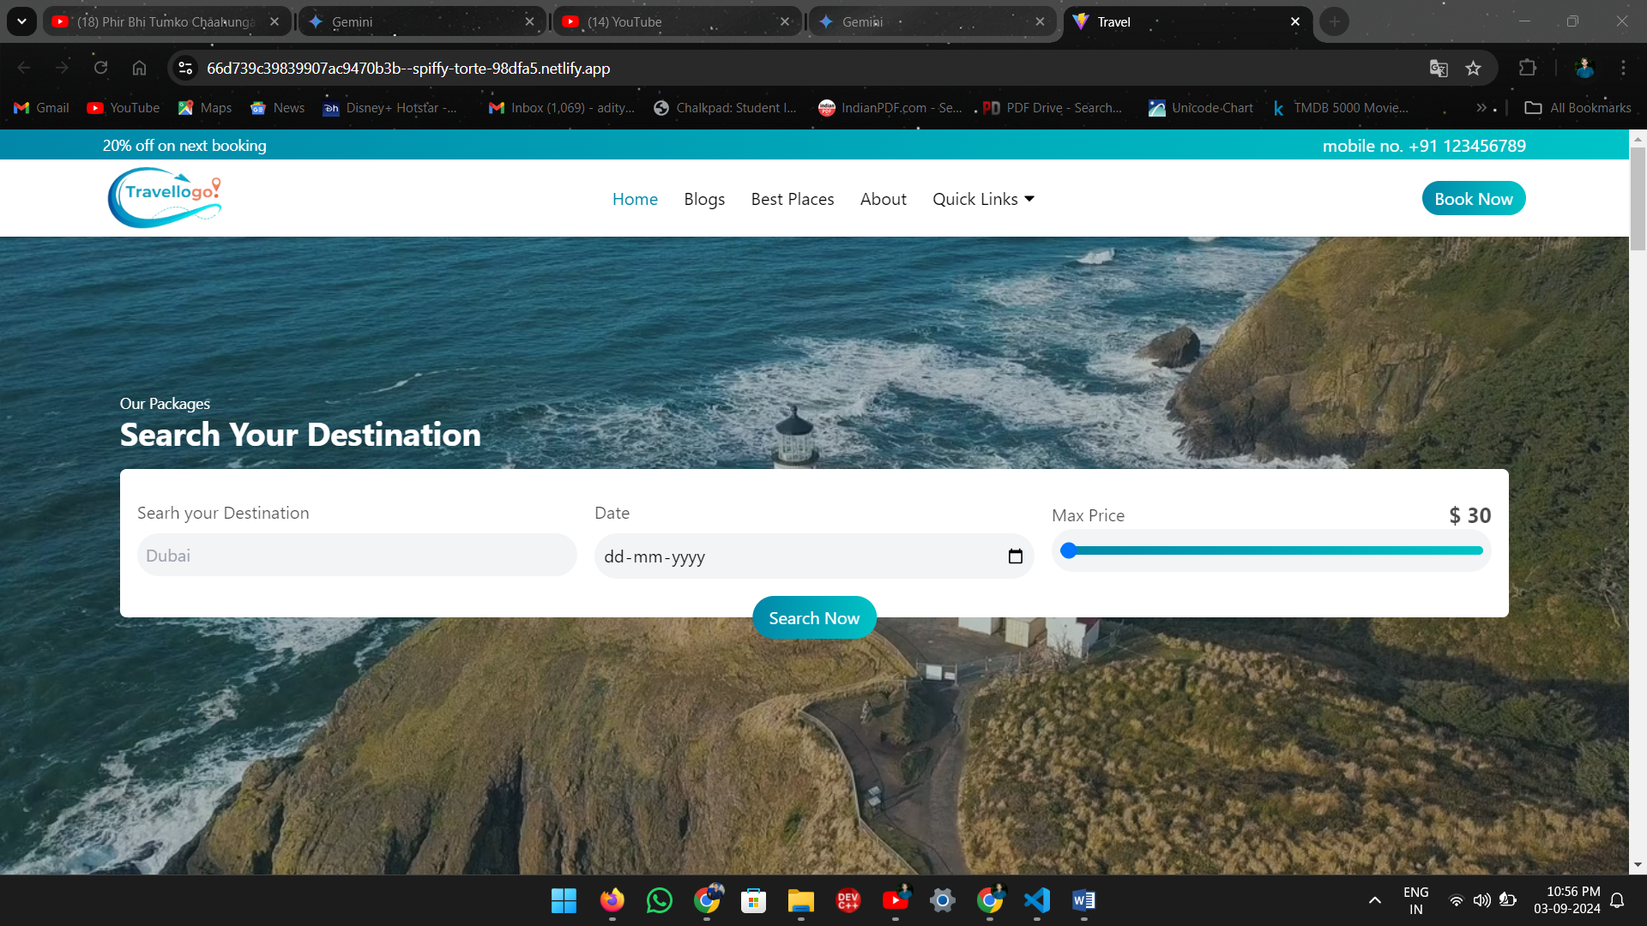

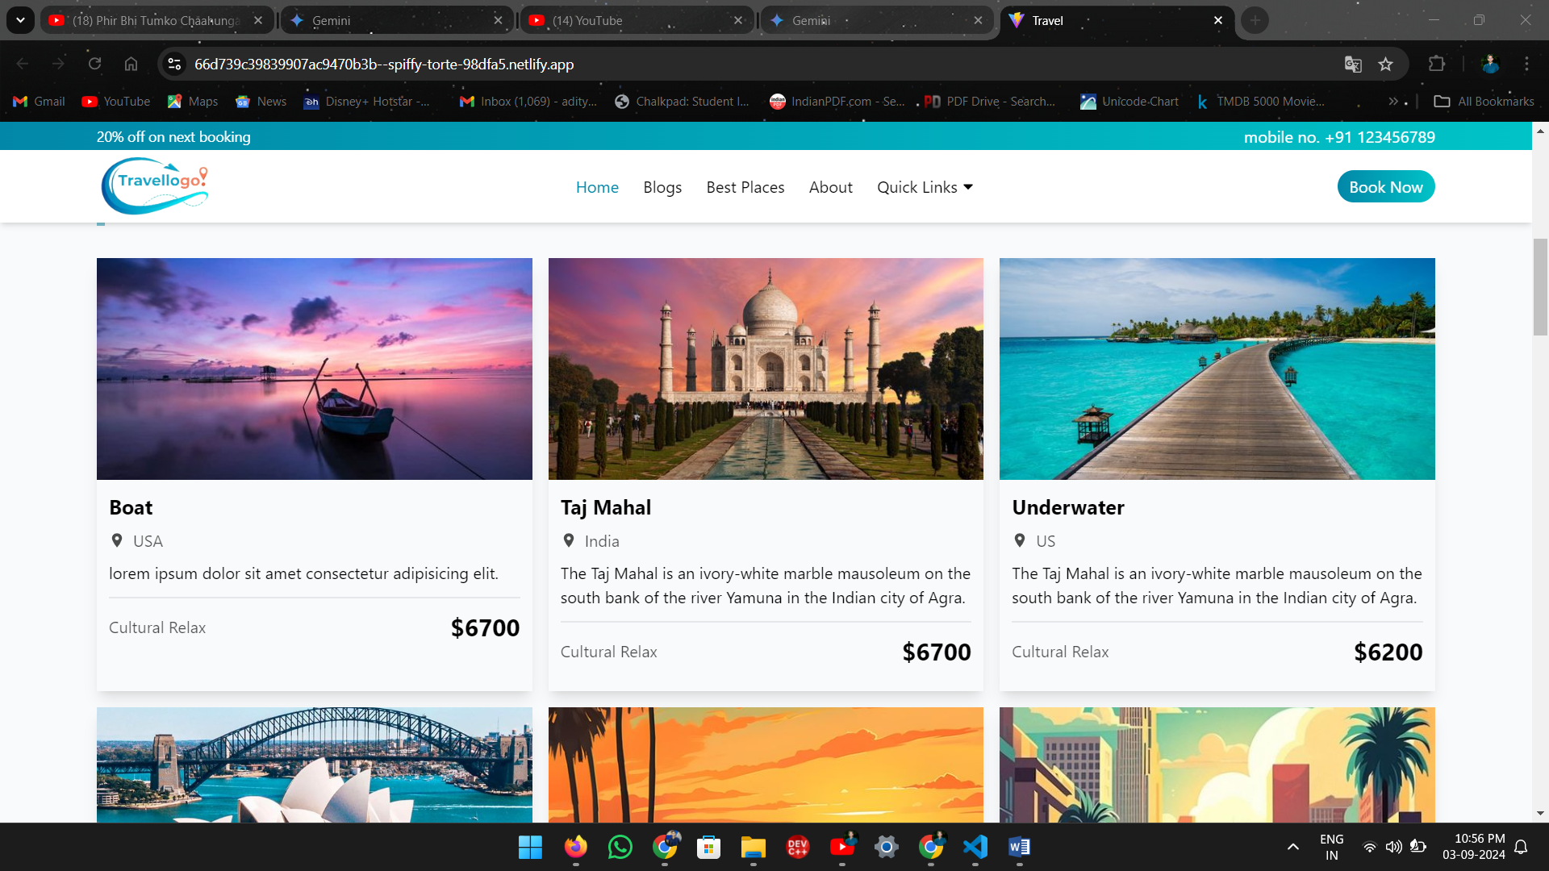

# Future Enhancements

The tour and travel website can be further enhanced by incorporating features such as virtual reality experiences, augmented reality integration, social media integration, community forums, gamification elements, improved personalization, offline functionality, a sustainability focus, AI-powered chatbots, and integration with travel management companies. These enhancements will provide a more engaging, personalized, and informative experience for users, while also staying competitive in the rapidly evolving travel industry.

# Conclusion

The tour and travel website, built using React, JavaScript, Tailwind CSS, and Vite, provides a comprehensive platform for users to plan and book their trips. By offering features such as destination search, trip planning tools, accommodation booking, flight and transportation options, activity and experience booking, user reviews and ratings, and personalized recommendations, the website aims to streamline the travel planning process and enhance the overall travel experience.

**Key Achievements:**

* **User-Friendly Interface:** The website's intuitive design and clear navigation make it easy for users to find the information they need.
* **Comprehensive Features:** The website offers a wide range of features to cater to different travel needs and preferences.
* **Personalized Experience:** The website's personalized recommendations and tailored suggestions provide a more customized experience for users.
* **Efficient Booking Process:** The website's booking platform simplifies the process of reserving flights, accommodations, and activities.
* **Informative Content:** The website provides valuable information on destinations, activities, and travel tips.

**Future Directions:**

While the website has achieved significant success, there is always room for improvement. Future enhancements could include integrating virtual reality and augmented reality experiences, expanding the range of destinations and activities offered, improving the personalization algorithms, and focusing on sustainability initiatives.

By continuously evolving and adapting to the changing needs of travelers, the tour and travel website can maintain its position as a leading platform in the industry.