WEEK 4 TASK

Predictive Modeling and Optimization
in Logistics Systems
Delivery-Time Forecasting Using Python and Machine Learning

Submitted by | Details
Name | Aditya Sharma
Program | B.Sc. Biotechnology, 3rd Year
Institution | Acropolis Institute of Management Studies and Research, Indore
University | Devi Ahilya Vishwavidyalaya (DAVV)
Task | Week 4 – Predictive Modeling and Optimization in Logistics Systems

1. Introduction
Predictive modeling allows logistics teams to estimate future operational outcomes before a shipment is completed. Accurate delivery-time forecasts can support route selection, customer communication, resource allocation, scheduling, and cost control. This report develops and evaluates machine-learning models for predicting shipment delivery time and then translates the model insights into practical optimization strategies.

2. Problem Definition
The prediction problem is to estimate Delivery_Time_days for an individual shipment using information available about its distance, shipment volume, traffic conditions, number of stops, transport mode, weather, priority level, and transportation cost. Delivery time is treated as a continuous target, making this a supervised regression problem.

3. Dataset and Variables
A hypothetical dataset of 320 shipment records was generated for educational analysis. It represents varied operating conditions and contains both numerical and categorical predictors.
Variable | Role | Description
Distance_km | Feature | Total route distance.
Shipment_Volume | Feature | Quantity/volume carried.
Traffic_Index | Feature | Simulated traffic intensity from 1 to 10.
Number_of_Stops | Feature | Stops made during shipment.
Transport_Mode | Feature | Road, Rail, or Air.
Weather | Feature | Clear, Rain, or Fog.
Priority | Feature | Standard or Express.
Transportation_Cost | Feature | Simulated transportation expense.
Delivery_Time_days | Target | Delivery duration to be predicted.

4. Data Preparation
Categorical variables are converted through one-hot encoding, while numerical variables are passed directly to the models. The dataset is divided into 80% training data and 20% testing data. The test set is held out so that model performance can be evaluated on observations not used during training.
X = df.drop(columns="Delivery_Time_days")
y = df["Delivery_Time_days"]
categorical = ["Transport_Mode", "Weather", "Priority"]
preprocessor = ColumnTransformer(
[("cat", OneHotEncoder(handle_unknown="ignore"), categorical)],
remainder="passthrough"
)
X_train, X_test, y_train, y_test = train_test_split(
X, y, test_size=0.20, random_state=42
)

5. Model Selection and Rationale

5.1 Linear Regression
Linear Regression is used as an interpretable baseline. It estimates a linear relationship between the predictors and delivery time and provides a useful benchmark for judging whether a more flexible model adds value.

5.2 Random Forest Regressor
Random Forest is an ensemble of decision trees. It can capture nonlinear relationships and interactions, such as changes in delivery time caused by combinations of distance, traffic, weather, and transport mode. It is therefore appropriate for a logistics problem in which relationships may not be purely linear.
linear_model = Pipeline([
("prep", preprocessor),
("model", LinearRegression())
])
rf_model = Pipeline([
("prep", preprocessor),
("model", RandomForestRegressor(
n_estimators=180,
max_depth=10,
random_state=42
))
])
linear_model.fit(X_train, y_train)
rf_model.fit(X_train, y_train)

6. Evaluation Metrics
- Mean Absolute Error (MAE): average absolute difference between actual and predicted delivery times; easy to interpret in days.
- Root Mean Squared Error (RMSE): penalizes larger prediction errors more strongly and is useful when large forecasting mistakes are operationally costly.
- R-squared (R²): describes the proportion of target variability explained by the model; higher values indicate stronger explanatory performance on the evaluated data.
Model | MAE (days) | RMSE (days) | R²
Linear Regression | 0.398 | 0.487 | 0.885
Random Forest | 0.556 | 0.718 | 0.750

For the Random Forest model, five-fold cross-validation produced a mean RMSE of approximately 0.763 days. Cross-validation provides a more stable assessment by repeatedly training and validating the model on different subsets of the data.

7. Validation and Hyperparameter Tuning
K-fold cross-validation can be combined with GridSearchCV to compare alternative model settings. For Random Forest, useful parameters include the number of trees, maximum tree depth, and minimum samples required to split a node.
param_grid = {
"model__n_estimators": [100, 180, 250],
"model__max_depth": [6, 10, None],
"model__min_samples_split": [2, 5]
}
grid = GridSearchCV(
rf_model,
param_grid,
cv=5,
scoring="neg_root_mean_squared_error"
)
grid.fit(X_train, y_train)
print(grid.best_params_)
print(-grid.best_score_)

8. Model Performance Visualizations
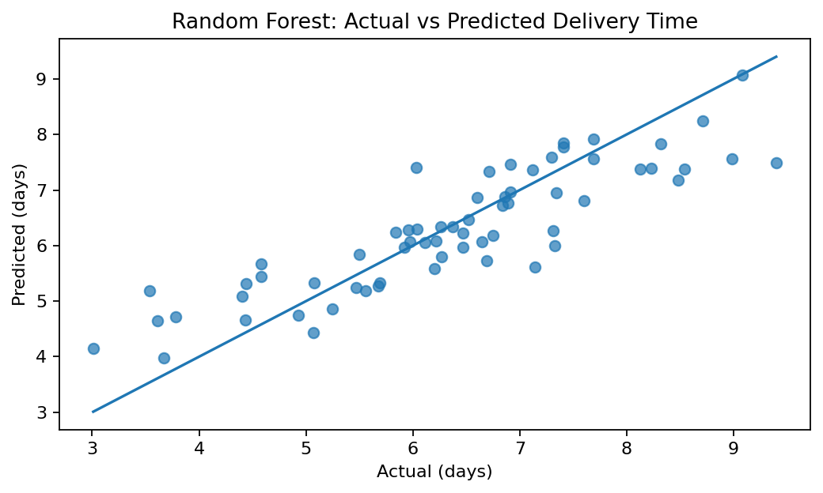
Figure 1. Actual versus predicted delivery time for the Random Forest model.
Points close to the diagonal indicate accurate predictions. Large vertical departures from the diagonal represent larger forecasting errors. This plot gives an intuitive view of how closely predictions follow observed delivery times.
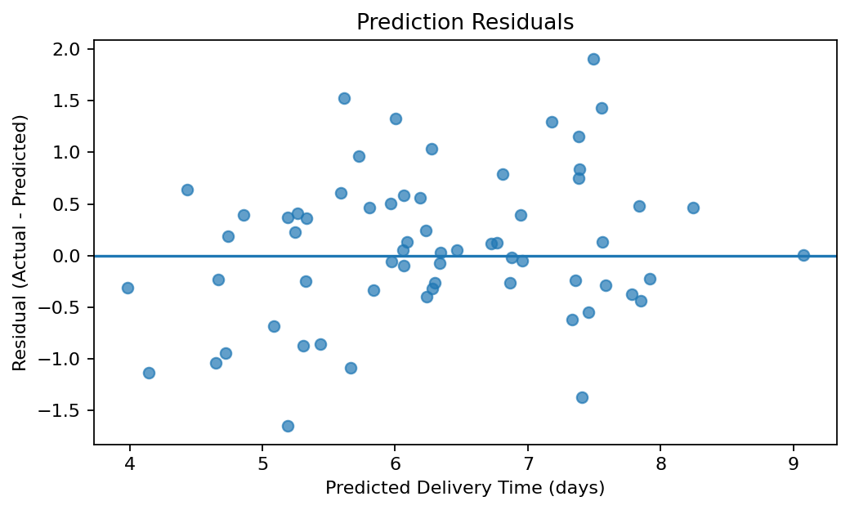
Figure 2. Residual plot for Random Forest predictions.
Residuals represent actual minus predicted delivery time. A reasonably balanced spread around zero suggests that the model is not consistently overpredicting or underpredicting across the fitted range.

9. Model Insights
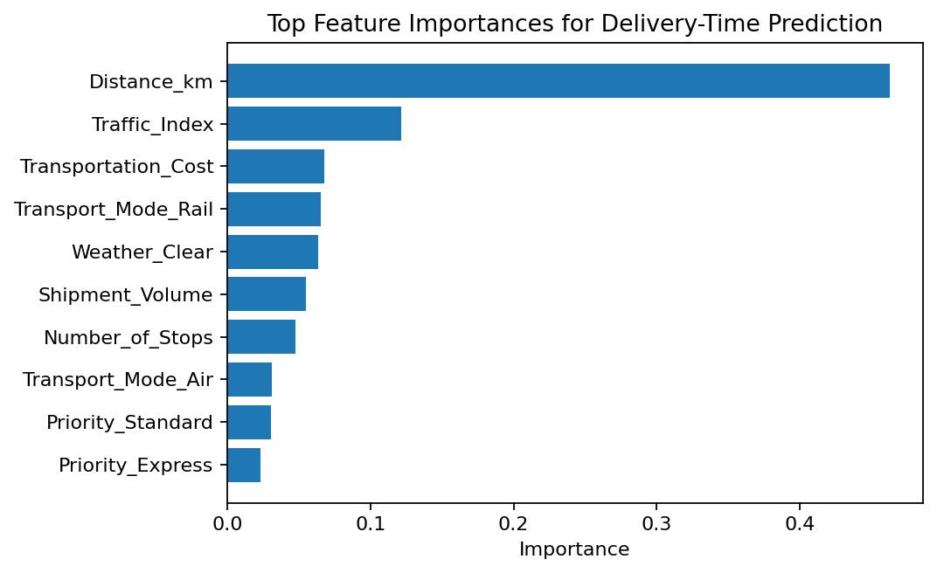
Figure 3. Top feature importances from the Random Forest model.
Feature importance helps identify variables that contribute strongly to the Random Forest's predictions. These values should be interpreted as model-based importance rather than proof of causation. Operational decisions should combine these insights with domain knowledge and real-world validation.

10. Optimization Strategies
Predicted delivery time becomes operationally useful when it is connected to decisions. The following strategies can use model outputs to improve logistics performance:
- Route planning: compare predicted delivery times for feasible routes and prioritize alternatives that meet service requirements while avoiding high traffic or excessive stops.
- Resource allocation: assign additional vehicles, drivers, or loading resources to shipments predicted to experience longer delivery times.
- Mode selection: evaluate road, rail, and air options by combining predicted delivery time with cost and shipment priority.
- Stop consolidation: reduce unnecessary intermediate stops where the model indicates that additional stops increase expected delivery time.
- Delay-risk alerts: flag shipments with high predicted delivery time for proactive customer communication and operational review.
- Cost minimization: optimize decisions using both predicted time and transportation cost rather than minimizing either metric in isolation.

11. Example Prediction-Based Optimization Logic
def shipment_action(predicted_days, priority, cost):
if priority == "Express" and predicted_days > 4:
return "Review faster mode or alternate route"
elif predicted_days > 6:
return "Allocate additional resources and monitor"
elif cost > 9000:
return "Review route/mode for cost reduction"
return "Proceed with planned operation"
prediction = rf_model.predict(new_shipment)[0]
action = shipment_action(prediction, "Express", 8500)
In a real logistics system, optimization would use business constraints such as vehicle capacity, delivery windows, driver hours, route availability, and service-level agreements. Mathematical optimization methods such as linear programming, vehicle-routing algorithms, or multi-objective optimization could then be combined with the predictive model.

12. Complete Modeling Workflow
import pandas as pd
from sklearn.model_selection import train_test_split, cross_val_score
from sklearn.preprocessing import OneHotEncoder
from sklearn.compose import ColumnTransformer
from sklearn.pipeline import Pipeline
from sklearn.ensemble import RandomForestRegressor
from sklearn.metrics import mean_absolute_error, mean_squared_error, r2_score
df = pd.read_csv("week4_logistics_modeling_dataset.csv")
X = df.drop(columns="Delivery_Time_days")
y = df["Delivery_Time_days"]
categorical = ["Transport_Mode", "Weather", "Priority"]
preprocessor = ColumnTransformer(
[("cat", OneHotEncoder(handle_unknown="ignore"), categorical)],
remainder="passthrough"
)
X_train, X_test, y_train, y_test = train_test_split(
X, y, test_size=0.20, random_state=42
)
model = Pipeline([
("prep", preprocessor),
("model", RandomForestRegressor(
n_estimators=180,
max_depth=10,
random_state=42
))
])
model.fit(X_train, y_train)
pred = model.predict(X_test)
mae = mean_absolute_error(y_test, pred)
rmse = mean_squared_error(y_test, pred) ** 0.5
r2 = r2_score(y_test, pred)
cv_rmse = -cross_val_score(
model, X, y, cv=5,
scoring="neg_root_mean_squared_error"
).mean()
print("MAE:", mae)
print("RMSE:", rmse)
print("R2:", r2)
print("5-fold CV RMSE:", cv_rmse)

13. Recommendations
- Use predicted delivery time as an early-warning indicator rather than as a guaranteed arrival time.
- Retrain the model periodically when route patterns, traffic conditions, pricing, or operational policies change.
- Collect richer real-world features such as departure time, GPS traffic, weather forecasts, vehicle type, loading time, and historical route delays.
- Monitor model performance over time using MAE and RMSE to detect model drift.
- Combine predictive analytics with constrained route and resource optimization for greater operational value.
- Validate optimization recommendations with dispatch managers before automated deployment.

14. Limitations
The dataset in this assignment is simulated, so the reported metrics demonstrate methodology rather than real company performance. A model trained on real logistics data may behave differently because of missing records, changing traffic patterns, seasonal demand, unusual disruptions, and business-specific constraints. Feature importance is also not causal evidence. Real deployment would require stronger validation, monitoring, and operational testing.

15. Conclusion
This report developed a supervised regression workflow for predicting shipment delivery time and demonstrated how model outputs can support logistics optimization. Linear Regression provided a baseline, while Random Forest offered a flexible ensemble approach for capturing nonlinear operational relationships. MAE, RMSE, R², hold-out testing, and five-fold cross-validation were used to evaluate performance. The predictive insights were then connected to route planning, mode selection, resource allocation, delay-risk management, and cost control. The exercise demonstrates how predictive modeling and optimization can work together to support data-driven logistics operations.

16. References
- McKinney, W. Python for Data Analysis. O'Reilly Media.
- scikit-learn Developers. Documentation for model selection, preprocessing, regression, ensemble models, and evaluation metrics.
- pandas Development Team. pandas documentation.
- Matplotlib Development Team. Matplotlib documentation.
- The dataset used in this report is hypothetical and was generated for educational demonstration.

