SeattleStay AI – Project Milestone Report
Executive Summary
SeattleStay AI analyzes more than half a million Airbnb guest reviews from Seattle to uncover what truly shapes guest satisfaction. The goal was to convert unstructured text data into clear insights for hosts, guests, and Airbnb management.
The project built and compared several topic modeling techniques, Latent Semantic Analysis (LSA), Latent Dirichlet Allocation (LDA), Non-Negative Matrix Factorization (NMF), and BERTopic to extract key experience themes from aggregated listing reviews.
In addition, a sentiment analysis layer was implemented using VADER to evaluate emotional tone, and a recommendation engine was developed to group listings based on shared themes and positive sentiment.
The analysis revealed that cleanliness, comfort, scenic views, and host communication dominate positive experiences, while location convenience and family-friendly amenities are consistent satisfaction drivers.

1. Data Exploration and Problem Statement
Problem Statement:
Airbnb hosts and managers receive vast amounts of textual feedback that are difficult to interpret at scale. The challenge was to automatically uncover the dominant topics in reviews and connect them to guest sentiment, helping Airbnb identify areas of improvement and competitive advantage.
Data Dictionary
The Seattle Airbnb dataset contains both review-level data and listing-level property details. Below is a concise data dictionary summarizing the key variables used in cleaning, aggregation, topic modeling, sentiment analysis, and recommendation generation.
Review Dataset Columns
Column | Meaning
listing_id | Unique identifier for each Airbnb property. Used to group all reviews belonging to the same listing.
id | Unique review identifier.
date | Date on which the review was posted by the guest.
reviewer_id | Unique identifier of the reviewer.
reviewer_name | Name of the guest who wrote the review.
comments | Raw text of the review, containing detailed guest feedback.
comments_clean | Preprocessed text after lowercasing, punctuation removal, and normalization.
tokens / tokens_lemmatized | Tokenized and lemmatized word lists used for NLP modeling.
review_len | Word count used for outlier detection (short or overly long reviews).
listing_id | Unique listing identifier used for joining with review data.
bedrooms | Number of bedrooms available in the property.
bathrooms | Number of bathrooms.
name / description / neighbourhood_overview | Text features describing the listing (not used for modeling but helpful for interpretation).

Data Overview:
- Reviews dataset: 541,092 entries and 6 columns (listing ID, reviewer details, comments, etc.)
- Listings dataset: 6,862 records and 79 attributes (property details, host data, price, etc.)
- Key text column: comments (guest reviews)
- Key numerical column: review_scores_rating (used later for correlation and comparison)
📊 sample dataframe head showing columns and first few reviews.
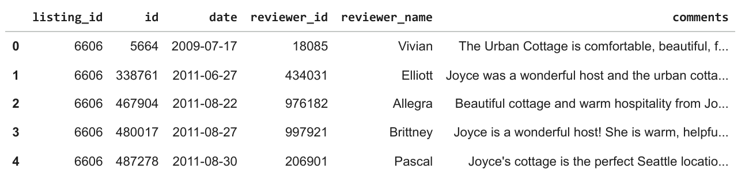

2. Data Cleaning and Preprocessing
Handling Missing Values
- 87 reviews had missing comments and were removed.
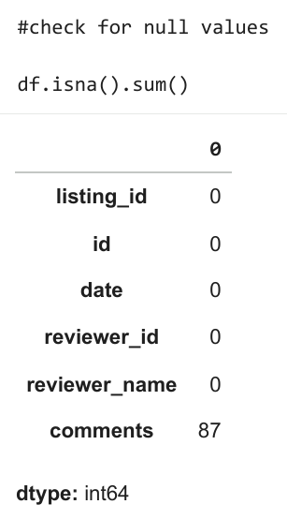
- Columns like neighbourhood_overview and host_about had partial missing values but were not essential for topic modeling.
Outlier Detection
- Word counts were calculated for each review.
- Using the IQR method, extremely short and long reviews were identified as outliers.
- Lower fence: –46; Upper fence: 122 tokens. About 27,500 outlier reviews were found.
📈 Boxplot on “Outlier Detection — Review Lengths”.
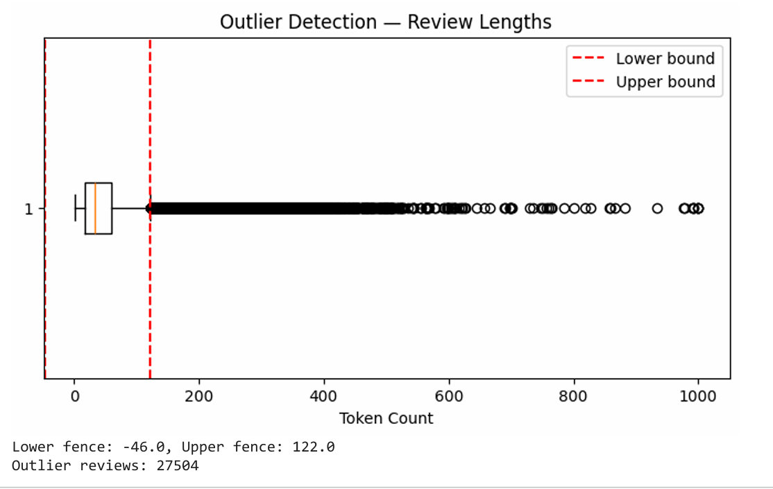
Transformations
- Reviews were converted to lowercase, punctuation and numbers removed.
- Tokenization and stopword removal were applied using NLTK.
- Custom stopwords were added to exclude overly common or city-specific words such as “Seattle,” “stay,” and “great.”
- Lemmatization reduced words to their base forms (e.g., “hosts,” “hosting,” → “host”).
- Very short reviews (fewer than 20 characters) were filtered out, leaving 521,447 meaningful entries.
🧩 Tokenization output table showing tokens and lemmatized tokens.
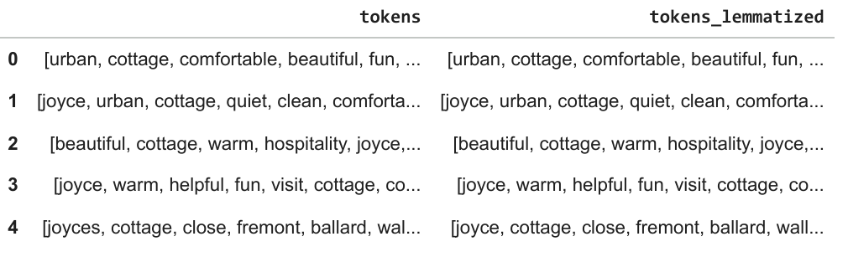

3. Exploratory Analysis
A word frequency analysis revealed the most common terms across all reviews.
- Frequent words included clean, comfortable, easy, quiet, close, and beautiful.
- These indicate that cleanliness and convenience dominate guest priorities.
☁️ Word cloud and bar chart of “Top 20 Most Frequent Words.”
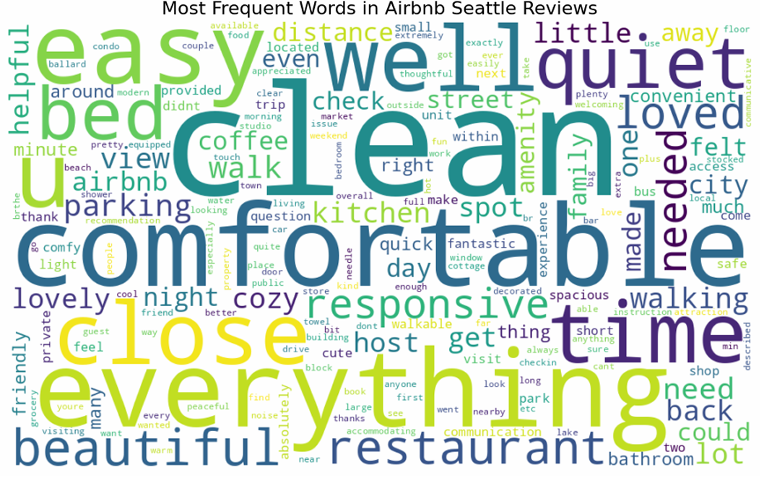
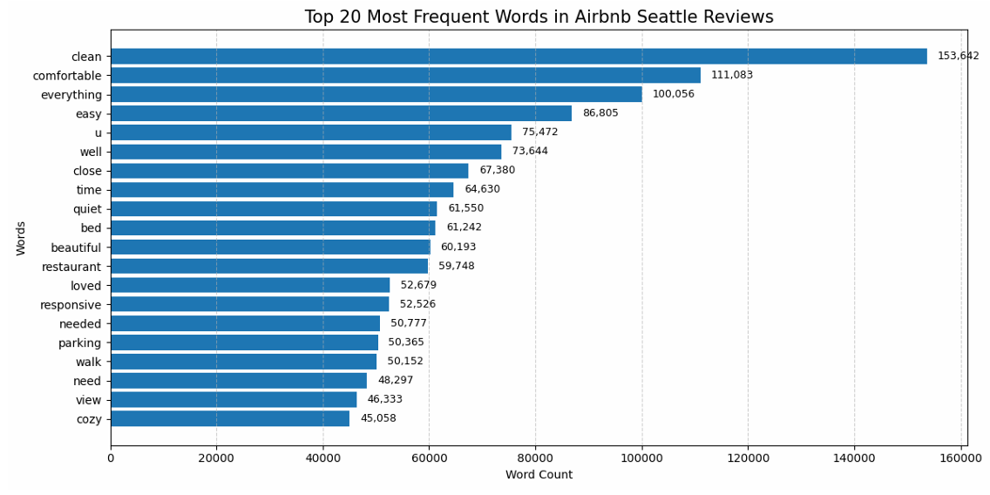

4. Modeling Approach and Feature Preparation
4.1 Aggregation
All reviews were grouped by listing_id so each property had a single aggregated review text.
This allowed modeling at a listing level rather than individual reviews, which reduces noise and captures overall guest perception per property.
Why Bedrooms and Bathrooms Were Included After Aggregation
When reviews were aggregated at the listing level, property attributes such as bedrooms and bathrooms were merged into the consolidated dataset. This was done intentionally for three reasons:
1. Structural Attributes Influence Guest Expectations
The number of bedrooms and bathrooms defines the type of listing — studio vs. entire home, family unit vs. shared accommodation.
These structural features help contextualize review themes.
For example:
- Listings with 3+ bedrooms often contain topics related to family stays, spaciousness, group comfort.
- Listings with multiple bathrooms commonly show themes like convenience, privacy, ease of getting ready.
2. Enables Richer Insights for Hosts and Platforms
By retaining these variables alongside topic distributions and sentiment:
- Airbnb can identify whether certain property types consistently receive particular experiences (e.g., “cleanliness issues” in large shared homes).
- Hosts can benchmark against similar-sized listings, not just any listing.
3. Useful for Future Modeling Enhancements
Although topic modeling itself uses only text, future extensions such as:
- Price recommendation
- Quality scoring
- Experience segmentation
…can incorporate bedrooms/bathrooms as predictive or grouping variables.
Thus, including them early ensures downstream compatibility and richer interpretation.

4.2 Text Vectorization
Two main representations were used:
- TF-IDF (term importance)
- Bag-of-Words (BoW) (term frequency)
After filtering rare and overly common words, 22 k–25 k unique terms were retained.

5. Topic Modeling and Results
A. Latent Semantic Analysis (LSA)
Purpose: Identify general latent concepts in the text.
Optimal Topics: 5
Findings:
- Topic 1 – Cleanliness and comfort
- Topic 2 – Family stays and neighborhood value
- Topic 3 – Scenic city views
- Topic 4 – Beachside and Alki area stays
- Topic 5 – Responsive and friendly hosts
📊 LSA bar charts of “Top words per LSA topic” and PCA topic distance scatter.
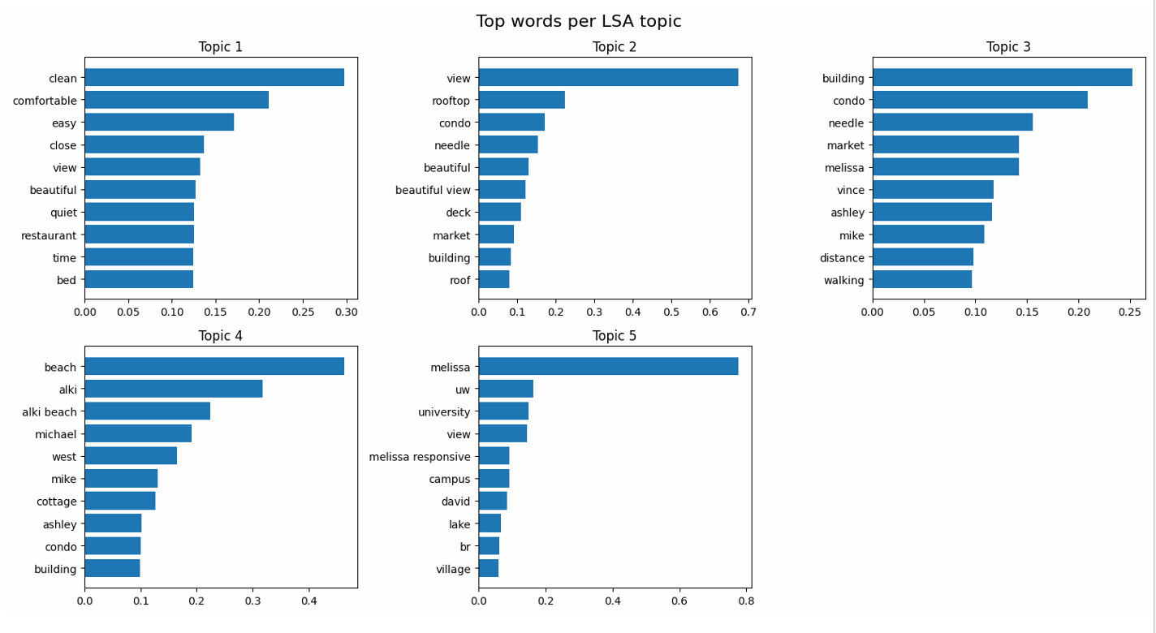
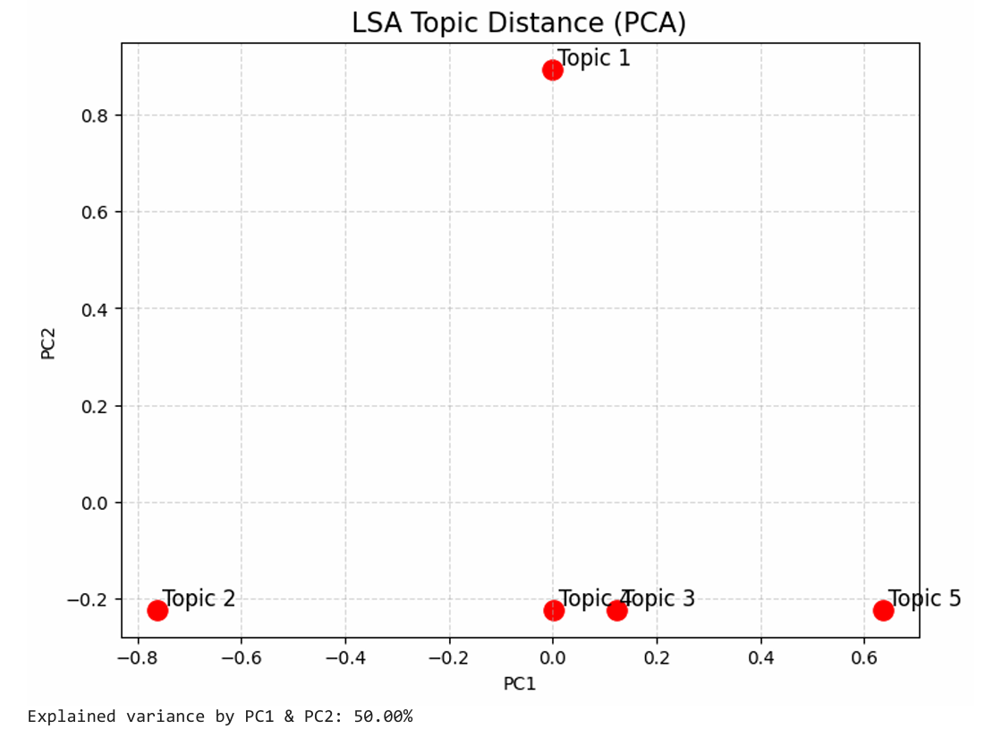
Interpretation:
Guests consistently appreciate cleanliness, peaceful neighborhoods, and proximity to landmarks such as the Space Needle or Alki Beach.

B. Latent Dirichlet Allocation (LDA)
Purpose: Generate interpretable probabilistic topics.
Optimal k = 5, determined by lowest perplexity (see validation plot on page 20).
Key Themes:
- Scenic downtown attractions
- Walkable, convenient city stays
- Cozy homes and friendly hosts
- Beachside or quiet local charm
- Family/group accommodations
📈 Bar chart “Dominant Topic Distribution (Listings)” and word clouds.
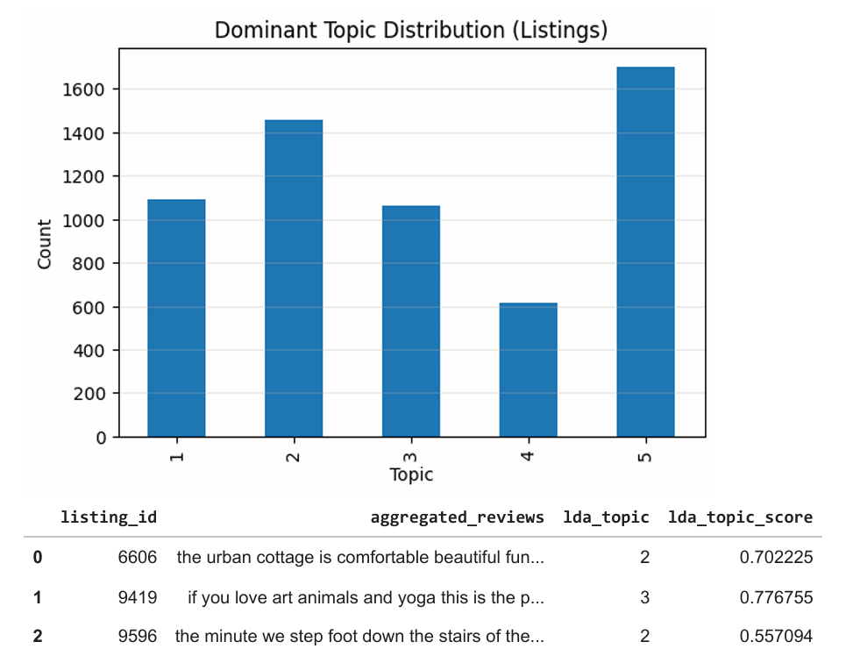
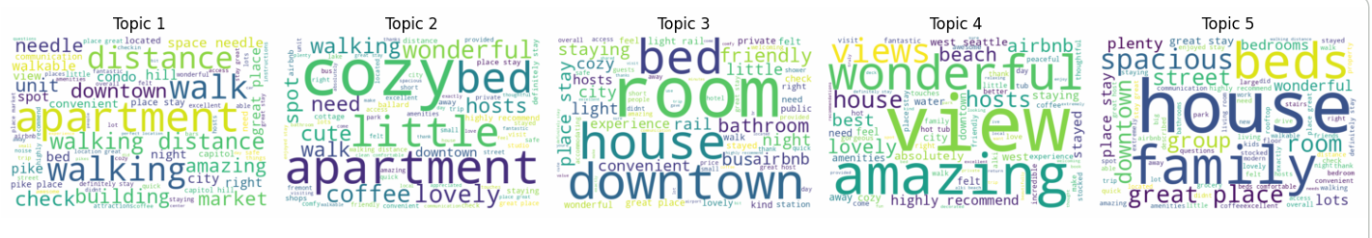
Insight:
Downtown access and family-oriented spaces dominate guest experiences, confirming Airbnb’s appeal to both tourists and group travelers.

C. Non-Negative Matrix Factorization (NMF)
Purpose: Capture more distinct, less-overlapping topics.
Main Themes:
- Comfortable homes and clean spaces
- Rooftop and scenic views
- Apartments near restaurants and markets
- University-district rentals
- Family/group stays
Include:
📊 NMF word clouds (page 27–31) and topic distribution chart (page 31).
Interpretation:
Guests value a mix of convenience, family comfort, and unique property features such as rooftop access or lake proximity.

D. BERTopic
Purpose: Use transformer embeddings for contextual and fine-grained theme detection.
Distinct Topics (after reduction to 15):
- Cleanliness & Host Responsiveness
- Easy Stay & Convenient Basics
- Family-Friendly Stay
- Rooftop / View / Deck Experience
- Pet-Friendly Stay
- Lake & Greenlake Views
- Quiet Stay + Parking Convenience
- Ballard Neighborhood Experience
- Cozy Cottage Experience
📊 “Top words per BERT topic” multi-panel chart and Intertopic Distance Map.
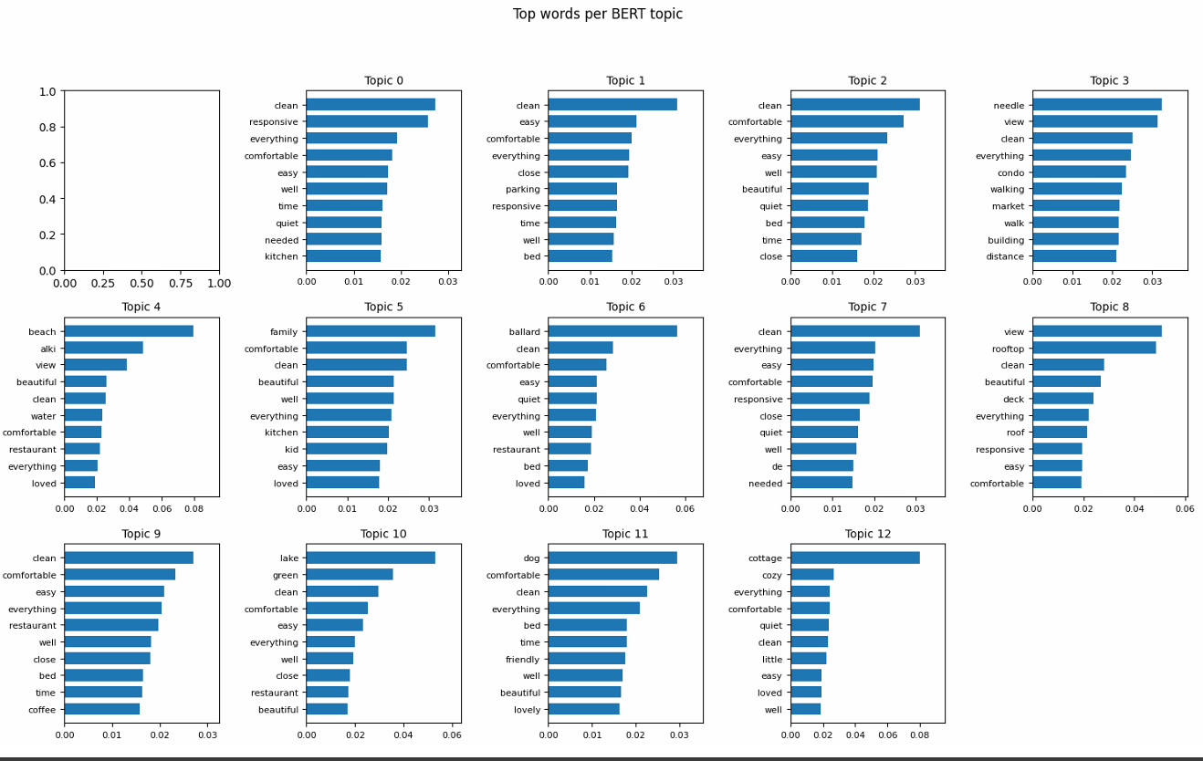
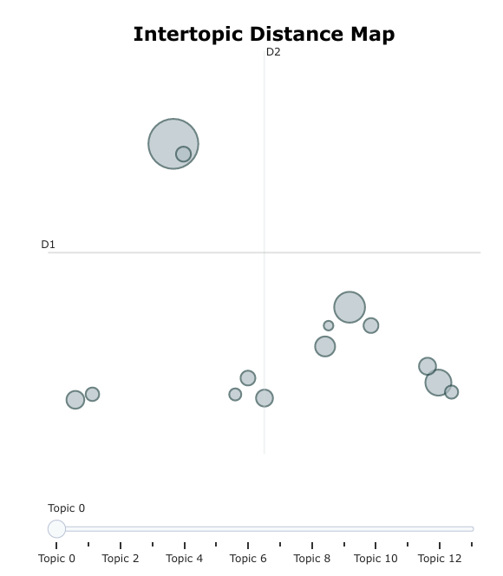
Interpretation:
BERTopic produced the most coherent, human-readable themes and clearly grouped listings by experience type — forming the foundation for the recommendation system.

6. Sentiment Analysis
Using VADER, compound scores were assigned to each aggregated listing review:
- 97% Positive, 1.3% Neutral, 1% Negative.
- Average compound score: 0.94.
- Sentiments were then linked with BERTopic labels to assess which experiences evoke the most positivity.
📊 Overall Sentiment Distribution bar chart and table of mean sentiment by BERT theme.
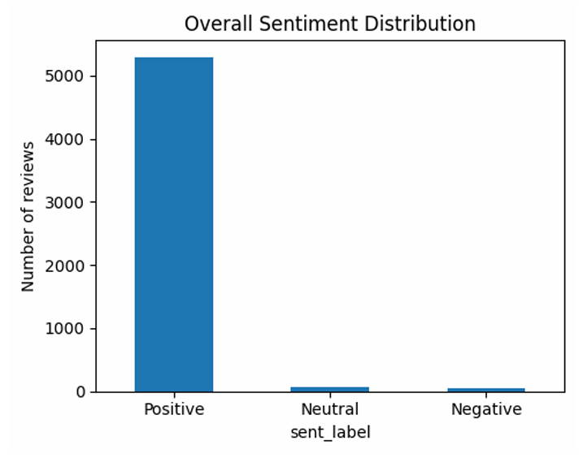
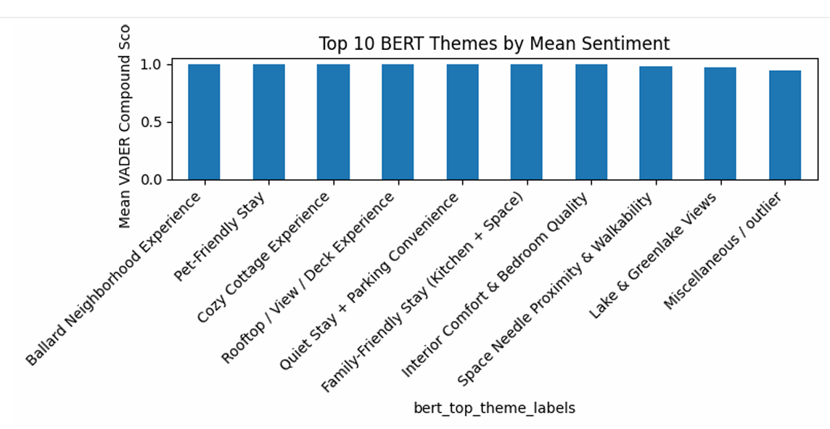
Insights:
- “Ballard Neighborhood Experience,” “Pet-Friendly Stay,” and “Cozy Cottage Experience” recorded the highest positive sentiment (mean ≈ 0.999).
- “Cleanliness & Host Responsiveness” had lower sentiment (0.78), suggesting that issues with consistency in these areas still occur.

7. Recommendation System
7.1 Overview
The final stage combined topic probabilities (from BERTopic) and sentiment features into a single feature vector per listing.
Using cosine similarity, the system identifies listings with the most similar guest-experience profiles.
When a user selects or views a listing:
- The model retrieves the closest listings with matching topics and high sentiment scores.
- For example, a listing labeled “Cozy Cottage Experience” might recommend other properties with similar tone and comfort themes.

7.2. Recommendation Method i: Listing-to-Listing Similarity

Objective
Recommend listings that share highly similar guest-experience themes with a selected listing.
How It Works
- User selects a listing ID.
- Model retrieves that listing’s BERTopic theme vector + sentiment score.
- Computes cosine similarity with every other listing.
- Removes the selected listing from the results.
- Returns Top-N most similar listings based purely on experience similarity.
What This Reveals
- Which listings “feel the same” according to guest reviews.
- Explanations come from topic alignment (e.g., quiet area, scenic views, cleanliness, responsiveness).
- Sentiment is shown for context but not used as a filter in this method.
Example
For listing 254340, the system may recommend:
- Other quiet, walkable, clean rentals
- With similar comfort and host responsiveness characteristics
This method helps guests explore experience-equivalent alternatives.
7.3. Recommendation Method ii: Search-by-Experience (Text-to-Listing Match)
Objective
Allow users to search using natural sentences describing the experience they want — not by filters.
Example Input Query:
“quiet, safe neighborhood near metro, very clean place”
How It Works
- User enters free-text description.
- Text is converted into a topic probability vector using BERTopic’s embedding pipeline.
- This becomes the preference vector.
- Cosine similarity is computed between the preference vector and all listing vectors.
- Top-matching listings are returned with their sentiment.
What It Reveals
- Which listings best match a user’s described ideal stay.
- AI converts unstructured text into structured theme probabilities.
- This avoids rigid filter-based search and enables experience-based searching.
Example Output Insight
For the above query, top matches emphasize:
- Cleanliness
- Safety
- Peaceful environment
- Convenience
Impact
- Makes search intuitive and human-friendly.
- Reduces reliance on dozens of manual filters.
- The system understands meaning, not just keywords.
7.4. Recommendation Method iii: Positive-Filtered Similar Listings
Objective
Provide similarity-based recommendations only from listings with strong positive sentiment — ideal for users who want high-quality, low-risk options.
How It Works
- Compute similarity exactly as in Method 1.
- Apply sentiment threshold: compound > 0.2.
- Remove listings with neutral/negative sentiment.
- Return only quality-assured similar listings.
Example (Listing ID 254340)
Listing ID | Name | Sentiment
17787304 | Charming 1910 Craftsman | Positive
7922663 | Beautiful View RM#2 | Positive
6.28E+17 | Seward Park Retreat | Positive
25725786 | Old Apple Trees Guest House | Positive
20029802 | Latona Guest Suite | Positive
What This Reveals
- These listings share similar themes with the selected property.
- Positive sentiment ensures reliability and guest satisfaction.
Business Value
- Highlights trustworthy, consistent listings.
- Protects users from low-rated experiences.
- Improves platform credibility and conversion.
7.5. Comparative Summary of All Three Methods:
Method | Purpose | Best Use Case
Listing-to-Listing Similarity | Shows experience-based alternatives to a selected listing | When users want similar options
Search-by-Experience (Text → Listing) | Matches user-described experiences to listings | Free-text search, first-time users
Positive-Filtered Similar Listings | Suggests similar listings with proven positive sentiment | Quality-assurance, risk reduction
Together, these three methods form a holistic recommendation ecosystem, balancing:
- Personalization
- Experience-matching
- Quality filtering
This multi-view approach ensures richer, more reliable, and user-centric recommendations.
🧭 Explanation paragraph and diagram description (“Measuring Similarity Between Listings” section).
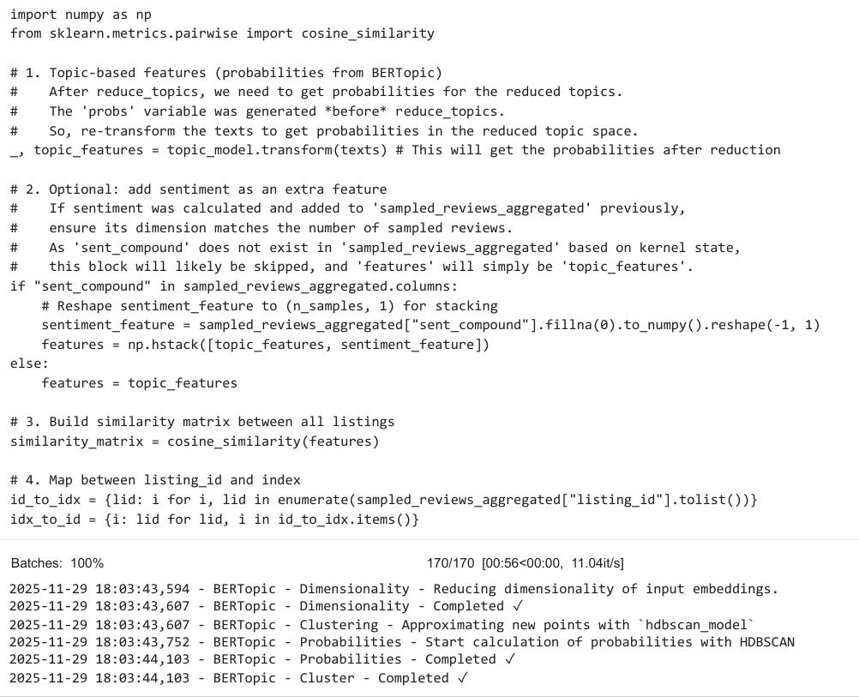
Practical use:
- Guests can discover listings offering similar experiences.
- Hosts can benchmark their properties against top-rated peers.
- Airbnb management can highlight or promote listings with consistently positive patterns.

8. Model Comparison and Evaluation
Model | Strengths | Weaknesses
LSA | Fast and interpretable | Overlaps topics, less coherent
LDA | Balanced interpretability | Sensitive to hyperparameters
NMF | Clearer topic separation | Slightly repetitive topics
BERTopic | Deep contextual meaning, strong clustering | Computationally heavy
Chosen Model: BERTopic, for its ability to capture nuanced context and support direct recommendation generation.
Proposed Improvements:
- Incorporate price and location coordinates to personalize recommendations further.
- Add user-driven feedback loops to refine topic clusters dynamically.
- Combine image metadata (e.g., “view,” “garden”) for multimodal insights.

9. Business Implications and Recommendations
For Airbnb Management
- Use topic clusters to benchmark city-level satisfaction trends (e.g., Ballard vs Downtown).
- Prioritize support for listings where guests express mixed sentiment on cleanliness or communication.
For Hosts
- Focus marketing text on the features guests discuss most (cleanliness, convenience, scenic views).
- Address recurring negative themes early to improve review quality and occupancy rate.
For Guests
- Use the recommendation system to identify listings that match desired experiences (relaxing, family-friendly, adventurous).

10. Generative AI Usage and References
GenAI Usage:
ChatGPT was used to:
- Draft report sections and summaries based on model outputs.
- Suggest code improvements for preprocessing and topic visualization.
- Assist in formatting and refining visual storytelling.
External References:
- scikit-learn documentation (TF-IDF, LDA, NMF modules)
- BERTopic official documentation (https://maartengr.github.io/BERTopic/)
- Airbnb Inside Data (Kaggle 2023)
- NLTK and VADER Sentiment libraries

