Programming Fundamentals of Analytics
CRN - 12794
Assignment one - MySQL
TOPIC: IG_CLONE_DATA
NAME: ADITYA SHROFF
COLLEGE ID: 101539669
DATE: 28/09/24

Q1. Store the 5 oldest users in a table

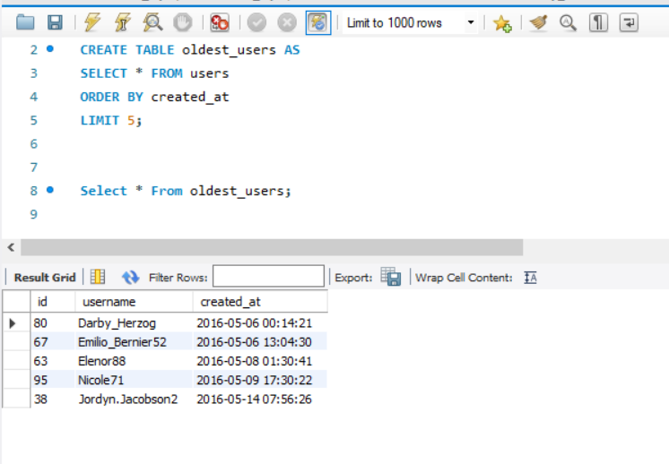

Q2. Store the two days with the most registrations
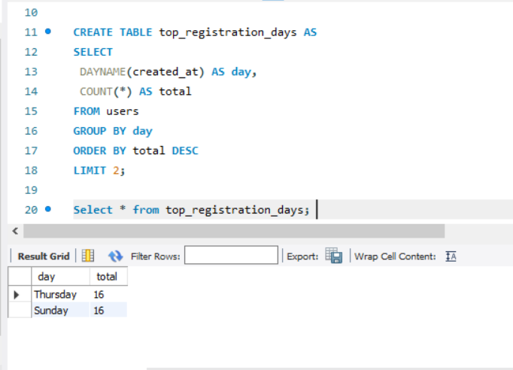

Q3 Store the usernames of users who have never uploaded a photo
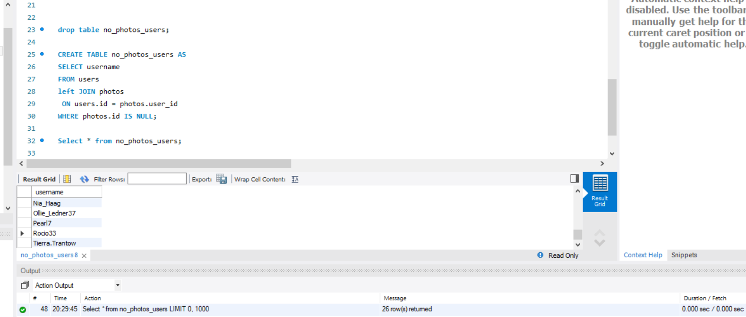

Q4. Store the photo with the highest number of likes
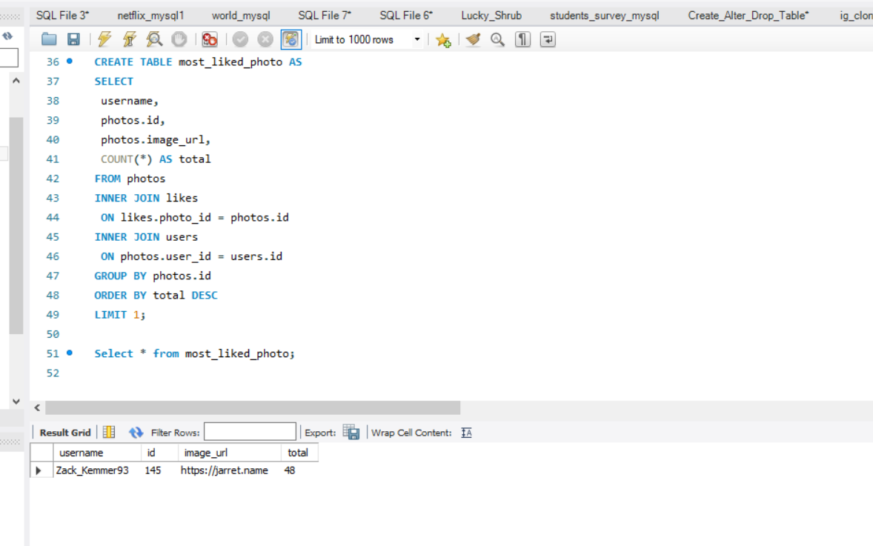

Q5. Store the average number of photos per user
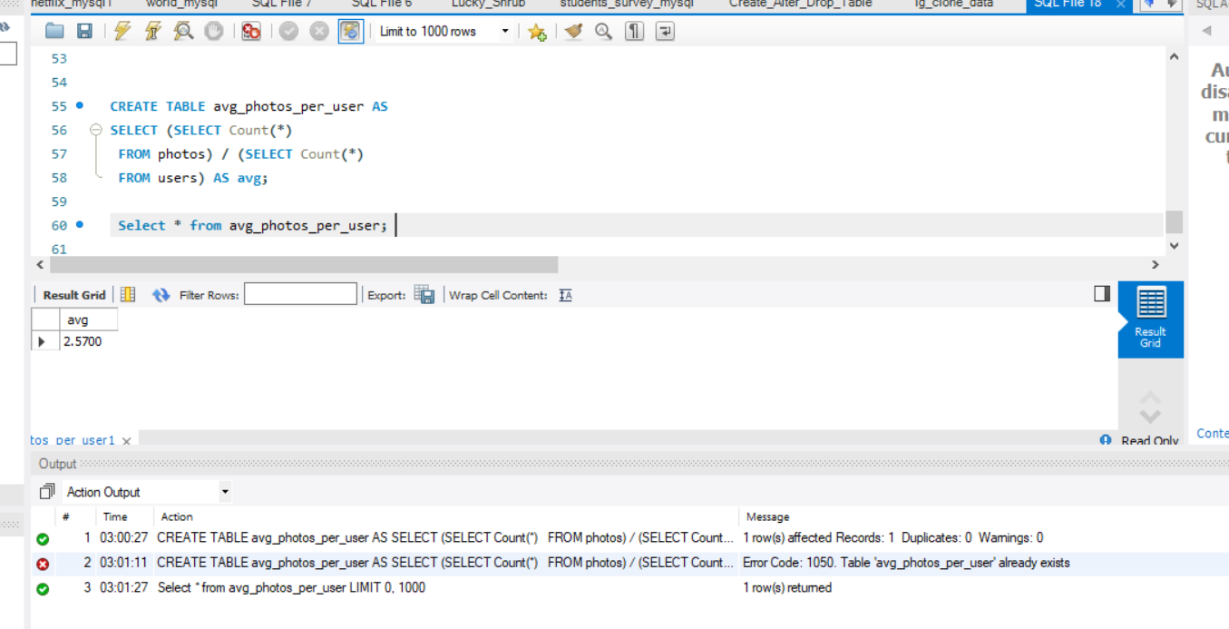

Q6. Store the top 5 most popular tags used in photos

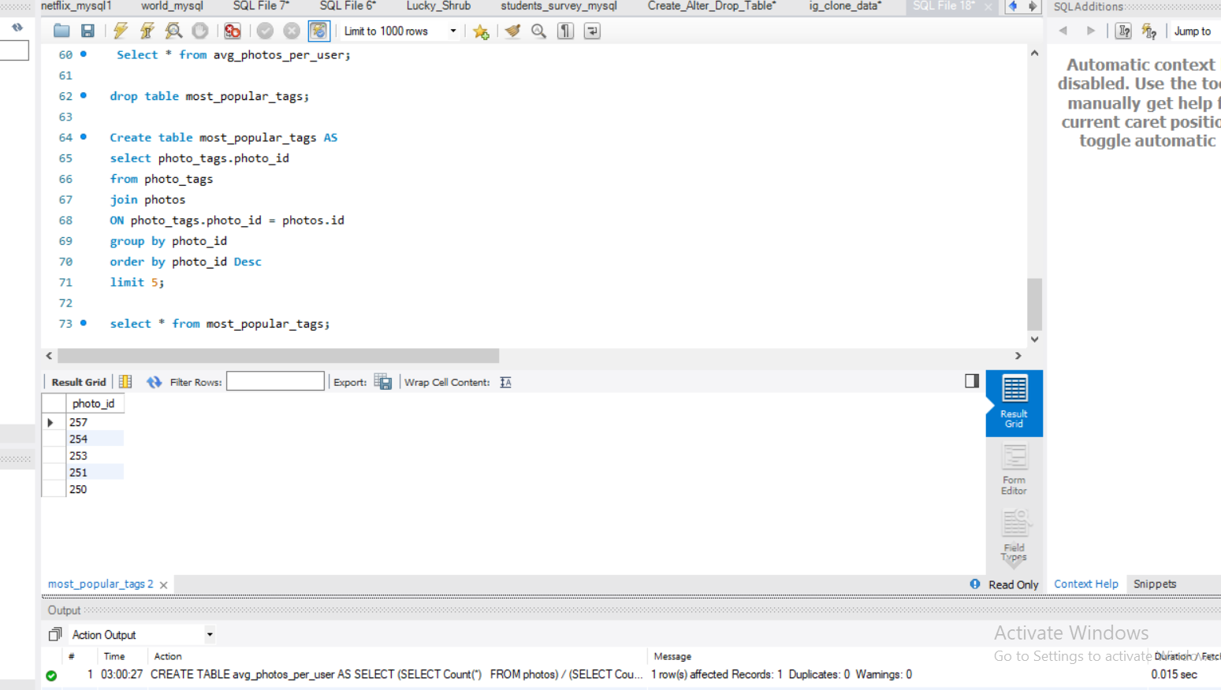

Q7. Store the usernames of users who have given exactly as many likes as there are total photos

