### Task Overview

1. **Data Collection and Preparation:**
   * **Collect Blogs:** Gather the 20 blogs from Motadata AIOps documentation.
   * **Preprocess Data:** Clean and preprocess the text data for efficient processing.
2. **Knowledge Base Creation:**
   * **Vector Embeddings:** Use LLaMA 3.1 to generate embeddings for each blog.
   * **Vector Database:** Store these embeddings in a vector database like LLaMA Cloud or Pinecone for efficient retrieval.
3. **Chatbot Architecture:**
   * **NLP Model:** Use LLaMA 3.1 for natural language understanding and response generation.
   * **Interaction Handling:** Implement mechanisms to handle user interactions and queries.
4. **Intelligent Response Generation:**
   * **Dynamic Responses:** Use the LLaMA 3.1 model to generate contextually relevant answers.
   * **Personalization:** Enhance user engagement with personalized responses.
5. **Deployment:**
   * **Backend:** Deploy the chatbot model on a cloud service.
   * **Frontend:** Develop a user-friendly interface for user interaction.

### Key Components

1. **Data Collection and Preparation:**
   * Collect and preprocess the blog content for use in the chatbot.
2. **Knowledge Base Creation:**
   * **Vector Embeddings:**
     + Generate vector embeddings for each blog using LLaMA 3.1.
     + Ensure that these embeddings capture the semantic meaning of the content.
   * **Vector Database:**
     + Store these embeddings in LLaMA Cloud or Pinecone.
     + Use the vector database to perform efficient similarity searches.
3. **Chatbot Architecture:**
   * **NLP Model:**
     + Utilize LLaMA 3.1 for processing and understanding user queries.
     + Fine-tune the model with the collected blog data to enhance performance.
   * **Interaction Handling:**
     + Implement a system to manage user inputs, context, and conversation flow.
     + Use embeddings to find the most relevant blog content for a given query.
4. **Intelligent Response Generation:**
   * **Dynamic Responses:**
     + Use LLaMA 3.1 to generate responses that are relevant and contextually appropriate.
     + Combine user input with the retrieved blog content to formulate responses.
   * **Personalization:**
     + Track user interactions to provide personalized responses.
     + Adapt responses based on user history and preferences.
5. **Deployment:**
   * **Backend:**
     + Deploy the LLaMA 3.1 model and vector database on a cloud platform.
     + Set up an API to handle user requests and generate responses.
   * **Frontend:**
     + Develop a web or mobile interface for user interaction.
     + Integrate the frontend with the backend API to enable seamless communication.

### Chatbot Interaction Flow

1. **User Input:**
   * The user interacts with the chatbot via a web or mobile interface, asking questions in natural language.
2. **Query Processing:**
   * The chatbot processes the user input using the LLaMA 3.1 model to understand the query.
   * Generate embeddings for the user query.
3. **Knowledge Retrieval:**
   * Search the vector database (LLaMA Cloud or Pinecone) using the query embeddings to find the most relevant blog content.
   * Retrieve the top-matching blog entries based on similarity scores.
4. **Response Generation:**
   * Combine the retrieved blog content with the user query.
   * Use LLaMA 3.1 to generate a contextually relevant and coherent response.
   * Personalize the response based on user history and context.
5. **User Response:**
   * The generated response is sent back to the user via the interface.
   * The chatbot continues the conversation based on further user input.

### Implementation Summary

* **Data Collection:** Gather and preprocess the 20 blogs.
* **Knowledge Base:** Create vector embeddings and store them in a vector database.
* **Chatbot Model:** Deploy LLaMA 3.1 on a cloud service.
* **User Interface:** Develop a user-friendly frontend for interaction.

### Design Approach

#### Components and Interactions

1. **User Interface:**
   * **Description:** The front-end component where users interact with the chatbot.
   * **Technology:** Web/Mobile application (e.g., React, Angular, Flutter).
   * **Interaction:** Sends user queries to the back-end API and displays responses.
2. **Backend API:**
   * **Description:** The middle layer that handles communication between the front-end and the core components.
   * **Technology:** FastAPI, Flask, or Django.
   * **Interaction:** Receives user queries, forwards them to the NLP Model and Vector Database, and returns responses to the front-end.
3. **NLP Model (LLaMA 3.1):**
   * **Description:** The core NLP engine that processes user inputs and generates responses.
   * **Technology:** LLaMA 3.1 from Ollama.
   * **Interaction:** Processes the user input to understand the query, generates embeddings, and formulates responses.
4. **Vector Database (Pinecone):**
   * **Description:** Stores and retrieves vector embeddings of the blog content for efficient similarity search.
   * **Technology:** Pinecone.
   * **Interaction:** Receives query embeddings from the NLP Model, performs similarity searches, and returns relevant content.
5. **Data Preprocessing:**
   * **Description:** Prepares and cleans the blog data for use in the NLP Model.
   * **Technology:** Python scripts, NLP libraries (e.g., NLTK, SpaCy).
   * **Interaction:** Cleans and tokenizes blog content, generates embeddings, and stores them in the Vector Database.
6. **Knowledge Base:**
   * **Description:** The collection of preprocessed and indexed blog content.
   * **Technology:** JSON/CSV files, stored in a database.
   * **Interaction:** Provides content for the NLP Model to generate embeddings and responses.
7. **FireCrawl:**
   * **Description:** Fetches and scrapes data from relevant websites to keep the knowledge base updated.
   * **Technology:** FireCrawl.
   * **Interaction:** Periodically scrapes websites, processes the data, and updates the knowledge base.
8. **LangChain:**
   * **Description:** Connects the NLP model with private documentation and ensures seamless data flow.
   * **Technology:** LangChain.
   * **Interaction:** Integrates private documentation with the chatbot for enriched responses.

#### Technologies, Frameworks, and Algorithms

1. **User Interface:**
   * **Technologies:** React, Angular, or Flutter.
   * **Purpose:** Provides an interactive platform for users to communicate with the chatbot.
2. **Backend API:**
   * **Technologies:** FastAPI, Flask, Django.
   * **Purpose:** Manages API requests and orchestrates interactions between the front-end, NLP Model, and Vector Database.
3. **NLP Model:**
   * **Technologies:** LLaMA 3.1 from Ollama.
   * **Purpose:** Understands user queries, generates embeddings, and formulates responses.
4. **Vector Database:**
   * **Technologies:** Pinecone.
   * **Purpose:** Stores and retrieves vector embeddings for efficient similarity searches.
5. **Data Preprocessing:**
   * **Technologies:** Python, NLTK, SpaCy.
   * **Purpose:** Cleans, tokenizes, and processes blog content to generate embeddings.
6. **Knowledge Base:**
   * **Technologies:** JSON/CSV files.
   * **Purpose:** Stores the cleaned and preprocessed blog content.
7. **FireCrawl:**
   * **Technologies:** FireCrawl.
   * **Purpose:** Fetches and updates website data for the knowledge base.
8. **LangChain:**
   * **Technologies:** LangChain.
   * **Purpose:** Connects private documentation with the NLP model for enriched data integration.

### Interaction Workflow

1. **User Query:**
   * Users input a question or query through the user interface (web or mobile app).
   * This initial interaction sets the conversation in motion.
2. **Backend API:**
   * The backend API acts as an intermediary layer between the user interface and the core components.
   * It receives the user query and forwards it to the NLP Model for processing.
3. **NLP Model (LLaMA 3.1):**
   * The heart of the chatbot system, the NLP Model processes the user input.
   * It understands the intent behind the query and generates embeddings (vector representations) for efficient search.
4. **Vector Database (Pinecone):**
   * The vector database stores precomputed embeddings of the blog content.
   * When the NLP Model sends query embeddings, the database performs a similarity search.
   * It returns the most relevant blog entries based on similarity scores.
5. **Response Generation:**
   * Armed with relevant blog content, the NLP Model combines the user query and retrieved information.
   * It generates a coherent and contextually relevant response.
   * Personalization can enhance the quality of responses based on user history and context.
6. **User Response:**
   * The generated response is sent back to the user interface via the backend API.
   * Users see the chatbot's answer displayed on their screen.

This approach leverages advanced technologies and frameworks to ensure the chatbot provides natural, accurate, and personalized interactions by efficiently integrating and utilizing multiple data sources.

### Execution Steps for Developing the Chatbot

#### 1. Data Collection and Preparation

1. **Collect Blog Data:**
   * **Source**: Obtain the 20 blogs from the Motadata AIOps documentation.
   * **Format**: Ensure data is in a usable format (e.g., text or HTML).
2. **Data Cleaning:**
   * **Text Extraction**: Extract the relevant text from the collected blogs.
   * **Remove Noise**: Eliminate irrelevant information such as advertisements, navigation elements, and HTML tags.
   * **Normalization**: Convert text to a standard format (e.g., lowercase, remove punctuation and special characters).
3. **Tokenization:**
   * **Split Text**: Break down the cleaned text into tokens (words, phrases).
   * **Stemming/Lemmatization**: Reduce words to their base forms if necessary.
4. **Data Augmentation (Optional):**
   * **Synonym Replacement**: Enhance data diversity by replacing words with synonyms.
   * **Paraphrasing**: Create variations of the text to improve model robustness.

#### 2. Embedding Generation

1. **Generate Embeddings:**
   * **Select Tool**: Use NLP tools or libraries to convert cleaned and tokenized text into vector embeddings.
   * **Embed Text**: Transform text into numerical vectors that represent semantic content.
2. **Store Embeddings:**
   * **Vector Database**: Store embeddings in a database like Pinecone for efficient retrieval and similarity searches.

#### 3. Model Training

1. **Select and Prepare NLP Model:**
   * **Model Choice**: Utilize LLaMA 3.1 from Ollama for handling NLP tasks.
   * **Training Data**: Use the preprocessed blog data and embeddings for training with the help of Langchain.
2. **Fine-Tuning:**
   * **Initial Training**: Train the model on the dataset to understand language patterns and context.
   * **Fine-Tuning**: Adjust model parameters and retrain using specific data from the Knowledge Base to improve performance.
3. **Evaluate Model:**
   * **Metrics**: Evaluate model performance using metrics such as accuracy, F1-score, and BLEU score.
   * **Validation**: Test the model with validation data to ensure it performs well on unseen queries.

#### 4. System Integration and Development

1. **Backend API Development:**
   * **Framework Choice**: Use frameworks like FastAPI, Flask, or Django to build the API.
   * **Integration**: Connect the API to the NLP Model, Vector Database, and other components.
2. **Frontend Interface Development:**
   * **Design and Implement**: Develop the user interface (e.g., web or mobile application) where users interact with the chatbot.
   * **Connect to API**: Ensure the frontend communicates with the Backend API for sending queries and receiving responses.

#### 5. Knowledge Base Management

1. **Data Fetching and Crawling:**
   * **FireCrawl**: Use FireCrawl to periodically fetch and scrape relevant data from websites.
2. **Update Knowledge Base:**
   * **Integration**: Update the Knowledge Base with new data obtained from web crawling.
   * **Preprocessing**: Clean and preprocess new data, then generate and store embeddings in the Vector Database.
3. **Maintain Data Quality:**
   * **Review and Validate**: Regularly review the quality of data in the Knowledge Base to ensure accuracy and relevance.

#### 6.

1. **Prepare for Deployment:**
   * **Environment Setup**: Set up deployment environments (e.g., cloud servers, containerization with Docker).
   * **Configuration**: Configure the system for production use, including security settings and performance optimization.
2. **Deploy System:**
   * **Backend and Frontend**: Deploy the backend API and frontend application to the chosen infrastructure.
   * **Continuous Integration**: Implement CI/CD pipelines for ongoing updates and deployments.
3. **Monitor and Maintain:**
   * **Monitoring**: Use monitoring tools to track system performance and user interactions.
   * **Maintenance**: Regularly update the system based on feedback and performance metrics. Address any issues or bugs promptly.

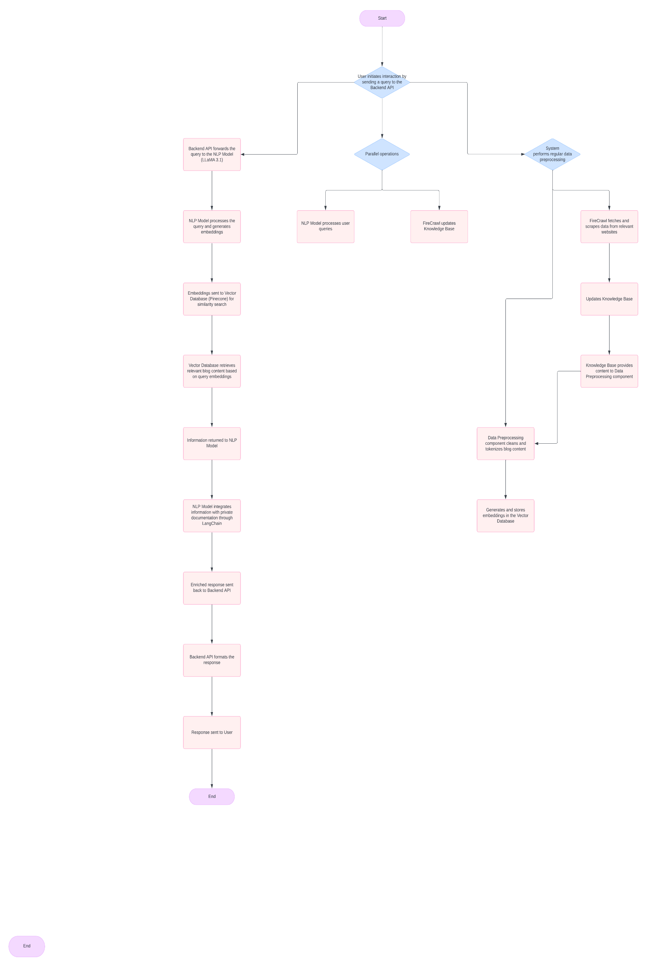**Workflow of the Chatbot**