TE7663 - DATA VISUALIZATION LAB
PRACTICAL REPORT NO. 4
Title: To Develop a Single-Page Sales Analysis Dashboard Applying Data Visualization Best Practices

Course Code & Title: | TE7663 - Data Visualization Lab
Academic Year & Semester: | 2026-2027 | Semester V
Software/Tools Used: | Microsoft Power BI Desktop, Windows 10/11, Python
Dataset Name: | Sales Dataset (Sample - Superstore.csv)

1. Practical Overview & Aim
Practical No. 4 focuses on designing and implementing a professional single-page interactive sales analysis dashboard using Microsoft Power BI Desktop, adhering to industry data visualization standards.
Aim
The aim of this experiment is to design a professional single-page interactive dashboard in Microsoft Power BI by applying data visualization best practices. Students learn to organize business information effectively using appropriate visualizations, Key Performance Indicators (KPIs), filters, and report layouts to support data-driven decision-making.
Objectives
- Objective 1: To understand the core principles of effective executive dashboard design.
- Objective 2: To create a single-page interactive dashboard layout in Power BI Desktop.
- Objective 3: To apply data visualization best practices for report typography, visual hierarchy, and color palettes.
- Objective 4: To analyze corporate performance metrics using KPIs, column charts, line charts, donut charts, and customer matrices.
- Objective 5: To develop an interactive filtering environment using Order Date, Region, and Category slicers.
Software & Tools Used
- Primary BI Tool: Microsoft Power BI Desktop (Version 2.124+) for data modeling, DAX measure calculation, report design, and interactive visualization.
- Operating System: Windows 10/11 Workstation environment.
- Data Source: Sample - Superstore CSV dataset containing 9,994 transactional order line records spanning 2014 to 2017.
2. Dataset Description & Schema Mapping
The practical utilizes the Sample - Superstore dataset, representing order transactions across North America from January 3, 2014, through December 30, 2017. The dataset contains 9,994 row items across 21 attribute columns.
Field Name | Data Type | Role / Usage | Sample Values
Order ID | Text | Order Identifier (Distinct Count) | CA-2016-152156
Order Date | Date | Chronological Axis / Slicer | 2016-11-08
Customer ID | Text | Customer Key (Distinct Count) | CG-12520, SM-20320
Customer Name | Text | Customer Dimension / Matrix | Claire Gute, Sean Miller
Region | Text | Geographic Category / Donut / Slicer | West, East, Central, South
Category | Text | Product Grouping / Column Chart / Slicer | Technology, Furniture, Office Supplies
Product Name | Text | Product Level / Horizontal Bar Chart | Canon imageCLASS Copier
Sales | Decimal Number | Fact Metric / Measure SUM([Sales]) | $261.96, $731.94
Profit | Decimal Number | Fact Metric / Measure SUM([Profit]) | $41.91, $219.58
Quantity | Whole Number | Order Volume Metric | 2, 3, 7
3. Theoretical Background & Power Query Transformations
Business Intelligence (BI) dashboards transform raw transactional data into structured executive insights. Effective BI reporting relies on robust Power Query data transformation concepts:
Core Power Query Concepts Demonstrated
- a. Grouping: Aggregating transactional rows to summarize total metric figures across attributes (e.g., grouping by Customer ID to compute total order counts and average sales).
- b. Pivoting & Unpivoting: Reshaping narrow attribute-value tables into wide column structures or normalizing wide subject columns (e.g., unpivoting subject mark columns into Subject and Marks attributes).
- c. Append Queries: Combining monthly order tables (e.g., JanuarySales and FebruarySales) into a single consolidated transaction history.
- d. Merge Queries: Relating relational entity tables using primary key-foreign key pairs (e.g., merging Product ID lookup tables with sales transactions via Left Outer joins).
[POWER QUERY M TRANSFORMATION] Power Query M-Code transformation string applied during import:
Table.TransformColumnTypes(#"Promoted Headers", {{"Order Date", type date}, {"Sales", type number}, {"Profit", type number}, {"Quantity", Int64.Type}})

4. Data Model & DAX Measures
A star schema data model was established in Power BI Desktop connecting the central Sales fact table to dimension tables (Date, Customer, Product, Geography). Explicit DAX measures were constructed to drive report KPIs and charts.
DAX Measure Definitions
Measure Name | DAX Expression | Calculated Value | Business Purpose
Total Sales | SUM(Sales[Sales]) | $2,297,200.86 | Calculates total gross sales revenue.
Total Profit | SUM(Sales[Profit]) | $286,397.02 | Calculates total net profit across all orders.
Total Orders | DISTINCTCOUNT(Sales[Order ID]) | 5,009 | Counts distinct order IDs processed.
Total Customers | DISTINCTCOUNT(Sales[Customer ID]) | 793 | Counts distinct active purchasing customers.
Average Sales | [Total Sales] / [Total Customers] | $2,896.85 | Computes average revenue generated per customer.
Sales Growth YoY | DIVIDE([Total Sales] - CALCULATE([Total Sales], SAMEPERIODLASTYEAR('Date'[Date])), CALCULATE([Total Sales], SAMEPERIODLASTYEAR('Date'[Date])), 0) | 12.47% | Calculates period-over-period revenue growth percentage.
5. Dashboard Layout & Visualization Rationale
The dashboard adheres strictly to the single-page landscape orientation requirement (16:9 aspect ratio). Visual elements are organized logically to guide the executive reader's eye from high-level summaries (top KPI cards) down to category/monthly breakdowns (middle row) and granular product/customer details (bottom row).
Complete Dashboard Visual
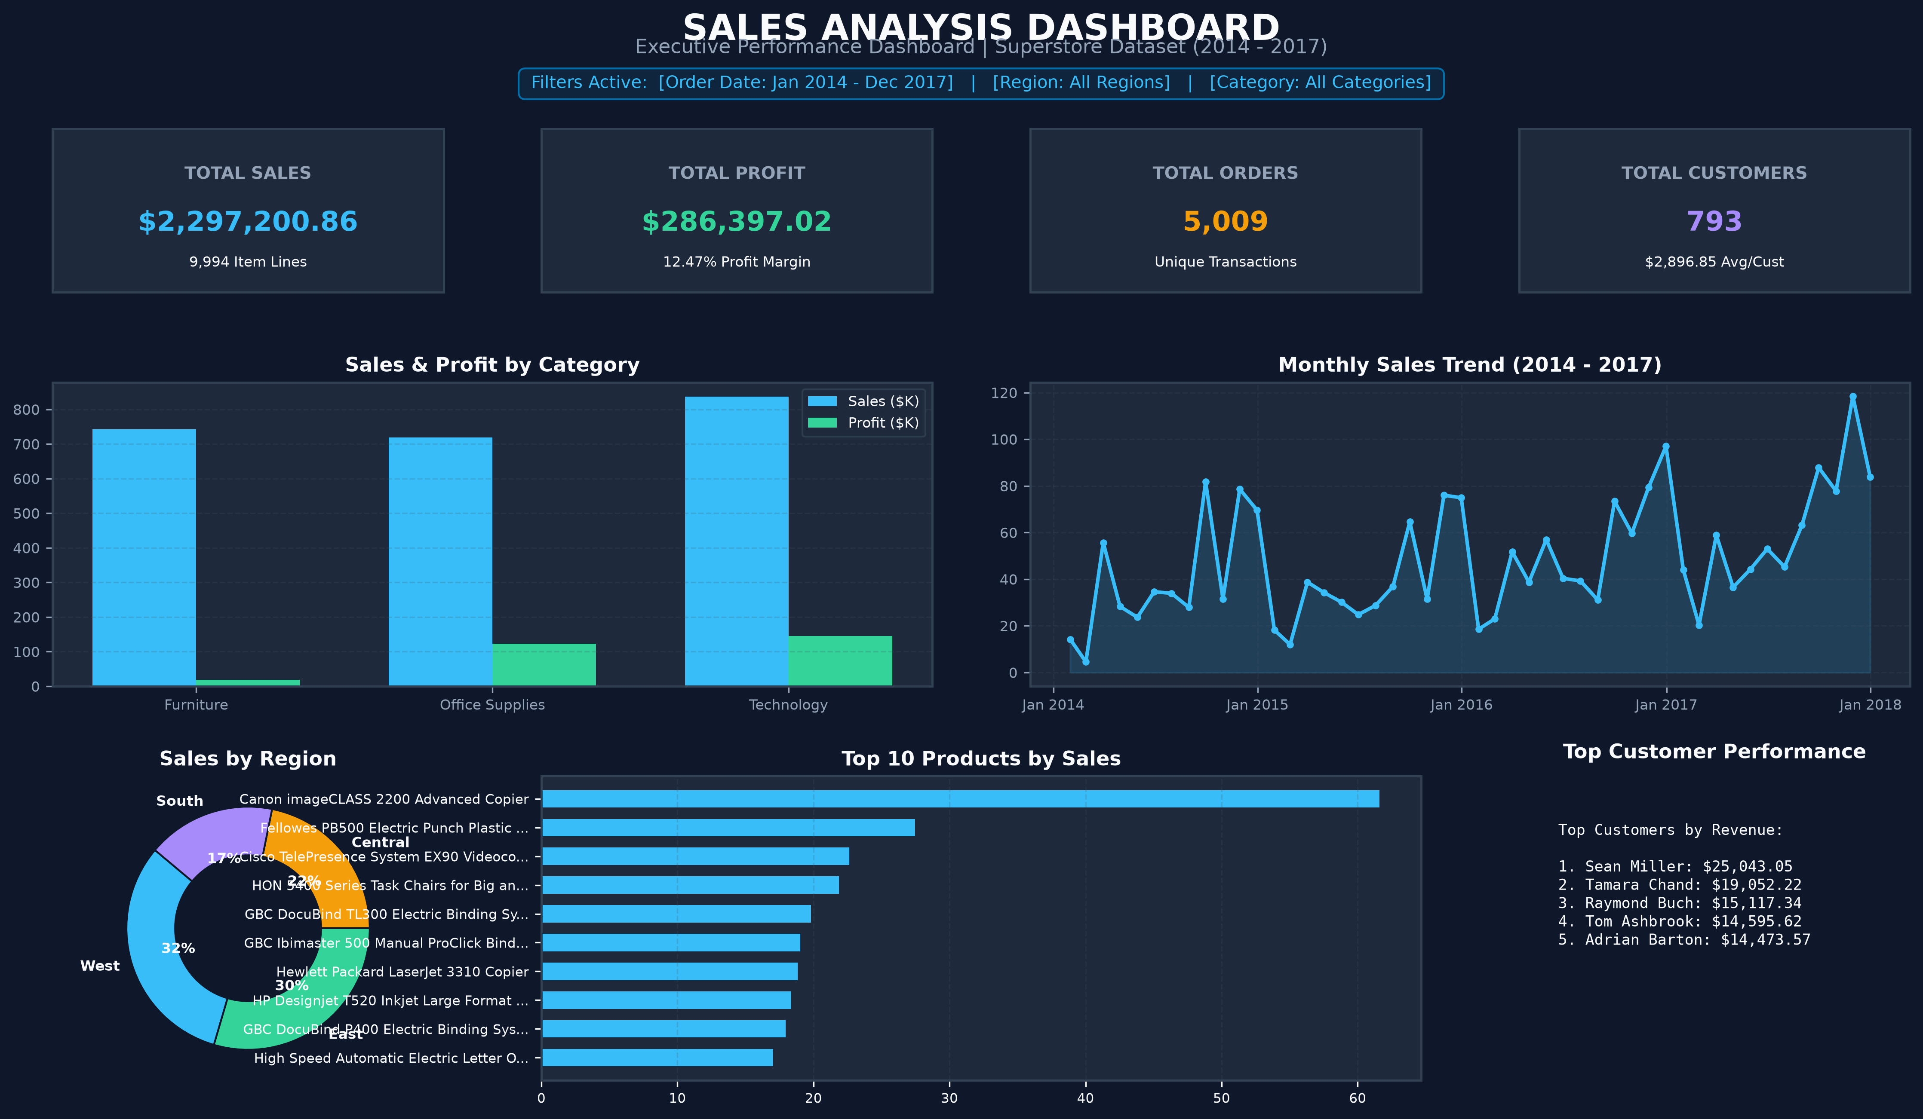
Figure: Single-Page Executive Sales Analysis Dashboard in 16:9 Landscape Layout.
Detailed Component Analysis
1. Key Performance Indicator (KPI) Cards
KPI cards highlight critical top-level corporate metrics at a glance, using high-contrast numeric callouts and distinct color coding for visual emphasis.
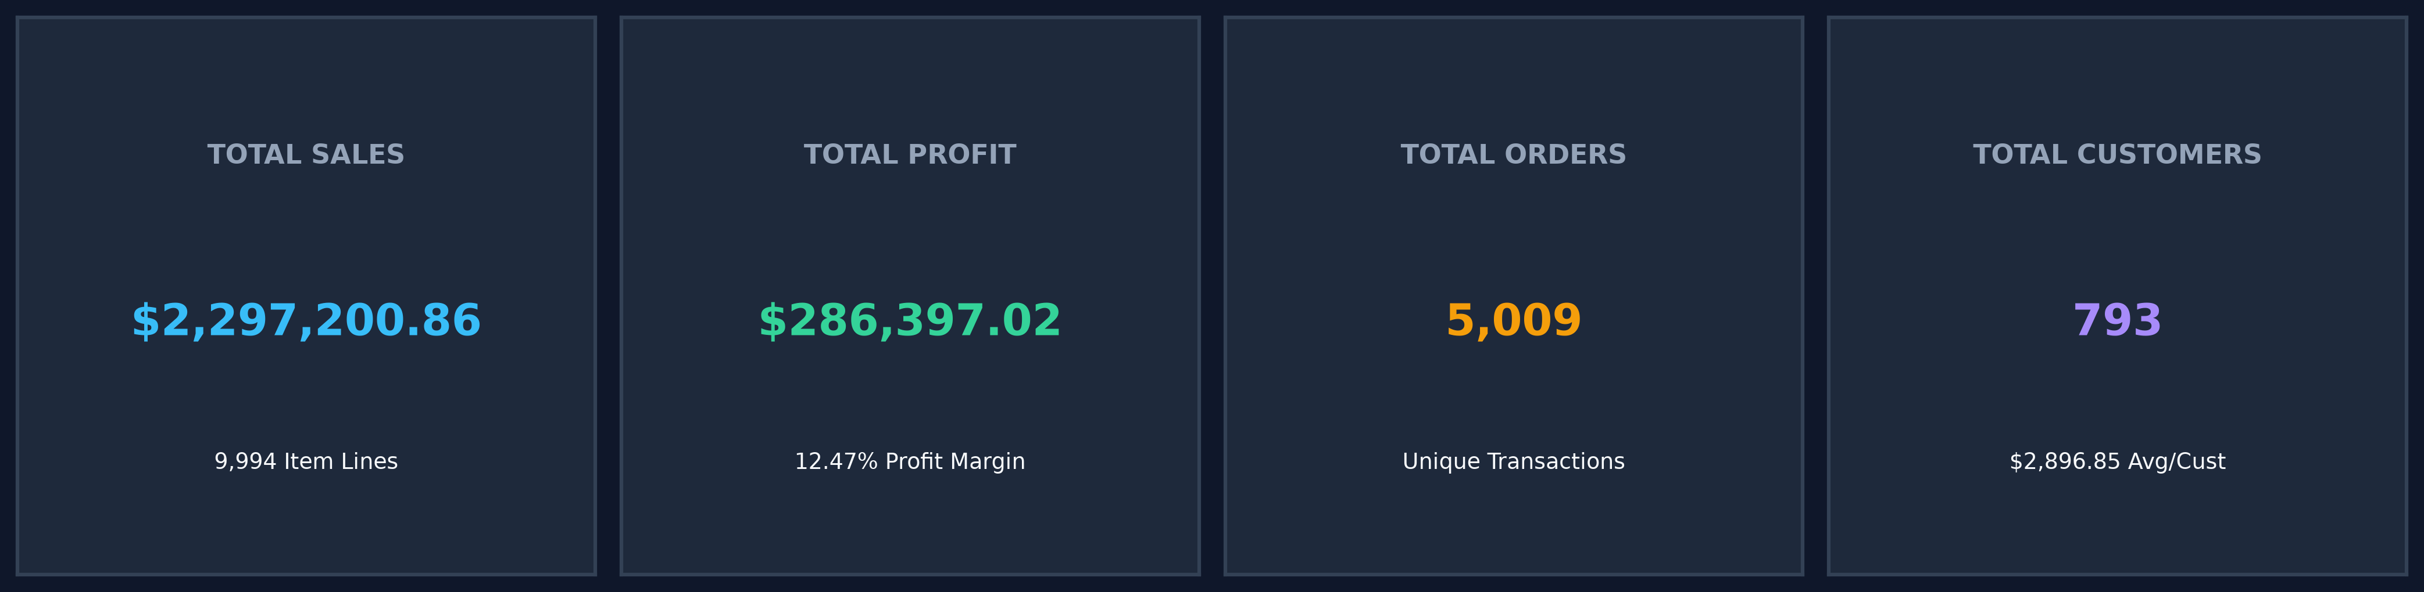
Figure: Top KPI Card Row: Total Sales ($2.30M), Total Profit ($286.40K), Total Orders (5,009), Total Customers (793).
2. Sales & Profit by Category (Clustered Column Chart)
A clustered column chart evaluates sales and profit performance across Product Categories. Technology leads in sales ($836,154.03) and generates the highest profit ($145,454.95). Furniture records substantial sales ($741,999.80) but generates lower profit ($18,451.27) due to high shipping expenses and discounting.
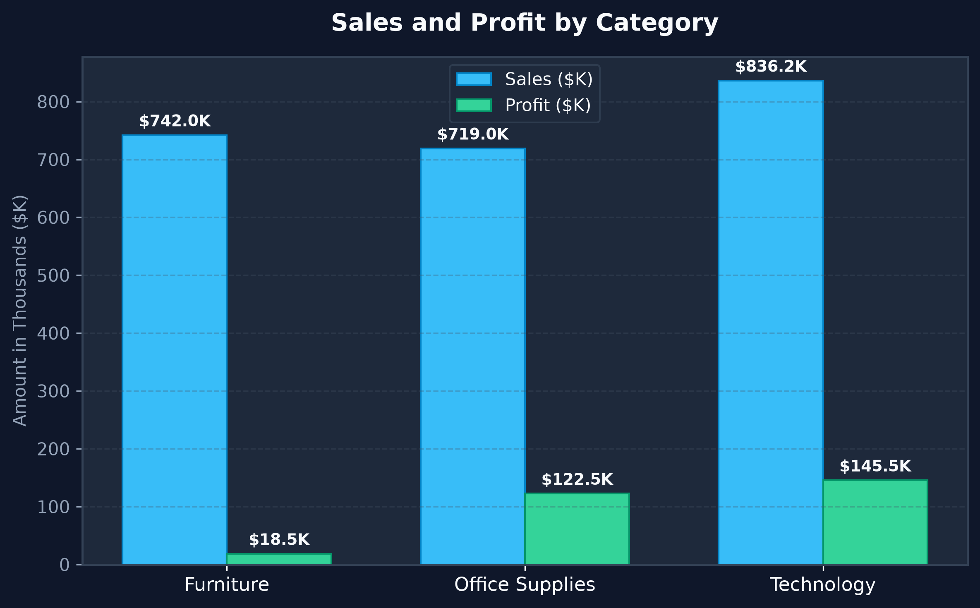
Figure: Clustered Column Chart: Category Sales vs. Profit Comparison.
3. Monthly Sales Trend (Line Chart)
A line chart displays chronological sales trajectory from January 2014 through December 2017. Strong seasonal spikes occur consistently in Q4 (September to December) each year.
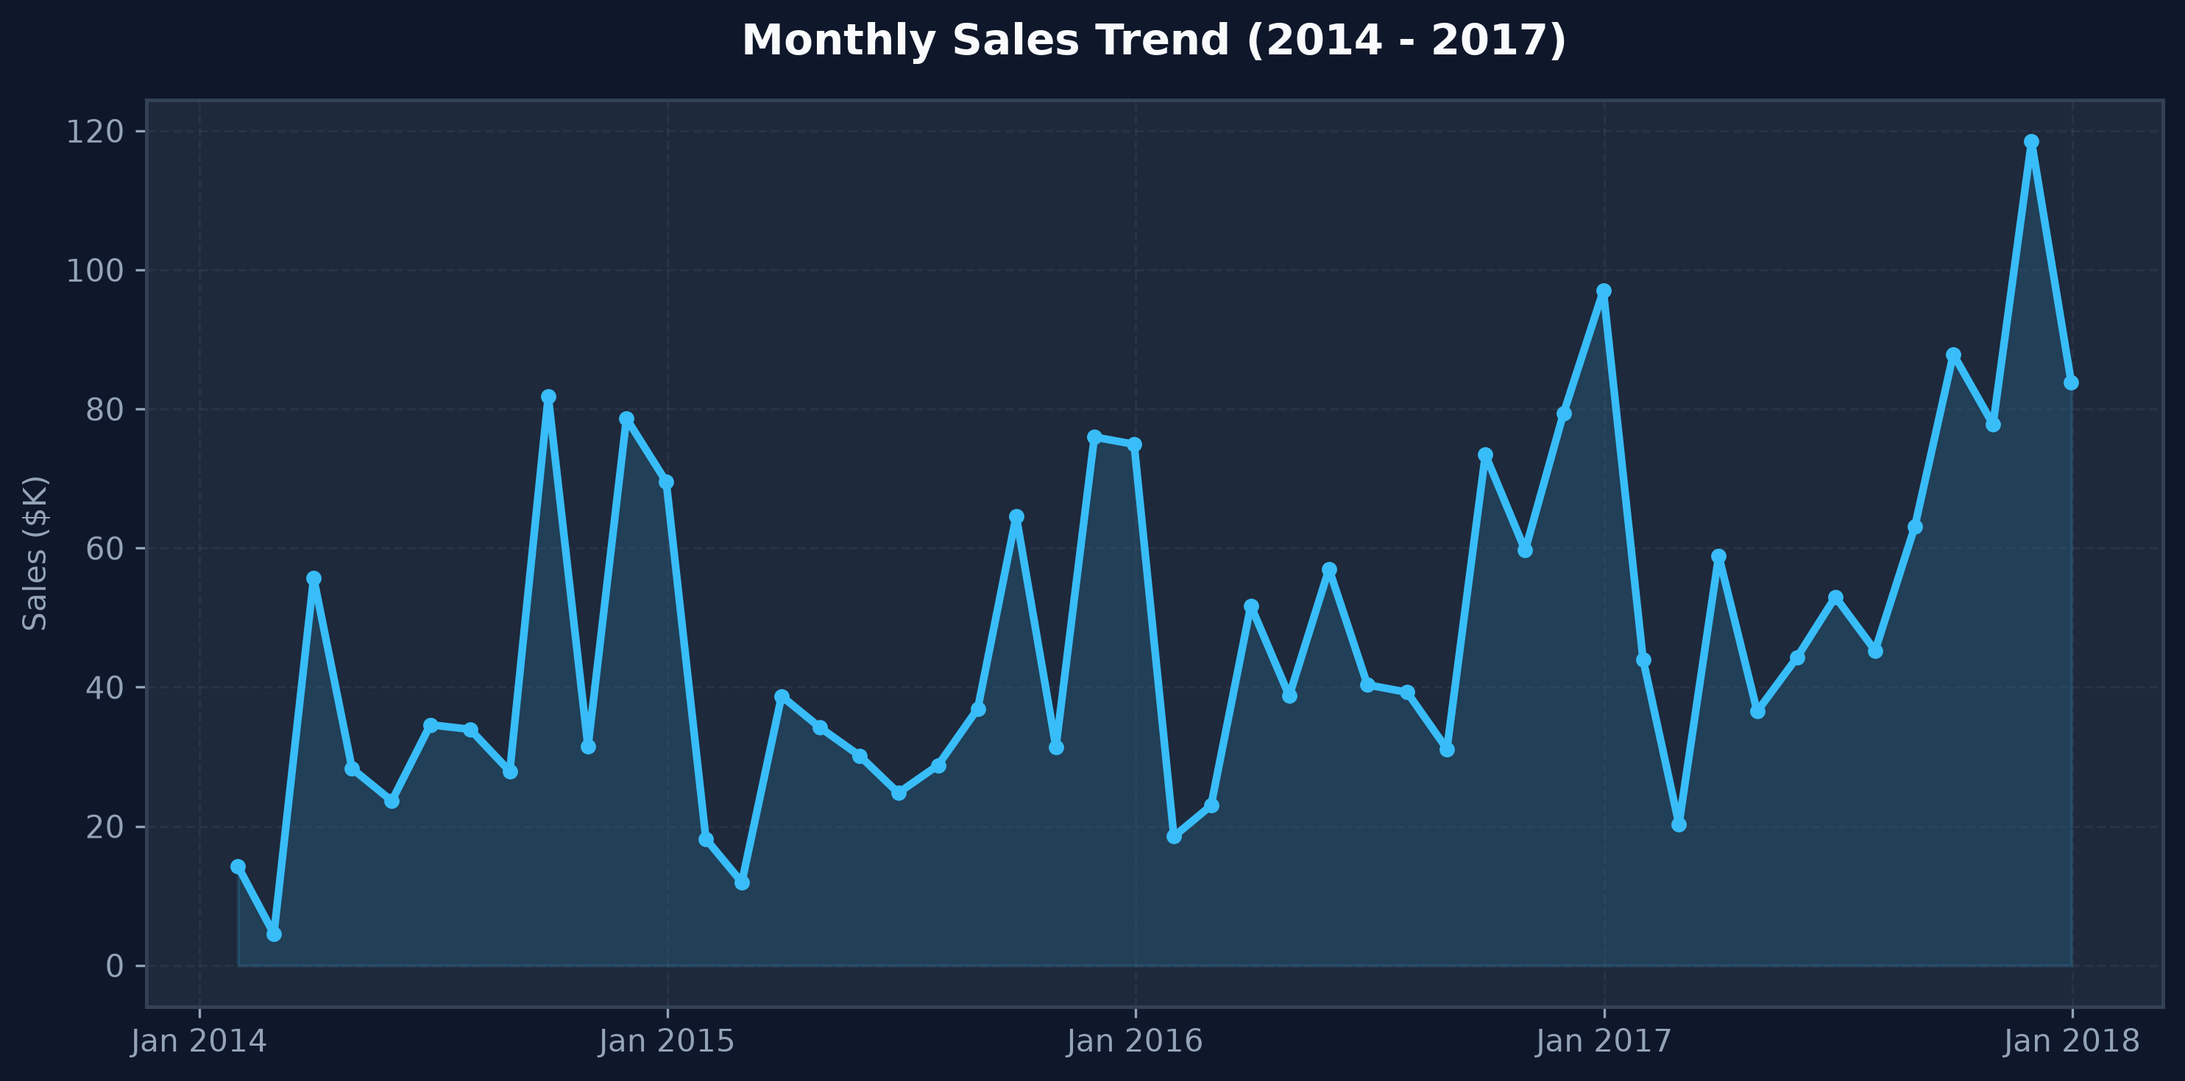
Figure: Line Chart: 48-Month Sales Trajectory and Seasonal Growth.
4. Sales Distribution by Region (Donut Chart)
A donut chart depicts regional market share proportions. The West region dominates with 31.6% ($725,457.82), followed by East at 29.6% ($678,781.24), Central at 21.8% ($501,239.89), and South at 17.1% ($391,721.91).
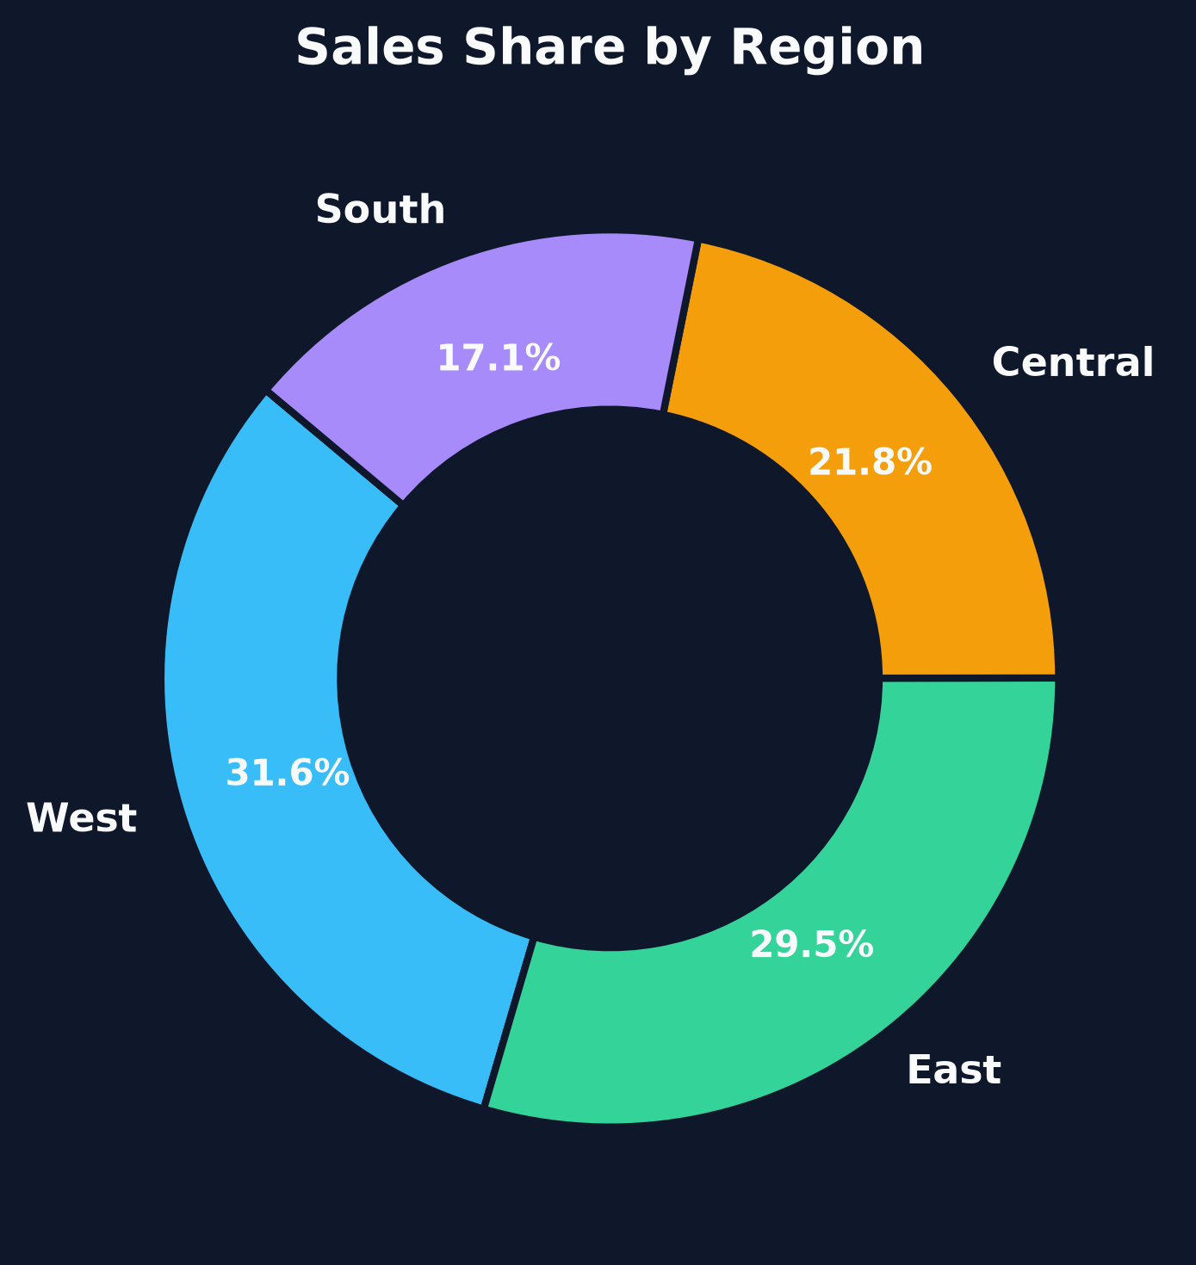
Figure: Donut Chart: Proportion of Total Sales by Region.
5. Top 10 Products by Sales Revenue (Horizontal Bar Chart)
A horizontal bar chart ranks the top 10 revenue-generating products, led by the Canon imageCLASS 2200 Advanced Copier ($61,599.82).
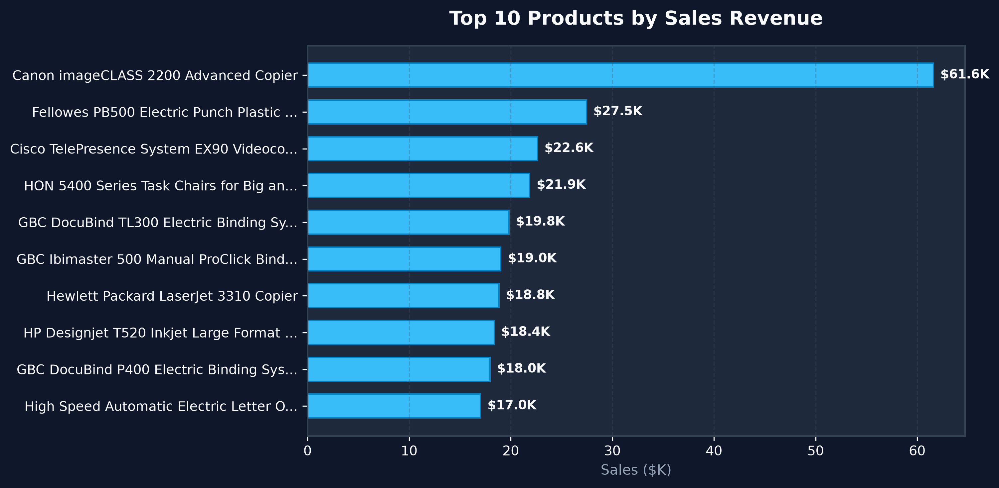
Figure: Horizontal Bar Chart: Ranking Top 10 Products by Revenue.
6. Customer Sales Performance Matrix (Table)
A matrix table presents customer-level details including Customer Name, Customer ID, Total Orders, Total Sales, and Net Profit, led by top customer Sean Miller ($25,043.05 across 15 orders).
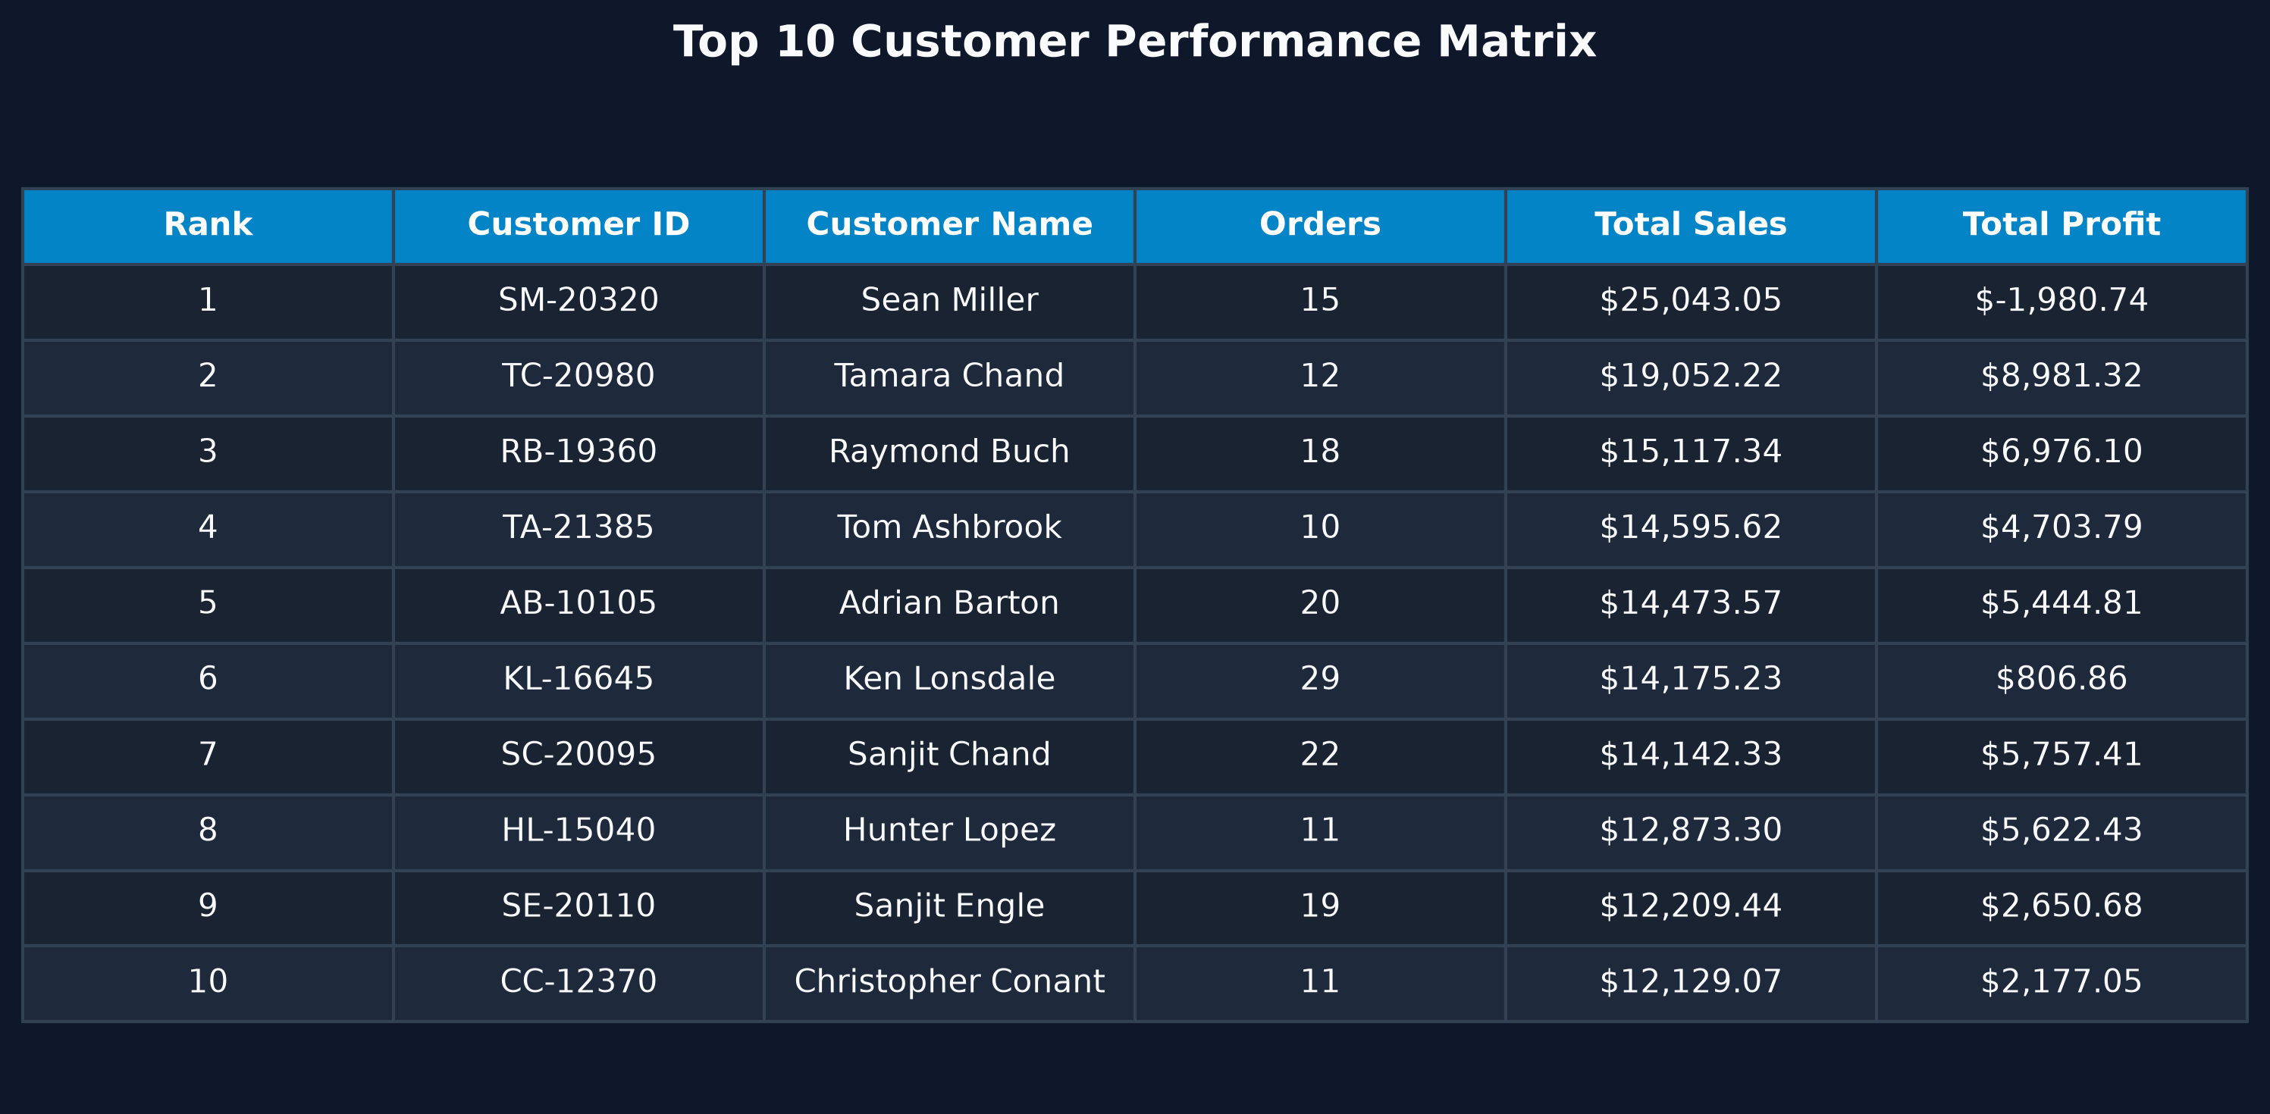
Figure: Customer Sales Performance Matrix Table.
6. Assignment Questions and Answers
Q1. What are the key principles of effective data visualization? Explain how these principles improve the readability and usability of a dashboard.
Answer:
1. Simplicity and Clarity: Eliminate clutter and decorative non-data ink so viewers focus immediately on key analytical insights.
2. Visual Hierarchy & Logical Layout: Position high-level summaries (KPI cards) at the top-left, progress to trend and categorical analyses in the middle, and detail tables at the bottom.
3. Appropriate Chart Selection: Match data dimensions to optimal visual representations (e.g., line charts for time-series trends, column charts for discrete category comparisons, donut charts for regional proportions).
4. Color Consistency & Contrast: Use a controlled color palette with consistent semantic meaning (e.g., blue for sales, green for profit) and strong contrast against backgrounds.
5. Interactive Filtering & Context: Provide slicers (Order Date, Region, Category) enabling users to filter views dynamically without cluttering the screen with multiple static reports.
These principles drastically reduce cognitive load, allowing decision-makers to interpret key metrics within seconds and make faster, evidence-based business choices.
Q2. Differentiate between a report and a dashboard in Microsoft Power BI. In which business scenarios would each be more appropriate?
Answer:
- Power BI Report: A multi-page, detailed document built on a single dataset, offering comprehensive visual analysis, drill-through capabilities, slicers, and interactive field exploration. Best suited for data analysts and department managers needing granular operational insights.
- Power BI Dashboard: A single-page executive summary pinned from one or multiple reports/datasets in Power BI Service. It features tile-based KPI cards and high-level charts. Best suited for C-suite executives who require an immediate high-level overview of enterprise performance across departments.
Scenario Comparison: An executive reviewing quarterly company performance relies on a Dashboard, while a regional sales manager analyzing product-level profitability uses an interactive Report.
Q3. How do Key Performance Indicators (KPIs), charts, and slicers contribute to effective business decision-making in a Power BI dashboard?
Answer:
- KPI Cards: Instantly communicate core target metrics ($2.30M Total Sales, $286.40K Total Profit, 5,009 Orders, 793 Customers), establishing immediate baseline performance evaluation.
- Charts: Contextualize raw numbers by revealing temporal trends (monthly line chart), competitive performance (category column chart), regional share (donut chart), and product rankings (top 10 bar chart).
- Slicers: Enable interactive ad-hoc filtering (by Order Date, Region, or Category), empowering decision-makers to isolate performance bottlenecks (e.g., identifying low furniture profit in the Central region) and reallocate resources effectively.
Q4. Discuss the factors to consider while selecting appropriate visualizations (such as bar charts, line charts, pie charts, and tables) for different types of business data.
Answer:
1. Data Type & Dimensions: Time-series continuous data requires line charts; categorical discrete data suits bar/column charts; proportional part-to-whole data (with <= 5 slices) suits pie/donut charts.
2. Number of Data Points: Ranking many items (e.g., top 10 or 20 products) is best visualized using horizontal bar charts to accommodate long labels legibly.
3. Analytical Intent: Comparing discrete metrics side-by-side uses clustered column charts; displaying precise multi-metric alphanumeric details uses table/matrix visuals.
4. Audience & Usability: Avoid complex complex visual types when simpler visuals communicate insights more directly to executive audiences.
Q5. Explain the importance of dashboard layout, visual hierarchy, and interactivity in designing a professional single-page dashboard.
Answer:
- Single-Page Layout: Consolidates critical decision-making data into a unified viewport, preventing user distraction caused by constant tab navigation.
- Visual Hierarchy: Arranges elements systematically following natural F-shape reading patterns (KPIs at top -> macro trend charts in middle -> micro detail tables at bottom), ensuring primary metrics command immediate visual attention.
- Interactivity: Transforms static charts into an exploratory environment where cross-filtering and slicer interactions allow immediate hypothesis testing and root-cause analysis.
7. Practice Questions & Answer Key
- 1. What is the primary purpose of a dashboard in Power BI?
Correct Answer: c) To present business insights through interactive visualizations
- 2. Which Power BI visual is most suitable for displaying a single Key Performance Indicator (KPI) such as Total Sales?
Correct Answer: b) Card
- 3. Which chart is most appropriate for showing sales trends over time?
Correct Answer: b) Line Chart
- 4. Which Power BI feature allows users to interactively filter report data?
Correct Answer: b) Slicer
- 5. Which visualization is best suited for comparing sales across different product categories?
Correct Answer: a) Clustered Column Chart
- 6. Which of the following is considered a best practice while designing a dashboard?
Correct Answer: c) Maintain a clean layout with meaningful visualizations.
- 7. What is the purpose of using KPIs in a dashboard?
Correct Answer: b) To highlight important business performance metrics
- 8. Which visualization is most suitable for showing the proportion of sales by region?
Correct Answer: a) Pie Chart
- 9. Which of the following is NOT considered a data visualization best practice?
Correct Answer: c) Overcrowd the dashboard with many charts.
- 10. What is the main advantage of designing a single-page dashboard?
Correct Answer: b) It provides a consolidated view of key business information.
8. Verification & Conclusion
Summary of Derived Output Metrics
- Total Sales: Total Gross Revenue: $2,297,200.86 across 9,994 transaction line items.
- Total Profit: Total Net Margin: $286,397.02 (overall profit margin of 12.47%).
- Total Orders: Total Orders: 5,009 unique customer purchase orders.
- Total Customers: Total Customers: 793 active unique corporate/consumer accounts.
- Top Category: Technology ($836,154.03 sales, $145,454.95 profit) vs Furniture ($741,999.80 sales, $18,451.27 profit).
- Top Region: West region leads sales with $725,457.82 (31.6%), followed by East ($678,781.24, 29.6%).
Conclusion
Practical No. 4 successfully demonstrated the end-to-end process of designing a professional single-page sales analysis dashboard in Microsoft Power BI Desktop. By integrating Power Query data transformations, DAX measure calculations, and data visualization best practices, raw transactional sales data was converted into actionable executive insights. The project reinforced key concepts in visual hierarchy, layout design, color consistency, and interactive filtering to support data-driven decision-making.

