PRACTICAL NO. 4
Sales Analysis Dashboard
Interactive Business Intelligence Dashboard in Power BI
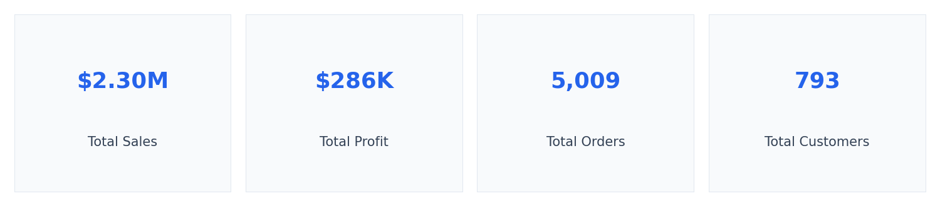
Dataset: Sample Superstore | 9,994 records | Jan 2014 – Dec 2017
Tool: Microsoft Power BI Desktop | Power Query (M) | DAX

1. Objective
To design and build an interactive Sales Analysis Dashboard in Power BI that consolidates key business metrics — sales, profit, orders and customers — into a single, decision-ready view, and to demonstrate the complete workflow from raw data import through Power Query transformation, DAX measure creation, and visual design.

2. Aim
To import, clean and model the Sample Superstore dataset in Power BI, define calculated measures using DAX, and build a single-page dashboard containing KPI cards, trend analysis, category/region breakdowns and a top-products ranking, so that sales performance can be explored interactively through slicers and filters.

3. Theory
Power BI Desktop is a business intelligence tool used to connect to, transform, model, and visualize data. A typical workflow has three stages:
- Power Query (M language) — imports raw data and applies repeatable transformation steps such as type conversion, cleaning, and column derivation, before the data is loaded into the model.
- Data Modelling — defines relationships between tables (e.g. a Fact table of Orders linked to a Date dimension table) so that time-intelligence and cross-filtering work correctly.
- DAX (Data Analysis Expressions) — a formula language used to create calculated measures (e.g. Total Sales, Sales Growth) that aggregate and manipulate the model at query time rather than storing pre-computed values.
The resulting model feeds a report canvas of visuals — cards, charts, tables and slicers — which stay synchronized: selecting a slicer value instantly filters every visual on the page, which is what makes a Power BI report “interactive” rather than a static image.

4. Dataset Description
The dataset used is the Sample Superstore dataset, a widely used retail sales dataset covering four years of orders across the United States.
Property | Value
Total records | 9,994
Date range | 2014-01-03 to 2017-12-30
Missing values | 0
Duplicate rows | 0
Key fields | Order ID, Order Date, Customer, Product, Category, Region, Sales, Profit

5. Power Query (M) Transformation Steps
- Get Data → Text/CSV → import Sample_-_Superstore.csv (source encoding: Windows-1252).
- Use First Row as Headers.
- Change Type: Order Date / Ship Date → Date; Sales / Profit / Discount → Decimal Number; Quantity → Whole Number; remaining columns → Text.
- Remove Duplicates on Row ID (verification step — dataset already contains zero duplicates).
- Add Column → Date → Month Name and Year, for chronological sorting and year-level filtering.
- Close & Apply to load the cleaned table into the data model as “Orders”.

6. DAX Measures
Total Sales = SUM(Orders[Sales])
Total Profit = SUM(Orders[Profit])
Total Orders = DISTINCTCOUNT(Orders[Order ID])
Total Customers = DISTINCTCOUNT(Orders[Customer ID])
Average Sales = DIVIDE([Total Sales], [Total Customers])
Since the data spans 48 months (Jan 2014 – Dec 2017), a month-over-month growth measure is valid once a proper Date table is marked as a date table and related to Orders[Order Date]:
Sales Growth =
VAR CurrentSales = [Total Sales]
VAR PrevMonthSales =
CALCULATE([Total Sales], DATEADD('Date'[Date], -1, MONTH))
RETURN
DIVIDE(CurrentSales - PrevMonthSales, PrevMonthSales)

7. Dashboard Design
The report is a single landscape page (1280 × 720) structured as a header strip, a KPI card row, four chart quadrants, and a slicer panel, so every visual is visible without scrolling.


7.1 Sales by Category
A clustered column chart comparing total Sales across the three product categories. Technology leads, followed closely by Furniture and Office Supplies.
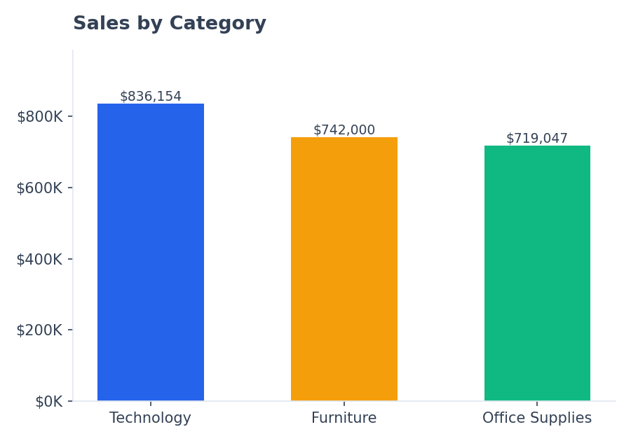

7.2 Monthly Sales Trend
A line chart of Sales aggregated by month across the full four-year period, X-axis sorted chronologically (not alphabetically) via the Month/Year date columns. A clear seasonal spike appears at the end of each year (Nov–Dec), consistent with holiday-season retail demand.
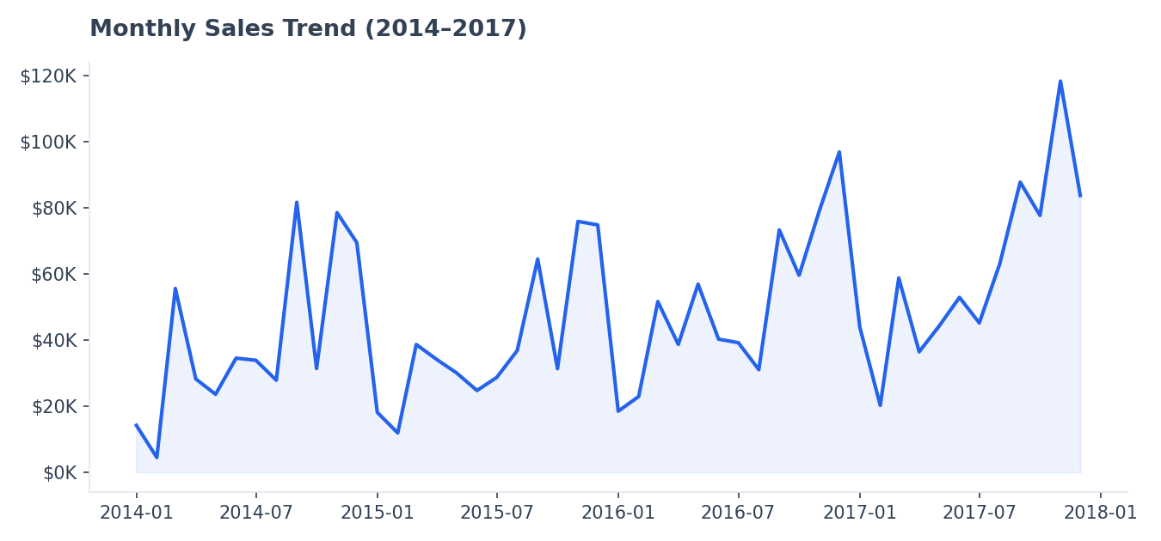

7.3 Sales by Region
A donut chart showing the regional split of Sales. The West and East regions together account for the majority of revenue, while the South region contributes the least.
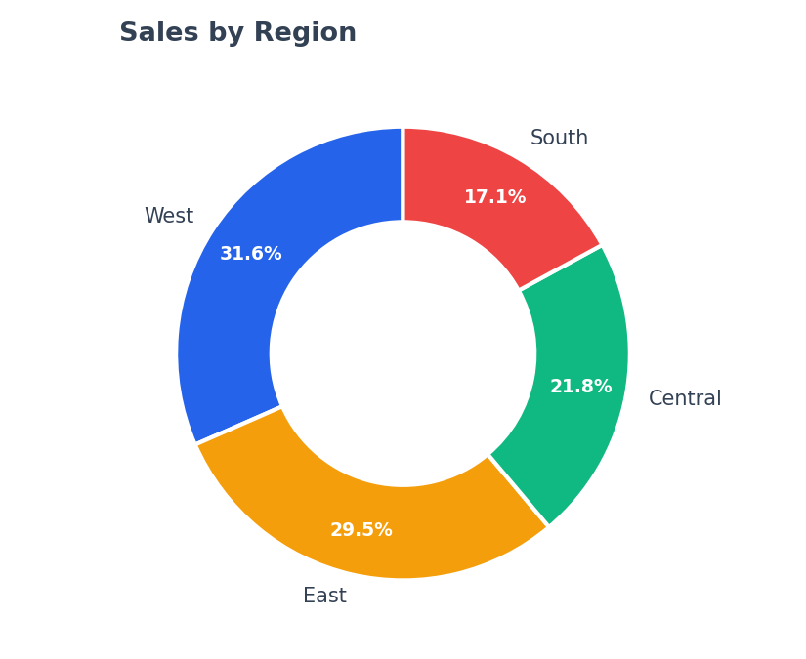

7.4 Top 10 Products by Sales
A horizontal bar chart filtered to the Top 10 products by Sales (Top N filter), which surfaces high-value equipment (copiers, binding systems, videoconferencing units) that a category-level view alone would hide.
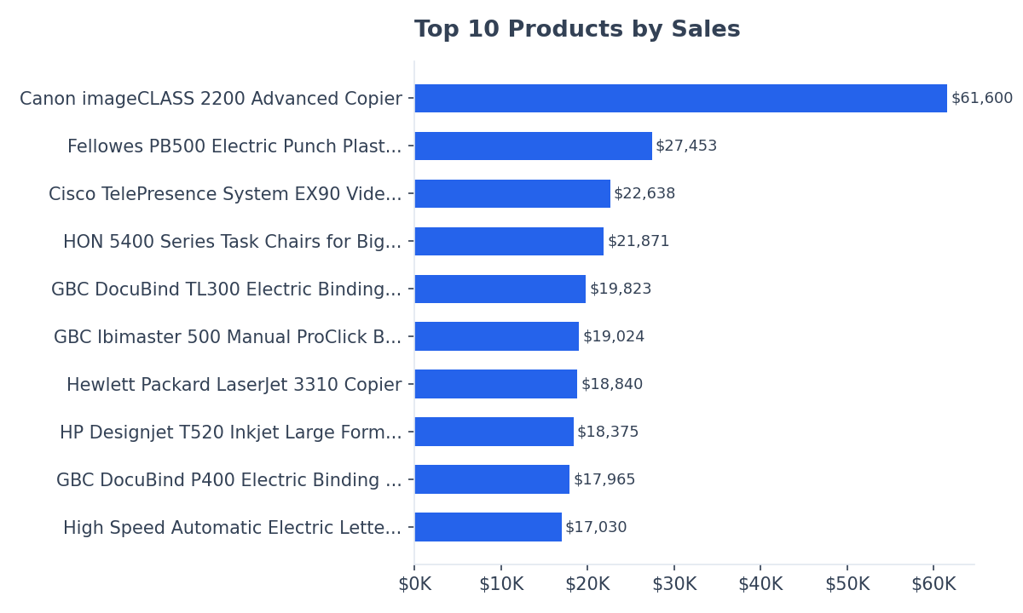

7.5 Full Dashboard Layout
Composite view of the assembled dashboard combining all visuals with the KPI header, as it appears on a single Power BI report page.
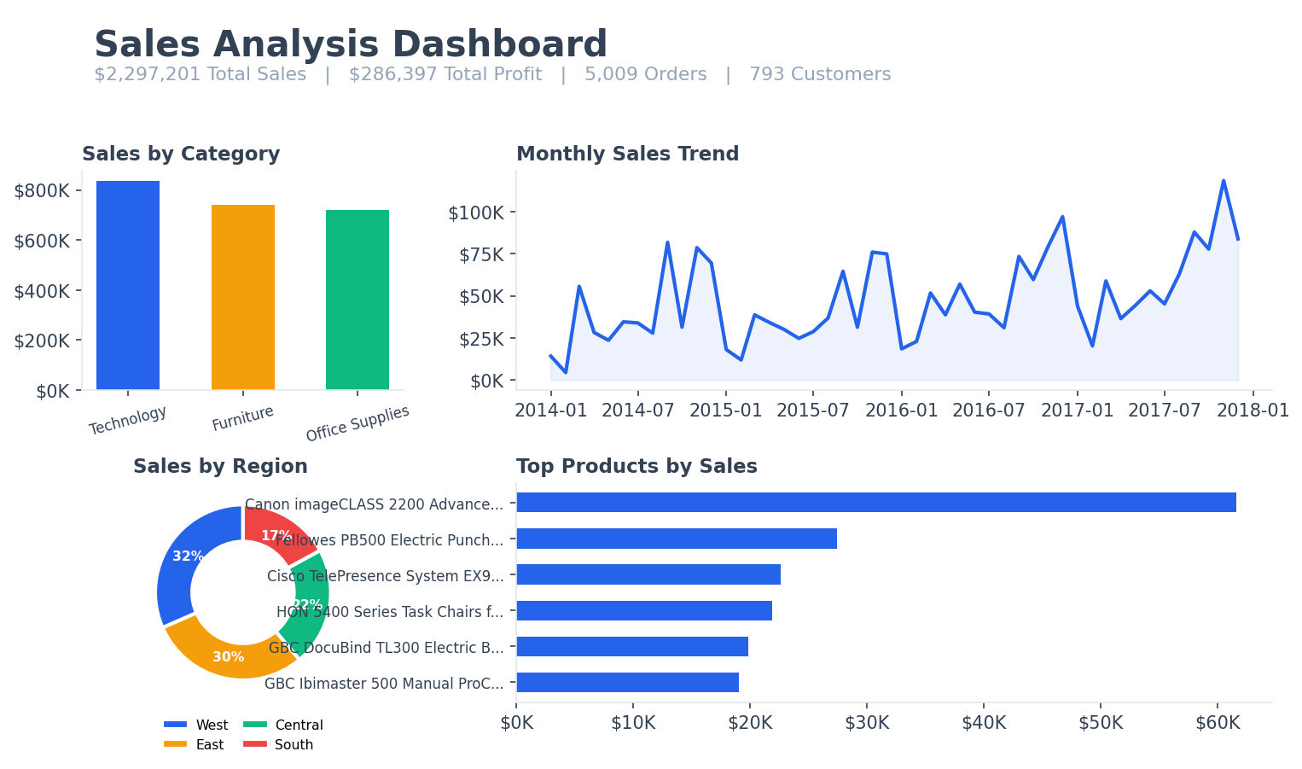

8. Validation — Key Numbers
The figures below were computed directly from the dataset and should match the values shown by the DAX measures once the dashboard is built in Power BI Desktop.
Metric | Value
Total Sales | $2,297,200.86
Total Profit | $286,397.02
Total Orders | 5,009
Total Customers | 793
Average Sales / Customer | $2,896.85
Top Category | Technology ($836,154.03)
Top Region | West ($725,457.82)
Top Product | Canon imageCLASS 2200 Advanced Copier ($61,599.82)

9. Conclusion
The Sales Analysis Dashboard was successfully built using the Sample Superstore dataset. Power Query was used to clean and type the raw CSV, DAX measures were defined for the core KPIs, and a single-page report combining KPI cards, a category comparison, a monthly trend line, a regional donut chart and a top-products ranking was assembled. The dashboard makes it possible to interactively filter by Order Date, Region and Category using slicers, immediately updating every visual — fulfilling the goal of turning raw transactional data into an at-a-glance, decision-ready view.

10. Viva / Assignment Questions

Q1. What is the difference between a Column and a Measure in Power BI?
A calculated Column is evaluated row-by-row and physically stored in the table (increasing model size), while a Measure is a DAX formula evaluated dynamically at query time in the context of whatever filters are currently applied (e.g. a slicer selection), and is not stored — making measures the correct choice for aggregations like Total Sales.

Q2. Why must Order Date be converted to a proper Date type before building the Date table?
The source column is imported as text (M/D/YYYY). Time-intelligence DAX functions such as DATEADD and CALCULATE with date filters require a true Date-typed column related to a table marked as a Date table; left as text, sorting is alphabetical and growth/trend measures cannot be computed.

Q3. What does marking a table as a “Date Table” do?
It tells the DAX engine that the table contains one row per unique, contiguous date, which is a prerequisite for built-in time-intelligence functions (DATEADD, SAMEPERIODLASTYEAR, TOTALYTD, etc.) to return correct results.

Q4. Why use a Top N filter instead of manually sorting and trimming the product list?
A Top N filter re-evaluates dynamically as slicers change — if the user filters to a single Region, the “Top 10 Products” visual automatically recalculates for that region, whereas a manually trimmed static list would not respond to interaction.

