Project Synopsis
HCLTech Career Shaper Programme | III Year Industry Project | 2025-26

Field | Details (Learner to complete)
Project Title | Credit Card Fraud Detection System using Unsupervised Isolation Forest Anomaly Detection (AEGIS RiskOps)
Project No. | [FILL IN]
Domain | Digital-Data-AI / AIML
Difficulty | Intermediate
Duration | 4 Weeks
Format | Individual Project
Learner Name | [FILL IN]
Roll Number | [FILL IN]
College / Campus | [FILL IN]
Mentor Name | [FILL IN]
Submission Date | [FILL IN]

1. Problem Statement
Banks, payment gateways and cardholders lose tens of billions of dollars to credit card fraud every year (over $32 billion in recent years), and the volume of real-time, contactless and cross-border payments makes manual review of every transaction impossible. The core difficulty is that fraud is extremely rare (only 0.172% of transactions in the benchmark data) and attackers keep changing tactics, so supervised models become biased towards “legitimate” and miss new patterns, while rigid rule-based filters block genuine customers. This project solves it by building an unsupervised anomaly-detection engine that scores each transaction in milliseconds and explains why it was flagged.

2. Proposed Solution & Approach
We built AEGIS RiskOps, a fraud-detection and risk-intelligence platform powered by an unsupervised Isolation Forest (100 trees, scikit-learn) trained on the European Cardholder dataset. Fraudulent transactions are rare and structurally different, so they are isolated in fewer random splits and receive a higher anomaly score; a decision threshold (τ = 0.036042), tuned on validation data to maximise the F1-score, converts the score into a Fraud / Legitimate verdict, a risk percentage and a LOW / MODERATE / HIGH / CRITICAL risk tier. A Flask REST API serves single-transaction and batch scoring, and a Z-score explainability module shows which PCA features (V1–V28) and the amount drove each flag. Every result is logged to SQLite (with optional MySQL sync) and presented in a web dashboard with a risk gauge, batch CSV auditor, live payment-stream radar and Chart.js analytics. Flagged payments are intended to trigger step-up authentication (OTP / 3-D Secure) rather than outright rejection, so genuine customers face minimal friction.

3. System Architecture
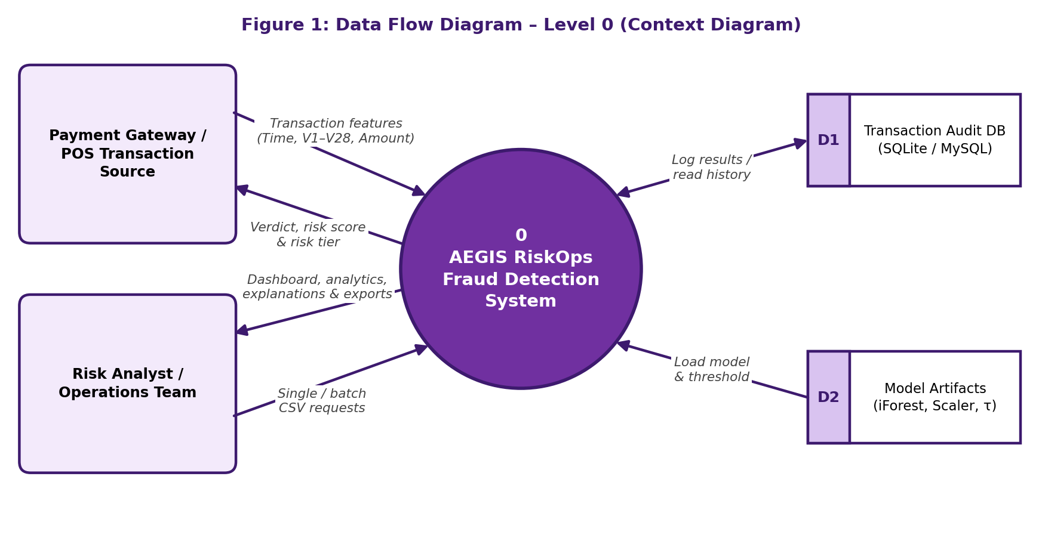
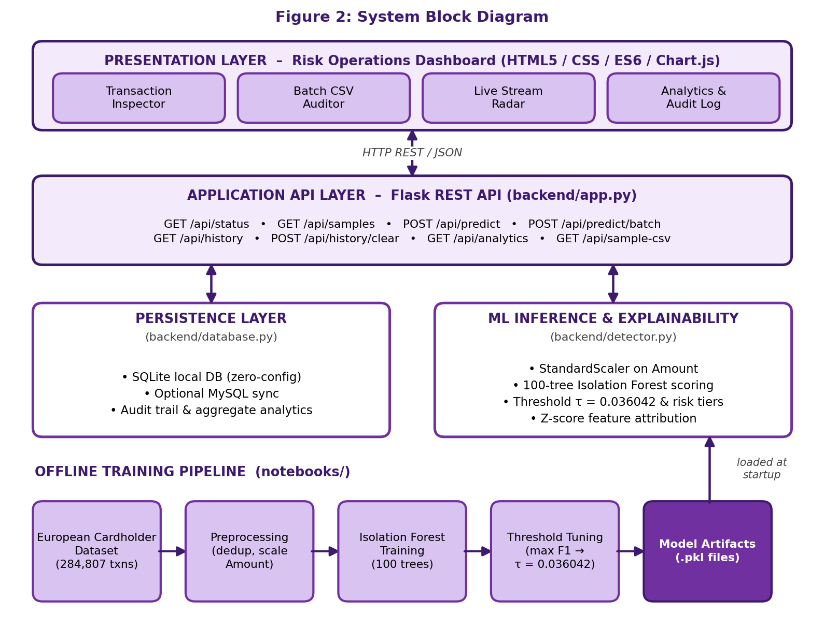

4. Technology Stack
Frontend / UI: HTML5, modern CSS and JavaScript (ES6) – single-page Risk Operations dashboard
Backend / Logic: Python 3.10+, Flask REST API (with CORS), pandas, NumPy, joblib
Database: SQLite (default, zero-configuration); optional MySQL sync via mysql-connector-python
AI/ML Framework: scikit-learn – IsolationForest (100 estimators) and StandardScaler
Visualisation: Chart.js analytics, animated SVG risk gauge, Canvas live-stream radar
Hardware: Not applicable – runs on a standard PC (dual-core CPU, 4 GB RAM, 500 MB free disk)

5. Dataset Used
Dataset file name: creditcard.csv – European Cardholder Dataset (Sept 2013, ML Group, Université Libre de Bruxelles)
Number of rows: 284,807 transactions (283,726 after removing 1,081 duplicates; 492 frauds in raw data, 473 after de-duplication)
Number of columns: 31 (Time, V1–V28, Amount and the binary target Class)
Key columns (list 5): Time, Amount, V14, V4, Class (plus the PCA components V1–V28 as model inputs)
Any additional data collected: None – only small sample / test CSV files (25–30 rows) provided for testing the dashboard and CLI

6. Key Results & Metrics
Metric 1: Model Accuracy — 99.68% (untouched 20% test split of 56,746 transactions)
Metric 2: ROC-AUC — 0.9407 (PR-AUC 0.0913)
Metric 3: F1 Score — 0.2115 (Precision 18.18%, Recall 25.26% at τ = 0.036042)
Metric 4: Response Time — < 3 ms per transaction; hundreds of rows scored in a batch in under 20 ms
Business value achieved: A label-free, first-line fraud filter that caught 24 of the 95 frauds in the test set (25.26% recall) while flagging only about 0.23% of transactions (132 of 56,746). Its sub-3 ms latency suits real-time payment authorisation, flagged payments are routed to step-up authentication instead of being declined, and analysts receive Z-score explanations and a full audit trail for every decision.
Note: because only 0.17% of transactions are fraud, accuracy alone is misleading; ROC-AUC, precision and recall are the more meaningful measures.

7. Challenges Faced & How Resolved
Challenge 1: Extreme class imbalance (0.172% fraud) – supervised models tend to predict everything as legitimate and look accurate while missing fraud. → Resolution: Used an unsupervised Isolation Forest that does not need labelled training data, and judged it with ROC-AUC, PR-AUC, precision, recall and F1 instead of accuracy alone.
Challenge 2: No natural cut-off between “normal” and “fraud” in the raw anomaly score. → Resolution: Swept the score range on validation data and fixed the threshold at τ = 0.036042 (maximum F1), then evaluated once on an untouched test set.
Challenge 3: Data quality – 1,081 duplicate transactions and a highly skewed Amount column. → Resolution: Removed the duplicates and standardised Amount with StandardScaler so large purchases do not distort tree path lengths.
Challenge 4: Explaining decisions when V1–V28 are anonymised PCA features, and false alarms on rare genuine high-value purchases. → Resolution: Added Z-score feature attribution (|z| > 1.8) to show the main drivers, and route flagged payments to OTP / 3-D Secure rather than blocking them.

8. References
1. Liu, F. T., Ting, K. M., & Zhou, Z.-H. (2008). Isolation Forest. Eighth IEEE International Conference on Data Mining (ICDM), pp. 413–422. DOI: 10.1109/ICDM.2008.17.
2. Liu, F. T., Ting, K. M., & Zhou, Z.-H. (2012). Isolation-based Anomaly Detection. ACM Transactions on Knowledge Discovery from Data (TKDD), 6(1), 1–39.
3. Dal Pozzolo, A., Caelen, O., Johnson, R. A., & Bontempi, G. (2015). Calibrating Probability with Undersampling for Unbalanced Classification. IEEE Symposium Series on Computational Intelligence (SSCI), pp. 159–166.
4. Pedregosa, F., et al. (2011). Scikit-learn: Machine Learning in Python. Journal of Machine Learning Research, 12, 2825–2830.
5. Grinberg, M. (2018). Flask Web Development: Developing Web Applications with Python. O’Reilly Media, 2nd Edition.

9. Ethical Compliance Declaration
I confirm that:
☐ All dataset usage complies with the source licence.
☐ No personally identifiable information (PII) is stored without consent.
☐ AI tools used for code/writing are disclosed in the Appendix.
☐ This project complies with the DPDP Act 2023 where applicable.
Learner Signature: _________________________ Date: ________________

Submit this file as 'Project_Synopsis_[YourName]_[RollNo].docx' | HCLTech Career Shaper Programme 2025-26

