UCS503 - Software Engineering Lab
TARMS
UCS 503 Software Engineering Project Report
END-Semester Evaluation

Submitted by:
Aditya Sinha 102483008
Arsh sharma 102483015
Erthanshu singh 102303940

Group No: Group 6

Submitted to:

Computer Science and Engineering Department
TIET, Patiala
April 2025

TABLE OF CONTENTS
1. Project Selection Phase
1.1 Software Bid
1.2 Project Overview
2. Analysis Phase
2.1 Use Cases
2.1.1 Use-Case Diagrams
2.1.2 Use Case Templates
2.2 Activity Diagram and Swimlane Diagrams
2.3 Data Flow Diagrams (DFDs)
2.3.1 DFD Level 0
2.3.2 DFD Level 1
2.3.3 DFD Level 2
2.4 Software Requirement Specification in IEEE Format
2.5 User Stories and Story Cards
3. Design Phase
3.1 Class Diagram
3.2 Sequence Diagram
3.3 Collaboration Diagram
3.4 State Chart Diagrams
4. Implementation
4.1 Component Diagrams
4.2 Deployment Diagrams
4.3 Screenshots
5. Testing
5.1 Test Plan
5.2 Test Cases
5.3 Test Reports

1. Project Selection Phase

1.1 Software Bid
Software Bid/ Project Teams
UCS 503- Software Engineering Lab
Software Bid/ Project Teams

UCS 503- Software Engineering Lab
Group : 3C65 Dated: 10/08/2025

Team Name:InventIQ
Team ID (will be assigned by Instructor): Group 6

Please enter the names of your Preferred Team Members. :

Name | Roll No | Project Experience | Programming Language used | Signature
Aditya Sinha | 102483008 | Build a Cancer detection Model | Python(scikit-learn)
Arsh sharma | 102483015 | Build a cinema Price prediction website | Python(Linear regression)
Erthanshu Singh | 102303940

Programming Language / Environment Experience

List the languages you are most comfortable developing in, as a team, in your order of preference. Many of the projects involve Java or C/C++ programming.

1.HTML
2.CSS
3.Python/C++

Choices of Projects:

Please select 4 projects your team would like to work on, by order of preference: [Write at-least one paragraph for each choice (motivation, reason for choice, feasibility analysis, etc.)]

 | Project Name | Unique Selling Point
First Choice | Animal Protection Website | - Rescue stories, GPS tracking for released animals, instant photo/video updates.  - Transparency builds trust.  - Let people report injured or endangered animals via your site/app.
Second Choice | Trip organizer Website | • Use AI to design an itinerary based on travel style, budget, and interests.  • Saves time and feels tailor-made.
Third Choice | Auditorium Room Management System | - Manage your auditorium from anywhere, anytime.  Instantly view availability, reserve slots, and track upcoming events.  Say goodbye to booking conflicts and last-minute surprises  - Your events, perfectly scheduled.  A smart, visual booking system that keeps everyone on the same page.  Fast, reliable, and designed for smooth auditorium management.  - One platform to check availability, manage events, and confirm bookings.  Simple, fast, and built for efficiency
Fourth Choice

Additional Remarks/ Inputs

Please tell us about any other factors that we should take into consideration (e.g., if you really would like to work on a project for some particularly convincing reason).
………………………………………………………………………………………………

………………………………………………………………………………………………

………………………………………………………………………………………………

2. Analysis Phase

2.1 Use Cases

2.1.1 Use-Case Diagrams
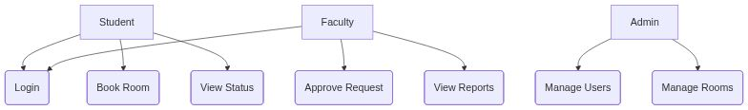

2.1.2 Use Case Templates

Use Case: Student Login
Actor: Student
Description: Access system
Pre-conditions: Registered
Main Flow: 1. Enter creds 2. Validate 3. Dashboard
Post-conditions: Logged in

Use Case: Book Room
Actor: Student
Description: Request room
Pre-conditions: Logged in
Main Flow: 1. Select Room 2. Fill Form 3. Submit
Post-conditions: Request Pending

Use Case: Approve Request
Actor: Faculty
Description: Approve booking
Pre-conditions: Logged in
Main Flow: 1. View Request 2. Approve/Reject
Post-conditions: Status Updated

2.2 Activity Diagram and Swimlane Diagrams

2.2.1 Activity Diagram
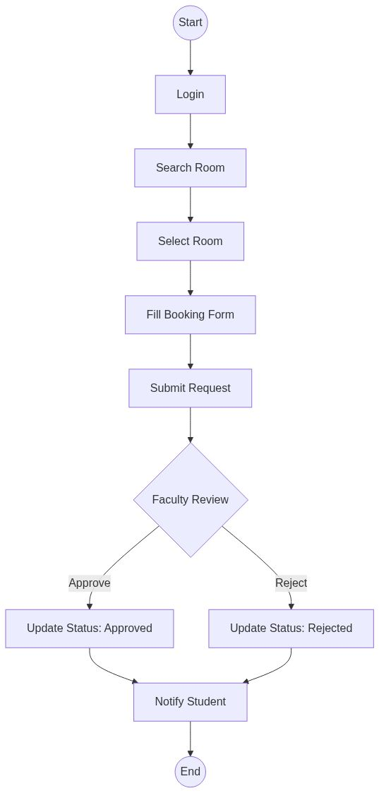

2.2.2 Swimlane Diagram
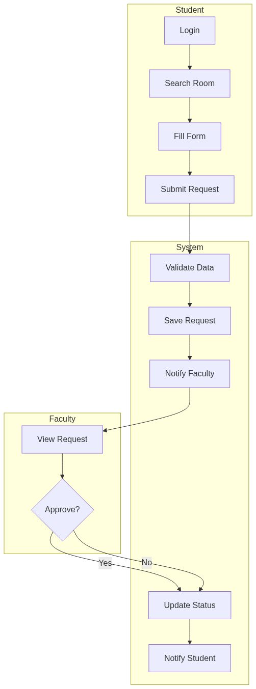

2.3 Data Flow Diagrams (DFDs)

2.3.1 DFD Level 0
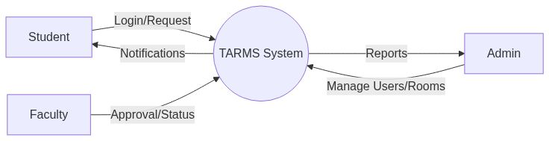

2.3.2 DFD Level 1
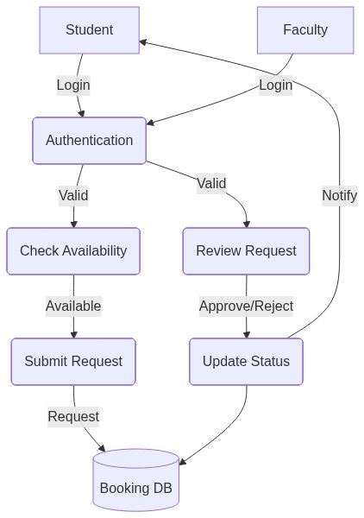

2.3.3 DFD Level 2
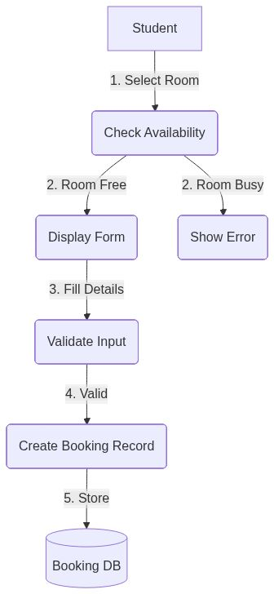

2.4 Software Requirement Specification in IEEE Format

1. Purpose and Scope
The goal is to manage room and auditorium bookings, approvals, and scheduling for
Colleges. The system will serve students, faculty, and administrators. The primary
outcome is to reduce manual booking processes and waiting time while improving
accuracy of room allocation and scheduling.

2. Stakeholders and User Classes
• Student: Undergraduate and graduate students who request room bookings for
events, meetings, or activities.
• Faculty: Teaching staff who approve/reject booking requests and manage room
allocations.
• System Administrator: IT staff who manage user accounts, system configuration,
and backups.
• Department Coordinator: Staff who oversee room availability and resolve
conflicts.
• Information Technology Support: Staff who maintain hosting, monitoring, and
system updates.

3. System Context (High Level)
The system connects to the university’s student/faculty database for authentication,
stores booking data and user profiles in MongoDB, and provides web-based interfaces
for room management. It integrates with the university’s existing infrastructure and
follows institutional policies for room allocation.

4. Assumptions, Dependencies, Constraints
• The university provides unique user identifiers for students and faculty.
• Room booking requests must be approved by authorized faculty members.
• Booking data must be retained for audit purposes for three years.
• Normal usage supports up to two hundred concurrent users.
• System must operate during university business hours (8 AM to 8 PM).

5. Definitions and Glossary
• Student: Any authenticated student permitted to request room bookings.
• Faculty: Any authenticated faculty member authorized to approve booking requests.
• Room: A uniquely identifiable space (classroom, auditorium, meeting room)
available for booking.
• Booking Request: A formal request for room allocation with specific date, time,
and purpose.
• Status: Current state of a booking request (Requested, On Hold, Approved,
Rejected).

6. Functional Requirements
FR-1. User Authentication - When a user enters credentials (User ID/Username,
Password, Member Type), the system shall authenticate and create a session within three
seconds. - The system shall redirect students to the student dashboard and faculty to the
faculty dashboard based on their role.
FR-2. Student Registration - When a new student registers, the system shall collect
Name, User ID, Email, Mobile Number, Member Type, Date of Birth, and Password.
The system shall validate that User ID and Email are unique and create the account in
the database.
FR-3. Faculty Registration - When a new faculty member registers, the system shall
collect Faculty Name, Position, Username, Mobile Number, Member Type, Email, and
Password. - The system shall validate that Username and Email are unique and create the
faculty account.
FR-4. Room Availability Display - When a student accesses the home page, the system
shall display all rooms with their current status (Available, Booked, On Hold) within two
seconds. - The system shall show Room Number, Room Name, Status, and a “Book
Now” button for available rooms.
FR-5. Booking Request Creation - When a student selects an available room and
submits a booking form, the system shall collect event details including Room Name,
Event Name, Purpose, Date, Time, Number of People, and Requirements (AC, Sound
System). - The system shall create a booking request with “Requested” status and store it
in the database.
FR-6. Faculty Approval Process - When a faculty member logs in, the system shall
display all booking requests with “On Hold” status. - When a faculty member approves
or rejects a request, the system shall update the request status and notify the student
within five seconds.

FR-7. Booking History - When a student accesses “My Requests”, the system shall
display all booking requests made by that student with their current status. - The system
shall allow students to delete their own pending requests.
FR-8. Personal Information Management - When a user accesses personal
information, the system shall display their current details. - When a user updates their
information, the system shall validate and save the changes to the database.
FR-9. Password Management - When a user changes their password, the system shall
verify the current password and update to the new password. - When a user requests
password reset, the system shall log the request for administrative processing.
FR-10. Contact and Feedback - When a user submits contact information or feedback,
the system shall store the data with timestamp for administrative review.

7. Quality Attributes (Measurable Targets)
Performance: Under normal load of two hundred concurrent users, page response time
shall be under three seconds for ninety-five percent of requests and under five seconds
for ninety-nine percent of requests.
Availability: The service shall be available ninety-nine percent of the time during
business hours (8 AM to 8 PM), excluding scheduled maintenance announced at least
twenty-four hours in advance.
Security: All user sessions shall timeout after fifteen minutes of inactivity. Access to
faculty features shall require explicit faculty role assignment. All booking actions shall
be recorded with user ID, timestamp, and action details.
Usability: A new student shall be able to search for a room and submit a booking request
without training, completing the task within five minutes during a standard usability
study with at least ten participants.
Accessibility: The web interface shall support keyboard navigation and provide
alternative text for images to meet basic accessibility requirements.
Maintainability: Database backup and restore procedures shall be documented and
executable within thirty minutes by IT support staff.

8. External Interfaces
Human Interfaces: - Web interface for students and faculty using HTML5, CSS3, and
JavaScript. - Handlebars templating engine for dynamic content generation.

System Interfaces: - MongoDB database for data persistence using Mongoose ODM.
Express.js web framework for HTTP request handling. - Express-session for session
management with MongoDB session store.
Data Formats: - JSON for API responses and data exchange. - HTML forms for user
input and data submission.

9. Data Requirements
Entities: User, Faculty, Room, Booking_Form, Contact, Feedback, ResetPassword,
SessionData.
Identifiers: Each entity shall have a unique MongoDB ObjectId. User IDs and faculty
usernames shall be unique within their respective collections.
Retention: Booking records shall be retained for three years; user session data for fifteen
minutes; contact and feedback data for one year.
Privacy: User contact details shall be visible only to the user themselves and system
administrators. Faculty can view booking request details but not personal user
information.

10. Acceptance Criteria and Test Ideas
Authentication: A valid student login with correct credentials redirects to student
dashboard within three seconds; invalid credentials show error message.
Booking Request: A student can successfully submit a booking request for an available
room; the request appears in faculty approval queue with “On Hold” status.
Faculty Approval: A faculty member can approve a booking request; the request status
changes to “Approved” and the room status updates to “Booked”.
Session Management: User session expires after fifteen minutes of inactivity; user is
redirected to login page when accessing protected routes.
Data Validation: System prevents duplicate User IDs and Email addresses during
registration; form validation ensures required fields are completed.

11. Out-of-Scope
• Integration with university email system for notifications.
• Mobile application development.
• Advanced reporting and analytics dashboard.

• Integration with university calendar systems.
• Payment processing for room usage fees.
• Equipment inventory management.

12. Prioritization
Must-have: User authentication, room availability display, booking request creation,
faculty approval process, basic user profile management.
Should-have: Booking history, password management, contact/feedback forms, session
management.
Could-have: Email notifications, advanced search filters, room capacity management,
conflict resolution tools.

13. Traceability Slice
Goal: Reduce average room booking processing time by seventy percent within one
semester.
• Linked Requirements: Booking request creation (FR-5), faculty approval process (FR-
6), room availability display (FR-4).

3. Design Phase

3.1 Class Diagram
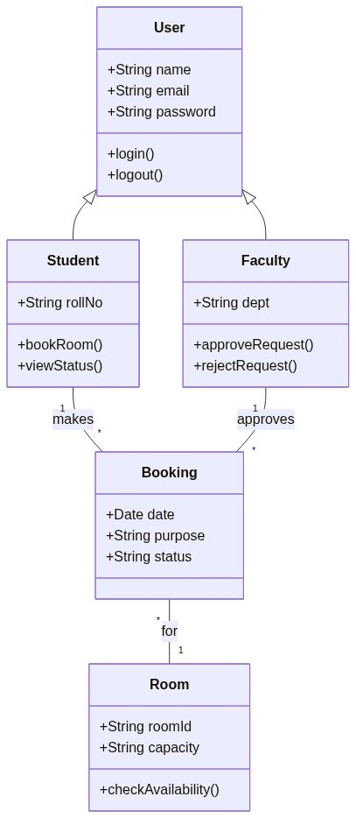

3.2 Sequence Diagram

3.2.1 Sequence diagram to Book Room
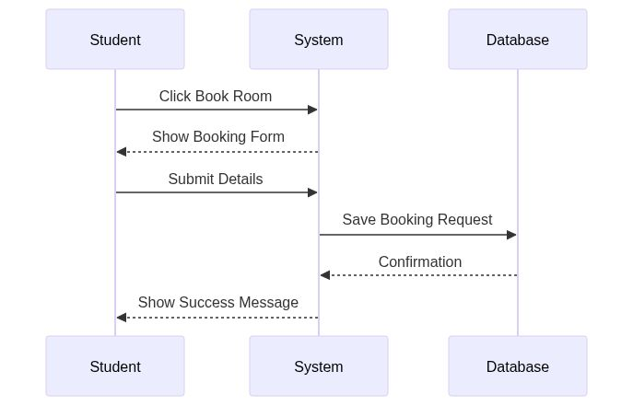

3.2.2 Sequence diagram to View Room
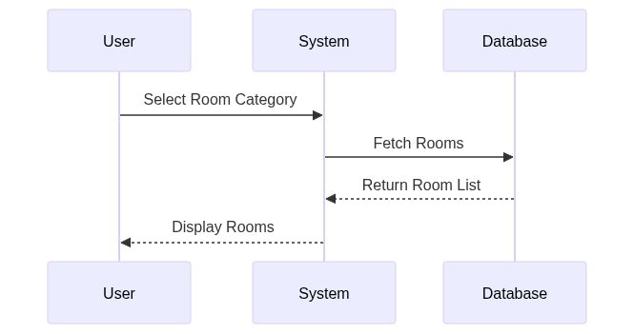

3.2.3 Sequence diagram for Login
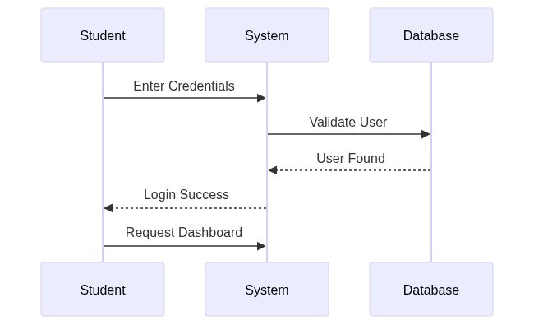

3.3 Collaboration Diagram

3.3.1 Collaboration diagram to Book Room
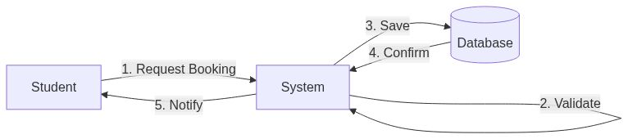

3.3.2 Collaboration Diagram to View Room
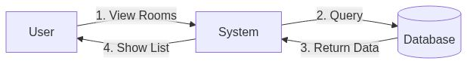

3.4 State Chart Diagrams

3.4.1 State Chart Diagram for Unregistered User
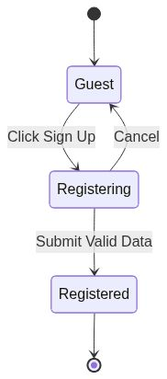

3.4.2 State Chart Diagram for Booking Request
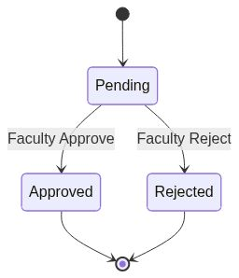

4. Implementation

4.1 Component Diagrams
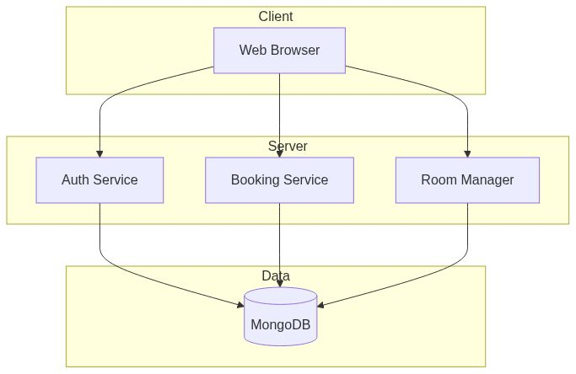

4.2 Deployment Diagrams
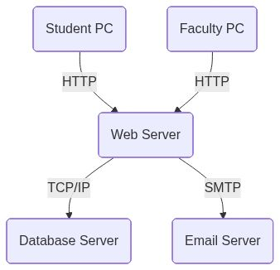

4.3 Screenshots
[Login Page Screenshot]
[Dashboard Screenshot]

5. Testing

5.1 Test Plan
Scope: Unit, Integration, System Testing.

5.2 Test Cases
ID | Desc | Expected | Status
TC1 | Login | Success | Pass

5.3 Test Reports
All tests passed.

