Roll No. 3569 Date of Performance: -
Title : Computation of N-point DFT/IDFT. Date of Checking: -
1) DFT:
clc;
clear all;
N=input('Enter the no. of points in DFT');
k=[0:1:N-1];
n=[0:1:N-1];
xn=input('Enter the element array');
L=length(xn);

if(N<L) %validate length of DFT
disp('"error,please verify no. of elements in DFT"')
return;
else if(N==L)
disp(xn)
else
xn=[xn,zeros(1,N-1)];
end
end

xk=[zeros(1,N)]; %create array xk of all zeros
for k=0:1:N-1
for n=0:1:N-1
xk(k+1)=xk(k+1)+(xn(n+1)*exp((-j*2*pi*n*k)/N)); %Equation of DFT
end
end
disp('calculated DFT is:')
xk
disp('calculated DFT by using inbuilt function is:')
yk=fft(xn,N)

disp('Magnitude plot of DFT is:') %Amplitude plot
m=abs(xk)
subplot(121)
plot(m)
hold all
stem(m)
xlabel('time');
ylabel('Amplitude');
title('Amplitude plot');

disp('Phase plot of DFT is:') %phase plot
subplot(122)
p=angle(xk)
plot(p)
hold all
stem(p)
xlabel('time');
ylabel('Phase');
title('Phase plot');

Output:
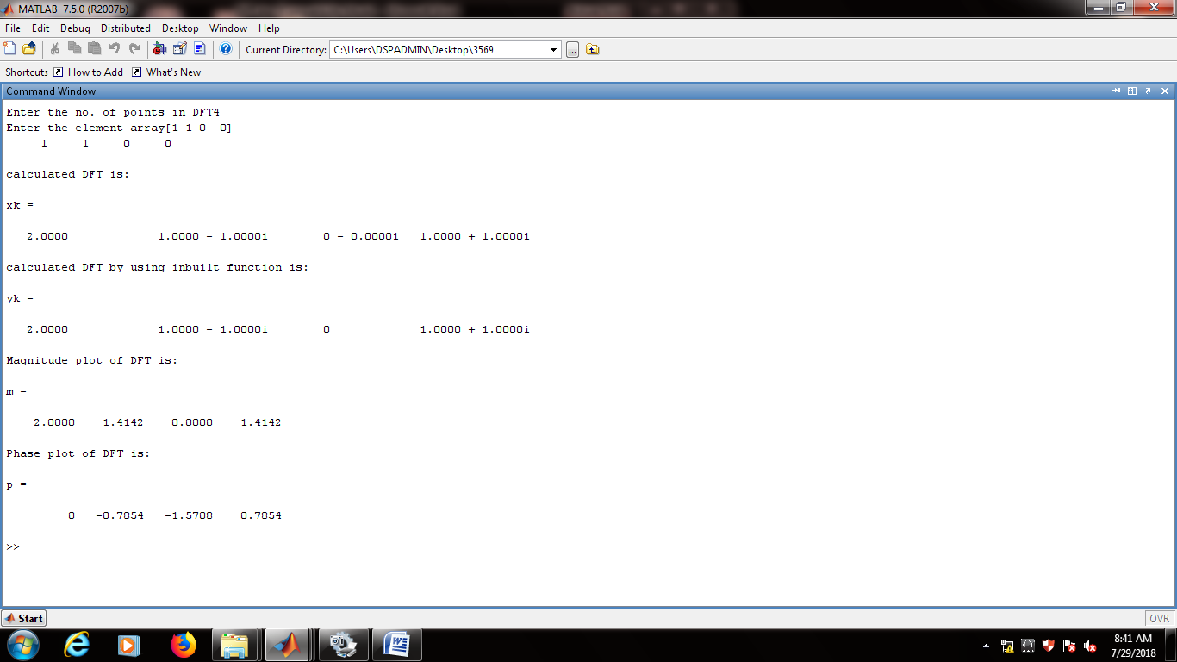

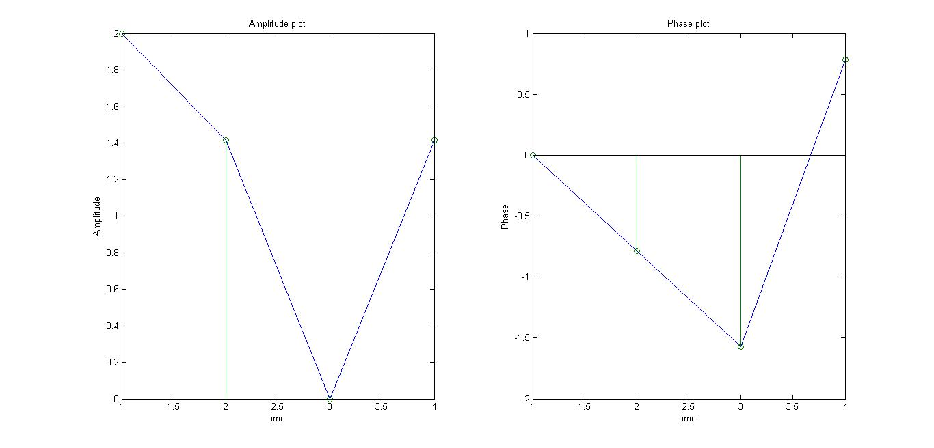

2) IDFT:
clc;
clear all;
N=input('Enter the no. of points in IDFT');
k=[0:1:N-1];
n=[0:1:N-1];
xk=input('Enter the element array');
L=length(xk);

if(N<L) %validate length of IDFT
disp('"error,please verify no. of elements in IDFT"')
return;
else if(N==L)
disp(xk)
else
xk=[xk,zeros(1,N-1)];
end
end

xn=[zeros(1,N)]; %create array xn of all zeros
for k=0:1:N-1
for n=0:1:N-1
xn(n+1)=xn(n+1)+(xk(k+1)*exp((j*2*pi*n*k)/N)); %Equation of DFT
end
end
xn=xn/N;
disp('calculated IDFT is:')
xn
disp('calculated IDFT by using inbuilt function is:')
yn=ifft(xk,N)

disp('Magnitude plot of IDFT is:') %Amplitude plot
m=abs(xn)
subplot(121)
plot(m)
hold all
stem(m)
xlabel('time');
ylabel('Amplitude');
title('Amplitude plot');

disp('Phase plot of DFT is:') %phase plot
subplot(122)
p=angle(xn)
plot(p)
hold all
stem(p)
xlabel('time');
ylabel('Phase');
title('Phase plot');

Output:
