**PROGRAM:**

set ns [new Simulator]

set nf [open TCP33.nam w]

$ns namtrace-all $nf

set tf [open TCP33.tr w]

$ns trace-all $tf

proc finish {} {

global ns nf tf

$ns flush-trace

close $nf

close $tf

exec nam TCP33.nam &

exit 0

}

set n0 [$ns node]

set n1 [$ns node]

set n2 [$ns node]

set n3 [$ns node]

set n4 [$ns node]

set n5 [$ns node]

set n6 [$ns node]

$ns duplex-link $n0 $n4 1Kb 50ms DropTail

$ns duplex-link $n1 $n4 1Mb 50ms DropTail

$ns duplex-link $n2 $n5 1Kb 50ms DropTail

$ns duplex-link $n3 $n5 1Mb 50ms DropTail

$ns duplex-link $n4 $n5 100Kb 50ms DropTail

$ns duplex-link $n6 $n5 1Mb 50ms DropTail

set source1 [new Agent/TCP]

$ns attach-agent $n0 $source1

set dest [new Agent/TCP]

$ns attach-agent $n2 $dest

$ns connect $source1 $dest

set appl [new Application/FTP]

$appl attach-agent $source1

$ns at 0.0 "$appl start"

$ns at 3.9 "$appl stop"

$ns at 4.0 "finish"

$ns run

**OUTPUT:**

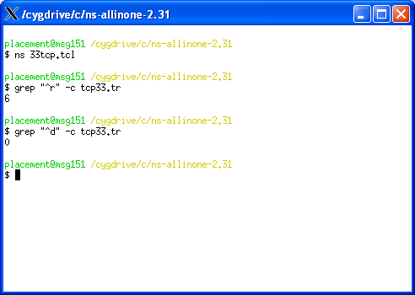

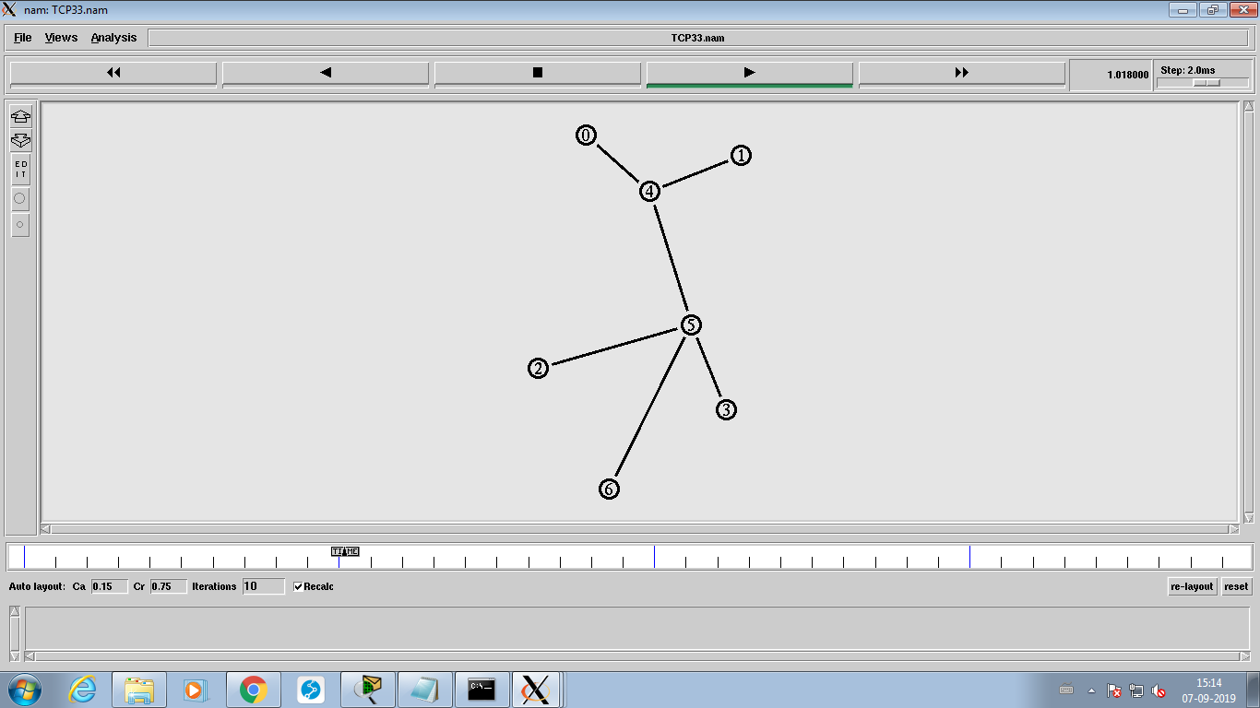

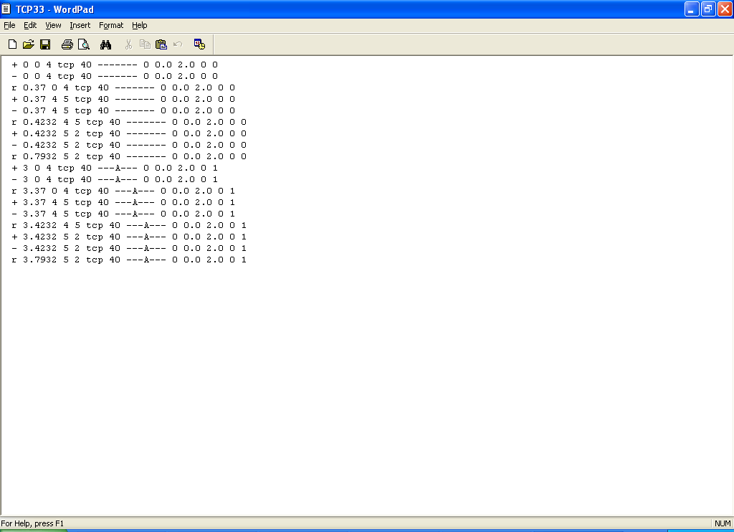

**UDP**

|  |
| --- |
|  |
|  | set ns[new Simulator] |
|  | $ns color 1 Blue |
|  | $ns color 2 Red |
|  |  |
|  | # Open the Trace files |
|  | set TraceFile [open outudp.tr w] |
|  | $ns trace-all $TraceFile |
|  |  |
|  | # Open the NAM trace file |
|  | set NamFile [open outudp.nam w] |
|  | $ns namtrace-all $NamFile |
|  |  |
|  | set n0 [$ns node] |
|  | set n1 [$ns node] |
|  | set n2 [$ns node] |
|  | set n3 [$ns node] |
|  | set n4 [$ns node] |
|  | set n5 [$ns node] |
|  |  |
|  | $ns duplex-link $n0 $n2 2Mb 10ms DropTail |
|  | $ns duplex-link $n1 $n2 2Mb 10ms DropTail |
|  | $ns duplex-link $n2 $n3 0.25Mb 100ms DropTail # bottleneck link |
|  | $ns duplex-link $n3 $n4 2Mb 10ms DropTail |
|  | $ns duplex-link $n3 $n5 2Mb 10ms DropTail |
|  |  |
|  | $ns queue-limit $n2 $n3 20 |
|  |  |
|  | $ns duplex-link-op $n0 $n2 orient right-down |
|  | $ns duplex-link-op $n1 $n2 orient right-up |
|  | $ns duplex-link-op $n2 $n3 orient right |
|  | $ns duplex-link-op $n3 $n4 orient right-up |
|  | $ns duplex-link-op $n3 $n5 orient right-down |
|  |  |
|  | #TCP N0 and N4 |
|  | set tcp [new Agent/TCP/Newreno] |
|  | $ns attach-agent $n0 $tcp |
|  |  |
|  | set sink [new Agent/TCPSink/DelAck] |
|  | $ns attach-agent $n4 $sink |
|  |  |
|  | $ns connect $tcp $sink |
|  | $tcp set fid_ 1 |
|  |  |
|  | #FTP TCP N0 and N4 |
|  | set ftp [new Application/FTP] |
|  | $ftp attach-agent $tcp |
|  | $ftp set type_ FTP |
|  |  |
|  | #UDP N1 and N5 |
|  | set udp [new Agent/UDP] |
|  | $ns attach-agent $n1 $udp |
|  | set null [new Agent/Null] |
|  | $ns attach-agent $n5 $null |
|  | $ns connect $udp $null |
|  | $udp set fid_ 2 |
|  |  |
|  | #CBR N1 and N5 |
|  | set cbr [new Application/Traffic/CBR] |
|  | $cbr attach-agent $udp |
|  | $cbr set type_ CBR |
|  | $cbr set packet_size_ 500 |
|  | $cbr set interval_ 0.005 |
|  |  |
|  | $ns duplex-link-op $n2 $n3 queuePos 0.5 |
|  |  |
|  | $ns at 0.1 "$ftp start" |
|  | $ns at 10.0 "$cbr start" |
|  | $ns at 40.0 "$cbr stop" |
|  | $ns at 50.0 "$ftp stop" |
|  |  |
|  | proc finish {} { |
|  | global ns TraceFile NamFile |
|  | $ns flush-trace |
|  | close $TraceFile |
|  | close $NamFile |
|  | exec nam outudp.nam & |
|  | exit 0 |
|  | } |
|  |  |
|  | $ns at 60.0 "finish" |
|  | $ns run |

OUTPUT:

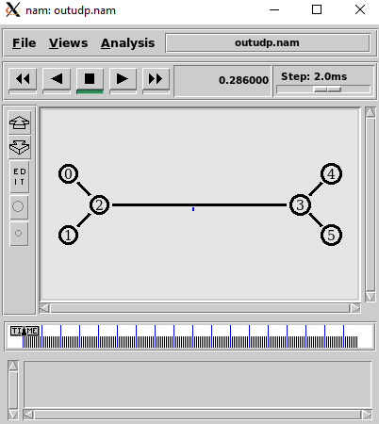

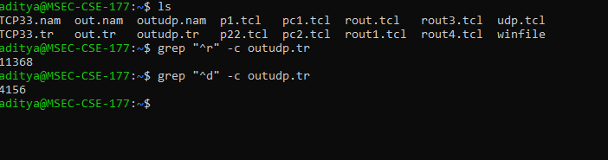

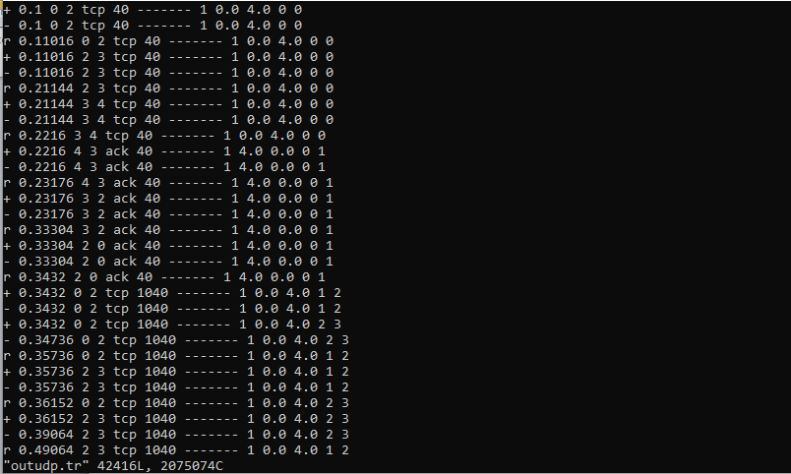

**Calculation**

$$efficiency=\frac{pkts received}{pkts received+pkts dropped}*100\%$$

$$efficiency=\frac{11368}{11368+4156}*100\%$$

$$efficiency=70\%$$

$$throughput=\frac{pkt size*pkt received}{time taken}$$

$$throughput=\frac{40*11368}{50.3158}$$

$$throughput=9040.27 bits/ms$$