

Aditya Gupta

A00268733

Assignment Report

Open Weather API implementation using HTML, CSS and JAVA

# Abstract

The objective of this project was to develop a Weather Website. The purpose of implementing this application was to allow users to see and view the weather updates of a particular city.

# Introduction

OpenWeatherMap is an online service that provides weather data, including current weather data, forecasts, and historical data to the developers of web services and mobile applications. The purpose is to use the api from openwathermaps using an ajax request. This data is then parsed into a website to make the data visually appealing. The Website will automatically detect the location of the user and display the weather information for that city. The weather information is displayed in form of 5 days with data of every 3 hrs. You can then hover over the graph to see the temperatures expected on that specific date.

# Key Features

* Tells your location on basis of your current location (Requires Location Permission).
* Shows Information of the current temperature in a current city with the minimum and maximum temperature.
* Shows forecast of 5 upcoming days with a brief weather information.
* Graph denoting minimum and maximum temperatures in the upcoming 5 days.
* Beautiful interface to keep Users engaged with the looks.
* City search to allow the user to search for information regarding any city.

# Code Snippets

Finding weather icon

Here I am converting the weather name from the openweather api to my local image file name. So that whenever I get a weather I can show my own icon instead of it

Updating chart data

This is the code for updating the charts. When we create the first instance of the graph object we don’t need to reinitialize the complete graph rather we can update the data only

Acquiring Data from API

Here I used ajax to get the data from the open weather api

Parsing Data

Here I am parsing the information from the api into the html elements

Background Animator

This code is responsible to give the background for a specific weather

Chart JS

# 

This is the code for chart initialization.

Chart Data Creation

Here I loop into the array and create three arrays for label and 2 datas which are passed to graph.

Location Access

We access the geolocation for the current position using this code

Button Click

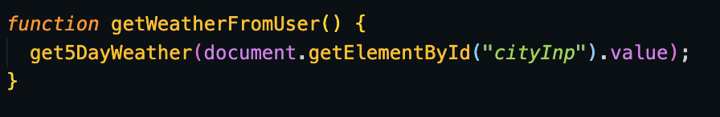

This is the event click for get weather

# Screenshots

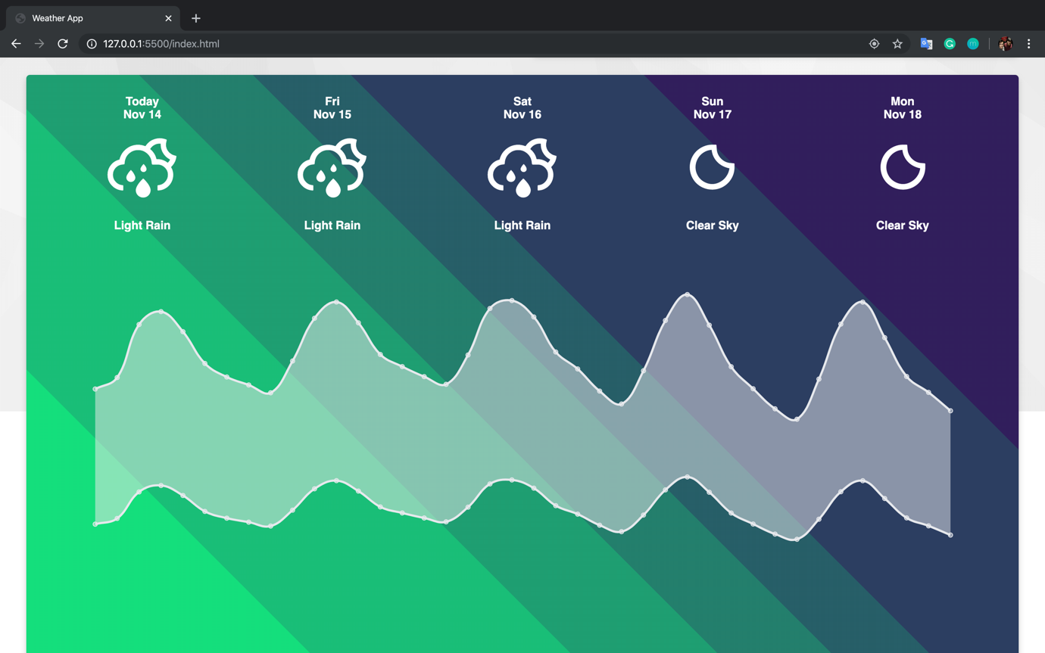

NOTE: I choose to hide the legends and the scales because of the aesthetics of the graph.

# Conclusion

### OpenWeatherMaps provides amazing API’s which can be used to create useful apps without much effort. This demonstration shows you how easy is creating interactive applications which also provide information.