**Does the negative media buzz affect the airline's performance in terms of revenue?**

    The statistics of fatalities over the decade and the media buzz on airline safety have not impacted the airlines' revenue much. And below are the factors that contribute to my case study.

**Airlines Accident Trend:**

    The occurrences of fatal accidents, fatalities, and incidents are getting reduced (see Figure 1: Airlines Fatalities Trend Graph). It signifies that airlines are getting better with improved infrastructure, and it is safe to travel.

[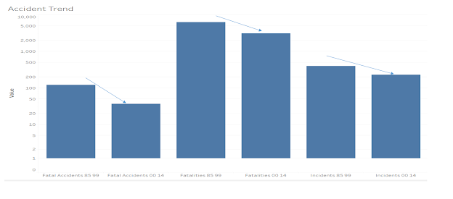](https://www.blogger.com/blog/post/edit/6573165392011511096/8438500131722962400?hl=en)

Figure 1: Airlines Fatalities Trend Graph

The below graph provides insights into fatal accident occurrences over a decade. On average, 70% of accidents are reduced, and the latest reported accidents are due to pilot negligence but not due to airline infrastructure.

[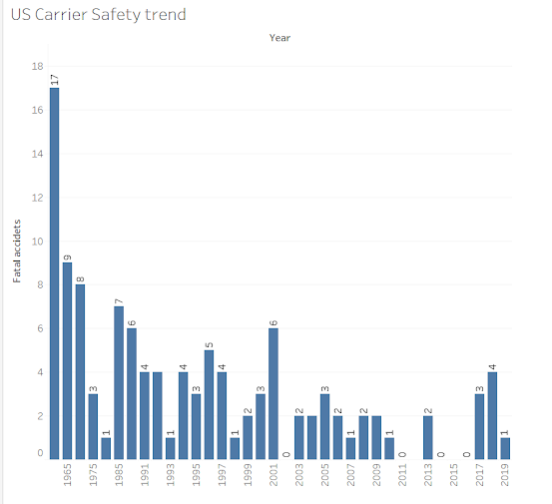](https://www.blogger.com/blog/post/edit/6573165392011511096/8438500131722962400?hl=en)

Figure 2: U.S Fatal Accidents Trend 1960-2019

**Airline Stock trends:**

If we observe the airline stock trends (Figure3: AirlineStocks), it has grown significantly, ranging from 20$ to 100 $ per stock over some time.

Let us discuss the factors that contributed to a stock price increase

**Factor 1**: Demand: Between 2002 and 2020, Airline revenues from certain services consistently increased year-over-year as airline customers became more willing to pay extra for a more comfortable flying experience.

**Factor 2**: Ticket fee. United Airlines' prices rose from $41 per passenger in the third quarter of 2019 to as much as $65 in the same quarter a year later—representing a remarkable increase of 59%. Alaska, Southwest.

**Factor 3** – Adding new routes: Airlines are beginning to add new routes to their networks to take advantage of voids left by competitors and coming up with a competitive strategy to serve customers. "Southwest airline"- The Dallas-based carrier is pushing into two large airports, Chicago's O'Hare International Airport and Houston's George Bush Intercontinental Airport, both historically dominated by rivals United and American. United following the same pattern; For the first time in five years, United will be returning to NYC John F. Kennedy International Airport this year, having already added over a dozen new flights, including one from Denver to Belize City Belize.

** United Airlines has improved its airline infrastructure, and today, it stands as the safest airline to travel globally.

[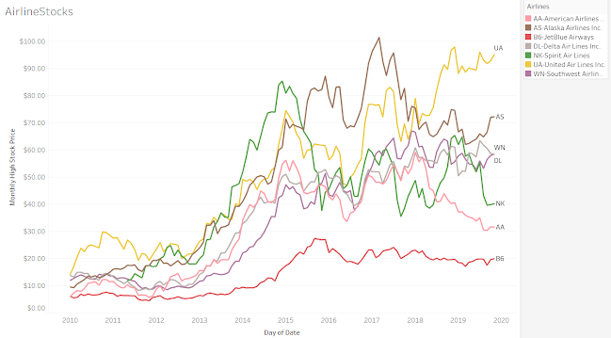](https://www.blogger.com/blog/post/edit/6573165392011511096/8438500131722962400?hl=en)Figure 3: AirlineStocks

**Revenues per passenger-per ASM:**

Revenue passenger miles (or RPM) is also called airline “traffic.” It includes air transport demand. RPM is calculated as the number of revenue passengers multiplied by the total distance traveled. It’s An increase in RPM is positive for an airline company. It means that more passengers are using their service. It results in topline growth—assuming the yield also increases.

Revenues per passenger per available seat mile, the industry’s standard measure of performance, plummeted by 69% in 2019, compared with 2002. It correlates to the same factors as discussed above, but significantly; all the airlines are now adapting

* Regulatory challenges
* Battery technology readiness
* Vehicle performance and efficiency
* Air Traffic Management
* Noise and Emissions
* Vertiport Infrastructure in cities
* Pilot training

[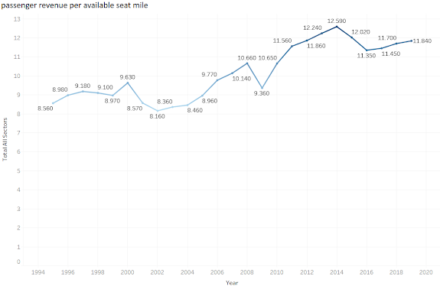](https://www.blogger.com/blog/post/edit/6573165392011511096/8438500131722962400?hl=en)Figure 4: Passenger Revenue per ASM 1194-2020

**Airline Market Share:**

**[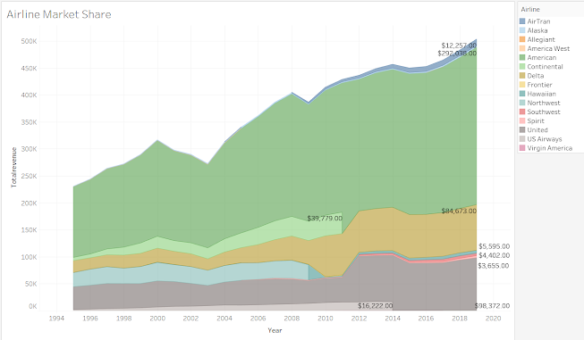](https://www.blogger.com/blog/post/edit/6573165392011511096/8438500131722962400?hl=en)**Figure 5: **Airline Market Share**

**Are fatalities still a fear to board a flight?**

The answer is “no.” People are opting for Air travel due to gained trust in modern infrastructure. The below dashboard clearly depicts that airlines are adding more routes to meet the customer's demand and increasing the stock per share value, and gaining a proportional increase in the market stake of profit margins. The increase in the stock price clearly exemplifies that “fear of fatality” is decreased due to increased airline safety measures.

[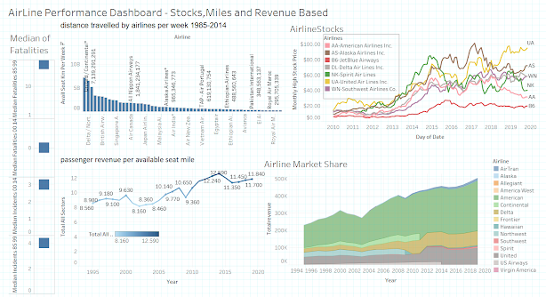](https://www.blogger.com/blog/post/edit/6573165392011511096/8438500131722962400?hl=en)

Figure 6: Airline Performance dashboard

**Resources:**

Holmes, F. (2021, June 28). *5 Reasons Airline Stocks Could Be A Buy In 2021*. Forbes. https://www.forbes.com/sites/greatspeculations/2021/02/04/5-reasons-airline-stocks-could-be-a-buy-in-2021/?sh=6b88e7036794.

Cederholm, T. (2014, October 30). *Why are revenue passenger miles important?* Market Realist. https://marketrealist.com/2014/10/why-revenue-passenger-miles-important/.

Goudarzi (IATA), H. (2018, January 2). *6 Technologies will Revolutionise the Aviation Industry in 2017*. International Airport Review. https://www.internationalairportreview.com/article/26374/technology-revolutionise-aviation-2017/.

**Data Sources:**

data.world, . (2019). BTS Airline Fuel Data by Carrier 2010-2019. https://data.world/utmlfall2019/bts-airline-fuel-data-by-carrier-2010-2019.

United States Department of Transportation. (2019). *U.S. Air Carrier Safety Data*. U.S. Air Carrier Safety Data | Bureau of Transportation Statistics. https://www.bts.gov/content/us-air-carrier-safety-data.

 MIT. Global Airline Industry Program. (2006). Airline Data Project. http://web.mit.edu/airlinedata/www/Traffic&Capacity.html.

Airline safety: [**https://github.com/fivethirtyeight/data/tree/master/airline-safety**](https://www.blogger.com/blog/post/edit/6573165392011511096/8438500131722962400?hl=en)

Blog link:

<https://asumbaraju-airlineperformance.blogspot.com/2021/07/does-negative-media-buzz-affect.html>