GLOWING TWO LEDs USING CONDITIONAL STATEMENTS

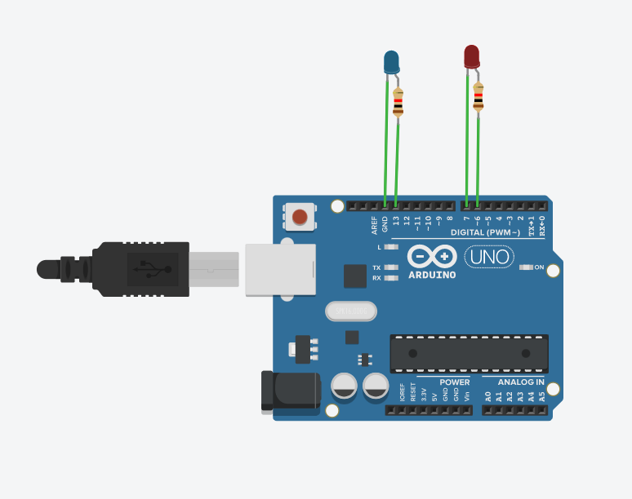

CODE

char i; //declaring variable I as character

void setup() // the setup function runs once when you press reset or power the board

{

pinMode(13, OUTPUT); //initializing pin 13 as output

pinMode(7, OUTPUT); //initializing pin 7 as output

pinMode(6, OUTPUT); //initializing pin 6 as output

digitalWrite(7, LOW); //giving 0v to pin 7

Serial.begin(9600); //initializing serial monitor at baud rate 96000

}

void loop() // the loop function runs over and over again forever

{

if (Serial.available() > 0) { //checking input is available in serial monitor

int i = Serial.read(); //to read value from serial monitor

if(i=='1') //checking if I is character 1

digitalWrite(13,HIGH); //giving 5v to pin 13

else if(i=='2') //checking if I is character 2

digitalWrite(6,HIGH); //giving 5v to pin 6

Else //checking if I is neither 1 nor 2

Serial.println("VALUE OF I IS WRONG"); //printing this statement in serial monitor

}

}

OUTPUT

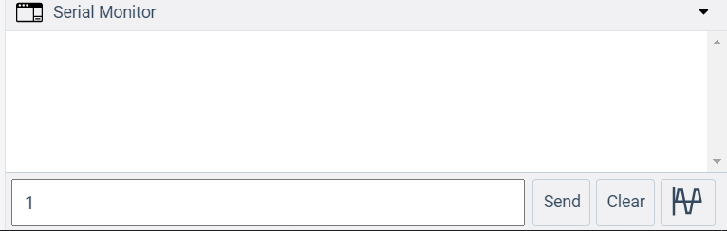

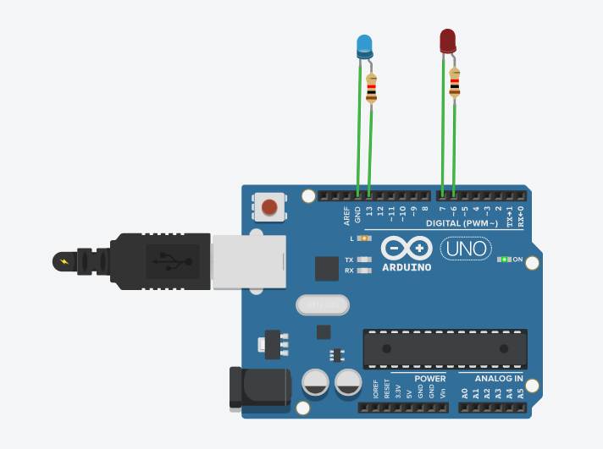

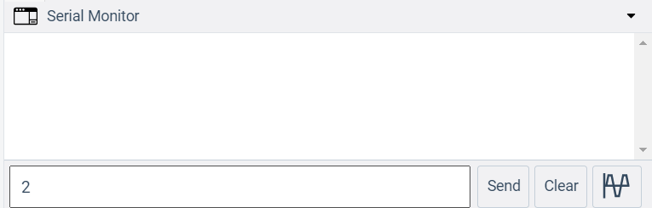

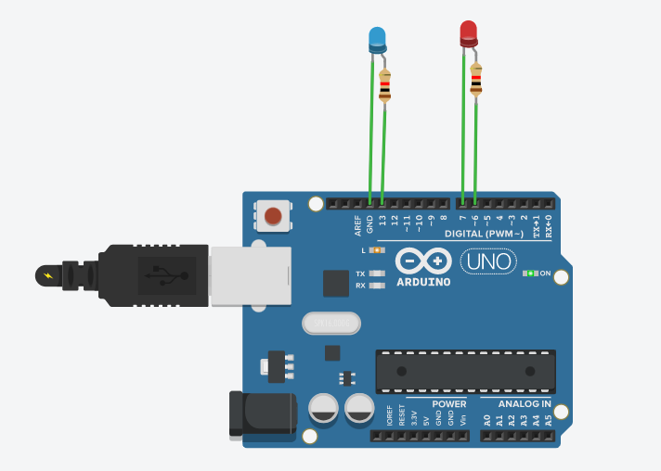

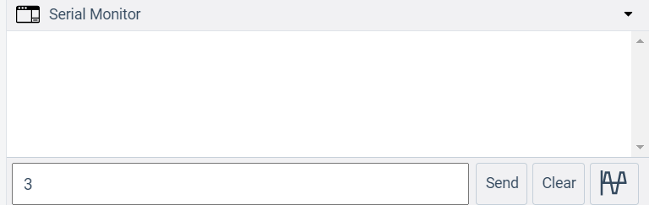

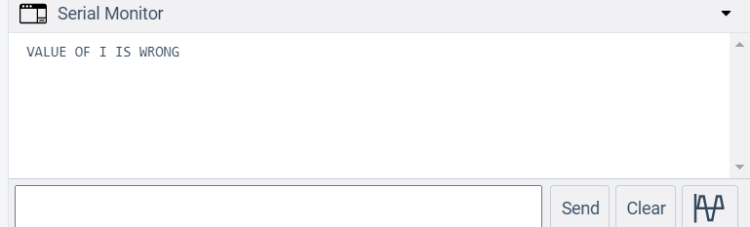

BLINKING OF LEDs

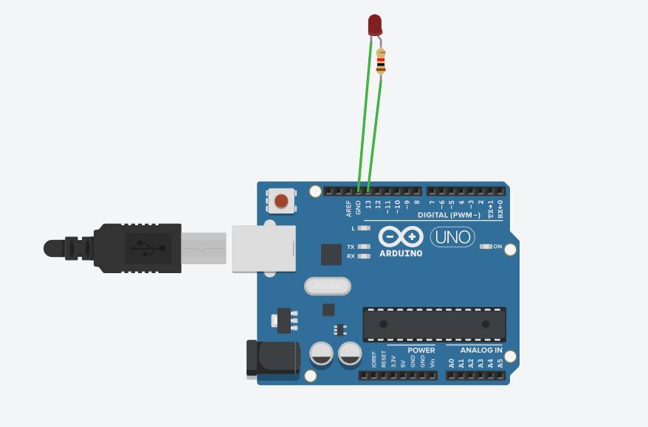

void setup() { // the setup function runs once when you press reset or power the board

pinMode(13, OUTPUT); // initialize digital pin 13 as an output.

}

void loop() { // the loop function runs over and over again forever

digitalWrite(13, HIGH); //giving 0v to pin 7

delay(1000); // wait for a second

digitalWrite(13, LOW); // giving 0v to pin 7

delay(1000); // wait for a second

}

OUTPUT



FADING LED

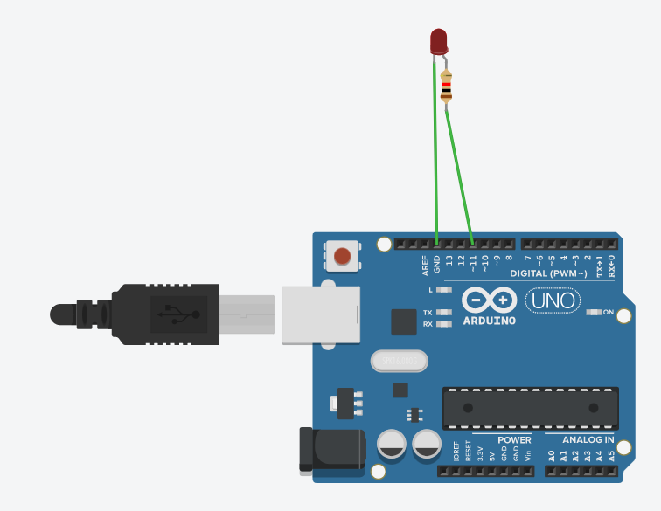

// the setup function runs once when you press reset or power the board

void setup() {

// initialize digital pin LED_BUILTIN as an output.

pinMode(11, OUTPUT);//CONNECT TO PWM PINS

}

// the loop function runs over and over again forever

void loop() {

analogWrite(11,255);//giving 225volts at pin 11

delay(1000); //wait for a second

analogWrite(11,150);//giving 150 volts at pin 11

delay(1000); //wait for a second

analogWrite(11,60);//giving 60 volts at pin 11

delay(1000); //wait for a second

analogWrite(11,30);//giving 30 volts at pin 11

delay(1000); //wait for a second

analogWrite(11,0);//giving 0 volts at pin 11

delay(1000); //wait for a second

}

OUTPUT



Controlling Speed of DC Motor

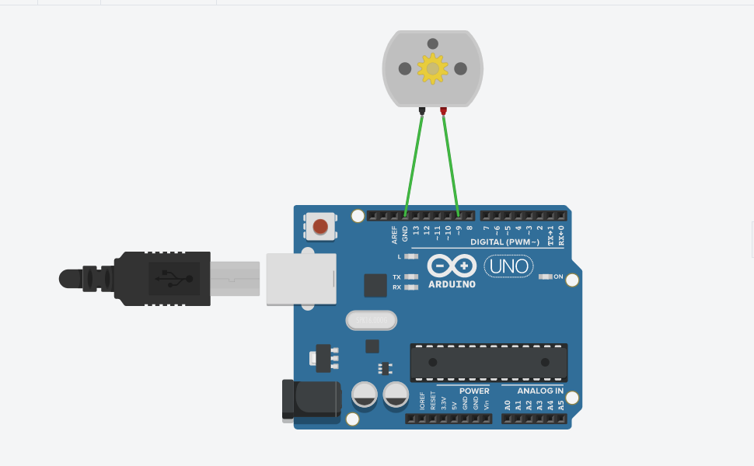

Code

//*Speed in 255 value*

void setup() {

pinMode(9, OUTPUT); // initializing pin 9 as output

}

void loop() {

analogWrite(9,255); //giving 5V to pin 9

}

Output

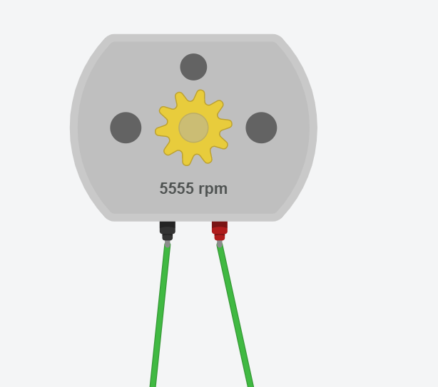

Code

//*Speed in 100 value*

void setup(){

pinMode(9, OUTPUT); // initializing pin 9 as output

}

void loop(){

analogWrite(9,100 ); //giving 1.96V to pin 9

}

Output

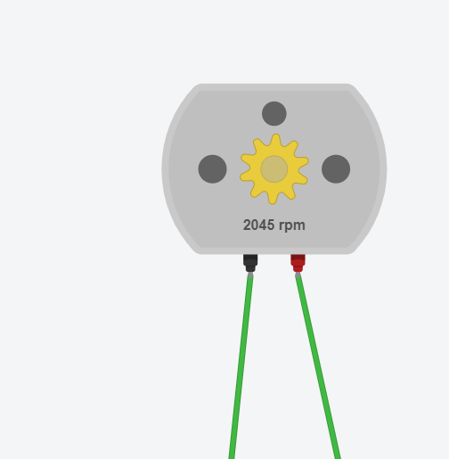

Blinking blue and red LED using loop

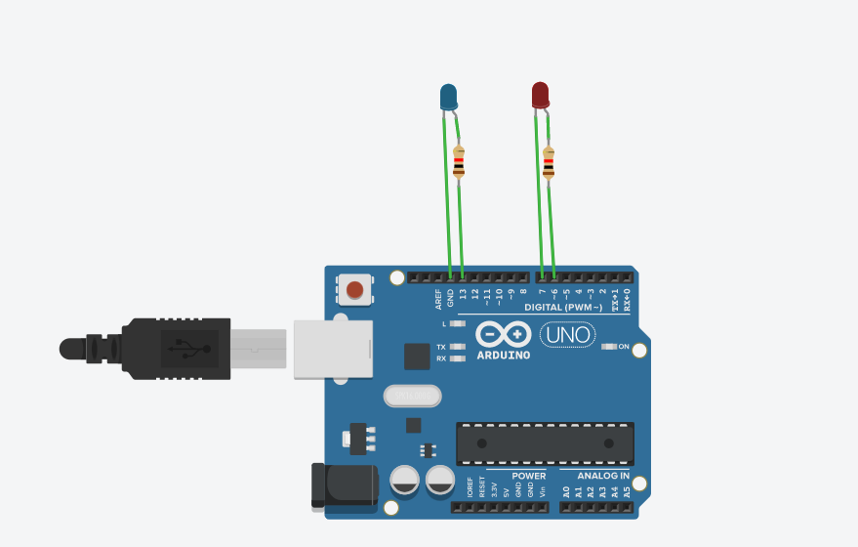

Code

//blinking blue and red led 5 times using loops

int i; //declaring integer i

void setup() {

pinMode(13, OUTPUT); //initializing pin 13 as output

pinMode(6, OUTPUT); //initializing pin 7 as output

pinMode(7, OUTPUT); //initializing pin 6 as output

digitalWrite(7,LOW); //giving 0V to pin 7

}

void loop(){

for(i=1; i<=5;i++) //loop continues till i<=5 and i increments after every iterations

{

digitalWrite(13,HIGH); //giving 5V to pin 13

delay(1000); //wait for 1 second

digitalWrite(13,LOW); //giving 0V to pin 13

delay(1000); //wait for 1 second

}

delay(5000); //wait for 5 second

for(i=1; i<=5;i++) //loop continues till i<=5 and i increments after every iterations

{

digitalWrite(6,HIGH); //giving 5V to pin 13

delay(1000); //wait for 1 second

digitalWrite(6,LOW); //giving 0V to pin 13

delay(1000); //wait for 1 second

}

delay(5000); //wait for 5 second

}

Output



REFERENCES

DOWNLOAD SOFTWARE

<https://www.arduino.cc/en/software>

ARDUINO DOCUMENTATION

<https://docs.arduino.cc/>

ARDUINO YOUTUBE

<https://youtube.com/playlist?list=PLGs0VKk2DiYx6CMdOQR_hmJ2NbB4mZQn->