* Creating 2 Directories and creating a new file.txt in it.

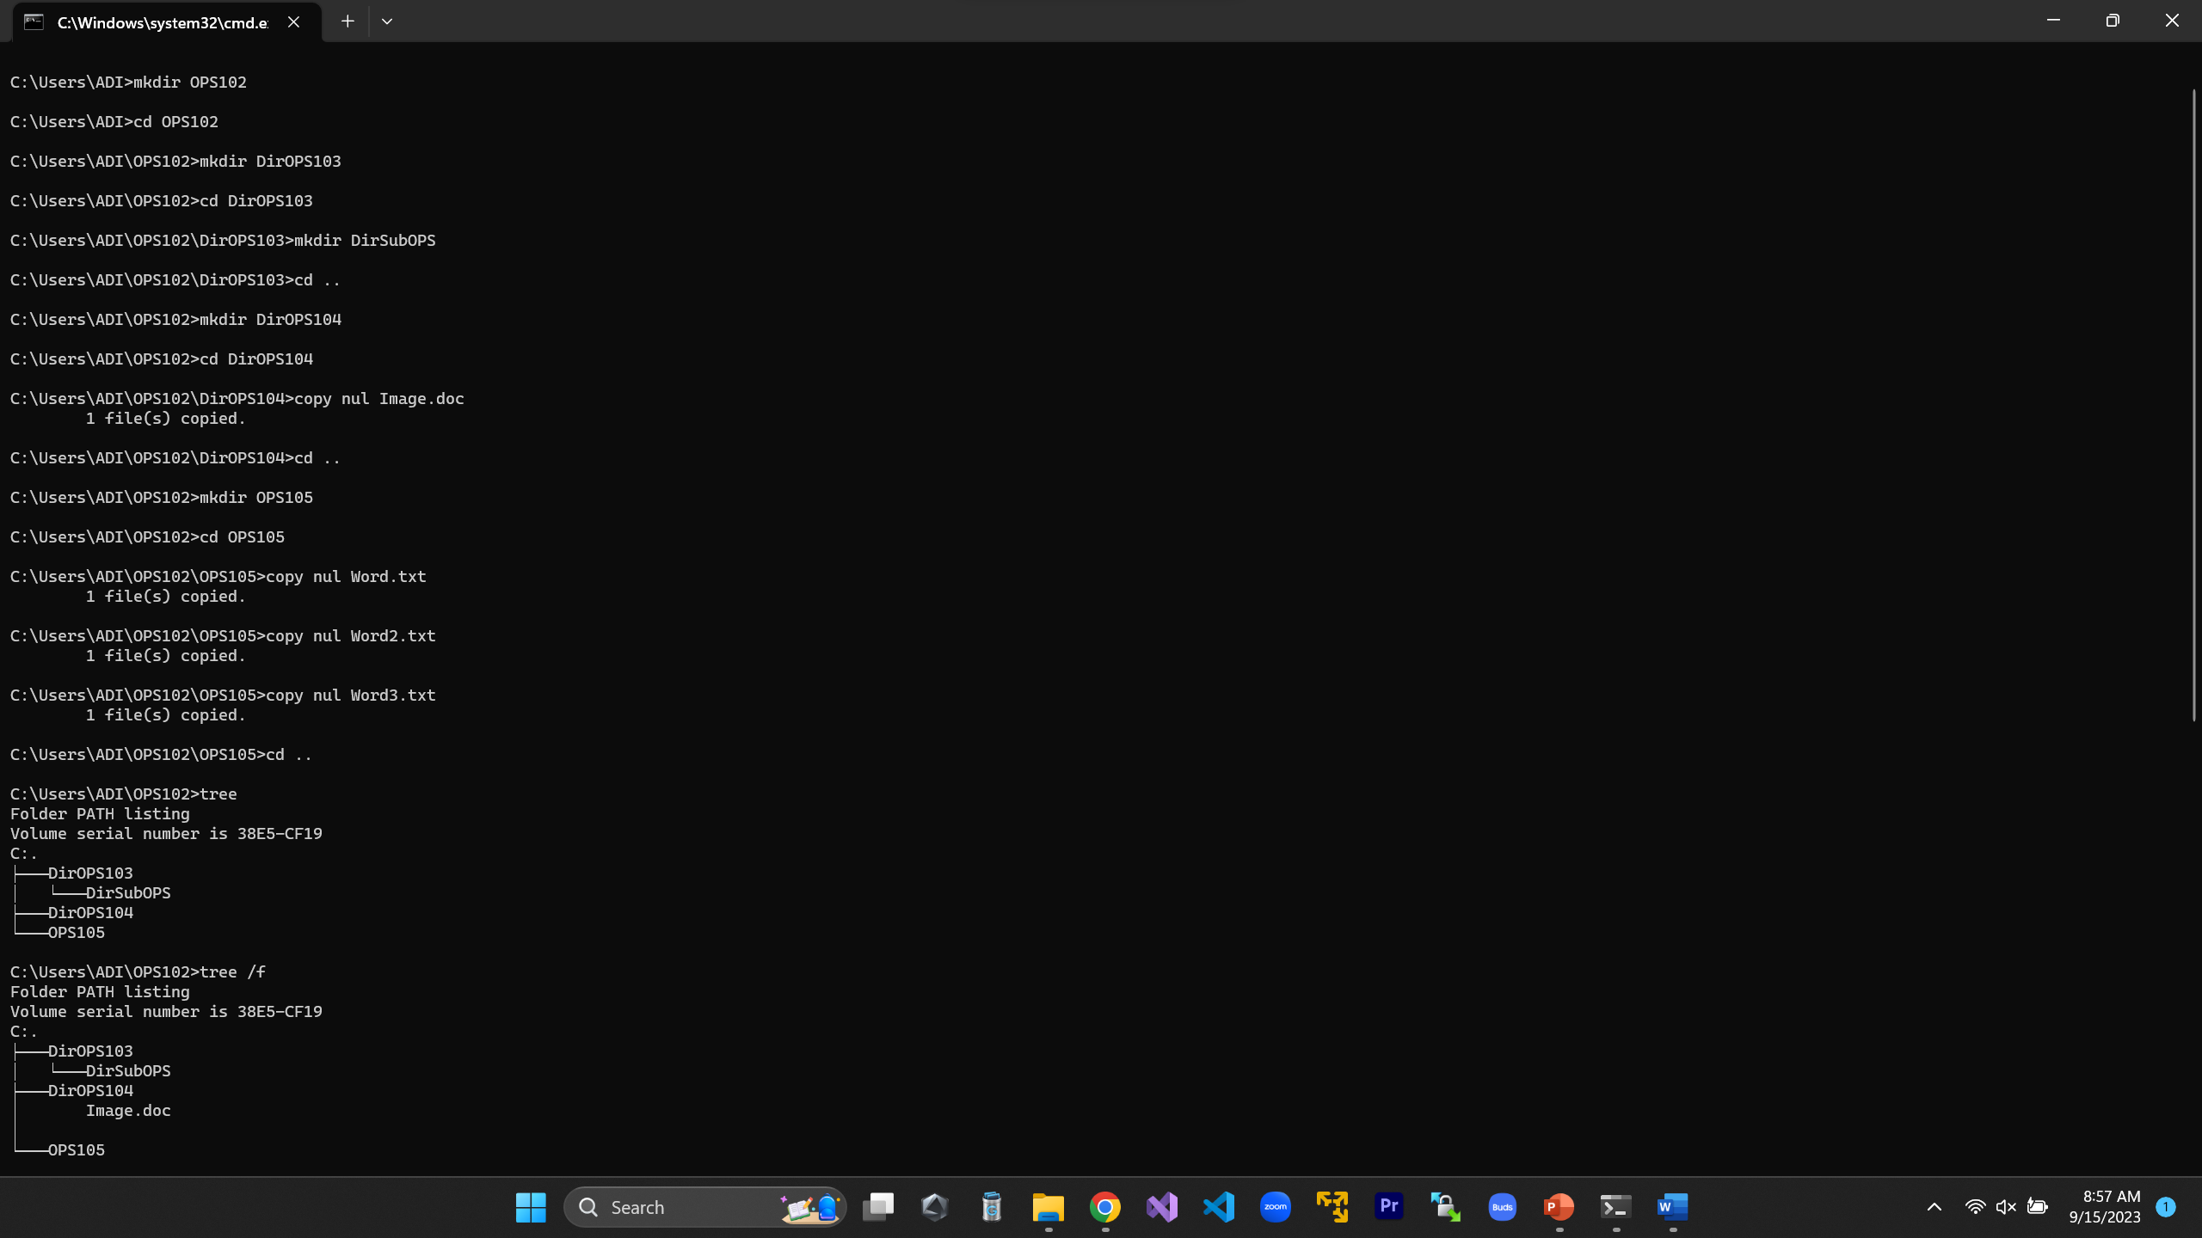

* Creating a main Directory (OPS102), then creating 3 Sub Directories (DirOPS103, DirOPS104, DirOPS105).

Then, in DirOPS103, create another sub-Directory named DirSubOPS & exit it.

* Now move to the next DirOPS104 Directory and create Image.doc file & exit.
* Then head to the Last Sub-Directory Create 3 files starting with name Word.txt, Word2.txt, Word3.txt & exit.