PAAS Service:

Create Azure SQL server:

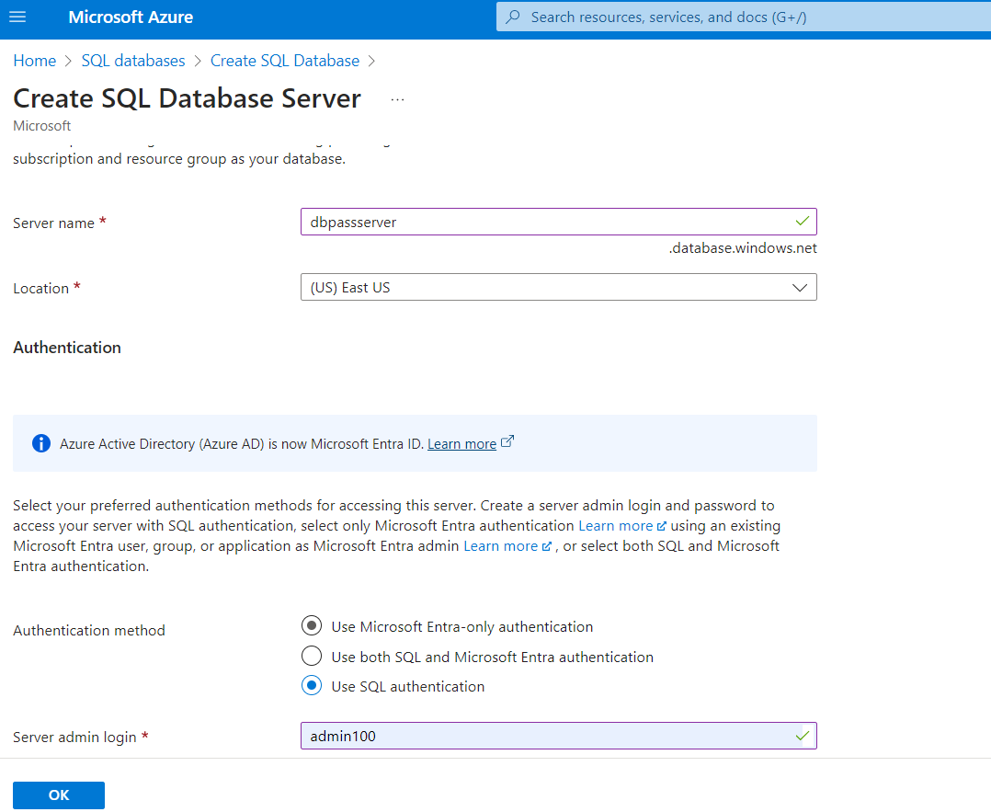

Create Azure database :

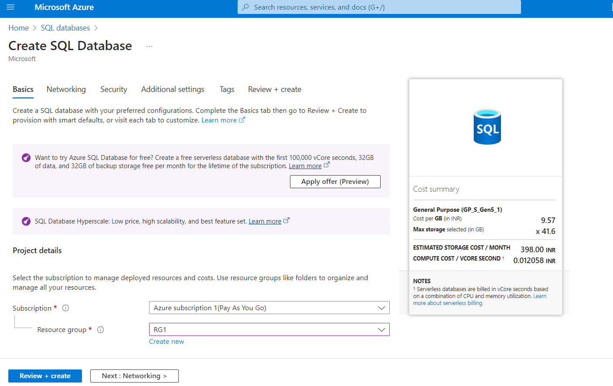

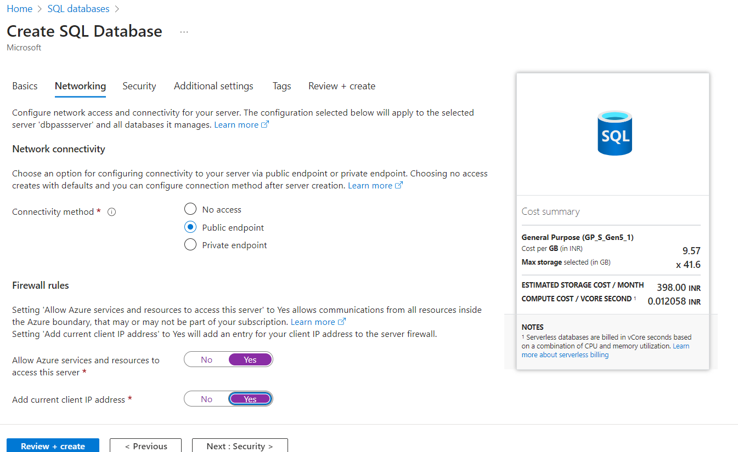

Created below two databases:

1)DB1-PAAS

2)DB2-PAAS

