

MGM University
JAWAHARLAL NEHRU ENGINEERING COLLEGE (JNEC)
Department of Artificial Intelligence and Data Science

A Mini Project Report on

BUSINESS ANALYTICS FOR AN EFFICIENT LIBRARY MANAGEMENT SYSTEM

Course: Introduction to Business Analytics
Submitted by:
- Aditya Wagh (202401128020)
- Aditya Wagh (202401128020)
- Aditya Wagh (202401128020)
Engineering Branch / Year / Division: __________________________
Submitted to: Mr. Vikas Shahane
Academic Year: 2026-27

DECLARATION

I hereby declare that the mini project titled “Business Analytics for an Efficient Library Management System” submitted to Jawaharlal Nehru Engineering College (JNEC) is the result of my own work carried out for the course Introduction to Business Analytics. This report has not previously been submitted, in whole or in part, to any University or Institute for the award of a degree or diploma.

Aditya Wagh – 202401128020

Abstract

This project explores how business analytics can support an efficient library management system. Libraries manage book inventories, issue and return transactions, reservations, and overdue items. The report uses an illustrative teaching dataset of 100 borrowing records to demonstrate data preparation, descriptive statistics, data visualization, and interpretation of operational indicators. The example analysis examines return status, transaction patterns, and service efficiency. The dataset is hypothetical and is used only to demonstrate the analytical approach; it does not represent actual records from the college library.

Contents
Sr. No | Title | Page. No
1 | Introduction | 5
2 | Problem Statement | 6
3 | Aim and Objectives | 7
4 | Data Collection and Sources | 8
5 | Data Analysis | 9
6 | Findings | 10
7 | Recommendations and Action Plan | 11
8 | Conclusion | 12

1. Introduction
Business analytics is the systematic use of data, statistical methods, and analytical tools to understand performance and support decisions. A library management system applies these principles to records such as book catalogues, issue and return transactions, reservations, and overdue items. Analysing these records can help library staff understand demand, monitor book availability, and improve services.
A college library serves students and faculty who need timely access to books and other learning resources. Inefficiencies may arise when book availability is unclear, issue and return records are not updated promptly, or overdue items are not tracked consistently. These issues can affect access to resources and increase the workload of library staff.
A data-driven library management system can track the number of books issued and returned, identify popular categories, calculate overdue rates, and monitor transaction volumes over time. This mini project applies introductory business analytics methods to an illustrative set of library transactions and proposes practical improvements based on the example indicators.

2. Problem Statement
Libraries may face difficulties in tracking available copies, identifying frequently borrowed books, monitoring overdue returns, and understanding service demand. When records are maintained inconsistently or are not analysed, staff may struggle to plan acquisitions, follow up on overdue items, and allocate resources effectively. The problem addressed by this project is how business analytics can be used to examine library operations and recommend feasible, evidence-based improvements.

3. Aim and Objectives
Aim: To demonstrate how business analytics can be applied to library transaction data to improve resource availability, circulation monitoring, and operational efficiency.
- Identify relevant library variables such as book category, issue date, return date, and return status.
- Describe the illustrative dataset, its variables, sample size, and limitations.
- Explain data-cleaning checks for missing values, duplicate transactions, and inconsistent dates.
- Calculate basic descriptive statistics and key performance indicators for library operations.
- Compare transaction counts across days and identify periods of higher library activity.
- Use percentage calculations and comparisons to interpret circulation and overdue patterns.
- Create charts and explain what the illustrative results indicate.
- Recommend practical improvements and define indicators for future monitoring.

4. Data Collection and Sources
- Limitation: this report uses hypothetical data for demonstration; the figures are not actual college library records.
- Privacy and permission: obtain library approval and exclude student names, roll numbers, phone numbers, and other unnecessary identifiers.
- Data quality: check duplicate transaction IDs, missing dates, inconsistent category labels, and return dates earlier than issue dates.
- Sampling: define the observation period in advance and include both busy and quieter periods where possible.
- Suggested fields: transaction ID, book category, issue date, due date, return date, and return status.
For a real study, the following data collection approach is recommended:
- Data source: authorized, anonymized library issue and return records, book-category counts, reservation logs, and overdue records.
For primary data, define the observation period and select a consistent set of fields. Suggested fields include transaction ID, book category, issue date, due date, return date, and status (on time or overdue). A sample covering both busy and quieter periods can help identify changes in demand. Date fields should use a consistent format, and overdue status should be calculated using the due date and return date.
Avoid including student names, roll numbers, phone numbers, or other unnecessary personal identifiers. Obtain permission before using institutional records and follow library and college rules. Document the data source, collection period, definitions, and limitations so that the analysis can be understood and reproduced.

5. Data Analysis
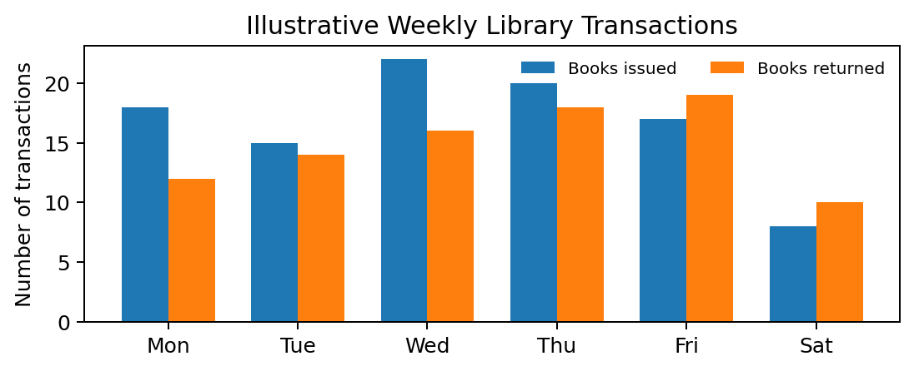
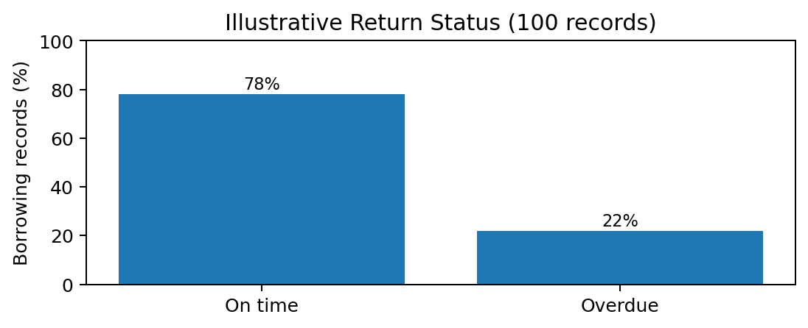
Illustrative dataset: 100 borrowing records. The following values are hypothetical and are included only to demonstrate the analysis method.
• Records analysed: 100
• Returned on time: 78 records (78%)
• Overdue returns: 22 records (22%)
• Average daily issues in the six-day example: 16.7 books
• Highest daily issues: Thursday (20 books)
• Lowest daily issues: Saturday (8 books)
Overdue rate = (Overdue records ÷ Total borrowing records) × 100 = (22 ÷ 100) × 100 = 22%.
Data preparation should check duplicate transaction IDs, missing due dates, return dates earlier than issue dates, and inconsistent category labels. The sample is illustrative, so the figures cannot be generalized to the actual college library.

6. Findings
- 78 records (78%) were returned on time in the illustrative dataset.
- 22 records (22%) were overdue, giving an illustrative overdue rate of 22%.
- Thursday had the highest number of book issues (20) in the six-day example.
- Saturday had the lowest number of book issues (8) in the six-day example.
- The example suggests that library activity can vary by day, so actual transaction data should be checked before changing staffing or service arrangements.
- These figures are hypothetical and are not verified results from the college library.
Note: These findings are based on hypothetical data and must not be reported as actual library performance.

7. Recommendations and Action Plan
The following actions are proposed for evaluation. They should be tested using actual library data before being adopted:
- Circulation support: review staffing and counter arrangements during days or periods with consistently high issue and return volumes.
- Issue and return workflow: maintain a clear, consistent process for recording book issues, returns, and renewals.
- Inventory planning: use borrowing frequency and reservation counts to identify books that may require additional copies.
- Overdue monitoring: generate a regular list of overdue items and send reminders through approved college channels.
- Performance dashboard: monitor total issues, returns, overdue rate, most-borrowed categories, and unavailable-book requests.
For evaluation, record baseline indicators before introducing a change and compare them with the same indicators afterward. Useful measures include overdue rate, percentage of records with complete fields, time taken to process a transaction, and the number of requests for unavailable books. Targets should be agreed with library staff and should not be presented as achieved results unless supported by collected data.

8. Conclusion

This mini project demonstrates how business analytics can be applied to library management. By organizing transaction records, calculating descriptive indicators, and visualizing issue and return patterns, a library can gain a clearer view of resource use and operational demand. The example analysis shows how overdue rates and day-wise transaction counts can be calculated and interpreted.
The numerical results in this report are hypothetical and must be replaced with authorized, real library data for an empirical study. A consistent data collection method, careful treatment of missing or invalid records, and periodic monitoring would make the analysis more useful for decision-making. The project connects introductory business analytics concepts with a practical information-management setting.

