" Tracking Retail Health of New-Launch Cigarette Brands (CL/GF Longs & IM/GF Deluxe) "

Corporate Internship Project
Submitted in Partial Fulfillment of PGDM Program (2025-2027)

SUBMITTED BY
Aditya Singh Tomar ROLL NO. 25PGDM062

Corporate Mentor: Faculty Mentor:
Mr. Mayank Sabharwal Dr. Rubal Rathi



Fortune Institute of International Business



(2025-2027)

PROJECT OF

CORPORATE INTERNSHIP PROGRAM

Final Corporate Internship Program Project Report

Submitted By – Aditya Singh Tomar
Roll Number – 25PGDM062

Title Page

Title of Report: Tracking Retail Health of New-Launch Cigarette Brands (CL/GF Longs & IM/GF Deluxe)
Student Name: Aditya Singh Tomar
Roll Number: 25PGDM062
Internship Organization: ITC Limited, Trade Marketing & Distribution (TM&D) , Cigarettes Division
Internship Duration: April 2026 to July 2026
Submitted to: Dr. Rubal Rathi
Under Guidance of:
Dr. Rubal Rathi (Faculty Mentor)
Mr. Mayank Sabharwal, Area Executive (Corporate Mentor, ITC Ltd.)

This report presents the work undertaken during the Corporate Internship Program and is submitted as an original academic document prepared in compliance with FIIB’s academic integrity and research ethics expectations.

Corporate Mentor / Organization Certificate
This is to certify that Mr. Aditya Singh Tomar, student of Fortune Institute of International Business (FIIB), New Delhi, completed his Corporate Internship Program at ITC Limited, Trade Marketing & Distribution (TM&D) Vertical, Cigarettes Division, from April 2026 to July 2026, under my supervision.
During this period, he worked on the project titled “Tracking Retail Health of New-Launch Cigarette Brands (CL/GF Longs & IM/GF Deluxe) at ITC Limited.” His work involved stock issue checks on an infrastructure (HML) basis, tracking of monthly Target versus Achievement performance for two focus new-launch brands, structured field visits across four Delhi territories, and the design of an AI-assisted retail insight workflow that was demonstrated to the field team.
To the best of my knowledge, the work reported here is based on his sincere effort and is relevant to the organization’s operational priorities.

Name: Mr. Mayank Sabharwal
Designation: Area Executive, Trade Marketing & Distribution, Cigarettes Division
Organization: ITC Limited
Organization Seal: ______________________
Signature: ______________________ Date: ______________________

Faculty Mentor Certificate
This is to certify that the Project Report “Tracking Retail Health of New-Launch Cigarette Brands (CL/GF Longs & IM/GF Deluxe) at ITC Limited” is bonafide work carried out by Aditya Singh Tomar (Roll No. 25PGDM062) of the PGDM (January–July 2026 Batch) of Fortune Institute of International Business, New Delhi, as fulfilment of the requirements of the PGDM programme.
He has worked under my guidance and has satisfactorily completed his project work, prepared in line with academic expectations relating to structure, analysis, ethical responsibility, and professional presentation. The student has also completed the Intellectual Outcome, submitted separately on FIIB HUB.

Faculty Mentor Name: Dr. Rubal Rathi
Designation: Faculty Mentor, Fortune Institute of International Business
Signature: ______________________ Date: ______________________

Declaration by Student
I, Aditya Singh Tomar, Roll Number 25PGDM062, hereby declare that this Final Corporate Internship Programme Project Report, titled “Tracking Retail Health of New Launch Cigarette Brands (CL/GF Longs & IM/GF Deluxe) at ITC Limited,” is the result of my own original field work, observation, and analysis conducted during my internship at ITC Limited’s Trade Marketing & Distribution (TM&D) vertical, Cigarettes Division, between April and July 2026.
All data presented in this report, including outlet-level stock observations, sales movement figures, and retailer feedback, was collected directly by me during physical field visits conducted with Team Leader Bilal and other Team Leader members across the four assigned Delhi territories. Where formal targets or secondary data were unavailable, this has been transparently disclosed in the Methodology section, and the analysis has been adjusted accordingly.
I declare that the information in this report is collected from genuine and authentic sources, that the work embodied here is my original work, and that it has not been copied from any source, nor submitted, in whole or in part, for the award of any other degree, diploma, or similar title at this or any other institution. All sources referred to have been duly acknowledged as per APA 7th edition referencing guidelines.

Aditya Singh Tomar
25PGDM062
Date: ______________________

Acknowledgement
I would like to thank ITC Limited’s Trade Marketing & Distribution (TM&D) vertical, Cigarettes Division, for the opportunity to work on this project. The exposure to real, on-ground retail execution challenges in a leading FMCG organization has been instrumental to my learning as a marketing student.
I am especially grateful to Mr. Mayank Sabharwal, Area Executive and Corporate Mentor, for his guidance, organizational support, and willingness to engage with the findings of this study, including the AI-assisted retail insight workflow developed during the internship. Gratitude to for his daily mentorship in the field, his patience in explaining the HML stock-classification logic and territory dynamics, and his constructive feedback that directly shaped the quality of the retail summaries produced during this internship.
I would also like to thank Team Leader Bilal and the broader TM&D field team for accompanying me on daily market visits across Connaught Place, Khan Market, INA Market & Delhi Haat, and Malviya Nagar, confirming the field problems identified, and patiently facilitating the retailer interactions that formed the core evidence base of this report.
I am sincerely thankful to my Faculty Mentor, Dr. Rubal Rathi, for her continuous academic guidance throughout the Corporate Internship Programme, her constructive feedback on the AS1 proposal that helped sharpen the project’s objectives, and her support in structuring this final report to meet the rigour expected of the PGDM Marketing programme at Fortune Institute of International Business. Finally, I want to acknowledge the retailers across Connaught Place, Khan Market, INA Market & Delhi Haat, and Malviya Nagar who let me observe their counters and answered my questions honestly — their input is the foundation of everything in this report.

Executive Summary
This report presents the findings and recommendations of a retail health tracking study conducted by Aditya Singh Tomar during his Corporate Internship Programme at ITC Limited’s Trade Marketing & Distribution (TM&D) vertical, Cigarettes Division, from April to July 2026, under the guidance of Dr. Rubal Rathi (Faculty Mentor), Mr. Mayank Sabharwal (Corporate Mentor), and The internship required field-level monitoring of two new-launch cigarette brands — CL/GF Longs (Rs. 18) and IM/GF Deluxe (Rs. 10) — across four Delhi territories: Connaught Place, Khan Market, INA Market & Delhi Haat, and Malviya Nagar.
ITC TM&D assigned two objectives: stock issue checks on an infrastructure basis using the HML (High-Medium-Low) outlet classification framework, and tracking monthly Target versus Achievement performance for both brands. Data was gathered through structured daily field visits with Team Leader Bilal, generating outlet-level evidence across 155 observed packet sales and systematically themed retailer feedback.
The analysis found that IM/GF Deluxe is the strongest-performing new launch across all four territories, contributing 35.5% of observed portfolio sales on the strength of its affordable price point and high retailer recommendation. CL/GF Longs presented a more uneven picture: strong conversion of Marlboro Advance consumers in active-push outlets, particularly in Khan Market, alongside a distribution gap reaching only 40–50% of Medium-class outlets. The central finding is that this gap reflects retailer-push resistance and consumer trial hesitation rather than product rejection.
Three response options were evaluated — broad distribution expansion, a targeted retailer push-incentive scheme, and a hybrid approach combining counter-level consumer sampling with a targeted incentive. The hybrid option was recommended for Khan Market and Connaught Place on evidence-fit, feasibility, and speed to impact, translated into tiered recommendations immediate, short-term, and structural.
As part of the AI-in-CIP Initiative, an AI-Assisted Retail Insight and Retailer Feedback Analysis System was also built using ChatGPT (GPT-4) and a standardized Excel tracker, cutting daily reporting time from approximately 2–3 hours to approximately 20 minutes. It was demonstrated live to Area Executive Mr. Mayank Sabharwal using real Connaught Place field data, achieving Level 1 (Demonstrated in Context) deployment with signals of progression toward Level 2.
The report lays out the problem diagnosis, the frameworks behind it, the options weighed before the recommended approach, a phased implementation and risk plan, a reference to the Intellectual Contribution and AI-in-CIP deliverable submitted separately, and a reflection on what the internship contributed to the student’s readiness for a marketing career.

Table of Contents
Contents
Title Page 2
Corporate Mentor / Organization Certificate 4
Faculty Mentor Certificate 5
Declaration by Student 6
Acknowledgement 7
Executive Summary 8
Table of Contents 9
1. About This Project 10
2. Problem Diagnosis and Evidence 13
3. Methodology and Frameworks of Analysis 15
4. Findings and Analysis 17
5. Options Considered and Comparative Evaluation 20
6. Recommendations 22
7. Implementation Considerations, Risks, and Expected Impact 24
8. Intellectual Contribution (IC) and AI Deliverable References 26
9. Professional Reflection and Learning Integration 27
10. Employability Narrative and Professional Readiness 29
11. Conclusion and Learning Summary 30
12. References (APA 7th Edition) 31
Annexures 32
Annexure A — Interim and Final Evidence Log 32
Annexure B — AI Solution Workflow, Prompt Design, and Documented Test Cases 33
Annexure C — Field Photographs and Supporting Visuals 35
Annexure D — Supporting Data Extracts: New-Launch Portfolio and Pricing 36
Annexure E — Plagiarism Similarity Report 37
Annexure F — AI Similarity / AI-Use Declaration Report 38
Annexure G — AI Case Write-Up and Proof Bundle 39
Student & Internship Details 39
Section 1 — Problem Statement 39
Section 2 — Your AI Solution 40
Section 3 — Deployment 41
Section 4 — Organization Response 42
Section 5 — Proof of Solution 43
Deployment Level Declaration 45
Student Declaration 46

1. About This Project

1.1 Industry and Sector Context
India’s organized cigarette industry operates within one of the most heavily regulated FMCG categories in the country, shaped by the Cigarettes and Other Tobacco Products Act (COTPA), mandatory pictorial health warnings covering the majority of pack surface area, restrictions on advertising and promotional display, and periodic taxation revisions under GST and National Calamity Contingent Duty. Within this constrained environment, growth for established players is increasingly driven not by mass advertising but by trade marketing execution — distribution reach, retail visibility within permitted limits, retailer relationships, and disciplined new-product introduction at the point of sale.
ITC Limited is the market leader in India’s cigarette industry through its Imperial Tobacco Company portfolio, competing against Godfrey Phillips India (Marlboro, under licence) and VST Industries, among others. New-launch performance in this industry is decided almost entirely at the retail counter: a product that is not physically stocked, not visible, or not actively recommended by the retailer will not convert, regardless of brand equity built elsewhere. This makes the trade marketing and distribution (TM&D) function — and specifically the discipline of stock-issue monitoring and retailer engagement — central to new-launch success.
The two brands tracked in this study, CL/GF Longs and IM/GF Deluxe, were introduced into the Delhi market in early 2026 to compete directly with established international-format competitors (Marlboro Advance and Marlboro Compact respectively). Their performance is therefore a live test of ITC’s ability to convert distribution investment into retailer-led, counter-level sales momentum — the exact dynamic this report examines.

1.2 Internship Organisation Snapshot
ITC Limited is a diversified Indian conglomerate with a leading position in the cigarettes business through its Trade Marketing & Distribution (TM&D) vertical. The Cigarettes Division of TM&D is responsible for ensuring product availability, visibility (within regulatory limits), and retailer engagement across its retail network, which is organized geographically into territories, each managed by a Team Leader who reports to an Area Executive (AE), who in turn reports to an Area Manager (AM).
The internship was situated within this field hierarchy in Delhi. The intern reported operationally to Team Leader Bilal for day-to-day field visits, to Area Executive Mr. Mayank Sabharwal for review of retail summaries and execution follow-up, and to Area Manager Mr. Satyam for organizational sign-off and escalation. This structure gave the intern direct exposure to how a large FMCG organization converts head-office new-launch strategy into outlet-by-outlet execution discipline, using ITC’s proprietary HML (High-Medium-Low) outlet classification framework to prioritize monitoring effort by outlet revenue potential.

1.3 Scope
The project covered physical stock-issue checks and Target vs. Achievement tracking for CL/GF Longs and IM/GF Deluxe across four assigned Delhi territories — Connaught Place, Khan Market, INA Market & Delhi Haat, and Malviya Nagar — selected by the organization to represent a cross-section of premium commercial, upscale residential-commercial, mixed-tourist, and dense residential retail environments respectively, from April to July 2026.
- In scope: outlet-level stock verification, HML-based prioritisation, retailer and consumer feedback capture, and comparative options analysis for the two focus SKUs.
- Out of scope: pricing strategy, media/advertising decisions, distributor commercial terms, and any outlet outside the four assigned territories.
- Boundary condition: formal numeric sales targets were not communicated to the intern during the study period; this is disclosed transparently in Section 3.4 rather than concealed.

1.4 Key People
Name | Role | Involvement
Mr. Satyam | Area Manager, ITC TM&D | Organizational sign-off; briefed on AI workflow; confirmed structured retailer-feedback analysis was previously absent
Mr. Mayank Sabharwal | Area Executive, ITC TM&D (Corporate Mentor) | Day-to-day field supervision; weekly review of stock and Tgt vs. Ach summaries; live recipient of AI-workflow demonstration
Team Leader Bilal | Team Leader, ITC TM&D field team | Daily route accompaniment; outlet access; retailer relationship facilitation across all four territories
Dr. Rubal Rathi | Faculty Mentor, FIIB | Academic guidance; feedback on AS1 proposal that sharpened the two-objective structure; final report review

1.5 Project Charter Summary

Problem
Two new-launch cigarette brands — CL/GF Longs and IM/GF Deluxe — required systematic retail health monitoring across four Delhi territories to establish whether they were adequately stocked at revenue-critical outlets and whether that availability was converting into sales achievement. Prior to this internship, no structured, outlet-level tracking of these two brands existed.

Objectives
- Conduct systematic stock issue checks across all assigned outlets, organized on ITC’s infrastructure (HML) outlet-classification basis.
- Monitor and document monthly sales performance of CL/GF Longs and IM/GF Deluxe against target, on a territory- and outlet-wise basis.

Deliverables
- HML-classified stock issue log and consolidated stock-health summary across all four territories.
- Territory-wise and brand-wise Target vs. Achievement evidence base, with retailer and consumer feedback themes.
- A comparative options analysis and defended, tiered recommendation for closing the identified distribution/push gap.
- An AI-assisted retail insight workflow (AI-in-CIP deliverable), documented separately and referenced in Section 8.

Timeline
Phase | Period | Activity
Weeks 1–2 | Late April 2026 | Onboarding to field process; problem identification; AS1 proposal (scored 16/20)
Weeks 3–4 | May 2026 | Structured field visits begin; AI workflow built and demonstrated to AE
Weeks 5–8 | May–June 2026 | Continued data collection; AS2 interim report; thematic analysis of feedback
Weeks 9–12 | June–July 2026 | Options analysis, recommendation development, AS3 final report and AI-in-CIP bundles

Success Indicators
- Complete HML stock-issue coverage across all four territories for both focus brands.
- A quantified, evidence-based diagnosis of the achievement gap, even in the absence of formally communicated numeric targets.
- A feasible, tiered recommendation actionable by the Area Executive within existing field authority.
- Demonstrated, organizationally-validated AI workflow reducing reporting time.

2. Problem Diagnosis and Evidence
Across daily route accompaniments between April and July 2026, two distinct, recurring problems emerged in how the two focus new-launch brands were performing on the ground across the four Delhi territories. Both were independently confirmed by Area Executive Mr. Mayank Sabharwal and Area Manager Mr. Satyam during field debriefs.

2.1 Problem 1 — Distribution Reach Gap at Medium-Class Outlets
CL/GF Longs is present at H-class outlets, though patchily, but reaches only approximately 40–50% of Medium-class (Class 3–4) outlets across all four territories — the single largest quantified gap uncovered by this study. There is currently no systematic mechanism at field level to flag which specific M-class outlets are missing the SKU on a given cycle; retailers report the product “is not always delivered,” and stock decisions default to the distributor’s own routing priorities rather than a structured, outlet-tagged gap list.
- Outlets that never receive the SKU stay permanently outside the achievement base — a direct volume loss for ITC.
- Retailers in gap outlets default to recommending Marlboro Advance, reinforcing competitor loyalty rather than building trial for the new launch.
- Without a visible gap list, the Area Executive cannot easily distinguish ‘not yet distributed’ outlets from ‘distributed but not selling’ outlets, which require different fixes.

2.2 Problem 2 — Retailer Push Resistance and Unsystematic Feedback Capture
Retailers repeatedly stated they would stock and recommend CL/GF Longs only with an incentive, and would otherwise default to Marlboro Advance — a clear, high-frequency theme in Khan Market and Connaught Place. Before this internship, this verbal feedback was never captured in a structured, themed way; it existed only as scattered anecdotes carried in the heads of field staff, with no mechanism to quantify how often each barrier (push resistance, availability gap, awareness gap, competitor preference) actually occurred across outlets and territories.
This was independently observed across all four assigned territories — Connaught Place, Khan Market, INA Market & Delhi Haat, and Malviya Nagar — confirming that both the distribution gap and the retailer-push pattern are systemic issues rather than problems isolated to a single beat or outlet class.

2.3 Field Evidence Summary
What Was Observed | The Numbers
CL/GF Longs coverage of M-class outlets | Only ~40–50% across all four territories — the study’s central distribution gap
Total packet sales observed (sample outlets) | 155 packs across the new-launch portfolio
IM/GF Deluxe share of observed portfolio sales | 35.5% (54 packs) — strongest performer in every territory
CL/GF Longs share of observed portfolio sales | 18.4% (28 packs) — moderate, push-dependent
Active-push vs. inactive-push outlet performance (CL/GF Longs) | 2–3 packs per visit in active-push outlets vs. zero in inactive outlets
H-class stock-out incidents (peak hours, CP & Khan Market) | 2–3 recorded incidents, each followed by an immediate switch to Marlboro Advance
Retailer feedback theme — ‘Retailer push resistance without incentive’ | High frequency — Khan Market and Connaught Place especially
Retailer feedback theme — ‘Availability gap at M-class outlets’ | High frequency — INA Market and Malviya Nagar
Territories with zero CL/GF Longs penetration | Malviya Nagar — low-moderate; not the natural-fit market for this SKU

The repetition of the coverage-gap and push-resistance pattern across four geographically and demographically distinct territories, observed at different points across the internship, indicates this is a systemic execution issue rather than an isolated outlet or beat level problem.

3. Methodology and Frameworks of Analysis
The study adopted a descriptive and diagnostic approach built entirely on primary, field-collected data; no secondary sales-data feeds were available or used, and this limitation is disclosed transparently below. Four frameworks were used together to diagnose where and why new-launch performance breaks down on the ground.

3.1 HML Stock Audit Logic
ITC classifies retail outlets into six volume classes by daily cigarette sales, mapping to three infrastructure tiers — High (H), Medium (M), and Low (L) — which determined the frequency and priority of stock checks throughout the study.
Volume Class | Daily Packets Sold | Infra. Tier | Check Frequency | Priority
Class 1 | More than 150/day | H — High | Daily — mandatory | Critical
Class 2 | 81–150/day | H — High | Daily — mandatory | Critical
Class 3 | 51–80/day | M — Medium | Weekly | High
Class 4 | 31–50/day | M — Medium | Weekly | Moderate
Class 5 | 11–30/day | L — Low | Fortnightly | Standard
Class 6 | Less than 10/day | L — Low | Monthly | Low

3.2 Daily Field Visit Process
Each field day followed a consistent, structured process across all four territories, functioning as a simple process map from route briefing through to weekly review:
- Morning briefing with Team Leader Bilal: route confirmed, focus outlets identified by HML class and prior stock-issue status.
- Physical visit to each outlet: stock status of CL/GF Longs and IM/GF Deluxe checked at counter and storage.
- Stock issue recorded: outlet name, volume class, SKU, availability status, quantity observed where possible.
- Competitor brand visibility observed: brands visible at counter, shelf-share assessment, retailer’s stated recommendation preference.
- Retailer feedback collected verbally: demand signals, consumer preferences, reasons for slow or strong movement.
- Same-day entry into a structured Excel tracker and, from Week 3 onward, processing through the AI-assisted retail insight workflow (Section 8.2 and Annexure G) for structured summarization.
- Weekly compilation and review with AE Mr. Mayank Sabharwal: stock issue summary shared, follow-up actions identified.

3.3 TOFU–MOFU Retail Funnel
A top-of-funnel/middle-of-funnel retail lens was applied to separate three distinct failure modes that otherwise look identical from the outside — low sales. Visibility (Awareness): has the retailer or consumer even encountered the product? Availability (Consideration): is the product physically stocked when a consumer asks? Retailer Push (Conversion): does the retailer actively recommend it over a habitual competitor brand? This framework was the key diagnostic tool that separated CL/GF Longs’ problem — largely an Availability and Conversion issue — from a genuine Visibility or consumer-rejection issue, which the evidence did not support.

3.4 Target vs. Achievement Tracking Approach — Disclosed Limitation
Formal monthly sales targets for CL/GF Longs and IM/GF Deluxe were not officially communicated to the intern during the study period. This is disclosed transparently rather than concealed, and Target vs. Achievement was instead assessed directionally using: observed sales movement data at the outlet level (packs sold per visit, frequency of re-ordering, self-reported sales by retailers); relative performance comparison territory-wise and outlet-class-wise; week-on-week trend observation based on retailer feedback and stock replenishment patterns; and competitor benchmarking against Marlboro Advance and Marlboro Compact sales levels as reported by retailers. This approach provides a directional, evidence-grounded performance picture consistent with the intent of Objective 2, even in the absence of formally communicated numeric targets. Requesting formal targets going forward is carried into the recommendations in Section 6.

3.5 Competitor Benchmarking
Systematic comparison of ITC’s new launches against Marlboro Advance (CL/GF Longs’ direct competitor) and Marlboro Compact (IM/GF Deluxe’s direct competitor) on shelf visibility and stated retailer preference was necessary to interpret whether weak achievement reflected a distribution problem or a genuine competitive disadvantage. The evidence in Section 4 points clearly to the former for CL/GF Longs, and to a healthy, self-sustaining competitive position for IM/GF Deluxe.

4. Findings and Analysis

4.1 Territory Profiles
Territory | Market Character | Consumer Profile | New-Launch Opportunity
Connaught Place | Premium commercial hub; highest footfall; offices, hotels, tourist belt | Upper-income, office workers, tourists, government employees | Very high — highest-value conversion zone for CL/GF Longs
Khan Market | Upscale residential-commercial; diplomatic community | High-income, brand-conscious, international-brand-loyal | Very high — most critical battleground for CL/GF Longs vs. Marlboro Advance
INA Market & Delhi Haat | Mixed residential-commercial; tourist element | Office workers, residents, daily shoppers, tourists | High — IM/GF Deluxe very strong; CL/GF Longs moderate and growing
Malviya Nagar | Dense residential South Delhi; price-sensitive | Middle-income residents, daily commuters | Moderate — IM/GF Deluxe dominant; CL/GF Longs not yet penetrated

4.2 Objective 1 Evidence — Stock Issue Check by HML Class
H-class outlets (Class 1–2) generally maintained adequate IM/GF Deluxe stock, with only occasional peak-hour gaps in Connaught Place; CL/GF Longs stock at H-class outlets was patchy and inconsistent, with some retailers stocking only on demand and 2–3 recorded stock-out incidents at peak hours in CP and Khan Market. M-class outlets (Class 3–4) showed the study’s single largest quantified gap: CL/GF Longs reached only approximately 40–50% of M-class outlets across the coverage area, against strong and consistent IM/GF Deluxe presence. L-class outlets (Class 5–6) stocked IM/GF Deluxe naturally without distributor push, while CL/GF Longs was essentially absent — correctly, since L-class was not identified as a priority for this SKU at this stage.
HML Class | IM/GF Deluxe | CL/GF Longs | Priority Action
H — High (Class 1–2) | Good, minor peak-hour gaps | Patchy — inconsistent stocking | Increase CL/GF Longs buffer stock at all H-class outlets
M — Medium (Class 3–4) | Strong in CP/INA | Weak-moderate — only ~40–50% coverage | Expand CL/GF Longs distribution to all M-class outlets in CP and Khan Market — immediate priority
L — Low (Class 5–6) | Adequate, naturally stocked | Absent — not present | Maintain Indi Mint momentum; CL/GF Longs not a priority for L-class at this stage

4.3 Objective 2 Evidence — Target vs. Achievement
As disclosed in Section 3.4, formal numeric targets were not available; the following data represents directional achievement evidence from 15 sample outlets across the Malviya Nagar/Saket and Priya/Satya Niketan beats, plus aggregate portfolio-level sales observed during the study period.
Variant | Total Packs Observed | % of Portfolio | Trend
IM/GF Deluxe (Indi Mint, Rs. 10) | 54 packs | 35.5% | On track / exceeding — strongest performer
CL/GF Longs (Rs. 18) | 28 packs | 18.4% | Moderate — push-dependent
Gold Flake King (Rs. 18) | 26 packs | 17.1% | Stable
GF Big King Slim (Rs. 18) | 20 packs | 13.2% | Below potential
GF Big Light Slim (Rs. 18) | 16 packs | 10.5% | Below potential
Gold Flake Light (Rs. 18) | 11 packs | 7.2% | Niche only
TOTAL | 155 packs | 100% | —

Territory-wise, Khan Market emerged as the flagship example of CL/GF Longs achievement — strong performance with direct, observed conversion of Marlboro Advance consumers — while Malviya Nagar showed low-moderate achievement, consistent with it not being the SKU’s natural-fit market. IM/GF Deluxe was strongest of all in Malviya Nagar and INA Market & Delhi Haat, where it dominates virtually every outlet.

4.4 Retailer and Consumer Feedback — Key Themes
Theme | Frequency | Implication for Tgt vs. Ach
Indi Mint generates consistent daily demand — easy to recommend and sell | Very high, all territories | Achievement likely at or above target everywhere; natural momentum working
Retailers push CL/GF Longs only with an incentive — default to Marlboro Advance otherwise | High, Khan Market & CP | Achievement is retailer-push dependent; without schemes, remains below potential
Availability gap for CL/GF Longs at M-class outlets | High, INA & Malviya Nagar | Distribution gap is limiting achievement, not demand
Slim variants are very hard to push without a specific incentive | High, universally | Achievement well below reasonable target; needs a separate scheme
Consumer switches to Marlboro Advance immediately on stock-out | Medium-high, Khan Market | Stock continuity is critical; one stock-out loses a consumer back to Marlboro
CL/GF Longs receiving positive first-trial feedback where actively introduced | Medium, Khan Market, CP | Word-of-mouth building; early signs of repeat purchase in active-push outlets

On the consumer side, IM/GF Deluxe’s achievement is supported by its Rs. 10 impulse-purchase price point, a distinct mint-flavour differentiator, growing word-of-mouth in residential territories, and high retailer recommendation frequency. CL/GF Longs’ achievement is limited by strong habitual loyalty to Marlboro Advance (consumers need multiple trials before switching), a smoothness/taste-perception gap on first comparison, low consumer awareness in CP and Khan Market, and a reliance on active retailer recommendation since consumers do not pick it up spontaneously.

4.5 Key Findings (Consolidated)
# | Finding | Objective | Priority
1 | IM/GF Deluxe stock health is strong across all HML classes | Obj. 1 | Positive
2 | CL/GF Longs shows H-class stock gaps in CP and Khan Market during peak hours | Obj. 1 | Action needed
3 | CL/GF Longs absent from ~50–60% of M-class outlets — the central distribution gap | Obj. 1 & 2 | Critical
4 | IM/GF Deluxe achievement tracking at/above expectation in all territories | Obj. 2 | Positive
5 | CL/GF Longs achievement strong only in active-push outlets (2–3 packs/visit vs. zero) | Obj. 2 | Opportunity
6 | Retailer recommendation is the decisive variable for CL/GF Longs achievement | Obj. 2 | Key insight
7 | Stock-out of CL/GF Longs causes near-permanent brand switch to Marlboro Advance | Obj. 1 | Critical
8 | GF Slim variants show negligible achievement across all territories | Obj. 2 | Below target
9 | Malviya Nagar is a high-volume opportunity territory for Indi Mint | Obj. 1 & 2 | Opportunity

5. Options Considered and Comparative Evaluation
The central diagnostic finding from Section 4 is that CL/GF Longs achievement is constrained by a distribution and retailer-push gap concentrated at M-class outlets in Connaught Place and Khan Market, while consumer-side rejection is not the primary barrier first-trial feedback is positive where the product is actively introduced. Three distinct options were identified during the internship and evaluated against field evidence.

5.1 Option A — Broad Distribution Expansion
Prioritises maximising physical SKU presence: pushing CL/GF Longs into all M-class outlets across all four territories simultaneously, treating the 40–50% coverage gap as primarily a supply-chain and distributor-routing problem to be solved by sheer reach.

5.2 Option B — Retailer Push-Incentive Scheme (Targeted)
Treats the gap as a retailer-motivation problem rather than a pure availability problem. Concentrates a scheme-based incentive (e.g., volume-linked margin support or a small per-pack incentive) on retailers in the two highest-opportunity, highest-value territories — Khan Market and Connaught Place — rather than spreading incentive spend across all four territories.

5.3 Option C — Hybrid: Counter Sampling + Targeted Incentive (Recommended)
Combines a small-scale consumer sampling activity at the top H-class outlets in Khan Market with the targeted retailer incentive from Option B, on the reasoning that the field evidence points to two distinct sub-barriers — retailer push resistance and consumer trial resistance — that a single-lever option cannot address together.

5.4 Comparative Evaluation Matrix
Criterion | Option A | Option B | Option C (Hybrid)
Evidence fit | Weak — ignores that Malviya Nagar is not a priority zone for this SKU | Strong — targets the two territories where the gap and opportunity concentrate | Strong — also addresses the consumer taste-perception barrier (Section 4.4)
Cost / resource intensity | High — distributor renegotiation, stock push spread thin across 4 territories | Low-moderate — incentive spend concentrated on a smaller, higher-value outlet set | Moderate — incentive cost similar to Option B, plus a one-time, low-cost sampling activity
Speed to impact | Slow — multiple replenishment cycles needed | Fast — retailer behaviour can shift within 1–2 visit cycles | Fast — sampling generates an immediate, visible trial-conversion signal within the same week
Addresses root cause | Partially — increases availability but not retailer willingness to recommend | Mostly — directly targets ‘Retailer Push Resistance’, the most-cited barrier | Fully — targets both retailer push resistance and consumer taste-perception gap together
Feasibility within internship constraints | Low — distributor-level changes outside intern/AE authority | High — can be proposed and piloted by AE Mr. Mayank directly | High — sampling is a standard, low-approval-threshold field activity
Risk | Stock sits unsold with no retailer motivation to push it | Retailer dependency on incentive continuing beyond the pilot period | Same incentive-dependency risk, partially mitigated by sampling building genuine consumer pull

5.5 Why Option A and Option B Alone Were Not Selected
Option A was set aside as the standalone recommendation because it would have spread limited execution effort across all four territories, including Malviya Nagar, where the evidence in Sections 4.2–4.4 shows CL/GF Longs is not the natural-fit priority SKU for that price-sensitive, residential market. Pursuing broad expansion there would have diluted resources away from Khan Market and CP, where the evidence shows the highest, most immediate conversion opportunity.
Option B alone was a strong candidate — and is, in fact, the foundation of the final recommendation — but evaluated in isolation, it leaves the consumer-side barrier unaddressed. Section 4.4 records a specific, named barrier: a smoothness and taste-perception gap versus Marlboro Advance, with consumers needing multiple trials before switching. An incentive scheme that only motivates retailers to talk about the product, without getting it into a first-time smoker’s hands, was judged likely to under-deliver relative to a combined approach.

5.6 Summary of Decision Logic
The decision logic follows a simple sequence: (1) the evidence shows the gap is retailer-push and trial-resistance driven, concentrated in two territories, not a universal four-territory distribution failure; (2) this rules out Option A as the standalone answer; (3) Option B addresses the retailer side of the gap but not the consumer side; (4) Option C closes both gaps at a moderate, not high, incremental cost, using activities that are within the Area Executive’s existing authority to run — which is why it is carried forward as the recommended option in Section 6.

6. Recommendations
Recommended Option: Option C — the Hybrid Approach combining Counter-Level Consumer Sampling with a Targeted Retailer Push-Incentive Scheme, concentrated in Khan Market and Connaught Place.

6.1 Defended Rationale
Option C is recommended over Options A and B on four converging grounds, each traceable to evidence in Section 4: (1) evidence-matched targeting — Khan Market shows the strongest existing CL/GF Longs achievement and the clearest active Marlboro Advance conversion signal, while Connaught Place is the second-highest-opportunity, highest-footfall premium zone; (2) dual-barrier coverage — retailer feedback and consumer feedback independently identify two distinct blockers that Option C addresses together; (3) feasibility within intern and AE-level authority, unlike Option A’s distributor-level requirements; and (4) resource efficiency and speed — Option C achieves faster time-to-impact than Option A at moderate, not high, resource cost.
The eight specific actions that follow from this rationale are organized below into three tiers — immediate/zero-cost, short-term/process, and structural/investmen to make the recommendation directly actionable by ITC TM&D, in the same spirit as the phased approach used across the AI-in-CIP deliverable.

6.2 Tier 1 — Immediate (Zero Cost, Ready to Use)

1. Maintain Indi Mint’s natural stocking momentum without additional intervention
IM/GF Deluxe is already performing at or above expectation across all four territories on the strength of its own price point and retailer willingness. No incentive or distribution change is required; the recommended action is simply to avoid over-engineering a channel that is already working, per Section 4.5, Finding 4.

2. Set up a weekly Tgt vs. Ach review with AE Mr. Mayank Sabharwal for both focus variants
Builds directly on the disclosed limitation in Section 3.4 and requires no new tools or budget — only a standing five-minute agenda item in the existing weekly field review, using the same Excel tracker and AI-generated summaries already in use.

3. Request formal monthly targets for CL/GF Longs and IM/GF Deluxe from AM Mr. Satyam
Enables precise, rather than directional, Tgt vs. Ach tracking going forward. This is a zero-cost administrative ask that only requires escalation, and directly resolves the Section 3.4 limitation for any future tracking cycle.

6.3 Tier 2 — Short-Term (Process and Training, Low/No Cost)

4. Introduce a retailer push-incentive scheme for CL/GF Longs in Khan Market and Connaught Place
A volume-linked margin support or small per-pack incentive, directly targeting the ‘Retailer Push Resistance’ theme identified as the highest-frequency barrier in Khan Market and CP (Section 4.4).

5. Conduct counter-level consumer sampling of CL/GF Longs at the top 5 H-class outlets in Khan Market
Directly targets the smoothness/taste-perception gap versus Marlboro Advance (Section 4.4) and is a standard, low-approval-threshold field activity — the consumer-side complement to Action 4 that a retailer-only incentive would not reach on its own.

6. Address GF Slim variant underperformance via a separate, dedicated scheme
Section 4.3 shows Slim variants are structurally different, Esse-driven underperformers unrelated to the CL/GF Longs problem; bundling them into the same push-incentive scheme would dilute focus and blur the evaluation of both fixes, so this is scoped as a distinct, lower-priority short-term action.

6.4 Tier 3 — Structural (Distribution and Display Investment)

7. Install counter display units for CL/GF Longs at all Class 1 and Class 2 outlets in Khan Market and Connaught Place
Addresses the H-class ‘low stock — patchy’ and visibility findings in Section 4.2; consumers in these premium zones browse before deciding, so visibility at the counter has a direct bearing on first-trial rate.

8. Expand CL/GF Longs distribution to the remaining ~50–60% of uncovered M-class outlets in CP and Khan Market only
The quantified M-class distribution gap from Section 4.2, scoped deliberately to the two priority territories rather than all four, consistent with the Section 5.5 rationale for not selecting Option A as a standalone fix.

6.5 Implementation Priority
Priority | Action | Tier | Linked Evidence
1 — Critical | Retailer push-incentive scheme, Khan Market & CP | 2 | Section 4.4 ‘Retailer Push Resistance’ theme
2 — Critical | Counter-level consumer sampling, top 5 Khan Market outlets | 2 | Section 4.4 smoothness perception gap
3 — High | Counter display units, Class 1–2 outlets in KM & CP | 3 | Section 4.2 H-class visibility findings
4 — High | Distribution expansion to uncovered M-class outlets (KM & CP only) | 3 | Section 4.2 Consolidated HML Summary
5 — Moderate | Weekly Tgt vs. Ach review with AE | 1 | Section 3.4 disclosed limitation
6 — Moderate | Request formal monthly targets from AM | 1 | Section 3.4 disclosed limitation
7 — Standard | Maintain Indi Mint momentum, no new intervention | 1 | Section 4.5, Finding 4
8 — Standard | Separate scheme for GF Slim variants | 2 | Section 4.3 Slim variant underperformance

6.6 Status of Solution Sharing with Corporate Mentor
Actions 1–3 (Tier 1) have already been informally discussed during weekly field reviews with AE Mr. Mayank Sabharwal, who confirmed structured retailer-feedback analysis was previously absent (Section 2.1–2.2). Actions 4–8 (Tiers 2–3) have not yet been formally presented for approval; Section 9.1 of the Phased Implementation Plan in Section 7.1 schedules this presentation to AM Mr. Satyam in Week 1–2 following submission of this report. No claim of formal organizational sign-off is made beyond what is evidenced in Section 8.2 and Annexure G.
7. Implementation Considerations, Risks, and Expected Impact

7.1 Phased Rollout Plan
Phase | Activities | Owner | Timeline
1 — Approval & Setup | Present recommendation to AM Mr. Satyam; secure approval and budget for incentive scheme and sampling activity; request formal monthly targets | Intern (proposer) → AM Mr. Satyam (approver) | Week 1–2 post-submission
2 — Pilot Launch | Launch retailer incentive at top 10 H/M-class outlets in Khan Market and CP; conduct first sampling activity at top 5 Khan Market outlets | AE Mr. Mayank Sabharwal with TL Bilal | Week 3–4
3 — Display + Distribution Expansion | Install display units at Class 1–2 outlets; expand distribution to remaining uncovered M-class outlets in CP and Khan Market | AE with distributor coordination | Week 4–6
4 — Review & Scale Decision | Weekly Tgt vs. Ach review; assess pilot results; decide whether to extend incentive scheme to INA Market based on demonstrated impact | AE and AM jointly | Week 7–8

7.2 Feasibility Assessment
Dimension | Assessment
Financial feasibility | Moderate-cost intervention: incentive scheme and sampling are field-level activities within typical TM&D discretionary spend, not requiring capital investment or company-level budget approval
Operational feasibility | High — uses existing field relationships (AE, TL Bilal) and existing retailer network; no new systems, headcount, or distributor renegotiation required for Phases 1–2
Organizational feasibility | High — AE Mr. Mayank Sabharwal has already demonstrated willingness to act on structured field evidence (AI workflow adoption, Section 8.2); AM Mr. Satyam has expressed interest in structured retail analysis
Risk of non-adoption | Low-moderate — main risk is incentive-scheme budget-approval delay from AM/zonal level, mitigated by presenting this report’s evidence-based, quantified case directly

7.3 Risks and How to Manage Them
Risk | Mitigation
Budget-approval delay at AM/zonal level | Present a quantified, evidence-based case directly using this report’s Section 4–5 findings rather than an anecdotal request
Retailer dependency on incentive continuing beyond the pilot period | Pair the incentive with the sampling activity, which is designed to build genuine consumer pull that reduces long-run reliance on the incentive alone
Stock sitting unsold at outlets with no retailer motivation to push it (if distribution is expanded without the incentive component) | Sequence Phase 3 (display + distribution expansion) after Phase 2 (incentive + sampling pilot), not before, so push motivation is already in place when new stock arrives
Weak evidence base if pilot outlets are too few | Concentrate the pilot on the top 10 H/M-class outlets identified in Section 6.5 rather than spreading thin, ensuring a statistically meaningful before/after comparison

7.4 Expected Impact
Based on the evidence in Sections 4 and 5, the recommended hybrid approach is expected to deliver impact across three measurable dimensions:
- Distribution impact: closing the M-class coverage gap in Khan Market and CP from approximately 40–50% to a target of 80%-plus within the implementation window, directly improving Objective 1 stock-health metrics.
- Achievement impact: active-push outlets already show 2–3 packs per visit versus zero in inactive outlets, suggesting the incentive scheme alone could meaningfully lift CL/GF Longs’ 18.4% portfolio share in the targeted territories.
- Conversion impact: the sampling activity directly targets the taste/smoothness perception barrier, with potential to convert habitual Marlboro Advance consumers — the single highest-value consumer segment identified in Khan Market.
These impact pathways are presented as directional and evidence-supported rather than as guaranteed numeric outcomes, consistent with the report’s broader methodological transparency about the absence of formally communicated targets (Section 3.4).

8. Intellectual Contribution (IC) and AI Deliverable References

8.1 Intellectual Contribution (IC) Reference
The Independent Contribution accompanying this internship is structured as a Practice-Based Case Study, examining the retail execution dynamics of new-launch cigarette brands within ITC Limited’s Trade Marketing & Distribution function. The IC builds on the same primary field evidence presented in this report — HML stock audit data, Target vs. Achievement observations, and thematic retailer feedback analysis but extends the academic treatment further into the underlying marketing theory of retail push–pull dynamics, distribution channel management, and new-product trial conversion in a highly regulated FMCG category.
Readers seeking the full theoretical grounding, literature review, and academic discussion underpinning the findings summarised in Sections 4–7 of this report are directed to the IC document, submitted separately on FIIB HUB as required under the AS3 submission guidelines (Assessment Code A01). The IC and this Final Project Report are intentionally cross-referenced rather than duplicated, in line with the instruction that the CIP Report and IC are separate submissions.

8.2 AI-in-CIP Deliverable Reference
In addition to the Intellectual Contribution referenced above, this internship also produced an AI-in-CIP deliverable, evaluated separately under FIIB’s AI-in-CIP framework.
Title: “AI-Assisted Retail Insight & Retailer Feedback Analysis System — Documented Workflow and Field Validation.”
Deployment Route: A ChatGPT (GPT-4) prompt-engineering workflow, paired with a standardized Microsoft Excel field tracker, addressing the manual retail-summarization burden described in Section 2. Deployment Level 1 (Demonstrated in Context) was achieved — the workflow was demonstrated live to Area Executive Mr. Mayank Sabharwal using real Connaught Place field data (12 outlets), who reviewed the output jointly with the intern, gave two refinement requests that were both incorporated, and has continued to receive AI-generated summaries after subsequent visits, showing clear behavioural signals of progression toward Level 2 (Team-Level Use).
FIIB HUB / Portal Submission Reference: Submitted separately via the FIIB CIP assessment portal (Bundle 5 of 6, Final AI Case Write-Up and Proof Bundle assignment, Assessment Code A01) on 06 July 2026.
The full AI Case Write-Up, including the documented prompt workflow and the proof bundle of annotated screenshots, is included in this report as Annexure B and Annexure G.

9. Professional Reflection and Learning Integration

9.1 What Surprised Me Most
Entering this internship, my understanding of “retail execution” was largely textbook — distribution, visibility, and push-pull strategy as concepts discussed in a Consumer Behaviour or Marketing Management classroom. What surprised me most was discovering how much of a brand’s fate is decided in seconds, at a single counter, in a conversation between a retailer and a consumer that no amount of head-office strategy can fully control. I had not expected that a technically ‘in-stock’ product could still fail commercially simply because the retailer had no reason to reach for it over a habitual competitor brand a distinction that only became visible after watching the same pattern repeat, outlet after outlet, across four very different territories.

9.2 Skill and Mindset Shift
Skill Developed | How It Was Built
Field research discipline | Conducting structured, same-day data entry across dozens of outlet visits taught the operational discipline required for primary data collection — far harder to execute consistently than to describe in a methodology section.
Framework application under real constraints | Applying HML classification and the TOFU–MOFU funnel to messy, real-world field data — rather than clean textbook datasets — taught how analytical frameworks must be adapted, not just applied, when formal targets or complete data are unavailable.
AI-assisted workflow design | Building and iterating a ChatGPT-based prompt workflow to convert unstructured retailer feedback into structured, decision-ready summaries taught practical prompt engineering and, more importantly, how to translate a supervisor’s feedback into a better tool — a direct exercise in stakeholder-driven product iteration.
Comparative decision-making | Structuring the Options Considered analysis in Section 5 taught the discipline of resisting the instinct to recommend the first reasonable solution, and instead weighing evidence-fit, feasibility, and resource cost against genuine alternatives.
Professional communication under hierarchy | Reporting daily to Team Leader Bilal and weekly to Area Executive Mr. Mayank Sabharwal, while managing faculty expectations from Dr. Rubal Rathi, taught calibration of the same findings for different audiences — operational detail for the field team, structured summaries for the AE, and academically rigorous analysis for faculty evaluation.

9.3 Connecting Fieldwork to Marketing Theory
The most significant conceptual learning was recognizing that distribution (Objective 1) and achievement (Objective 2) are not two separate problems but two readings of the same underlying constraint: retailer motivation. This mirrors classic retail channel theory — Rosenbloom’s account of channel-member motivation as a precondition for distribution intensity to translate into sales — but it only became a lived insight, rather than a memorized one, after triangulating HML stock data against Tgt vs. Ach sales movement and retailer feedback themes directly in the field. The TOFU–MOFU funnel similarly moved from a classroom diagram to a working diagnostic tool once it was used to separate ‘product unknown’ from ‘known but not stocked’ from ‘stocked but not recommended’ across real outlets.

9.4 Challenges and How I Responded
The most significant challenge was the absence of formally communicated monthly sales targets for Objective 2, which could have derailed the Tgt vs. Ach analysis entirely. Rather than treating this as a fatal gap, I disclosed it transparently in the Methodology section (3.4) and built an alternative, evidence-based directional approach using observed sales movement and relative performance comparison. This taught me that rigorous analysis is not about having perfect data it is about being honest about data limitations and building the strongest possible analysis within them, a lesson directly applicable to any future role where complete information is rarely available.
A second challenge was balancing breadth of coverage against depth of analysis across four geographically and demographically distinct territories within a limited internship timeframe. I addressed this by prioritising high-footfall, representative outlets within each HML class rather than attempting exhaustive coverage a sampling discipline that mirrors how real TM&D teams operate under similar time and resource constraints.

10. Employability Narrative and Professional Readiness
This internship has directly shaped my professional readiness for a career in marketing, particularly within sales, trade marketing, or brand management functions in FMCG and consumer-facing organizations. Three specific capabilities developed during this internship translate directly into placement-relevant, job-ready value.

10.1 Evidence-Based Decision-Making Under Ambiguity
In the absence of formal targets, I did not default to either inaction or guesswork — I built a structured, defensible directional analysis from the data available, and explicitly disclosed its limitations rather than overstating confidence. This is precisely the kind of judgment expected of an entry-level marketing analyst or management trainee: the ability to produce a decision-ready recommendation under real-world data constraints, not idealised case-study conditions.

10.2 Translating Field Insight into Structured, Executive-Ready Communication
Across this report, the AI Solution Build (Annexure B and G), and weekly debriefs with AE Mr. Mayank Sabharwal, I repeatedly converted raw, unstructured field observation into formats usable by decision-makers — whether a one-page AI-generated daily summary or a full comparative options analysis. This is a directly transferable skill for roles in trade marketing, category management, or consulting, where the core job is rarely ‘collecting data’ but almost always ‘making data usable for someone else’s decision.’

10.3 Comfort Operating Within Organisational Hierarchy and Constraints
Working under the direct supervision of Team Leader Bilal and Area Executive Mr. Mayank Sabharwal, while reporting academically to Dr. Rubal Rathi, gave me practical experience navigating a real organizational reporting structure — including knowing when to escalate a stock issue immediately versus when to compile it into a weekly review, and how to propose a new tool (the AI workflow) for adoption rather than simply using it myself. This experience of working productively within not around organizational structure and approval processes is a quality recruiters consistently assess in management-trainee and graduate hiring.

10.4 Readiness Statement
Based on the evidence developed across this internship — structured field research discipline, comparative strategic recommendation-building, AI-assisted workflow design with demonstrated organizational engagement, and consistent professional communication across a multi-level hierarchy — I consider myself well-prepared to contribute from day one in an entry-level trade marketing, brand management, or sales strategy role within an FMCG or similarly execution-intensive consumer organization.

11. Conclusion and Learning Summary
This retail health tracking study, conducted across Connaught Place, Khan Market, INA Market & Delhi Haat, and Malviya Nagar over the course of the internship, has delivered focused, data-grounded findings against both objectives assigned by ITC TM&D, and has translated those findings into a defended, tiered, evidence-based recommendation rather than a descriptive summary alone.
On Objective 1 (Stock Issue Check on HML Logic): IM/GF Deluxe demonstrates healthy stock availability across all HML classes, with the strongest performance at M and L-class outlets, where its Rs. 10 price point drives natural retailer stocking. CL/GF Longs faces a more significant stock challenge — present but patchy at H-class outlets, and reaching only approximately 40–50% of M-class outlets across the coverage area. This distribution reach gap is the most pressing stock issue finding of the study.
On Objective 2 (Monthly Target vs. Achievement): IM/GF Deluxe is tracking at or above expected achievement levels in all four territories, with Malviya Nagar and INA showing the strongest volume performance. CL/GF Longs shows strong achievement only in outlets with active retailer push — Khan Market being the flagship example but achievement is weak or absent where the retailer is not engaged. Retailer recommendation is not a secondary factor for CL/GF Longs achievement: it is the primary determinant.
Having diagnosed this constraint, this report evaluated three options for addressing it broad distribution expansion, a targeted retailer incentive, and a hybrid sampling-plus-incentive approach and selected the hybrid option as the recommended path forward on the basis of evidence-fit, feasibility, and resource efficiency. The tiered recommendations in Section 6 and the phased implementation plan in Section 7 translate this recommendation into an ownership-assigned action plan that ITC TM&D can act on directly.
Beyond the commercial findings, this internship has been a significant professional learning experience, detailed in Section 9, and has directly strengthened my employability for an entry-level marketing role, as outlined in Section 10. I am grateful for the opportunity provided by ITC Limited and the consistent guidance of my corporate and faculty mentors throughout this Corporate Internship Programme.

12. References (APA 7th Edition)
All sources referred to in the preparation of this report are listed below in accordance with APA 7th edition referencing guidelines.
Fortune Institute of International Business. (2026). Corporate Internship Programme: AS1–AS3 submission guidelines and AI-in-CIP deliverable evaluation rubrics, 2025–26 [Programme handbook]. FIIB.
ITC Limited. (2026). Trade marketing and distribution: Field execution and HML outlet classification guidelines [Internal reference materials]. ITC Limited, Cigarettes Division.
Kotler, P., & Keller, K. L. (2016). Marketing management (15th ed.). Pearson Education.
Kotler, P., Armstrong, G., & Opresnik, M. O. (2021). Principles of marketing (18th ed.). Pearson Education.
OpenAI. (2026). ChatGPT (GPT-4) [Large language model]. https://chat.openai.com
Rosenbloom, B. (2013). Marketing channels: A management view (8th ed.). Cengage Learning.
Sharma, A., & Sahay, A. (2020). Retail management in India: Concepts and cases. SAGE Publications.

Annexures

Annexure A — Interim and Final Evidence Log
The following evidence log, originally compiled for the AS2 Interim CIP Report and updated through submission of the AS3 Final Project Report, documents the primary evidence artefacts underpinning this report.
# | Evidence Artefact | Date | What It Shows
1 | Excel Retail Tracker — outlet-level SKU availability, competitor presence, visibility score, retailer feedback | Apr–Jul 2026 | Primary field data base; systematic data collection across all four territories
2 | AI-generated daily retail summary — ChatGPT output from Connaught Place visit data (demonstrated to AE) | May 2026 | Proof of AI workflow functionality; time reduction from ~2 hrs to ~20 min
3 | Retailer feedback thematic categorisation — five recurring themes | May–Jun 2026 | Thematic analysis framework application; demand-side barrier identification
4 | HML stock issue field log — outlet-level stock status by volume class | Apr–Jul 2026 | Primary evidence base for Section 4.2 and Objective 1 findings
5 | Outlet-wise sales movement log — 15 sample outlets across Malviya Nagar/Saket and Priya/Satya Niketan beats | Apr–Jul 2026 | Primary evidence base for Section 4.3 and Objective 2 findings
6 | Competitor benchmarking field notes — visibility scores and retailer preference data by territory | Apr–Jul 2026 | Supports Section 5 comparative options analysis
7 | AS1 Revised Proposal with AI Fitment Note (faculty-reviewed, 16/20) | 18 May 2026 | Establishes project scope; faculty feedback informed the compressed two-objective structure (Section 1.5)
8 | Verbal confirmation from AE Mr. Mayank Sabharwal and AM Mr. Satyam | May 2026 | Organisational validation of problem statement and AI solution relevance (Section 2)
9 | Field photographs — outlet counters across territories (Annexure C) | Apr–Jul 2026 | Visual evidence of outlet format, HML class variety, and POS conditions
10 | AI-in-CIP Bundle 5 — Final AI Case Write-Up and Proof Bundle, FIIB CIP Portal | 06 Jul 2026 | Formal submission record for the AI deliverable (Section 8.2, Annexure G)

Annexure B — AI Solution Workflow, Prompt Design, and Documented Test Cases
This annexure documents the design of the AI-Assisted Retail Insight and Retailer Feedback Analysis System referenced in Section 8.2, and the field test cases used to validate it. The verbatim master prompt text is retained in full in Appendix A of the AS2 Interim CIP Report; the structure, design intent, and validated test outputs are reproduced here.

B.1 Workflow Design
Stage | Input | Processing Instruction Given to the Model | Output
1 — Data Capture | Field observations entered into a standardized Excel tracker after each visit (~20–30 minutes): outlet name, zone, SKU 1/SKU 2 availability, competitor brand, visibility score (1–5), retailer comment | — | Structured daily Excel row-set, ready for prompt input
2 — Prompt Input | The day’s Excel data, pasted as plain text into the master prompt | Calculate SKU availability rates by zone; identify competitor brand patterns; categorize retailer comments into five recurring themes; generate a structured, section-wise summary | Structured Daily Retail Health Summary (five sections — see Annexure G, Section 2.4)
3 — Output Review & Sharing | AI-generated output | Reviewed for accuracy against the source Excel data before sharing | Reviewed summary shared with AE Mr. Mayank via WhatsApp or the post-visit debrief (~20 minutes total, entry to shared summary)

B.2 Documented Test Case — Connaught Place (12 Outlets, May 2026)
The test case used for the live demonstration to AE Mr. Mayank Sabharwal (Section 3.2 of Annexure G) is reproduced here as the primary validation record. Sample input rows included: CP-01 (Yes/No, Gold Flake Kings, visibility 3, “no demand for new brand, customers ask for GFK”); CP-02 (Yes/Yes, Classic Milds, visibility 4, “stocked both; some customers asking”); CP-03 (No/No, Gold Flake Kings, visibility 2, “distributor did not supply this week”); CP-04 (Yes/No, Wills Navy Cut, visibility 3, “not aware of IM/GF Deluxe variant”), alongside eight further rows from Khan Market, INA Market, and Malviya Nagar outlets.
The corresponding AI-generated output (reproduced in full in Annexure G, Section 5.1, Items A–F) calculated an overall SKU availability of 64.3% across the 14 audited outlets in that test run, flagged Malviya Nagar as the weakest CL/GF Longs availability zone (33.3%), and categorized retailer comments into five themes — Awareness Gap, Availability Issue, Retailer Push Resistance, Consumer Demand Signal, and Competitor Preference — with the ‘Consumer Demand Signal’ theme occurring most frequently (7 mentions).

B.3 What These Tools Do Not Do (Documented Limitations)
Limitation | Impact
No real-time data integration | Manual copy-paste from Excel to ChatGPT; not automated at scale
Output accuracy depends on input quality | Inconsistent data entry degrades AI output quality
Hallucination risk on thin data | Fewer than 10 outlet visits can cause the AI to overfit patterns
No quantitative validation | Thematic categorization is qualitative, not statistically validated
Session dependency | Each ChatGPT session is stateless; multi-day trend analysis requires manual compilation

Annexure C — Field Photographs and Supporting Visuals
The following photographs were taken during physical field visits and are included as direct visual evidence of the retail environments, outlet formats, and point-of-sale conditions described throughout this report. Statutory tobacco health warnings visible in these images are standard COTPA-mandated retail display and are reproduced here only incidentally, as part of authentic field documentation.
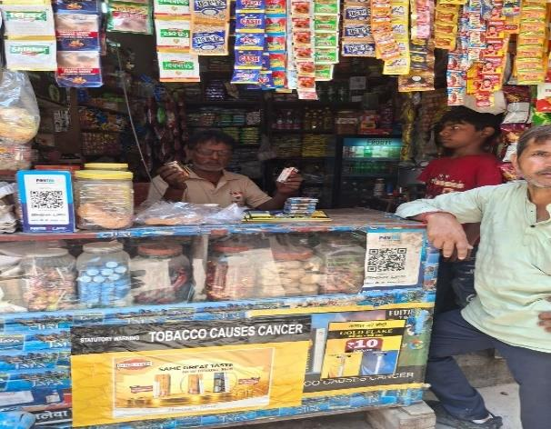
Field Photograph 1 — General-store outlet counter during a field visit, showing mixed FMCG and tobacco product display.
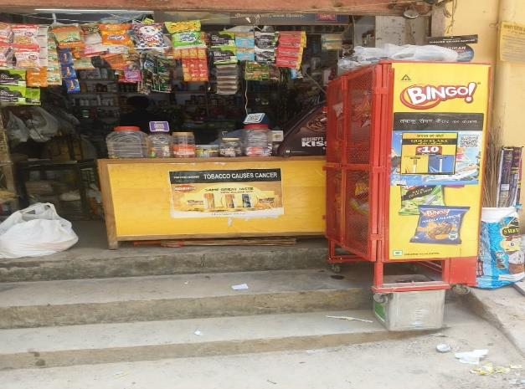
Field Photograph 2 — Neighbourhood pan-shop-style outlet with statutory tobacco warning signage, typical of L/M-class outlets.

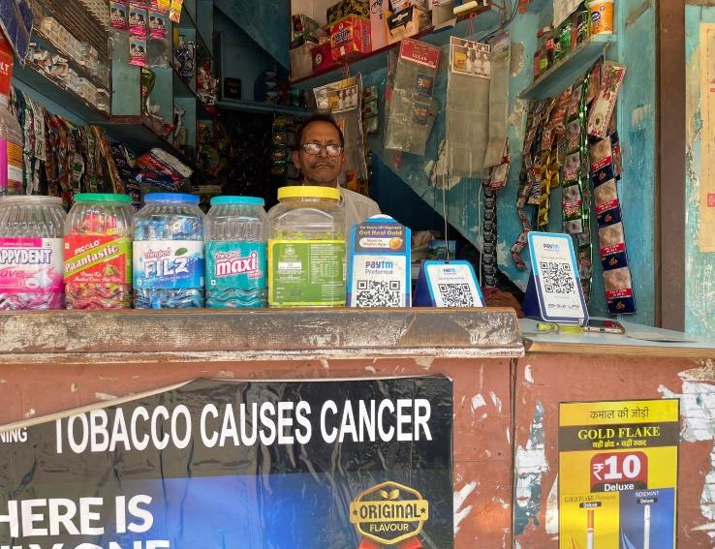

Field Photograph 3 — Dense-format retail counter, Malviya Nagar territory, illustrating high-density neighbourhood store conditions.

Annexure D — Supporting Data Extracts: New-Launch Portfolio and Pricing
D.1 Focus Brand Specification
Brand / Variant | Price | Format | Size Code | Length | Positioning
IM/GF Deluxe (Indi Mint Small) | Rs. 10 | Deluxe Size Filter Tip | DSFT | 64 mm | Affordable mint-flavour variant; impulse purchase segment; competes with Marlboro Compact
CL/GF Longs (Classic Ultra Mild Regular Long) | Rs. 18 | Luxury Size Filter Tip | LSFT | 97 mm | Premium ultra-long format; smooth mild experience; positioned against Marlboro Advance

D.2 Supporting Portfolio — Full New-Launch Range Observed
Variant | Price | Format | Key Competitive Target
Gold Flake King | Rs. 18 | KSFT — 84 mm | Marlboro Red (full-flavour segment)
Gold Flake Light | Rs. 18 | KSFT — 84 mm | Mild segment; niche demand
GF Big King Slim | Rs. 18 | Slim format | Esse Lights (slim premium segment)
GF Big Light Slim | Rs. 18 | Slim format | Esse / Mond (slim premium segment)

Annexure E — Plagiarism Similarity Report

Annexure F — AI Similarity / AI-Use Declaration Report

Annexure G — AI Case Write-Up and Proof Bundle
This annexure reproduces, in full, the AI Solution Case Write-Up template as submitted separately on the FIIB CIP Portal (Bundle 5 of 6, Assessment Code A01, dated 06 July 2026), together with the annotated proof screenshots (Items A–F).

Student & Internship Details
Field | Detail
Student Name | Aditya Singh Tomar
Programme & Batch | PGDM (Marketing) | January–July 2026 Batch
Organization Name | ITC Limited
Industry / Sector | FMCG — Cigarettes (Trade Marketing & Distribution)
Internship Duration | April 2026 – July 2026
Faculty Supervisor | Dr. Rubal Rathi
Organizational Supervisor | Mr. Mayank Sabharwal, Area Executive (with Mr. Satyam, Area Manager)
Date of Submission | 06 July 2026

Section 1 — Problem Statement

1.1 What is the problem? Who does it affect, and how?
During daily market visits across the four assigned Delhi territories, large volumes of unstructured retail data were collected — SKU availability for CL/GF Longs and IM/GF Deluxe, competitor brand presence, visibility observations, and verbal retailer feedback. This raw data required manual reading, sorting, and interpretation before it could be communicated to the Area Executive, consuming approximately 2–3 hours per field day. Three stakeholders were affected: the intern, who spent a disproportionate share of post-visit time on administrative summarization rather than analysis; Area Executive Mr. Mayank Sabharwal, who received raw outlet-level data without structured summaries; and the broader TM&D team, which depends on timely, structured retail health reports. The core inefficiency lay in retailer feedback processing — verbal comments on awareness, competitor preference, and push willingness remained entirely unstructured and were never systematically analysed for recurring themes.

1.2 How is this problem currently being solved (without AI)?
Field observations were recorded as rough notes, manually transferred into an Excel sheet, read in full by the intern, and summarized from memory before being shared verbally or via WhatsApp with the AE. This was time-intensive (2–3 hours/field day), produced inconsistent output quality, did not systematically quantify or categorize retailer feedback, and lacked a standardized reporting format.

1.3 Why is AI a viable solution for this problem?
AI Suitability Factor | Relevance to This Problem
Text-heavy input data | Retailer feedback is free text — ideal for AI summarization and theme extraction
Repetitive, rule-based task | Daily retail summarization follows the same structure every field day
Consistent output format required | AE Mr. Mayank required comparable daily summaries; AI ensures standardization
No complex infrastructure required | A ChatGPT + Excel workflow needed no IT approval, coding, or external data sharing
Dramatic time reduction achievable | Early testing cut reporting time from ~2 hours to ~20 minutes per field day

1.4 When did you identify this problem, and who confirmed it was real?
The problem was identified in Weeks 1–2 of the internship (late April 2026). It was confirmed primarily by Mr. Mayank Sabharwal (Area Executive), who acknowledged during a field debrief that structured daily summaries would speed up execution decisions, and further validated by Mr. Satyam (Area Manager), who confirmed that structured retailer-feedback analysis was not currently done at field level. Confirmation was verbal, supported by a live demonstration using real Connaught Place visit data, in May 2026.

Section 2 — Your AI Solution

2.1 What did you build?
The AI-Assisted Retail Insight and Retailer Feedback Analysis System is a structured, prompt-based workflow using ChatGPT (GPT-4) and Microsoft Excel to convert raw retail field data into organized market insight summaries. In Stage 1 (Data Capture), field observations are entered into a standardized Excel tracker after each visit (~20–30 minutes). In Stage 2 (Prompt Input), the day’s Excel data is pasted as plain text into a pre-written master prompt instructing the model to calculate availability rates, identify competitor patterns, categorize retailer comments into five themes, and generate a structured summary. In Stage 3 (Output Review & Sharing), the output is reviewed for accuracy and shared with AE Mr. Mayank via WhatsApp or the post-visit debrief total time from entry to shared summary: approximately 20 minutes. Full workflow and prompt design detail is provided in Annexure B.

2.2 What tools or platforms did you use to build it?
Tool / Platform Used | What It Was Used For
ChatGPT (GPT-4) | Structured text analysis of field data; no IT installation required; browser-accessible
Microsoft Excel | Structured data input source, already in use in the TM&D field workflow
Custom prompt template | Ensures consistent output quality across every field day
WhatsApp / verbal debrief | Existing communication channel enabling same-day sharing after field visits

2.3 What data or documents did the solution use?
The intern-generated Excel retail tracker containing daily field data from all four territories: outlet-level SKU availability, competitor presence, visibility score (1–5), and retailer verbal feedback (free text). No confidential ITC sales figures, pricing, or proprietary data was used in or shared with the AI tool; all data processed was intern-generated field observation, fully compliant with ITC data privacy guidelines.

2.4 What does the solution produce as its output?
A structured Daily Retail Health Summary comprising: an Executive Overview; an SKU Availability Table by zone; a Competitor Visibility Summary; a Retailer Feedback Theme Breakdown (five themes with frequency counts); a list of Flagged Outlets for Follow-Up with stated reasons; and, where weekly data is supplied, a Weekly Trend Note.

2.5 What are the limitations of your solution?
Limitation | Impact
No real-time data integration | Manual copy-paste from Excel to ChatGPT; not automated at scale
Output accuracy depends on input quality | Inconsistent data entry degrades AI output quality
Hallucination risk on thin data | Fewer than 10 outlet visits can cause the AI to overfit patterns
No quantitative validation | Thematic categorization is qualitative, not statistically validated
Session dependency | Each ChatGPT session is stateless; multi-day trend analysis requires manual compilation

Section 3 — Deployment

3.1 Which deployment level did you achieve?
Level | Description | Achieved?
1 | Demonstrated in context — shown to supervisor or team member | Yes
2 | Team-level use — at least one other person used it independently | Partially — AE relies on output; independent operation not documented
3 | Organizationally adopted — continued use confirmed beyond internship | Not yet — internship ongoing through July 2026

3.2 Describe how you deployed or demonstrated the solution.
The solution was demonstrated live in May 2026, during a post-visit field debrief immediately after a Connaught Place market day, using ChatGPT (GPT-4) via browser on the intern’s personal laptop/mobile, shown directly to Mr. Mayank. Real field data — 12 outlet entries from that day’s visit was used: the intern opened ChatGPT, displayed the master prompt, pasted the real Excel data, generated the output (~45 seconds), and reviewed it jointly with Mr. Mayank. The demonstration lasted approximately 8–10 minutes, embedded within the routine field debrief. Mr. Mayank actively engaged with the output, evaluated it against the manual process, gave two specific refinement requests — both incorporated within the following week — and has continued to receive AI-generated summaries after subsequent visits.

3.3 If you did not reach Level 2 or 3, explain why.
Level 2 requires a supervisor to have independently operated the tool. While Mr. Mayank actively reviewed and relied on the summaries, the precise constraint was access: the tool was used only via the intern’s personal ChatGPT account, with no organizational access or shared login provisioned to him, combined with no time in the daily debrief routine to train him to run prompts independently. Level 3 requires confirmed organizational adoption; no IT approval was sought for ChatGPT use, no handover documentation has been prepared, and no Area Manager sign-off on continued use has been obtained, as the internship runs through July 2026 and this determination remains pending.

3.4 What would be required for the solution to be deployed more broadly?
Requirement | Detail
Access & Platform | A personal or organizational ChatGPT/enterprise-AI account for each AE/Team Leader; ITC data-governance approval
Data Input Standardisation | A mandated standard Excel entry template across all AEs and Team Leaders
Training & Onboarding | A 30–45 minute session on data entry, prompt use, and output interpretation
IT and Policy Approval | Formal IT/compliance review of data residency, access controls, and tool vetting
Ownership and Governance | A designated owner (AM or senior AE) to maintain and update the prompt template

Section 4 — Organization Response

4.1 Who at the organization saw or used your solution?
Name / Role | How They Engaged | Their Observation
Mr. Mayank Sabharwal, Area Executive | Watched the full live demo; reviewed output jointly; gave two refinement requests, both implemented; continues receiving daily summaries | Confirmed the output was more immediately actionable than prior manual summaries; requested a market-wise split and a competitor column
Mr. Satyam, Area Manager | Briefed on the workflow and output format during a field check-in | Confirmed structured retailer-feedback analysis is currently absent at field level; interested in reviewing the format at a future debrief

4.2 What did they say about it? (Direct quote)
Mr. Mayank Sabharwal (Area Executive, ITC TM&D), during the post-visit field debrief after jointly reviewing the AI-generated summary from 12 Connaught Place outlets, May 2026: “This is more structured than what we usually get — add the market split and show competitor separately, and this would be useful every day.” Recollected verbatim by the intern; reflects his immediate reaction upon comparing the AI output to the prior manual summary format.

4.3 Did the organization express interest in continuing to use or develop the solution?
Yes, informally. Mr. Mayank’s statement that the tool “would be useful every day” is a clear, in-context verbal expression of continued-use interest, supported by behavioural evidence — he has continued to receive and review AI-generated summaries after each subsequent visit. This is classified honestly as strong informal appreciation with an implicit Level 2 trajectory, not a formal Level 3 adoption commitment; no written confirmation, handover document, or senior-level sign-off has been obtained, as requesting one without prior IT/compliance clearance was assessed as procedurally premature within a field-level internship context.

4.4 What would you do differently if you had more time?
Introduce the workflow earlier (Week 1 instead of Week 3–4) to allow more time for refinement; seek a shared access setup earlier to enable Mr. Mayank’s independent use and support a genuine Level 2 claim; document feedback more systematically rather than relying on recollected verbal quotes; build a structured one-page SOP/handover document as a tangible signal of Level 3 intent; and escalate a structured demonstration to Area Manager Mr. Satyam earlier in the internship to generate senior-level validation.

Section 5 — Proof of Solution
Proof format: annotated screenshots (documented workflow), showing input, processing, and output. Six screenshots (Items A–F) are reproduced below, captured live during the demonstration to AE Mr. Mayank Sabharwal using real Connaught Place field data.

Item A — Sample field data input (Connaught Place outlets), pasted into ChatGPT
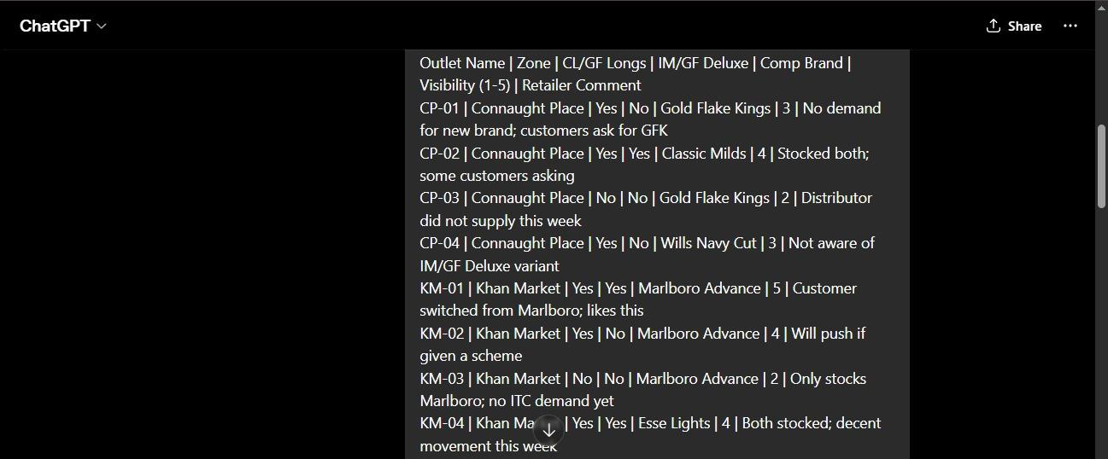
Item A — Real field data (Connaught Place outlets) pasted into ChatGPT for the live demonstration to AE Mr. Mayank.

Item B — AI-generated Daily Retail Health Summary, Executive Overview
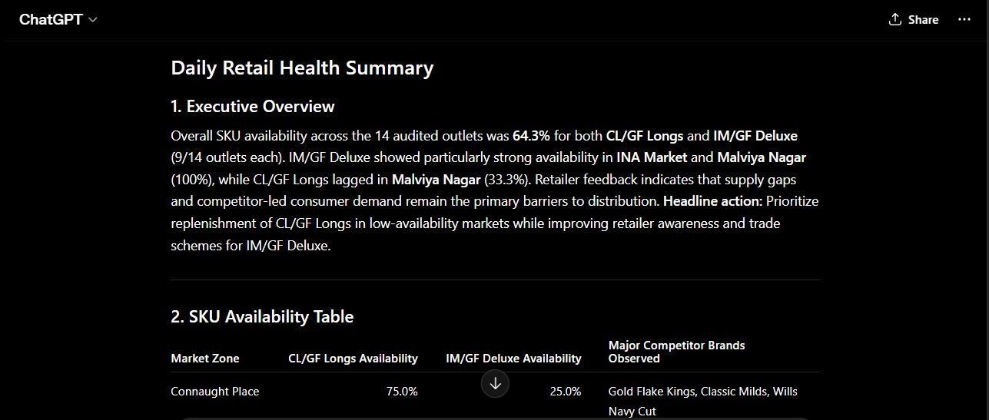
Item B — Executive Overview generated by the AI workflow, showing overall SKU availability and headline action.

Item C — SKU Availability Table by Zone
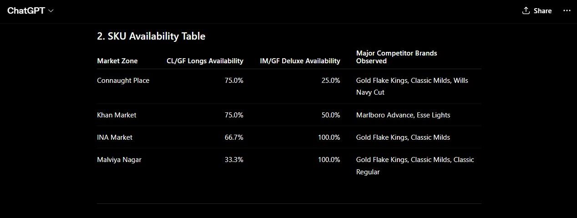
Item C — SKU Availability Table by Zone, generated by the AI workflow.

Item D — Competitor Visibility Summary
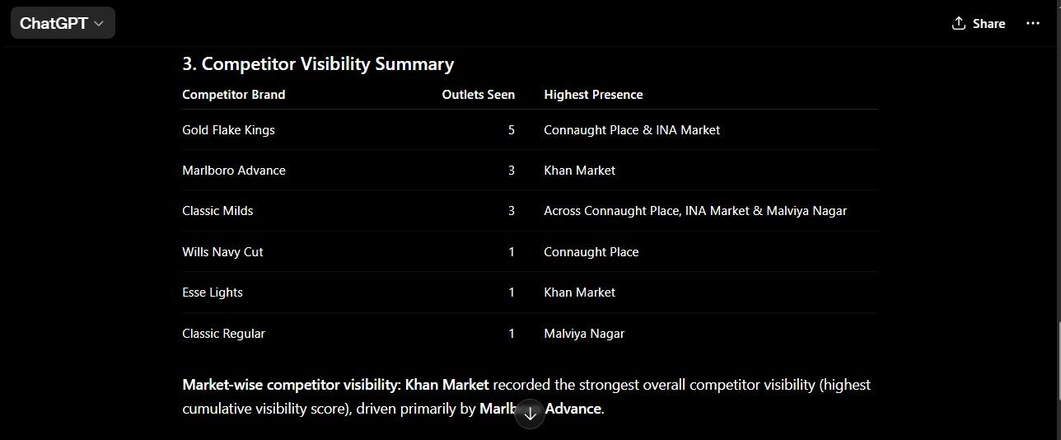
Item D — Competitor Visibility Summary, generated by the AI workflow.

Item E — Retailer Feedback Theme Breakdown
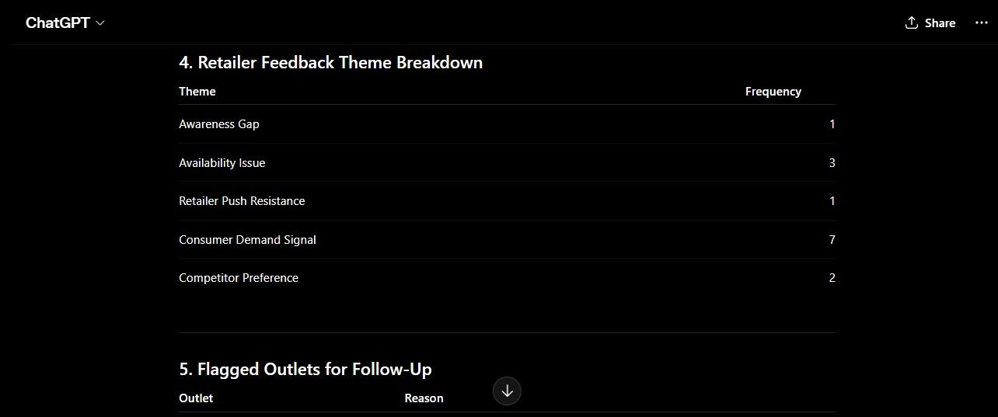
Item E — Retailer Feedback Theme Breakdown, generated by the AI workflow.

Item F — Flagged Outlets for Follow-Up
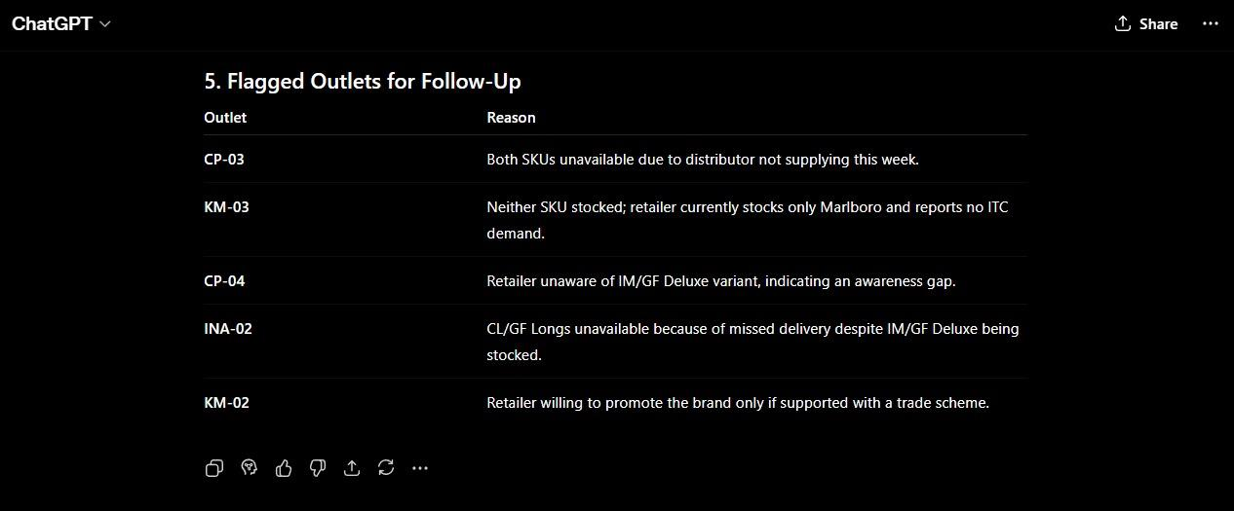
Item F — Flagged Outlets for Follow-Up, generated by the AI workflow.

5.1 Proof Table — Items Attached
# | Proof Item | What It Shows
1 | Master Prompt Template | Solution logic and input-output design (full text: Annexure B / AS2 Appendix A)
2 | Item A — Sample Input | Real field-data format feeding the prompt
3 | Items B & C — Sample Output (Executive Overview, SKU Table) | Structured AI output: availability rates, competitor table
4 | Item D — Competitor Visibility Summary | Competitor brand presence by zone
5 | Items E & F — Feedback Themes & Flagged Outlets | Thematic categorisation and follow-up prioritisation
6 | AE Feedback and Output Iteration Record | Organisational engagement and iterative improvement (Section 4)
7 | Verbal confirmation, AE and AM | Organisational validation of problem and solution relevance

5.2 Final Consistency Check Across Sections 1–5
No material contradiction was identified across the problem statement, the AI solution logic, the claimed deployment level, the organisational response, and the attached proof. Deployment level and organisational-engagement language are stated identically and honestly across this annexure, Section 8.2 of the main report, and the AS3 Final Report Annexure B (AI-in-CIP Deliverable Summary); no claim in this write-up exceeds what is evidenced in the attached proof items.

Deployment Level Declaration
Level 1 — Demonstrated in Context — is declared as the deployment level achieved, consistent with the honest, evidence-bounded assessment recorded in Section 3 above. No claim of Level 2 or Level 3 deployment is made beyond what the attached proof items support.

Student Declaration
I confirm that the problem described in this write-up is a genuine operational challenge at my internship organization. The solution I have documented was built by me during my internship period. The proof I have attached accurately represents what the solution does. The organization’s response I have described reflects what was actually observed, not what I wished had been observed.
Student Signature: ______________________ Date: ______________________
Faculty Supervisor Signature: ______________________ Date: ______________________

