**Problem Statement:**

Inventory Management System

**Group Details**

* **Group No- 14**
* **Group POC- Bhimashankar Gavkare**



Develop a barcode reading system using OpenCV to automate inventory management for retail stores using the barcodes available on the product. The system will identify and categorize items, updating the MySQL database via Fast APIs for real-time inventory tracking.

**Approach/Solution:**

To create a web application which will manage the inventory using the image processing libraries such as OpenCV to identify the products related to the inventory, using the barcodes available. The system will keep track of products that come in and go out of the inventory to make management easy. After identification of the item such as category and other details will be stored in the database such as SQL and NoSQL databases as per the user requirements. An E bill will be generated and shared with the customers of the shop via the WhatsApp by using the available python library Pywhatkit to make a billing system paperless.

**System Features:**

* Centralized data storage
* Authentication and Authorization
* Admin control
* Product detection Model (Barcode Scanner using webcam)
* Realtime updates
* E bill generation
* User friendly interface
* Dashboard with products details

**Technologies to be used:**

* Front end – HTML, CSS, JavaScript
* Database – MySQL, Firebase
* API – Python (Fast Api), Postman
* Product detection model – Python (OpenCV, pyzbar)
* QA – SonarQube
* Version control system – Git
* Task tracking – JIRA
* Authentication and E bill – Python (Pywhatkit)

**Diagrams**

**System Architecture:**

**Notes:** The above system architecture is based on MVC. Below are the details of Model, View, Controller.

Model:

* Database
* Barcode scanning model (using OpenCV)
* Backend business logic (CRUD)

View:

* User Interface (Webpages)
* Report and analytical interface

Controller:

* User authentication and authorization controller
* Inventory management controller

Api’s endpoints are used for communication.

**Site Map:**

**Admin Site Map**

**Manager Site Map**

**Users Site Map**

**Data flow diagram:**

**Level 0 DFD**

**Level 1 DFD**

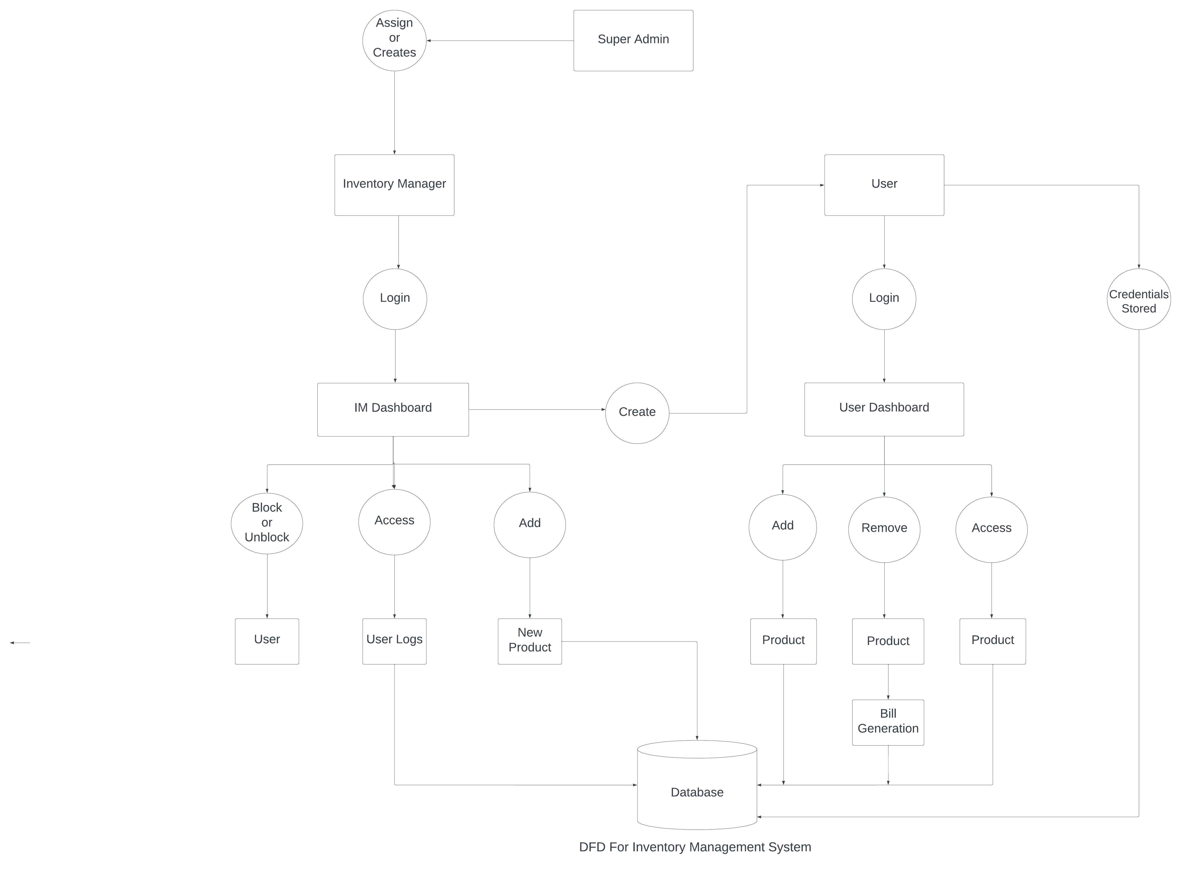

**Level 2 DFD**

**Use Case Diagram:**

**Entity Relationship/Database Architecture Diagram:**

**Class Diagram:**

[www.persistent.com](http://www.persistent.com)

**USA India**

Persistent Systems, Inc. Persistent Systems Limited  
2055 Laurelwood Road, Suite 210 Bhageerath,402

Santa Clara, CA 95054 Senapati Bapat Road

Tel: +1(408) 216 7010 Pune 411016

Fax: +1(408) 451 9177 Tel: +91(20) 6703 0000

Email: Info@persistent.com Fax: +91(20) 6703 0008