- https://pmc.ncbi.nlm.nih.gov/articles/PMC3673154/?utm_source=chatgpt.com
  - Computational fluid dynamics of coronary arteries with implanted stents: Effects of Newtonian and non-Newtonian blood flows

Novel laser-textured grooves extended to the sidewall edges of CoCr surfaces for rapid and selective endothelialization following coronary artery stenting

https://pubmed.ncbi.nlm.nih.gov/24787629/

https://www.sciencedirect.com/science/article/pii/S2405844024024563?utm_source=chatgpt.com

https://pmc.ncbi.nlm.nih.gov/articles/PMC9844968/?utm_source=chatgpt.com

https://www.jstage.jst.go.jp/article/aem/5/0/5_128/_article/-char/en?utm_source=chatgpt.com

Fluid dynamics in shark skin
https://pubmed.ncbi.nlm.nih.gov/20855320/
https://pubmed.ncbi.nlm.nih.gov/38936827/

compares continuous vs. segmented riblets, spacing, geometry, and flow behavior. This could directly inspire your different stent designs.
https://pubs.rsc.org/ra/article-abstract/6/13/10962/499526/Fluid-flow-analysis-of-continuous-and-segmented?redirectedFrom=fulltext
Modeling and optimization of shark-inspired riblet geometries for low drag applications
sciencedirect.com/science/article/pii/S0021979716302399?utm_source=chatgpt.com

Local Hemodynamic Forces After Stenting: Implications on Restenosis and Thrombosis
https://pubmed.ncbi.nlm.nih.gov/29122816/
Hemodynamic Performance of a New Punched Stent Strut: A Numerical Study
https://pubmed.ncbi.nlm.nih.gov/26581476/

Strut thickness: google.com/search?q=average+stur+thickness+of+stent&rlz=1C5OZZY_enUS1177US1178&oq=average+stur+thickness+of+stent&gs_lcrp=EgZjaHJvbWUyBggAEEUYOTIJCAEQIRgKGKABMgkIAhAhGAoYoAEyCQgDECEYChigATIJCAQQIRgKGKABMgcIBRAhGKsCMgcIBhAhGKsCMgcIBxAhGI8CMgcICBAhGI8C0gEINDM0MGowajeoAgCwAgA&sourceid=chrome&source=chrome.ob&ie=UTF-8

Carou blood model

Poiseuille's law states that the rate of blood flow through a vessel is directly proportional to the pressure gradient and the radius of the vessel to the fourth power, and inversely proportional to the vessel's length and the blood's viscosity
The formula for Poiseuille's law is:

Q=πΔPr48ηLcap Q equals the fraction with numerator pi cap delta cap P r to the fourth power and denominator 8 eta cap L end-fraction
𝑄=𝜋Δ𝑃𝑟48𝜂𝐿
- Q: Blood flow volume per unit time
- Δ P: Pressure gradient (difference in pressure between two ends)
- r: Radius of the blood vessel
- η
: Viscosity of the blood
- L: Length of the blood vessel
https://royalsocietypublishing.org/rsta/article/374/2073/20160133/66456/Vibrations-and-spatial-patterns-in-biomimetic
Blood clotting prevention

10) https://www.researchgate.net/publication/350507328_Hydrodynamic_efficiency_in_sharks_the_combined_role_of_riblets_and_denticles
11) https://pubmed.ncbi.nlm.nih.gov/21819223/
12. https://pubmed.ncbi.nlm.nih.gov/25852825/
13. https://pmc.ncbi.nlm.nih.gov/articles/PMC4385044/?utm_source=chatgpt.com

Key Causes of Platelet Attachment
- Foreign Material Recognition: A coronary stent is a foreign object (typically metal or a polymer coating). When blood flows over it, plasma proteins like fibrinogen immediately adsorb to the surface, signaling platelets to stick. [1, 2]
- Vessel Wall Injury: Placing a stent requires balloon inflation that compresses plaque and injures or tears the inner lining (endothelium) of the artery. This damage exposes collagen and von Willebrand factor (vWF) in the subendothelial matrix, which naturally trap and activate passing platelets. [1, 2, 3, 4]
- Platelet Activation & Recruitment: Once platelets touch the stent or exposed tissue, they change shape, extend sticky arms (pseudopods), and release chemical signals like ADP and thromboxane A2. This creates a chain reaction that pulls in more platelets to form a clot (stent thrombosis). [1, 2, 3, 4]

Factors
Compare a stent w holes vs. a stent without
Did not account for the expansion
- The present study evaluated the new design numerically by comparing it with the traditional stent in terms of local hemodynamic parameters such as flow velocity, flow recirculation area, time-averaged wall shear stress (TAWSS), oscillating shear index (OSI), and relative residence time (RRT).

- To simplify the analysis, the blood was assumed to be an incompressible, homogenous, Newtonian viscous fluid, with a density of 1060 kg/m3 and a constant viscosity of 3.5 × 10−3 kg/m·s. The arterial wall and the stent surface were set as no-slip rigid (21).

Need to prevent: low Wall shear stress, flow recirculation, or long residence time
Which can lead to thrombosis

Patrick kelly
send me a document detailing your project idea—just write out bullet points and all that stuff about what the project idea is, what problem it's solving, how you're going to approach it. i'll put it through a really good gpt model and have it output an entire plan and let's see what it says, maybe we can get some good ideas

Project Idea
- Develop a shark-skin-inspired microtextured coronary stent
- Base the surface patterns on shark dermal denticles
- Create multiple variations of the denticle-inspired microtexture
- Determine which texture provides the most favorable combination of blood-flow performance and biological compatibility

Problem
- Coronary stents can have platelet adhesion and thrombus formation, which can caouse….
- Thrombosis can lead to serious complications, including stent blockage
- There is also potential for bacterial adhesion and biofilm formation on implanted devices

Why Shark Skin?
- Shark skin is covered in microscopic dermal denticles
- These structures naturally influence how fluid moves across the surface
- Shark-skin-inspired textures have potential to create more favorable flow patterns and reduce surface adhesion

Approach
- Design several different dermal-denticle-inspired microtexture patterns
- Use CFD to compare the blood-flow dynamics of each design
- Identify the texture with the most favorable hemodynamic characteristics
- Test the optimized designs for platelet adhesion
- Test bacterial adhesion/biofilm formation
- Compare the results to an untextured control

Main Goal
- Find a specific shark-inspired microtexture that improves blood flow while reducing platelet adhesion and potentially thrombosis, with bacterial adhesion as an additional biological endpoint.

using this: I want to develop a shark-skin-inspired microtextured coronary stent, using the structure of shark dermal denticles as inspiration. The goal is to explore how different denticle-like surface designs affect blood flow and determine whether an optimized texture could reduce platelet adhesion and bacterial biofilm formation, ultimately helping prevent stent thrombosis. create me a detailed research plan. what i should do.

Exp 1 ) plain stent

Things to consider:
- Fluid: blood/water, all conditions, velocity, nonewtonian, etc
  - Carua model fo blood https://onlinelibrary.wiley.com/doi/full/10.1002/eng2.12779
- Outer layer: arterial wall

https://github.com/cbonsig/open-stent/tree/master/STL
The file of design: measurements chosen by me
https://my.clevelandclinic.org/health/articles/22486-stent
The opening width

https://aseanheartjournal.com/10-31762-ahj1926-0301-fulltext/
Average opening width
3
https://pubmed.ncbi.nlm.nih.gov/15165911/
Mean STENT length mean stent length 20.0 +/- 7.9 mm,

Caruou bllo

- Pulsatile flow
- A human LAD flow waveform
- Parabolic velocity profile at the inlet
- Average flow:
  - Case A: 42.2 mL/min
  - Case B: 45.1 mL/min
- Peak flow:
  - Case A: 79.1 mL/min
  - Case B: 84.7 mL/min
- Blood density: 1060 kg/m³
- Carreau non-Newtonian blood
- Rigid artery
- No-slip artery and stent surfaces
- Laminar flow
- Reynolds number at peak flow:
  - Case A: 195
  - Case B: 260
- Womersley number:
  - Case A: 1.9
  - Case B: 1.4
- Time step: 0.009 s
- 100 time steps per cardiac cycle
They simulated one cardiac cycle.
This is important because it gives you an actual physiological coronary flow waveform, rather than arbitrarily choosing a velocity.
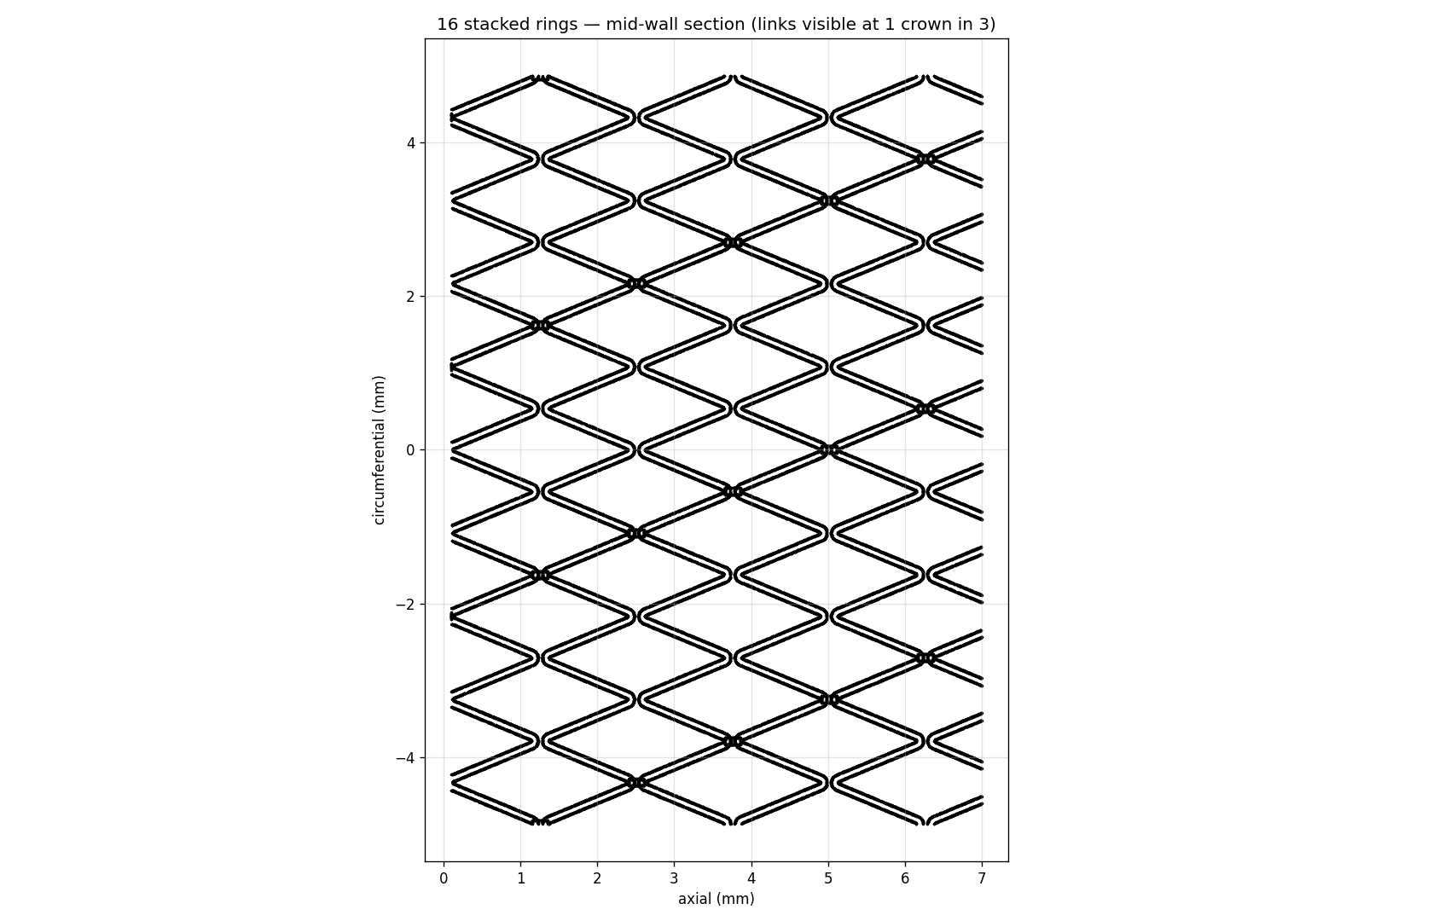
Experiments:

- Stent by itself
- Basic denticles
- Optimization process
- Platelet adhesion
- Bacterial bioflim

- Literature search on blood flow/ learning cfd through blllod vessels, understanding math behind it, learning cad software.
- Creation of many designs
- Running cfd on many stent designs, and comparing them
  - Looking into various factors, oscillating etc etc
- 3d print
- Looking at their platelets and bacterial adhesion properties:

Be vague

Research Plan
Title:
Name: Sanhita Tummala
Rationale:
Coronary stents are widely used to restore blood flow in narrowed arteries, but complications such as platelet adhesion, thrombus formation, and in-stent restenosis remain significant challenges. This project proposes the establishment and foundation for a shark-skin-inspired microtextured coronary stent in hopes to improve blood-flow characteristics and reduce platelet adhesion in heart stents, decreasing the risk of stent thrombosis and restenosis.

Research Question:

To examine whether the edible microbe Blakeslea trispora can produce sufficient β-carotene when grown on natural starches, such as cassava, to serve as a strategy for addressing vitamin A deficiency.

Hypothesis: A shark skin inspired microtexture based stent will improve blood-flow characteristics and reduce platelet adhesion in heart stents, decreasing the risk of stent thrombosis and restenosis.

Expected Outcomes:
- Blakeslea Trispora will successfully grow on cassava and other natural starch substrates.
- Extraction and quantification methods for β-carotene from cassava will be optimised.
- The optimal harvest time for achieving maximum β-carotene yield will be identified.
- β-carotene production will be enhanced by modifying substrate formulations and/or key process variables.
- Culture volumes will be successfully scaled up from 100 mL to 500 mL while maintaining growth and pigment production.
- A reliable re-culturing method will be established to enable continuous propagation of Blakeslea Trispora.

List of Equipment and Materials:

Equipment/softwares:

- OpensCAD
- meshing software/ running software
- Statistical software- Excel , StatEase and other suitable software
- FreeCAD ….
- SolidWorks Software
- 3D printing machine
- Biological
  - blood testing, etc
  - bacterial testing,
    - pipettes, lab gloves, lab coats, goggles, etc

Materials:
- plga
- 3d printing filiment
- negative mold material s
- blood
- bacteria of sum sort

Procedures
- : Computer Aided Design(CAD) Formation: Designs were create don softwares such as OpensCAD, FreeCAD, and Solidworks. By leveraging open source dermal denticle models, and stent replications. we are able to create different designs and optimization through literature
- Computational Fluid Dynamic(CFD) testings/optimization
  - meshing, inlet and outlet surfaces, factors/variables tested,
- CAD Optimization:
- 3D Pritning: After fermentation, the entire biomass was freeze-dried. Samples were first frozen at a slant and then placed in a freeze dryer at –80 °C for approximately 48 hours. From each dried sample, 0.2 grams was combined with a teaspoon of sand and ground for about 30 seconds. β-carotene was extracted from the ground material using 5 mL of ethyl acetate and allowed to sit for 30 minutes. The resulting extract was then filtered and injected into the HPLC for analysis.
- HPLC analysis: β-Carotene was quantified using Shimadzu LC-40D HPLC with a C18 column and Diode Array Detector (DAD). The mobile phase consisted of Acetonitrile: Methanol (90:10) at a flow rate of 1.5 mL/min. The concentration in the unknown sample was determined by comparing chromatogram peak areas to a standard curve prepared with commercially purchased β-carotene.

Risk and safety:
This project involves working with Blakeslea trispora, an edible, generally regarded as safe (GRAS) microorganism; however, standard microbiological safety practices must still be followed to prevent contamination and ensure safe handling. All culturing, inoculation, and harvesting procedures will be conducted using proper personal protective equipment and within biosafety hoods to minimise exposure to spores and prevent unintended microbial growth. Care will be taken when preparing and sterilising starch substrates such as cassava, as high temperatures and heated equipment present burn risks. Solvents or reagents used for β-carotene extraction will be handled in accordance with chemical safety guidelines, including working in a well-ventilated area, chemical fume hood,
and following appropriate disposal procedures. All biological waste will be autoclaved or disinfected before disposal. All experiments will be performed after training from the supervisor or a graduate student. Overall, the project poses minimal risk when standard laboratory safety protocols are consistently applied.

Experiment 1: Substrate Comparison
Purpose:
To compare the performance of Cassava as a fermentation substrate in relation to Tapioca.
Hypothesis:
Cassava is a better substrate than Tapioca for the growth and production of β-Carotene by Blakeslea Trispora.
Rationale:
Tapioca is a purified starch that requires additional supplements, such as yeast extract, potassium phosphate, and magnesium sulfate, for the growth and production of β-carotene by Blakeslea Trispora. Starches such as Cassava have a complex nutrient mix and higher natural mineral content that can eliminate the need for additional nutrients and minerals. In addition, Cassava contributes broader nutritional value through the presence of proteins, fats, vitamins, and minerals.

Question 1: Substrate + Supplement Comparison
Purpose:
To compare the performance of Cassava with Tapioca, with or without supplements.
Hypothesis:
Cassava with/and without supplements will perform better than Tapioca with supplements.
Rationale:
Cassava naturally contains additional minerals like magnesium, potassium, phosphorus, iron, zinc, manganese, etc, which are important for Blakeslea Trispora’s growth and sporulation[established in phase 1]. Moreover, it may not need additional mineral supplements to produce β-carotene.

Question 2: Lipid Supplementation
Purpose:
To evaluate the impact of oil supplementation (soybean oil) on both the total β-carotene concentration and the rate of production in Cassava-based media.
Hypothesis:
The addition of oil will enhance β-carotene performance in Cassava.
Rationale:
Oils, like soybean oil, provide fatty acids that increase acetyl-CoA levels, which fuel the mevalonate pathway responsible for carotenoid biosynthesis [Mantzouridou et al., 2006; Saejung et al., 2023; Varzakakou & Roukas, 2009].

Question 3: Determine the Rate of β-Carotene Production and Identify the Optimal Time for Harvesting the Culture.
Based on phase 1, day 9 produced the highest amounts of β-carotene in the tapioca culture. In that experiment, we didn’t determine the concentration after day 9. Therefore, we will collect samples on days 5, 7, 9, and 12, and determine the total yield and beta-carotene levels.

Experiment 2: Solid-State Fermentation in Cassava Chunks
Purpose:
To evaluate the impact of a solid-state fermentation method compared to submerged-state fermentation in terms of total β-carotene production and rate of production in Cassava-based media.
Hypothesis:
Solid-state fermentation in Cassava chunks will be a better fermentation compared to submerged-state fermentation methods.
Rationale:
Blakeslea trispora is a filamentous fungus that develops as a mycelium [Wang et al., 2023]. Therefore, it may grow throughout and into the Cassava chunks during solid-state fermentation.

Experiment 3: Optimization with additional supplements
Purpose:
To determine the optimal conditions for the highest β-carotene production with varying amounts of supplements(soy peptone, aspergine, glycerol, yeast Extract).
Hypothesis:
Optimizing addition supplements will enhance the growth of Blakeslea Tripora and the production of β-carotene.
Rationale:
Blakeslea trispora can benefit from supplements such as glycerol, soy-based peptone, yeast extract, and free amino acids like asparagine because these additions improve carbon and nitrogen availability, supporting stronger fungal growth. Glycerol has been shown to substantially increase β-carotene yield in B. trispora by serving as a carbon source ([Crawford et al., 2008]). Likewise, complex nitrogen sources (yeast extract, soy peptone) and amino-acid nitrogen (asparagine) enhance fungal biomass and metabolic activity. ([Zhang et al., 2023]; [Li et al., 2022]).

From Shark Skin to Coronary Stents: A Biomimetic Approach to Cardiovascular Stent Engineering

