On Collatz Conjecture: Branching and Node Values

*Aditya Vishwakarma (*[*adityav31121999@gmail.com*](mailto:adityav31121999@gmail.com)*)*

***Abstract***

*This paper delves into the Collatz Conjecture, specifically the generalized formula for nodes on a particular branch. This formula is derived from the pattern of the node values. It explores the relationship between the values of consecutive branches, both vertically and diagonally. The entire Collatz tree is divided into three main components: the Base Stem, Nodes, and Branches that emerge from the nodes. While the pattern for branches on the base stem is known, the pattern for other branches cannot be determined. The paper details these concepts and provides examples to illustrate them.*

***Keywords:*** *Collatz Conjecture, Tree, Node, Branch*

## Introduction

Collatz Conjecture is a problem in which we end in a loop of 4-2-1 after applying two operations based on the number being odd or even.

-Eqn. 1

Ex: **17, 52, 26, 13, 40, 20, 10, 5, 16, 8, 4, 2, 15, 4, 2, 1**, 4, 2, 1, 4, 2, 1, ...

In this example, which applies to all natural numbers, the sequence eventually falls into an infinite loop of 4-2-1. The number of steps required for an integer to either enter this 4-2-1 loop or reach 1 is known as the stopping time. This stopping time can vary widely, sometimes being a single digit or multiple digits, and appears random. Interestingly, it can be higher for smaller values and lower for larger values, or vice versa. For instance, it takes 12 steps for (n = 17), 111 steps for (n = 27), but only 10 steps for (n = 1024) to reach 1. For values of 2n, it takes exactly n steps. Importantly, the stopping time is finite for any number.

## Base Stem and Powers of 2

If whole tree of Collatz conjecture is considered, a certain distinction can be made by looking at the pattern and the odd-even conditions. In the examples presented below, see that every number leads to certain value which is power of 2 and from there it gets divided by 2 till it reaches 1.

* **23**, 70, 35, 106, 53, 160, 80, 40, 20, 10, 5, 16, 8, 4, 2, 1 (15 steps)
* **16384**, 8192, 4096, 2048, 1024, 512, 256, 128, 64, 32, 16, 8, 4, 2, 1 (14 steps)
* **9,** 28, 14, 7, 22, 11, 34, 17, 52, 26, 13, 40, 20, 10, 5, 16, 8, 4, 2, 1 (17 steps)

Additionally, consider other values: an even number can be obtained by dividing a number that is even or specifically a multiple of 2n or by (3x + 1). However, an odd number can only be achieved through division by 2. Therefore, values of 2n should be considered as the primary branch or Base Stem since they require the fewest steps. Another reason for this is that it simplifies visualization, making it more linear and straightforward as the tree grows from the base stem, which then leads to multiple branches.

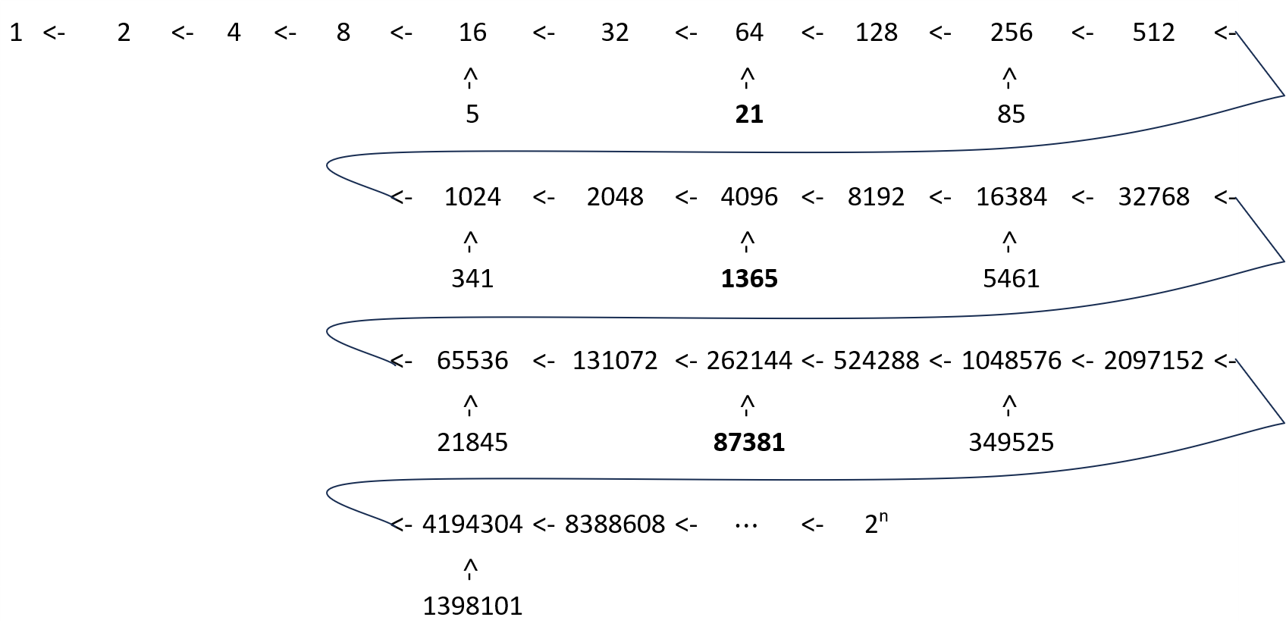

From here, R is considered as Root Term with following value and condition:

-Eqn. 2

Following observations can be drawn from this base stem:

1. The values when are divisible by 3, they lead to values or form branch which do not branch further. These are 26n values of the base stem.
2. Values 24n or powers of 2 which are multiples of 4 (i.e., 16n) leads to branch which is multiple of 5 ( is multiple of 5).
3. Values which are 26n-2 and 26n+2 forms branch which further branch on odd and even nodes.

Visualization is crucial for understanding such problems, as it provides clearer explanations of arrangements. The Collatz conjecture can be visualized in various ways. Some visualizations depict stopping time, showing all values falling below a certain function’s limit. Others illustrate a growing tree or display only odd numbers in a directed graph. A new visualization approach could involve creating a tree where each branch grows based on powers of 2. This new method can offer deeper insights into the values of nodes and their relationships with other branches.

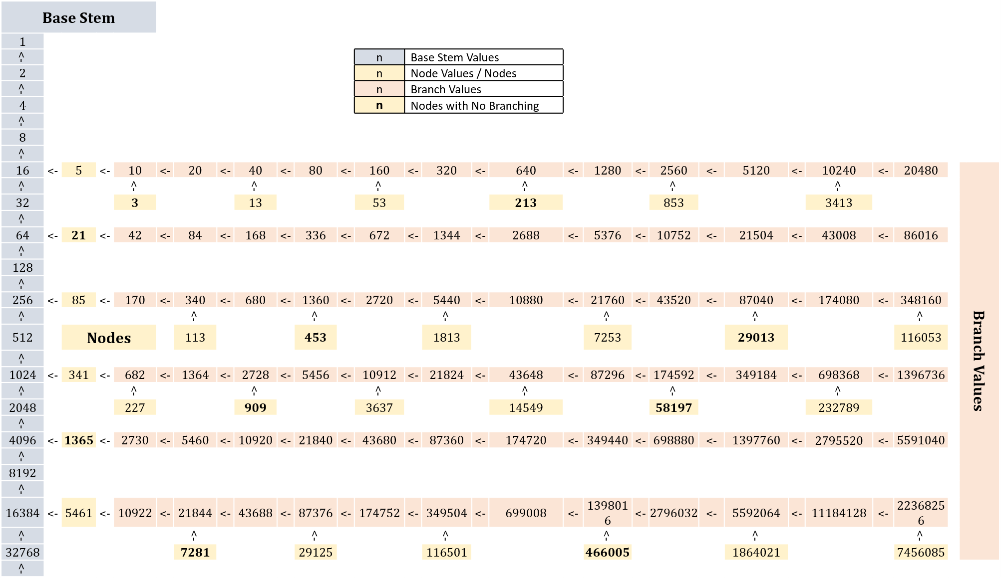

***Fig. 1:*** *Tree Structure*

## Nodes and Branches

It is assumed that all node values are at position 0(). Nodes are value which raises whole branch. This can be made in two forms: First being by Base Stem values and other being formed from branch values.

-Eqn. 3

Branch Values are created from node values. An all these branch values are multiple of values of 2n.

-Eqn. 4

From base stem, branches that occur are illustrated in following:

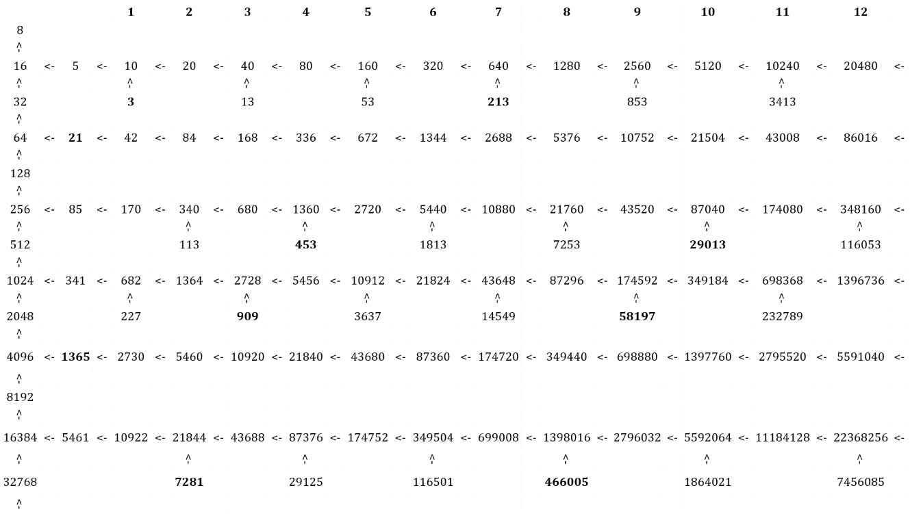

The branches that occur through 26n-2 and 26n+2, cause further branching and hence they show similar pattern as either they will branch on even positions and odd positions or certain values will not branch. There are values that do not branch further and these nodes are formed through R = 26n values.

For node value 5:

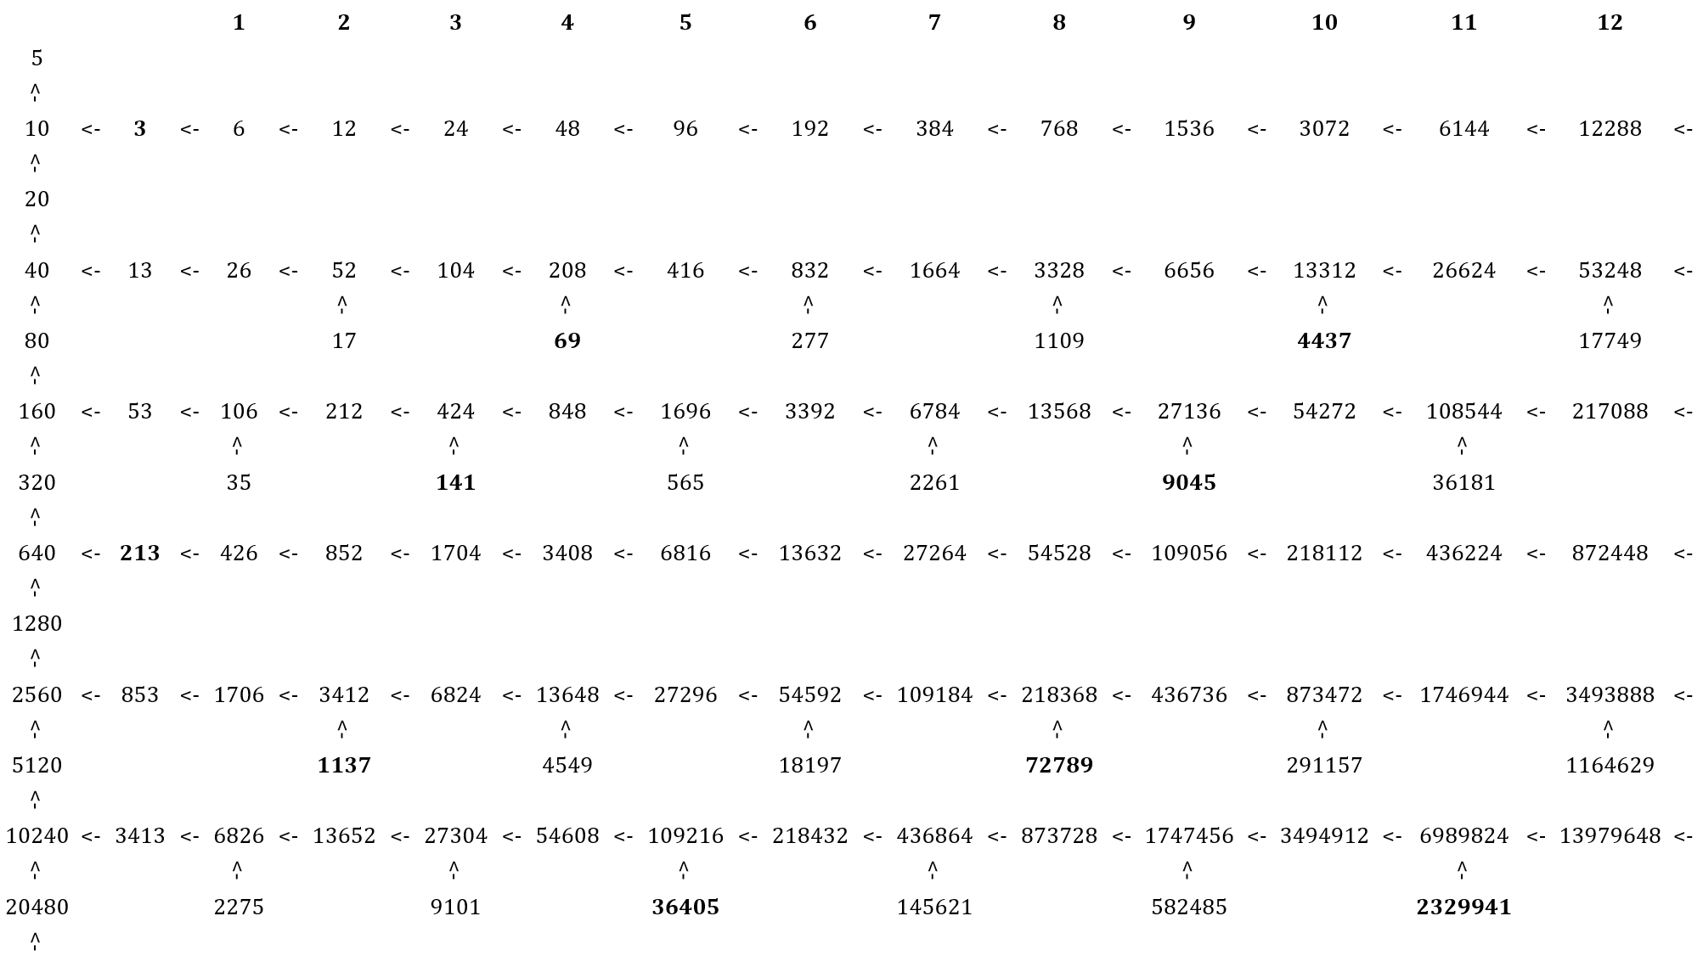

Similarly for a random value something like this and can be created to illustrate a random approach to this tree. Here the example is of n = 7 (7, 22, 11, 34, 17, 52, 26, 13, 40, 20, 10, 5, 16, 8, 4, 2, 1).

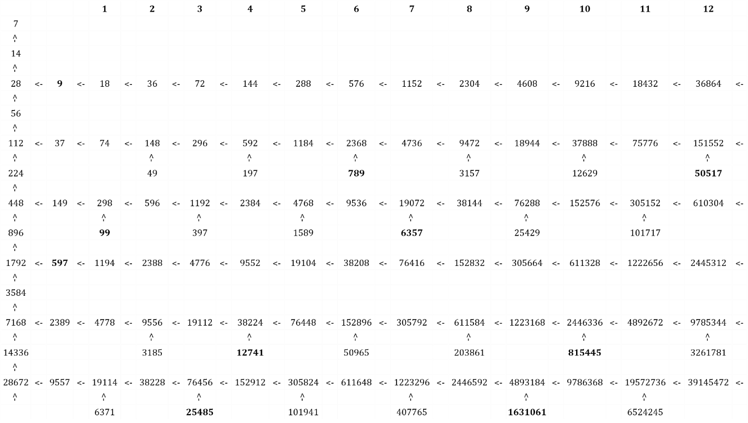

Following is for n = 25 (25, 76, 38, 19, 58, 29, 88, 44, 22, 11, 34, 17, 52, 26, 13, 40, 20, 10, 5, 16, 8, 4, 2, 1).

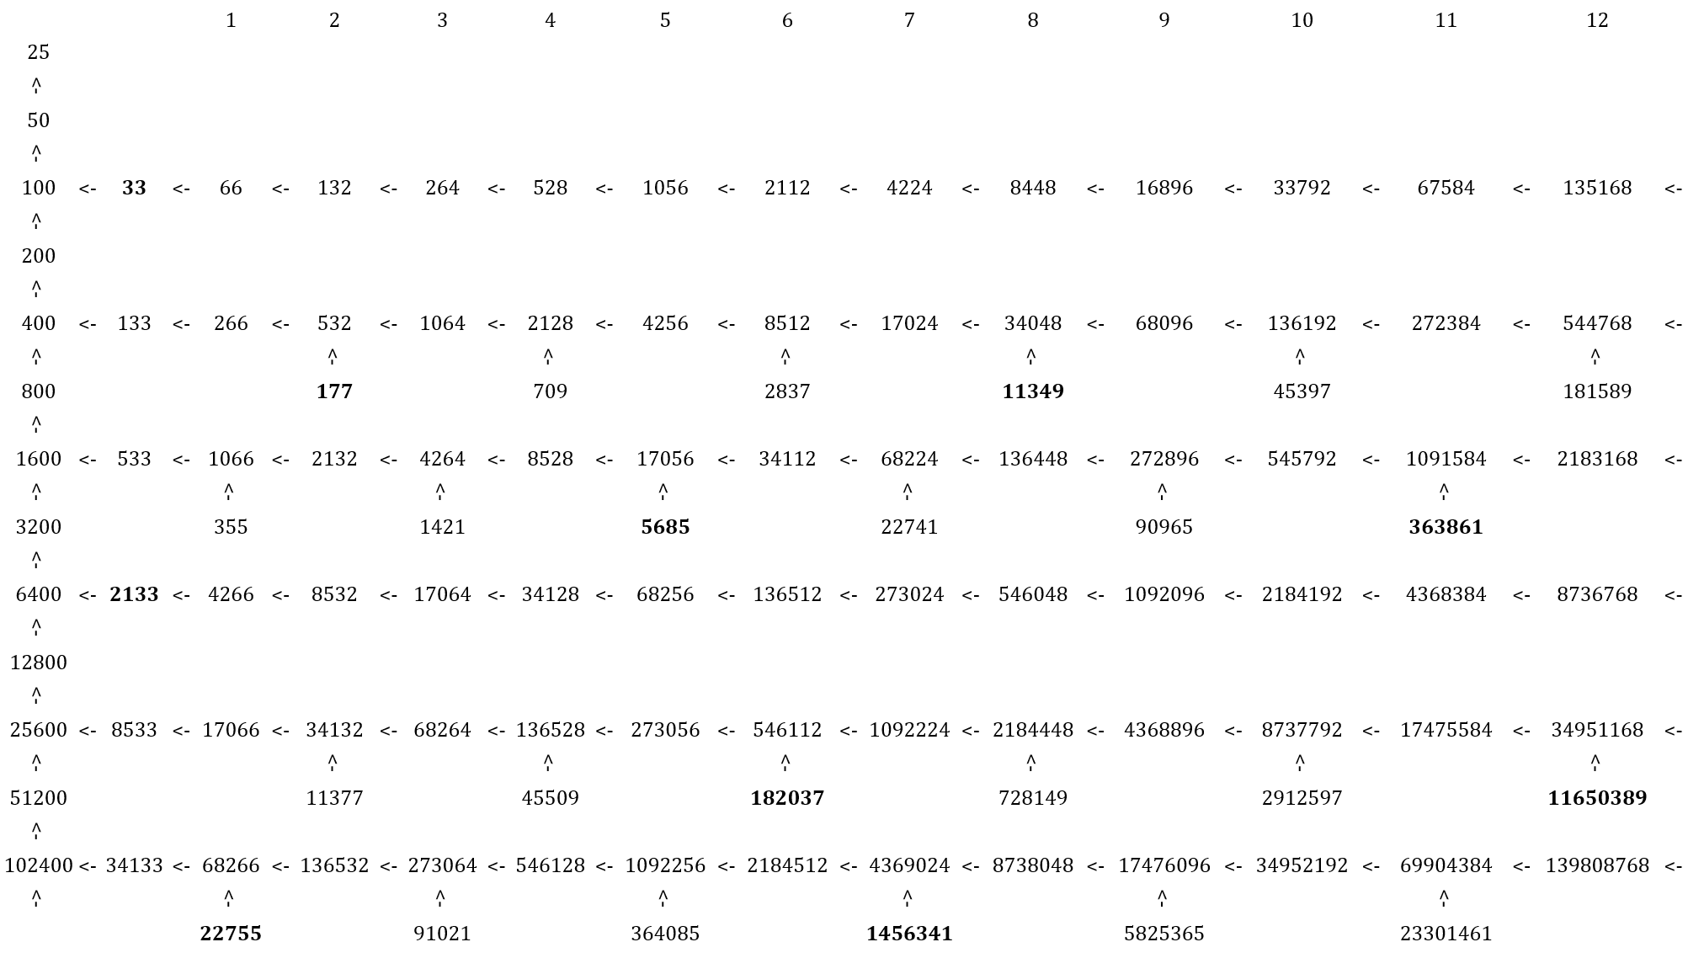

As it can be seen from these examples presented above, that any number m can be taken and a branch can be created in this format with values m*2n, n > 0. This will lead to further branching on either odd or even nodes. An important thing to notice is that m will always be an odd number as is always odd. So, the branch obtained from the Branch Value will have values:

Branches can be formed at odd or even positions. The nodes that lead to branching at even or odd positions appear randomly, although for a specific branch, this pattern will always repeat.

This represents the occurrence of powers and nodes and their random appearance in these six combinations throughout the tree. Consequently, no discernible pattern exists apart from the powers of 2 originating from the base stem

s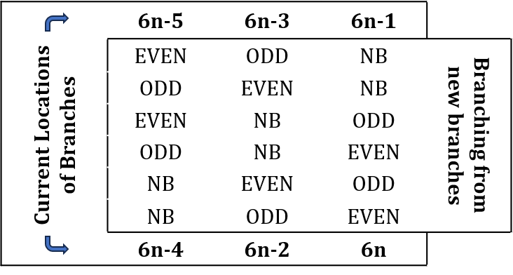

***Fig. 2:*** *Different Permutations of Further Branching on a current Branch*

## Approximation of Generalised Term

For base stem, values that have branching can be given as follows:

-Eqn. 5

Here 26n values are not taken since these values create branches with no branching. For branches, it can be said that they cause branching when an odd value is obtained.

Again, Nodes are at zeroth position. The first value of branch is node*2, and so on given by node*2n, where n is position of each branch value. So, a branch is to be created from m1 position of branch of R. This node can be expressed as:

Now for m2 position of this branch, node value can be expressed as:

For m3 position of this branch, node value can be expressed as:

For m4 position of a particular branch, node value can be expressed as:

A generalisation can be made using this division ladder:

After simplification, following expression is obtained:

Following is the generalised term:

-Eqn. 7

Here:

= number of branches to be traversed for the node value

= set of values of positions of nodes in each branch for traversing (total k values)

Following are two illustrations for values 9 and 267, with a follow up of visual representation of Generalised term.

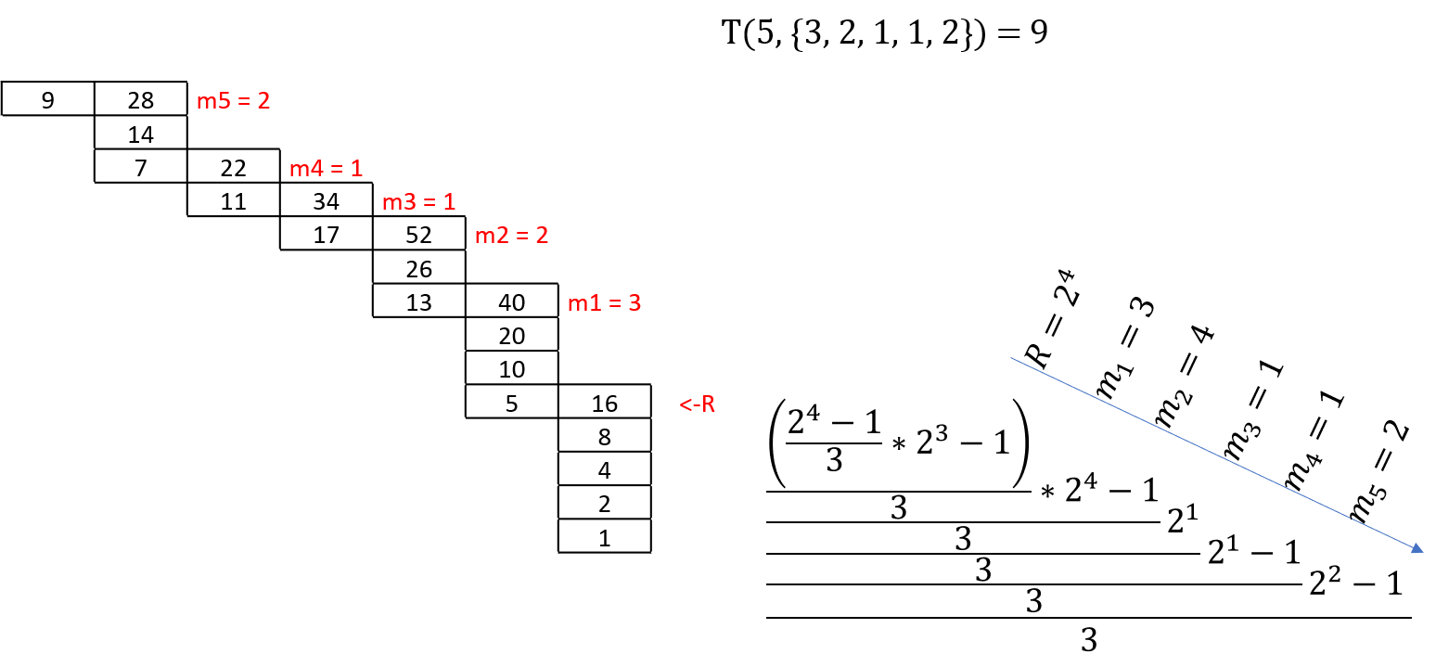

***Fig. 4(a):*** *Illustration of Formula for Value 9*

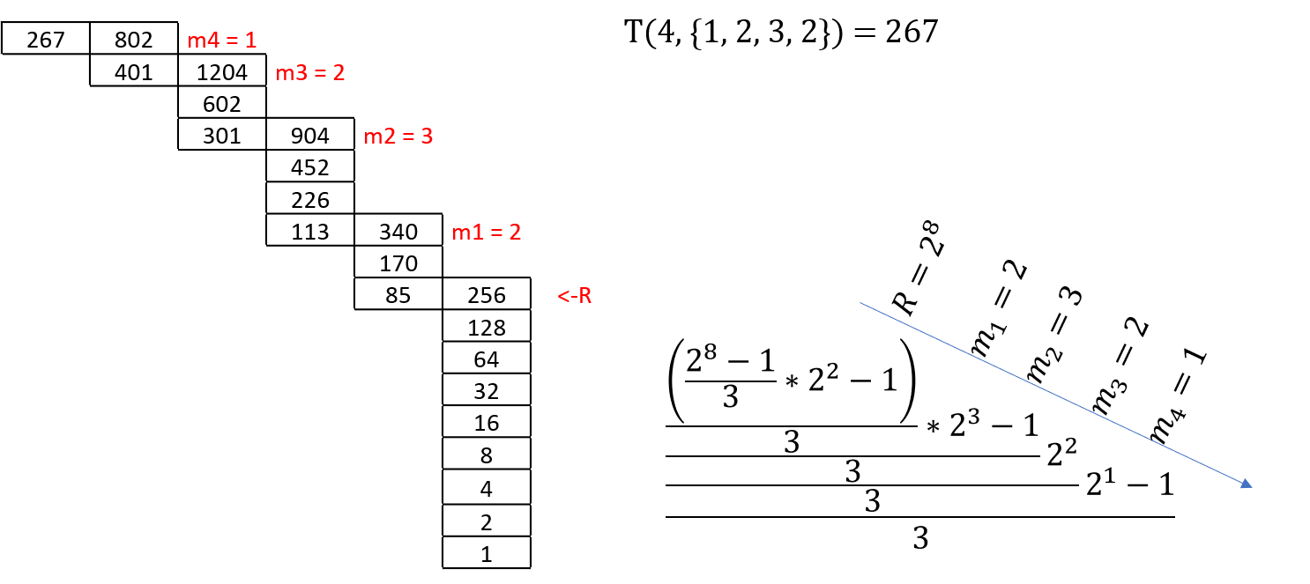

***Fig. 4(b):*** *Illustration of Formula for Value 267*

The values of mi are random as there is not pattern for positions of branching over other nodes and the branches form on alternative nodes and hence only pattern available is for R.

Apart from 26n, there will be values in {mi} which will fall on branchless nodes and will cause failure as there will not be integer result but a fraction.

This function or generalised term (Eqn. 7) is like proposition 7[4] given by Bohm et. Al.:

*we have: if and only if with for such that*

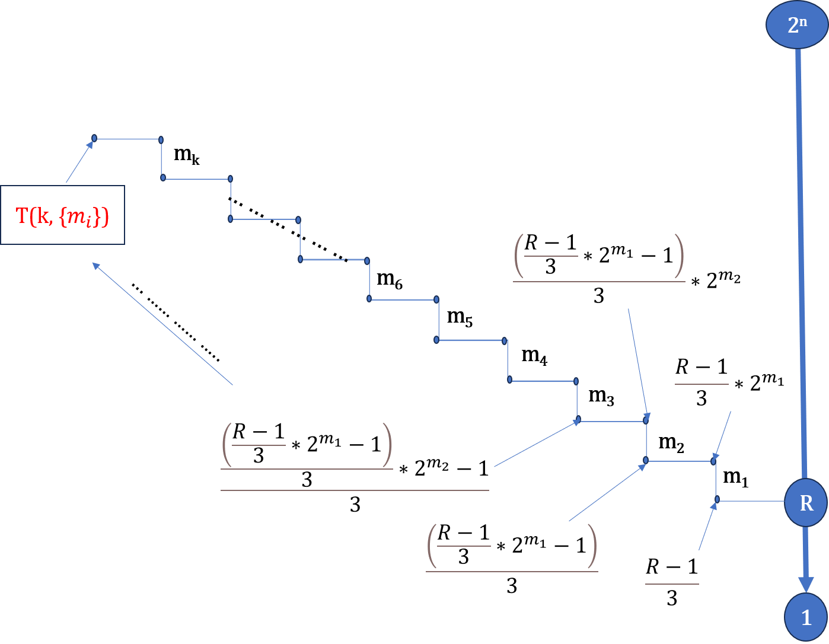

***Fig. 5:*** *Node Positions w.r.t. formula*

## Node Values and Consecutive Branches

If we take a branch of any value m, this branch will be related to the next branch in the manner of 4*(branch value at position n) + 2n. For example, base stem and their branches can be expressed as:

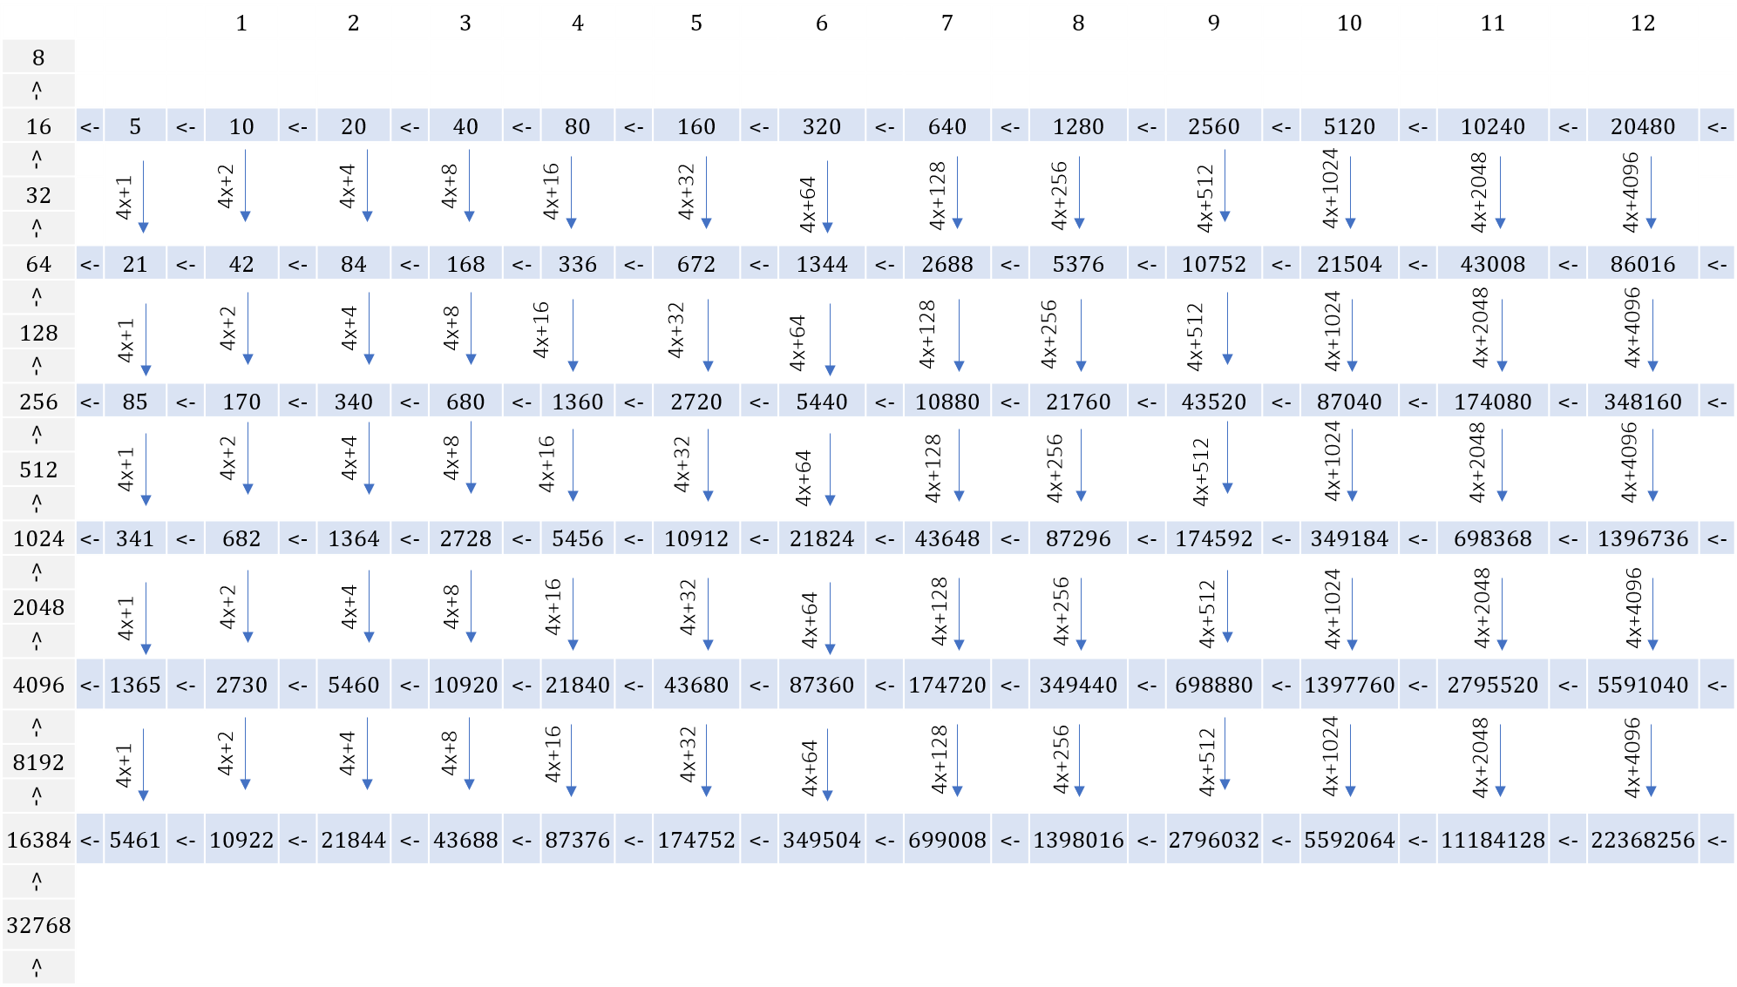

For nodes itself: **21** = 4*5 + 20 **85** = 4*21 + 20 **341** = 4*85 + 20

For branch values: Value at position n of current branch = 4*value at position n of previous branch +2n

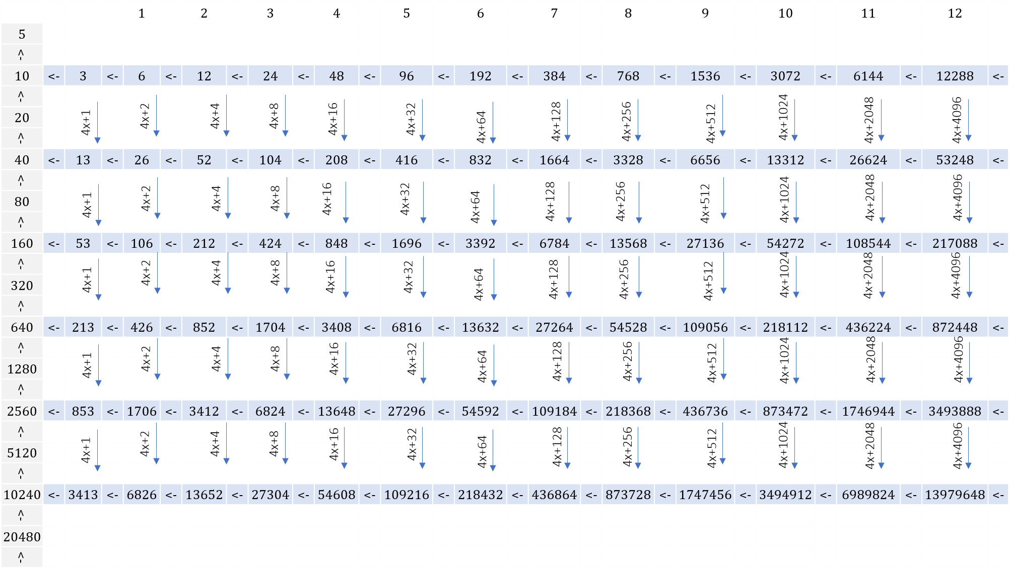

Another relation that can be drawn from these values is that in current branch a value at a position n is that it has addition of 2n to the value at n+2 position of previous branch. Again taking example of branches of base stem:

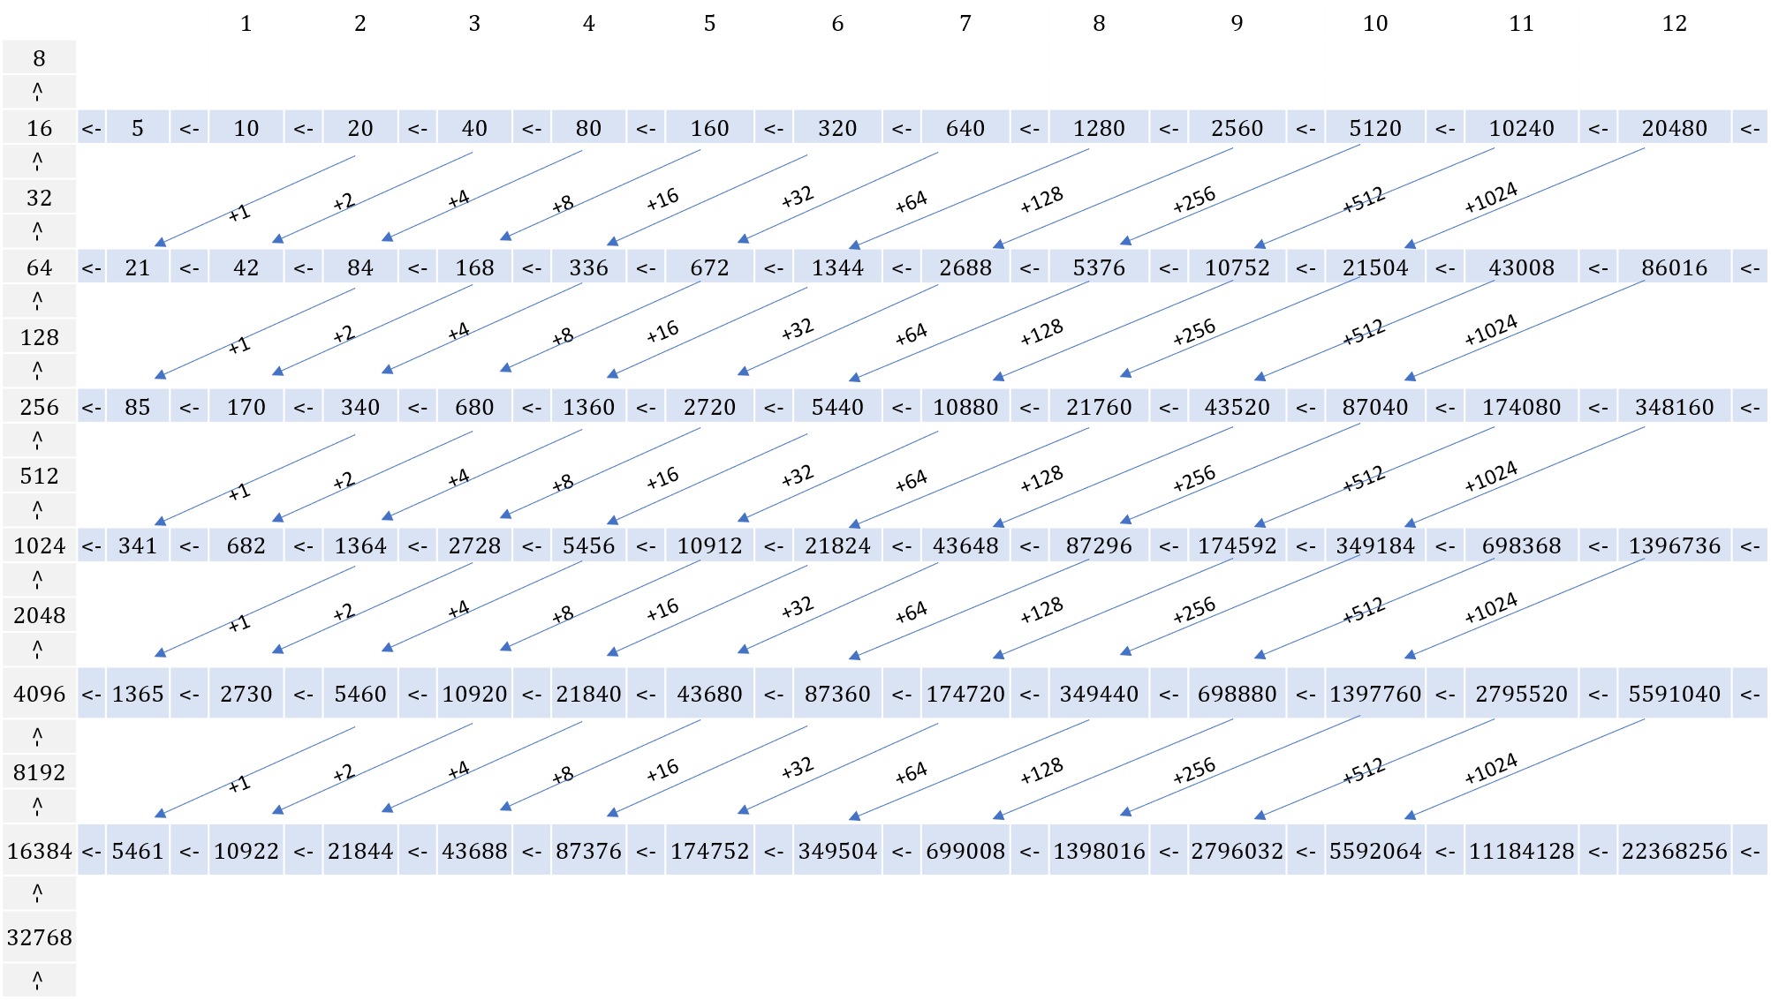

Similarly, for other node values it can be shown in the same way. Following is example for node value 5:

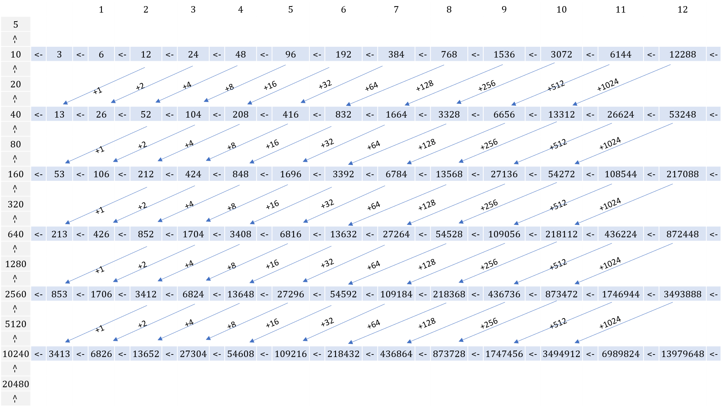

Value of nth position of branch = value at (n+2)th position at previous branch + 2n (including nodes at n = 0)

Similarly other relations can be made by looking at the values which are:

* Value of nth position of branch = 2 * value at (n+1)th position at previous branch + 2n
* Value of (n+1)th position of next branch = 8 * value at nth position at current branch + 2n+1
* There are similar relations diagonally.

# Conclusion

Here are the key points from this work:

* The tree’s structure can be visualized starting from the base stem, which follows the powers of 2, and the branches follow a similar pattern.
* The position pattern is either odd or even, but the nodes for even, odd, and no-branching branches appear randomly.
* The criteria for no branching:
* Base stem and branch values are even (except for 1), while node values are odd.
* Consecutive branches of the same node are related either vertically by 4x+2n or diagonally by (previous branch value at nth position) + 2n-2.
* The generalization of node values can be designed with a root term that follows a known pattern, while the branches have random values. The formula in the division ladder is in its simplest form.

# References

1. Collatz conjecture, <https://en.wikipedia.org/wiki/Collatz_conjecture>
2. The Ultimate Challenge: The 3x+1 Problem; Jeffery C. Lagarias
3. On the existence of cycles of given length in integer sequences like xn+1 = xn/2 if xn even, and xn+1 = 3xn + 1; Corrado Böhm, Giovanna Sontacchi