* **Write a shell script that takes a command line argument and reports on whether it is a directory or a file.**

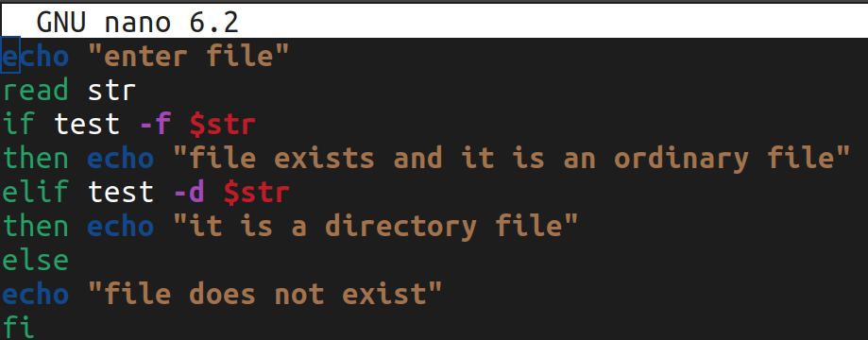

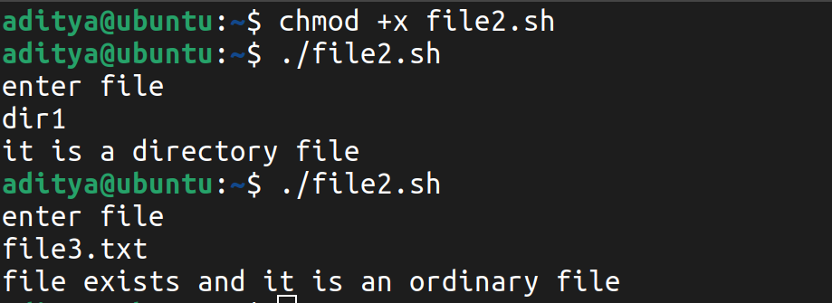

* **Write a shell script that takes file names as arguments and convert all of them to uppercase.**

