Customer Behavior Analysis Report

Customer Behaviour Analysis

Objective
In this case study, you will be working on E-commerce Customer Behavior Analysis using Apache Spark, a powerful distributed computing framework designed for big data processing. This assignment aims to give you hands-on experience in analyzing large-scale e-commerce datasets using PySpark. You will apply techniques learned in data analytics to clean, transform, and explore customer behavior data, drawing meaningful insights to support business decision-making. Apart from understanding how big data tools can optimize performance on a single machine and across clusters, you will develop a structured approach to analyzing customer segmentation, purchase patterns, and behavioral trends.

Business Value
E-commerce businesses operate in a highly competitive market where understanding customer behavior is critical to driving growth and retention. To stay ahead, companies must leverage data-driven insights to optimize marketing strategies, personalize customer experiences, and improve product offerings. In this assignment, you will analyze e-commerce transaction data to uncover patterns in purchasing behavior, customer preferences, and sales performance. With Apache Spark's ability to handle large datasets efficiently, businesses can process vast amounts of customer interactions in real-time, helping them make faster and more informed decisions.
As an analyst at an e-commerce company, your task is to examine historical transaction records and customer survey data to derive actionable insights that can drive business growth. Your analysis will help identify high-value customers, segment users based on behavior, and uncover trends in product demand and customer engagement. By leveraging big data analytics, businesses can enhance customer satisfaction, improve retention rates, and maximize revenue opportunities.

Assignment Tasks

Dataset Overview
The dataset can be accessed the following link.
The dataset used in this analysis comprises longitudinal purchase records from 5,027 Amazon.com users in the United States, spanning 2018 to 2022.
It is structured into three CSV files (amazon-purchases.csv, survey.csv, and fields.csv) that capture transactional data, demographic profiles, and survey responses.
Collected with informed consent, the dataset enables analysis of customer behavior, product preferences, and demographic trends.
NOTE: Personal identifiers (PII) were removed to ensure privacy, and all data were preprocessed by users before submission.
Data Dictionary:

Loading the Datasets

1. Data Preparation
Before analysis, the data needs to be prepared to ensure consistency and efficiency.
+-----------------+----------+-----------------------+--------+----------------------+-----+------------------------+--------+-----------+----------------+------------+-----------------+--------------+--------------+--------------------+-------------+--------------------+--------------------+--------------------+--------------------------+-------------------------+-----------------------+-------------------+---------------------+--------------+----------------+--------------------+---------------+------------+------------------+
|Survey ResponseID|Order Date|Purchase Price Per Unit|Quantity|Shipping Address State|Title|ASIN/ISBN (Product Code)|Category|Q-demos-age|Q-demos-hispanic|Q-demos-race|Q-demos-education|Q-demos-income|Q-demos-gender|Q-sexual-orientation|Q-demos-state|Q-amazon-use-howmany|Q-amazon-use-hh-size|Q-amazon-use-how-oft|Q-substance-use-cigarettes|Q-substance-use-marijuana|Q-substance-use-alcohol|Q-personal-diabetes|Q-personal-wheelchair|Q-life-changes|Q-sell-YOUR-data|Q-sell-consumer-data|Q-small-biz-use|Q-census-use|Q-research-society|
+-----------------+----------+-----------------------+--------+----------------------+-----+------------------------+--------+-----------+----------------+------------+-----------------+--------------+--------------+--------------------+-------------+--------------------+--------------------+--------------------+--------------------------+-------------------------+-----------------------+-------------------+---------------------+--------------+----------------+--------------------+---------------+------------+------------------+
|144 |0 |0 |0 |87812 |89740|960 |89557 |39479 |39479 |39479 |39479 |39479 |39479 |39479 |39479 |39479 |39479 |39479 |39479 |39479 |39479 |39479 |39479 |1252437 |39479 |39479 |39479 |39479 |39479 |
+-----------------+----------+-----------------------+--------+----------------------+-----+------------------------+--------+-----------+----------------+------------+-----------------+--------------+--------------+--------------------+-------------+--------------------+--------------------+--------------------+--------------------------+-------------------------+-----------------------+-------------------+---------------------+--------------+----------------+--------------------+---------------+------------+------------------+

root
|-- Survey ResponseID: string (nullable = true)
|-- Order Date: date (nullable = true)
|-- Purchase Price Per Unit: double (nullable = true)
|-- Quantity: double (nullable = true)
|-- Shipping Address State: string (nullable = true)
|-- Title: string (nullable = true)
|-- ASIN/ISBN (Product Code): string (nullable = true)
|-- Category: string (nullable = true)
|-- Q-demos-age: string (nullable = true)
|-- Q-demos-hispanic: string (nullable = true)
|-- Q-demos-race: string (nullable = true)
|-- Q-demos-education: string (nullable = true)
|-- Q-demos-income: string (nullable = true)
|-- Q-demos-gender: string (nullable = true)
|-- Q-sexual-orientation: string (nullable = true)
|-- Q-demos-state: string (nullable = true)
|-- Q-amazon-use-howmany: string (nullable = true)
|-- Q-amazon-use-hh-size: string (nullable = true)
|-- Q-amazon-use-how-oft: string (nullable = true)
|-- Q-substance-use-cigarettes: string (nullable = true)
|-- Q-substance-use-marijuana: string (nullable = true)
|-- Q-substance-use-alcohol: string (nullable = true)
|-- Q-personal-diabetes: string (nullable = true)
|-- Q-personal-wheelchair: string (nullable = true)
|-- Q-life-changes: string (nullable = true)
|-- Q-sell-YOUR-data: string (nullable = true)
|-- Q-sell-consumer-data: string (nullable = true)
|-- Q-small-biz-use: string (nullable = true)
|-- Q-census-use: string (nullable = true)
|-- Q-research-society: string (nullable = true)

+-----------------+----------+--------+-----------------------+-------------+
|Survey ResponseID|Order Date|Quantity|Purchase Price Per Unit|Category |
+-----------------+----------+--------+-----------------------+-------------+
|R_01vNIayewjIIKMF|2018-12-04|1 |7.98 |FLASH_MEMORY |
|R_01vNIayewjIIKMF|2018-12-22|1 |13.99 |HEADPHONES |
|R_01vNIayewjIIKMF|2018-12-24|1 |8.99 |NULL |
|R_01vNIayewjIIKMF|2018-12-25|1 |10.45 |DISHWARE_BOWL|
|R_01vNIayewjIIKMF|2018-12-25|1 |10.0 |SHAVING_AGENT|
+-----------------+----------+--------+-----------------------+-------------+
only showing top 5 rows

2. Data Cleaning [20 marks]
Prepare the data for further analysis by performing data cleaning such as missing value treatment, handle data schema, outlier analysis, and relevant feature engineering techniques.

2.1 Handling Missing values [10 marks]
Handle missing values in the data
+-----------------+----------+-----------------------+--------+----------------------+-----+------------------------+--------+-----------+----------------+------------+-----------------+--------------+--------------+--------------------+-------------+--------------------+--------------------+--------------------+--------------------------+-------------------------+-----------------------+-------------------+---------------------+--------------+----------------+--------------------+---------------+------------+------------------+
|Survey ResponseID|Order Date|Purchase Price Per Unit|Quantity|Shipping Address State|Title|ASIN/ISBN (Product Code)|Category|Q-demos-age|Q-demos-hispanic|Q-demos-race|Q-demos-education|Q-demos-income|Q-demos-gender|Q-sexual-orientation|Q-demos-state|Q-amazon-use-howmany|Q-amazon-use-hh-size|Q-amazon-use-how-oft|Q-substance-use-cigarettes|Q-substance-use-marijuana|Q-substance-use-alcohol|Q-personal-diabetes|Q-personal-wheelchair|Q-life-changes|Q-sell-YOUR-data|Q-sell-consumer-data|Q-small-biz-use|Q-census-use|Q-research-society|
+-----------------+----------+-----------------------+--------+----------------------+-----+------------------------+--------+-----------+----------------+------------+-----------------+--------------+--------------+--------------------+-------------+--------------------+--------------------+--------------------+--------------------------+-------------------------+-----------------------+-------------------+---------------------+--------------+----------------+--------------------+---------------+------------+------------------+
|144 |0 |0 |0 |0 |0 |0 |0 |0 |0 |0 |0 |0 |0 |0 |0 |0 |0 |0 |0 |0 |0 |0 |0 |0 |0 |0 |0 |0 |0 |
+-----------------+----------+-----------------------+--------+----------------------+-----+------------------------+--------+-----------+----------------+------------+-----------------+--------------+--------------+--------------------+-------------+--------------------+--------------------+--------------------+--------------------------+-------------------------+-----------------------+-------------------+---------------------+--------------+----------------+--------------------+---------------+------------+------------------+

2.2 Feature Engineering [5 marks]
Perform feature engineering on the dataset to extract relevant/ create new features as required and map specific data types.
+----------+-----+----+--------+-----------------------+-----------+
|Order Date|Month|Year|Quantity|Purchase Price Per Unit|TotalAmount|
+----------+-----+----+--------+-----------------------+-----------+
|2018-12-04|12 |2018|1 |7.98 |7.98 |
|2018-12-22|12 |2018|1 |13.99 |13.99 |
|2018-12-24|12 |2018|1 |8.99 |8.99 |
|2018-12-25|12 |2018|1 |10.45 |10.45 |
|2018-12-25|12 |2018|1 |10.0 |10.0 |
+----------+-----+----+--------+-----------------------+-----------+
only showing top 5 rows

2.3 Data Cleaning [5 marks]
Handle data cleaning techniques such as data duplication, dropping unnecessary values etc.
+-----------------+-----------+-----------------+-----------+
|Q-demos-income |Income_Code|Q-demos-gender |Gender_Code|
+-----------------+-----------+-----------------+-----------+
|$25,000 - $49,999|1 |Male |0 |
|$25,000 - $49,999|1 |Male |0 |
|$25,000 - $49,999|1 |Male |0 |
|$25,000 - $49,999|1 |Male |0 |
|$25,000 - $49,999|1 |Male |0 |
|$25,000 - $49,999|1 |Male |0 |
|$25,000 - $49,999|1 |Male |0 |
|Prefer not to say|NULL |Prefer not to say|3 |
|$25,000 - $49,999|1 |Male |0 |
|$25,000 - $49,999|1 |Male |0 |
+-----------------+-----------+-----------------+-----------+
only showing top 10 rows

3. Exploratory Data Analysis [55 marks]

3.1 Analyse purchases by hour, day and month [5 marks]
Examine overall trends in purchases over time and analyse the trends by hour, day, month.
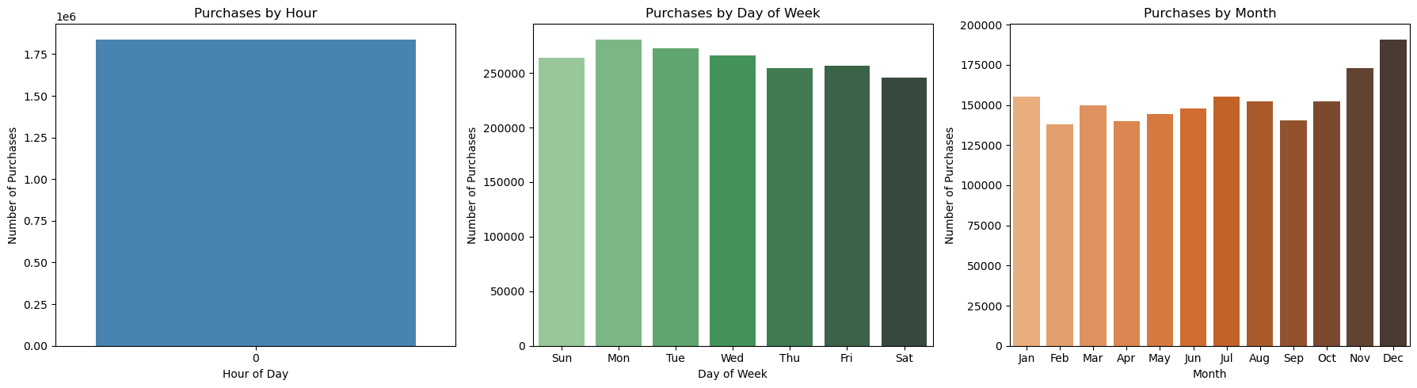
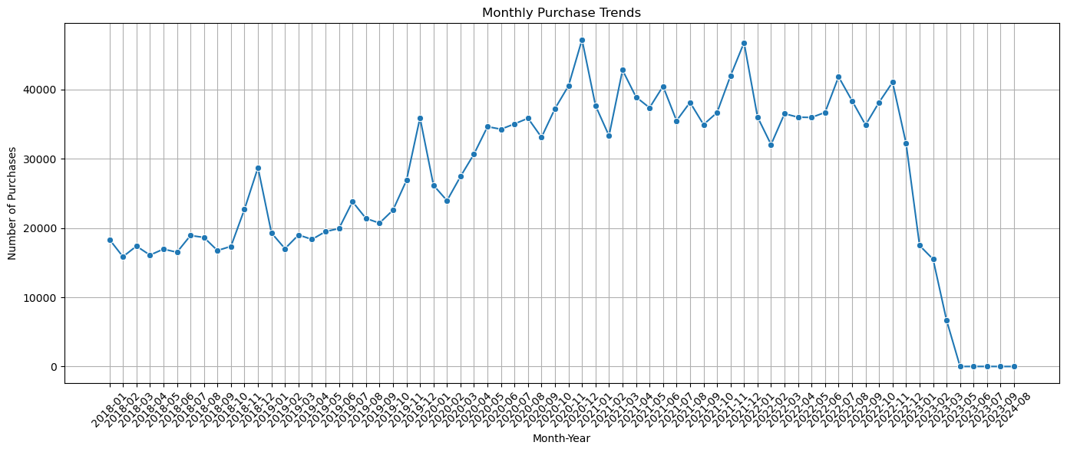
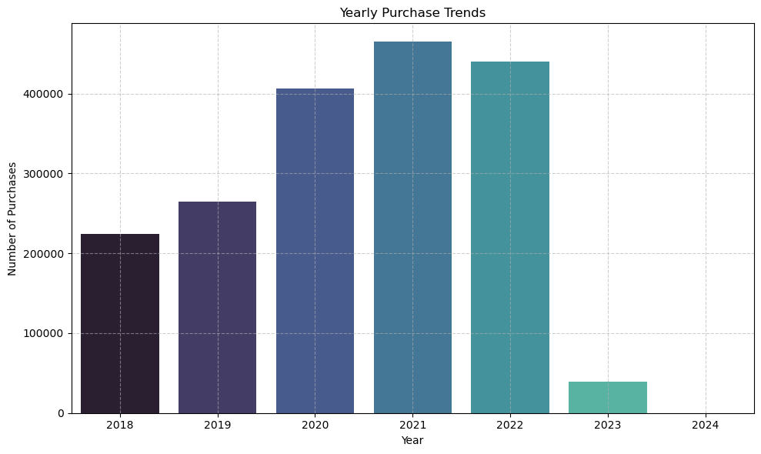

3.2 Customer Demographics vs Purchase Frequency [5 marks]
Analyse the trends between the customer deographics and the purchase frequency
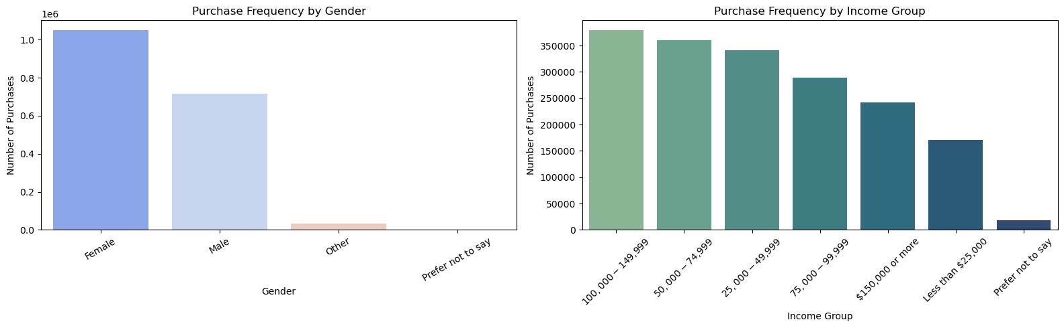

3.3 Purchase behavior weekend vs weekday [5 marks]
Compare the purchase behavior of customer's on weekdays vs. weekends.
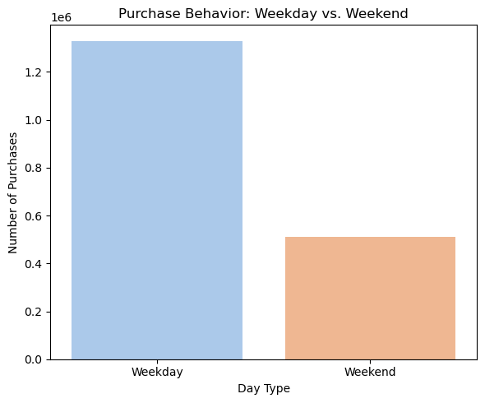

3.4 Frequently purchased product pairs [5 marks]
Analyze how frequently products are purchased together (also known as Market Basket Analysis)
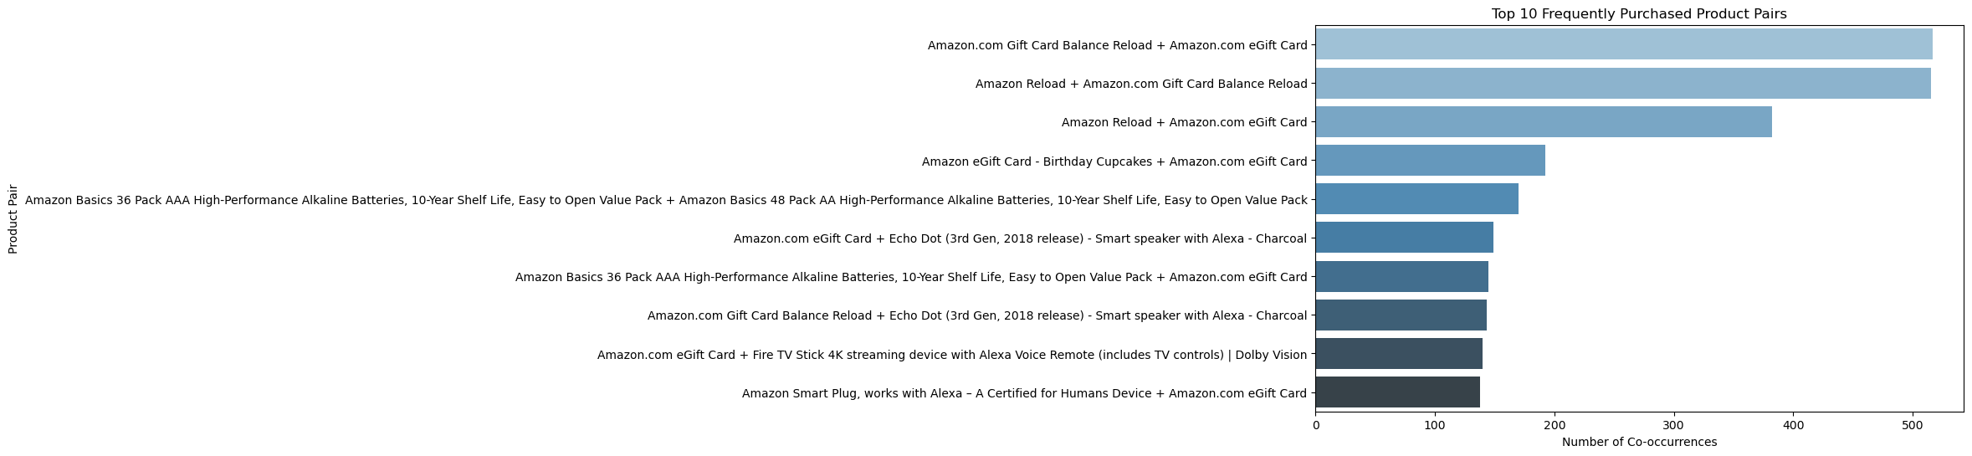

3.5 Examine Product Performance [5 marks]
Examine the performance of products by calculating revenue and item popularity.
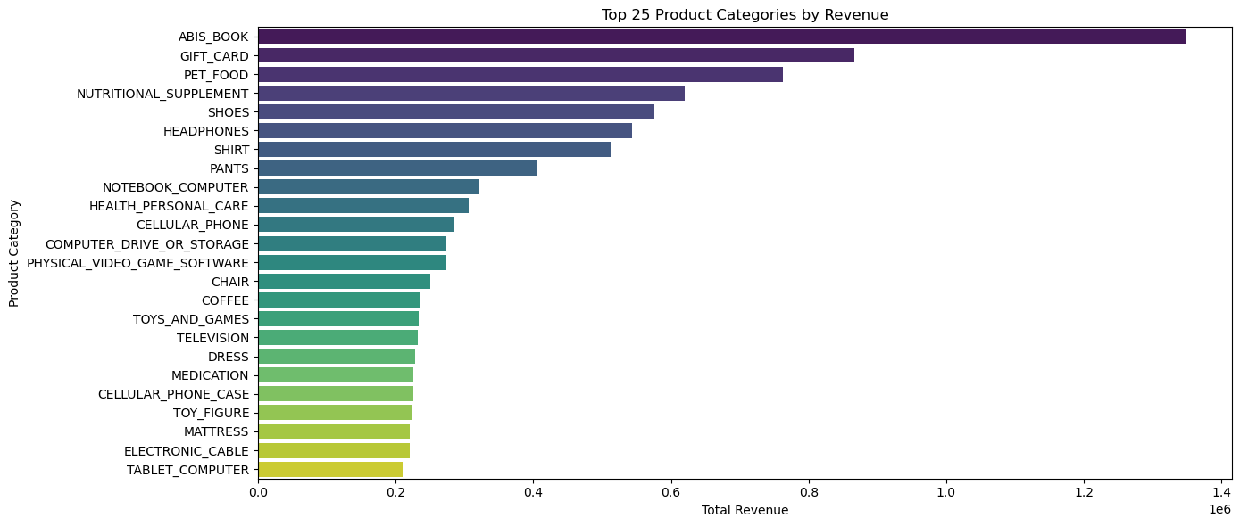

3.6 Top products by quantity [5 marks]
Identify the most frequently purchased products.
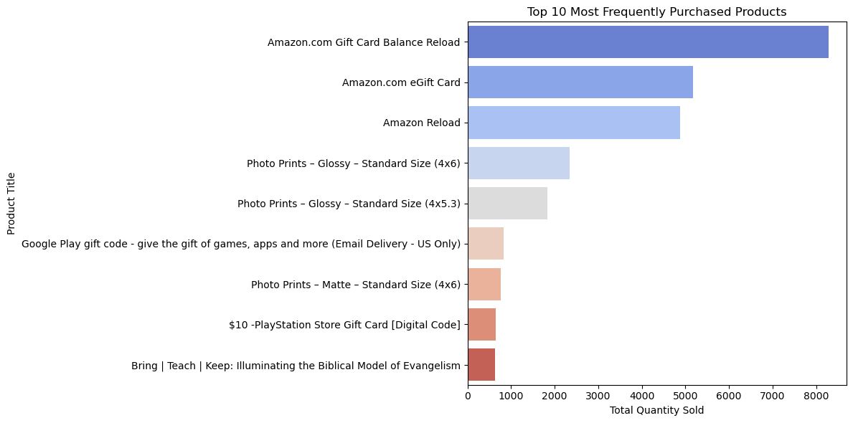

3.7 Distribution of Purchases by State [5 marks]
Analyze the distribution of purchases across states and categories.
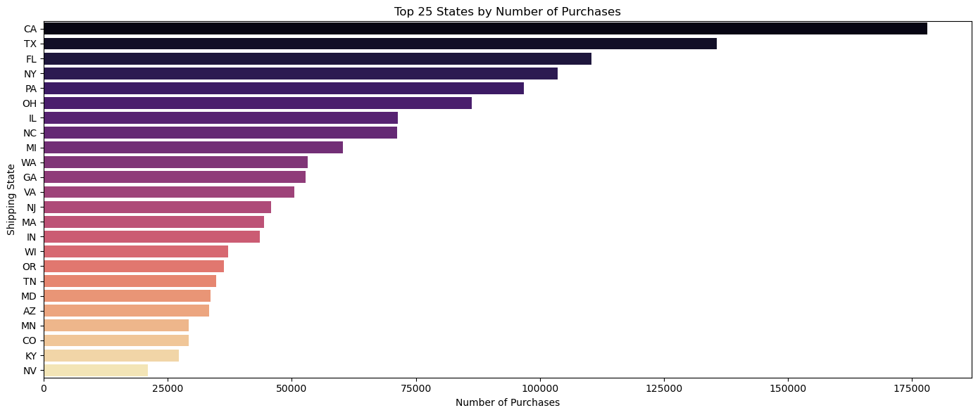

3.8 Price vs Product Quantity [5 marks]
Identify the Relationship between Price and Quantity
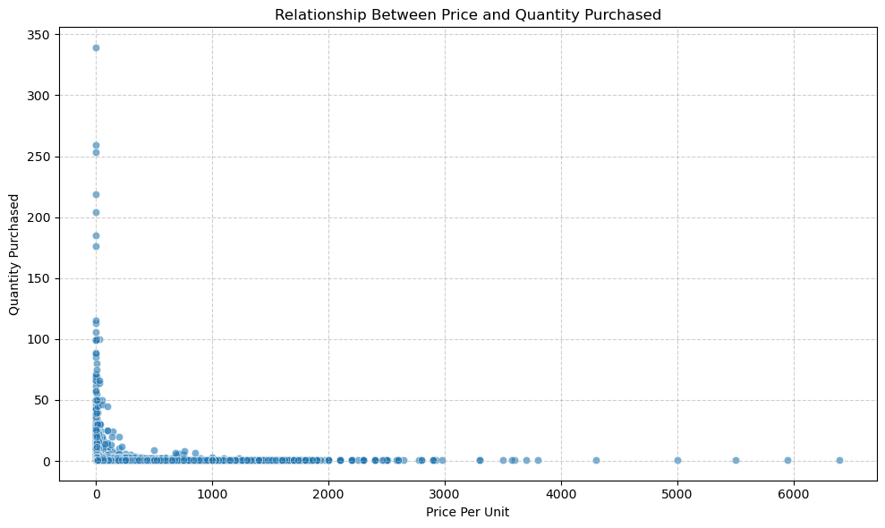

3.9 Analyse the spending KPIs [5 marks]
A popular KPI is average spend per customer. Calculate this metric as the ratio of total transaction amount from non-recurring payments divided by the total number of customers who made a purchase
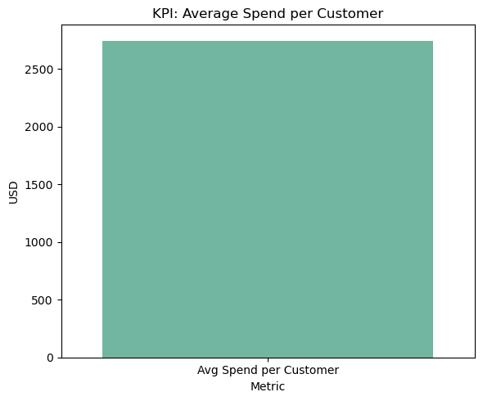
Analyse the Repeat Purchase Behavior of Customers
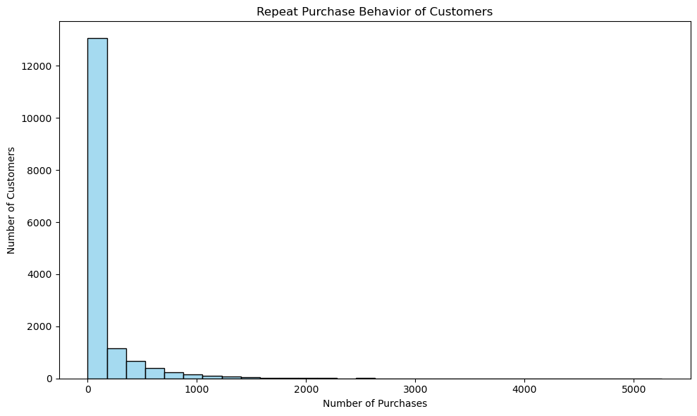
Analyse the top 10 high-engagement customers
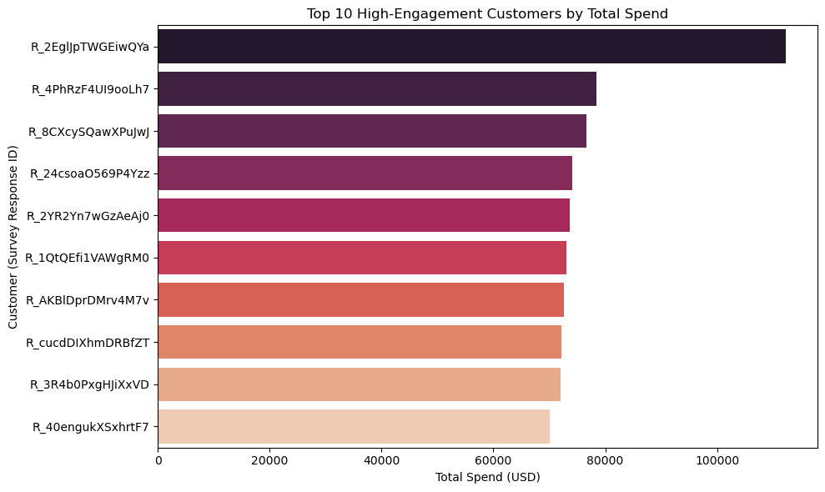

3.10 Seasonal trends in product purchases and their impact on revenues [5 marks]
Investigate the seasonal trends in product purchases and their impact on the overall revenue.
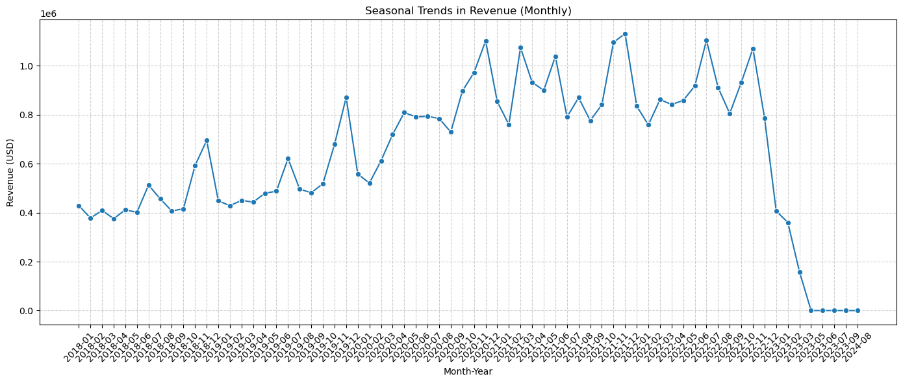

3.11 Customer location vs purchasing behavior [5 marks]
Examine the relationship between customer's location and their purchasing behaviors
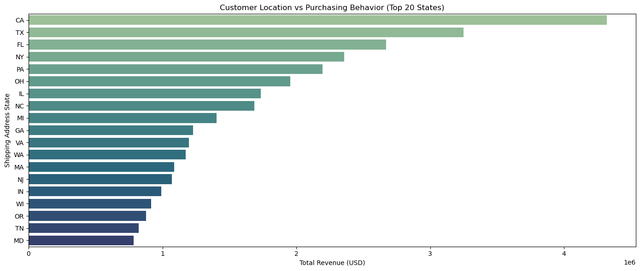

4. Customer Segmentation and Insights [45 marks]

4.1 Perform RFM Analysis [10 marks]
RFM Analysis is a powerful customer segmentation technique used to evaluate and quantify customer value based on three key dimensions:
This method is particularly effective in identifying high-value customers, optimizing marketing strategies, and improving customer retention in the e-commerce industry.

1. Recency (R)
Recency measures how recently a customer made a purchase Customers who have purchased more recently are more likely to respond to promotions and offers.

2. Frequency (F)
Frequency counts the number of purchases a customer has made over a given period.
Frequent purchasers tend to be more loyal and are often a source of recurring revenue.

3. Monetary (M)
Monetary value represents the total amount of money a customer has spent.
Customers who spend more are often more profitable, making them ideal targets for retention and upsell strategies.

Prepare data for RFM Analysis [2 marks]
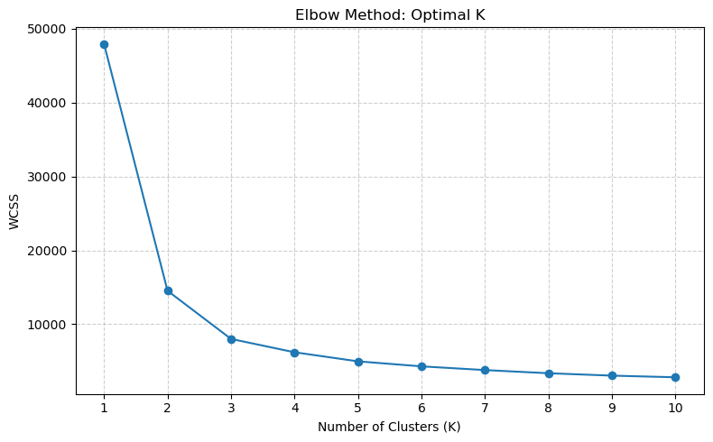
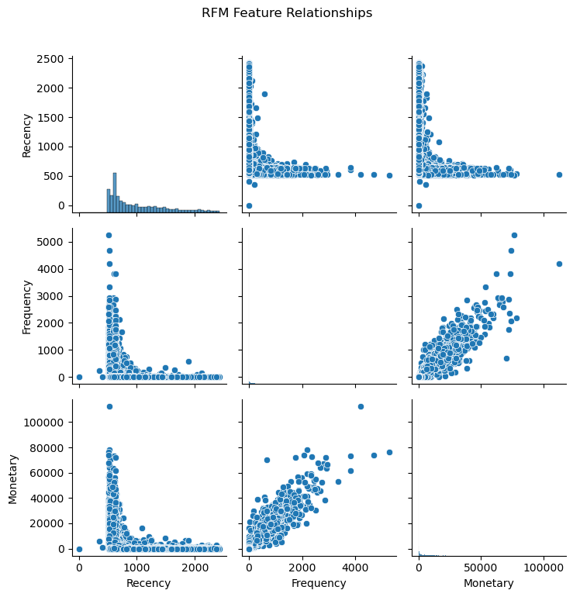

Behavioral Trends Analysis [8 marks]
Perform RFM analysis to study the behavior of customers to tailor marketing strategies
Analyse the Cluster Distribution by Income [2 marks]
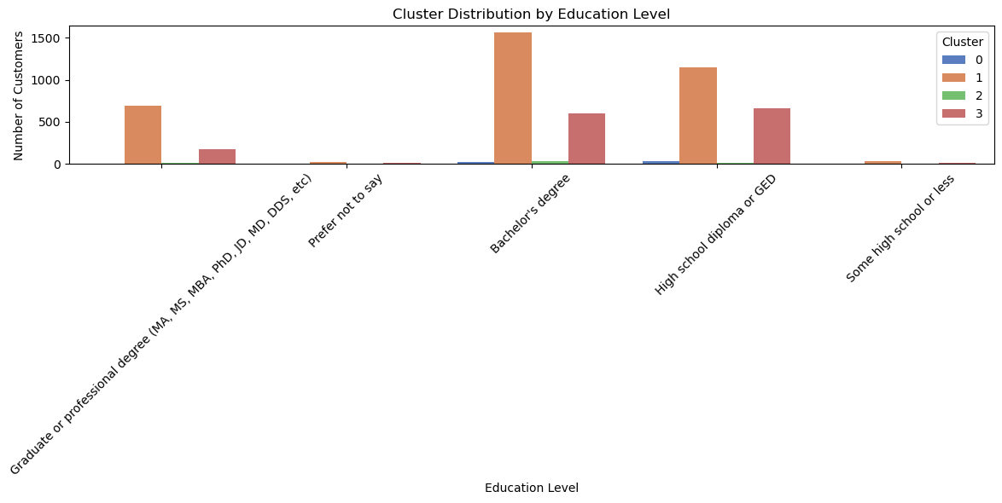
Analyse the Average Spending by Cluster [2 marks]
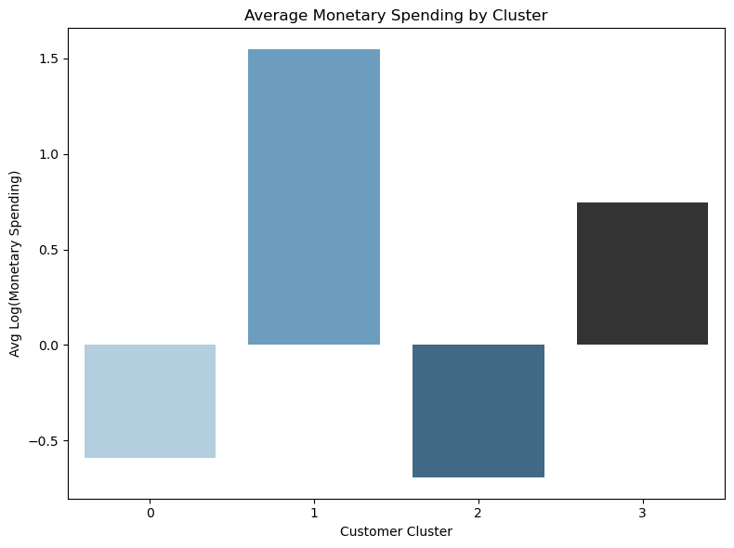
Analyse the Purchase Frequency vs. Recency [2 marks]
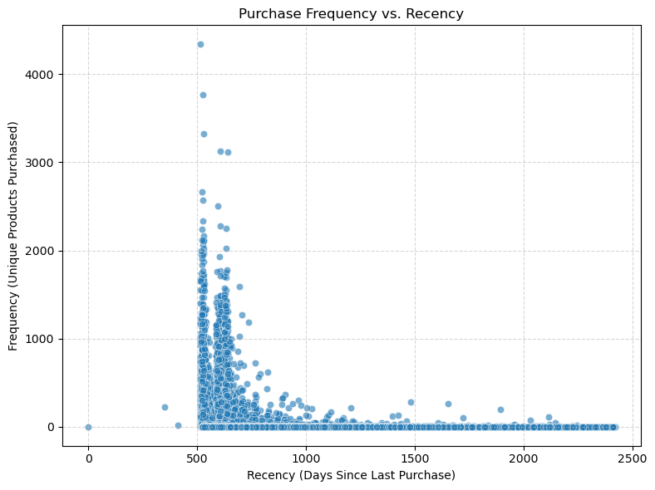
Analyse the top categories by clusters [2 marks]
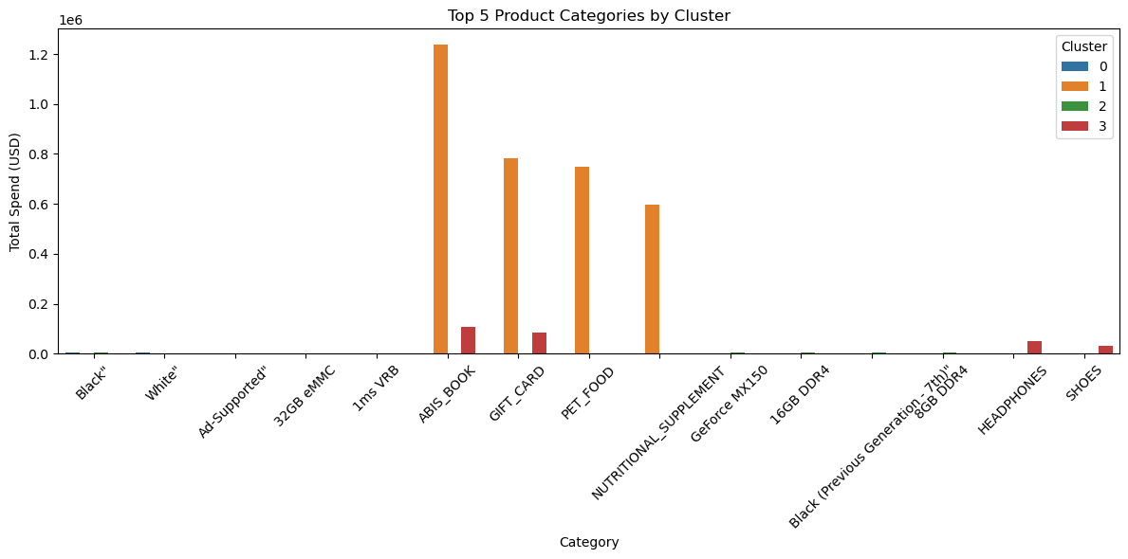

4.2 Insights [35 marks]

4.2.1 When to schedule effective promotions. [3 marks]
Compare sales across weekdays to schedule effective promotions
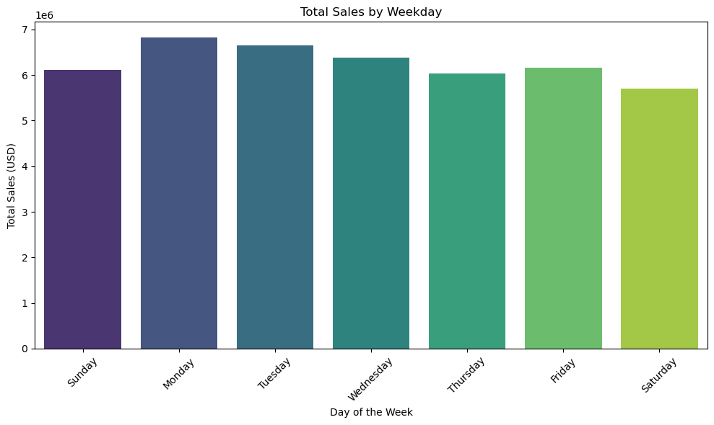

4.2.2 Top-selling Products [2 marks]
Identify top-selling products by considering revenue and engagement metrics
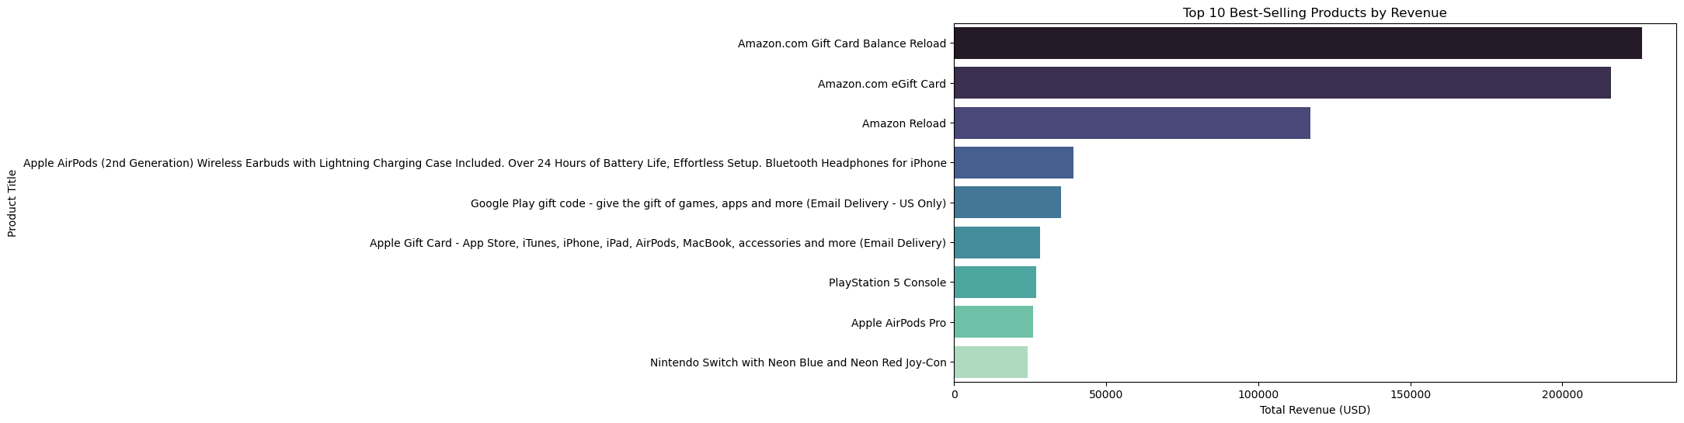

4.2.3 State-wise revenue Distribution [5 marks]
Assess state-wise revenue to focus on high-growth areas
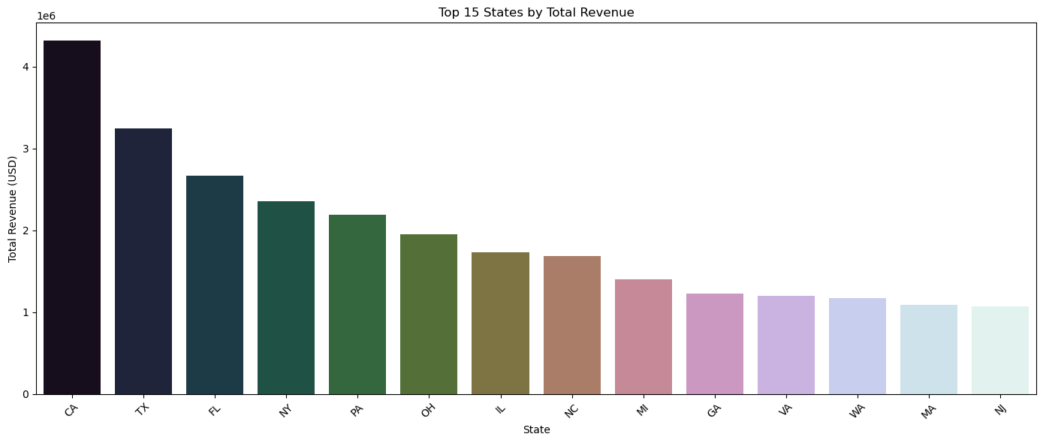

4.2.4 Repeat Purchase Behavior [5 marks]
Examine repeat purchase behavior to enhance retention initiatives.
+-----------------+---------------+
|Survey ResponseID|Total_Purchases|
+-----------------+---------------+
|R_10TV1zyi4yCEEkl|1124 |
|R_1QgWXnlpERvWjrY|89 |
|R_1LBvKYfg8hgoloJ|7 |
|R_1mxX9jjBSLwxiDU|248 |
|R_297dOANqCntVXou|588 |
|Easter |7 |
|R_1CqGMkfiCiATbn4|183 |
|R_1N52McSjcCnVqIm|11 |
|R_1eWdieBjoYJXAYv|965 |
|R_1esG9Jlh9NISLaO|368 |
+-----------------+---------------+
only showing top 10 rows

4.2.5 Flagging Potential Fraud [5 marks]
Identify irregular transaction patterns to flag potential fraud.
Fraud Threshold: 171.7 USD
+-----------------+----------+--------------------------------------------------------------------------------------------------------------------------------------------------------------------------------------------------------+--------+-----------------------+-----------+
|Survey ResponseID|Order Date|Title |Quantity|Purchase Price Per Unit|TotalAmount|
+-----------------+----------+--------------------------------------------------------------------------------------------------------------------------------------------------------------------------------------------------------+--------+-----------------------+-----------+
|R_0BWkZUjRId7FDZn|2018-03-05|Optoma S341 3500 Lumens SVGA 3D DLP Projector with Superior Lamp Life and HDMI |1 |289.0 |289.0 |
|R_1CJ6LgP7rtL24ny|2020-07-01|HTC SteamVR Base Station 2.0 |1 |178.97 |178.97 |
|R_1H7zLm1nT1XvnWc|2019-02-06|PlayStation 4 Pro 1TB Console |1 |399.95 |399.95 |
|R_1QB1ztGTGqYRyPX|2021-05-13|Omen GeForce RTX Studio 2019 15-Inch Laptop, 9th Gen Intel Core i7-9750H, NVIDIA GeForce RTX 2060 (6 GB) W/HDR 400 True Black, 32 GB RAM, 1 TB SSD, Windows 10 Pro (15-dh0015nr, Shadow Black) |1 |973.63 |973.63 |
|R_0BCm9hRP9iTI081|2020-06-21|HSH Natural Real Wood Bookcase, 5 Tier Industrial Rustic Vintage Etagere Bookshelf, Open Metal Farmhouse Solid Wooden Book Shelf, Distressed Brown |1 |239.96 |239.96 |
|R_1BNwZP0DdTOa4rT|2021-05-06|Schwinn Fitness Indoor Cycling Exercise Bike Series |1 |801.32 |801.32 |
|R_1IFq9WjfDcelfCl|2019-03-19|ASUS L402WA-EH21 Thin and Light 14” HD Laptop; AMD E2-6110 Quad Core 1.5GHz Processor,AMD Radeon R2 Graphics,4GB RAM,32GB eMMC Flash Storage,Windows 10 S with FREE 1yr Office 365 Subscription Included|1 |189.99 |189.99 |
|R_1N2pRfCrIwFtKcN|2020-08-09|Scimitar Sword |1 |206.53 |206.53 |
|R_1BPo7cRkGaVw2zj|2022-12-18|Milestar MS932 Sport All Season Radial Tire - 215/55R17 98V |2 |86.48 |172.96 |
|R_1CEeWOcxWHKG89k|2018-11-13|Salomon Men's Pulse Softshell Jackets |1 |175.0 |175.0 |
+-----------------+----------+--------------------------------------------------------------------------------------------------------------------------------------------------------------------------------------------------------+--------+-----------------------+-----------+
only showing top 10 rows

4.2.6 Demand Variations across product categories [5 marks]
Perform inventory management by monitoring demand variations across product categories.
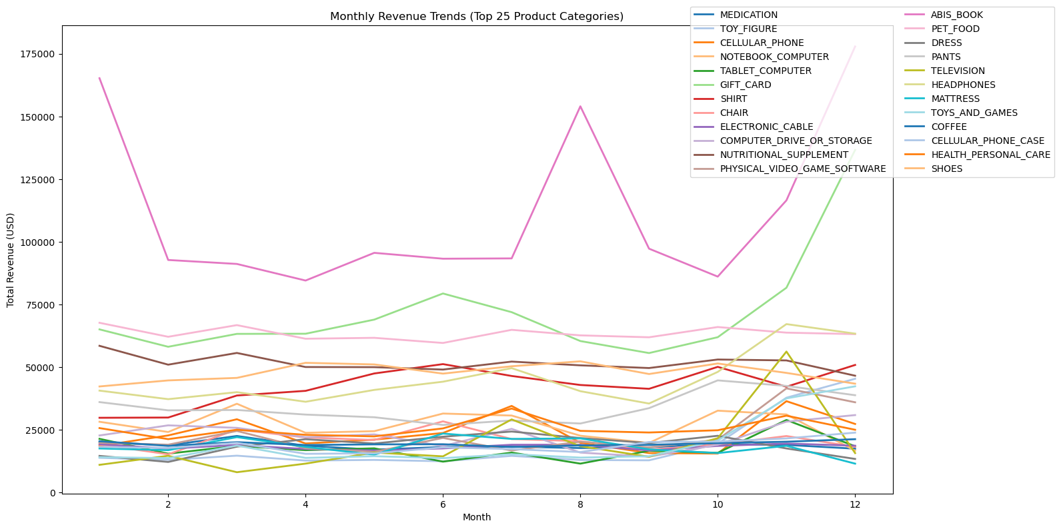

4.2.7 Assess how bulk purchases affect revenue and supply chain operations [5 marks]
Analyse the impact of how bulk purchasing behavior affects revenue and the overall supply chain operations.
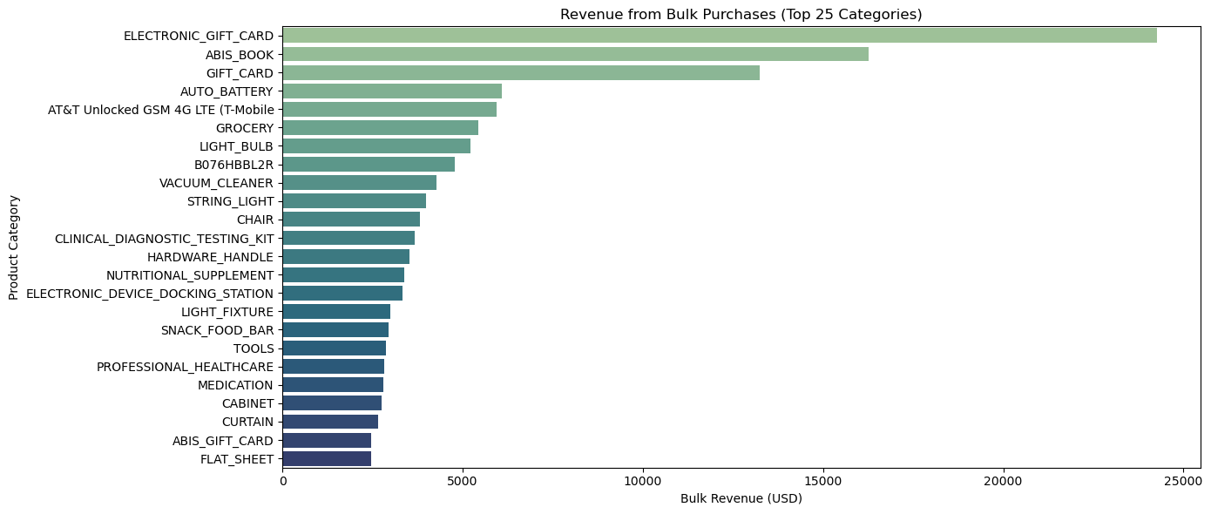

4.2.8 Compare lifecycle strategies [5 marks]
Compare new and established products to inform and compare lifecycle strategies to make informed decisions.
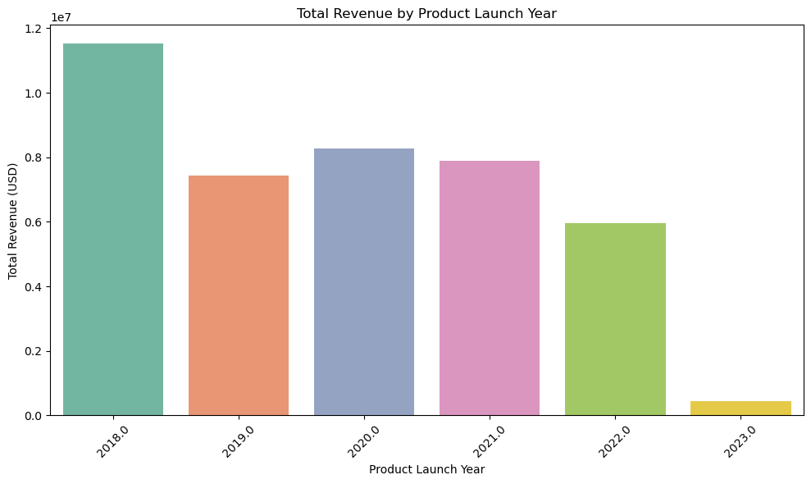

5 Conclusion [10 marks]
In this project, we utilized Apache Spark to perform a detailed behavioral and transactional analysis of customers in a large-scale e-commerce environment. By integrating transactional, demographic, and survey datasets, we were able to uncover meaningful patterns that support data-driven business decision-making.
The customer segmentation using RFM (Recency, Frequency, Monetary) analysis enabled us to categorize users based on their engagement and value. This segmentation forms the foundation for personalized marketing campaigns, allowing the business to target high-value, frequent, or at-risk customers with tailored messaging and promotions.
Our promotional timing analysis revealed that purchases tend to peak midweek, particularly on Wednesdays and Thursdays. This insight can be leveraged to schedule campaigns and discounts when customer engagement is naturally higher, maximizing conversion rates. Furthermore, the top-selling products and high-revenue regions such as California and Texas provide direction for optimizing marketing spend and inventory allocation.
In terms of inventory management, monthly revenue trends across the top 25 categories showcased clear seasonal variations in demand. Analyzing bulk purchases (orders with large quantities) further helped identify categories that require proactive inventory planning due to high-volume orders. These findings can be used to adjust supply chain operations and maintain stock levels efficiently.
We also identified potential instances of fraudulent activity by flagging transactions with spending far above average thresholds. This not only adds a layer of operational security but also highlights customers who might be engaged in wholesale or irregular purchasing behaviors. Additionally, a comparison between new and established products based on launch years revealed how newer entries perform in the market and when product life cycle strategies like renewal or phase-out should be considered.
Overall, the analysis presents several actionable insights. Businesses can optimize stock levels in alignment with seasonal and category-specific trends, enhance customer retention through targeted engagement strategies, and ensure pricing strategies reflect customer segmentation. Lastly, high-performing regions can be prioritized for marketing campaigns, ensuring both budget efficiency and revenue growth.

