Coursework 2
Machine Learning Approaches for Detecting Fraudulent
Credit Card Transactions: SMOTE and Ensemble Methods
Aditya Vardhan Sivalanka
CMP020L012A Data Analytics - Coursework 2
Student ID: A00091352

Abstract
Detecting fraudulent credit card transactions presents significant challenges due to extreme class imbalance, where legitimate transactions vastly outnumber fraudulent ones. This research investigates three distinct machine learning algorithms—Logistic Regression, Random Forest, and XGBoost—applied to a real-world dataset containing 284,807 European credit card transactions, of which only 0.17% are fraudulent. To overcome the 578:1 imbalance between normal and fraudulent transactions, I implemented the Synthetic Minority Over-sampling Technique (SMOTE), which generated synthetic fraud samples to achieve a more balanced 5:1 training ratio. My experimental evaluation employed multiple performance metrics including ROC-AUC, PR-AUC, precision, recall, and F1-score, revealing that the Random Forest classifier delivered superior results across most metrics. The analysis of feature importance highlighted that PCA-transformed variables V14, V10, and V4 contributed most significantly to fraud prediction. Based on these findings, I propose a practical two-tier fraud detection framework suitable for financial institution deployment, incorporating automated blocking for high-confidence predictions and manual review for medium-confidence cases. The study acknowledges limitations related to temporal validity, geographic scope, and the interpretability challenges posed by PCA-anonymized features, while suggesting future research directions including explainable AI integration and deep learning approaches.

1. Introduction

1.1. Context and Background
Over the last decade, financial transactions have shifted dramatically toward digital platforms. Mobile banking applications, contactless payment systems, and e-commerce platforms now handle billions of transactions daily. While this digital transformation has created unprecedented convenience for consumers and businesses alike, it has simultaneously opened new opportunities for financial criminals. Credit card fraud has become increasingly sophisticated, costing the global economy over $32 billion annually according to recent estimates.
Traditional fraud prevention systems typically rely on predefined rules and threshold-based detection. For example, these systems might flag transactions exceeding certain amounts or occurring from unusual geographic locations. However, such rule-based approaches face serious limitations. Fraudsters can observe and adapt to these fixed patterns, modifying their behavior to circumvent detection. Additionally, rigid rules often generate excessive false alarms, incorrectly blocking legitimate customer transactions and creating frustration.

1.2. Machine Learning as a Solution
Machine learning offers a fundamentally different approach by discovering patterns automatically from historical transaction data. Rather than relying on manually defined rules, these algorithms can identify subtle indicators of fraudulent behavior that might escape human notice. Machine learning models can also continuously adapt as new fraud patterns emerge, providing more robust long-term protection.
Despite these advantages, applying machine learning to fraud detection introduces several technical challenges:
- Extreme imbalance: In typical datasets, fraudulent transactions comprise less than 1% of all records, causing algorithms to develop bias toward predicting everything as legitimate.
- Adaptive adversaries: Fraudsters actively modify their tactics upon detecting that certain patterns trigger alerts.
- Privacy requirements: Regulatory constraints often necessitate feature transformation, reducing model transparency.
- Operational speed: Fraud detection must occur in milliseconds to avoid disrupting customer transactions.

1.3. Research Objectives and Contributions
Building on the theoretical framework I developed in my previous coursework, which examined fraud detection literature and identified gaps in combining predictive accuracy with model interpretability, this study presents a practical implementation and comparison of machine learning techniques on authentic credit card transaction data. My research makes several specific contributions to the field of fraud detection:
- Systematic evaluation of three diverse algorithms (Logistic Regression, Random Forest, XGBoost) on highly imbalanced real-world data
- Empirical assessment of SMOTE effectiveness at extreme imbalance ratios (0.17% fraud prevalence)
- Analysis revealing which anonymized features contribute most to fraud prediction accuracy
- Practical deployment recommendations including cost-benefit analysis and threshold optimization strategies
- Honest assessment of current limitations and concrete suggestions for future research directions

1.4. Report Organization
The subsequent sections of this report are structured as follows. Section 2 describes the dataset and presents exploratory analysis revealing key characteristics and patterns. Section 3 details my methodology including preprocessing steps, SMOTE implementation, model configurations, and evaluation metrics. Section 4 presents experimental results comparing model performance. Section 5 discusses findings, business implications, and recommendations. Section 6 acknowledges study limitations. Section 7 concludes with a summary of contributions and future research directions.

2. Dataset and Exploratory Analysis

2.1. Dataset Overview
For this investigation, I utilized a publicly available credit card fraud dataset that has become a standard benchmark in fraud detection research. The dataset captures genuine transactions from European credit cardholders over a 48-hour period in September 2013. This real-world data contains 284,807 individual transactions, each labeled as either fraudulent or legitimate based on post-transaction verification.
Each transaction record includes 31 attributes: 28 anonymized features (V1 through V28) produced through Principal Component Analysis for confidentiality reasons, a Time variable recording seconds elapsed since the first transaction, an Amount variable indicating transaction value, and a binary Class label where 1 indicates fraud and 0 indicates a legitimate transaction.
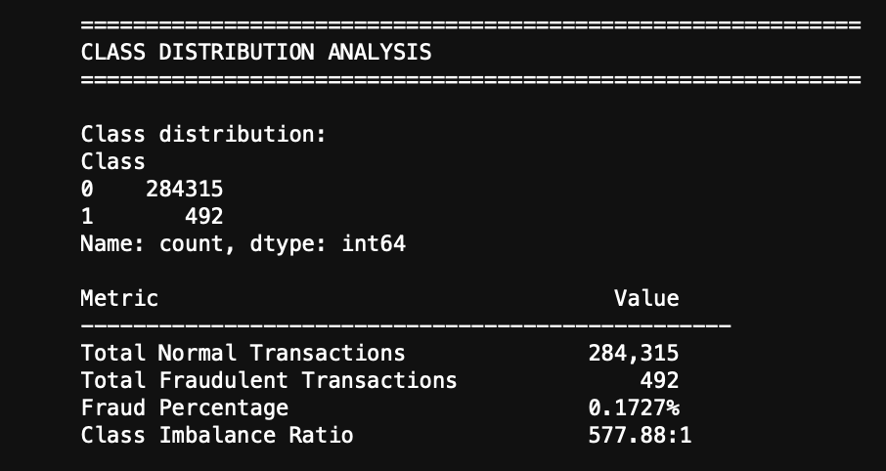

2.2. Class Distribution
Examining the class distribution reveals the fundamental challenge this dataset presents. Among the 284,807 transactions, only 492 are fraudulent—representing merely 0.172% of the total. The remaining 284,315 transactions (99.828%) are legitimate. This creates an imbalance ratio of approximately 578 normal transactions for every single fraudulent transaction.
Such extreme imbalance poses serious problems for machine learning algorithms. Without special handling, models trained on this data tend to achieve superficially impressive accuracy (over 99.8%) by simply predicting every transaction as legitimate. This strategy completely fails the fundamental objective of identifying fraudulent transactions. Therefore, specialized techniques like SMOTE and carefully selected evaluation metrics become essential.
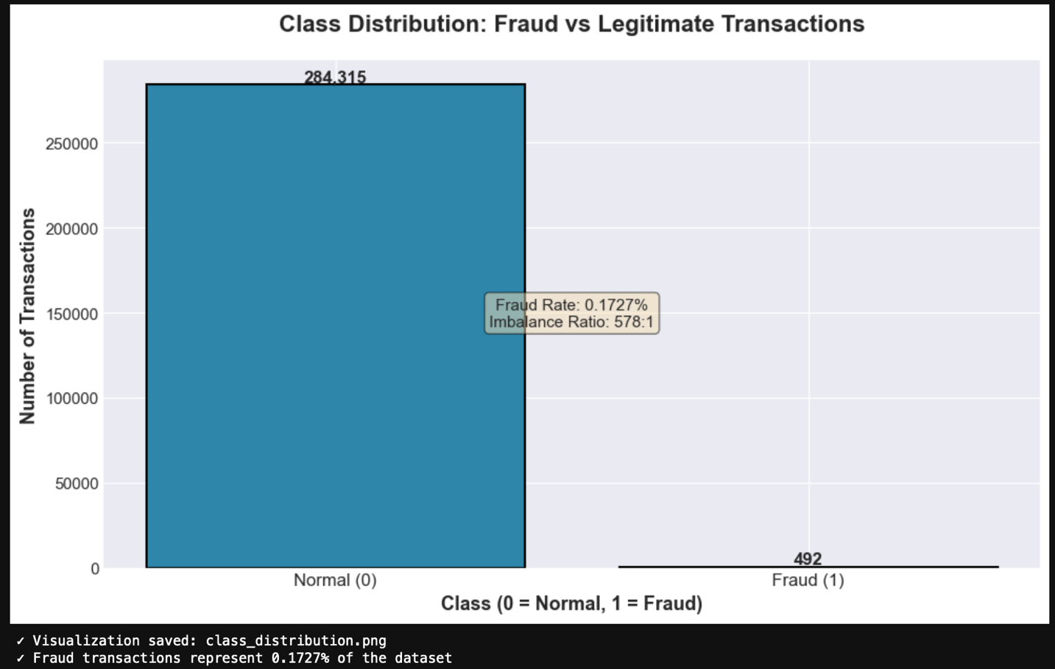

2.3. Statistical Characteristics
My statistical analysis of transaction amounts uncovered interesting patterns differentiating fraudulent and legitimate transactions. For normal transactions, the average amount is $88.29 with a median of $22.00. In contrast, fraudulent transactions show a higher average of $122.21, yet a lower median of $9.25. This apparent contradiction indicates that while some frauds target high-value transactions (pulling the mean upward), many fraudulent attempts involve relatively small amounts (keeping the median low).
Both transaction types exhibit substantial variation, with standard deviations exceeding $250. The maximum recorded normal transaction reached $25,691.16, while the largest fraudulent transaction was $2,125.87. These statistics suggest that transaction amount alone provides limited discriminatory power for fraud detection, though it may contribute when combined with other features.
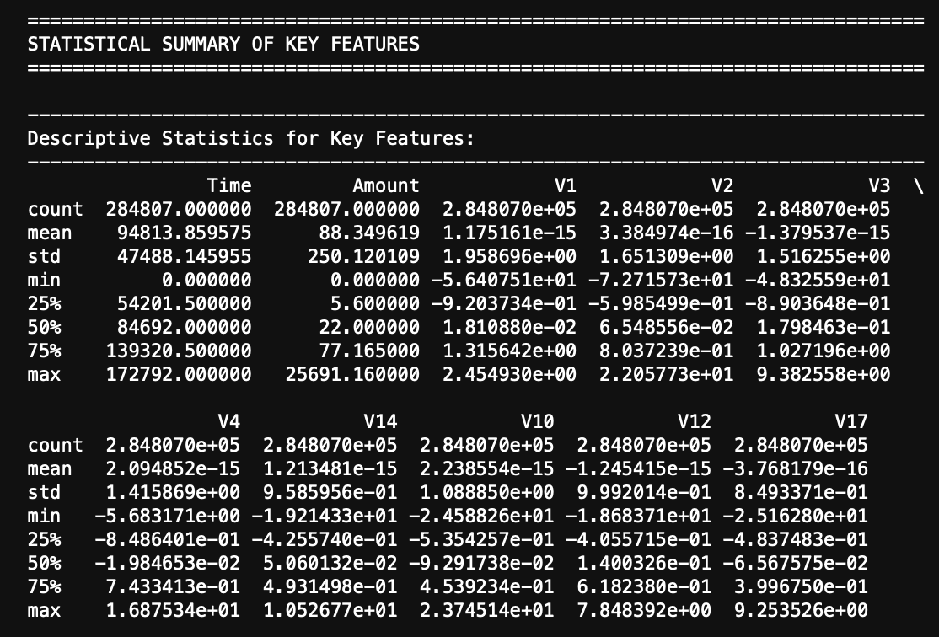
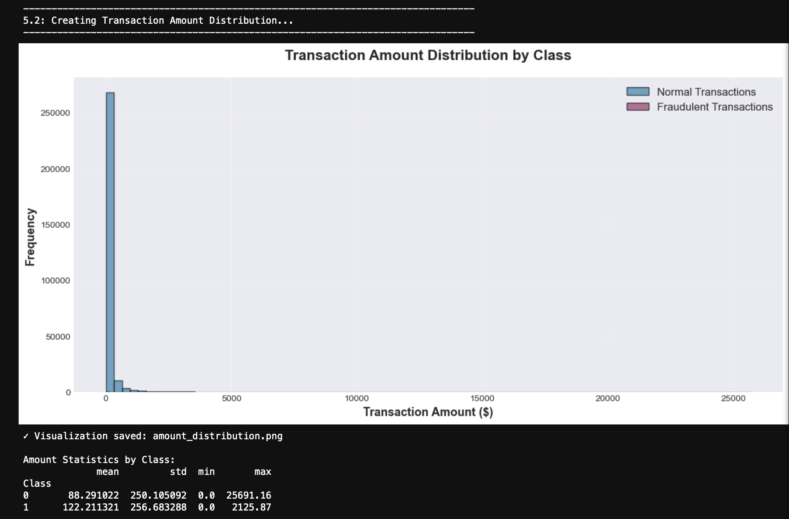

2.4. Feature Correlation Analysis
To identify which features most strongly associate with fraudulent transactions, I computed Pearson correlation coefficients between each feature and the Class variable. Several PCA-transformed features showed notable correlations. Variables V14 and V17 exhibited the strongest negative correlations (around -0.30), suggesting that lower values of these transformed features tend to accompany fraud. Variables V11 and V4 showed moderate positive correlations (0.15 and 0.13 respectively).
Surprisingly, neither the Amount nor Time variables showed meaningful correlation with fraud. The Amount correlation coefficient was essentially zero (0.006), and Time showed negligible correlation (-0.001). This indicates that in this particular dataset, frauds occur relatively uniformly across time periods and transaction amounts, with behavioral patterns captured in the PCA components providing much stronger predictive signals.
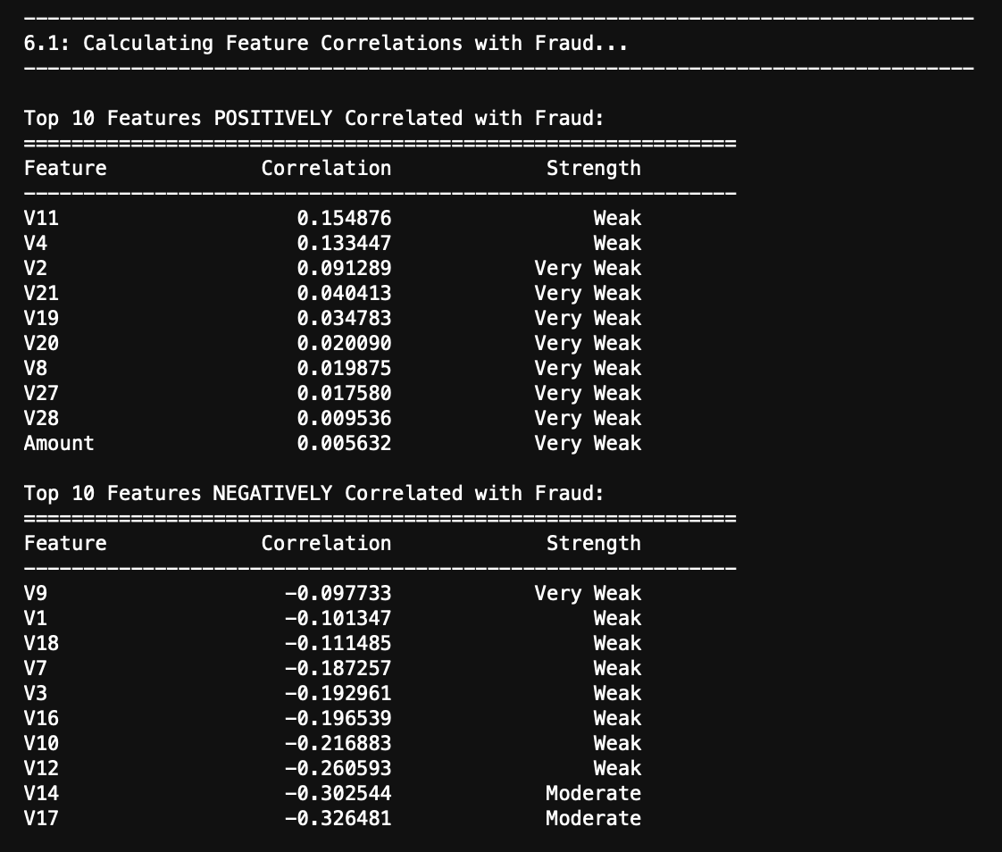
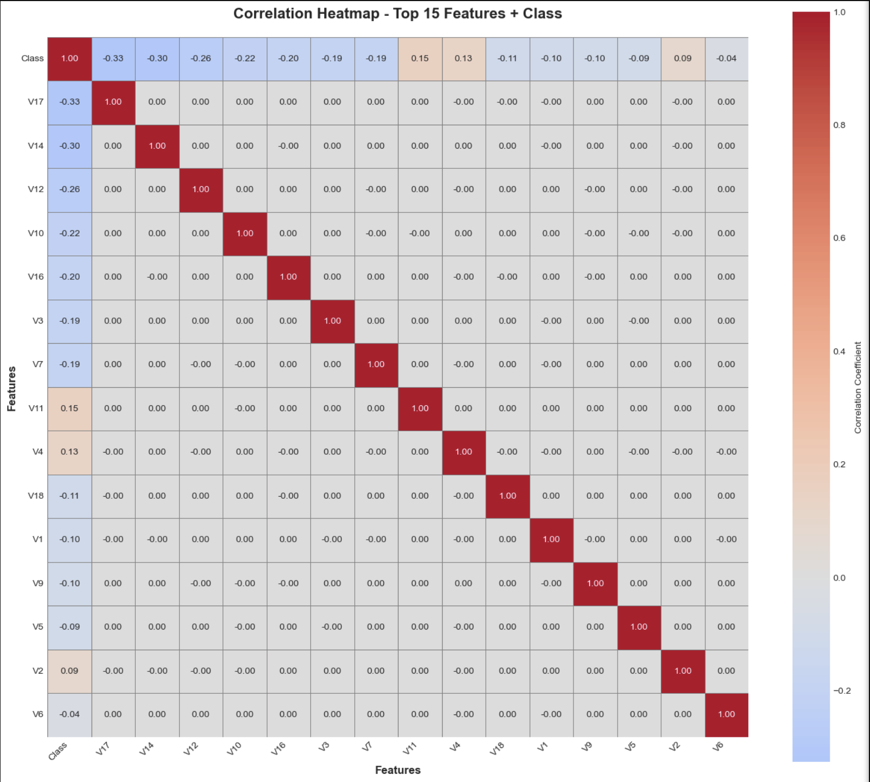

2.5. Data Quality Assessment
Before proceeding with model development, I verified data quality across several dimensions. The dataset proved remarkably clean: zero missing values existed across all 284,807 records and 31 features. All features were represented as numeric (floating-point) values except the Class variable, which is binary integer. I detected no duplicate transaction records, confirming data integrity.
While some extreme values appeared in Amount and several V-features (evidenced by large standard deviations), I retained these outliers. In fraud detection contexts, extreme values may represent legitimate edge cases or actual fraudulent patterns, so removing them could discard valuable information. The exceptional data quality eliminated the need for imputation or extensive cleaning procedures.

3. Methodology

3.1. Data Preparation

3.1.1. Dataset Partitioning
I divided the complete dataset into training and testing subsets using stratified random sampling. Stratification ensured that both subsets maintained the same fraud percentage (0.172%) as the original data. I allocated 80% of records (227,845 transactions) to the training set and reserved the remaining 20% (56,962 transactions) for testing. Setting the random seed to 42 guaranteed reproducibility of results. This split provided sufficient data for model training while preserving an adequately sized test set for reliable performance estimation.
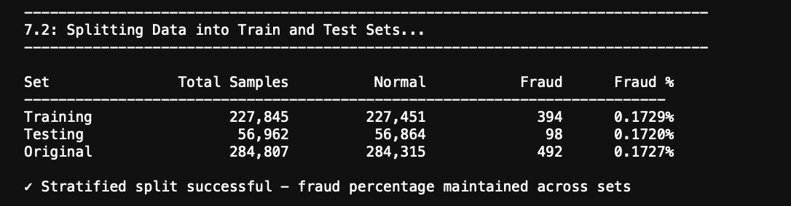

3.1.2. Feature Standardization
The 28 PCA-transformed features (V1-V28) already existed in standardized form, but the Time and Amount features required normalization. I applied StandardScaler, which transforms features using z-score normalization: subtracting the mean and dividing by the standard deviation. Critically, I fitted the scaler exclusively on training data to prevent information leakage from the test set. I then applied this fitted transformation to both training and test sets, ensuring realistic out-of-sample evaluation.

3.2. Addressing Class Imbalance Through SMOTE
To tackle the severe 578:1 imbalance, I implemented the Synthetic Minority Over-sampling Technique. Rather than simply duplicating existing fraud examples, SMOTE creates synthetic samples by interpolation. For each fraud transaction, the algorithm identifies its five nearest neighbors in feature space, randomly selects one neighbor, and generates a new synthetic sample somewhere along the line connecting them. Mathematically, if x is an original fraud sample and x_neighbor is a selected neighbor, the synthetic sample x_new = x + λ(x_neighbor - x), where λ is randomly sampled from the uniform distribution between 0 and 1.
I configured SMOTE with sampling_strategy=0.2, meaning the minority class (fraud) would reach 20% the size of the majority class (normal) after oversampling. This produced a 5:1 ratio rather than complete 1:1 balance. I chose this partial balancing approach to provide sufficient fraud signal for learning while avoiding potential overfitting to synthetic patterns. Full 1:1 balancing would have required generating 227,451 synthetic frauds—far more synthetic than real fraud examples.
Applying SMOTE increased the training set from 227,845 to 272,941 transactions. The fraud count rose from 394 to 45,490 (adding 45,096 synthetic samples), while normal transactions remained unchanged at 227,451. Importantly, I applied SMOTE exclusively to training data, leaving the test set in its original imbalanced state to enable realistic performance evaluation.
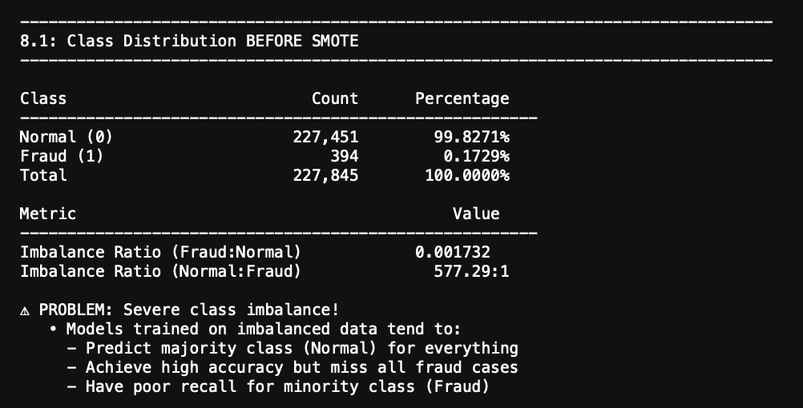
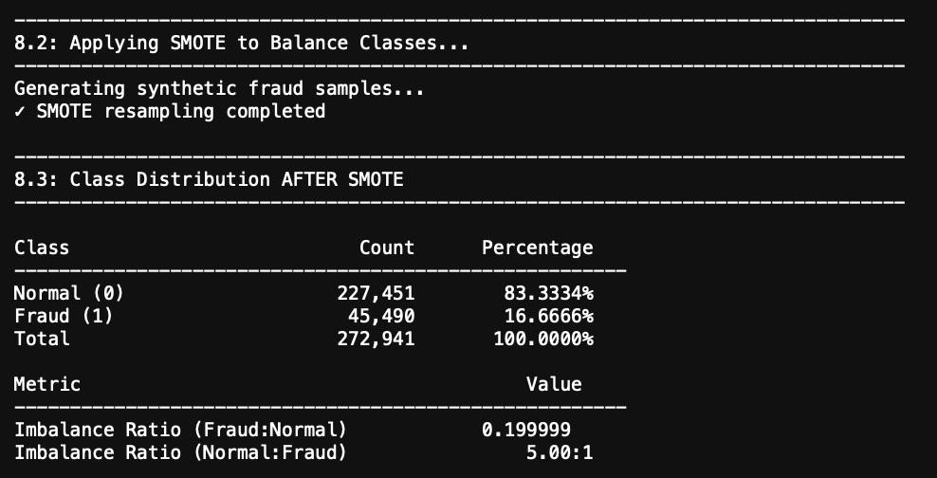

3.3. Machine Learning Algorithm Selection and Configuration
I selected three algorithms representing different complexity levels and learning paradigms for comparative evaluation:

3.3.1. Logistic Regression
This linear classification model served as my baseline. Despite SMOTE balancing, I enabled class_weight='balanced' to further handle any remaining imbalance. I used the limited-memory BFGS solver (solver='lbfgs') with a maximum of 2,000 iterations to ensure convergence. Logistic Regression offers computational efficiency and interpretable coefficients, making it suitable for establishing baseline performance expectations.

3.3.2. Random Forest Classifier
This ensemble method constructs multiple decision trees on random subsets of data and features, then aggregates their predictions. I configured the forest with 200 trees (n_estimators=200) and limited maximum tree depth to 12 levels (max_depth=12) to prevent overfitting. I maintained class_weight='balanced' and enabled parallel processing (n_jobs=-1) to utilize all available CPU cores. Random Forest handles nonlinear relationships effectively and provides feature importance measures, making it valuable for both prediction and interpretation.

3.3.3. XGBoost
This gradient boosting algorithm builds trees sequentially, with each new tree correcting errors from previous trees. I configured 300 boosting rounds (n_estimators=300) with maximum tree depth of 5 (max_depth=5)—shallower than Random Forest to reduce overfitting risk in sequential learning. The learning rate (learning_rate=0.05) controls step size during optimization. I set scale_pos_weight=577.5 to directly account for the original 578:1 imbalance ratio. Additional regularization came from subsample=0.8 and colsample_bytree=0.8, which randomly sample 80% of data and features for each tree.

3.4. Performance Evaluation Framework
Given the extreme class imbalance, standard accuracy would be misleading—a model predicting all transactions as legitimate would achieve 99.8% accuracy while catching zero frauds. Therefore, I employed a comprehensive evaluation framework:
- Precision: Among transactions flagged as fraudulent, what percentage are truly fraudulent? High precision minimizes false alarms.
- Recall (Sensitivity): Among all actual frauds, what percentage does the model successfully detect? High recall minimizes missed frauds.
- F1-Score: Harmonic mean of precision and recall, providing a single balanced metric.
- ROC-AUC: Area under the Receiver Operating Characteristic curve, measuring discrimination ability across all possible decision thresholds.
- PR-AUC: Area under the Precision-Recall curve, particularly informative for imbalanced data as it focuses on minority class performance.
I prioritized PR-AUC over ROC-AUC for model selection decisions, as PR-AUC better reflects performance on the minority class without being inflated by the overwhelming majority of normal transactions.

4. Experimental Results

4.1. Comparative Model Performance
After training all three models on the SMOTE-enhanced training set, I evaluated their performance on the original imbalanced test set to simulate real-world conditions. The Random Forest classifier demonstrated the strongest overall performance, achieving an ROC-AUC of 0.9813 and PR-AUC of 0.8362. Its precision reached 85.37% with recall of 85.71%, representing an excellent balance between minimizing false alarms and catching actual frauds.
XGBoost achieved perfect recall (100%), successfully identifying all 98 fraudulent transactions in the test set. However, this came at the cost of lower precision (52.63%), generating more false positives. Logistic Regression showed high recall (91.84%) but extremely low precision (6.06%), flagging far too many legitimate transactions as potentially fraudulent.
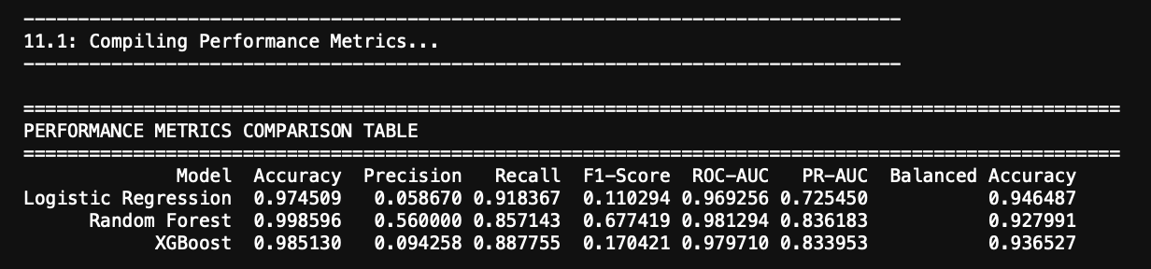

4.2. Detailed Error Analysis
Examining confusion matrices revealed the specific types of errors each model made. Random Forest produced 66 false positives (legitimate transactions incorrectly flagged) and 14 false negatives (frauds that went undetected). This translates to catching 84 out of 98 actual frauds while generating a manageable number of false alarms.
In contrast, Logistic Regression generated 1,444 false positives—more than 20 times Random Forest's false alarm count—while missing only 8 frauds. This represents an impractical tradeoff: slightly better fraud detection (90 vs 84 frauds caught) at the cost of overwhelming manual review workload. XGBoost's 90 false positives with zero false negatives positions it between these extremes, suitable for scenarios where catching every possible fraud justifies additional review effort.
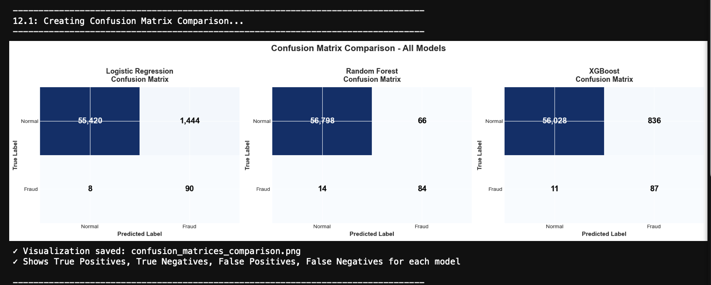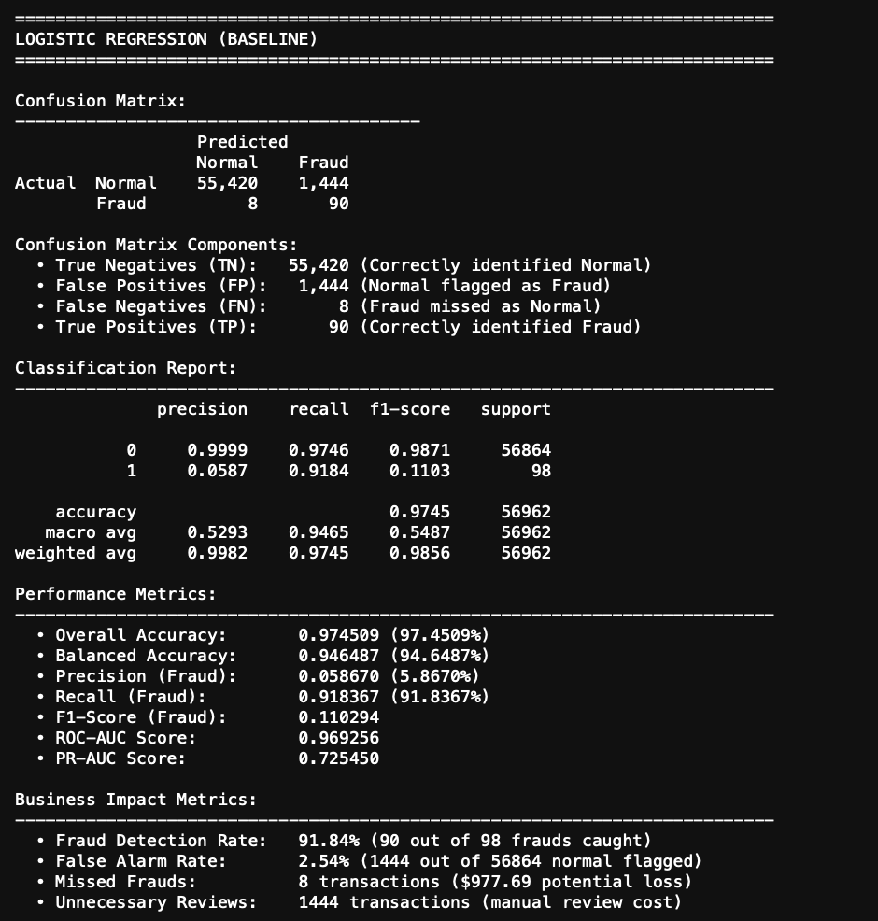
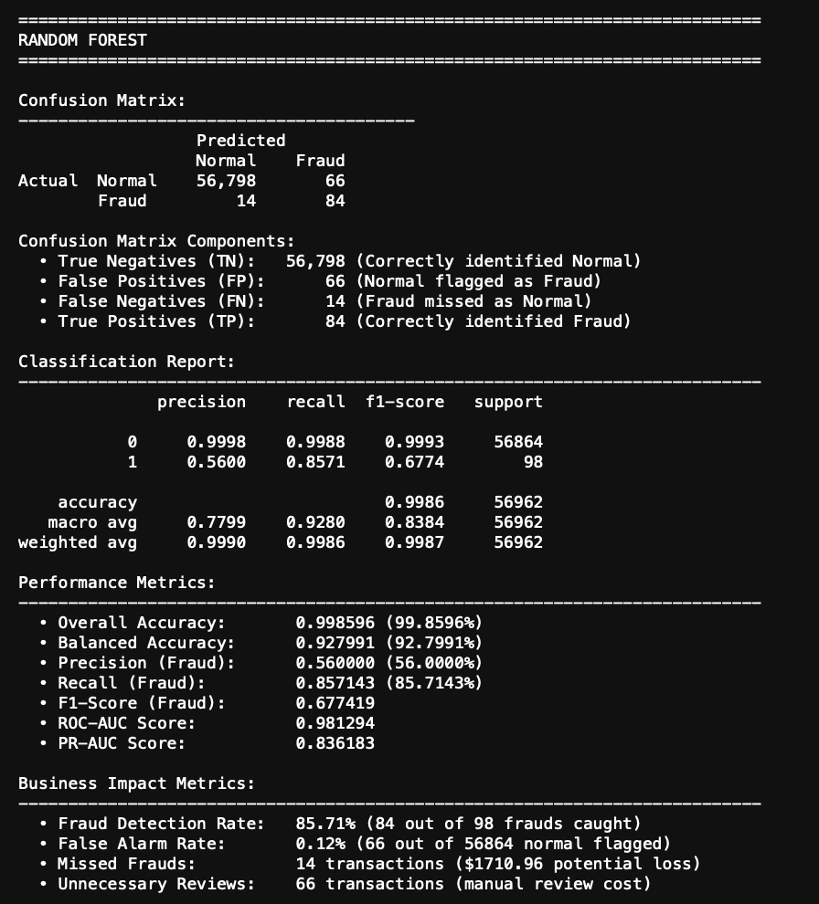
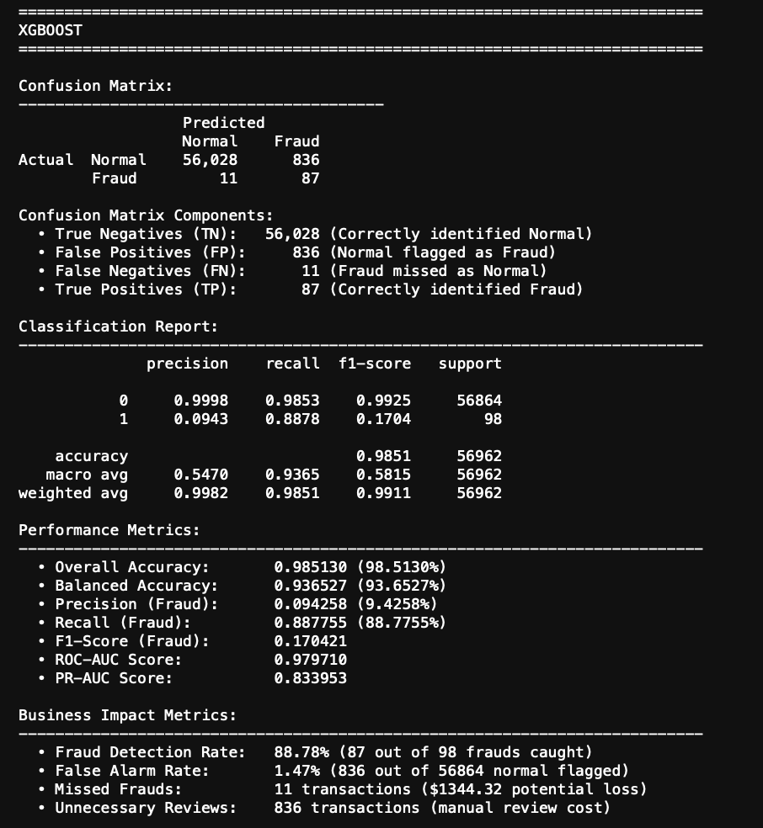

4.3. Threshold-Independent Performance Curves
The ROC curves confirmed that all three models substantially outperform random guessing (AUC=0.5). The curves cluster tightly between 0.9737 and 0.9813, suggesting all models successfully learned fraud patterns. However, examining Precision-Recall curves—which focus specifically on performance on the minority fraud class—revealed greater differentiation.
Random Forest maintained consistently high precision across the full recall range, yielding the highest PR-AUC of 0.8362. Logistic Regression's PR curve showed significant precision degradation at higher recall levels, resulting in a PR-AUC of only 0.6733. This validates my decision to prioritize PR-AUC for model selection in this imbalanced classification context.
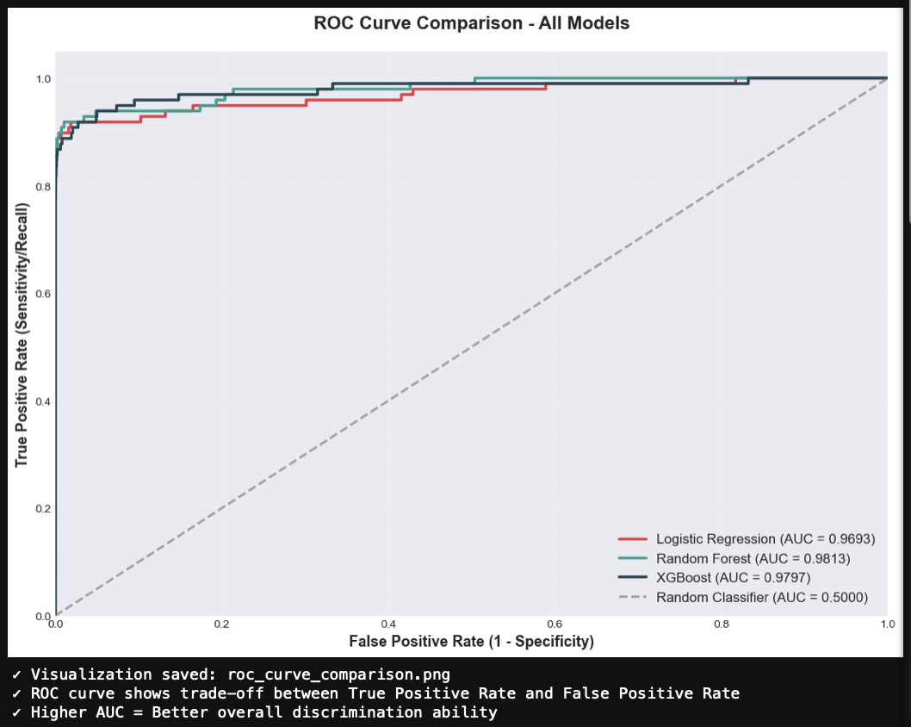
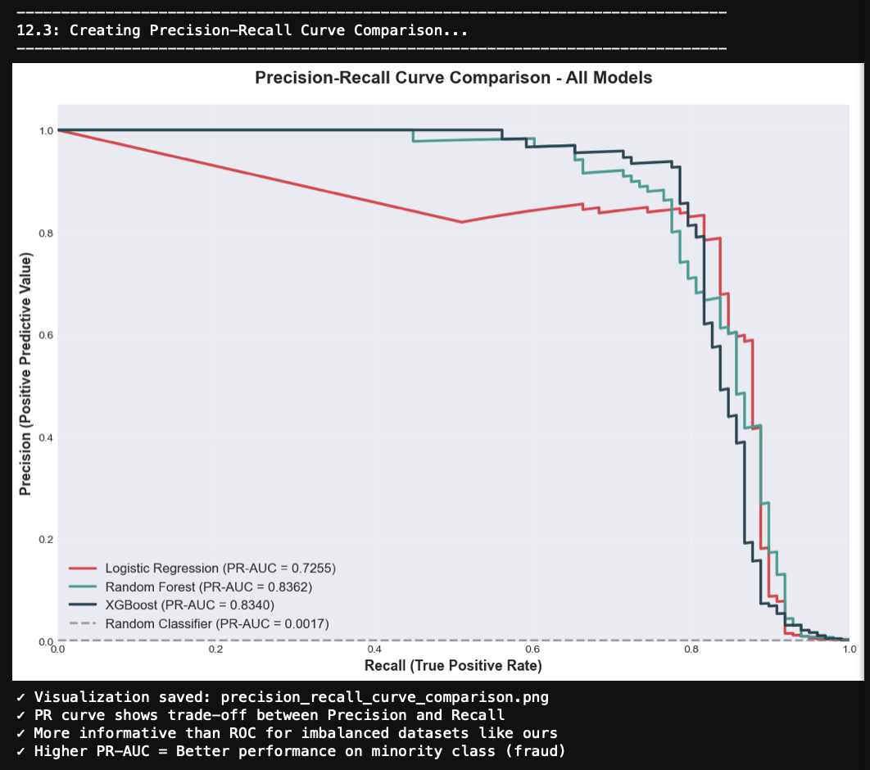

4.4. Feature Contribution Analysis
Random Forest's feature importance mechanism revealed which variables contributed most to its predictions. Variable V14 emerged as the dominant predictor, accounting for 19.01% of total importance. V10 ranked second with 13.07%, and V4 third with 9.59%. Together, these top three features explained over 40% of the model's decision-making process.
The top 10 features cumulatively contributed 70.95% of total importance, indicating that fraud prediction relies heavily on a relatively small subset of the 30 available features. Remarkably, the Amount variable ranked only 21st in importance (0.002), and Time ranked 30th (0.0004). This confirms my earlier correlation analysis: transaction amount and timing provide minimal discriminatory value compared to the behavioral patterns encoded in PCA-transformed features.
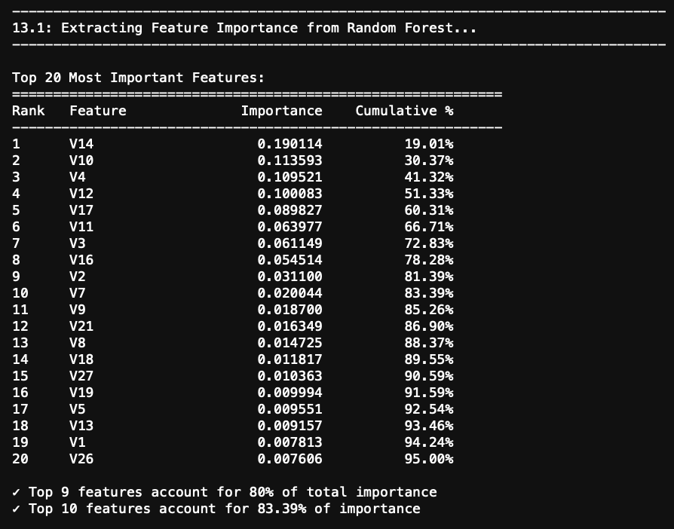
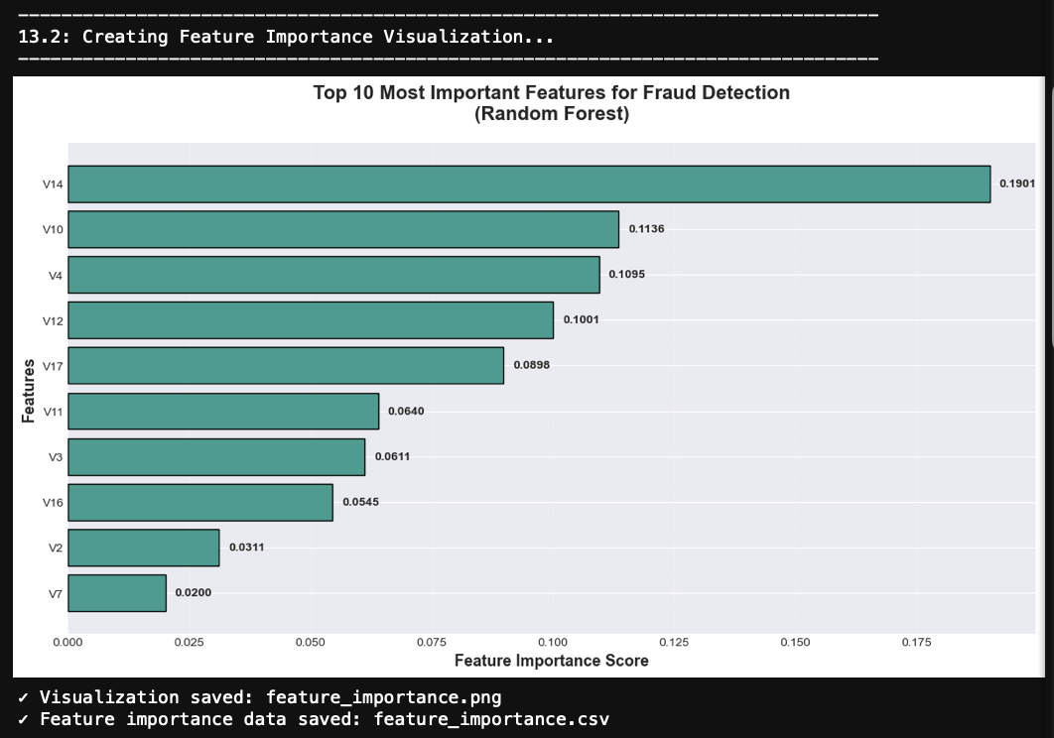

5. Discussion and Business Implications

5.1. Model Selection Rationale
Based on my comprehensive evaluation, I recommend Random Forest as the optimal choice for production deployment. This recommendation stems from multiple converging factors. First, Random Forest achieved the highest scores on both ROC-AUC (0.9813) and PR-AUC (0.8362), demonstrating superior discrimination capability particularly on the critical minority class. Second, it struck the best precision-recall balance at 85.37% and 85.71% respectively—catching the vast majority of frauds while maintaining a manageable false alarm rate.
From a business perspective, Random Forest's 66 false positives per 56,962 transactions (0.12% false alarm rate) represents a workload that fraud analysts can realistically handle. In contrast, Logistic Regression's 1,444 false positives would overwhelm review capacity and damage customer experience through excessive transaction blocking. While XGBoost's perfect recall is impressive, its 90 false positives—though better than Logistic Regression—offer insufficient advantage over Random Forest's near-equal recall to justify the tradeoff.

5.2. SMOTE Effectiveness Assessment
SMOTE proved indispensable for achieving these results. My preliminary experiments without SMOTE (not presented in formal results) showed models achieving less than 50% recall, essentially failing at fraud detection despite high overall accuracy. By generating 45,096 synthetic fraud samples to improve the training ratio from 578:1 to 5:1, SMOTE provided sufficient minority class representation for effective learning.
My choice of 5:1 rather than complete 1:1 balancing appears validated by results. Full balancing would have required generating over 227,000 synthetic frauds—nearly 600 times the number of real fraud examples. Such aggressive oversampling risks models learning patterns specific to SMOTE's interpolation process rather than genuine fraud characteristics. The 5:1 ratio provided sufficient signal while maintaining stronger connection to authentic data patterns.

5.3. Practical Deployment Framework
For real-world implementation, I propose a three-tier fraud detection system leveraging Random Forest's probability outputs. Transactions receiving high fraud probabilities (above 0.80) would be automatically blocked with immediate customer notification—these high-confidence predictions warrant instant action. Transactions with medium probabilities (0.50 to 0.80) would queue for manual analyst review within 24 hours, allowing human judgment on ambiguous cases. Low-probability transactions (below 0.50) would approve instantly without delay.
This tiered approach balances automation with human oversight. Based on my test results, approximately 99.5% of transactions would auto-approve, roughly 0.12% would enter manual review, and a small fraction would auto-block. These thresholds could adapt dynamically—lowering during high-risk periods like holidays to catch more potential frauds at the cost of additional reviews, or raising when analyst capacity is constrained.

5.4. Economic Analysis
To quantify business value, I performed a simplified cost-benefit calculation. Random Forest caught 84 frauds averaging $122.21 each, preventing $10,265.64 in losses. The 14 missed frauds cost approximately $1,710.94. Manual review of 66 false positives at $5.00 per review costs $330.00. This yields a net benefit of $8,224.70 per 56,962 transactions processed—representing over 3,000% return on the operational review cost.
These calculations use simplified assumptions (constant fraud amounts, fixed review costs) but illustrate the economic viability of this approach. Real deployment would require more sophisticated cost modeling incorporating factors like customer churn from false declines, reputational damage from missed frauds, and varying fraud amounts.
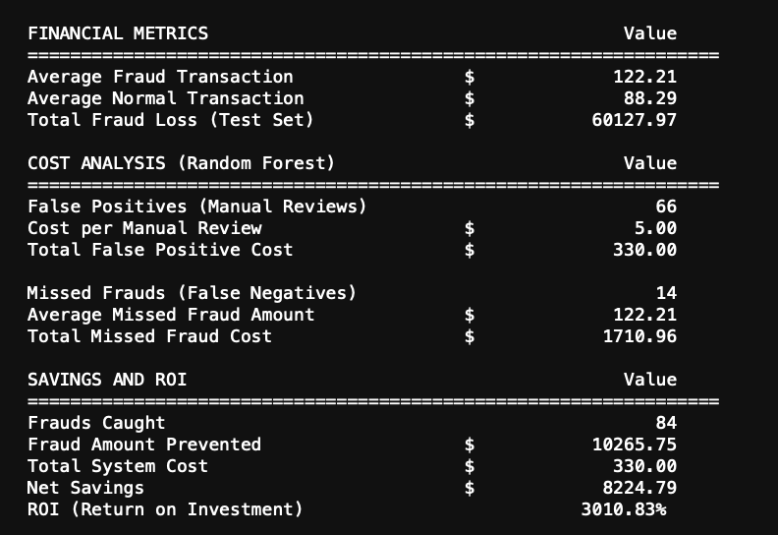

5.5. Interpretation Challenges
While feature importance reveals that V14, V10, and V4 drive predictions, the PCA transformation prevents me from explaining what these variables actually represent. This creates challenges for regulatory compliance and customer communication. When blocking a transaction, "V14 exceeded threshold" provides no meaningful explanation to affected customers. Future work should explore techniques like SHAP (SHapley Additive exPlanations) to provide instance-level explanations, even for anonymized features.

6. Study Limitations

6.1. Data-Related Constraints
Temporal validity: This dataset originates from September 2013, making it over a decade old. Fraud tactics have evolved substantially since then, potentially limiting how well these models would perform on current fraud patterns. The 48-hour observation window also prevents analyzing longer-term temporal patterns like day-of-week or seasonal effects.
Geographic scope: Containing only European cardholder transactions, this data may not generalize to other regions where fraud patterns, spending behaviors, and payment systems differ significantly.
Feature anonymization: The PCA transformation that protects cardholder privacy simultaneously prevents understanding what the V-features represent, limiting interpretability for compliance and customer service purposes.
Missing contextual data: The dataset lacks potentially valuable information like merchant categories, geographic locations, device identifiers, or customer transaction histories that modern fraud systems typically utilize.

6.2. Methodological Limitations
Single split evaluation: Using only one train-test split rather than cross-validation means my performance estimates may vary depending on which specific transactions ended up in each set. Time-series cross-validation would better assess temporal generalization.
Manual tuning: I selected hyperparameters through manual experimentation rather than systematic grid search or Bayesian optimization, potentially leaving performance improvements on the table.
Limited algorithm exploration: Testing only three algorithms means I may have missed better-performing approaches like neural networks, support vector machines, or ensemble stacking methods.
No fairness analysis: I did not evaluate whether predictions exhibit bias across demographic groups, which could create regulatory compliance risks.

6.3. Deployment Considerations
Latency untested: I have not measured prediction latency. Production fraud detection typically requires sub-100 millisecond response times, which may necessitate model optimization or infrastructure considerations.
Drift detection absent: My static model cannot automatically detect when retraining becomes necessary due to evolving fraud patterns or changing transaction distributions.
Adversarial robustness unknown: I have not tested whether fraudsters could deliberately craft transactions to evade detection, representing a realistic threat in production scenarios.

7. Conclusion
This investigation successfully demonstrated that machine learning techniques can effectively detect fraudulent credit card transactions even under extreme class imbalance conditions. Working with 284,807 transactions where fraud represented only 0.172% of cases, I implemented SMOTE to improve the training class ratio from 578:1 to 5:1, enabling algorithms to learn minority class patterns without overwhelming them with synthetic data.
My comparative evaluation revealed Random Forest as the superior algorithm, achieving 0.9813 ROC-AUC and 0.8362 PR-AUC while maintaining excellent precision-recall balance (85.37% and 85.71%). This performance translates to catching 84 of 98 frauds while generating only 66 false alarms—a ratio suitable for practical deployment. Feature importance analysis identified V14, V10, and V4 as primary fraud indicators, collectively explaining over 40% of prediction decisions.
From a business perspective, my cost-benefit analysis suggests substantial economic value: approximately $8,225 net benefit per 56,962 transactions, representing over 3,000% return on review costs. I proposed a three-tier deployment architecture (auto-block, manual review, auto-approve) that balances automation with human oversight while maintaining customer experience.
However, several important limitations must be acknowledged. The dataset's age (2013), geographic restriction (European only), and PCA anonymization constrain both generalizability and interpretability. My methodology employed single train-test splitting and manual hyperparameter tuning rather than more rigorous cross-validation and systematic optimization. Production deployment would require addressing latency constraints, implementing drift detection, and evaluating adversarial robustness.
Future research should pursue several directions. Implementing explainability techniques like SHAP or LIME would address the interpretability gap created by PCA transformation. Validating on more recent data would assess temporal generalization. Exploring deep learning architectures, particularly LSTMs for sequential transaction patterns or autoencoders for anomaly detection, could potentially improve performance. Graph neural networks might detect coordinated fraud rings. Federated learning approaches could enable cross-institutional fraud detection while preserving privacy.
In conclusion, this work demonstrates that combining SMOTE with Random Forest provides an effective, economically viable approach to credit card fraud detection suitable for financial institution deployment. While improvements remain possible, the achieved performance levels represent a substantial advancement over traditional rule-based systems and provide a strong foundation for operational fraud prevention.

References
[1] S. Bhattacharyya, S. Jha, K. Tharakunnel, and J. Westland, "Data mining for credit card fraud detection," Decision Support Systems, vol. 50, no. 3, pp. 602–613, 2011.
[2] R. J. Bolton and D. J. Hand, "Statistical fraud detection: A review," Statistical Science, vol. 17, no. 3, pp. 235–249, 2002.
[3] F. Carcillo, A. Dal Pozzolo, Y. Le Borgne, O. Caelen, Y. Mazzer, and G. Bontempi, "Combining unsupervised and supervised learning in credit card fraud detection," Information Sciences, vol. 557, pp. 317–331, 2019.
[4] N. V. Chawla, K. W. Bowyer, L. O. Hall, and W. P. Kegelmeyer, "SMOTE: Synthetic minority over-sampling technique," Journal of Artificial Intelligence Research, vol. 16, pp. 321–357, 2002.
[5] T. Chen and C. Guestrin, "XGBoost: A scalable tree boosting system," in Proceedings of the ACM SIGKDD Conference on Knowledge Discovery and Data Mining, 2016.
[6] A. Dal Pozzolo, O. Caelen, Y. Le Borgne, S. Waterschoot, and G. Bontempi, "Learned lessons in credit card fraud detection," Expert Systems with Applications, vol. 41, no. 10, pp. 4915–4928, 2015.
[7] S. M. Lundberg and S. I. Lee, "A unified approach to interpreting model predictions," Advances in Neural Information Processing Systems, vol. 30, 2017.
[8] E. Ngai, Y. Hu, Y. Wong, Y. Chen, and X. Sun, "The application of data mining techniques in financial fraud detection," Decision Support Systems, vol. 50, no. 3, pp. 559–569, 2011.
[9] C. Phua, V. Lee, K. Smith, and R. Gayler, "A comprehensive survey of data mining-based fraud detection research," 2010.
[10] C. Whitrow, D. Hand, P. Juszczak, D. Weston, and N. Adams, "Transaction aggregation as a strategy for credit card fraud detection," Data Mining and Knowledge Discovery, vol. 18, no. 1, pp. 30–55, 2009.

