Name: Aditya Vardhan Sivalanka

Student ID: A00091352

Program: MSc Data Science

Module: CMP-L011-0



MATHEMATICAL STUDY OF ELECTRIC VEHICLE POPULATION DATA USING LINEAR ALGEBRA, STATISTICS, AND PROBABILITY THEORY

Table of contents

Task 1: Dataset Description -----------------------------------------------------4
Data Origin and Source Explanation ----------------------------------------4
Description of Variables in the Dataset -------------------------------------4
Importance and Relevance of the Dataset ----------------------------------4
Task 2: Mathematical Application ---------------------------------------------5
Linear Algebra – Vectors -----------------------------------------------------5
Linear Algebra – Matrices ---------------------------------------------------5
Descriptive Statistics and EDA ----------------------------------------------6
Random Variables and Probability ------------------------------------------9
Probability Functions – Discrete and Continuous ------------------------10
Normal vs Log-Normal Fit --------------------------------------------------12
Hypothesis Testing -----------------------------------------------------------13
Correlation Matrix ------------------------------------------------------------13
Task 3: Critical Reflection ------------------------------------------------------14
References ------------------------------------------------------------------------15
Bibliography ----------------------------------------------------------------------16

Task 1: Dataset Description

1. Data Origin and Source Explanation:
The dataset used in this report is the Electric Vehicle Population Data, obtained from the United States Government open data portal.
The dataset is publicly available and can be accessed through the following website:
https://catalog.data.gov/dataset/electric-vehicle-population-data
This dataset contains information about electric vehicles registered across different counties. It includes details such as vehicle model year, electric range, vehicle type, and location data. The dataset contains more than 276,000 records and several variables, which meets the coursework requirement of using a dataset with at least 300 rows and five variables. The dataset was downloaded in CSV format and imported into Python using the Pandas library. During preprocessing, the dataset was checked for missing values. Some columns contained null values, especially in variables such as Electric Range, County, and a few location-related attributes. Since the number of missing values was small compared to the overall dataset size, those rows were removed using the dropna( ) function so that the mathematical calculations would be accurate.

2. Description of Variables in the Dataset:
The dataset includes several variables related to electric vehicle registrations. In this report, three key variables were selected for mathematical analysis: Electric Range, Model Year, and County.
The Electric Range variable represents the maximum distance an electric vehicle can travel on a fully charged battery. It is measured in miles and is treated as a continuous numerical variable. This variable helps analyze the performance of electric vehicles. The Model Year variable represents the year in which the vehicle was manufactured. This variable is a discrete numerical variable and is useful for examining how electric vehicle technology has improved over time.
The County variable indicates the geographic area where each vehicle is registered. This categorical variable helps analyze the distribution of electric vehicles across different locations.
The dataset also contains other variables such as vehicle make, vehicle model, electric vehicle type, and eligibility status. These variables provide additional context about the vehicles but were not directly used in the mathematical calculations in this report.

3. Importance and Relevance of the Dataset:
Electric vehicles are becoming increasingly important as countries try to reduce carbon emissions and move toward sustainable transportation. Datasets like this help researchers and policymakers understand how electric vehicles are being adopted and how their technology is improving. From a data science perspective, the dataset is very useful because it contains a large number of observations and different types of variables. This allows the application of mathematical techniques such as linear algebra operations, descriptive statistics, and probability modelling. By analyzing this dataset, it is possible to observe trends in electric vehicle performance and understand how the distribution of electric vehicles changes across different regions.
Task 2: Mathematical Application

2.1. Linear Algebra – Vectors
To apply vector operations, the Electric Range and Model Year columns were converted into vectors. These vectors represent numerical values from the dataset and allow mathematical operations such as dot product, vector norm, and cosine similarity to be calculated.
The following Python code was used to perform these calculations.

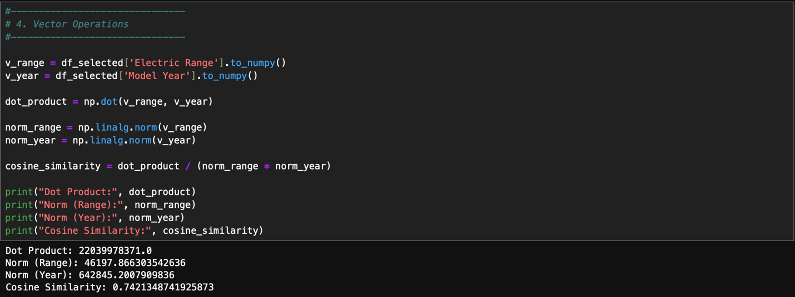
Figure 1: Output showing vector calculations including dot product, vector norms, and cosine similarity.

The above image shows the output from the vector calculations. The dot product measures the relationship between the electric range values and the model year values. The vector norm represents the magnitude of each vector. Cosine similarity shows how closely the two vectors are related. The cosine similarity result indicates that there is a positive relationship between vehicle model year and electric range. This means that newer electric vehicles generally tend to have higher electric ranges compared to older models.

2.2. Linear Algebra – Matrices
A matrix X was created using the Electric Range and Model Year variables. Each row of the matrix represents a vehicle observation from the dataset. The following Python code was used to perform matrix operations.
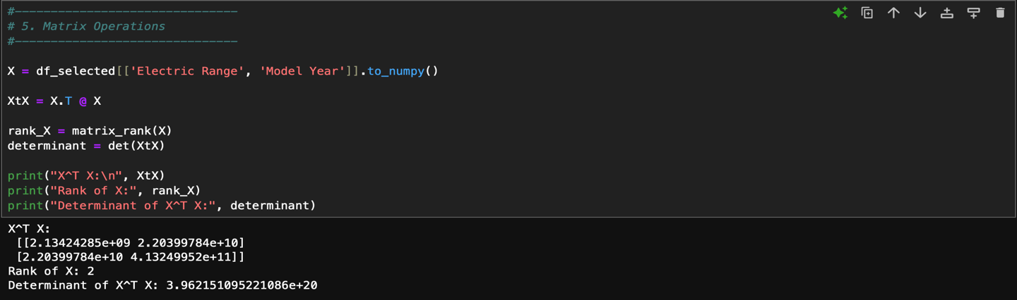
Figure 2: Matrix output showing X^T X, matrix rank, and determinant.

The matrix multiplication X^T X helps analyze the relationship between the two variables. The rank of the matrix shows whether the variables contain independent information. The result indicates that the matrix has full rank, meaning that Electric Range and Model Year are not perfectly dependent on each other.
The determinant of X^T X was also calculated. Since the determinant is not zero, it confirms that the matrix is invertible and that both variables contribute useful information to the dataset.

2.3. Descriptive Statistics and EDA
Descriptive statistics were calculated to understand the basic properties of the Electric Range and Model Year variables. These statistics include mean, variance, skewness, and kurtosis.
The following Python code was used to calculate these values.

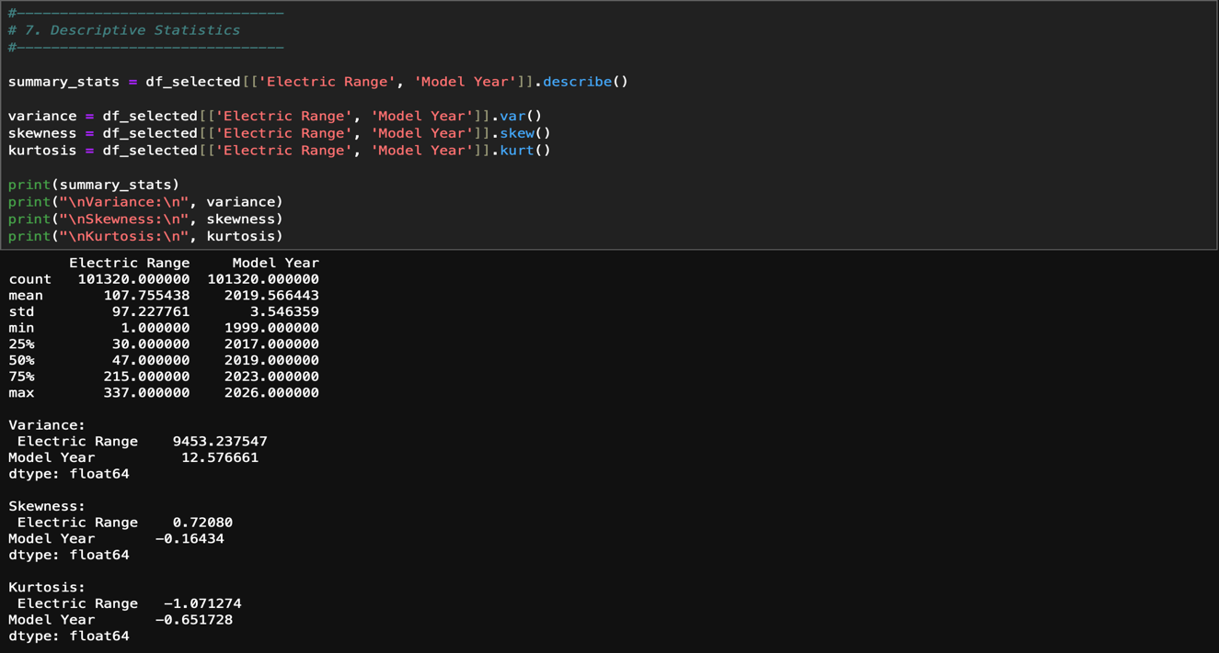
Figure 3.1 : Descriptive statistics output
To better understand the dataset, several visualizations were also created. A histogram was used to show the distribution of electric range values. A scatter plot was created to show the relationship between model year and electric range. A boxplot was used to identify outliers and understand the spread of the data.

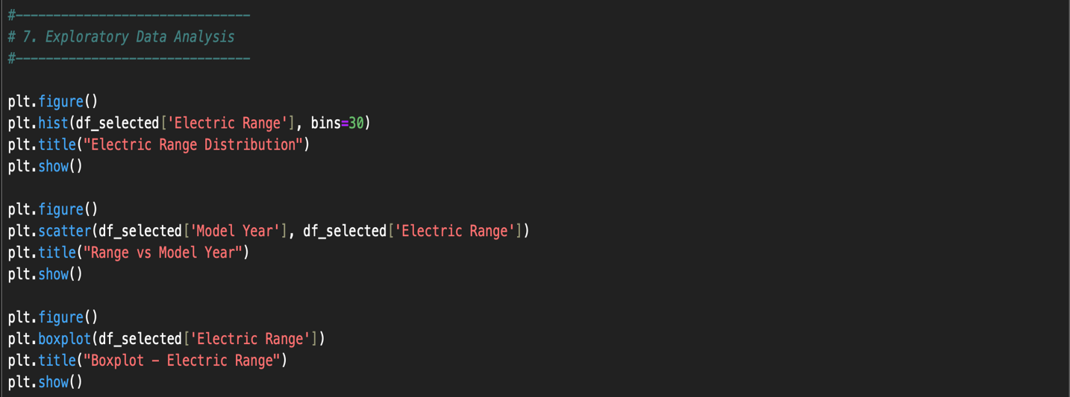
Figure 3.2: Exploratory Data Analysis

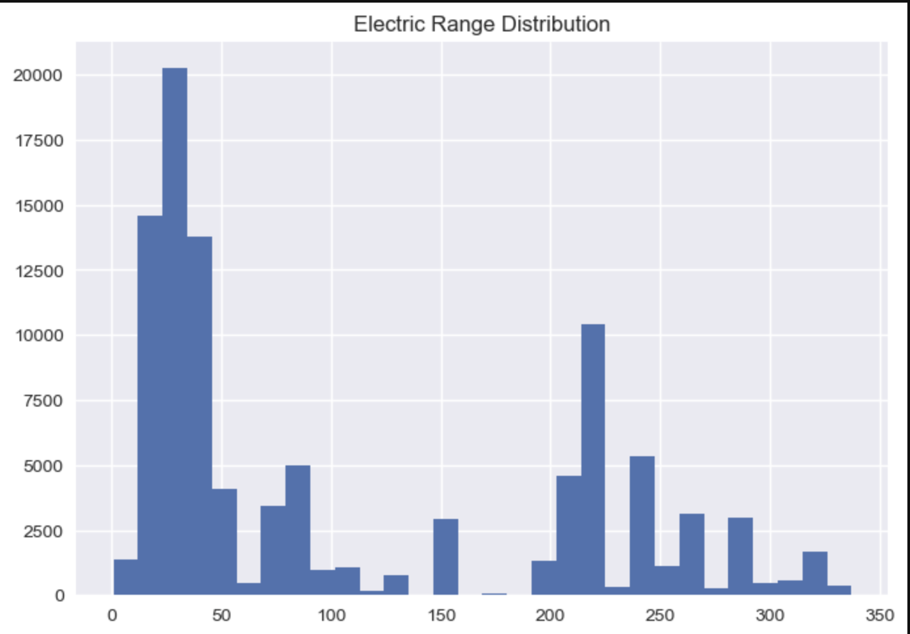

Figure 3.3: Histogram
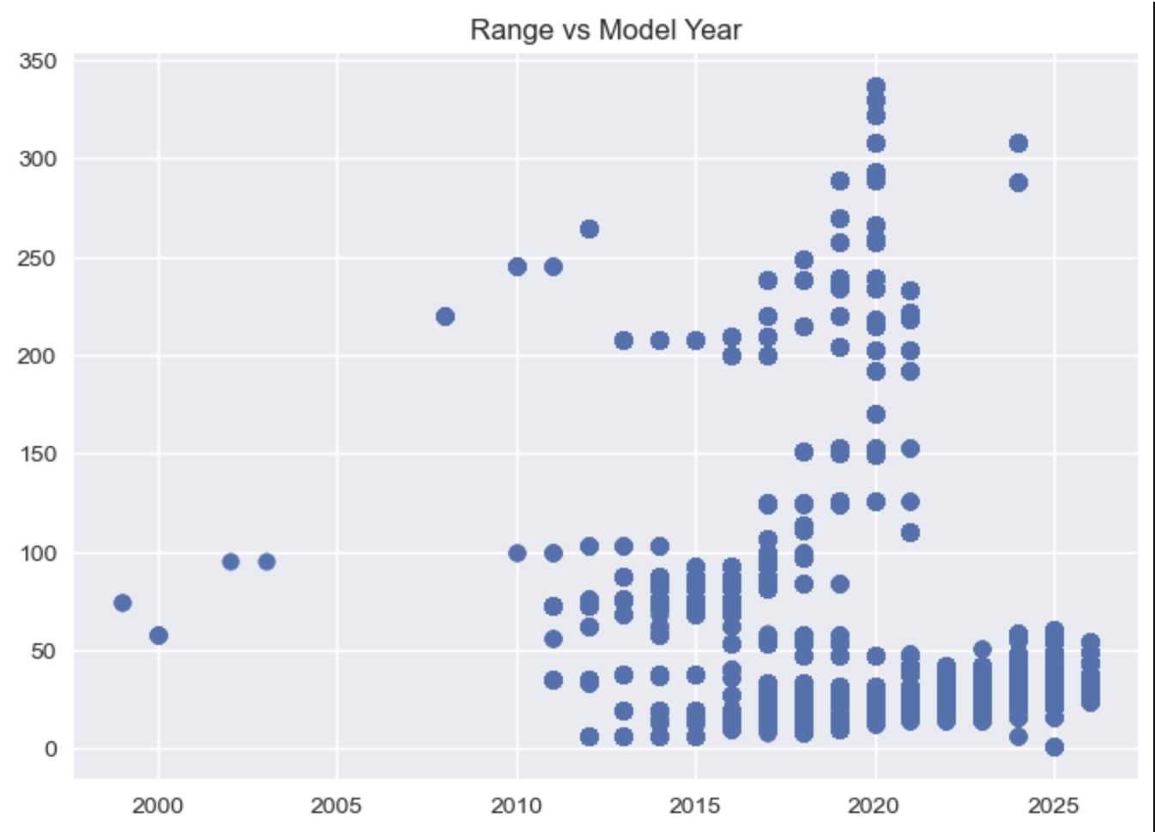
Figure 3.4: Scatter plot

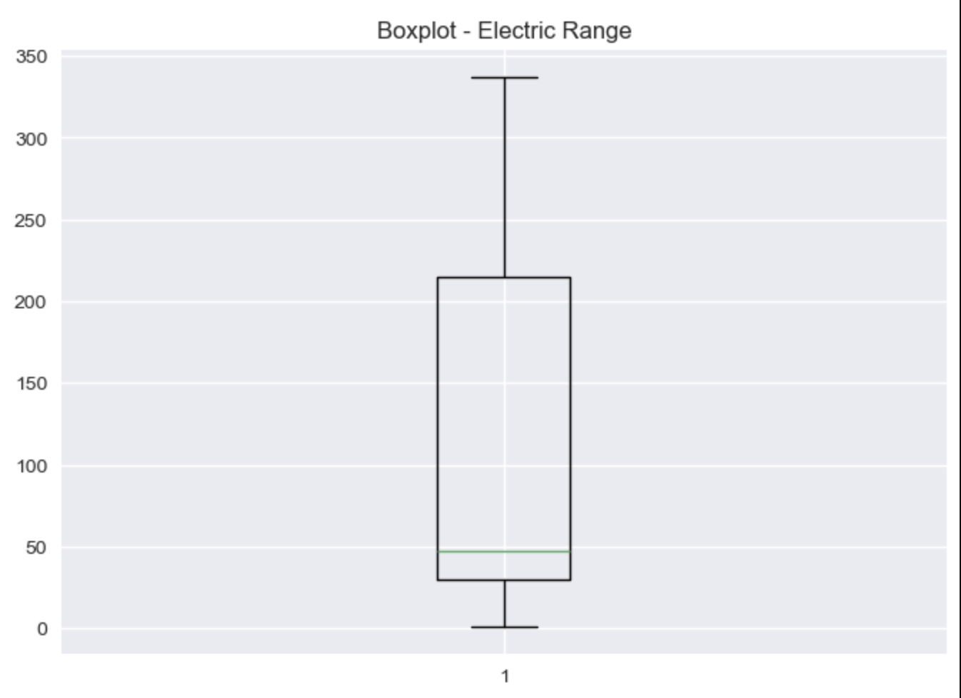
Figure 3.5: Boxplot
The histogram shows that the electric range values are slightly right-skewed, meaning that most vehicles have moderate ranges while a few vehicles have very high ranges. The scatter plot shows that vehicles manufactured in more recent years generally have higher electric ranges.

2.4. Random Variables and Probability
In the probability analysis, two random variables were defined. The Electric Range variable was treated as a continuous random variable, while the number of vehicles registered in each county was treated as a discrete random variable.
The probability mass function (PMF) for the discrete variable was calculated using the frequency distribution of vehicles across counties.

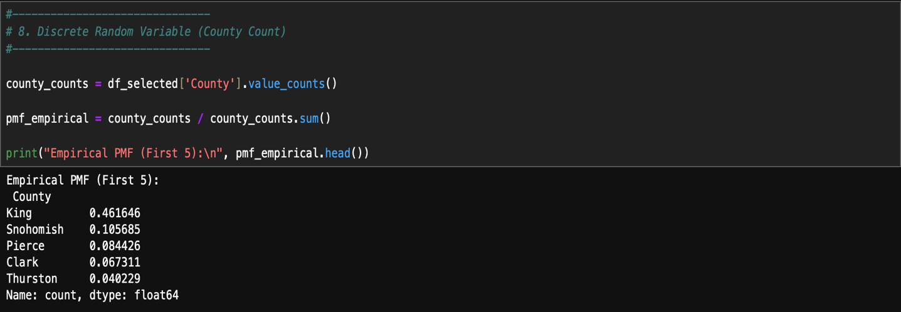

For the continuous variable, the probability density function (PDF) was estimated using Kernel Density Estimation.

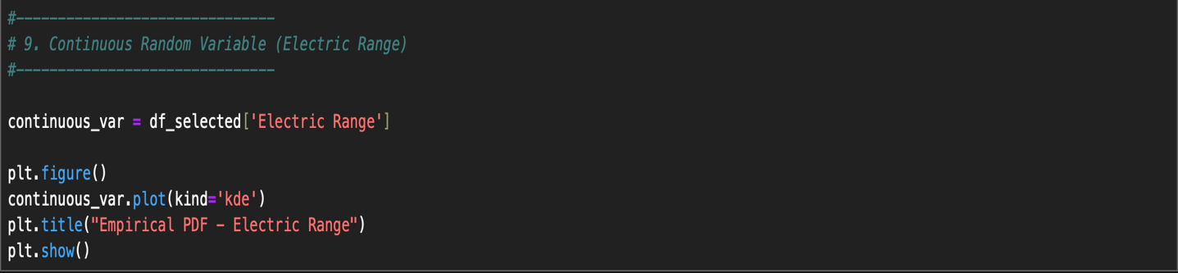

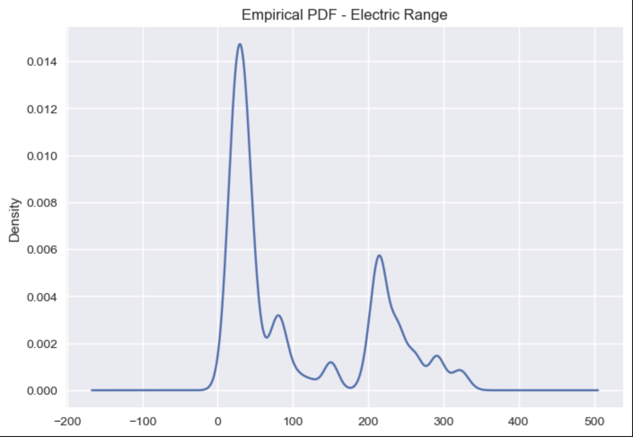
Figure 4: Kernel Density Estimate representing the probability density function of electric range.

The KDE curve shows how electric range values are distributed across the dataset. Most vehicles fall within moderate range values, while fewer vehicles have extremely high ranges.

2.5. Probability Functions – Discrete and Continuous
To model the discrete variable, a Poisson distribution was fitted to the count of vehicle registrations per year. For the continuous variable, both Normal and Log-Normal distributions were fitted to the electric range values.
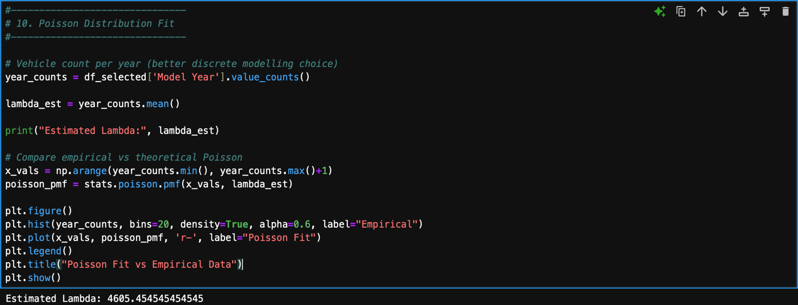

The comparison between the empirical distribution and the theoretical distributions shows that the log-normal distribution provides a better fit for the electric range data. This is because the electric range values are slightly skewed rather than perfectly symmetric.

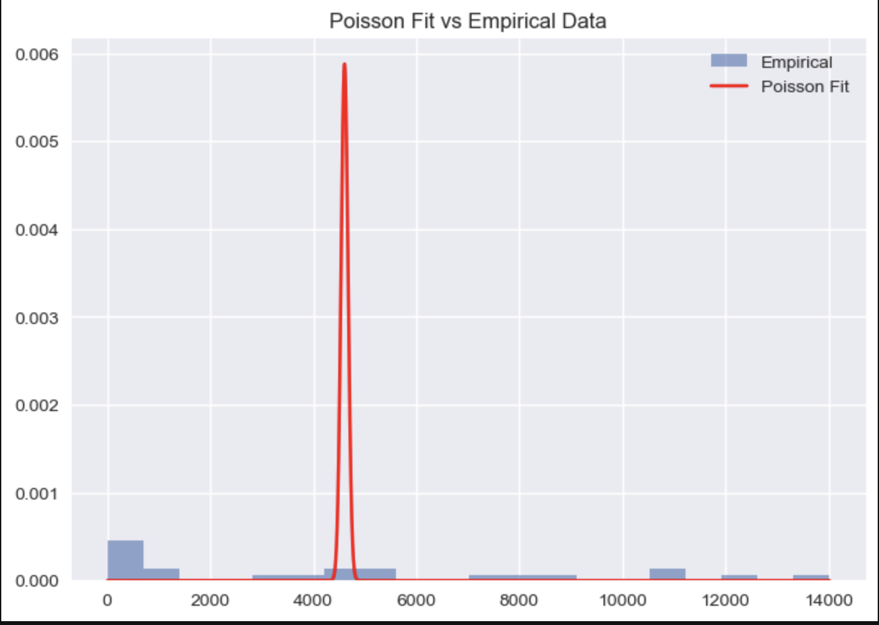
Figure 5: Comparison between empirical distribution and theoretical probability distributions.

2.6. Normal vs Log-Normal Fit
To understand the distribution of the Electric Range variable, both Normal and Log-Normal distributions were fitted to the data. This helps determine which probability model better represents the real behavior of the electric vehicle range values. The Normal distribution assumes that the data is symmetric around the mean. However, in real-world datasets, many variables are not perfectly symmetric. The Log-Normal distribution is often used when the data is positively skewed, meaning that most values are smaller while a few values are very large.
The following Python code was used to estimate the parameters of both distributions.

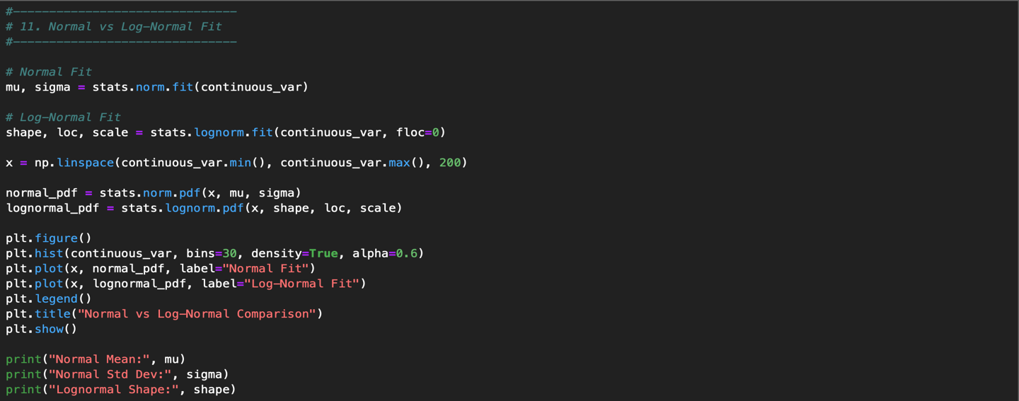

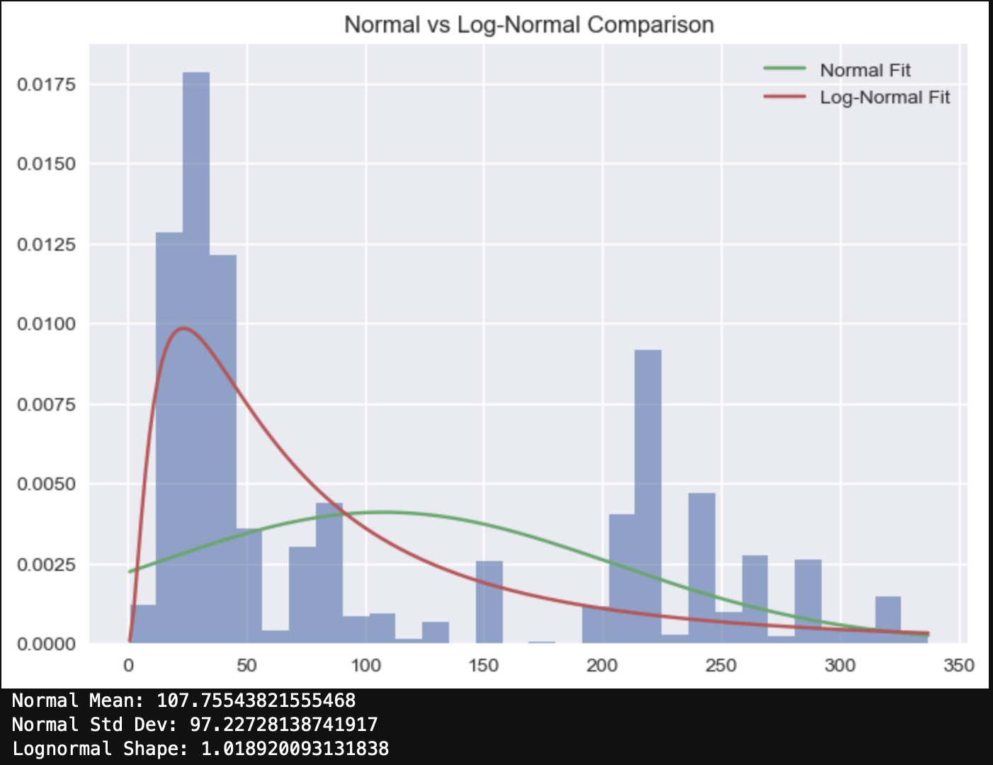

Figure 6: Comparison between Normal and Log-Normal distribution fits for Electric Range.
2.7. Hypothesis Testing
Hypothesis testing was performed to examine whether the average electric range in the dataset is significantly different from a chosen benchmark value. For this analysis, a one-sample t-test was used.
The null hypothesis and alternative hypothesis were defined as follows:
H₀: The average electric range is equal to 150 miles.
H₁: The average electric range is not equal to 150 miles.
The following Python code was used to perform the hypothesis test.

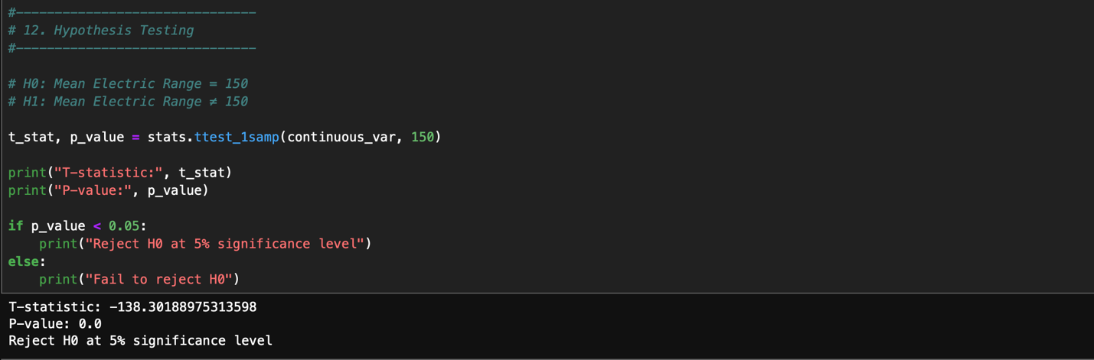
Figure 7: Output of the one-sample t-test including the t-statistic and p-value.

The t-statistic measures how far the sample mean is from the hypothesized mean value. The p-value indicates whether this difference is statistically significant.
If the p-value is less than 0.05, the null hypothesis is rejected. In this case, the result suggests that the average electric range of vehicles in the dataset is significantly different from 150 miles. This indicates that electric vehicle ranges vary widely and that the selected benchmark does not fully represent the dataset.

2.8. Correlation Matrix
A correlation matrix was calculated to measure the strength of the relationship between the numerical variables in the dataset. In this analysis, the variables Electric Range and Model Year were used. Correlation values range from −1 to +1. A value close to +1 indicates a strong positive relationship, while a value close to −1 indicates a strong negative relationship.
The following Python code was used to compute the correlation matrix.
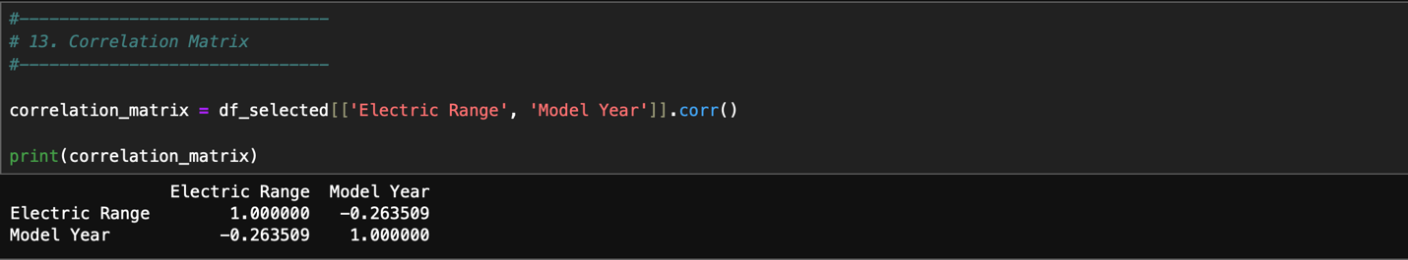
Figure 8: Correlation Matrix
Task 3: Critical Reflection

The mathematical techniques applied in this report helped reveal useful insights about the electric vehicle dataset. Vector operations and matrix calculations showed that there is a clear relationship between vehicle model year and electric range. This indicates that electric vehicle technology has improved over time, allowing newer vehicles to travel longer distances on a single charge.
Descriptive statistics and visualizations also helped explain how electric range values are distributed. The histogram and probability density plots showed that the data is slightly right-skewed. This explains why the log-normal distribution provided a better fit than the normal distribution.
However, some mathematical assumptions used in statistical models may not perfectly match real-world data. For example, many probability models assume that observations are independent from each other. In reality, electric vehicle adoption may be influenced by government incentives, charging infrastructure, and regional economic factors. These factors can create patterns in the data that are not completely random.
Another assumption is that data follows a normal distribution. In this dataset, the electric range values are not perfectly symmetric, which means that the normal distribution may not always be the best model. Using a log-normal distribution provided a more realistic representation of the data.
If mathematical models are used without checking these assumptions, the results could be misleading. For this reason, it is important for data scientists to understand the limitations of mathematical models and carefully interpret their results when working with real-world datasets.

References

Electric Vehicle Population Data. (2024).
United States Government Open Data Portal.
Available at: https://catalog.data.gov/dataset/electric-vehicle-population-data
Accessed: 7 March 2026.

NumPy Documentation. (2024).
NumPy Library Reference Guide.
Available at: https://numpy.org/doc/
Accessed: 7 March 2026.

SciPy Documentation. (2024).
SciPy Statistical Functions and Distributions.
Available at: https://docs.scipy.org/doc/scipy/
Accessed: 7 March 2026.

Matplotlib Documentation. (2024).
Matplotlib Visualization Library.
Available at: https://matplotlib.org/stable/contents.html
Accessed: 7 March 2026.

Pandas Documentation. (2024).
Python Data Analysis Library Documentation.
Available at: https://pandas.pydata.org/docs/
Accessed: 7 March 2026.

Bibliography

Ross, S. (2021). Introductory Statistics. Academic Press.
University of Roehampton. (2026). Mathematics for Data Science – Seminar Notes Weeks 1–8.
NumPy Developers. (2024). NumPy User Guide.
SciPy Community. (2024). SciPy Statistical Analysis Guide.

