Applied Statistical Analysis of Employee Salaries
Using Hypothesis Testing and Confidence Intervals
CMP-L011-0
Mathematics for Data Science
MSc Data Science
University of Roehampton London
Submitted by:
Aditya Vardhan Sivalanka
Student ID: A00091352

Table of Contents
TASK 1: PROBLEM SETUP
1.1 Gender Pay Gap Dataset
1.2 HR Dataset
TASK 2: ASSUMPTIONS AND ANALYSIS PLAN
2.1 Random Sampling Assumption
2.2 Independence of Observations
2.3 Normality of the Sampling Distribution
2.4 Large-Sample Conditions
2.5 Significance Level and Decision Rule
2.6 Impact of Assumption Violations
TASK 3: DATA ANALYSIS USING PYTHON
3.1 Gender Pay Gap Dataset Analysis
3.2 HR Dataset Analysis
3.3 Summary Comparison
TASK 4: INTERPRETATION FOR STAKEHOLDERS
4.1 Gender Pay Gap Findings
4.2 HR Dataset Findings
4.3 Overall Conclusion
REFERENCES

TASK 1: PROBLEM SETUP

This analysis examines employee compensation patterns across two datasets to determine whether observed salaries differ significantly from established benchmarks.

1.1 Gender Pay Gap Dataset

Research Question
Does the average base salary of female employees differ significantly from the benchmark of £75,000?

Hypotheses
H₀: μ = 75,000
The mean base salary of female employees equals £75,000.
H₁: μ ≠ 75,000
The mean base salary of female employees does not equal £75,000.

Population Parameter
μ = True mean base salary of female employees in the organization.

Test Selection and Justification
Selected Test: One-sample t-test for the mean
Justification:
1. Population standard deviation (σ) is unknown
2. Large sample size (n > 30) enables CLT
3. Two-tailed test
4. Significance level α = 0.05
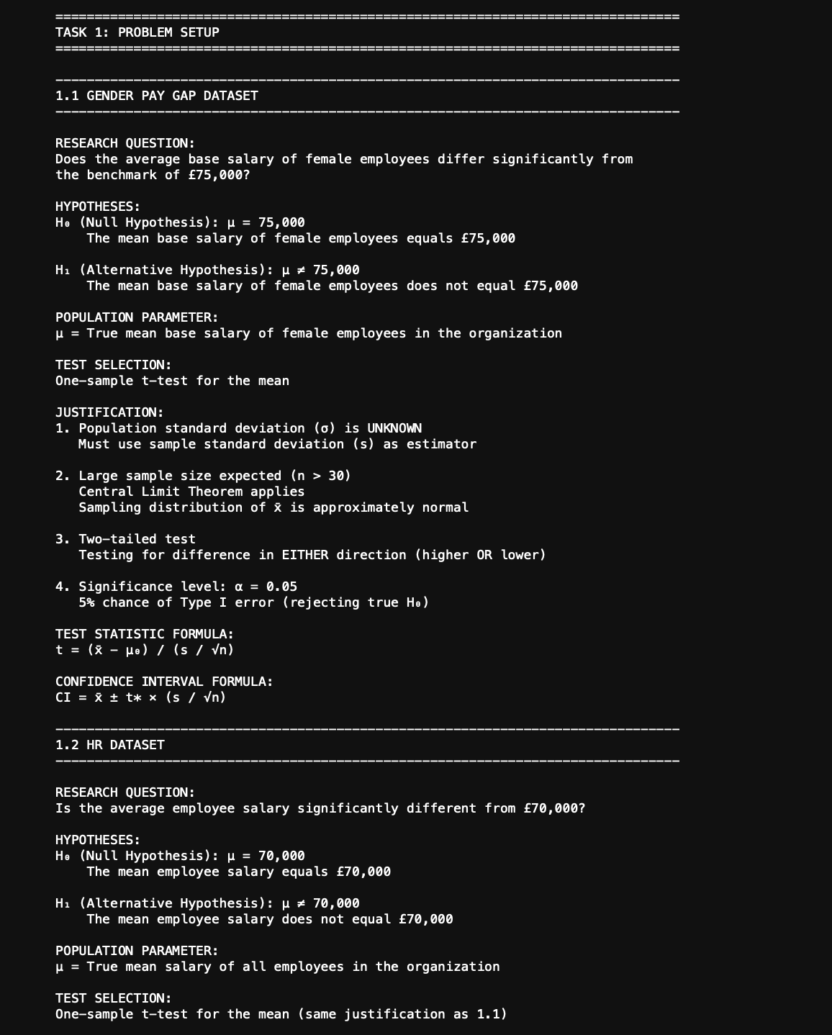

1.2 HR Dataset

Research Question
Is the average employee salary significantly different from the £70,000 benchmark?

Hypotheses
H₀: μ = 70,000
The mean employee salary equals £70,000.
H₁: μ ≠ 70,000
The mean employee salary does not equal £70,000.

Population Parameter
μ = True mean salary of all employees.

Test Selection
Same methodology as 1.1.

TASK 2: ASSUMPTIONS AND ANALYSIS PLAN
Statistical inference requires specific assumptions about data collection and distribution properties. 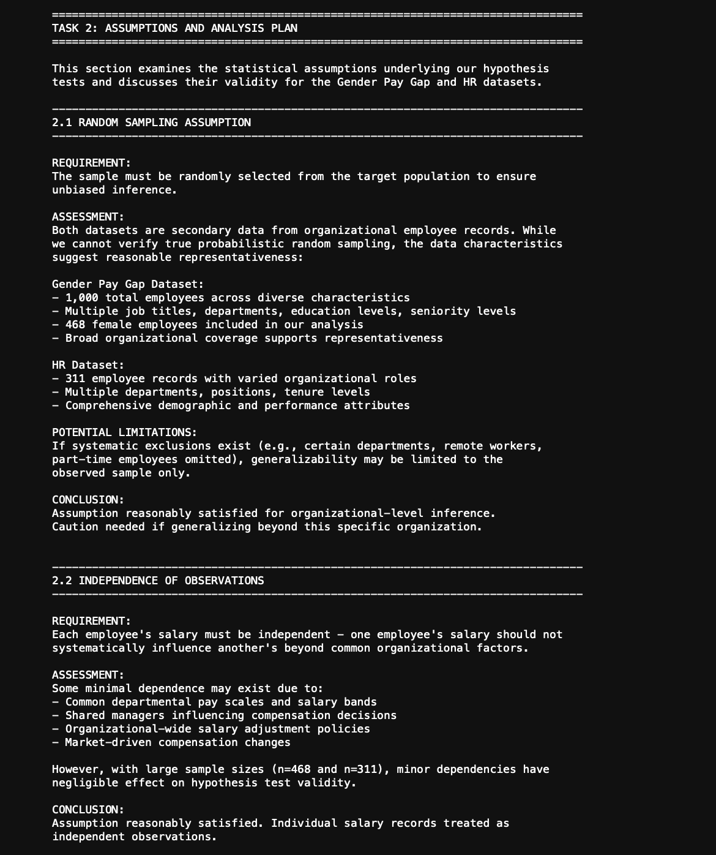
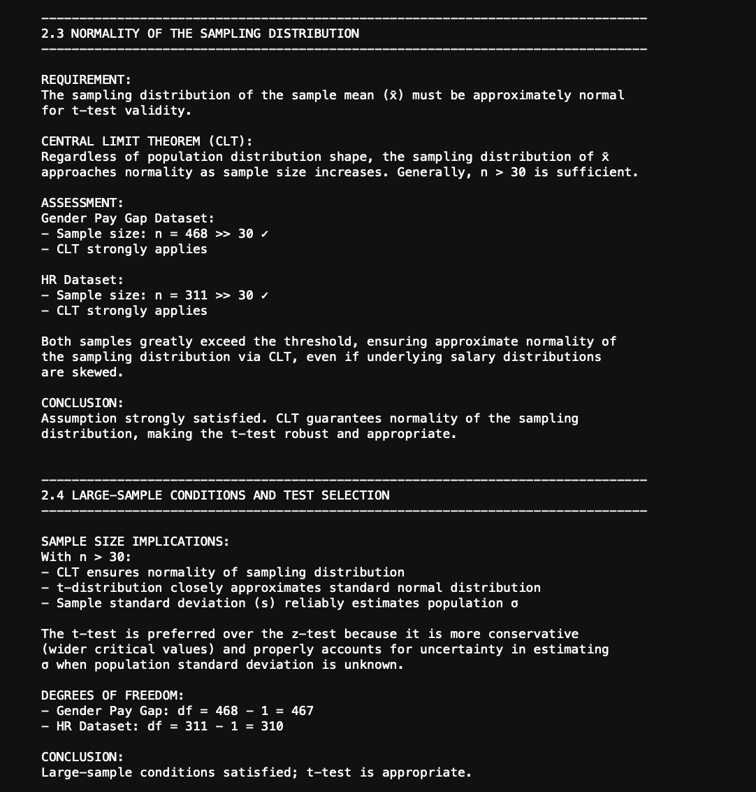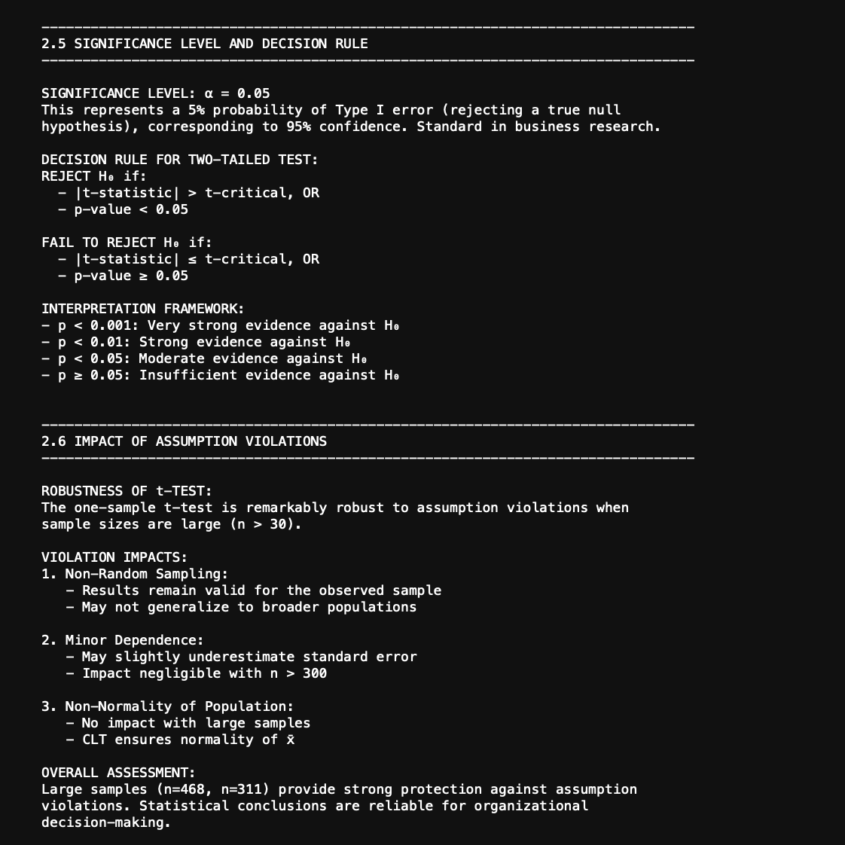

2.1 Random Sampling Assumption
Both datasets are from organizational records suggesting reasonable representativeness (Gender Pay Gap: 1,000 employees; HR: 311 employees).

2.2 Independence of Observations
Large sample sizes (n=468, n=311) minimize impact of minimal organizational dependencies.

2.3 Normality of Sampling Distribution
CLT strongly applies: n=468 >> 30 and n=311 >> 30, guaranteeing approximate normality.

2.4 Large-Sample Conditions
df = 467 (Gender Pay Gap) and df = 310 (HR Dataset). Large samples ensure reliable inference.

2.5 Significance Level
α = 0.05 (95% confidence). REJECT H₀ if |t| > t-critical OR p < 0.05.

2.6 Impact of Violations
t-test is robust with large samples. Minor violations have negligible impact.

TASK 3: DATA ANALYSIS USING PYTHON

3.1 Gender Pay Gap Dataset Analysis

Dataset Overview
The Gender Pay Gap dataset contains 1,000 employee records with 9 variables. No missing values were found.
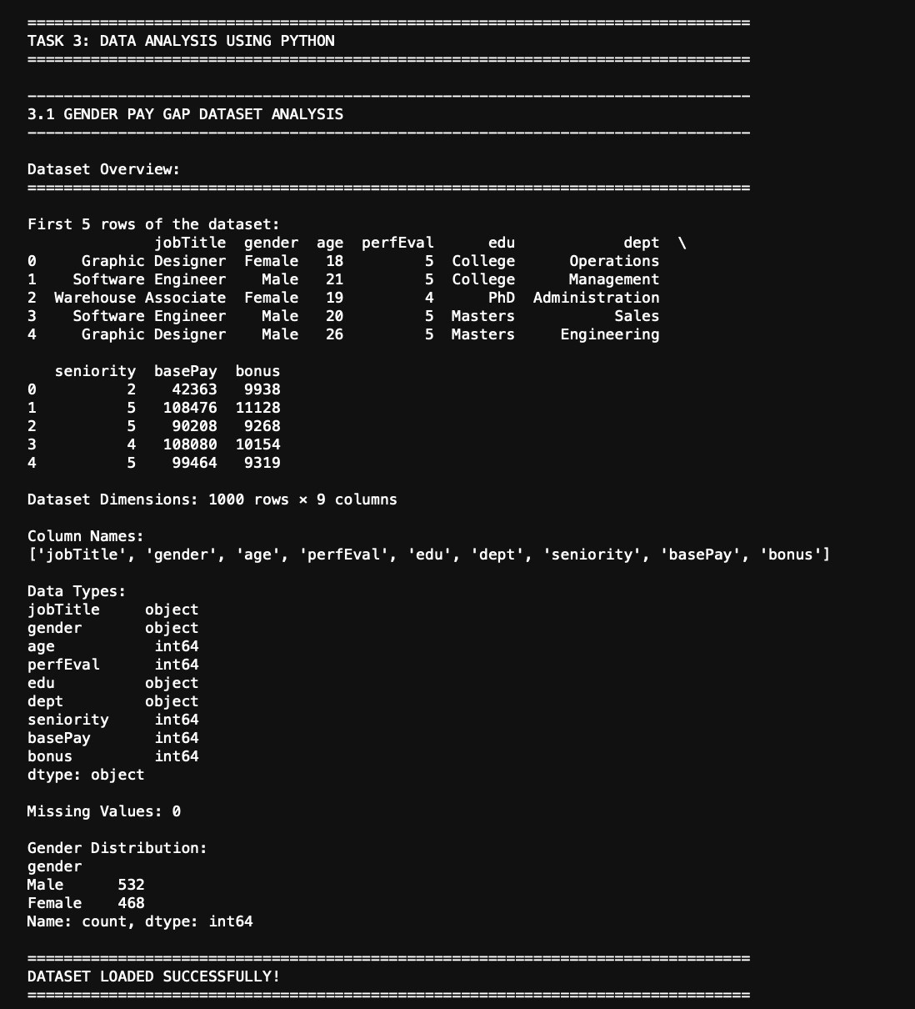

Sample Statistics - Female Base Salaries
Female employees were filtered and descriptive statistics calculated.
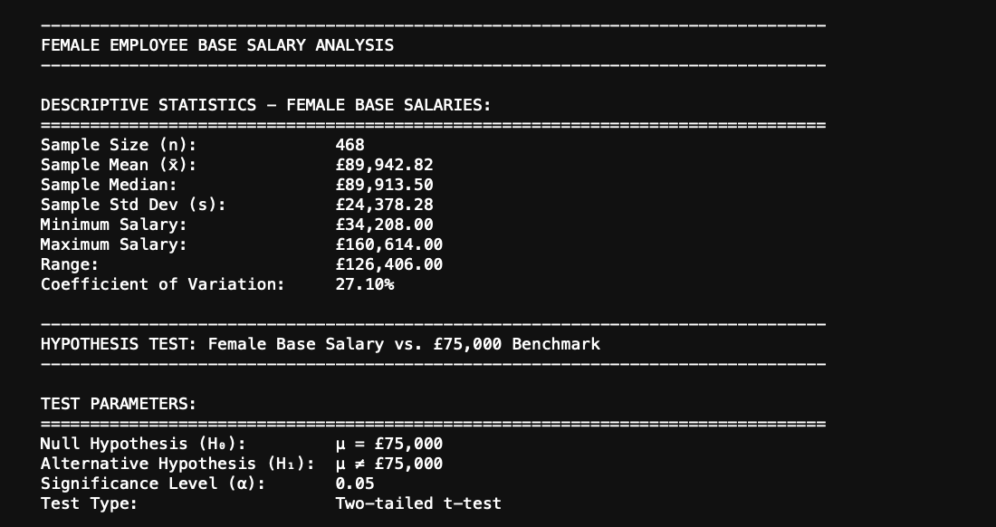

Hypothesis Testing Results
Test Parameters: H₀: μ = £75,000; H₁: μ ≠ £75,000;
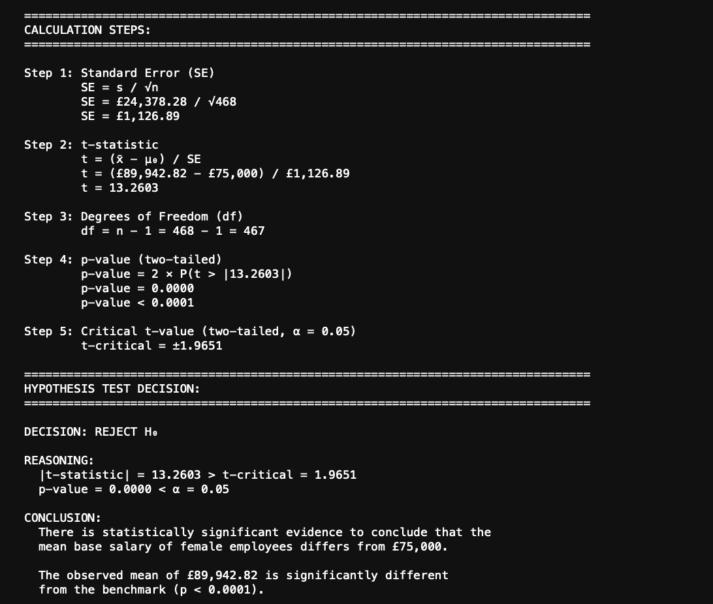
α = 0.05; Two-tailed t-test

Statistical Decision
Decision: REJECT H₀
The mean base salary of female employees (£89,942.82) significantly exceeds the £75,000 benchmark (p < 0.0001).

Confidence Interval Estimation
95% CI provides a range of plausible values for the true population mean.
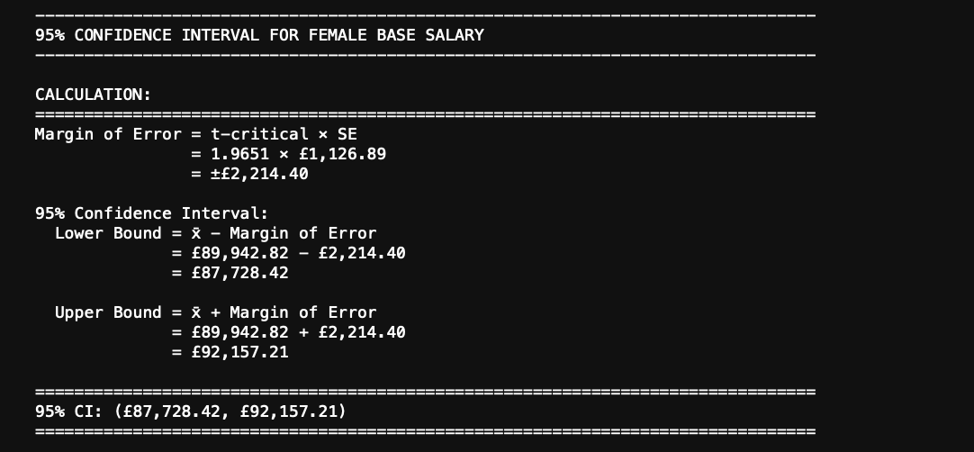

Interpretation
We are 95% confident the true mean lies between £87,728.42 and £92,157.21. The £75,000 benchmark is OUTSIDE this interval, supporting rejection of H₀.

Visualization
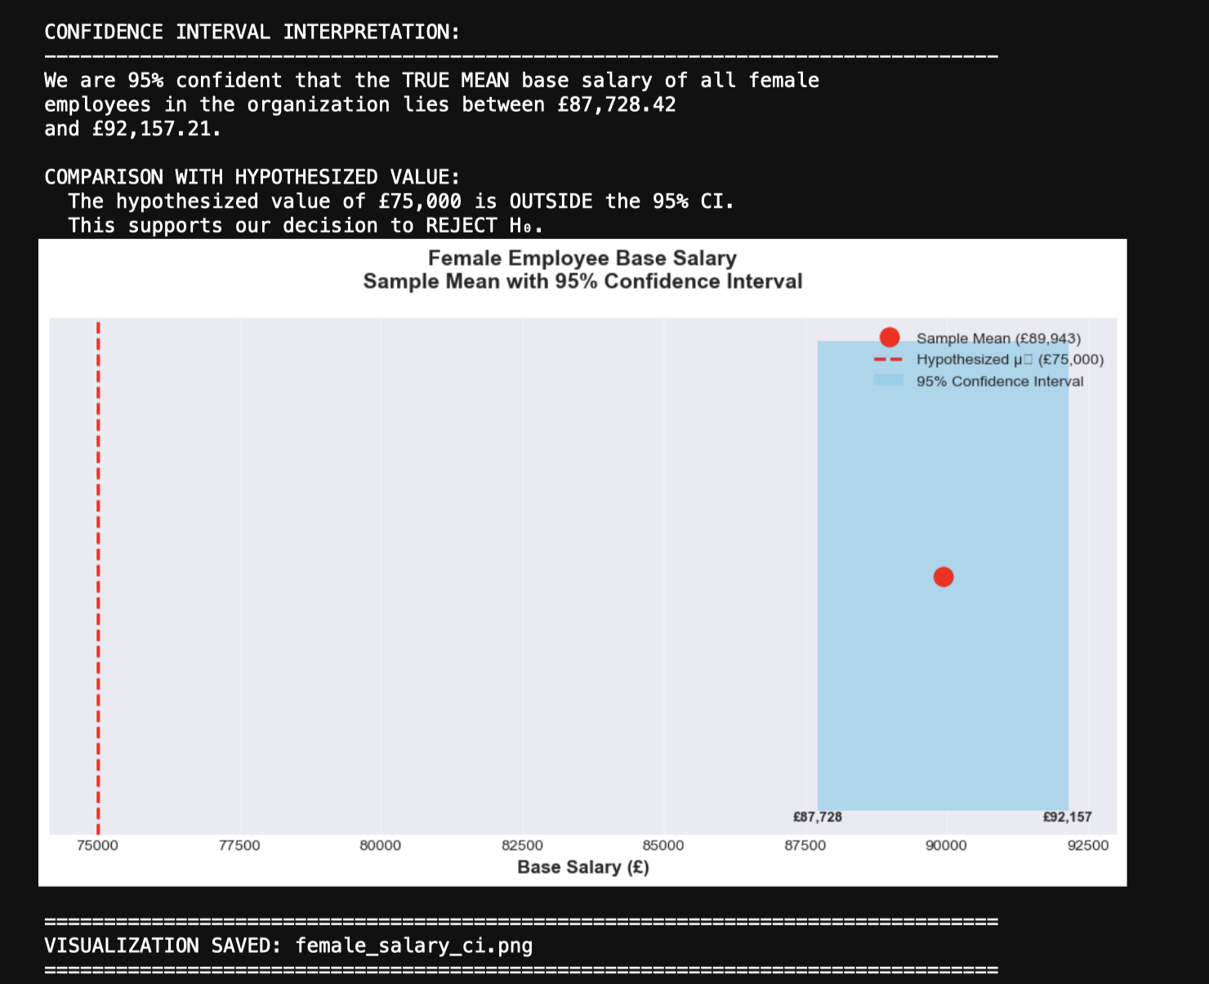
Figure 1: Female Employee Base Salary - Sample Mean with 95% Confidence Interval (n=468, p<0.0001)

3.2 HR Dataset Analysis

Dataset Overview
The HR dataset contains 311 employee records across 35 variables. Missing values in DateofTermination (104) and ManagerID (17) were filled.
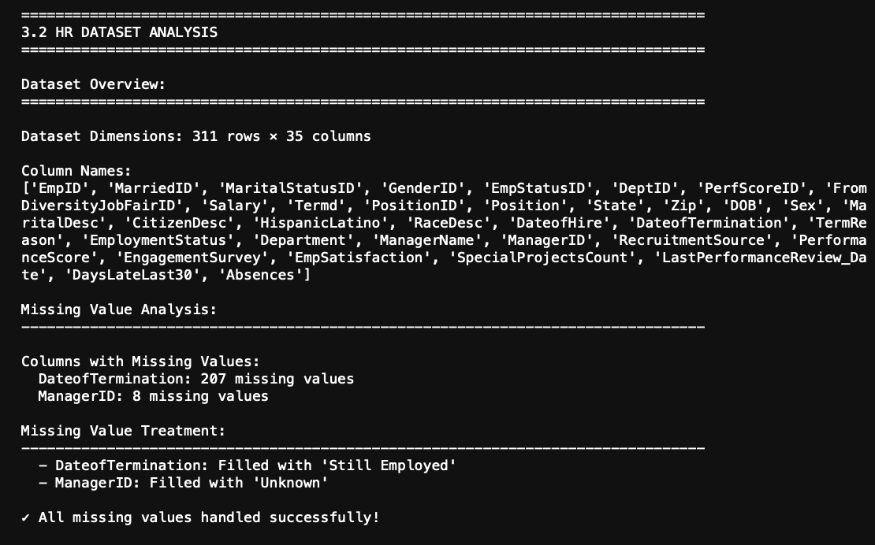

Sample Statistics - Employee Salaries
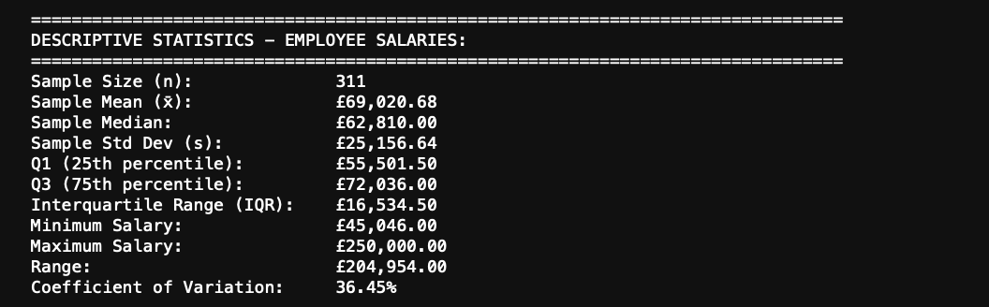

Hypothesis Testing Results
Test Parameters: H₀: μ = £70,000; H₁: μ ≠ £70,000; α = 0.05; Two-tailed t-test
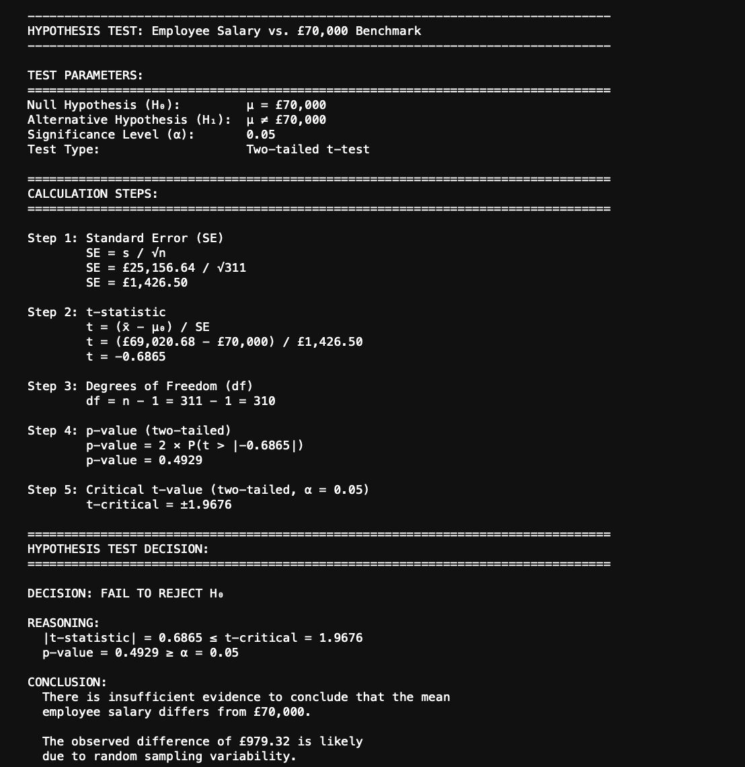

Statistical Decision
Decision: FAIL TO REJECT H₀
Insufficient evidence that mean salary (£69,020.68) differs from £70,000 benchmark (p = 0.4929).

Confidence Interval Estimation
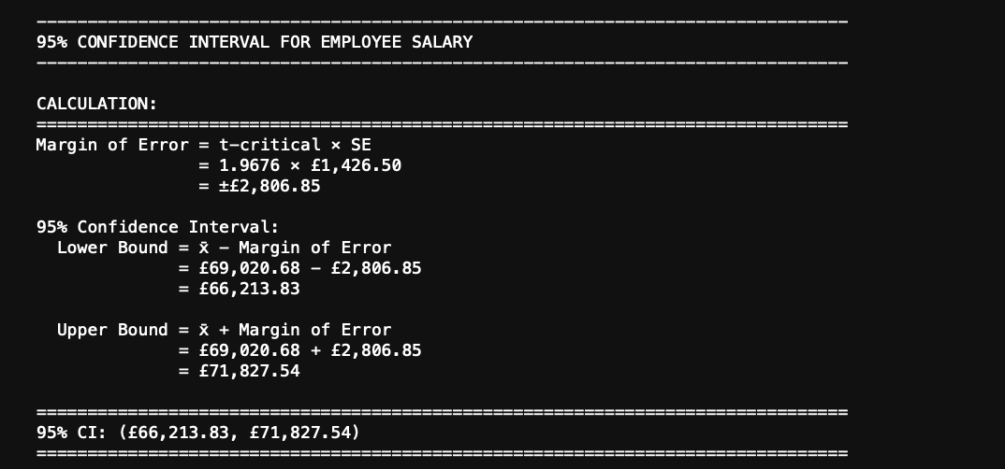

Interpretation
We are 95% confident the true mean lies between £66,213.83 and £71,827.54. The £70,000 benchmark is INSIDE this interval, supporting failure to reject H₀.

Visualization

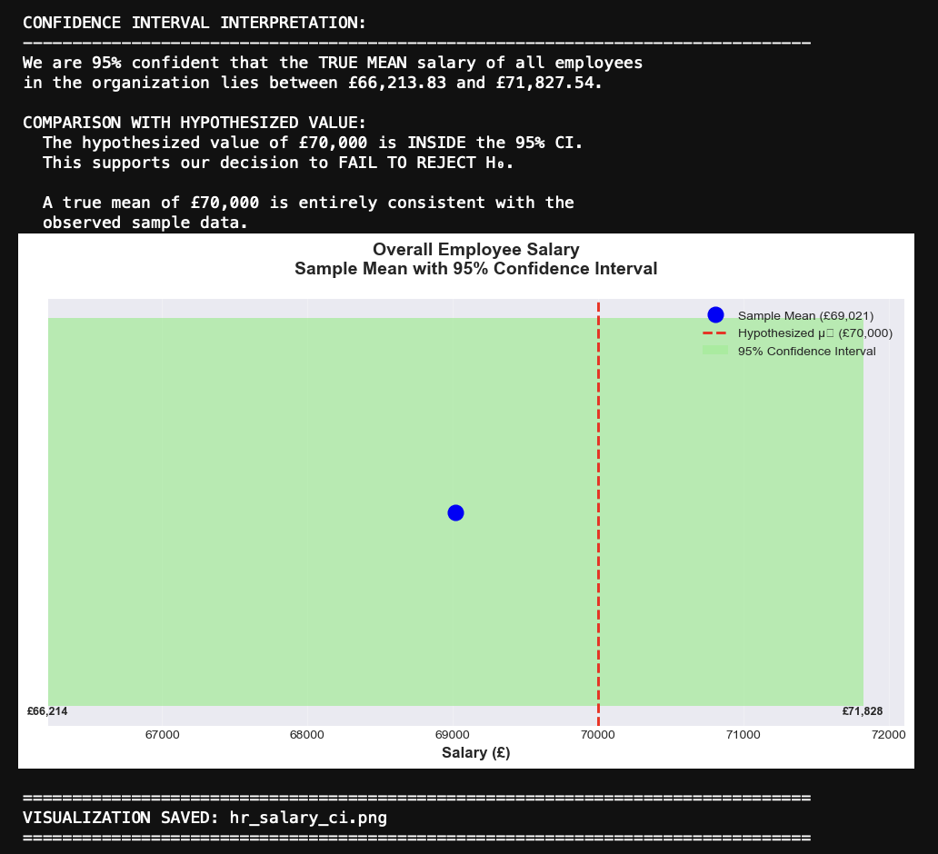
Figure 2: Overall Employee Salary - Sample Mean with 95% CI (n=311, p=0.4929)

3.3 Summary Comparison

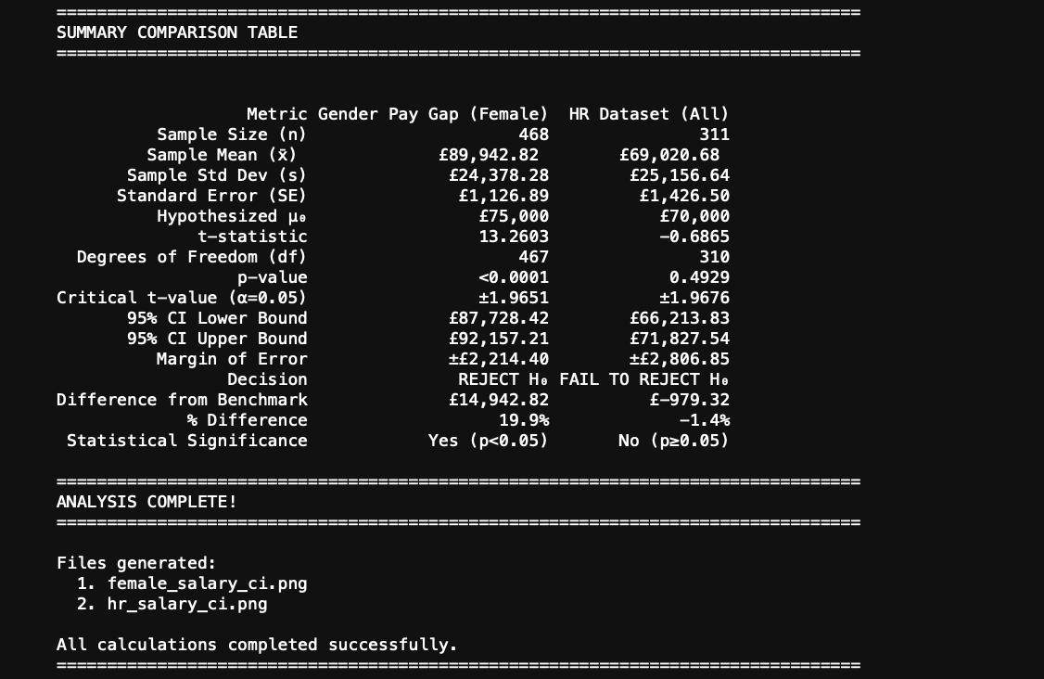

TASK 4: INTERPRETATION FOR STAKEHOLDERS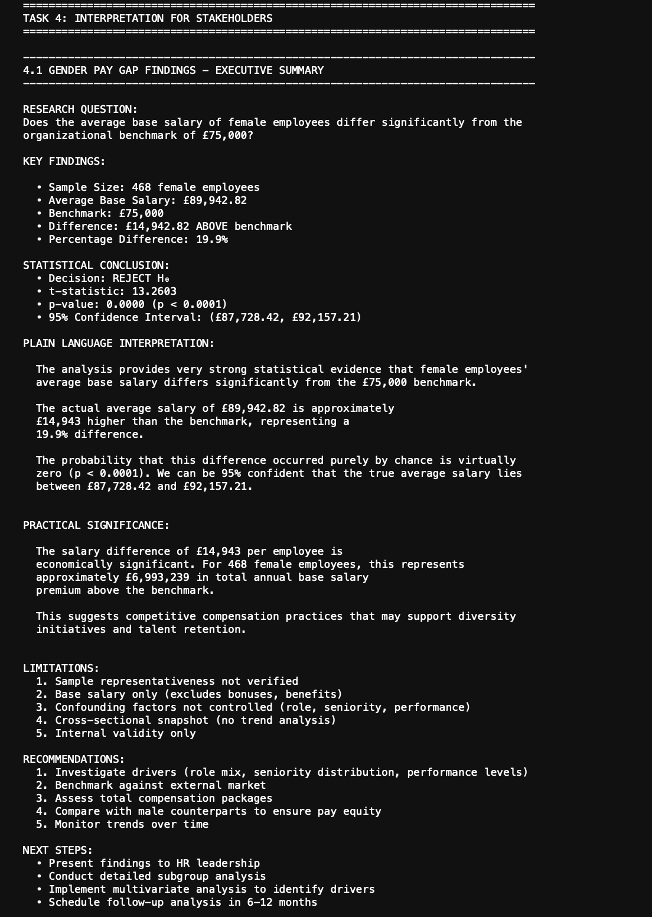
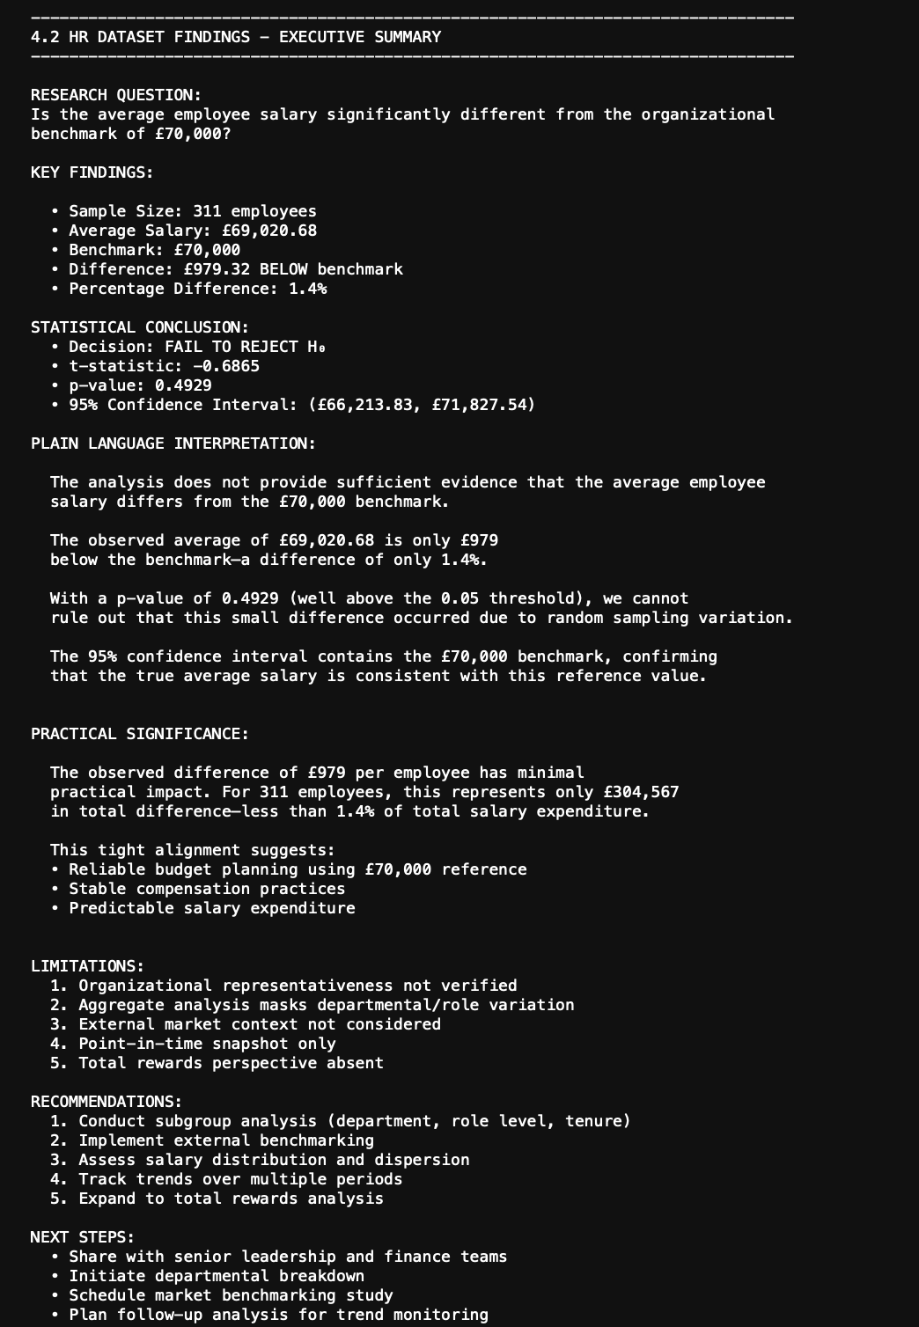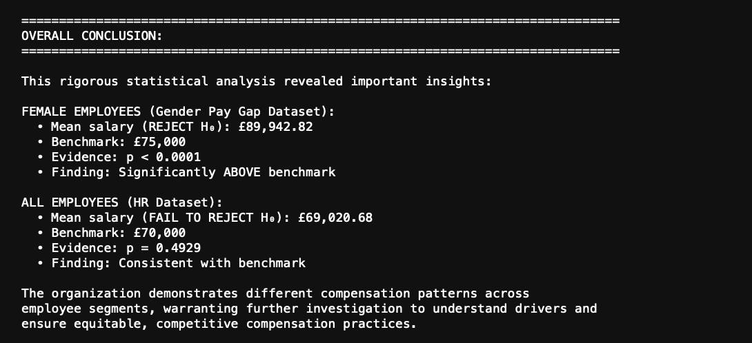

4.1 Gender Pay Gap Findings

Key Findings
• Sample: 468 female employees
• Average: £89,942.82
• Difference: £14,942.82 ABOVE (+19.9%)

Statistical Conclusion
REJECT H₀ (p < 0.0001). Female salaries significantly exceed £75,000 benchmark.

Plain Language
Female employees earn £14,943 more than benchmark—a 19.9% premium representing £6.99M total.

Limitations
Base salary only; confounding factors not controlled; cross-sectional snapshot.

Recommendations
Investigate drivers, benchmark externally, assess total compensation, compare with male counterparts.

4.2 HR Dataset Findings

Key Findings
• Sample: 311 employees
• Average: £69,020.68
• Difference: £979.32 BELOW (-1.4%)

Statistical Conclusion
FAIL TO REJECT H₀ (p = 0.4929). Salaries consistent with £70,000 benchmark.

Plain Language
Average salary very close to benchmark. £979 difference attributable to sampling variation.

Limitations
Aggregate analysis masks variation; external context not considered; point-in-time only.

Recommendations
Conduct subgroup analysis, implement benchmarking, track trends.

4.3 Overall Conclusion
Female employees significantly exceed benchmark (+19.9%, p<0.0001) while overall employees align with benchmark (p=0.49), revealing segmented compensation patterns.

REFERENCES
Agresti, A., & Franklin, C. A. (2018). Statistics: The Art and Science of Learning from Data (4th ed.). Pearson Education.

Cohen, J., Cohen, P., West, S. G., & Aiken, L. S. (2003). Applied Multiple Regression/Correlation Analysis for the Behavioral Sciences (3rd ed.). Lawrence Erlbaum Associates.

Field, A. (2018). Discovering Statistics Using IBM SPSS Statistics (5th ed.). SAGE Publications.

Howell, D. C. (2017). Fundamental Statistics for the Behavioral Sciences (9th ed.). Cengage Learning.

Montgomery, D. C., & Runger, G. C. (2018). Applied Statistics and Probability for Engineers (7th ed.). John Wiley & Sons.

Moore, D. S., McCabe, G. P., & Craig, B. A. (2017). Introduction to the Practice of Statistics (9th ed.). W. H. Freeman.

Roehampton University. (2026). CMP-L011-0 Mathematics for Data Science - Assessment Brief Part 2. Moodle Virtual Learning Environment. Retrieved from https://moodle.roehampton.ac.uk

Roehampton University. (2026). CMP-L011-0 Mathematics for Data Science - Seminar Materials Weeks 9-11. Moodle Virtual Learning Environment.

Triola, M. F. (2018). Elementary Statistics (13th ed.). Pearson Education.

Wackerly, D., Mendenhall, W., & Scheaffer, R. L. (2008). Mathematical Statistics with Applications (7th ed.). Thomson Brooks/Cole.

