MACHINE LEARNING PROJECT

Car Price Prediction Using Machine Learning
Project Report

Prepared by
Aditya Vishwakarma

A beginner-friendly supervised learning project using historical CarDekho vehicle listings

Submitted for academic project evaluation
September 2026

1. Introduction
Used-vehicle prices vary with age, reference price, distance driven, fuel, transmission, seller channel and ownership history. A data-driven estimate can help demonstrate how these details relate to historical selling prices. This project builds a small regression workflow that is simple to explain and reproduce. The final output is an educational estimate, not a professional appraisal or a statement of current market value.

2. Problem Statement
The project addresses the task of estimating a vehicle’s selling price from structured listing information. Given seven features, the model predicts the numeric Selling_Price target. A held-out test set is used to compare predictions against values not used during model fitting.

3. Objectives
- Understand the dataset structure and clean duplicate or invalid records.
- Explore price patterns with labelled visualizations.
- Encode categorical features and avoid preprocessing leakage.
- Train and compare two regression algorithms using standard metrics.
- Save a reusable fitted pipeline and demonstrate a sample prediction.

Scope and Interpretation
The packaged dataset contains 301 historical rows and includes some motorcycles in addition to cars. The report therefore uses “vehicle” where appropriate. Prices are expressed in Indian rupees lakh. Because the sample is small and old, observed accuracy should not be generalized to current listings.

4. Dataset Description
The project uses a CarDekho-based dataset commonly distributed as the Kaggle “Vehicle dataset from CarDekho.” The included CSV is a mirror copy of the commonly used 301-record dataset. It contains nine source columns; Car_Name is excluded from the requested compact feature set. Seller_Type is renamed Selling_Type in the notebook.
Column | Description
Year | Vehicle model year
Present_Price | Reference/ex-showroom value, in lakh
Kms_Driven | Distance driven, in kilometres
Fuel_Type | Fuel category such as Petrol, Diesel or CNG
Selling_Type | Dealer or Individual seller
Transmission | Manual or Automatic
Owner | Count of previous owners
Selling_Price | Target selling value, in lakh
Dataset links:
Kaggle: https://www.kaggle.com/datasets/nehalbirla/vehicle-dataset-from-cardekho
CSV mirror: https://raw.githubusercontent.com/RimjimRazdan/cars_price_prediction/master/car%20data.csv

5. Technologies Used
Python, Pandas, NumPy, Matplotlib, Seaborn, Scikit-learn, Jupyter Notebook and Joblib. The sklearn Pipeline and ColumnTransformer keep transformations and prediction together.

6. System Requirements
Item | Recommended setup
Operating system | Windows, macOS or Linux, 64-bit
Python | Python 3.10 or newer
Memory | 4 GB RAM or more
Storage | About 1 GB free for Python packages and project files
Connectivity | Internet for package installation; dataset is included

7. Methodology
The notebook loads the local CSV with a relative path, inspects data types and summary statistics, removes exact duplicate records, converts numeric fields safely, and removes rows with missing target values. It preserves the requested predictor columns and does not use Car_Name as a model input.

8. Data Preprocessing
The cleaned rows are divided into training and test sets with an 80/20 split and random_state=42. After duplicate removal, 239 rows are used for training and 60 for testing. Numeric features receive median imputation. Categorical features receive most-frequent imputation followed by OneHotEncoder(handle_unknown="ignore").
All preprocessing lives inside each estimator pipeline. The pipeline is fitted only on training data, which prevents imputers and encoders from learning from the test set. The same fitted steps are then applied when evaluating and predicting.

9. Exploratory Data Analysis
Six charts inspect the target distribution and relationships with model year, reference price, kilometres driven, fuel type and transmission. The plots are descriptive: group differences and correlations do not demonstrate causal effects.

Exploratory Data Analysis
The selling-price distribution is right-skewed, with a small number of high-price listings. The reference price and selling price show a positive association. These patterns help describe the training sample but can be influenced by the mixture of vehicle types and the limited dataset size.
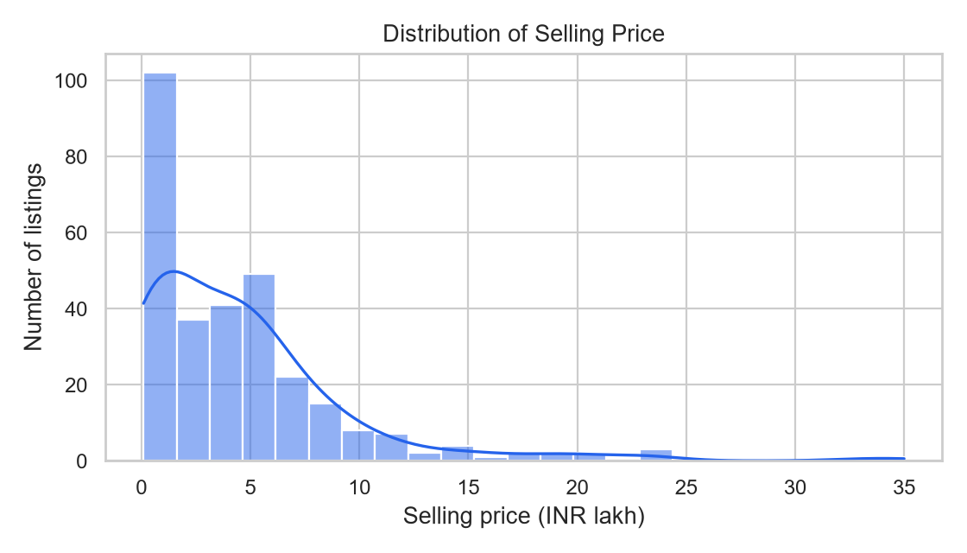
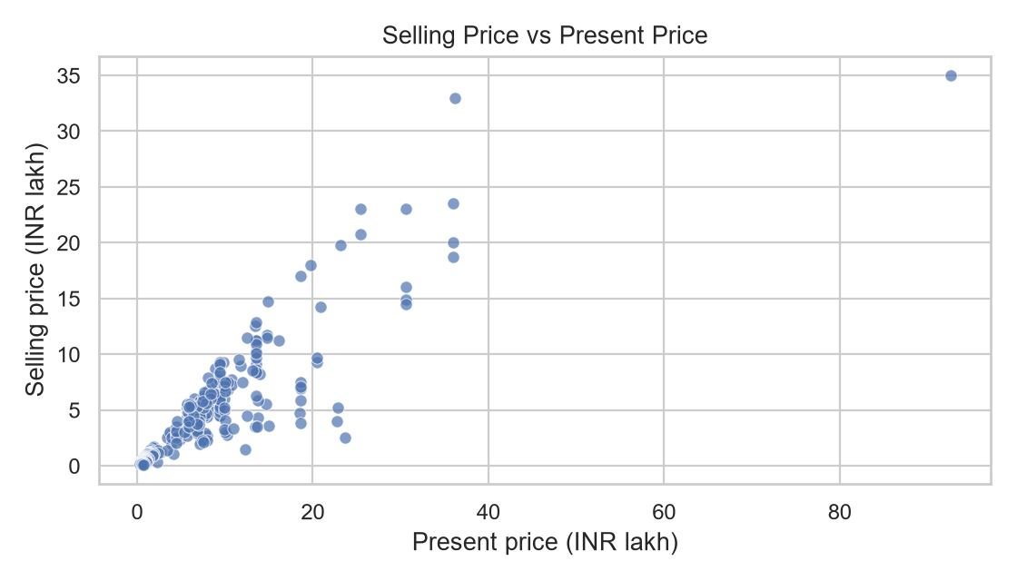
Figures 1–2. Actual distributions and listing values generated by the executed notebook.

10. Machine Learning Models
Selling_Price is numeric and continuous, so regression is appropriate. Linear Regression provides a straightforward baseline; Random Forest Regressor combines decision trees and can model nonlinear relationships. Both were trained with the same split and the same feature preprocessing.

11. Model Evaluation
MAE is average absolute prediction error. MSE is the mean squared error and penalizes larger misses more heavily. RMSE is the square root of MSE and is expressed in lakh rupees. R² measures variance explained relative to a test-set mean baseline. Lower error values and a higher R² are preferred.
Model | MAE (lakh) | MSE (lakh²) | RMSE (lakh) | R²
Linear Regression | 1.4729 | 6.3708 | 2.5240 | 0.7528
Random Forest | 1.4971 | 12.7285 | 3.5677 | 0.5061

12. Selected Model and Results
Linear Regression was selected because it achieved the lowest RMSE (2.5240 lakh) and highest R² (0.7528) on the defined holdout split. Its MAE was 1.4729 lakh. Random Forest did not outperform the simpler baseline on this test set. This result is specific to this random split and the small historical sample; another split or newer data may change the comparison.

13. Actual vs Predicted Analysis
The chart compares the selected model’s predictions with the actual target values for the 60 held-out rows. Points near the dashed line indicate smaller errors. The distance of some points from the line indicates that individual estimates can still miss by several lakh.
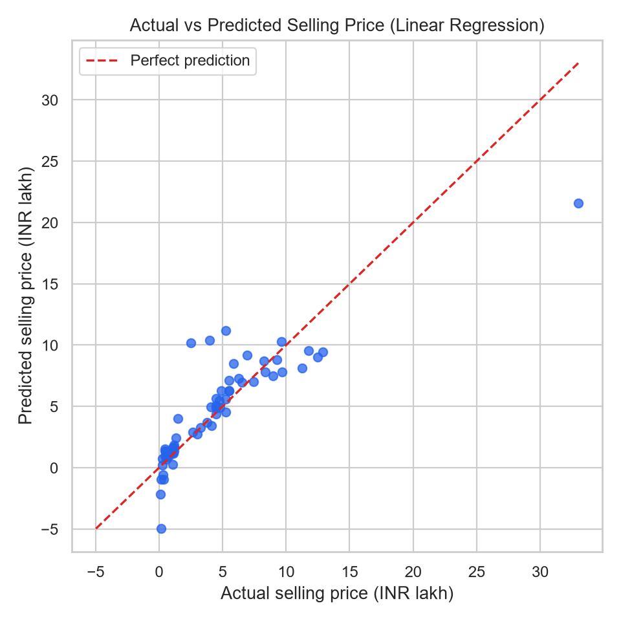

14. Sample Prediction
Input | Value
Year | 2015
Present_Price | 8.0 lakh
Kms_Driven | 30,000 km
Fuel_Type / Selling_Type | Petrol / Dealer
Transmission / Owner | Manual / 0
The selected pipeline predicts an estimated selling price of INR 5.29 lakh for this example. The notebook computes this result from the trained model; it is not a fabricated or hand-entered value.

Feature Discussion
The model uses reference price, year, distance, fuel, seller channel, transmission and owner count. The selected Linear Regression model has coefficients rather than tree feature_importances_; the notebook displays absolute coefficient magnitudes after one-hot encoding. These values describe model associations and should not be interpreted causally.

15. Conclusion
This project builds an end-to-end beginner-friendly machine learning workflow: data inspection and cleaning, exploratory charts, leakage-aware preprocessing, model comparison, evaluation, sample inference and model persistence. Linear Regression performed better than Random Forest on the fixed 80/20 holdout test split. Its mean absolute error was about INR 1.47 lakh and its RMSE was about INR 2.52 lakh.
Reference price and vehicle age are plausible useful signals in these listings; mileage and the categorical details contribute additional context. The sample is too small and historical to support claims about today’s whole used-car market.

16. Future Scope
- Add more recent observations and more cars; record make/model, condition, location and service history.
- Use cross-validation and tune model settings before selecting a final estimator.
- Compare gradient boosting approaches with appropriate validation.
- Deploy a Streamlit interface and monitor performance on new listings.

17. References
- Kaggle, “Vehicle dataset from CarDekho,” https://www.kaggle.com/datasets/nehalbirla/vehicle-dataset-from-cardekho
- Public CSV mirror used in the included data file, https://raw.githubusercontent.com/RimjimRazdan/cars_price_prediction/master/car%20data.csv
- Scikit-learn documentation, https://scikit-learn.org/stable/
- Pandas documentation, https://pandas.pydata.org/docs/

