CS 6301 Introduction to Robot Manipulation and Navigation Homework 1

Name: Aditya Kulkarni

NetID: axk230069

# Problem 1

Grübler’s Formula. Exercise 2.7 in Lynch and Park, Modern Robotics.

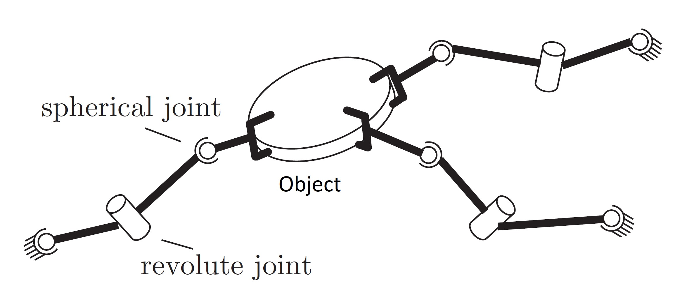

Figure 1: Three cooperating SRS arms grasping a common object.

Three identical SRS open-chain arms are grasping a common object, as shown in Figure 1. Find the number of degrees of freedom of this system using Grübler’s formula. Write down how you apply Grübler’s formula to this system.

**Solution:**

Grübler’s Formula is applied to the above system as follows:

Number of Links including ground, N = 1(ground) + 1(Planar disc) + 6(2 links each for 3 arms) = ***8***

Number of joints, J = 6(Spherical Joints) + 3(Revolute Joints) = ***9***

Degree of freedom of each link, m = ***6*** (Spatial system)

Sum of degree of freedom of all joints, $\sum_{i=1}^{J}{f_{i}}$ = 6(3) + 3(1) = ***21***

Grübler’s Formula: $DOF= m\left(N-1-J\right)+\sum_{i=1}^{J}{f_{i}}$

$DOF= 6\left(8-1-9\right)+21$

$DOF= 9$

**Degree of freedom of above system is *9*.**

# Problem 2

Zip file:

Rviz interface by running “roslaunch urdf_tutorial display.launch”.

Rviz visualization of a Fetch mobile manipulator.