**TOPIC:-INSTANT MEASURE**

**ABSTRACT**

The software to be produced is on Object Measurement System. Here the employees are the users of the software. The employees will click a picture of the required object to be measured. The picture must be clicked such that the object should be on right side and the reference object should be on left side. The size of reference object should already be present in the program .By calculating the pixels of the reference object and actual object the object can be easily measured.

Then the image should be processed using OpenCv and the objects are detected. Then with the help of left reference object actual dimensions are calculated and used .The app uses image processing using the OpenCV library.

The system is useful to the shipping company employees which manually measure the objects. Using this app they can easily measure the objects to be measure

**INTRODUCTION**

We have done a project on Measurement of objects using smart phones. This system is proposed to be an automate system to measure various objects with respect to a reference object. This displays dimensions of an object and its distance from ground. This system provides dimension display & report generation with graphical user interface (GUI).

It is always necessary to study and recognize the problems of existing system, which will help in finding out the requirements for the new system. System study helps in finding different alternatives for better solution. The project study basically deals with different operations and steps involved in measurement of objects. It includes:

1. Data gathering

2. Study of existing system

3. Analyzing problem

4. Studying various documents

5. Feasibility study for further improvements

Following are the steps taken during the initial study:

Initially, we studied about factors for measuring an object. Then we studied the working of the current system which is done manually. We noted the limitation of that system which motivated them to have new system. With the help of these documents we got basic ideas about the system as well as input output of the developed system. The most important thing is to study system thoroughly. Here we are studying both existing system and proposed system so that advantages & disadvantages of both the systems can be Understood The first task was identifying how system can be computerized. Some analysis and projections was done regarding changes to be made to the existing system. The new developed system for Object Measurement is simple without complexities.

**ARCHITECTURE OF PROPOSED SYSTEM**

The proposed system is managed by the Android Studio, which are user friendly windows for every user and for maintaining the database Firebase is used. Scope of proposed system:

The system proposed has many advantages.

1. The proposed system is highly secured, because for login the system it requires the username and password which is different for each employee.

2. It gives measurement of any required object

3.It is faster than the manual work done.

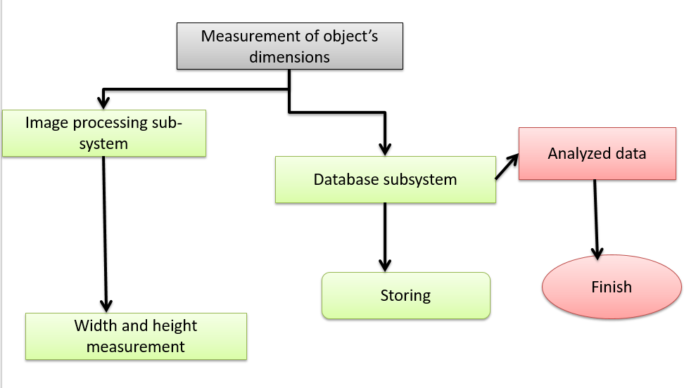

Fig 1. ARCHITECTURE Diagram

We have done a project on Object measurement using smart phones. This system is designed to reduce manual work of measuring objects by busing tapes, etc. It is designed basically for shipping companies that transport goods. It provides login and registration for the employees of the company using Firebase. This system provides employee data storing & report generation with graphical user interface (GUI).

It is always necessary to study and recognize the problems of existing system, which will help in finding out the requirements for the new system. System study helps in finding different alternatives for better solution. The project study basically deals with different operations and steps involved in generation of examination mark sheets. It includes:

1. Data gathering

2. Study of existing system

3. Analyzing problem

4. Studying various documents

5. Feasibility study for further improvements

Following are the steps taken during the initial study:

Initially, we collected all the information, which they wanted to store. Then we studied the working of the current system which is done manually. We noted the limitation of that system which motivated them to have new system. With the help of these documents we got basic ideas about the system as well as input output of the developed system. The most important thing is to study system thoroughly. Here we are studying both existing system and proposed system so that advantages & disadvantages of both the systems can be Understood The first task was identifying how system can be computerized. Some analysis and projections was done regarding changes to be made to the existing system. The new developed system for Object Measurement is simple without complexities.

**MODULES AND IMPLEMENTATION**

**MODULE DESCRIPTION**

**MODULES**:

1. User Registration:

2. User Login in system

3. Splash Screen

4. Camera Access Module

5. Measurement Module

6. Logout

**IMPLEMENTATION**

1. **User Registration:**

This module helps for the registration of a new user.

1. **User Login in system:**

This module helps for login of an existing user.

1. **Splash Screen:**

This module displays logo and app name when the app is opened.

1. **Camera Access Module:**

This module helps for camera permissions in the app.

1. **Measurement Module:**

This module helps for measuring the actual dimensions. This is the main module of the app.

1. **Logout:**

This module helps to logout an user.

**SOFTWARE DEVELOPMENT MODELS:**

**WATERFALL MODEL**

The **waterfall model** is a linear [sequential](https://en.wikipedia.org/wiki/Sequence) (non-iterative) [design](https://en.wikipedia.org/wiki/Design) approach for [software development](https://en.wikipedia.org/wiki/Software_development_process), in which progress flows in one direction downwards (like a [waterfall](https://en.wikipedia.org/wiki/Waterfall)) through the phases of conception ,initiation , [analysis](https://en.wikipedia.org/wiki/Analysis) , [design](https://en.wikipedia.org/wiki/Software_design) , [construction](https://en.wikipedia.org/wiki/Software_construction) , [testing](https://en.wikipedia.org/wiki/Software_testing) , [deployment](https://en.wikipedia.org/wiki/Implementation) and [maintenance](https://en.wikipedia.org/wiki/Software_maintenance).

The waterfall development model originated inthe [manufacturing](https://en.wikipedia.org/wiki/Manufacturing) and [construction](https://en.wikipedia.org/wiki/Construction) industries: highly structured physical environments in which after-the-fact changes are impossible or at least prohibitively expensive. At the time it was adopted for software development, there were no recognized alternatives for knowledge-based creative work.

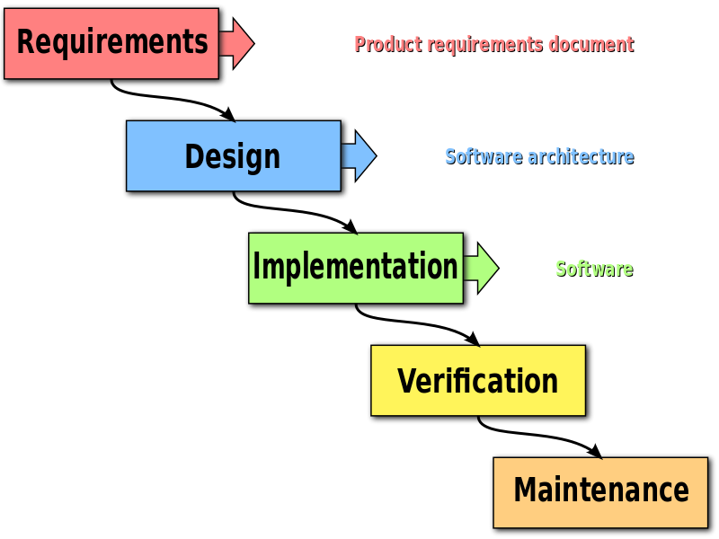

Fig2:WATERFALL MODEL

**SYSTEM DESIGN**

**UML DIAGRAMS**

UML is a general-purpose visual modeling language for specifying, visualizing, constructing and documenting the artifacts of a software system. It captures decision and understanding about systems that must be constructed. It is used to design, browse, configure, maintain and control information about such systems. UML includes different diagrams as Class diagram, Object diagram, Interaction diagrams, Activity diagrams, Use case diagrams, State chart diagrams, Component diagrams and deployment diagrams.

**CLASS DIAGRAM**

A class diagram in the (UML) is a type of static structure diagram that describes the structure of a system by showing the system’s classes their attributes, and the relationships between the classes.

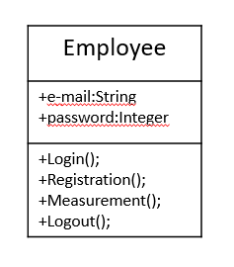

Fig2.1.CLASS Diagram

**USE CASE DIAGRAM**

It shows a set of use cases and actors (a special kind of class and their relationships). Use Case diagrams address the static use case view of system. These diagrams are especially important in organizing and modeling the behavior of a system.

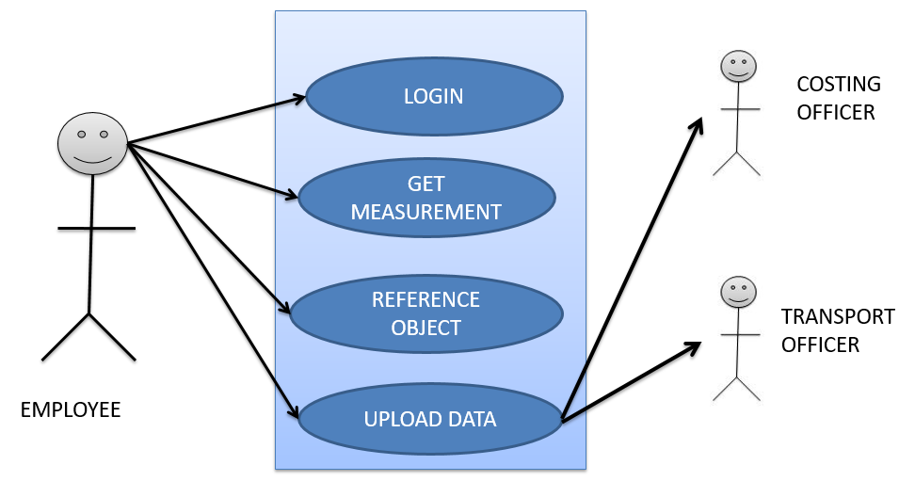

Fig 2.2.USECASE Diagram

**SEQUENCE DIAGRAM**

A Sequence diagram is an interaction diagram that emphasizes the time ordering of messages. Interaction diagram shows that interaction consisting of a set of objects and their relationships including messages that may be dispatched among them.

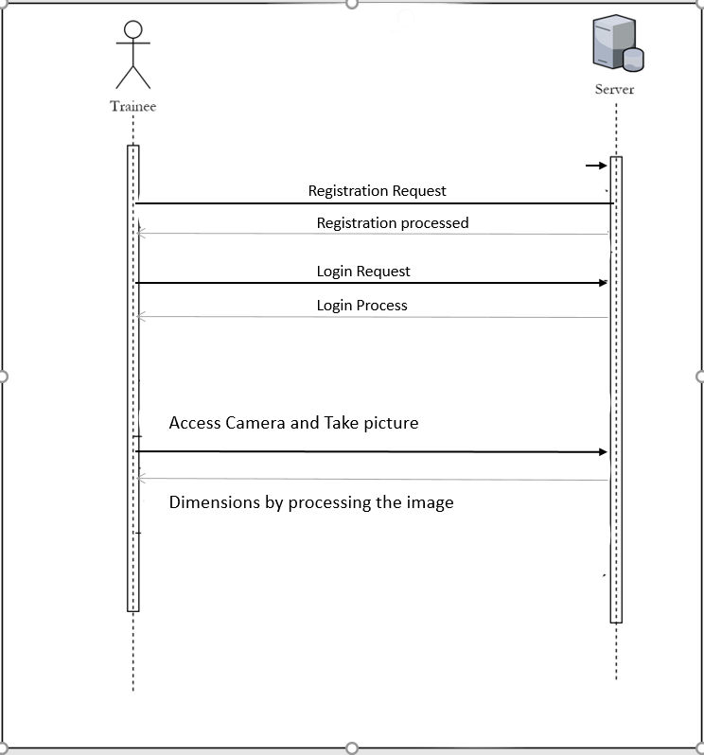

Fig 2.3.SEQUENCE Diagram

**Output Symbol**

The output symbol is used when a hardcopy is produced and the user of the copies cannot be clearly specified or there are several users of the output. The DFD at the simplest level is referred to as the Context Analysis Diagram. These are expanded by level, each explaining in process in detail. Processes are numbered for easy identification and are normally labeled in block letters. Each data flow is labeled for easy understanding.

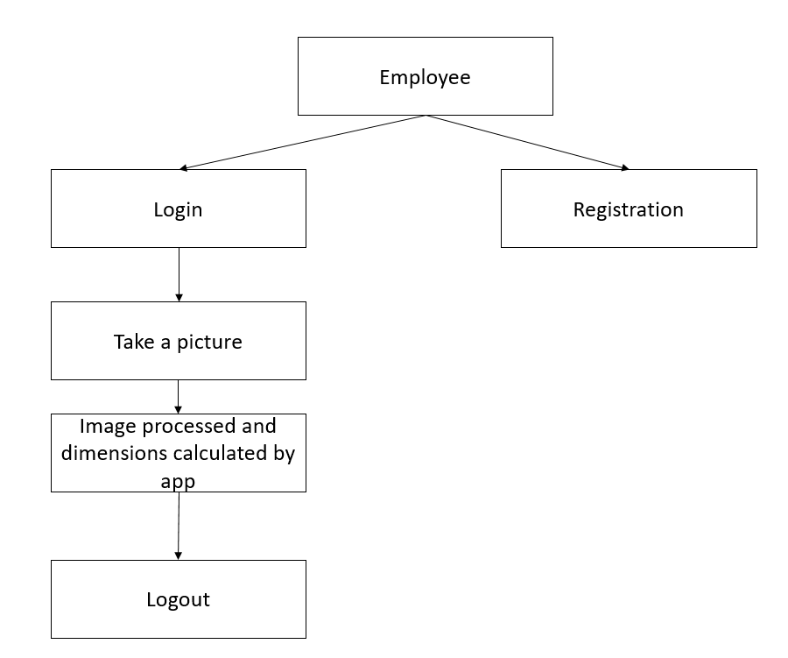

Fig 2.4.DATAFLOW Diagram

**SCREENSHOTS**

REGISTRATION PAGE

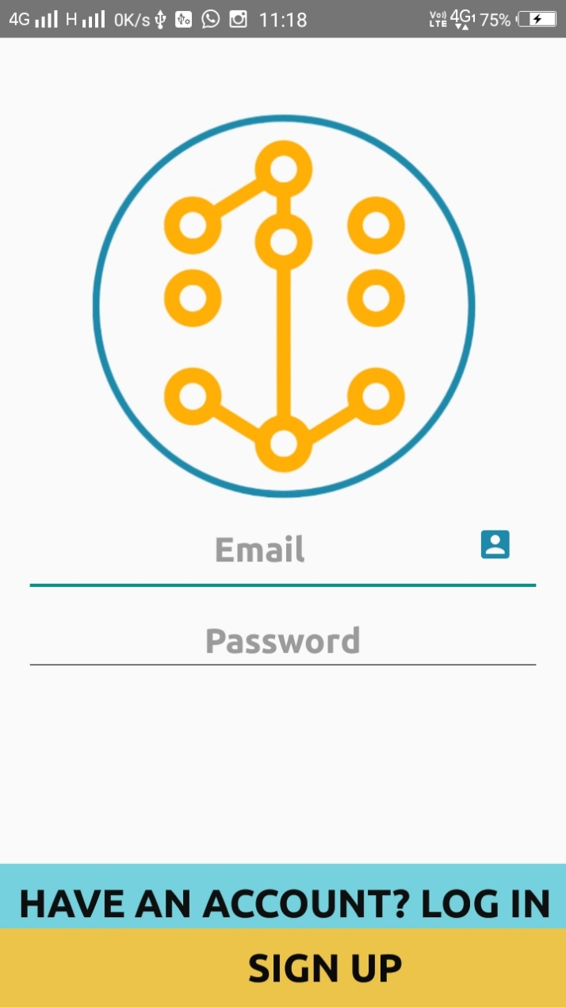

Fig 3.REGISTRATION PAGE

LOGIN PAGE

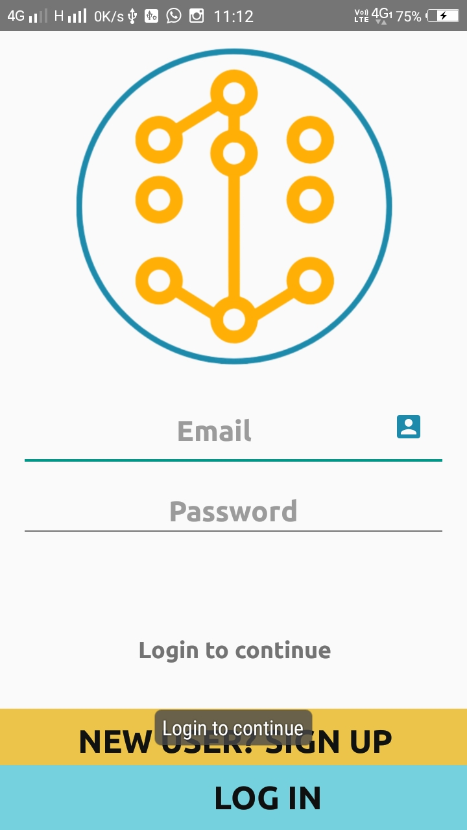

Fig 4.LOGIN PAGE

MAIN SCREEN PAGE

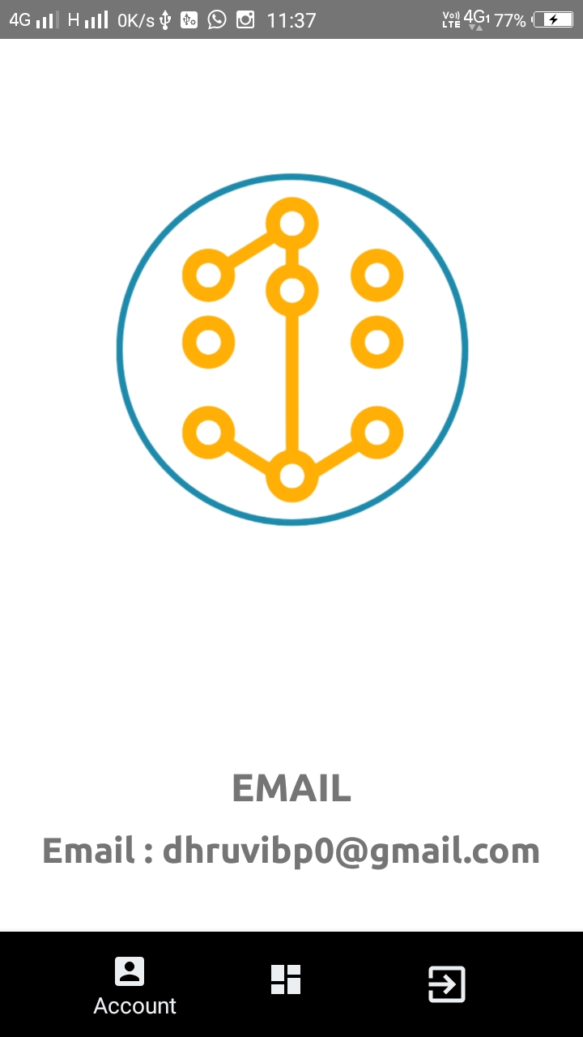

Fig 5.MAIN SCREEN PAGE

SPLASH SCREEN

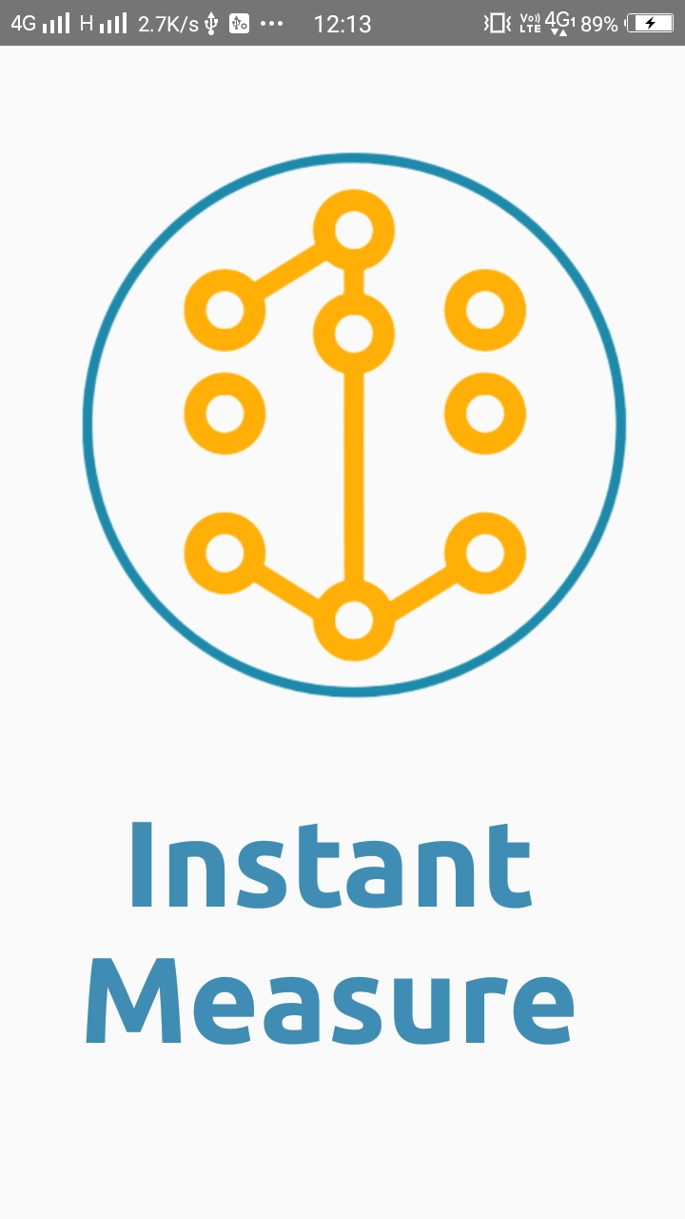

Fig 6.SPLASH SCREEN

CAMERA MODULE

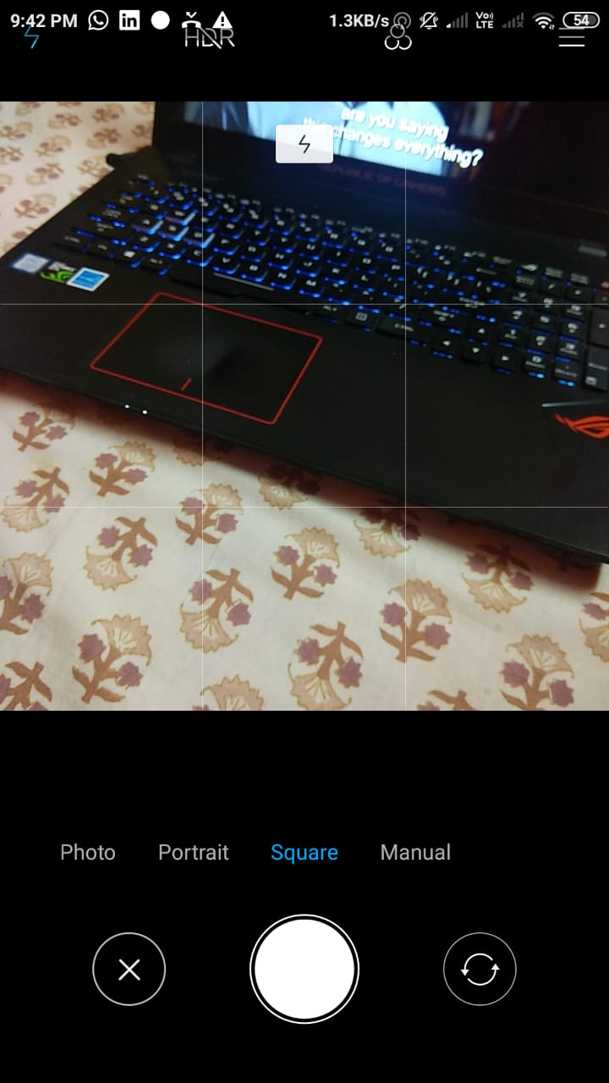

Fig 7.CAMERA MODULE

OUTPUT

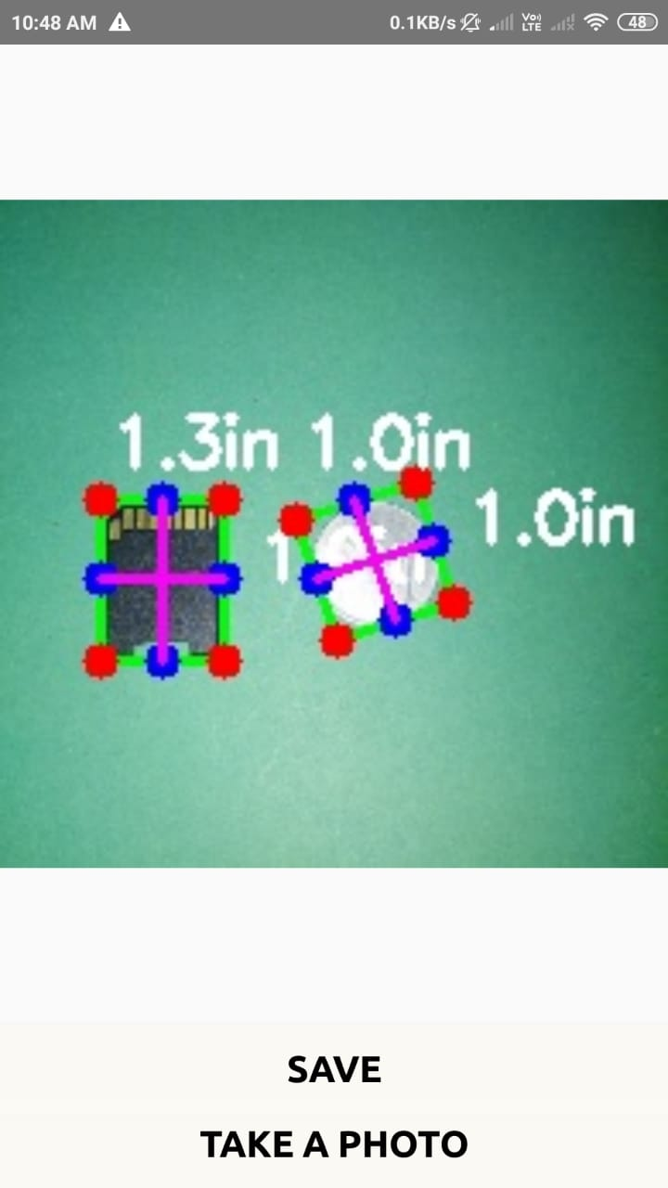

Fig 8.OUTPUT

**CONCLUSION**

The “INSTANT MEASURE” is successfully designed and developed to fulfilling the necessary requirements, as identified in the requirements analysis phase, such as the system is very much user friendly, form level validation and field level validation are performing very efficiently.

The new computerized system was found to be much faster and reliable and user friendly then the existing system, the system has been designed and developed step by step and tested successfully. It eliminates the human error that is likely to be introduced while measuring manually.

The system gives quick results that are very vital for the progress any organization. Cost is minimized in case of employee requirement. Burden of manual work is reduced.

**FUTURE SCOPE**

The software has been developed in such a way that it can accept modifications and further changes. The software is very user friendly and future any changes can be done easily. Software restructuring is carried out. Software restructuring modifies source code in an effort to make it amenable to future changes. In general, restructuring does not modify the overall program architecture. It tends to focus on the design details of individual modules and on local data structure defined within modules. Every system should allow scope for further development or enhancement. The system can be adapted for any further development. The system is so flexible to allow any modification need for the further functioning of programs. Since the objectives may be brought broad in future, the system can be easily modified accordingly, as the system has been modularized. The future expansion can be done in a concise manner in order to improve the efficiently of the system.

|  |
| --- |
| Mr. Aditya Kulkarni |
| Mr. Shubham Mhaske |
| Ms. Manali Munot |
| Ms. Dhruvi Patel |

**DRAFTED BY:-**

|  |
| --- |
|  |