UK GDPR Security Control Assessment
Technical report | Report date 1 September 2026

Meridian Trust Bank plc (MT-ENT-002) - fictional portfolio case study
Portfolio Case Study - fictional/synthetic MTFS content only. Methodology demonstration; not a real client audit, certification audit, legal opinion or regulatory assurance engagement.

Assessment verdict
Needs improvement. Seven of twelve selected control outcomes were Effective and five were Partially Effective. The five partial outcomes are supported by material exceptions and are reported as findings. The assessment does not conclude on legal compliance with the UK GDPR as a whole.
12  Article 32 outcomes | 7  Effective | 5  Partial | 5  Findings
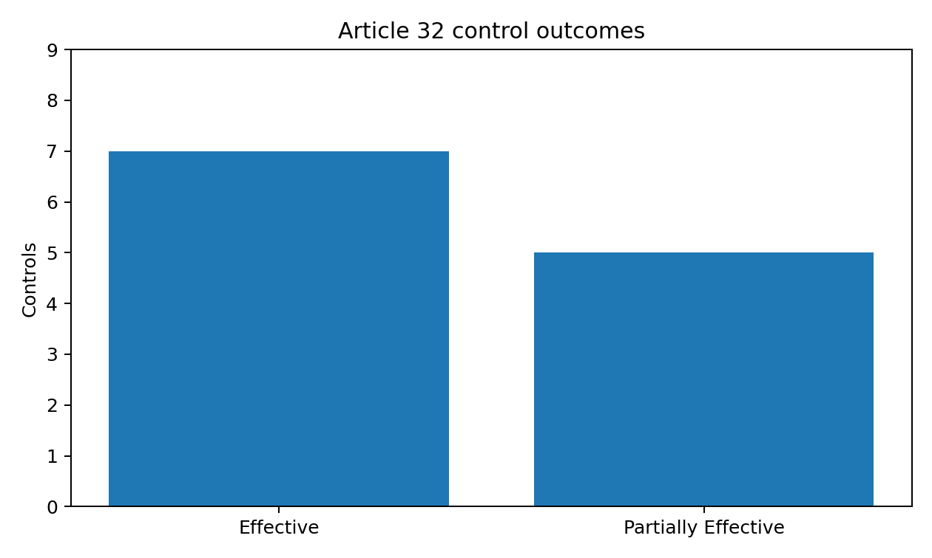

1. Scope, boundary and criteria
Engagement type: security and technical/organisational control assurance supporting UK GDPR compliance. It is not legal advice, an ICO audit, regulatory assurance or certification.
Primary entity: MT-ENT-002 Meridian Trust Bank plc. Assessment period 1 April-31 July 2026; fieldwork 3-21 August 2026.

In-scope assurance areas
- Article 32 risk-appropriate technical/organisational security measures
- ROPA/processing context sufficient to anchor the security assessment
- Article 33-style personal-data breach readiness
- Articles 15/17 rights-process workflow review
- Articles 28/32 processor-security assurance
- Chapter V restricted-transfer spot checks using UK safeguards

Explicit exclusions
Full Article-by-Article legal compliance; lawful basis; privacy notices; PECR; full DPIA legal sufficiency; automated-decision legality; full retention-law analysis; penetration testing; DORA/EEA assessment; financial-audit ITGC or SAP control testing.

Public criteria used
UK GDPR Articles 5(1)(f), 5(2), 15, 17, 28, 32, 33 and Chapter V/Article 46 concepts, interpreted for this portfolio through current ICO guidance and the Data (Use and Access) Act 2025 changes where material.

2. Processing and data context
Article 32 appropriateness depends on risk and processing context. Six selected processing activities anchor the assessment in customer identity, account/transaction, authentication, fraud, privacy-case and workforce-access data.
Processing | Activity | Data subjects | Applications | Processors
GDPR-PA-001 | Current account and savings servicing | Retail and SME customers | MT-APP-011;MT-APP-012;MT-APP-018 | MT-TP-001;MT-TP-010
GDPR-PA-002 | Digital authentication and account access | Customers and workforce administrators | MT-APP-001;MT-APP-012 | MT-TP-001
GDPR-PA-003 | Fraud response and account protection | Customers | MT-APP-018;MT-APP-014 | MT-TP-008;MT-TP-010
GDPR-PA-004 | Customer onboarding and identity verification | Prospective customers | MT-APP-012;MT-APP-018 | MT-TP-010;MT-TP-011
GDPR-PA-005 | Privacy rights and personal-data incident coordination | Customers; employees; requesters | MT-APP-019;MT-APP-018;MT-APP-002 | MT-TP-003;MT-TP-010;MT-TP-001
GDPR-PA-006 | Workforce identity and access administration | Employees and contractors | MT-APP-001;MT-APP-007 | MT-TP-001;MT-TP-003

Key canonical risk linkages
- MT-RSK-001 Identity & Access
- MT-RSK-003 Vulnerability Management
- MT-RSK-004 Security Monitoring & Logging
- MT-RSK-005 Backup & Recovery
- MT-RSK-006 Third-Party ICT
- MT-RSK-007 Data Protection & Confidentiality
- MT-RSK-009 Cyber Incident Response
The ROPA file in this repository is a sample extract used as an assurance input. It is not presented as a legal sufficiency determination under Article 30.

3. Assessment methodology
The methodology preserves the portfolio chain: risk -> control objective -> control -> design effectiveness -> population/sample -> evidence -> exception -> underlying issue -> GDPR finding -> remediation -> future retest.

Design vs operating effectiveness
Design effectiveness considers whether the defined control could meet the intended security outcome. Operating effectiveness considers whether it operated consistently during the period. Inquiry alone was not accepted as sufficient operating-effectiveness evidence where the control should leave a record.

Sampling rationale
Sampling is risk-directed rather than statistical. Full-population testing was used for small/high-impact populations such as 42 privileged identities, 12 critical log sources and 27 Critical/High vulnerabilities. Judgemental samples were used where full-population testing added little assurance: 20 of 99 JML events, 4 of 8 critical backup sets, 3 of 5 material processors, 12 of 74 rights cases and 2 selected restricted-transfer paths.

Evidence sufficiency
Evidence was evaluated for relevance, reliability, completeness, timeliness, integrity and corroboration. Twenty-two synthetic evidence artifacts are logged and hashed with SHA-256. The manifest is generated from the actual files and is validated before release.

Finding rating
Likelihood and impact are each scored 1-5; score is the product. Thresholds: 1-4 Low, 5-9 Moderate, 10-16 High, 17-25 Critical. Planned management action does not change the historical assessment rating.

4. Article 32 control results
Control | Theme | Design | Operating | Sample | Finding
GDPR-CTL-001 | Security governance & risk management | Effective | Effective | 2 of 2 | -
GDPR-CTL-002 | Privileged authentication | Partially Effective | Partially Effective | 42 of 42 | GDPR-FND-001
GDPR-CTL-003 | Joiner/mover/leaver access | Effective | Effective | 20 records (12 leavers, 8 movers) | -
GDPR-CTL-004 | Encryption & key protection | Effective | Effective | 6 of 6 | -
GDPR-CTL-005 | Data loss prevention / exfiltration protection | Effective | Effective | 8 incidents plus all 12 policy-rule configurations | -
GDPR-CTL-006 | Vulnerability management | Effective | Partially Effective | 27 of 27 | GDPR-FND-005
GDPR-CTL-007 | Logging & security monitoring | Effective | Partially Effective | 12 of 12 | GDPR-FND-002
GDPR-CTL-008 | Availability & resilience | Effective | Effective | 4 of 4 | -
GDPR-CTL-009 | Backup restore capability | Effective | Partially Effective | 4 backup sets including core banking, CRM, privacy case management and identity configuration | GDPR-FND-003
GDPR-CTL-010 | Control effectiveness testing | Effective | Effective | 6 of 6 | -
GDPR-CTL-011 | Personal-data breach readiness | Effective | Effective | 1 tabletop + 5 incident records | -
GDPR-CTL-012 | Processor security assurance | Effective | Partially Effective | 3 processors: MT-TP-001, MT-TP-003, MT-TP-010 | GDPR-FND-004

Result interpretation
Seven controls were Effective. Five controls were Partially Effective and produced the five findings below. No selected control was rated wholly Ineffective. This coverage is intentionally deep rather than an exhaustive checklist of every possible technical measure.


5. Detailed findings - identity and monitoring

GDPR-FND-001 - Legacy privileged access path does not consistently enforce MFA (High)
Element | Detail
Underlying issue / risk | MT-IAM-001 | MT-RSK-001;MT-RSK-007
Condition | Three of 42 privileged identities remained able to use a legacy remote-access path without the approved MFA enforcement.
Criteria / expected state | Authentication safeguards for privileged access should be proportionate to the high impact of administrative compromise and consistently applied across access paths.
Cause | Legacy VPN migration created an exception path that was not brought under equivalent conditional-access enforcement; compensating controls were not formally defined for all affected identities.
Risk | Compromise of a privileged credential could enable unauthorised access to systems processing customer personal information, increasing confidentiality, integrity and account-security risk.
Evidence / testing | MT-EV-503;MT-EV-504 | MT-TST-502;MT-WP-502;MT-EXC-501
Recommendation | Retire or isolate the legacy path; enforce phishing-resistant or otherwise risk-appropriate MFA for privileged interactive access; define tightly controlled emergency-account exceptions; and monitor/report any remaining bypasses until closure.
Management action | Agreed. IAM will migrate vendor support to the modern access path and place break-glass accounts under enhanced monitoring with documented activation controls. Owner: Director of IAM; target 2026-10-31.

GDPR-FND-002 - Central monitoring does not cover two critical personal-data systems (High)
Element | Detail
Underlying issue / risk | MT-LOG-001 | MT-RSK-004;MT-RSK-007;MT-RSK-009
Condition | Two of 12 critical sources - Meridian Customer CRM audit logs and Privacy Case Management administrative activity - were retained locally but not centrally ingested or covered by Sentinel alerting.
Criteria / expected state | Security-relevant activity affecting restricted personal information should be available for timely detection, investigation and correlation at a level proportionate to risk.
Cause | SIEM onboarding prioritised core transaction and identity systems; privacy/CRM administrative logs were left in a backlog without risk-based completion dates.
Risk | Misuse or compromise of privileged access in the two systems may be detected late or require fragmented investigation, increasing the chance and duration of unauthorised processing.
Evidence / testing | MT-EV-509;MT-EV-510 | MT-TST-507;MT-WP-507;MT-EXC-502
Recommendation | Risk-rank and onboard both sources to central monitoring, implement priority privileged/admin activity detections, confirm retention and time synchronisation, and add quarterly reconciliation of critical systems to SIEM coverage.
Management action | Agreed. SOC engineering has created onboarding work items for CRM and privacy-case administration logs. Owner: Head of Security Operations; target 2026-11-15.

6. Detailed findings - recovery and processor assurance

GDPR-FND-003 - Critical core-banking restore testing evidence is incomplete (High)
Element | Detail
Underlying issue / risk | MT-RES-001 | MT-RSK-005;MT-RSK-007;MT-RSK-010
Condition | Backups were operating, but one of four sampled critical backup sets - the core-banking platform - had no completed annual restore-test evidence in the prior 12 months.
Criteria / expected state | Recovery capability for critical personal-data processing should be periodically tested so the organisation can demonstrate timely restoration, not only backup-job success.
Cause | The planned restore exercise was rescheduled twice because of release-calendar conflicts; governance did not escalate repeated deferral against the criticality of the service.
Risk | A latent restore defect could remain undetected until a real disruption, extending loss of availability or access to customer information.
Evidence / testing | MT-EV-512;MT-EV-513 | MT-TST-509;MT-WP-509;MT-EXC-503
Recommendation | Complete an end-to-end core-banking restore exercise against approved recovery objectives, record data-integrity validation, and require formal risk acceptance/escalation when critical restore tests are deferred.
Management action | Agreed. Recovery Engineering has reserved a controlled exercise window and will obtain business-owner sign-off on recovered data validation. Owner: Director of Cloud & Infrastructure; target 2026-10-15.

GDPR-FND-004 - Ongoing security assurance for a material CRM processor is overdue (Moderate)
Element | Detail
Underlying issue / risk | MT-TPR-001 | MT-RSK-006;MT-RSK-007
Condition | Northbridge CRM Services Ltd had not received its planned annual security assurance refresh since January 2025, and a penetration-test remediation item in the prior review had no documented closure evidence.
Criteria / expected state | A controller should maintain risk-proportionate assurance that a processor provides sufficient guarantees and continues to operate appropriate security measures, with identified weaknesses tracked to closure.
Cause | Third-party risk scheduling focused on DORA/critical-service providers and did not preserve privacy-processor review cadence for this UK CRM relationship.
Risk | MTFS may lack current assurance over security controls protecting customer information processed by a material supplier, weakening accountability and increasing exposure to undetected supplier control deterioration.
Evidence / testing | MT-EV-517;MT-EV-518 | MT-TST-512;MT-WP-512;MT-EXC-504
Recommendation | Complete a refreshed risk-based security assessment of Northbridge, obtain closure evidence for the prior penetration-test action, record subprocessor/transfer changes, and integrate privacy-processor review dates into the enterprise third-party assurance schedule.
Management action | Agreed. Supplier Risk and Privacy will run a joint assurance refresh and move the relationship to a single risk-based review calendar. Owner: Head of Third-Party Risk; target 2026-12-15.

7. Detailed finding - vulnerability ageing
Element | Detail
Finding | GDPR-FND-005 - Critical and high vulnerabilities exceed approved remediation windows (High, score 12)
Underlying issue / risk | MT-VUL-001 | MT-RSK-003;MT-RSK-007
Condition | Ten of 27 Critical/High vulnerabilities on selected personal-data systems exceeded approved remediation windows at 31 July 2026, including four Critical items.
Criteria / expected state | Known vulnerabilities affecting personal-data processing should be assessed and remediated within risk-based timelines, with time-bound exceptions where treatment is delayed.
Cause | Application release dependencies and incomplete ownership escalation allowed vulnerability tickets to age beyond SLA without consistent compensating-control or exception records.
Risk | Known exploitable weaknesses may remain available to attackers for longer than risk appetite, increasing the probability of compromise, data exposure or service disruption.
Evidence / testing | MT-EV-508 | MT-TST-506;MT-WP-506;MT-EXC-505
Recommendation | Prioritise the four Critical items, enforce owner escalation before SLA breach, require documented time-bound exceptions with compensating controls, and introduce weekly aged-vulnerability reporting for restricted-data assets.
Management action | Agreed. Vulnerability Management will establish an executive escalation queue for Critical items and require formal exceptions for overdue High items. Owner: Head of Vulnerability Management; target 2026-10-31.

Remediation status
Action | Finding | Status | Owner | Target
MT-REM-501 | GDPR-FND-001 | In Remediation | Director of IAM | 2026-10-31
MT-REM-502 | GDPR-FND-002 | In Remediation | Head of Security Operations | 2026-11-15
MT-REM-503 | GDPR-FND-003 | In Remediation | Director of Cloud & Infrastructure | 2026-10-15
MT-REM-504 | GDPR-FND-004 | Open | Head of Third-Party Risk | 2026-12-15
MT-REM-505 | GDPR-FND-005 | Open | Head of Vulnerability Management | 2026-10-31
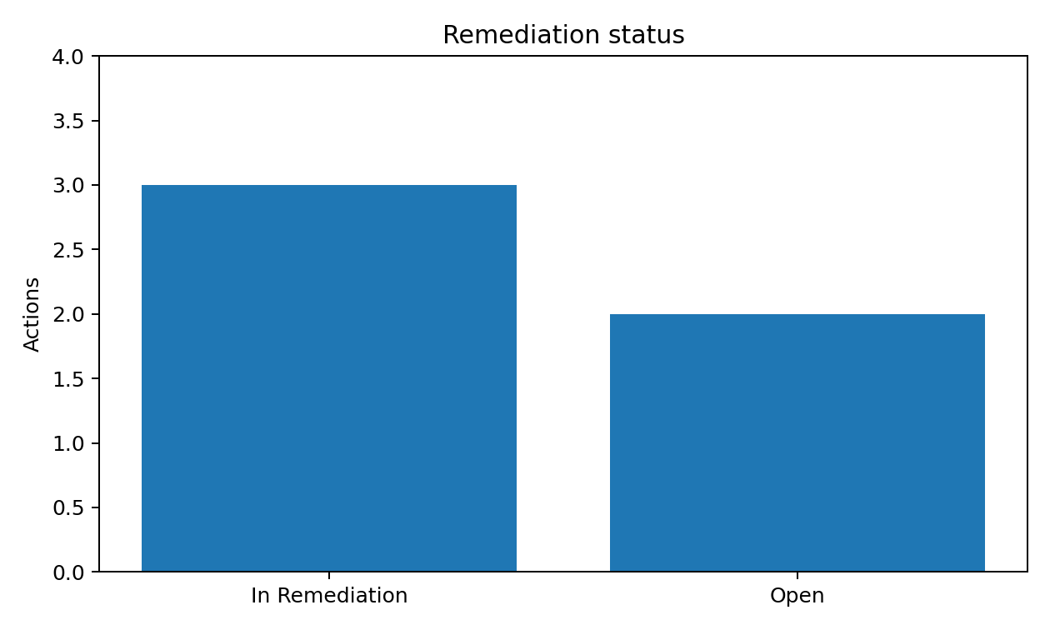

8. Supporting governance exercises

Breach readiness - Article 33-style tabletop
Synthetic scenario: unauthorised access to 860 customer accounts with contact-data exfiltration for 143. The DPO was engaged 37 minutes after awareness; a notification decision was made the same day; the hypothetical submission package was ready after 26 hours 30 minutes. No real ICO notification occurred.

Data subject rights - Articles 15 and 17 process review
Population 74 Q2 cases; 12 sampled. All were timely under the documented workflow. The review explicitly considered DUAA 2025 clarification timing and the requirement to make reasonable and proportionate searches. Two terse search-rationale records were treated as an advisory documentation observation, not a material finding.

Processor security - Articles 28 and 32
Three of five material processors were sampled. Contractual design was adequate in all three. Northbridge operating assurance was stale, producing GDPR-FND-004.

Restricted transfers - Chapter V
Two US support paths were spot-checked. One used the UK Addendum and one used the UK IDTA. Both had a documented TRA/data protection test and additional security measures. The assessment does not treat EU SCCs alone as the UK transfer mechanism.

9. Evidence lineage and cross-framework traceability

Evidence lineage
The evidence log contains 22 synthetic artifacts. Each record includes an MT-EV ID, exact relative path, SHA-256 hash, source owner/system, collection timestamp, period, canonical asset/application/service linkage and control/test references. Evidence files are immutable after logging; changed evidence receives a new ID.

Canonical issue reuse
GDPR finding | Underlying issue | Condition theme
GDPR-FND-001 | MT-IAM-001 | Legacy privileged access path does not consistently enforce MFA
GDPR-FND-002 | MT-LOG-001 | Central monitoring does not cover two critical personal-data systems
GDPR-FND-003 | MT-RES-001 | Critical core-banking restore testing evidence is incomplete
GDPR-FND-004 | MT-TPR-001 | Ongoing security assurance for a material CRM processor is overdue
GDPR-FND-005 | MT-VUL-001 | Critical and high vulnerabilities exceed approved remediation windows
This reuse is deliberate: the same underlying condition is not assigned a new technical issue solely because UK GDPR provides a different assurance lens. Framework-specific criteria and findings remain separate.

Open finding closure rule
All five findings remain Open or In Remediation. No closure or retest has been fabricated. Closure requires new evidence and a targeted retest linked to the original exception and remediation action.

10. Conclusion and source register

Conclusion
The selected control environment provides meaningful protection for personal information but requires remediation in five areas before stronger assurance is warranted. The highest priorities are privileged-access MFA consistency, vulnerability ageing, central monitoring coverage and evidenced core-banking recovery. Processor assurance should be refreshed on a risk-based schedule. Supporting breach, rights and transfer exercises were satisfactory within their stated scope.

Authoritative public sources checked 1 September 2026
- ICO - Security outcomes (UK GDPR security guidance).
- ICO - Personal data breach reporting processes / 72-hour readiness.
- ICO - A guide to subject access, updated 16 July 2026.
- ICO - Right to erasure.
- ICO - Records of processing and lawful basis audit framework.
- ICO - Controller/processor responsibilities and Article 28 contract guidance.
- ICO - International transfers, appropriate safeguards and transfer risk assessment guidance updated in 2026.
- ICO - Data (Use and Access) Act 2025 implications for organisations, updated 19 June 2026.
- GOV.UK - Data (Use and Access) Act 2025 data-protection/privacy changes.
Full URLs are maintained in references/framework-sources.md and the assessment workbook. The portfolio uses public UK GDPR Article identifiers and original assessment wording; it does not reproduce proprietary standards.

Final boundary statement
This report demonstrates GRC/cyber-assurance methodology using fictional/synthetic information. It does not represent professional client work and does not provide a legal opinion or regulatory assurance conclusion.

