CHAPTER 1
  - INTRODUCTION
The most common public-key algorithm is the RSA Cryptosystem,named for its invention (Rivest ,Shamir and adleman). In Public-key cryptosystem, asymmetric algorithm rely on one key for encryption and a different key for decryption, one algorithm is used for encryption and a related algorithm for decryption. In these cryptosystem both the sender and receiver must each have one of the matched pair of keys(not the same one) and one of the two keys must be kept secret.

RSA uses two exponents, e and d, where e is public and d is private. Suppose P is the plain text and C is the cipher text. Alice uses C=P^e modn to create cipher text from plain text P, Bob uses P=C^dmodn to retrieve the plain text sent by the alice. The modulus n, a very large number is created during the key generation process.
RSA is one of the first practical public-key cryptosystems and is widely used for secure data transmission. In such a cryptosystem, the encryption key is public and differs from the decryption key which is kept secret. In RSA, this asymmetry is based on the practical difficulty of factoring the product of two large prime numbers, the factoring problem.

Encryption and Decryption use modular exponentiation, modulae exponentiation is feasible in polynomial time using the fast exponentiation algorithm. However modular logarthim is as hard as factoring the modulus , for which there is no polynomial algorithm yet. This means that alice can encrypt in polynomial time(e is public),bob also can decrypt in polynomial time(because he knows d), but Eve cannot decrypt because she would have to calculate the eth root of C using modular arithmetic.

In other words, alice uses one way function(modular exponentiation) with a trapdoor known only to Bob. Eve, who does not know the trapdoor, cannot decrypt the message. If some day, a polynomial algorithm for eth root modulo n calculation is found, modular exponentiation is not a one way function anymore.
1.2 HISTORY OF RSA ALGORITHM :
Rivest is a computer scientist with an exemplary ability to apply new ideas in new places. He also kept up with the latest scientific papers, so he always had these zany new ideas for the one way function. Shamir, also a computer scientist, has a lightning intellect, and an ability to cast aside the technicalities and focus on the core of a problem. He as well as Rivest generated ideas for the one-way function. Adleman is a mathematician with extraordinary stamina, rigor and patience. He was largely responsible for spotting the flaws within the ideas of Rivest and Shamir, and he ensured that they did not follow false leads. Rivest and Shamir spent a year coming up with ideas, and Adleman spent a year shooting them down. It was very discouraging, but they knew that each failure steered them away from sterile math into more fertile mathematical ground.
In April 1977, Rivest, Shamir, and Adleman spent Passover at the house of a student and consumed liberal quantities of Manischewitz wine before returning to their respective homes sometime around midnight. Rivest was unable to sleep, so he lay on his couch with a math textbook. He began to mull over the question that had been nagging him all year: Is it possible to find a one-way function that can be reversed only if the receiver has some special information? Suddenly, the mists began to clear and he had a revelation. He spent the rest of the night formalizing his idea, and by daybreak he had effectively written a complete mathematical paper. Rivest had a breakthrough, but it could not have come without the help of Shamir and Adleman. The system was later dubbed RSA, for Rivest, Shamir, and Adleman
The RSA algorithm, introduced in 1977 by Rivest, Shamir, and Adlemen, is an algorithm for public-key cryptography. RSA was the first and is still the most widely-used algorithm for public key cryptography and it is used for thousands of applications from e-mail encryption to secure online purchasing. It was the first cryptosystem to enable senders to “sign” each message they send so that the recipient has proof of who sent the message.
RSA is named according to its inventors Ron Rivest, Adi Shamir and Adleman Leonard. RSA supports encryption and digital signature. The keys must be made in such a way that the decryption key may not be easilydeduced from the public encryption key.

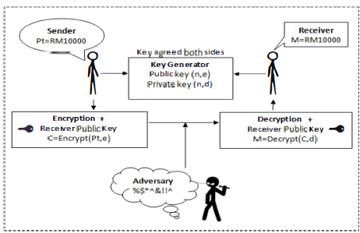
Fig.1.1. RSA encryption algorithm
Figure 1.1 shows the encryption algorithm that is RSA encryption keys are public, while the decryption keys are not, so only the person with the correct decryption key can decipher an encrypted message. In RSA sender can encrypt in polynomial time, similarly receiver can also decypt in polynomial times with a polynomial time complexity.

1.3 LITERATURE SURVEY
Digital signature has been providing security services to secure electronic transaction over internet. Rivest, Shamir and Adlemen (RSA) algorithm was most widely used to provide security technique. Here we have modified the RSA algorithm to enhance its level of security. This paper presents a fair comparison between RSA and Modified RSA algorithm along with time and security by running several encryption and decryption setting to process data of different sizes. The efficiency of these algorithms was considered based on key generation speed and security level. The texts of different sizes were encrypted and decrypted using RSA and modified RSA algorithms. The simulation result proves that in Modified RSA algorithm key generation is faster and it enhances security by two levels. RSA algorithm is faster than Modified RSA in terms of encryption and decryption speed.

Cryptography is study of converting original message called plaintext to coded message called cipher text using the process of encryption and decryption. Many schemes used for this encryption and decryption constitute cryptographic system. This system is characterized with three independent dimensions as type of operation used for converting plaintext to cipher text, number of key used and the way in which the plain text is processed.
Symmetric key cryptography: It is based on substitution and permutation tools. Same key is used for encryption and decryption. Sender and receiver must share the algorithm and key. It is necessary to kept key secret and trust on communication channel.
Asymmetric key cryptography: It is based on mathematical function. It uses two separate keys one for encryption and one for decryption. Security of any encryption is depend on length of the key and computational work. Each sender and receiver must have one of the matched pair of the keys. One of the key must kept secret[1].

The weaknesses of RSA algorithm when we use two prime’s number are the following points which are used to break the algorithm in most cases.

The weaknesses of RSA algorithm are:
(a) Small encryption exponent, if you use a small exponent like e=3 and send the same message to different recipients.
(b) Using the same key for encryption and signing.
(c) Acting as an oracle: there are techniques to recover the plaintext if a user just blindly returns the RSA transformation of the input. So don't do that.

The New Approach RSA cryptosystem ,the idea of the new approach is, instead of using two primes numbers to generate a public key and private key, we use three primes numbers with reduced size, generates the variable N Large and the process of analysis of the factors is more difficult than the original algorithm, as well as, increases the ease of generating Public key and private key. The key strength of the RSA depends on the two prime numbers p and q.
The process of factorizing of n will lead to gain the values of p and q. It is much easier to find two numbers from factoring n than finding the value of three numbers from n. In this case it is very difficult for the intruder to find the three values from factoring n.

KEY GENERATION
(a) Choose three distinct prime numbers p, q and s.
(b) Find n such that n = p*q*s. n will be used as the modulus for both the public and private keys.
(c) Find the Phi of n, (n) = (p-1)(q-1)(s-1).
(d) Choose an e such that 1 < e < (n), and such that e and (n) share no Divisors other than 1 (e and (n) are relatively prime). e is kept as the public key exponent. (e) Determine d (using modular arithmetic) which satisfies the congruence relation .d.
In other words, pick d such that de - 1 can be evenly divided by (p- 1)(q-1)(s-1), the Phi, or (n).This is often computed using the Extended Euclidean Algorithm, since e and (n) are relatively prime and d is to be the modular multiplicative inverse of e*d is kept as the private key exponent. The public key has modulus n and the public (or encryption) exponent e. The private key has modulus n and the private (or decryption) exponent d, which is kept secret . The encryption equation is c me (mod n) and the decryption one is m cd (mod n)[3].

Analysis of the New Approach RSA Cryptosystem

The new approach RSA Cryptosystem requires the use of a public key and a private key. Both these keys must fulfill certain conditions to ensure the integrity of the system. The following steps illustrate the key generation algorithm for the proposed RSA :
a. Choose three large prime numbers of approximately same size, namely p, q and s.
b. Compute the product of these three primes, n = pqs.
c. Also, compute the value of (n) = (p-1)(q-1)(s-1).
d. Choose an integer e between 1 and (n) such that gcd(e ,(n)) = 1.
e. Finally, compute d whereby d = e-1 mod((n)).The public key is (n , e) whereas the private key is (n , d).
The security is increased by two levels, one as finding number of factors of n are three (3) instead of two (2), which is quite difficult for intruder. Second modulus x is passed instead of modulus n, from that finding public key and private key is quite difficult because only from these keys it is possible to encrypt or decrypt to maintain confidentiality of message. No doubt time complexity is increased, but it is negligible in compare to security level which is more important in information transformations[1].

Hybrid(RSA & AES) encryption algorithm to safeguard data security in Cloud. Security being the most important factor in cloud computing has to be dealt with great precautions. Following are the key tasks:

- Secure Upload of data on cloud such that even the administrator is unaware of the contents.
- Secure Download of data in such a way that the integrity of data is maintained.
- Proper usage and sharing of the public, private and secret keys involved for encryption and decryption.

The use of a single key for both encryption and decryption is very prone to malicious attacks. But in hybrid algorithm, this problem is solved by the use of three separate keys each for encryption as well as decryption. Out of the three keys one is the public key, which is made available to all, the second one is the private key which lies only with the user. In this way, both the secure upload as well as secure download of the data is facilitated using the two respective keys. Also, the key generation technique used in this paper is unique in its own way. This has helped in avoiding any chances of repeated or redundant key.

The proposed system is implemented in Eye os that is one of the cloud providers. In order to apply security features, a hybrid encryption technique using the AES and RSA algorithms is used where 128 bit secret key for AES and 1024 bit key for RSA is used.
Upload option leads to a generation of RSA public key-n, RSA public key-e, .RSA private key-d and AES secret key, user will require to save the RSA private key and AES secret key, As soon as user tries to upload the data on cloud, the data is first stored in a temporary directory and after calling AES and RSA algorithm, requiring the user to enter the AES secret key the file will get stored into the data base permanently corresponding to the user account and the temporary file get deleted.

A hybrid encryption algorithm using RSA and AES algorithms for providing data security to the user in the Cloud. The biggest advantage it provides us is that the keys are generated on the basis of system time and so no intruder can even guess them there by giving us increased security along with convenience. Private Key and Secret key is only known to the user and therefore user’s private data is not accessible to anyone not even the Cloud’s Administrator. The main purpose behind using RSA and AES encryption algorithm is that it provides three keys i.e. public key for encryption, and private key and secret key for decryption. The data after uploading is stored in an encrypted form and can be only decrypted by the private key and the secret key of the user. The main advantage of this is that data is very secure on the cloud[2].

Several techniques have been proposes to enhance RSA algorithm. Hence, the present paper proposes i-RSA algorithm to generate the cryptographic keys required by participants to secure communication using their identities, which is similar to identity based encryption scheme (tBE). In 1984, Shamir[4] proposed public key encryption scheme in which the public key can be an arbitrary string. The basic idea IBE was to use trusted third party called Certificate Authority (CA) to provide trusted public key to the various participants on demand[4].

The asymmetric key cryptosystem involves the use of two distinct but related keys namely, the public key and the private key. Plaintext is converted to cipher text using the public key. This process is known as encryption which is performed by the sender. On the other hand, deciphering of the cipher text is performed by making use of the private key. This process is known as decryption and is performed by the receiver. Only the receiver possesses the knowledge of the private key.
In order to maintain the confidentiality of the private key, the public key is disclosed to the public. The public key is used for authentication to ensure that the message is coming from the intended sender. Public key cryptosystem also ensures confidentiality. Only the receiver’s private key can decipher the cipher text originating from the sender.

Communication of messages can be done in a secure manner since knowledge of the public key is not sufficient to decrypt the cipher text. Due to the above advantages, in our proposed algorithm we follow the asymmetric key cryptography technique. In this scheme, there is a mathematical relation between the two keys. Owing to this fact, it is likely that the system may be compromised if someone discovers the relation between the keys and successfully derives the private key.

Applications of RSA algorithm:
- It can be used to encrypt message without the need to exchange a secret key separately.
- It can be used for both public key encryption and digital signatures.
- It can be widely used for secure data transmission and factoring large numbers.
- RSA is also used for authentication.

1.4. OBJECTIVES
- Provide a secure data transmission particularly when being sent over an insecure network such as the Internet.
- RSA is used in digital signatures and other cryptosysytems that often need to encrypt a small message without having access to a symmetric key.
- RSA is also used for authentication.

CHAPTER 2
ALGEBRAIC STRUCTURES
2.1 Encryption/Decryption ring:
Encryption and decryption are done using the commutative ring R=<Zn,+,*> with two arithmetic operations: addition and multiplication. In RSA, this ring is public because modulus n is public. Anyone can send a message to bob using this ring to do encryption.

2.2. Key Generation Group:
RSA uses a multiplicative group G=<Z,*> for key generation. This group supports only multiplication and division (using multiplicative inverses), which are needed for generating public and private keys. This group is hidden form the public because its modulus is hidden from the public, if eve (intercepter) can find this modulus, she can easily attack the cryptosystem.
The RSA scheme is a cipher in which the plaintext and cipher text are integers between 0 and n-1 foe some n. A typical size for n is 1024 bits, or 309 decimal digits . that is n is less than 2^1024 bits. RSA makes use of an expression with exponentials. Plain text is encrypted in blocks with block having a binary value less than some number n. That is, the block size must be less than or equal to logn+1, in practice the block size is i bits, where 2^i<n<2^i+1.

CHAPTER 3
OPERATIONS IN RSA (DESIGN)

3.1. KEY GENERATION:

Receiver of the cryptosystem used this to create public and private key. After key generation , receiver announces the tuple (e,n) as public key, receiver of the cryptosystem keep the integer d as his private key, receiver can discard p, q and z, they will not be needed unless receiver needs to change his private key without changing the modulus. To be secure , the recommended size for each prime, p or q is 512 bits(almost 154 decimal digits).this makes the size of n,the modulus 1024bits(309 digits)
In summary , the procedure for picking a prime number is as follows.

- Pick an odd integer n at random (e.g using a pseudorandom number generator)
- Pick an integer a<n at random.
- Perform the probabilistic primary test with a as parameter. If n fails the test, reject the value of n and go to step1.
- If n has passed a sufficient number of tests, accept n, otherwise go to step2

RSA_KEY-GENERATION
{
Select two large prime numbers p and q such that p is not equal to q.
N= p*q;
Z= (p-1) (q-1);
Select e such that 1<e<z and e is coprime to z;
d*e modz=1
public key(e,n);
private key(d,n)
return public_key and private_key }
3.2. ENCRYPTION:
Anyone can send message to receiver of the public key cryptosystem using receiver public key. Encryption in RSA can be done using an algorithm with polynomial time complexity. The size of the plain text must be less than n, which means that if the size of the plaintext is larger than n it should be divided into blocks.

RSA_ENCRYPTION(P,e,n)
{
C <- fast exponentiation (p,e,n) //calculation of (P^emodn)//
Return c
}

3.3. DECRYPTION:
Receiver can use the algorithm to decrypt the cipher text message that is received. Decryption in RSA can be done using an algorithm with polynomial time complexity. The size of the cipher text is less than n.

RSA_DECRYPTION(C,d,n)
{
P <- fast exponentiation (c,d,n) //calculation of (C^dmodn)//
Return p;
}

3.4 KEY DISTRIBUTION:
Key distribution which enables the sender to encrypt the plain text using the receiver Public key, which is distributed in reliable way not in secured manner. Public key is kept in registry or file which can be publically available and adversary key is kept to be secret called Private key.

CHAPTER 4
IMPLEMENTATION

Since cost and security are two important factors for feasible solution to any problem in digital media. To reduce cost of encryption and decryption by increasing speed of conversion and at the same time increasing level of security is challenging work. Many researchers accept this challenge and tried to solve problem by modifying various parameters of the algorithm.

In our new proposed algorithm we use three prime random number instead of two prime random number for calculating ‘n’, and passing value of ‘x’ instead of ‘n’ in public key and private key. This approach is more secure than RSA algorithm as the public key and private key exponent can be found only by knowing the three prime numbers p, q, and r and which can be known only through ‘n’, but ‘n’ is not transmitted in any key and thus it is very difficult to know e and d hence encrypted message cannot read easily. Again it is quite difficult to find three factors of ‘n’ by factorizing method. So security maintains.

The security is increased by two levels, one as finding number of factors of n are three (3) instead of two (2), which is quite difficult for intruder. Second modulus x is passed instead of modulus n, from that finding public key and private key is quite difficult because only from these keys it is possible to encrypt or decrypt to maintain confidentiality of message. No doubt time complexity is increased, but it is negligible in compare to security level which is more important in information transformation.

CHAPTER 5
RESULTS AND ANALYSIS
Digital signature has been providing security services to secure electronic transactions over an internet. RSA algorithm was most widely used to provide security technique. The efficiency of this algorithm is considered based on key generation speed and security level. The texts of different sizes were encrypted and decrypted using RSA algorithm. RSA is used in digital signatures and other cryptosysytems that often need to encrypt a small message without having access to a symmetric key. RSA is also used for authentication.

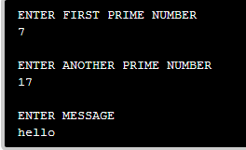
Fig 5.1 RSA Algorithm Execution

Figure 5.1 shows the execution of RSA algorithm, after the execution of c code of RSA algorithm, it need to enter the first prime number, second prime number and message.

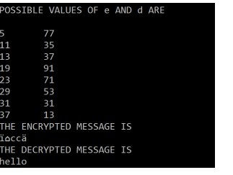
Fig.5.2 Output of RSA algorithm
Figure 5.2 shows the output of RSA algorithm, after entering the two primes numbers and message, operations of RSA is performed to obtain plain text, cipher text and public-private pair of keys.

CHAPTER 6
CONCLUSION AND FUTURE DIRECTIONS
RSA algorithm provides a secure data transmission particularly when being sent over an insecure network such as the Internet. Time complexity is increased, but it is negligible in compare to security level which is more important in information transformations. RSA is used in digital signatures and other cryptosystems that often need to encrypt a small message without having access to a symmetric key. For those interested in extremely high security, RSA algorithm should also provide extremely high speed of operations.
The future step of our work is modified the RSA algorithm in such a way that security is increased by two levels, one as finding numbers of factors of n are three(3) instead of two(2),which is quite difficult for intruder. Second modulus x is passed instead of modulus n , from that finding a public key and private key is quite difficult because only from these keys it is possible to encrypt or decrypt to maintain confidentiality of message. No doubt time complexity is increased , but it is negligible in compare to security level which is more important in information transformations.

REFERENCES
- A Modified RSA Algorithm to Enhance Security for Digital Signature, IEEE
- Enhancing the Data Security in Cloud by Implementing Hybrid (RSA & AES) Encryption Algorithm, 2015 Fifth International Conference on Communication Systems and Network TechnologY.
- An algorithm to enhance security in RSA, Rohit Minni, kaushal sultania ,Surabh mishra VTU university
- Loop based RSA key generation algorithm using string identity, International conference on control ,automations and systems-2013 .
- Enhanced method for RSA cryptosystem algorithm, 2012 International conference on Advanced computer science applications and technologies.
- Rivest, Shamir adleman 1978. A method for obtaining digital signatures and public key cryptosystem.

ASP.NET is supported on Windows 2000 (Professional, Server, and Advanced Server), Windows XP Professional, and the Windows Server 2003 family for both
In addition, to develop ASP.NET server applications, the following software is also required:
- Windows 2000 Server or Advanced Server with Service Pack 2, Windows XP Professional or 64-Bit Edition, or one of the Windows Server 2003 family products.
- MDAC 2.7 for Data.
- Internet Information Services.
    - Introduction to C#:
C# (pronounced as ‘C Sharp’) is a new computer-programming language developed by Microsoft Corporation, USA. C# is a fully object-oriented language like Java and is the first Component-oriented language. It has been designed to support the key features of .NET Framework, the new development platform of Microsoft for building component-based software solutions. It is a simple, efficient, productive and type-safe language derived from the popular C and C++ languages.
C# is designed for building robust, reliable and durable components to handle real-world applications. Major highlights of C# are:
- It is a brand new language derived from the C/C++ family.
- It simplifies and modernizes C++.
- It is the only component-oriented language available today.
- It is the only language designed for the .NET Framework.
- It is a concise, lean and modern language.
- It combines the best features of many commonly used languages: the productivity of Visual Basic, the power of C++ and the elegance of Java.
- It is intrinsically object-oriented and web-enabled.
- It has a lean and consistent syntax.
- It embodies today’s concern for simplicity, productivity and robustness.
- It will become the language of choice for .NET programming.
- Major parts of .NET Framework are actually coded in C#.
    - Ado.Net - Database Connectivity:
Most applications need data access at one point of time making it a crucial component when working with applications. Data access is making the application interact with a database, where all the data is stored. Different applications have different requirements for database access. ASP.NET uses ADO .NET (Active X Data Object) as its data access and manipulation protocol which also enables us to work with data on the Internet.
ADO.NET Data Architecture
Data Access in ADO.NET relies on two components: Data Set and Data Provider.
1.Data Set
The dataset is a disconnected, in-memory representation of data. It can be considered as a local copy of the relevant portions of the database. The Data Set is persisted in memory and the data in it can be manipulated and updated independent of the database. When the use of this Data Set is finished, changes can be made back to the central database for updating. The data in Data Set can be loaded from any valid data source like Microsoft SQL server database, an Oracle database or from a Microsoft Access database.
2.Data Provider
The Data Provider is responsible for providing and maintaining the connection to the database. A Data Provider is a set of related components that work together to provide data in an efficient and performance driven manner. The .NET Framework currently comes with two Data Providers: the SQL Data Provider which is designed only to work with Microsoft's SQL Server 7.0 or later and the OleDb Data Provider which allows us to connect to other types of databases like Access and Oracle. Each Data Provider consists of the following component classes:
The Connection object which provides a connection to the database. The Command object which is used to execute a command. The Data Reader object which provides a forward-only, read only, connected record set. The Data Adapter object which populates a disconnected Data Set with data and performs update.
  - Introduction to SQL Server 2005:
Microsoft SQL Server is a full-featured relational database management system (RDBMS) that offers a variety of administrative tools to ease the burdens of database development, maintenance and administration. In this article, we'll cover six of the more frequently used tools: Enterprise Manager, Query Analyzer, SQL Profiler, Service Manager, Data Transformation Services and Books Online.
Enterprise Manager is the main administrative console for SQL Server installations. It provides you with a graphical "birds-eye" view of all of the SQL Server installations on your network. You can perform high-level administrative functions that affect one or more servers, schedule common maintenance tasks or create and modify the structure of individual databases.
Query Analyzer offers a quick and dirty method for performing queries against any of your SQL Server databases. It's a great way to quickly pull information out of a database in response to a user request, test queries before implementing them in other applications, create/modify stored procedures and execute administrative tasks.
SQL Profiler provides a window into the inner workings of your database. You can monitor many different event types and observe database performance in real time. SQL Profiler allows you to capture and replay system "traces" that log various activities. It's a great tool for optimizing databases with performance issues or troubleshooting particular problems.
Service Manager is used to control the MSSQLServer (the main SQL Server process), MSDTC (Microsoft Distributed Transaction Coordinator) and SQLServerAgent processes. An icon for this service normally resides in the system tray of machines running SQL Server. You can use Service Manager to start, stop or pause any one of these services.
Data Transformation Services (DTS) provide an extremely flexible method for importing and exporting data between a Microsoft SQL Server installation and a large variety of other formats. The most commonly used DTS application is the "Import and Export Data" wizard found in the SQL Server program group.
  - Internet Information Server [IIS]:
IIS server includes a broad range of administrative features for managing web sites and the web server. With programmatic features like ASP, ASP.NET, you can create and deploy scalable, flexible web applications.
Features of IIS:
Support of Internet standards:
The features include HTTP support and standard internet services such as:
- World Wide Web (WWW): It supports HTTP allowing users to publish content to the internet. Files can be placed in folders in our websites so the users can view with a web browser. We can install business applications and publish in HTML.
- File Transfer Protocol: It is a industry standard protocol used for transferring files between computers on a TCP/IP network. FTP enables to use one computer to host multiple domain names.
- Simple Mail Transfer Protocol (SMTP): It is a standards-based, secure and scalable email server. It supports a distributed email server using SMTP and Post Office Protocol (POP3).

Following work has been reviewed with respect to summarization task.
A summarization approach using simplified Lesk algorithm was used in [2]. After weighting, the sentences are arranged in descending order and summarization is performed by taking percentage of summarization as input. Result is measured in terms of precision, recall, f-measure. This algorithm is simple and each sentence is considered separately for evaluation hence useful in summarization of user posts. Extractive text summarization based on sentence scoring techniques is done. A keyword based summarization approach is proposed.
Following work has been reviewed with respect to Association task.
A text analyzer that uses rule reduction technique to derive the structure of input text was developed. A new method to find out association rules from medical transcripts using NLP tools, Apriori and FP-growth algorithms is used. Hybrid model of lexicon based and rule based techniques was used on unstructured and informal medical text.
A medical ontology that provides an interface for navigating through discussions using MeSH was proposed. JesminNahar et al applied association rule mining on UCIDataset of heart disease. After getting rules they analyzed rules in association with gender and significant risk factors. They used apriori, predictive apriori and tertiusalgorithms for rule generation. Their research shows that how computational intelligence can be used to identify important factors responsible for disease.

CHAPTER 3
SYSTEM ANALYSIS
  - PROCESS MODEL SELECTION AND JUSTIFICATION
According to Software Engineering the approach adopted to develop this project is the Iterative waterfall Model. The iterative waterfall Model [Figure 3.1] is a systematic approach that begins at the feasibility study phase and progress through analysis, design, coding, testing, integration and maintenance. Feedback paths are there in each phase to its preceding phase as show in the fig to allow the correction of the errors committed during a phase that are detected in later phase.
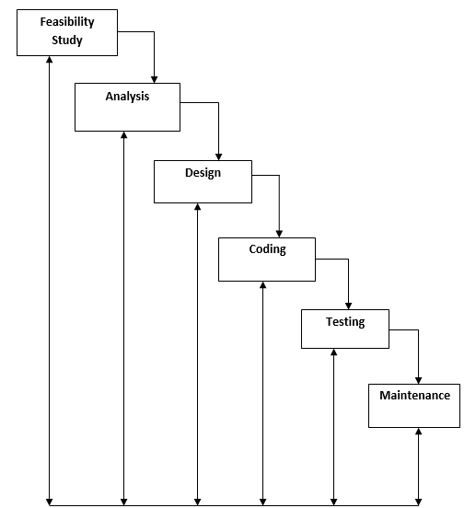
Figure 3.1: Waterfall model
Feasibility study:
The main aim of this phase is to determine whether it would be financially and technically feasible to develop the product. The feasibility study activity involves the analysis of the problem and collection of all the relevant information relating to the product such as different data items which would be input to the system, processing required to be carried out on these data, the output data required to be produced by the system, as well as constraints on the behavior of the system.
Requirement Analysis and Specification:
The main aim of this phase is to understand the exact requirements of the customer and to document them properly.
Design:
The goal of design phase is to transform the requirements specified in the SRS document into a structure that is suitable for implementation in some programming language. In technical terms, during the design phase the software architecture is derived from SRS document. Two distinctly different design approaches are available: the traditional approach and the object oriented approach. We have adopted traditional design to develop the product.
Coding:
Once design is complete, goal of the coding phase is to translate the design of the system into code in a given programming language. For a given design, the aim in this phase is to implement the design in the best possible manner. We have coded the design using C# language to develop the product.
Testing:
Testing is the major quality control measure employed during software development. Its basic function is to detect errors in the software.
Maintenance:
Maintenance is not a part of software development. It is an extremely important activity in the life of software product. Maintenance involves performing any one or more of the following kinds of activities:
- Correcting errors that were not discovered during the product phase. This is called corrective maintenance.
- Improving the implementation of the system, and enhancing the functionalities of the system according to the customer’s requirements. This is called perfective maintenance.
- Porting the software in a new environment. This is called adaptive maintenance.
CHAPTER 4

SYSTEM REQUIREMENTS

PLATFORM: DOT NET -- VISUAL STUDIO 2008/2010
4.1 Hardware Requirements:
  - Minimum of 2GB RAM
  - Pentium IV or higher
  - Minimum of 40GB HARD DISK
  - Standard PC configuration to carryout challenging computing.
4.2 Software Requirements:
OS : windows 2000/NT/XP/higher
back end : SQLSERVER 2005/2008
designed tool kit : visual studio 2010
front end : ASP.Net 4.0
programming language : C#

CHAPTER 5:
SYSTEM DESIGN
The purpose of the design phase is to plan a solution of the problem specified by the requirements document. This phase is the first step in moving from the problem domain to the solution domain. In other words, starting with what is needed, design takes us toward how to satisfy the needs. The design of a system is perhaps the most critical factor affecting the quality of the software; it has a major impact on the later phases particularly testing and maintenance.
The design activity often results in three separate outputs –
- Architecture design.
- High level design.
- Detailed design.
Architecture Design:
Architecture focuses on looking at a system as a combination of many different components, and how they interact with each other to produce the desired result. The focus is on identifying components or subsystems and how they connect.
High Level Design:
In high level design identifies the modules that should be built for developing the system and the specifications of these modules. At the end of system design all major data structures, file format, output formats, etc., are also fixed. The focus is on identifying the modules. In other words, the attention is on what modules are needed.
Detailed Design:
In the detailed design the internal logic of each of the modules is specified. The focus is on designing the logic for each of the modules. In other words how modules can be implemented in software is the issue.
5.1 Architectural Design:
In this project three tier architecture is used.
As a developer, the .NET framework and Visual Studio present many choices for choosing the right architecture, from placing the data access code directly in the UI through datasets and data source controls, to creating a data access layer that talks to the database, all the way to creating an n-tier architecture approach that consists of multiple layers, and use data-transfer objects to pass data back and forth.
A layer is a reusable portion of code that performs a specific function. In the .NET environment, a layer is usually setup as a project that represents this specific function. This specific layer is in charge of working with other layers to perform some specific goal. In an application where the presentation layer needs to extract information from a backend database, the presentation would utilize a series of layers to retrieve the data, rather than having the database calls embedded directly within itself.
    - Three tier Architecture:
Three tier architecture consists of three layers. They are:
- The Data Layer:
The key component to most applications is the data. The data has to be served to the presentation layer somehow. The data layer is a separate component (often setup as a separate single or group of projects in a .NET solution), whose sole purpose is to serve up the data from the database and return it to the caller. Through this approach, data can be logically reused, meaning that a portion of an application reusing the same query can make a call to one data layer method, instead of embedding the query multiple times.
- Business Layer:
Though a web site could talk to the data access layer directly, it usually goes through another layer called the business layer. The business layer is vital in that it validates the input conditions before calling a method from the data layer. This ensures the data input is correct before proceeding, and can often ensure that the outputs are correct as well. This validation of input is called business rules, meaning the rules that the business layer uses to make “judgments” about the data.
One of the best reasons for reusing logic is that applications that start off small usually grow in functionality. The business layer helps move logic to a central layer for “maximum reusability.”
- Presentation Layer:
The ASP.NET web site or windows forms application (the UI for the project) is called the presentation layer. The presentation layer is the most important layer simply because it’s the one that everyone sees and uses. Even with a well structured business and data layer, if the presentation layer is designed poorly, this gives the users a poor view of the system.
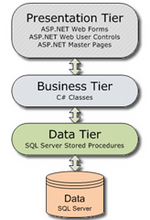
Fig 5.1: Three tier Architecture.
The presentation tier contains the UI elements of the site, and includes all the logic that managers the interaction between the visitor and the client’s business.
The business tier receives requests from the presentation tier and returns a result to the presentation tier depending on the business logic it contains. (C# Classes)
The data tier is responsible for storing the application’s data and sending it to the business tier when requested. (SQL Server Stored Procedures).

  - High level design:
    - Data Flow Diagram:
A data flow diagram (DFD) is a graphical representation of the "flow" of data through an information system. DFDs can also be used for the visualization of data processing (structured design).
On a DFD, data items flow from an external data source or an internal data store to an internal data store or an external data sink, via an internal process. A DFD provides no information about the timing of processes, or about whether processes will operate in sequence or in parallel. It is therefore quite different from a flowchart, which shows the flow of control through an algorithm, allowing a reader to determine what operations will be performed, in what order, and under what circumstances, but not what kinds of data will be input to and output from the system, nor where the data will come from and go to, nor where the data will be stored.
Symbols used in DFD’s:
Processes:
A process transforms data values. The lowest processes are our functions without side effects.
Data Flows:
A data flow connects the output of an object or process to the input of another object or process. It represents the intermediate data values within the computation. It is draws as an arrow between the procedure and the consumer of the data value.
Actors:
An actor is an active object that drives the data flow graph by producing or consuming values. Actors are attached to the inputs and the outputs of a dataflow graph.
Data Store:
A data store is a passive object within a data flow diagram that stores data for later access. Unlike an actor, a data store does not generate any operations on its own but merely responds to requests to store and access data.

FIG 5.1 Shows the DATA STRUCTURE, it consists of the following table, tblkeywords, tdlopinions, tdlLogin. In tblkeywords – keywords is the primarykey, In tblLogin – LoginId is primarykey, In tblOpinions – patientId is primarykey.
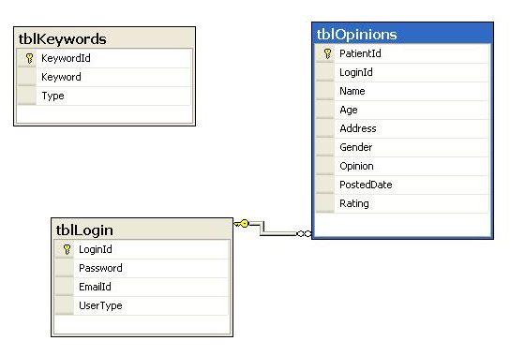
Figure 5.1 : Data structure
Fig 5.2 Shows the DFD (Data flow diagram) of Admin, in which it shows the access of admin in the application , after login into the application admin can perform the below operations.
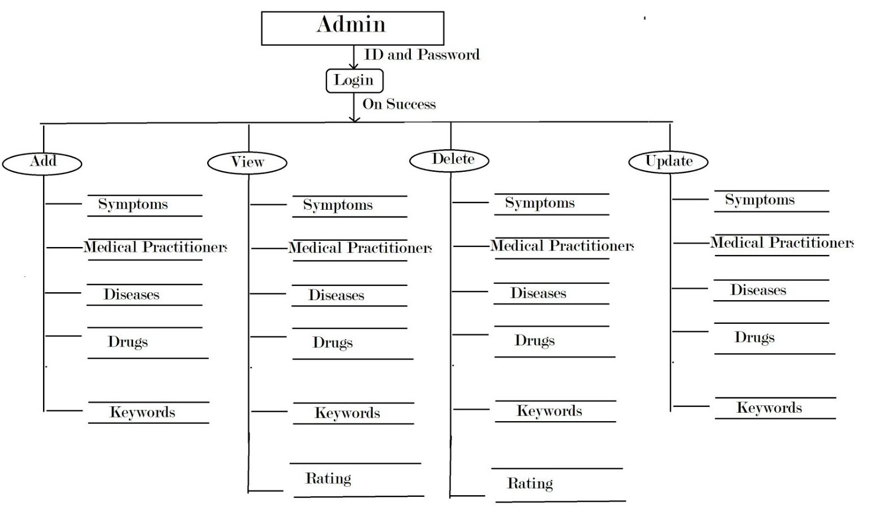
Figure 5.2: Data flow diagram of Admin
FIG-5.3 Shows the DFD (Data flow diagram) of Medical practitioner, First step it consists of login into the application by providing unique ID and Password given by the admin to the medical practitioner and further it shows the fields access by the medical practitioner.
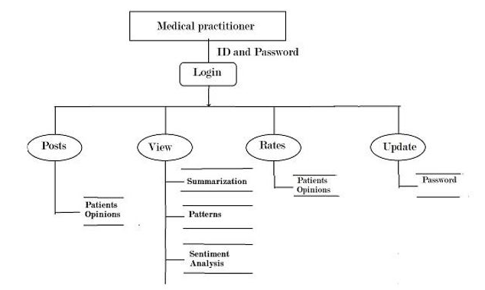
Figure - 5.3: Data flow diagram of Medical practitioner
FIG-5.4 Shows the PROPOSED SYSTEM ARCHITECTURE, it describes the process of Association rule performed to extract the best pattern of symptom-disease-drug.
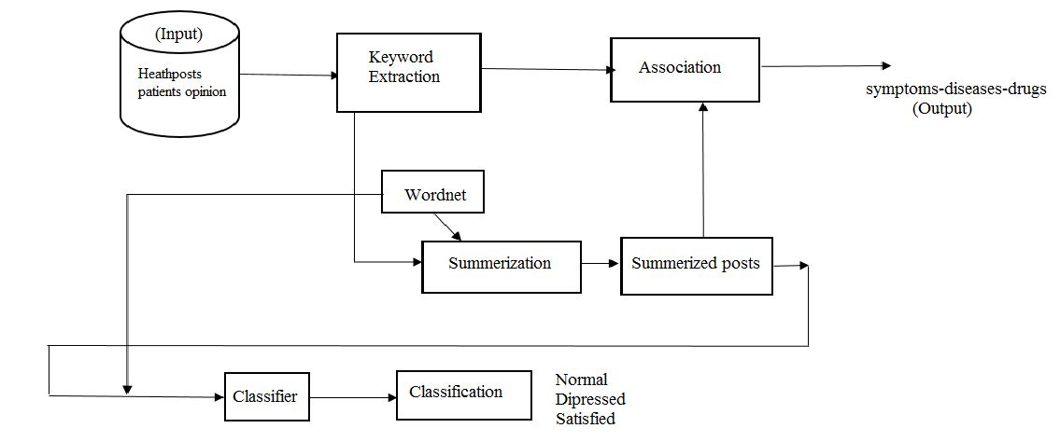
Figure-5.4: Proposed system architecture
Context data flow diagram:
It is common practice to draw a context-level data flow diagram first, which shows the interaction between the system and external agents which act as data sources and data sinks. On the context diagram (also known as the 'Level 0 DFD') the system's interactions with the outside world are modelled purely in terms of data flows across the system boundary. The context diagram shows the entire system as a single process, and gives no clues as to its internal organization.
This context-level DFD is next "exploded", to produce a Level 1 DFD that shows some of the detail of the system being modeled. The Level 1 DFD shows how the system is divided into sub-systems (processes), each of which deals with one or more of the data flows to or from an external agent, and which together provide all of the functionality of the system as a whole. It also identifies internal data stores that must be present in order for the system to do its job, and shows the flow of data between the various parts of the system.
FIG-5.5 Shows the context flow diagram, it is also called as level 0 diagram
It shows relationship between the admin and drug symptom -diseases, medical practitioner and vice versa. Admin maintains system of generating drug-symptoms-diseases, medical practitioner receives the summarization and inputs patient’s opinions to the system for pattern prediction.
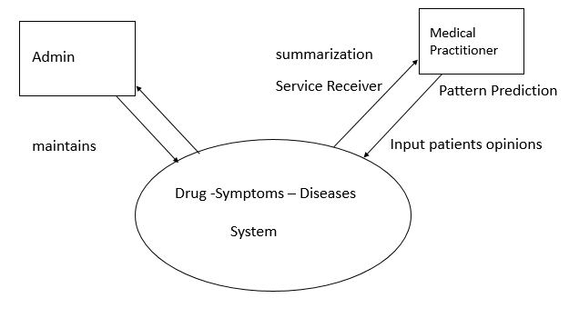
Figure – 5.5: Context flow diagram

Level 1 (high level diagram):
This level (level 1) shows all processes at the first level of numbering, data stores, external entities and the data flows between them. The purpose of this level is to show the major and high-level processes of the system and their interrelation. A process model will have one, and only one, level-1 diagram. A level-1 diagram must be balanced with its parent context level diagram, i.e. there must be the same external entities and the same data flows, these can be broken down to more detail in the level1.
5.3 Use Case Diagram:
A use case diagram in the Unified Modeling Language (UML) is a type of behavioral diagram defined by and created from a Use-case analysis. Its purpose is to present a graphical overview of the functionality provided by a system in terms of actors, their goals (represented as use cases), and any dependencies between those use cases.
The main purpose of a use case diagram is to show what system functions are performed for which actor. Roles of the actors in the system can be depicted. Interaction among actors is not shown on the use case diagram. If this interaction is essential to a coherent description of the desired behavior, perhaps the system or use case boundaries should be re-examined. Alternatively, interaction among actors can be part of the assumptions used in the use case.[3]
Use cases:
A use case describes a sequence of actions that provide something of measurable value to an actor and is drawn as a horizontal ellipse.
Actors:
An actor is a person, organization, or external system that plays a role in one or more interactions with the system.
System boundary boxes:
A rectangle is drawn around the use cases, called the system boundary box, to indicate the scope of system. Anything within the box represents functionality that is in scope and anything outside the box is not.

FIG-5.6 Shows the USECASE DIAGRAM (Admin), is a representation of a user's interaction with the system that shows the relationship between the user and the different use case in which the user is involved. it specifies the different fields access by the admin in the application.
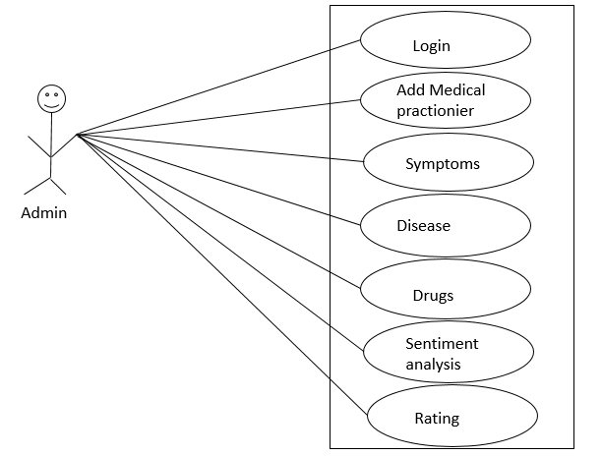
Figure-5.6 Admin Usecase Diagram
FIG-5.7 Shows USECASE DIAGRAM (MEDICAL PRACTITIONER), is a representation of a user's interaction with the system that shows the relationship between the user and the different use case in which the user is involved. it specifies the different fields access by the medical practitioner in the application.
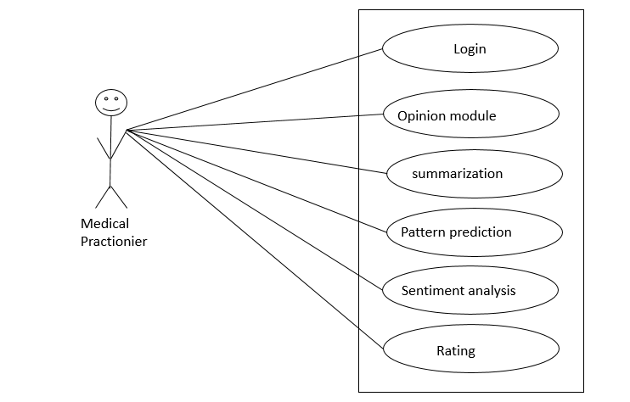
Figure – 5.7 Medical Practionier Usecase Diagram
  - ER Diagram:
In software engineering, an entity-relationship model (ERM) is an abstract and conceptual representation of data. Entity-relationship modeling is a database modeling method, used to produce a type of conceptual schema or semantic data model of a system and its requirements in a top-down fashion. Diagrams created by this process are called entity-relationship diagrams, ER diagrams, or ERDs.
5.4.1 Entity-Relationship Diagram
An Entity-Relationship Diagram is model that identifies the concept or entities that exist in a system and the relationship between those entities. An ERD is often used as a way to visualize a relational database: each entity represents a database table, and the relationship lines represent the keys in one table that point to specific records in related tables. ERDs may also be more abstract, not necessarily capturing every table needed within a database, but serving to diagram the major concepts and relationships.
FIG-5.8 Shows the ER DIAGRAM, in which it shows the relation between attributes.
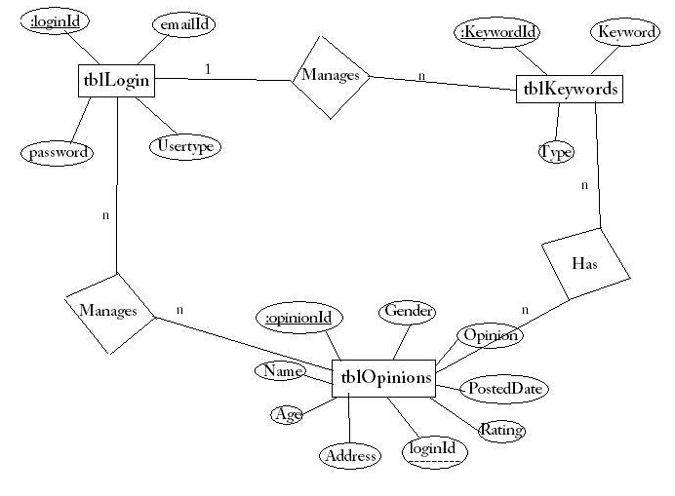
Figure – 5.8: ER diagram
CHAPTER 6:
IMPLEMENTATION
This web application is implemented using object oriented programming language. Object oriented programming is an approach that provides a way of modularizing programs by creating partitioned memory area for both data and functions that can be used as templates for creating copies of such modules on demand.
Features of Object Oriented paradigm:
- Emphasis is on data rather than procedure.
- Programs are divided into what are known as objects.
- Data structures are designed such that they characterize the objects.
- Methods that operate on the data of an object are tied together in the data structure.
- Objects may communicate with each other through methods.
- New data and methods can be easily added whenever necessary.
- Follows bottom-up approach in program design.
- Data is hidden and cannot be accessed by external functions.

It is implemented using three tier architecture. ASP.NET is used in the presentation layer, C# classes are used in the Business logic, Table adopter is used in the data tier and MS SQL server 2005 (database) is used as the backend.
Implementation Steps:
- Presentation Layer is Asp.net (front end) which invokes the Business logic through button click or page load event or SelectedIndexChange event of the dropdownlist.
- Business Logic contains the class members and member functions. An object for Business logic class is created and object will invoke the methods.
The business logic object will call table Adopter method. Table Adopter will open the database connection. Since SQL server 2005 is used as the backend, to interact with the database SqlDataSource is used.
Connection String:
<connec

(1). Function for calculating (L1)
Private void calculate L1 ( )
{
for (int i=0; i<c1s.length; i++)
{
if (c1s[i] >= support)
{
L1.item.Add(C1s[i]);
} } }

(2). Function to calculate (C2)

Private void calculate C2( )
{
for(int i=0;i<L1.Length;i++)
{
string item=L[i];
for(int j=i+1;j<L1.Length;j++)
{
C2.item.add();
}
}
}

(3). Function to calculate support(C1,S)

Private void calculate C1S( )
{
for(int i=0;i<C1.Length;i++)
{
string item= C1[i];
for(int y=0;y<t1.Rows.Count;y++)
{
string[]S.t1.Rows[y].cell.text.split('.');
for(int z=0,z<S.length;z++)
{if(S[z]==item)
{
cnt++;
}
}
}
(4). Function to calculate support (C2S)

private void calculate C2S( )
{
for(int i=0;i<C2.Length;i++)
{
string.item = C2[i];
for(int j=0;j<t1.rows.count;j++)
{
string []s->',';

check if []S contains both the items
then
cnt++;
then
S=cnt/count and add to c2(S)

(5). Function calculate L2->L1

untill C=null or L=null
CHAPTER 7:
TESTING
Testing is a process of executing a program to ensure that defined input will produce actual results that agree with required outputs. In developing a software project, error can be initiated at any stage during the development. For each phase of the software development cycle there are different techniques for detecting and elimination errors that originate in that phase. However some errors will reflect in the code. Testing performs a very crucial role for quality assurance and for ensuring the reliabilities of the software. The quality of the system depends on its design, development, testing and implementation. Weaknesses in any of these areas will seriously affect the quality and therefore value of the system to its users. Once the code has been generated, testing of the modules begins implementation ends with formal tests.
  - Purpose of Testing:
Testing accomplishes a variety of things, but most importantly it measures the quality of the software we are developing. This view presupposes there are defects in the software waiting to be discovered and this view is rarely disproved or even disputed.
Several factors contribute to the importance of making testing a high priority of any software development effort. These include:
- Reducing the cost of developing the program.
- Ensuring that the application behaves exactly as we explain to the user for the vast majority of programs, unpredictability is the least desirable consequences of using an application.
- Reducing the total cost of ownership. By providing software that looks and behaves as shown in the documentation, the customers require fewer hours of training and less support from product experts.
- Developing customer loyalty and word-of-mouth market share.

  - Different types of Testing:
    - Unit Testing:
Unit testing focuses verification on the smallest unit of software design, the software component or module. Using the component level design description as a guide, important control paths are tested to uncover errors within the boundary of the module. The unit testing is a white box oriented testing.
First of all the module interface is tested to ensure that the information properly flows into and out of the program until under test. Then the local data structure is tested to ensure the data stored temporarily maintains its integrity during all steps in an execution. Boundary conditions are tested to ensure that the module operates properly at boundaries established to limit or restrict processing. All independent paths through the control structure are exercised to ensure that all statements in a module have been executed at least once. And finally, all errors handling paths are tested. In this project the testing is done according to bottom-up approach. Starting with smallest and lowest level modules and processing one at a time. For each module a driver and corresponding stubs were also written. If any errors found they were corrected immediately and the unit was tested again.
    - Integration Testing:
Integration testing is a logical extension of unit testing. In its simplest form, two units that have already been tested are combined into a component and the interface between them is tested. A component, in this sense, refers to an integrated aggregate of more than one unit. The idea is to test combinations of pieces and eventually expand the process to test your modules with those of other groups. Eventually all the modules making up a process are tested together. Any errors discovered when combining units are likely related to the interface between units. This method reduces the number of possibilities to a far simpler level of analysis.
In this software, the bottom-up integration testing approached has been used, starting with the smallest and lowest level modules and proceeding one at a time. For each module the tests were conducted and the results were noted down.
    - User Testing:
User Testing is nothing but the test of the software by the users themselves with live data being fed to the system. This helps in building really robust system. User testing in this system has been done extensively ascertain the results.
Walkthroughs, Reviews and Demos:
Sometimes known as the informal peer group review, walkthroughs are one of a handful of techniques that make a big difference to the chances of success in a software project.
The aim of a walkthrough is to improve the quality of a piece of work by discovering potential problems. A walkthrough, when done properly, is seen as a positive contribution to the producer and his or her work; it is not seen as criticism or a negative activity or a threat.
Plenty of “Reviews, Walkthroughs or Demos to the Managers and client done regularly in various meetings”. This helped ascertaining the work being done, whether it is going in a correct way or not, and it also helped in lot of it continues improvement in the features of the system.
7.1.3 Test cases:

SI. no | Scenario Description | Test ID | Test Cases | Expected Result | Actual Result | Result Status
1 |  | 1 | Login Page username, Password Validation | If User is Admin, go to the Admin Home page and if User is Medical practitioner go to the Medical practitioner Home Pages | Successfully enter into their specific home page | pass
2 | Administrator | 2 | Adding medical practitioner details | Saved details into Database | Details saved Successfully into Database | Pass
 |  | 3 | Edit and delete medical practitioner details | Saved Details into Database | New details saved Successfully into Database | Pass
 |  | 4 | Updating password | Saved new password into Database | Saved new password into Database | Pass
 |  | 5 | Add key words to dataset | Saved Details into Database | Saved Details into Database | Pass
 |  | 6 | Over view of required opinions | It should be show related opinions posted by medical practitioner | Related patient opinions | Pass
 |  | 7 | Logout from admin page | It should return to login page | Successfully enter to login page | pass
3 | Medical practitioner | 8 | Add information about patient like name, age, opinion, rating | Saved Details into Database | Saved Details into Database | Pass
 |  | 9 | Edit and delete information about patient like name, age, opinion, rating | Saved Details into Database | Saved Details into Database | Pass
 |  | 10 | Summarizing opinions based on dates given | It should be show related opinions and patient is satisfied or not posted by medical practitioner between the dates given | Showed related patient opinions with summarization | Pass
 |  | 11 | Pattern prediction based on drugs-symptoms-diseases using Association Rule Mining | It should show high confidence opinions | It should show high confidence opinions | Pass
 |  | 12 | Editing old password | Saved new password into Database | Saved new password into Database | Pass
 |  | 13 | Logout from medical practitioner page | It should return to login page | Successfully enter to login page | pass
4 | Visitor | 14 | View of opinions | It should show all recently posted opinions by medical practitioner | It should show all recently posted opinions by medical practitioner | Pass

8. CONCLUSION
Analyzing user posts from health communities for knowledge discovery is an interesting area in research. This work will help patients to find out association among different drugs, disease and symptoms. It will help doctors to find out side effects of different drugs, so they can prescribe better drugs to other patients with similar disease. Pharmaceutical companies will also be benefited as we are classifying users of particular drug into different classes like depressed and satisfied. This will be indirect input to companies to decide which drug is popular, whether to produce alternate drug to this etc. Thus this work shall equally benefit all three parties-medical fraternity, patient community and pharmaceutical companies.

FUTURE ENHANCEMENT

- Social media posts contain a lot of errors or spelling mistakes. We are not considering spelling mistakes and their correction. So this could be further improvement.
- Posts in social networking may also contain symbolic expressions, which are not considered in this network. Not stopping just at looking at attitudes but also to help people at the moment of indecision.
- Advertising the best available medicine to the customers looking at his opinions and desires, to correlate between the sentiment and the behavior and come up with a pattern for each individual.

REFERENCES
[1] https://www.advisory.com/technology/healthpost
[2]http://www.academia.edu/551323/Patients_Satisfaction_on_Health_Post_User_of_Kathmandu_Valley_Nepal
[3] JayashreeR,Srikanta Murthy K,Basavaraj .S.Anami, “Categorized Text Document Summarization in the Kannada Language by Sentence Ranking”, 12th International Conference on Intelligent Systems Design and Applications (ISDA), pp 776-781, 2012.
[4] AlokRanjan Pal, DigantaSaha, “An Approach to Automatic Text Summarization using WordNet”, IEEE International Advance Computing Conference (IACC), 2014.
[6] Lakshmi K.S, G. Santhosh Kumar, “Association Rule Extraction from Medical Transcripts of Diabetic Patients”,IEEE,2014.
[7] WalaaMedhat, Ahmed Hassan, HodaKorashy, “Sentiment analysis algorithms and applications: A survey”, In press, Elsevier, 2014.

11. SNAPSHOTS
FIG: 11.1 Shows the login page for admin and medical practitioner and it’s the home page for visitor to view the opinions posted by the medical practitioner. Admin and medical practitioner can login into his account by entering the login id and password.
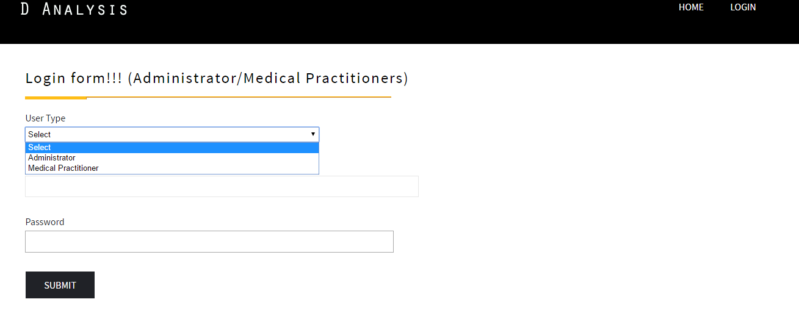
Figure-6.1 Login page
6.2.2 Admin: Manage medical practitioner
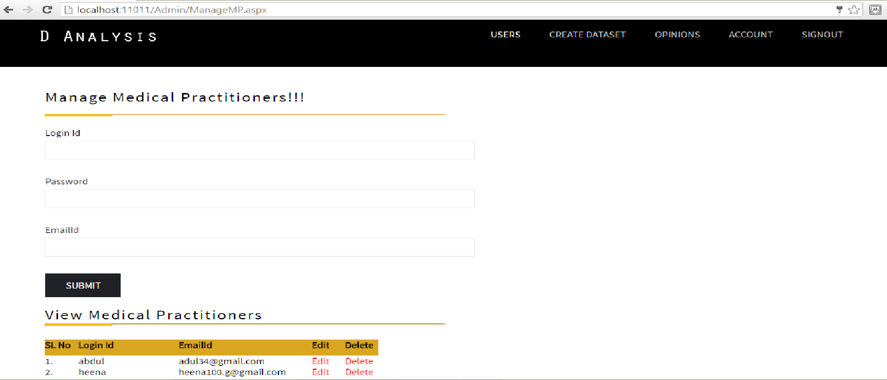
Figure-6.2 Manage medical practitioner
Fig 6.2 shows the home page of admin, where administrator adds the medical practitioners into the server based on the hospital. During this process administrator assigns unique id and password for each medical practitioner. And below admin can view the registered medical practitioners.
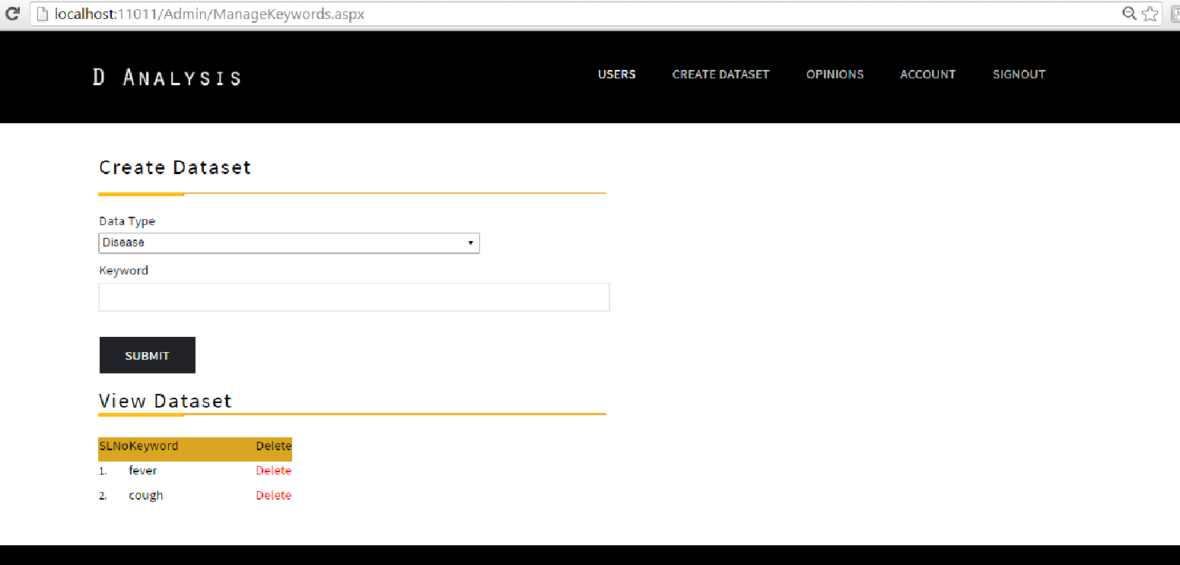
Figure-6.3 Creation of Dataset
Fig 6.3 shows the creation of Dataset by administrator. During this process administrator assigns unique drug names, symptoms, diseases, depression and satisfied.
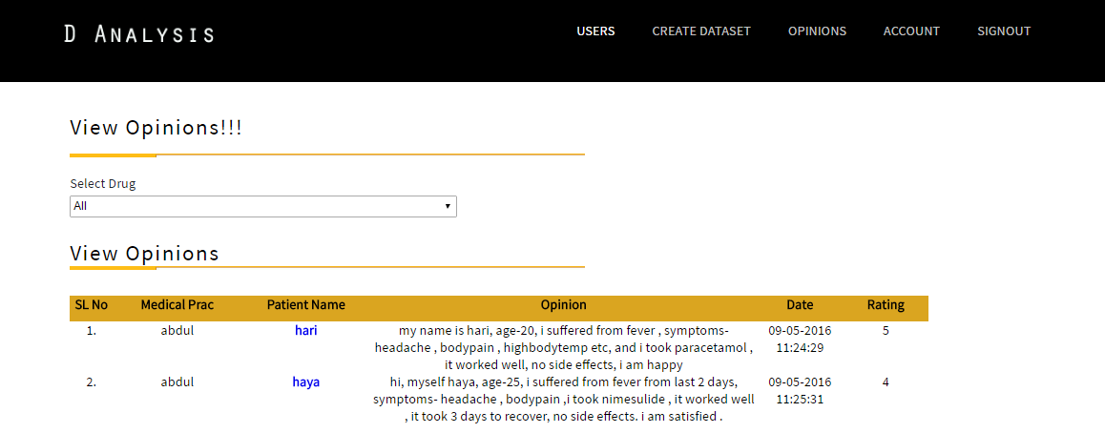
Figure-6.4 View of opinions
Fig 6.4 shows the overview of opinions created by medical practitionersr
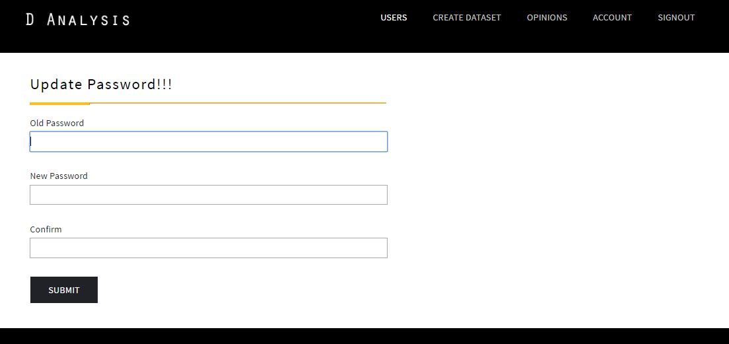
Figure-6.5 updating password
Fig 6.5 shows updating password of administrator
6.2.3 Medical practitioner: Manage Patient Opinion
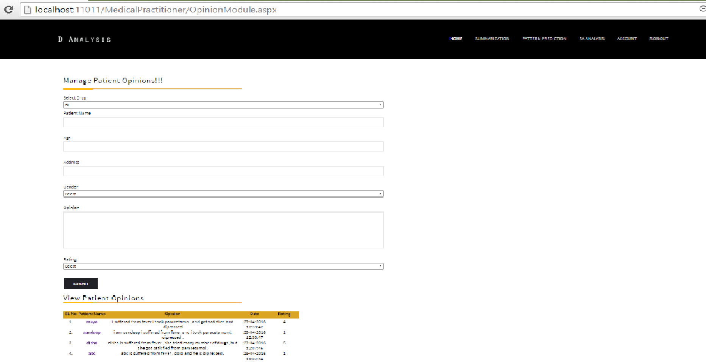
Figure-11.6 Manage Patient Opinion
FIG 11.6 shows the opinion module where, medical practitioner registers patient details to the system and uploads the health posts into the server. Detail includes patient name, age, address, gender, opinion about the drug and rating. Below he can view all the patient opinion.

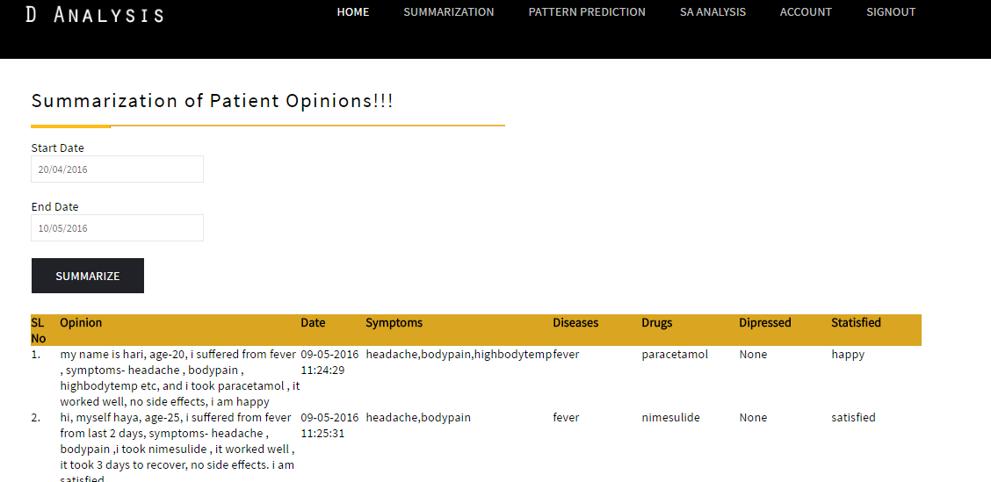
Figure-11.7 Summarization of Patient Opinions

FIG 11.7 shows the opinions of patient details to the system by medical practitioner. It can be summarize based on the dates posted between those days.
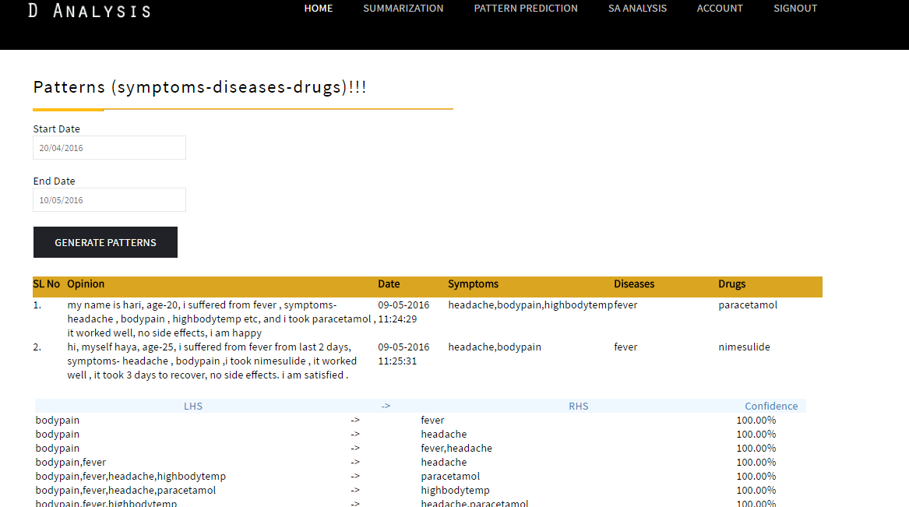
Figure-11.8 Pattern prediction based on drugs-symptoms-diseases
FIG 11.8 Shows the Pattern prediction based on drugs-symptoms-diseases using Association Rule Mining.

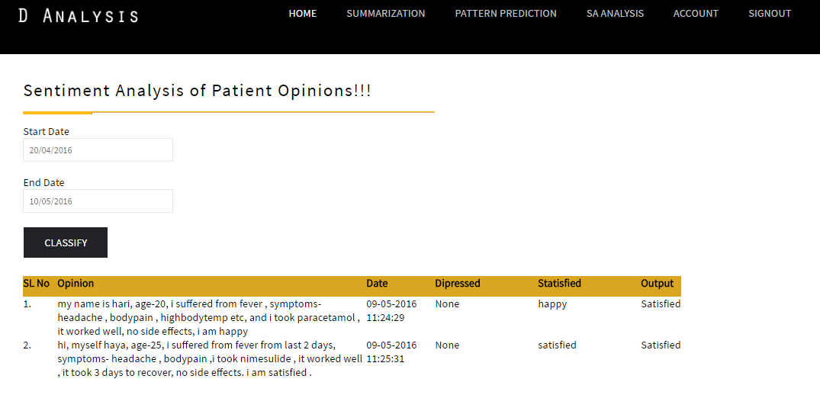
Figure-11.9 Sentiment analysis of patient opinions
FIG 11.9 Shows the Pattern prediction based on drugs-symptoms-diseases using Association Rule Mining.
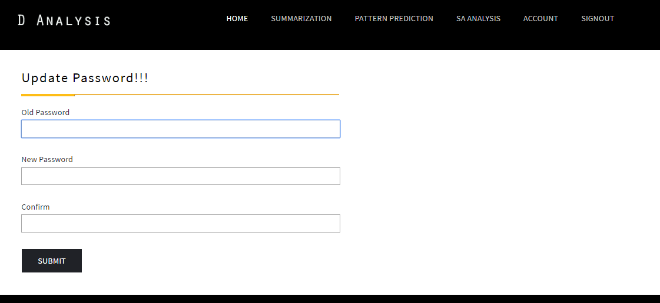
Figure-11.10 updating password
FIG 11.10 shows updating the password of medical practitioner which is created by administrator
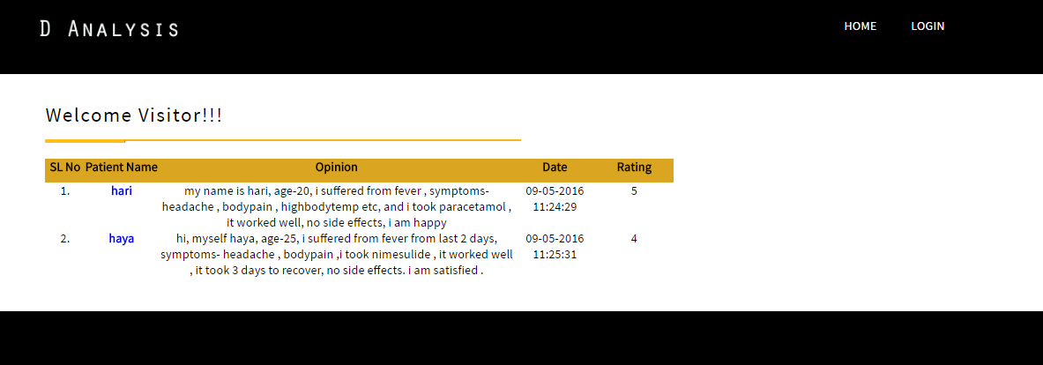
Figure-11.11 Home page for visitors
FIG 11.11 shows the home page for visitors. It contains over view of recently opinions posted by medical practitioner.

