VISVESVARAYA TECHNOLOGICAL UNIVERSITY

JNANA SANGAMA, BELAGAVI-590018


A Self-study Report
Intrusion Detection and Prevention Systems

Submitted in partial fulfillment for self-study component of

MASTER OF TECHNOLOGY
in
COMPUTER NETWORK ENGINEERING
Submitted by

RESHMA NADAF

Dr.Sowmyarani C N,
Associate Professor,
R V College of Engineering



Department of Computer Science and Engineering

R V COLLEGE OF ENGINEERING

R.V.VIDYANIKETAN POST, MYSURU ROAD,

BENGALURU- 560059
2016-17

VISVESVARAYA TECHNOLOGICAL UNIVERSITY, BELAGAVI

R.V. College of Engineering,

Department of Computer Science and Engineering

Mysuru Road, R.V.Vidyaniketan Post, Bengaluru - 560059

ACKNOWLEDGEMENT

The satisfaction that accompanies the successful completion of this Self Study would be complete only with the mention of the people who made it possible, whose support rewarded our effort with success.

I am grateful to R V College of Engineering for its ideals and its inspirations for having provided us with the facilities that have made this Self Study a success.

I express my sincere gratitude to Dr.Subramanya K N, Principal, R V College of Engineering.

I express my sincere gratitude to Dr.Shobha G, Head of the Department, Computer Science and Engineering.

I express my sincere thanks to our internal guide Dr.Sowmyarani C N, Associate professor, Department of Computer Science and Engineering for her advice, supervision and guidance throughout the course of the Self Study.

I am also grateful to all other members of the faculty of Computer Science and Engineering Department for their cooperation.

Table of Contents

Acknowledgement | 2
List of Figures | 4
Chapter 1  - Introduction  - Literature Survey  - Objectives | 5-11
Chapter 2  2 Requirement Specification | 12
Chapter 3  3 Design | 13-15
Chapter 4  4 Implementation, usage of tools. | 16-17
Chapter 5  - Results and Analysis | 18-20
Chapter 6  - Conclusion and Future directions | 21
References and Annexure | 22

List of Figures
Sl.No | Name of the Figure | Page no.
1.1 | IDS or IPS alerts | 6
1.2 | Host based IDS | 7
1.3 | Network based IDS | 7
3.1 | IDS/IPS architecture | 13
4.1 | Screenshot of Snort package for Windows | 16
4.2 | Screenshot of Snort rules | 16
4.3 | Screenshot of Snort –V command | 17
5.1 | Screenshot of Interface running on system | 18
5.2 | Screenshot of Output –A option | 19
5.3 | Screenshot of Output –A option | 20
5.4 | Screenshot of Generated log file | 21

Chapter 1

  - Introduction

Computer security is the main issue to be addressed nowadays as the internet is growing with drastic speed and securing data has been a prominent issue ever since the computers and their enormous applications developed. Intrusion is unwanted or unauthorized action with bad intentions to destroy others properties but in computer words its compromise of security components such as integrity, confidentiality and privacy. Intrusion detection is process of monitoring unwanted traffic on computer network.
Intrusion detection system (IDS) is software or tool which is used to detect and monitor unauthorized or malicious activity on computer system or network from outside world which violate the security policy. IDS is combination of both hardware and software which detects intrusion into network. It complement firewall by providing inspection of both packet and TCP/IP header by splitting up the packets into small fragment and detecting the possible attacks and alerting the administrator and then reassemble the frames to form packets. In firewall the packet is allowed or denied entering trusted network based on rules specified by administrator. A rule specifies whether a host or a network, or an application should be allowed into the trusted network. To check the rules, a firewall has to just inspect the header of the TCP/IP protocol, it does not inspect the data.
Intrusion prevention system (IPS) is software or tool which has all the properties of intrusion detection system and prevent all the unauthorized or malicious activity from outside world entering the network. Intrusion Detection and Prevention System (IDPS) is software or tool used both detection and prevention of unauthorized or malicious activity on computer system from outside world by logging information and sending alert to the administrator.

1.1.1 IDS or IPS alerts:

- True Positives:
These are alerts that something is not right when it is actually not right. Example: The IDS finds a packet as containing malicious code and it was actually true that the packet had malicious code, as confirmed by investigation.
- True Negatives:
These are alerts that something is right when it is actually right. Example: The IDS finds a packet as containing no issues and it actually had no issues.
- False Positives:
These are alerts indicating that something is not right with a packet when actually it is right. Example: The IDS finds a packet as having malicious code but it is actually a genuine code.

- False Negatives:
These are alerts that something is right when actually it is wrong. Example: The IDS finds that a packet does not have any malicious code but it actually does contain a malicious code, as found through investigation.

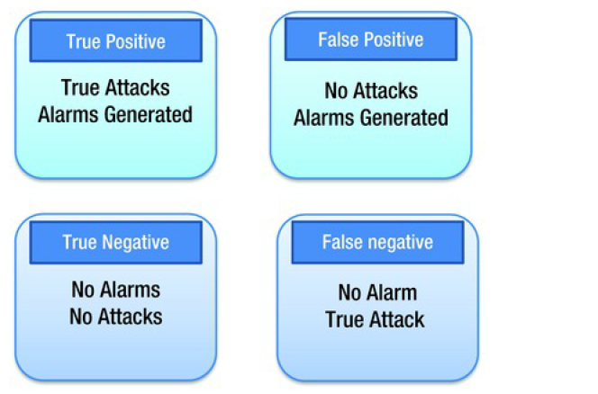
Figure 1.1: IDS or IPS alerts.

1.1.2 Types of Intrusion Detect and Prevention Systems (IDPS):
IDPS technology is divided into four types

- Host Based IDPS
- Network Based IDPS
- Wireless IDPS
- NBA(Network behavior analysis) system

Host Based IDPS:
Host-based IDPS, which monitors the characteristics of a single host and the events occurring within that host for suspicious activity. Examples of the types of characteristics a host based IDPS might monitor are network traffic of host, system logs, running processes, application activity, file access and modification, system and application configuration changes. Host-based IDPSs are most commonly deployed on critical hosts such as publicly accessible servers and servers containing sensitive information.

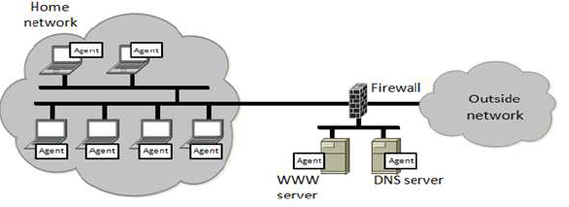
Figure 1.2 : Host based IDS

Network Based IDPS:
Network-based IDPS, which monitors network traffic for particular network segments or devices and analyses the network and application protocol activity to identify suspicious activity. It can identify many different types of events of interest. It is most commonly deployed at a boundary between networks, such as in proximity to border firewalls or routers, remote access servers, and wireless networks.

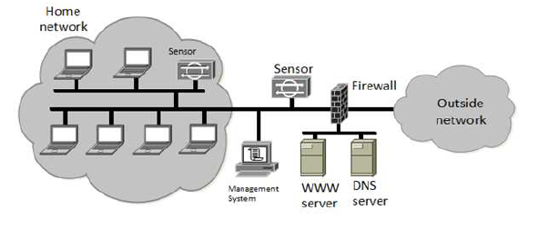

Figure 1.3 : Network based IDS

Wireless Based IDPS:
Wireless IDPS, which monitors wireless network traffic and analyses its wireless networking protocols to identify suspicious activity involving the protocols themselves. It cannot identify suspicious activity in the application or higher layer network protocols (e.g., TCP, UDP) that the wireless network traffic is transferring. It is most commonly deployed within range of an organization’s wireless network, but can also be deployed at locations where unauthorized wireless networking could be occurring.

Network behaviour analysis (NBA):
Network behaviour analysis (NBA) system, which examines network traffic to identify threats that generate unusual traffic flows, such as distributed denial of service attacks, certain forms of malware like worms, backdoors), and policy violations example a client system providing unauthorized network services to other systems. NBA systems are most often deployed to monitor flows on an organization’s internal networks, and are also sometimes deployed where they can monitor flows between an organization’s networks and external networks (e.g., the Internet, business partners’ networks).

1.1.3 Mechanism to detect Intrusion Detection and Prevention System
The Intrusion Detection and Prevention Systems detect intrusions through the following mechanisms

- Signature based detection
- Anomaly based detection
- Stateful protocol analysis

Signature based detection:
Signature is a pattern that corresponds to a known threat. In signature based detection, observed events are compared against the pre-defined signatures in order to identify possible unwanted traffic. This type of detection technique is very fast and easy to configure. Signature-based detection is very effective at detecting known threats but largely ineffective at detecting previously unknown threats, threats disguised by the use of evasion techniques, and many variants of known threats. An attacker can slightly modify an attack to render it undetectable by a signature based IDS. Still, IDS using signature based methodology, though having limited capability, can be very accurate.

Anomaly based detection:
Anomaly-based detection is the process of comparing definitions of what activity is considered normal against observed events to identify significant deviations. An IDS using anomaly-based detection has profiles that represent the normal behaviour of such things as users, hosts, network connections, or applications. The profiles are developed by monitoring the characteristics of typical activity over a period of time. The major benefit of Anomaly based detection technique is that they can be very useful for detecting unwanted traffic that is not specifically known. For instance, anomaly-based IDS will detect that an Internet protocol (IP) packet is malformed. It does not detect that it is malformed in a specific way, but indicates that it is anomalous.

Stateful protocol analysis:
Stateful protocol analysis is the process of comparing predetermined profiles of generally accepted definitions of benign protocol activity for each protocol state against observed events to identify deviations. Stateful protocol inspection is similar to anomaly based detection, but it can also analyse traffic at the network and transport layer and Vender-specific traffic at the application layer, which anomaly-based detection cannot do.

1.1.4 History

Securing and protecting data is been challenging since the computer came into picture. The research for intrusion detection started more than three decade from now. It was James P. Anderson who published a study “Computer Security threat monitoring and surveillance” in 1980, it was the first research paper in this field. “An Intrusion Detection Model” paper proposed by Dorothy Denning’s explained framework which inspired other researcher to work in this field. In 1990, IDS technique used to address network attack using anomaly detection. In between 1990 and early 2000, inconsistent nature of network resulted in many number false positive alert, and administrator thought slow death of IDS. The origin of cloud computing brought new scope to IDS systems.

  - Literature Survey

- Evaluating intrusion detection systems: The 1998 DARPA off-line intrusion detection evaluation.[1]

Intrusion detection bed was developed which generated normal traffic. Different groups participated to evaluate and result was analyzed for probe, DOS, remote to local and user to root. The best system failed to detect new attacks so this paper deals with techniques for new attacks.

- Indra: A peer-to-peer approach to network intrusion detection and prevention.[2]

This paper proposed distributed scheme called Indra which is based on sharing
Information between trusted peers to avoid any intrusion. Drawback of this was that it only shared between peers.

- A hardware platform for network intrusion detection and prevention.[3]

IDS was placed in hardware of end host which was called as network node
IDS (NNIDS). Main functionality was to protect host from intrusion by running on network interface hardware other than host operating system hence performance was high.

- A high throughput string matching architecture for intrusion detection and prevention.[4]

This paper tell how string matching algorithm can be used to split larger database string into many tiny state machines, each of which uses rules to match bit.

- SIP intrusion detection and prevention: recommendations and prototype
Implementation. [5]

Session initiation protocol (SIP) intrusion detection and prevention requirement was analyzed and architecture implemented using Snort features like preprocessor for capturing the packet.

- Intrusion Detection System and Intrusion Prevention System: A Comparative Study.[6]

This paper will give comparative study about IDS and IPS, types of IDPS and methodologies.

- A Proposed Intrusion Detection System.

This paper proposed Intrusion detection system (IDS) which use advantage of host and network intrusion detection system. And provide high performance, scalability, security and provide best result in capturing packet for abnormal behaviour.

  - Objectives
The self-study include the overall study of Intrusion Detection and Prevention System which tells how the both systems i.e. Intrusion Detection system (IDS) and Intrusion Prevention system (IPS) will detect, monitor and prevent the intrusion on the computer network. To protect computer network from attack many tool or techniques are build, one of such technique is intrusion detection and prevention systems, there are many open source tools available which alerts, generate logs and inform the administrator. Common open source tools are Snort, Security Onion, Bro ID, OSSEC and OpenWIPS-NG which work in different platform like windows, linux and MAC etc. Snort is used to analyze real time traffic, packet sniffing, packet logger and alerting the administrator.

Chapter 2

- Requirement Specification
Requirement specification for self-study is the Snort tool, Windows operating system, WinPcap and snort rules.

Snort is an open source network intrusion detection and prevention system. It is capable of performing real-time traffic analysis, alerting, blocking and packet logging on IP networks. It utilizes a combination of protocol analysis and pattern matching in order to detect anomalies, misuse and attacks. Snort uses a flexible rules language to describe activity that can be considered malicious or anomalous as well as an analysis engine that incorporates a modular plugin architecture. Snort is capable of detecting and responding in real-time, sending alerts, performing session sniping, logging packets, or dropping sessions/packets when deployed in-line.

To perform a basic install of Snort on a Windows system, we need to download a couple of programs. First we will need to get the Snort Installer binary from Snort.org. For Snort to work properly, we will need to put our network interface card (NIC) into promiscuous mode where it can see all traffic the flows to it. To do this on Windows, we will need to download the Windows Packet Capture library from WinPCap.org.

WinPcap is the industry-standard tool for link-layer network access in Windows environments, it allows applications to capture and transmit network packets bypassing the protocol stack, and has additional useful features, including kernel-level packet filtering, a network statistics engine and support for remote packet capture.

Snort rules are a methods used for performing detection. Unlike signatures rules are based on detecting the actual vulnerability, not an exploit or a unique piece of data.
Chapter 3

- Design
The architecture of a typical network-based IDS/IPS is as shown in Figure 4. It consists of a hardware device, management console, a database, and connectivity to network management consoles.

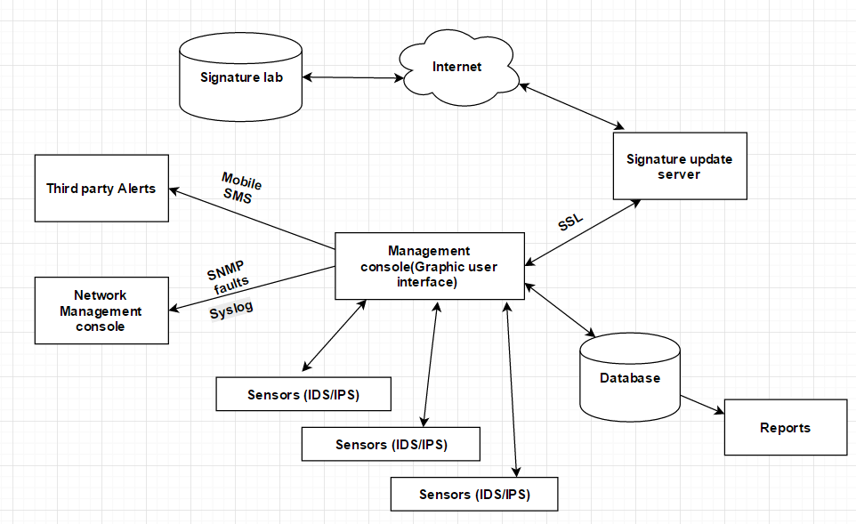

Figure 3.1: IDS/IPS architecture

Sensor:
Primary function of a sensor is to analyse traffic and respond when the attacks are detected. The sensor examines each and every packet’s header and data content that enters the network. The sensor looks for a pattern and behaviour in the network traffic that indicates malicious activity and sends alerts to the management console. The sensor examines the packets and checks against the user defined policies or rule sets, which contains the priorities of the attacks to be monitored and the counter measures to be taken when an attack is detected. If an attack is detected, the sensor sends an alert to the management console, logs the alert, and responds to the attack as per the defined policy. The policies for sensors can be configured to several types of responses - generating alerts, logging events, resetting TCP connections, blocking traffic at firewalls, scrubbing malicious packets, and even dropping the packets entirely before reaching the final destination.

Database:
A database server is an important component of the overall IDS/IPS architecture. It is a repository of all the events triggered by the sensors, logs generated, user policies and profiles, and other functional information.

Management console:
Management console provides an interface to the users and administrators for configuring and managing sensor systems. The users connect to the management console through a client system over a web interface or any other client software.
Management Graphical Interface should provide the following:
- Alert/Event Viewer:
Displays all the intrusions detected by the sensors, which have violated the defined set of policies. The alert viewers should be able to provide drill-down capabilities to view all the details of individual alerts such as host, destination, service, type of attack, and action taken.
- Incident Generator:
This enables the creation of real-time correlative analysis of attacks on the network. This should provide the type of incident that has occurred and when it has occurred.
- Report Generators:
To generate various security reports for the management and further analysis. It should have the capability of generating reports automatically as well e-mailing them to individuals.
- System Configuration Tools:
Provides all the system configuration features. Setting polices, profiles, responses to attacks, sensor mode of operation, user created profiles, baseline scheduling, defining user roles and responsibilities, sending alerts to central network management console, and other sensor level configurations. It should also have the capabilities to send alerts to the central network management console and alerting administrators through triggering cell phone calls and SMS services.

Signature update server:
For the IDS system to detect the latest vulnerabilities and threats, its threat signatures must be up to date. Sensors should be updated with the latest signatures regularly. Both the management console and the sensors should always be up to date with the threat signature set and software patches. A good system should have the capability to connect to the latest threat vulnerability lab and download the signatures on a regular basis and update the sensor that are detecting the intrusions. In the architecture illustrated, the signature update server connects to the signature library to download the latest signature set and then the management console pushes the updated signature to the sensors. The polling interval of the update server, and the signature push to the sensors can be configured using the management user interface. Once the update server receives the new signature updates, the management interface determines what signatures need to be pushed onto the sensors based on the policies that are defined and applied. For example, a policy defined for a particular LAN segment will only update those signatures defined for that LAN segment.

Chapter 4

- Implementation and Usage of Tool

Intrusion Detection and Prevention System (IDPS) implemented using Snort tool.
Snort tool is open source software for Intrusion Detection and Prevention system used to perform real time traffic analysis and packet logging on Internet protocol (IP).

Steps to download Snort tool and related files:
- Register for Snort tool by creating login id.
- Download Snort tool from Snort website. Find the link below.
https://www.snort.org/#get-started

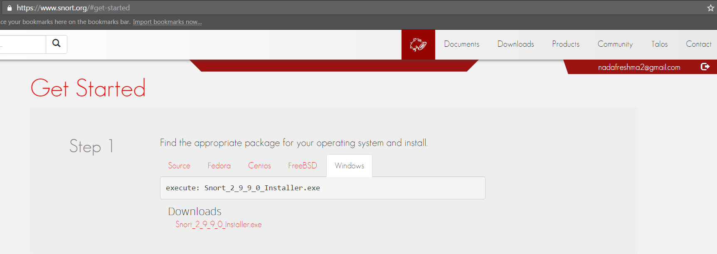

Figure 4.1 : Screenshot of Snort package for windows.

- Download the recent Snort rule. For ex in Figure 3 download the recent highlighted rules.
https://www.snort.org/downloads

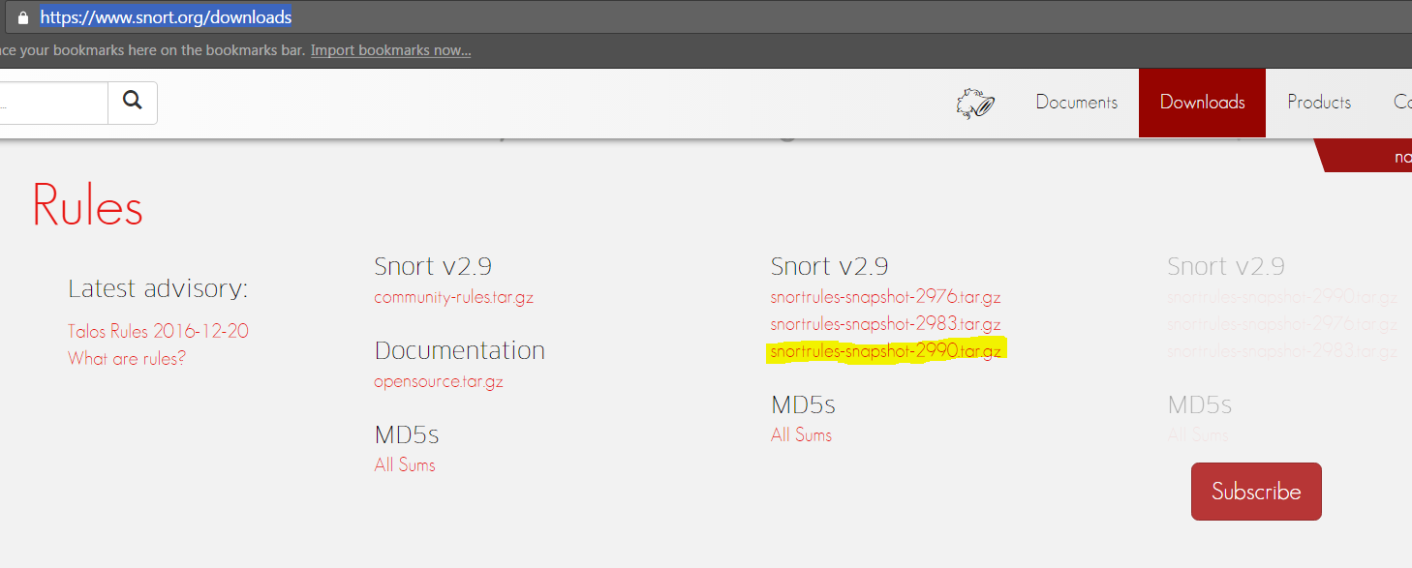

Figure 4.2: Screenshot of Snort rules

- Download the recent version of WinPcap from below website
http://www.winpcap.org/

Installation steps:

- First install WinPcap by clicking all default setting.
- Install snort tool which was download above in step 2 of download.
- Unzip the rules file which was downloaded in the step 3 of download into C:\Snort\etc, C:\Snort\preproc_rules and C:\Snort\rules respectively.
- Change the snort.conf file (watch below video for configuration and installation steps) located in the directory C:\Snort\etc
https://www.youtube.com/watch?v=wXFVLXIsZdA
- To check if Snort is installed properly or not go to command prompt and give
snort –V

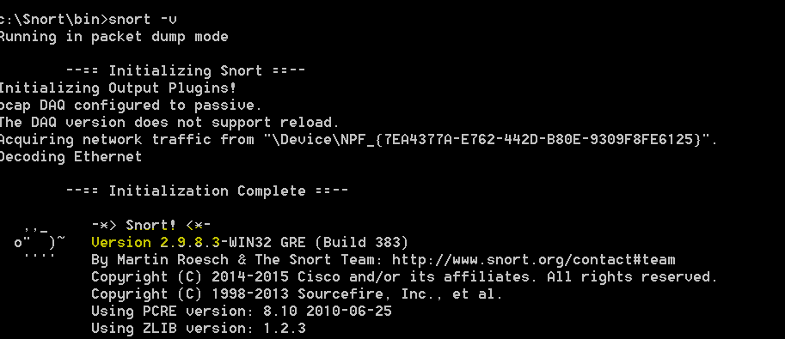
Figure 4.3: Screenshot of snort –V command.

- Finally the Snort tool is ready to be used.

Chapter 5

- Result and Analysis

Below are the screenshots of the result and analysis of the tool.

- To check which all interface running on respective system just type snort –W in command prompt

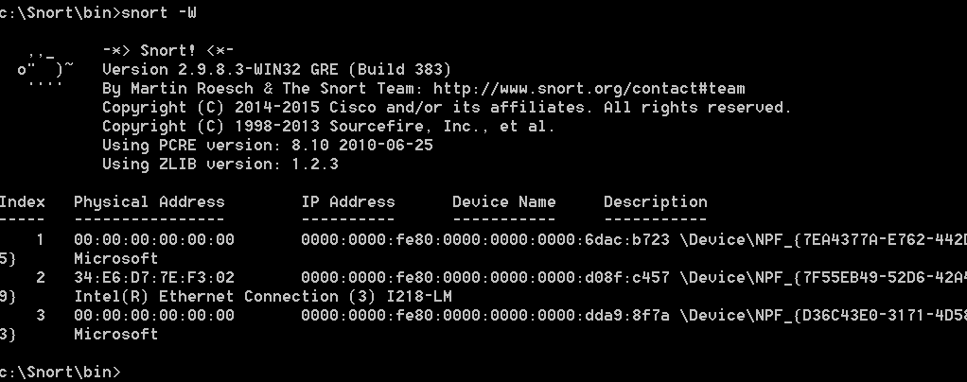

Figure 5.1: Screenshot of Interface running on system.

- To create testing rules, go to local.rules file located in C:\Snort\rules i.e.
- Open local.rules file with any of the text editor.
- At the end of the file right the rule. Starting with some generic rules like
alert icmp any any -> any any (msg: "ICMP TEST"; sid: 1000001 ;)

alert tcp any any -> any any (msg: "TCP TEST"; sid: 1000002 ;)

alert udp any any -> any any (msg: "UDP test"; sid: 1000003 ;)

- You can create any number of rules, just be sure to start in new line.

- To print the output on screen we can use –A option i.e.
- snort -i 3 –c C:\Snort\etc\snort.conf –A console (here 3 is the above interface which can be seen in Figure 5)
- Open another command prompt window, leaving snort running in first.
- Send ping to local gateway or any host (ex: ping www.google.com)
- Open the web browser and browse any web page.
- You can see the alert generating on the screen.

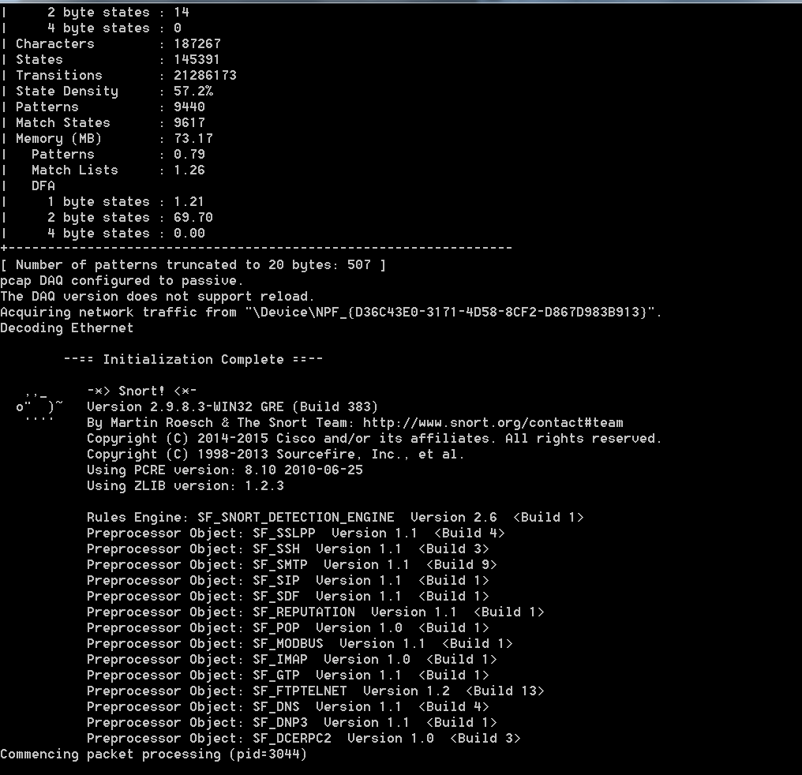

Figure 5.2: Screenshot of Output –A option

Figure 5.2 is screenshot of the result obtained when command snort –A is entered in command prompt, which tells how many characters, states, transitions, patterns and memory used by the snort tool are listed down.
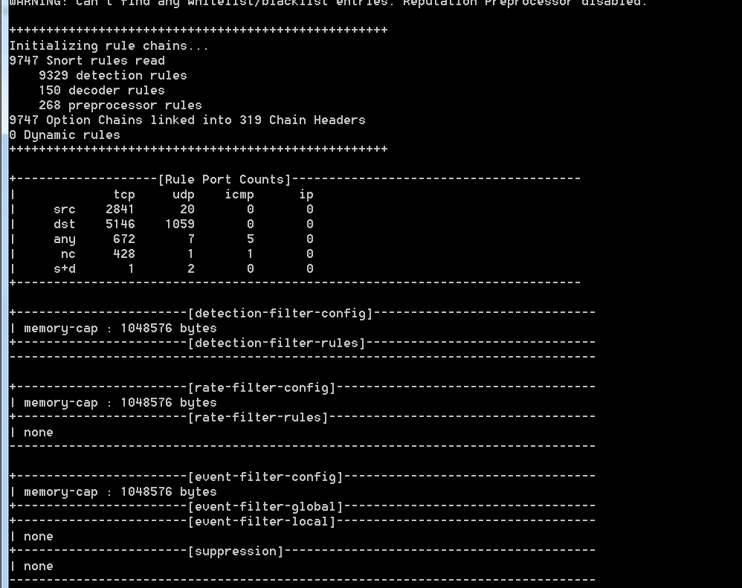

Figure 5.3: Screenshot of Output of –A option

Figure 5.3 is continuation of screenshot of the result obtained when command snort –A is entered in command prompt, which give rule part count of TCP, UDP, ICMP and IP.

- To capture into log file you ca use redirecting key > and then file name example testlog.txt
snort -i 3 -c C:\Snort\etc\snort.conf -A console > C:\Snort\log\testlog.txt

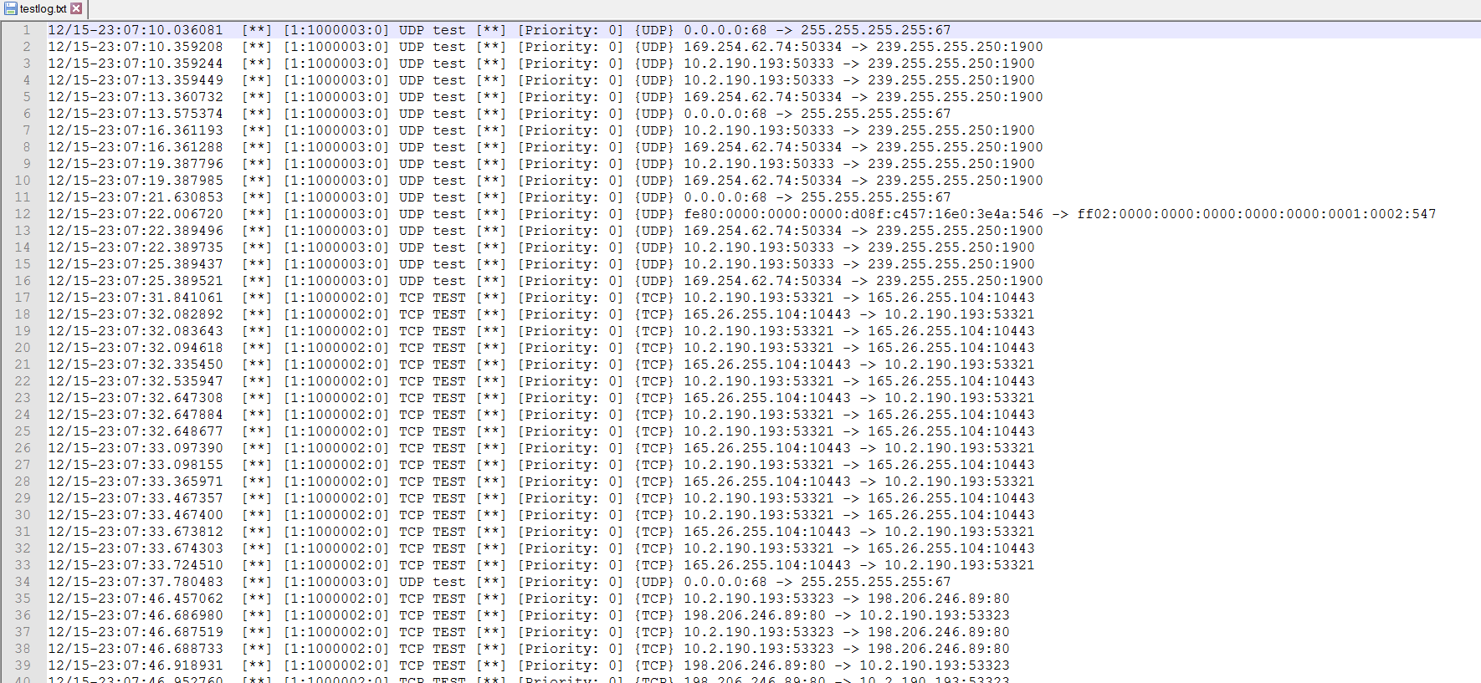

Figure 5.4: Screenshot of Generarted log file

Figure 5.4 is screenshot obtained after the command snort –i 2 –c C:\Snort\etc\snort.conf –A console > C:\Snort\log\testlog.txt. All the alert are loaded to log file called textlog.txt depending on the local rules.

Chapter 6

- Conculsion

There are many technologies in the market today to help companies fight the inevitable network and system attack. Having IPS and IDS technologies are only two of many resources that can be deployed to increase visibility and control within a corporate computing environment. IDS and IPS are to provide a foundation of technology that meets the requirement of tracking, identifying network attacks to which detect through logs of IDS systems and prevent an action through IPS systems. If the host is with critical systems, confidential data and strict compliance regulations, then it’s a great to use IDS, IPS or both in network environments. Snort is one such tool used to analyse the real time traffic and packet logger on Internet protocol.

References:

[1] Lippmann, Richard P., David J. Fried, Isaac Graf, Joshua W. Haines, Kristopher R. Kendall, David McClung, Dan Weber et al. "Evaluating intrusion detection systems: The 1998 DARPA off-line intrusion detection evaluation." In DARPA Information Survivability Conference and Exposition, 2000. DISCEX'00. Proceedings, vol. 2, pp. 12-26. IEEE, 2000.

[2] Janakiraman, Ramaprabhu, Marcel Waldvogel, and Qi Zhang. "Indra: A peer-to-peer approach to network intrusion detection and prevention." In Enabling Technologies: Infrastructure for Collaborative Enterprises, 2003. WET ICE 2003. Proceedings. Twelfth IEEE International Workshops on, pp. 226-231. IEEE, 2003.

[3] Clark, C. R., Wenke Lee, D. E. Schimmel, Didier Contis, Mohamed Koné, and Ashley Thomas. "A hardware platform for network intrusion detection and prevention." In Proceedings of the 3rd Workshop on Network Processors and Applications (NP3). 2005.

[4] Tan, Lin, and Timothy Sherwood. "A high throughput string matching architecture for intrusion detection and prevention." In ACM SIGARCH Computer Architecture News, vol. 33, no. 2, pp. 112-122. IEEE Computer Society, 2005.

[5] Niccolini, Saverio, R. G. Garroppo, S. Giordano, G. Risi, and S. Ventura. "SIP intrusion detection and prevention: recommendations and prototype implementation." In 1st IEEE Workshop on VoIP Management and Security, 2006, pp. 47-52. IEEE, 2006.

[6] Chakraborty, Nilotpal. "Intrusion Detection System and Intrusion Prevention System: A Comparative Study." International Journal of Computing and Business Research (IJCBR) ISSN (Online) (2013): 2229-6166.

[7] Creech, Gideon, and Jiankun Hu. "A semantic approach to host-based intrusion detection systems using contiguous and discontinuous system call patterns." IEEE Transactions on Computers 63, no. 4 (2014): 807-819.

[8] Bhuyan, Monowar H., Dhruba Kumar Bhattacharyya, and Jugal K. Kalita. "Network anomaly detection: methods, systems and tools." IEEE Communications Surveys & Tutorials 16, no. 1 (2014): 303-336.

