VISVESVARAYA TECHNOLOGICAL UNIVERSITY

JNANA SANGAMA, BELAGAVI-590018


A Self-study Report on
DIGITAL SIGNATURES
Submitted in partial fulfillment for self-study component of

MASTER OF TECHNOLOGY
in
COMPUTER NETWORK ENGINEERING
Submitted by
SAI HARISH M A
16PG1REG0472
Dr Sowmyarani C N
Associate Professor
R V College of Engineering



Department of Computer Science and Engineeri
R V COLLEGE OF ENGINEERING

R.V.VIDYANIKETAN POST, MYSURU ROAD,

BENGALURU- 560059
2016-17

VISVESVARAYA TECHNOLOGICAL UNIVERSITY, BELAGAVI

R.V. College of Engineering,

Department of Computer Science and Engineering

Mysuru Road, R.V.Vidyaniketan Post, Bengaluru - 560059

ACKNOWLEDGEMENT

The satisfaction that accompanies the successful completion of this Self Study would be complete only with the mention of the people who made it possible, whose support rewarded our effort with success.

We are grateful to R V College of Engineering for its ideals and its inspirations for having provided us with the facilities that have made this Self Study a success.
We express our sincere gratitude to Dr.Subramanya K N, Principal, R V College of Engineering.
We express our sincere gratitude to Dr.Shobha G, Head of the Department, Computer Science and Engineering.
We express our sincere thanks to our internal guide Dr.Sowmyarani C N, Associate professor, Department of Computer Science and Engineering for their advice, supervision and guidance throughout the course of the Self Study.
We are also grateful to all other members of the faculty of Computer Science and Engineering Department for their cooperation.

Table of Contents
Acknowledgement | (i)
List of Figures | (ii)
Chapter 1  - Introduction  - Literature Survey  - Objectives | 1  2  3
Chapter 2  - What is Digital signatures  - Types of Digital signatures  - Requirements | 4  4  5
Chapter 3  - Digital image authentication and encryption using digital signatures  - PRELIMINARIES  - Encryption  - Decryption  - Simulation results | 6  7  8  9
Chapter 4  - Drawbacks | 11
Chapter 5  - Conclusions | 11
References and Annexure | 12

List of Figures

FIG 3.1 ENCRYPTED

FIG 3.2 DECRYPTION

FIG 3.3 ORIGINAL IMAGE

FIG 3.4 ENCODED IMAGE

FIG 3.5 ENCRYPTED IMAGE

FIG 3.6 RECOVERED IMAGE

FIG 3.7 ALTERED IMAGE

Chapter 1

  - Introduction
A digital signature is a mathematical scheme for demonstrating the authenticity of a digital message or documents. A valid digital signature gives a recipient reason to believe that the message was created by a known sender (authentication), that the sender cannot deny having sent the message (non-repudiation), and that the message was not altered in transit (integrity).
Digital signatures are a standard element of most cryptographic protocol suites, and are commonly used for software distribution, financial transactions, contract management software, and in other cases where it is important to detect forgery or tampering.
Definition of Digital signatures
A digital signature scheme typically consists of three algorithms;
- A key generation algorithm that selects a private key uniformly at random from a set of possible private keys. The algorithm outputs the private key and a corresponding public key.
- A signing algorithm that, given a message and a private key, produces a signature.
- A signature verifying algorithm that, given the message, public key and signature, either accepts or rejects the message's claim to authenticity.
Two main properties are required. First, the authenticity of a signature generated from a fixed message and fixed private key can be verified by using the corresponding public key. Secondly, it should be computationally infeasible to generate a valid signature for a party without knowing that party's private key. A digital signature is an authentication mechanism that enables the creator of the message to attach a code that acts as a signature. The Digital Signature Algorithm (DSA), developed by the National Institute of Standards and Technology, is one of many examples of a signing algorithm.

History of digital signatures
In 1976, Whitfield Diffie and Martin Hellman first described the notion of a digital signature scheme, although they only conjectured that such schemes existed.^{[10][11]} Soon afterwards, Ronald Rivest, Adi Shamir, and Len Adleman invented the RSA algorithm, which could be used to produce primitive digital signatures^{[12]} (although only as a proof-of-concept – "plain" RSA signatures are not secure^{[13]}). The first widely marketed software package to offer digital signature was Lotus Notes 1.0, released in 1989, which used the RSA algorithm.^{[14]}
Other digital signature schemes were soon developed after RSA, the earliest being Lamport signatures,^{[15]} Merkle signatures (also known as "Merkle trees" or simply "Hash trees"),^{[16]} and Rabin signatures.^{[17]}
In 1988, Shafi Goldwasser, Silvio Micali, and Ronald Rivest became the first to rigorously define the security requirements of digital signature schemes.^{[18]} They described a hierarchy of attack models for signature schemes, and also presented the GMR signature scheme, the first that could be proved to prevent even an existential forgery against a chosen message attack.^{[18]}

  - ^{LITERATURE SURVEY}
- Digital Image Authentication and Encryption usingDigital Signature
In this paper, a methodology for digital image authentication using digital signature is proposed. The hash of the original image is taken and is encrypted by RSA. The digital signature obtained is concealed in the image. Digital signature is sent along with the encrypted image which decreases the probability of meticulous attack by the intruder. The encrypted image is shuffled using Chaotic Logistic Map to get the final shuffled encrypted image. The use of Logistic Map improves the randomness in the image. For the authentication, a comparator Is employed which evaluates correctness of the hash extracted. The simulations have been carried out to examine the proposed
authentication and encryption technique.

- Research of Web Resources Protection Based on Digital Watermarking and Digital Signature
Web resources protection is one of the most
difficult problems on network. Many solutions relevant have
been put forward and some protecting systems have come out
until now. However, almost all solutions are based on the method that compares with files’ digital signature firstly and judges files have been tampered with or not secondly [1]. And all these solutions are useless for resolving misusing web resources. This paper puts forward a new solution that combines digital watermarking and digital signature to monitor and protect web resources, which can not only prevent to tamper with web resources but also can protect copyrights of important resources

- A Modified RSA Algorithm to Enhance Security for Digital Signature
Digital signature has been providing security services to secure electronic transaction over internet. Rivest, Shamir and Adlemen (RSA) algorithm was most widely used to provide security technique. Here we have modified the RSA algorithm to enhance its level of security. This paper presents a fair comparison between RSA and Modified RSA algorithm along with time and security by running several encryption and decryption setting to process data of different sizes. The efficiency of these algorithms was considered based on key generation speed and security level. The texts of different sizes were encrypted and decrypted using RSA and modified RSA algorithms. The simulation result proves that in Modified RSA algorithm key generation is faster and it enhances security by two levels. RSA algorithm is faster than Modified RSA in terms of encryption and decryption speed.

  - OBJECTIVES

Authentication
Although messages may often include information about the entity sending a message, that information may not be accurate. Digital signatures can be used to authenticate the source of messages. When ownership of a digital signature secret key is bound to a specific user, a valid signature shows that the message was sent by that user. The importance of high confidence in sender authenticity is especially obvious in a financial context. For example, suppose a bank's branch office sends instructions to the central office requesting a change in the balance of an account. If the central office is not convinced that such a message is truly sent from an authorized source, acting on such a request could be a grave mistake.
Integrity
In many scenarios, the sender and receiver of a message may have a need for confidence that the message has not been altered during transmission. Although encryption hides the contents of a message, it may be possible to change an encrypted message without understanding it. (Some encryption algorithms, known as nonmalleable ones, prevent this, but others do not.) However, if a message is digitally signed, any change in the message after signature invalidates the signature. Furthermore, there is no efficient way to modify a message and its signature to produce a new message with a valid signature, because this is still considered to be computationally infeasible by most cryptographic hash functions (see collision resistance).

Non-repudiation
Non-repudiation, or more specifically non-repudiation of origin, is an important aspect of digital signatures. By this property, an entity that has signed some information cannot at a later time deny having signed it. Similarly, access to the public key only does not enable a fraudulent party to fake a valid signature.
Note that these authentication, non-repudiation etc. properties rely on the secret key not having been revoked prior to its usage. Public revocation of a key-pair is a required ability, else leaked secret keys would continue to implicate the claimed owner of the key-pair. Checking revocation status requires an "online" check; e.g., checking a certificate revocation list or via the Online Certificate Status Protocol. Very roughly this is analogous to a vendor who receives credit-cards first checking online with the credit-card issuer to find if a given card has been reported lost or stolen. Of course, with stolen key pairs, the theft is often discovered only after the secret key's use, e.g., to sign a bogus certificate for espionage purpose.

CHAPTER 2

- WHAT IS DIGITAL SIGNATURE
A digital signature or digital signature scheme is a mathematical scheme for demonstrating the authenticity of a digital message or document.
A digital signature can be used with any kind of message, whether it is encrypted or not, simply so that the receiver can be sure of the sender's identity and that the message arrived intact.
A digital signature scheme typically consists of three algorithms:
- HASHING algorithm
- Signature Generation Algorithm
- A signature verifying algorithm that, given a message, public key and a signature, either accepts or rejects the message's claim to authenticity.
  - TYPES OF DIGITAL SIGNATURES
- Blind signature
A form of digital signature in which the content of a message is disguised (blinded) before it is signed. The resulting blind signature can be publicly verified against the original, un blinded message in the manner of a regular digital signature. Blind signatures are typically employed in privacy-related protocols where the signer and message author are different parties
Uses:
Blind signature schemes see a great deal of use in applications where sender privacy is important. This includes various "digital cash" schemes and voting protocols.
For example, the integrity of some electronic voting system may require that each ballot be certified by an election authority before it can be accepted for counting; this allows the authority to check the credentials of the voter to ensure that they are allowed to vote, and that they are not submitting more than one ballot. Simultaneously, it is important that this authority does not learn the voter's selections. An un linkable blind signature provides this guarantee, as the authority will not see the contents of any ballot it signs, and will be unable to link the blinded ballots it signs back to the un-blinded ballots it receives for counting

- Detached signature
A detached signature is a type of digital signature that is kept separate from its signed data, as opposed to bundled together into a single file

  - REQUIREMENTS
- Private Key
The private key is one which is accessible only to the signer. It is used to generate the digital signature which is then attached to the message.
b) Public Key
The public key is made available to all those who receive the signed messages from the sender. It is used for verification of the received message.
c) Digital Signature Certificate
A subscriber of the private key and public key pair makes the public key available to all those who are intended to receive the signed messages from the subscriber.
But in case of any dispute between the two sides, there must be some entity with the receiver which will allow the receiver of the message to prove that the message was sent by the subscriber of the key pair. This can be done with the Digital Signature Certificate

CHAPTER 3

3 Digital Image Authentication and Encryption using
Digital Signature

INTRODUCTION:

In modern era, technology has its own benefits and pitfalls. The major drawbacks include the unethical intrusion over the channels to steal the important information from the sender. To reduce the information leakage over the channels, various encryption methods have been proposed. With the advancement in technology, the security of digital images has become more and more crucial since the communications of digital products over internet are taking place more and more frequently. The organizations are migrating towards the electronic documents to reduce the paper work. To safeguard the electronic documents from potential hackers, public-key cryptography known as digital signatures are used to authenticate the data sent over the channels. The image encryption and decryption algorithm is designed and implemented to provide confidentiality and protection in transmission of information in digital form . Encryption can protect the privacy of data, but other methods are still needed to protect the integrity and authenticity of data. For example verification of a message authentication codes (MAC) or a digital signature. A digital signature has many advantages like relative alleviate of laying down that the signature is authentic, the difficulty of forging a signature, the non transferabilityof signature, the difficulty of altering signature,and the nonrepudiation of digital signature to insure that the signer cannot later deny signing. The signature must employ some information which is unique to sender to preclude both counterfeit and denial . It must be comparatively easy to produce. To tackle this problem, a simple and effective method employing the concept of digital signature and error coding technique for image encryption is proposed by Aloka . In Aloka et al. the digital signature is appended to the encoded image which is obtained by applying BCH encoding technique.At the receiver side, the digital signature can be employed to verify the legitimacy of the image. A digital correlation technique is used to verify the legitimacy of the deciphered image. In this paper, we tapped the features of SHA-1 hash scheme, Reed Solomon algorithm and digital signature to verify the authenticity of the image received. We used chaotic logistic map to spread the digital signature within the encrypted image,consequently making the proposed technique secure.

3.1 PRELIMINARIES

In this section, we discuss the prerequisite which are required in the proposed approach. SHA-1, Reed Solomon code, RSA and Logistic map are briefly described below:
A. SHA-1 hash generation SHA1 is an acronym for “Secure Hashing Algorithm”. It is a hash algorithm designed by the US National Security Agencyand released by NIST. It is better than the previous SHA-0algorithm and was first published in 1995. SHA-1 is presently the most widely used SHA [11] hash function. SHA-1 produces the outputs of 160-bit digest of all sized file or input. In implementation, it is like to the former MD4 and MD5 hash functions, in fact dealing some of the initial hash values. It employ a 512-bit chunk size and has a content size of 264- 1 bits. As an example, the message “hello word” has a hash value given
by:“aaf4c61ddcc5e8a2dabede0f3b482cd9aea9434d

B. Reed Solomon Algorithm Reed-Solomon codes are block-based codes having a wide range of applications in digital transmission and storage of digital data. The Reed-Solomon encoder takes a chunk of digital information and adds additional “supernumerary " bits in the information as shown in Figure 1. Errors occur during communication or storage of bits for a number of causes. The Reed-Solomon decoder processes each chunk (block) and then tries to rectify errors and retrieve the original information. Reed Solomon codes are linear block code and sub set of BCH codes. RS (n, k) with s-bit symbols indicates that the encoder takes k bits of information symbols of s bits each and adds extra redundant parity bits to construct an bits of symbol code
word. There are n and k extra redundant symbols of each s bits. A Reed-Solomon decoder can rectify up to t bits that incorporate errors in a code word, where 2t = n-k. Following diagram shows a typical format of Reed-Solomon codeword. Fig. 1. Reed-Solomon code word A popular Reed Solomon code is RS (255, 223) having 8- bits of symbols. Each code word comprises 255 code word bytes in which 32 bytes are extra redundant parity bits and 223 bytes are information and. An Example can be taken into consideration:
n = 255, k = 223, s = 8
2t = 32, t = 16
The decipherer can rectify up to 16 symbol faults anywhere in the code word and can be automatically rectify the errors. Given a symbol size of s bits, the upper bound of word size (n) for a Reed-Solomon code is given by:
n =2s – 1.
C. RSA RSA is public-key cryptosystems and is widely applied for
safe information transmission. It is an asymmetric cryptographic algorithm. RSA is an acronym for Ron Rivest, Adi Shamir and Leonard Adleman, who formulated encryption algorithm in 1978. It involves a public key and private key. In RSA, both the public and the private keys collectively encrypt the plaintext message; the opposite key from the one used to encrypt a message is used to decrypt it. It provides a method of assuring the confidentiality, integrity, authenticity and non-reputability of electronic communications and data storage.

D. Chaotic Logistic Map The one-dimensional Logistic map proposed by R. M. May [12] is one of the simplest nonlinear chaotic discrete systems
that show disorderly behavior; it is governed by the following equation.
z(n􀀎1) 􀀠􀀃􀁏 × z(n) × (1􀀐 z (n)) (1) Where z is map’s variable and z(0) acts as the initial condition, λ is system parameter and n is number of iterations
needs to be applied. The research shows that the map exhibits chaotic dynamics for 3.57 < λ < 4 and z(n) 􀂏􀀃(0, 1) for all n. This chaotic map is used to select 1-D matrix values in random fashion.

3.2 ENCRYPTION

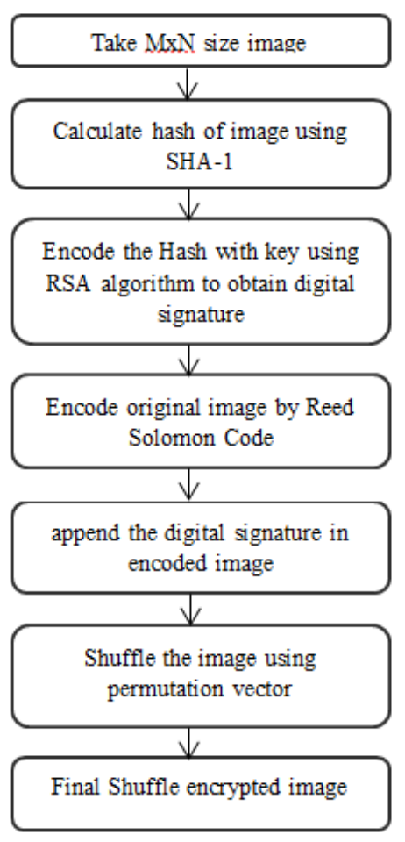
Fig3.1.encryption

- A plain image M*N dimension is taken.
- Take out the hash of the image using SHA-1
- Apply RSA algorithm to encrypt the hash with a private key. We get the 64 byte digital signature as a result.
- Apply Reed Solomon Encoding algorithm on original image
- Append the digital signature with the encoded image to get the encrypted image. Encrypted image =append (encoded image + digitalsignature)
- The encrypted image is shuffled using chaotic Logistic mapping.
- resultant encrypted image

3.3 DECRYPTION

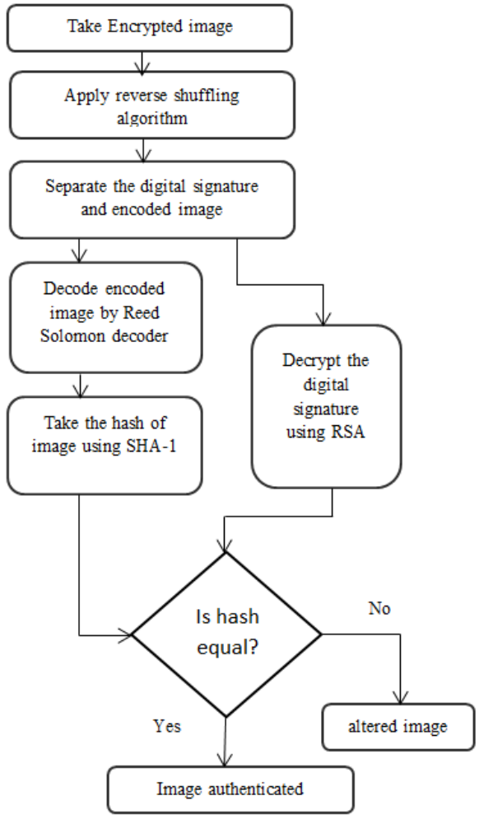
Fig 3.2.decryption
- Use the reverse shuffling algorithm to de shuffle the encrypted image.
- Get a de shuffled image .Now separate the digital signature and the encoded image.
- The encoded image obtained is decoded using Reed Solomon Decoder and finally the original image is obtained.
- Next we decrypt the digital signature which is sliced from encrypted image, using public key RSA .We get the hash value.
- Finally take out the hash of obtained image (final) using SHA-1. Compare the hashes of obtained image (final) and one obtained in above step.
- If the hashes are same, then there is no noise interruption. Else if hashes are not same then there are some bits changes made by the intruder.

3.4 SIMULATION RESULTS

This section presents experimental results for Lena image. The proposed scheme is simulated on Python language to verify the correctness of the proposed methodology for image encryption. The figure 4 and figure5 shows the simulation result on gray scale Lena. The original image is encoded using RS algorithm before the addition of digital signature. The message
digest generated by using SHA-1 and encrypted by RSAalgorithm to obtain 64byte or 512bit as shown in table 1. The encrypted image obtained is larger in size than the original Lenaimage because of redundant bits added due to error control coding. At the receiver side decision is taken after obtaining the hash value of image and embedded hash value. If the hash values are same then this is the indication that the original image has not been intervened by intruders. If image is altered as shown in figure 4(e) then it is easily detected by comparing the hash values. This enables us to authenticate the image transmitted by the known sender. The added advantage in proposed technique is that there is no requirement to transmit separately the random keys.



Fig3.3.original image Fig 3.4 encoded image

 Fig 3.5 encrypted image

 Fig 3.6 recovered image


Fig 3.7 altered image

CHAPTER 4
4 DRAWBACKS
- The private key must be kept in a secured manner.
- The process of generation and verification of digital signature
requires considerable amount of time. So, for frequent exchange of
messages the speed of communication will reduce.
- For using the digital signature the user has to obtain private and
public key, the receiver has to obtain the digital signature
certificate also. This requires them to pay additional amount of
money. Although digital signature provides authenticity, it does not
ensure secrecy of the data. To provide the secrecy, some other
technique such as encryption and decryption needs to be used

CHAPTER 5

5 CONCLUSION
The robust technique of image authentication and Image encryption technique based on digital signature and error correcting code is proposed. It has implemented successfully in Python language. We have tested the algorithm on the Lena image. The dimension of image is changed due to addition of extra bits by Reed Solomon code that makes difficulty to encrypt the image. The authenticity of received image is checked using digital signature. This project successfully transfers the digital signature over the channel without giving the chances of intrusion by the intruder. Even if the image is intruded at the receiver end, the receiver will be able to differentiate between obtained image and original image by comparing the hashes. The digital signature is also verified with the same technique. Furthermore, the algorithm is shown to be highly sensitive to its alteration of image. Experimental results show that our scheme has high security and is capable of authenticating the image. To employ a more secure image encryption, X-box Mapping may be used which uses no stego keys, on which we will lay emphasis in our future works.

REFERENCES

[1] A. Sinha, K. Singh, “A technique for image encryption using digital
signature”, Optics Communications, vol. 218, no. 4-6, pp. 229–234, 2003.
[2] Nidhi Sethi,Deepika Sharma “A novel method of image encryption using
logistic mapping”, International Journal of Computer Science Engineering,
vol. 01, no. 2, pp. 115-119, 2012.
[3] B. Schneier, “Applied cryptography algorithms”, Wiley, 1996.
[4] R. Blahut, “Theory and practice of error control codes”, Addison Wesley,
Reading, MA, 1983
[5] F. MacWilliams, N. Sloane, “The theory of error correcting codes”, North
Holland, Amsterdam, 1977.
[6] H. Feistel, "Cryptography and computer privacy", Scientific American, vol.
228, no. 5, pp. 15-23, 1973.
[7] R. Rivest, A. Shamir, L. Adleman, "A method for obtaining digital
signatures and public-key cryptosystems", Communications of the ACM
vol. 21, no. 2, pp. 120–126, 1978.
[8] D. Bhattacharya, N. Bansal, A. Banaerji and D. R. Chowdhury, "A near
optimal S-box design", Information Systems Security, Lecture Notes in
Computer Science, vol. 4812, pp. 77–90, 2007

