**Exercise: - 1 Git and GitHub Tutorials – Version Control for Beginners**



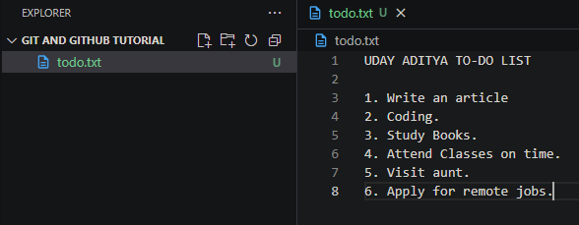

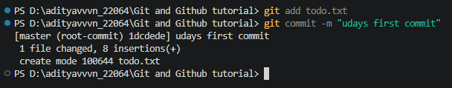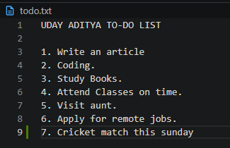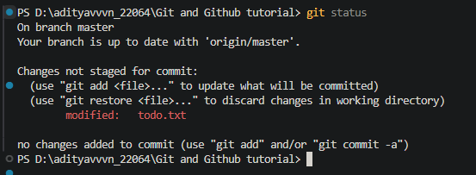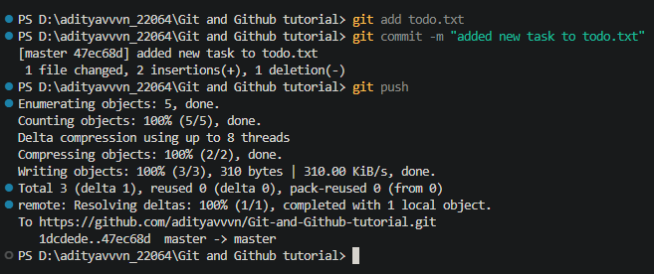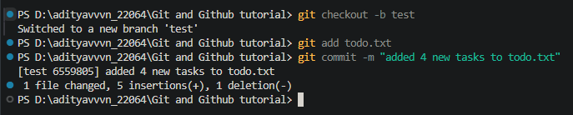

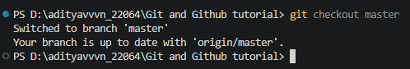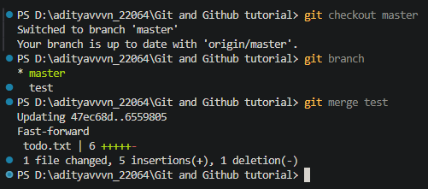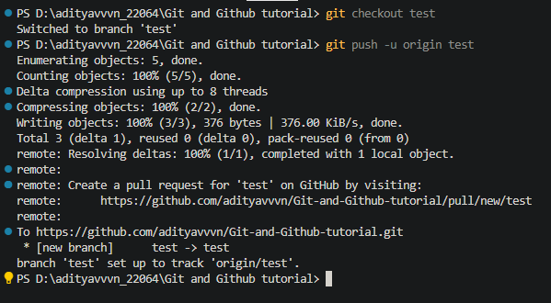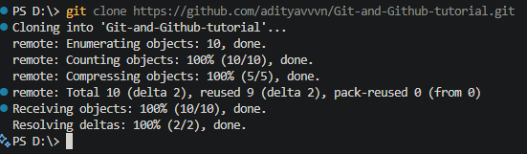

**Exercise: - 2 Installation of Node JS on Windows**

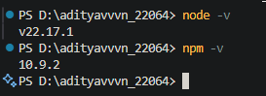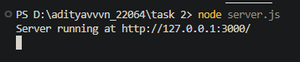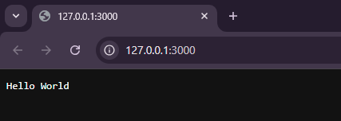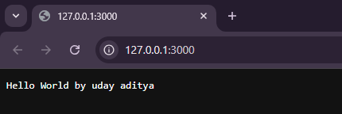

**Exercise: - 3**

**3a. Basic Structure of an HTML Document**

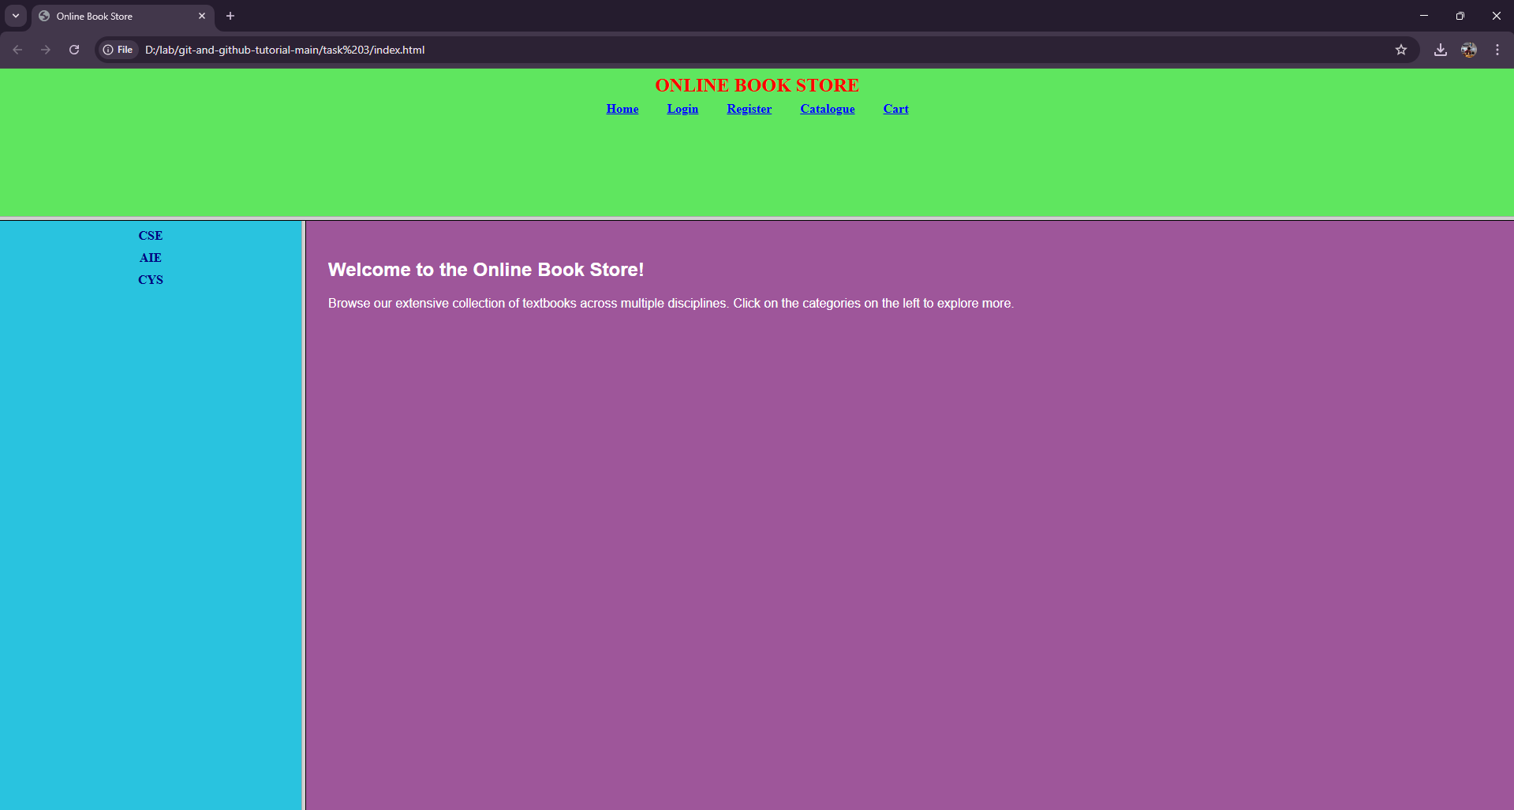

**3b. Design the following static web pages required for an online book store web site.**

1. **Home Page**
2. **Login Page**
3. **Catalogue Page**

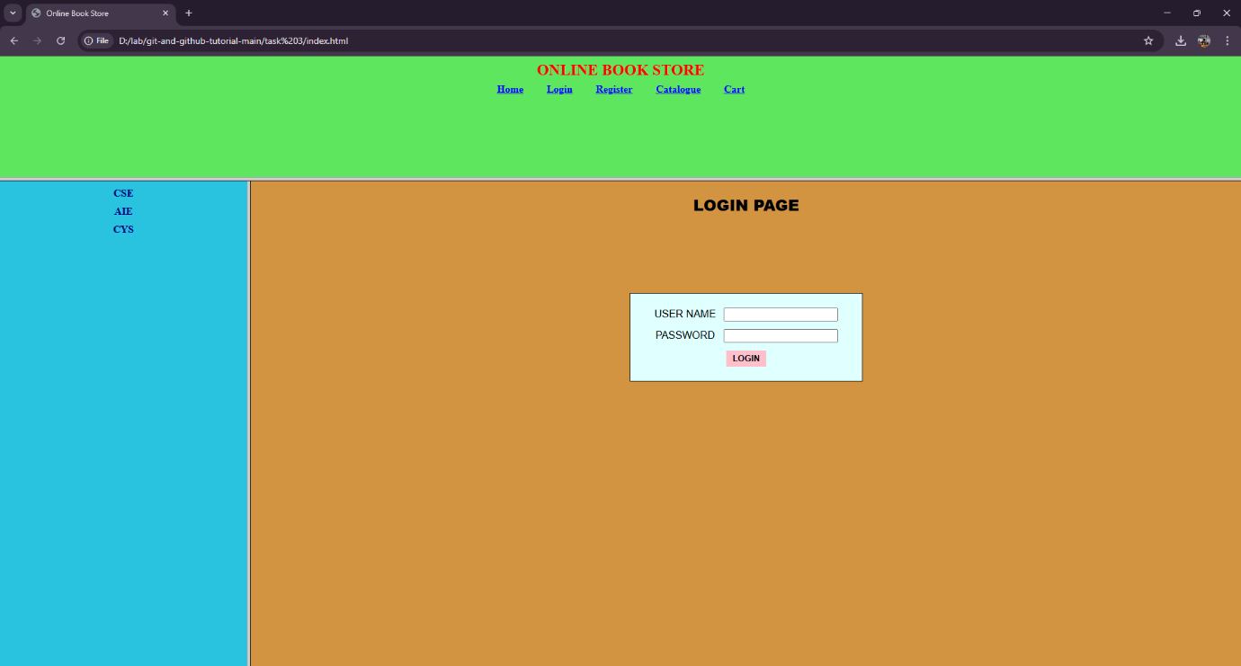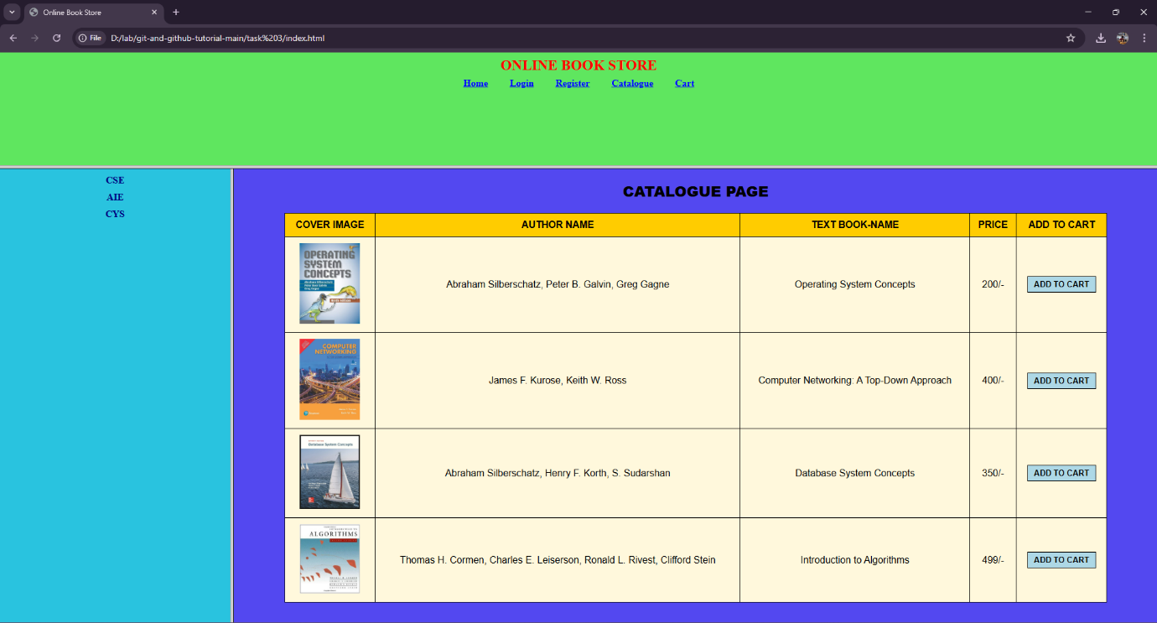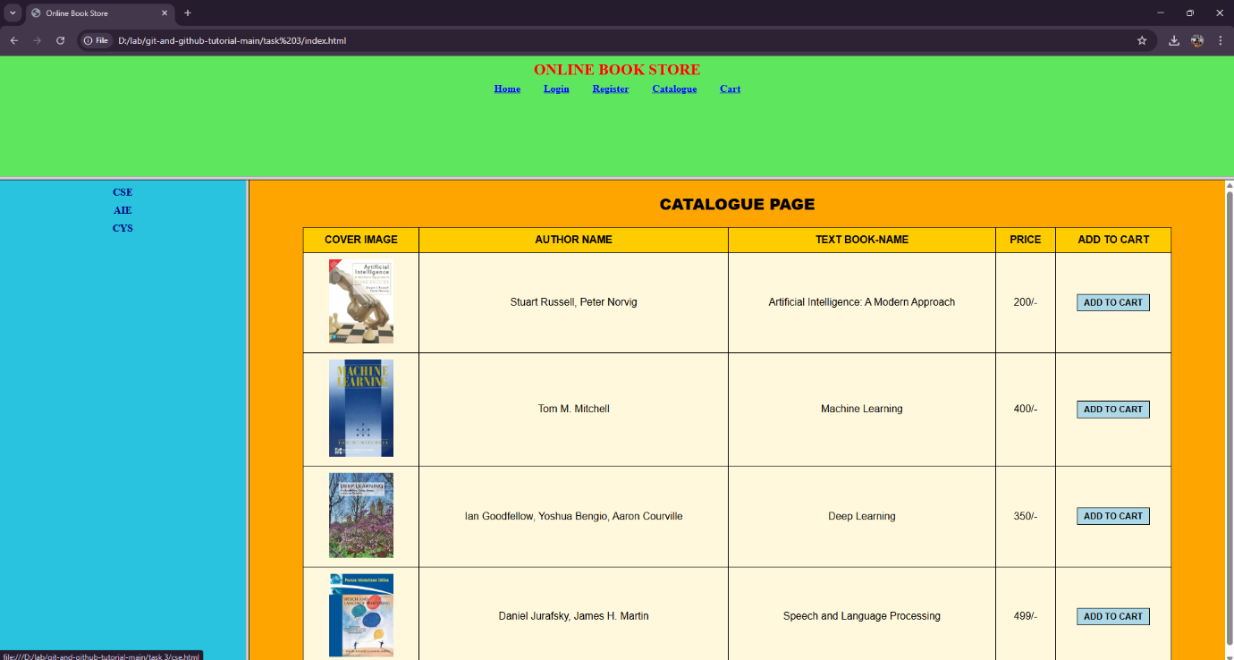

**3c. Design a web page using CSS which includes the following:**

1. **Use different font and text styles**
2. **Set a background image for both the page and single element on the page.**
3. **Define styles for links**
4. **Working with layers**
5. **Adding a Customized cursor**

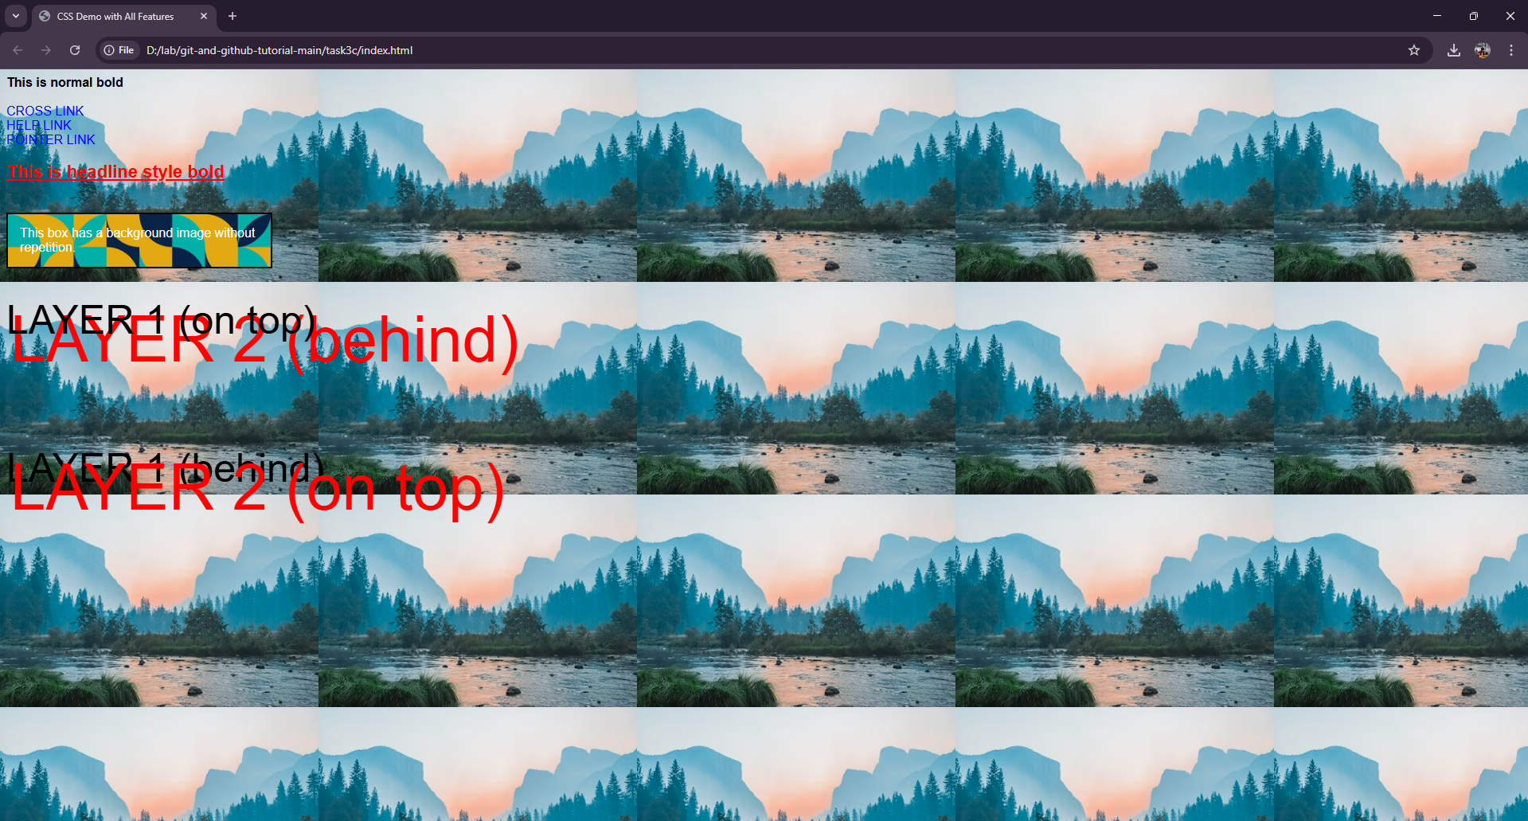

**Exercise: - 4 HTML Responsive Web Design**

**Examples of HTML Responsive Web Design**

1. **HTML Viewport meta tag for Responsive Web Design**
2. **Responsive Images**
3. **Responsive Texts**
4. **CSS media Queries**
5. **Responsive Layouts**

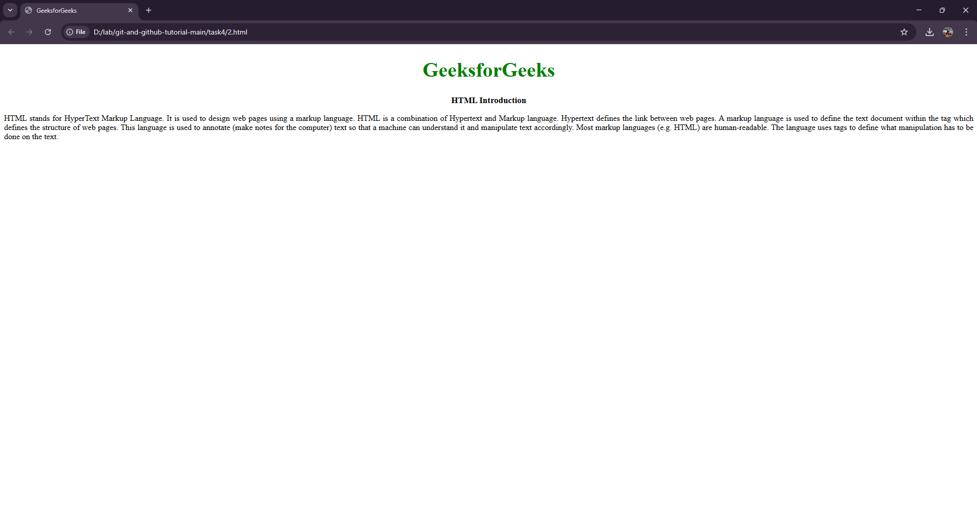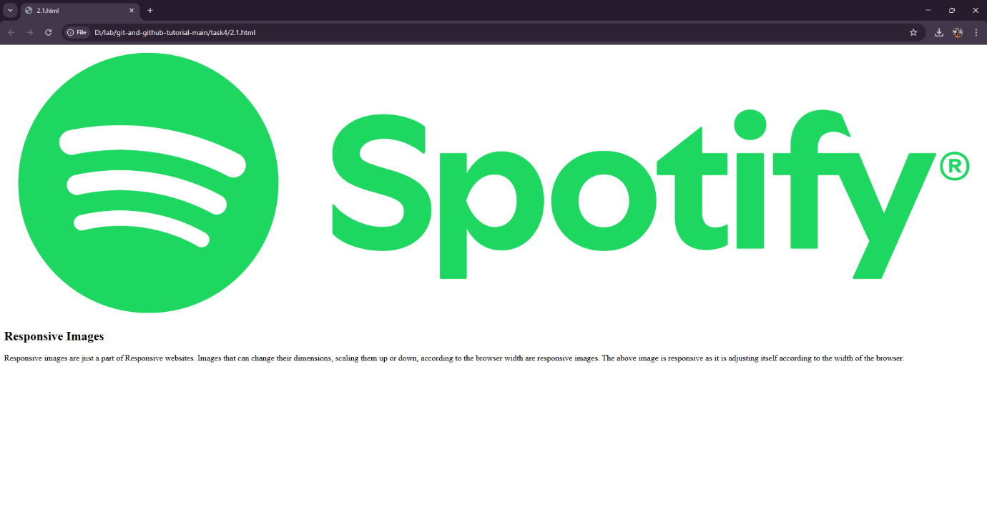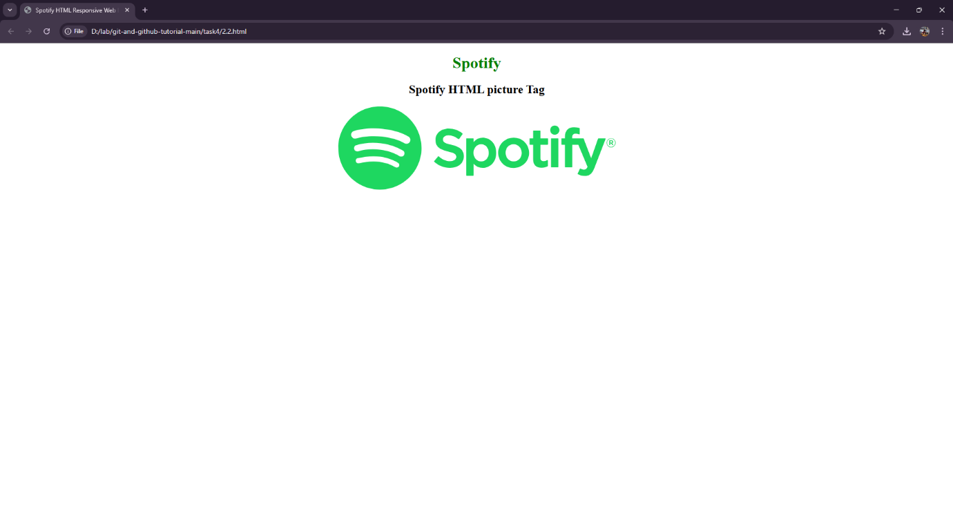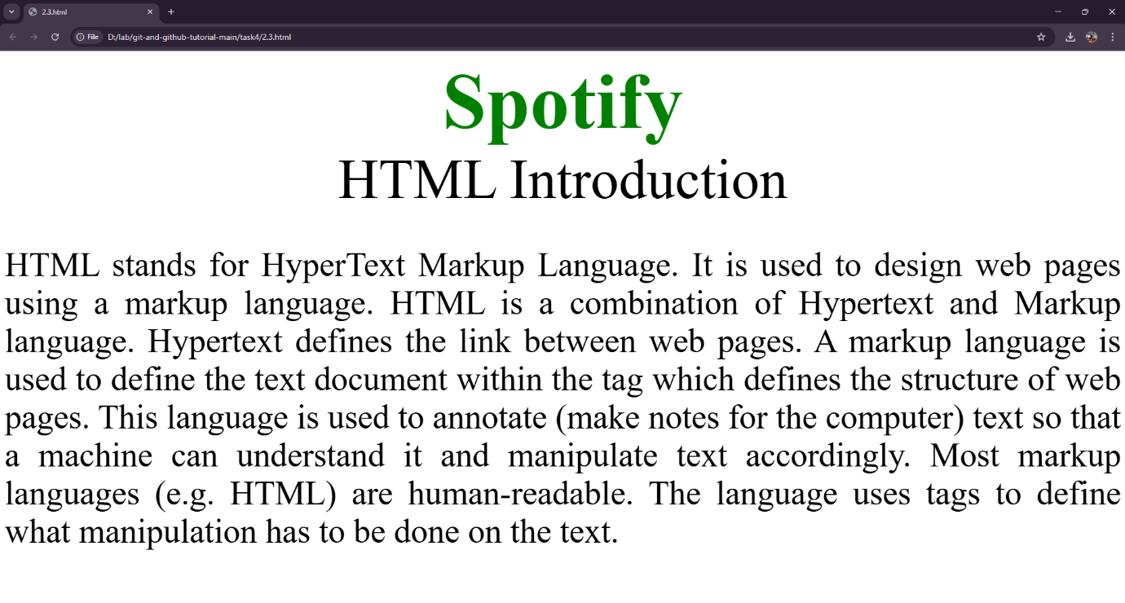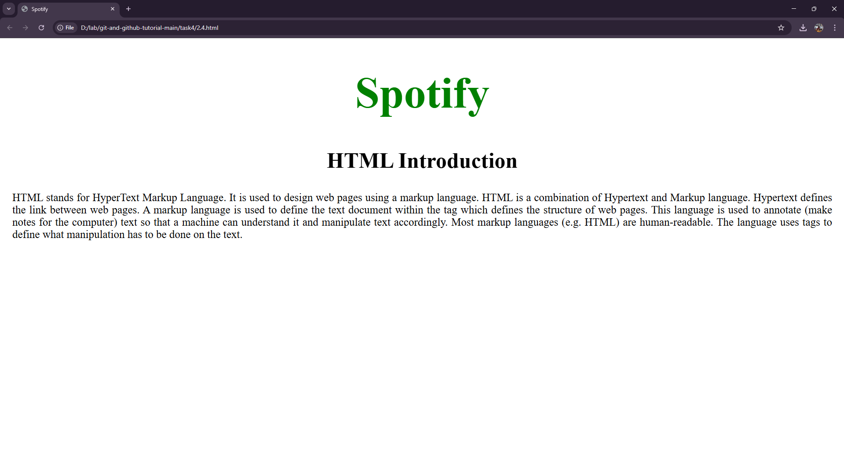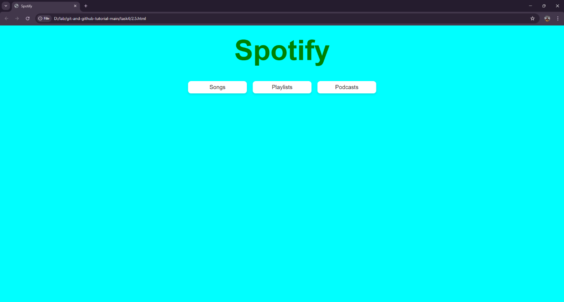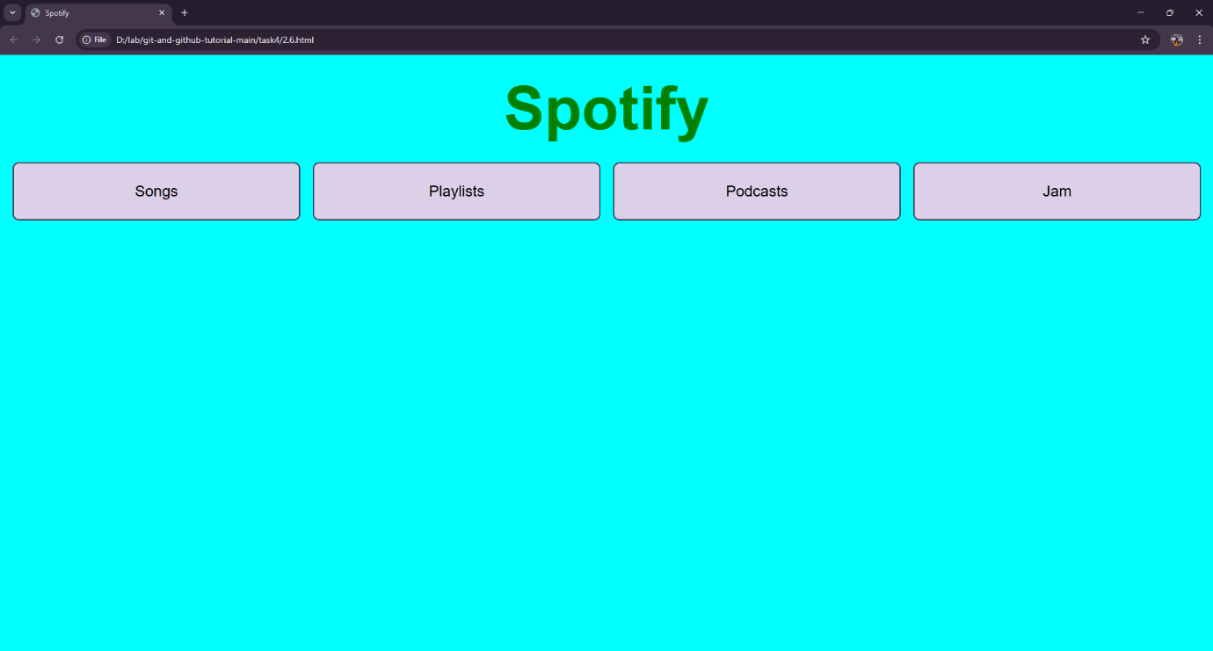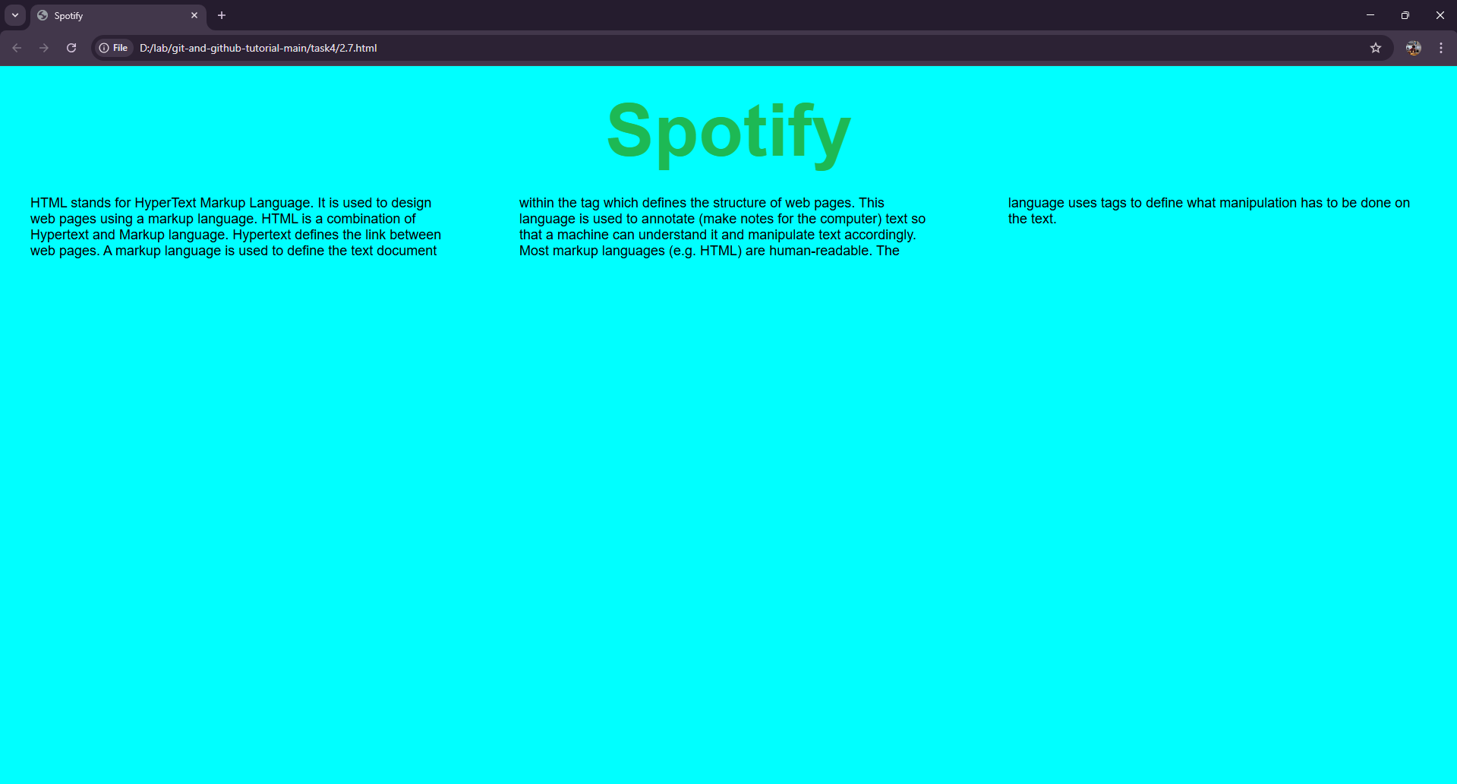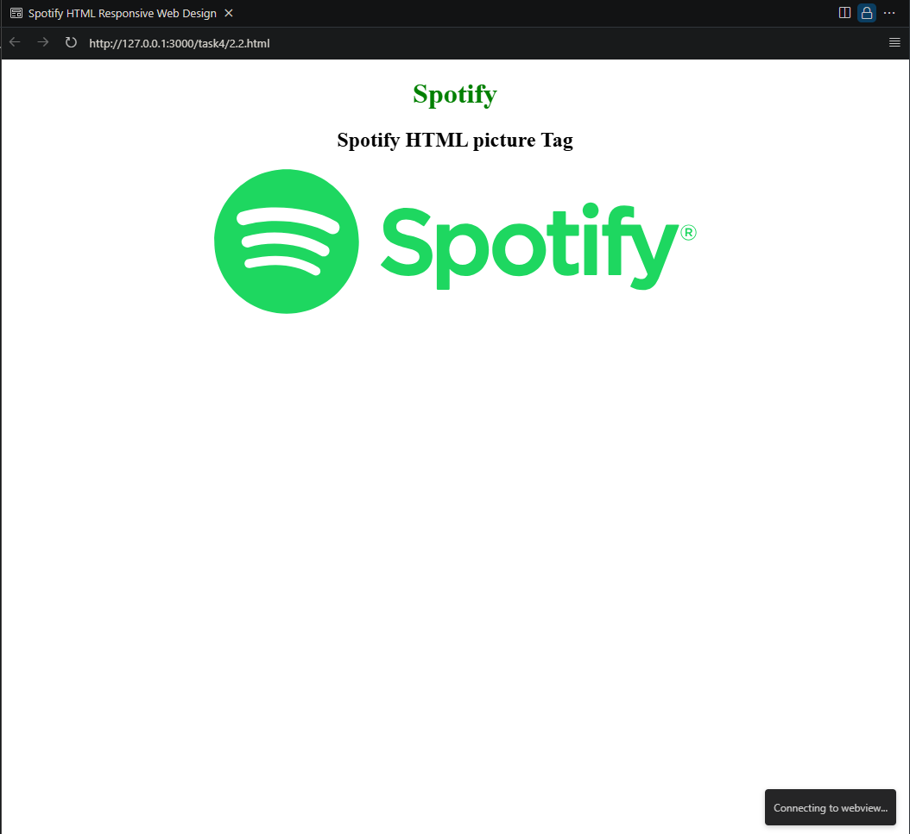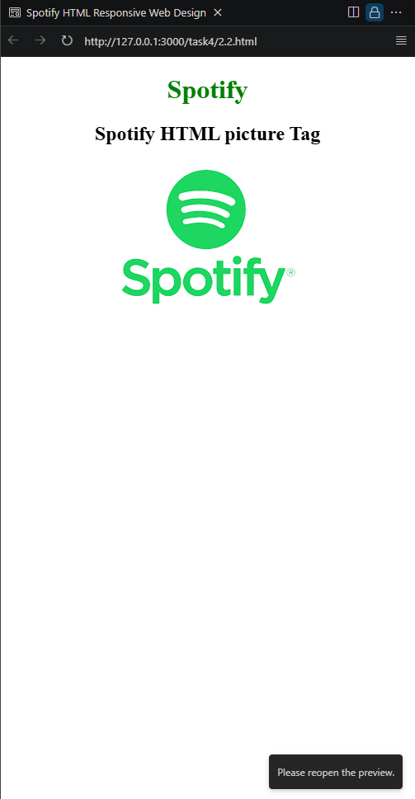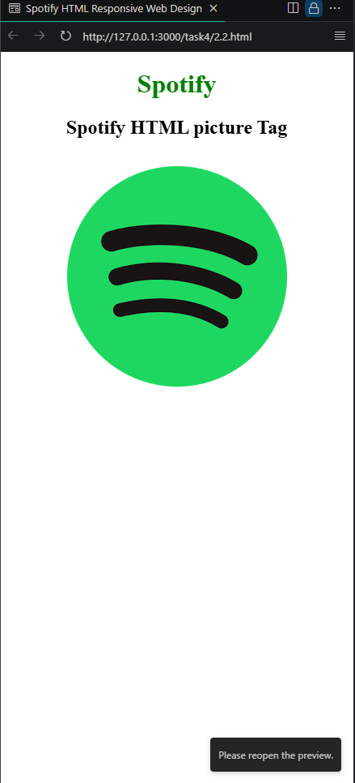

**Exercise: - 5 HTML Responsive Web Design**