Project Synopsis: VendorGuard AI – Evidence-Grounded Supplier Verification & Risk Intelligence
Verify the Supplier. Verify the Evidence. Verify the AI. Major Project Synopsis, Academic Year 2026–2027.

Cover
Project title: VendorGuard AI – Evidence-Grounded Supplier Verification, Predictive Risk Intelligence & AI Reliability Platform
Official problem statement: AI-Powered B2B Supplier Verification and Predictive Trust Scoring Engine
Student / Team: Aditya Yadav – Individual project (team size 1)
Enrollment / Roll number: 2315510016
Institute / Course: GLA University, Mathura – B.Tech (AI & ML), 4th Year (Final Year), Section AC – Major Project
Project mentor: ______________________________
Version: Draft v0.1
Date: 05 Oct 2026
GitHub repository link: https://github.com/adityayadav161003/VendorGuardAI

Revision history
Version | Date | Author | Change
v0.1 | 05 Oct 2026 | Aditya Yadav | Initial scope, methodology, architecture and evaluation plan

1. Overview
Problem statement: AI-Powered B2B Supplier Verification and Predictive Trust Scoring Engine. Businesses onboarding unfamiliar suppliers must review GST, PAN, company-registration, ISO/compliance, bank and invoice documents, cross-check them against external sources and judge risk – a slow, error-prone process that is hard to audit, and generic AI tools can add unsupported claims.
Project summary: VendorGuard AI is an evidence-grounded supplier due-diligence platform intended to help businesses review supplier documents, identify inconsistencies, surface risk indicators, and inspect the evidence behind an assessment. It combines document processing, entity resolution, evidence retrieval, predictive risk modelling, supplier relationship-graph analysis, and claim-level verification of AI-generated explanations. It is a decision-support tool, not an automated legal or procurement authority.
Goal: Design, implement and evaluate a working web platform that produces explainable supplier risk assessments from submitted documents and permitted evidence sources, while identifying unsupported or contradictory claims in its AI-generated reports.
Non-goals:
- No definitive legal finding that a supplier is fraudulent and no guarantee of supplier quality.
- No automatic purchases, payments, contracts or blacklisting.
- No claim of live government-registry verification unless an authorized source/API is actually available.
- No paid proprietary AI API as a mandatory core dependency.
Value proposition: A single workflow for supplier document review, evidence-backed risk indicators, relationship analysis and transparent AI explanations. Material factual claims should link to evidence or be labelled contradicted, unsupported, or unverifiable.

2. Scope and Control

2.1 In-scope
- Supplier profiles and controlled user access.
- PDF/image intake, OCR, document classification and field extraction.
- Cross-document consistency checks and entity resolution for names, addresses, identifiers and dates.
- Evidence store with source references and observation timestamps.
- Claim-level verification: supported, contradicted or insufficient evidence.
- Explainable risk indicators and a documented baseline model where suitable labels exist.
- Supplier relationship graph and suspicious-pattern analysis; GNN as an optional experiment.
- Web dashboard, evidence-linked reports, supplier comparison, REST API, testing and documentation.

2.2 Out-of-scope
- Automated final credit/legal/procurement decisions.
- Guaranteed access to every registry or confidential transaction database.
- Production ERP integrations, paid data brokers and training an LLM from scratch.
- Real-world fraud-accuracy claims without representative labelled data.

2.3 Assumptions
- Users are authorized to submit the documents they upload.
- External sources are used only where access and terms permit.
- Initial experiments may require public, curated and clearly labelled synthetic data.
- Risk outputs are decision-support indicators requiring human review.

2.4 Constraints
- Solo development alongside academic work.
- Limited compute and potentially limited labelled supplier-fraud data.
- OCR quality varies by scan quality, layout and language.
- Public sources can be incomplete, stale or restricted.

2.5 Dependencies
- Python and open-source AI/ML libraries.
- Database and protected document storage.
- Permitted source material and curated evaluation fixtures.
- Optional local/open LLM; rules and conventional ML baselines remain available.

2.6 Acceptance criteria and sign-off
ID | Acceptance criterion | Verification
AC1 | Supported PDF/image uploads are stored and processed or fail safely. | Upload tests
AC2 | Extracted fields show source page/snippet and confidence where available. | Labelled field test set
AC3 | Known cross-document conflicts are flagged with both sources. | Conflict fixtures
AC4 | AI claims are labelled supported, contradicted or insufficient evidence with evidence links. | Claim benchmark
AC5 | Reports show risk indicators, explanations, evidence and limitations. | UI/report review
AC6 | Evaluation includes baselines, error analysis and reproducible metrics. | Evaluation report

Sign-off: Mentor approves scope, demo and evaluation report; core acceptance criteria AC1–AC6 pass.

Sign-off table
Stakeholder | Role | Decision area | Signature/Approval | Date
____________________ | Project mentor | Scope, final acceptance | ____________ | __________
Aditya Yadav | Student / project lead | Release readiness | ____________ | __________

3. Stakeholders and RACI
Activity | Responsible (R) | Accountable (A) | Consulted (C) | Informed (I)
Requirements/scope | Student | Student | Mentor, potential users | Department
Architecture/data | Student | Student | Mentor | Department
Implementation | Student | Student | Mentor/peers | Department
Testing/evaluation | Student | Student | Mentor | Department
Security/privacy | Student | Student | Mentor | Department
Final demo/docs | Student | Student | Mentor | Department

4. Team and Roles
Member | Role | Responsibilities | Key skills | Availability | Contact
Aditya Yadav | Individual project lead | Research, architecture, coding, data prep, modelling, testing, documentation and demo | Python, ML, NLP, document AI, graph analysis, full-stack development | 3 months | ____________

5. Week-wise Plan and Assignments
(Indicative 16-week plan; replace with official semester dates and mentor milestones. All work is owned by the student as an individual project. Figure 6 shows an extended 6–8 month roadmap for the full platform vision; this synopsis commits to the 16-week core scope, with GNN experiments, monitoring and integrations deferred if time is short.)
Week | Milestone | Main work (Aditya) | Deliverables | Status
1 | Requirements | Mentor scope review; identify use cases and non-goals; user discovery if feasible. | Approved scope | Planned
2 | Literature/data plan | Review supplier risk, document AI, claim verification and graph fraud; assess dataset access. | Literature matrix and data plan | Planned
3 | Architecture/setup | Repository, API skeleton, schema, configuration, tests and logs. | Running skeleton and diagrams | Planned
4 | Document intake | File validation, metadata, PDF/image parsing and storage. | Upload workflow | Planned
5 | OCR/extraction | OCR and extraction of selected fields; preserve source references. | Extraction baseline | Planned
6 | Entity resolution | Normalize fields and detect cross-document conflicts/expiry. | Consistency module | Planned
7 | Evidence retrieval | Index passages and store source metadata/timestamps. | Evidence API | Planned
8 | Claim verification | Claim extraction and support/contradiction/insufficient-evidence classification. | Claim benchmark baseline | Planned
9 | Risk baseline | Define interpretable features; train only if labels are defensible, otherwise use rules. | Baseline report | Planned
10 | Graph intelligence | Build relationship graph and test shared-entity/anomaly signals. | Graph view and synthetic tests | Planned
11 | Explainability | Combine indicators and evidence into reviewable reports. | Traceable report | Planned
12 | Frontend/API integration | Dashboard, supplier profile, document review and comparison. | End-to-end workflow | Planned
13 | Security/robustness | Access control, upload checks, secrets, audit trail and error handling. | Security checklist | Planned
14 | Evaluation | Held-out tests, baselines, latency, false-positive/negative analysis. | Results and limitations | Planned
15 | Deployment/user review | Deploy demo if feasible; test usability and fix priority issues. | Demo and test report | Planned
16 | Finalization | README, diagrams, reproducibility, report, slides and demo script. | Final submission package | Planned

6. Users and UX

6.1 Personas
SME procurement owner: Reviewing an unfamiliar supplier before a purchase.
Procurement/operations staff member: Checking missing, expired or conflicting documents.
Manager/reviewer: Needs the evidence and uncertainty behind risk indicators.

6.2 Top user journeys
Onboarding review: Create supplier profile → upload documents → inspect extracted fields → review conflicts → generate evidence-backed report.
Report review: Open report → inspect risk indicators → follow evidence links → record human review decision.
AI analyst query: Ask AI analyst a question → retrieve evidence → verify material claims → return a cited answer with uncertainty labels.

6.3 User stories
- As a procurement user, I want extracted fields linked to sources so I can verify them.
- As a reviewer, I want document conflicts and expiry dates highlighted.
- As a user, I want factual AI statements backed by evidence.
- As a manager, I want comparable risk indicators without treating scores as definitive verdicts.

6.4 Accessibility & localization
The initial interface targets English, keyboard-operable core workflows, readable contrast, clear status labels and a responsive desktop-first layout.

7. Market and Competitors

7.1 Competitor table
Category | Typical capabilities | Potential gap / hypothesis | VendorGuard differentiation
Enterprise supplier-risk platforms | Monitoring, compliance workflows, risk dashboards, integrations | May be complex or costly for some SMEs; validate through interviews | Focused supplier-onboarding workflow
OCR/document extraction tools | Extract fields from PDFs/images | Extraction alone does not establish identity or reconcile records | Cross-document checks plus provenance
Generic LLM/RAG apps | Answer questions over documents | Can generate unsupported claims | Independent claim verification and uncertainty labels
Fraud/graph analytics | Shared-entity and network signals | May require proprietary transaction data | Transparent graph signals on permitted/synthetic data

7.2 Positioning
Unique angle: An affordable, evidence-first supplier due-diligence assistant for small and medium-sized businesses.
Validation status: Positioning hypothesis only – demand and willingness to pay are not yet proven.

7.3 Validation plan
- Interview 3–5 prospective users initially and expand if feasible.
- Ask about onboarding steps, document types, review time, common failure cases and decision owners.
- Test whether evidence-linked reports solve a recurring problem and earn user trust.
- Use synthetic/anonymized data in demos unless permission for real records is obtained.

8. Objectives and Success Metrics
Objective | Metric | Evaluation plan
Document extraction | Per-field precision, recall, F1 | Label test documents; report field-level errors.
Consistency detection | Precision, recall, F1 | Compare rules with normalization/entity-resolution pipeline.
Claim verification | Per-class precision/recall, macro-F1 | Evaluate supported, contradicted and insufficient-evidence classes.
Risk model | ROC-AUC/PR-AUC where appropriate; calibration/confusion matrix | Use only when labels and sample size are defensible; compare simple baselines.
Graph signals | Precision@k/recall on labelled or planted cases | Separate synthetic benchmark results from real-world validity.
Explainability | Share of material claims linked to evidence or uncertainty labels | Audit generated reports.
Usability | Task completion and user feedback | Small task-based review; set thresholds after pilot.
Reliability | Latency, failures, reproducibility | Benchmark on documented hardware and sample sizes.

No model-performance results are claimed in this synopsis; all outcomes will be measured after implementation.

9. Key Features
Feature | Description | Priority | Acceptance criteria
Supplier profiles | Business details, documents, status and review notes. | Must | Create/view/edit profile and audit changes.
Document intake | Validate supported PDF/images and file limits. | Must | Valid files accepted; invalid files fail safely.
OCR/extraction | Extract configured fields with page references. | Must | Field metrics and source links displayed.
Consistency checks | Compare fields and detect conflicting/expired values. | Must | Known test conflicts flagged.
Evidence retrieval | Search uploaded docs and permitted source snapshots. | Must | Results show source ID and timestamp.
Claim verification | Label claims supported/contradicted/insufficient evidence. | Must | Test claims return label and evidence.
Risk indicators | Transparent rules/features with explanations. | Must | Every indicator has definition and reason.
Graph intelligence | Map entities and shared relationships. | Should | Inspectable graph and flagged patterns.
AI analyst | Answer evidence-grounded questions. | Should | Citations or uncertainty on material claims.
Comparison/export | Compare suppliers and export report. | Could | Report includes evidence and limitations.
Monitoring/API | Refresh permitted sources and expose endpoints. | Could | Only implemented sources are labelled active.

10. Architecture

10.1 High-level
Clients: React + TypeScript dashboard (supplier workflow, report visualization, graph view).
Services: FastAPI backend (authentication, validation, audit) → document intake → OCR/parsing → field extraction → entity resolution → supplier profile + evidence store → evidence retrieval → claim verification | risk model/rules | supplier graph.
Outputs: Explainable risk report, evidence-linked AI analyst and human review.
Data stores: PostgreSQL (profiles, metadata, claims, evidence, assessments), FAISS vector index, protected document storage.
Integrations: Permitted external sources only (e.g., MCA/GST portals, public registries, news, sanctions lists) where access and terms allow.

10.2 Proposed technology components
Layer | Candidate technology | Purpose
Frontend | React, TypeScript, Tailwind CSS | Supplier workflow and report visualization
Backend | Python, FastAPI, Pydantic | Business logic, validation and APIs
Document AI | PyMuPDF/pdfplumber, PaddleOCR or Tesseract | PDF/image text extraction
NLP | spaCy, Transformers, rules | Entity/field/claim extraction
Evidence retrieval | Sentence embeddings, FAISS, PostgreSQL metadata | Retrieve source passages and preserve provenance
Claim verification | NLI model plus rules/evidence thresholds | Support/contradiction/insufficient-evidence labels
Risk modelling | Scikit-learn; optional XGBoost/LightGBM | Interpretable prediction where labelled data supports it
Graph analysis | NetworkX; optional PyTorch Geometric | Relationships and suspicious-pattern experiments
Database | PostgreSQL | Profiles, metadata, claims, evidence and assessments
Deployment | Docker; local first, hosting if feasible | Reproducible demo

10.3 API spec snapshot
Endpoint | Method | Purpose
/api/suppliers | POST | Create supplier profile
/api/suppliers/{id}/documents | POST | Upload document
/api/suppliers/{id}/analyze | POST | Start analysis job
/api/suppliers/{id}/report | GET | Retrieve evidence-linked report
/api/claims/verify | POST | Verify claims against evidence
/api/suppliers/compare | POST | Compare selected suppliers

10.4 Config and secrets
Keep secrets in environment variables, not Git; commit .env.example only. Validate file types/sizes, store uploads outside public paths and restrict access to uploaded files. Avoid logging raw documents or sensitive identifiers.

11. Data Design

11.1 Data dictionary
Entity | Key fields | Notes
User | user_id, name, email, role, organization, created_at | Store minimum necessary personal data.
Supplier | supplier_id, name, business_type, industry, website, address, status, created_by | Access-control sensitive identifiers.
Document | document_id, supplier_id, document_type, file_path, extracted_text, metadata, uploaded_by, status | Protected file storage and metadata.
ExtractedEntity | entity_id, document_id, entity_type, entity_value, confidence_score, page_number | Keep source provenance.
EvidenceSource | evidence_id, source_type, title, url, snippet, retrieved_at, reliability_score | Record origin and observation time.
AnalysisResult | analysis_id, supplier_id, risk_score, risk_level, summary, model_version, generated_at | Record model/rule version.
Claim | claim_id, analysis_id, document_id, claim_text, claim_type, status, confidence_score | Supported / contradicted / insufficient evidence / review.
ReviewerAction | review_id, claim_id, reviewer_id, action, comment, reviewed_at | Human decisions stored separately from model output.
RiskReport | report_id, supplier_id, generated_by, overall_risk_score, key_findings, recommendation, report_url | Final evidence-linked supplier report.

11.2 Schemas and migrations
Use versioned migrations and keep raw documents, extracted fields, evidence, claims and assessments logically separate. Store model/rule versions for reproducibility.

11.3 Privacy, retention, backup/DR
Prefer synthetic/anonymized demo data. Obtain permission before processing real supplier records and define deletion procedures. Use role-based access and protect files in transit and at rest where deployed. Document retention/backup settings; do not claim recovery targets until tested.

12. System Design Diagrams

12.1 State Transition Diagram (claim verification)
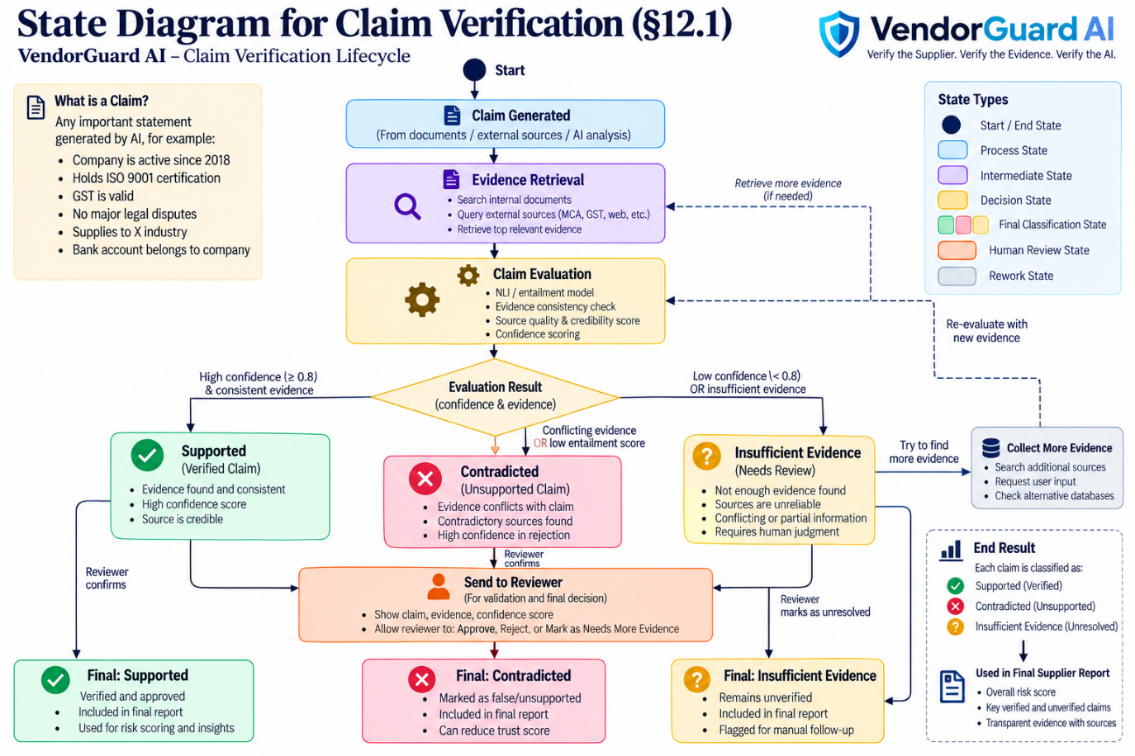
Figure 1: Claim verification state diagram
Claim → retrieve candidate evidence → assess relevance → apply rules/NLI → supported / contradicted / insufficient evidence → attach sources and model version → reviewer accepts, rejects or requests more evidence.

12.2 Sequence Diagram
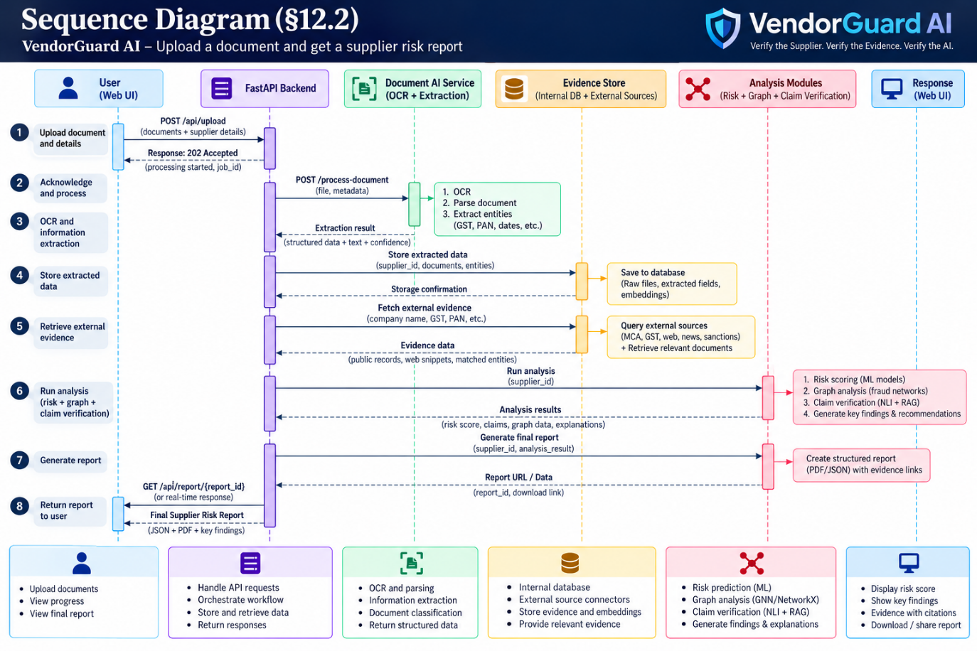
Figure 2: Sequence diagram – upload a document and get a supplier risk report
The user uploads documents and supplier details; the FastAPI backend returns a job ID, calls the document AI service for OCR and extraction, stores the results in the evidence store, retrieves external evidence, runs the analysis modules (risk scoring, graph analysis and claim verification) and returns an evidence-linked supplier risk report to the web UI.

12.3 Use Case Diagram
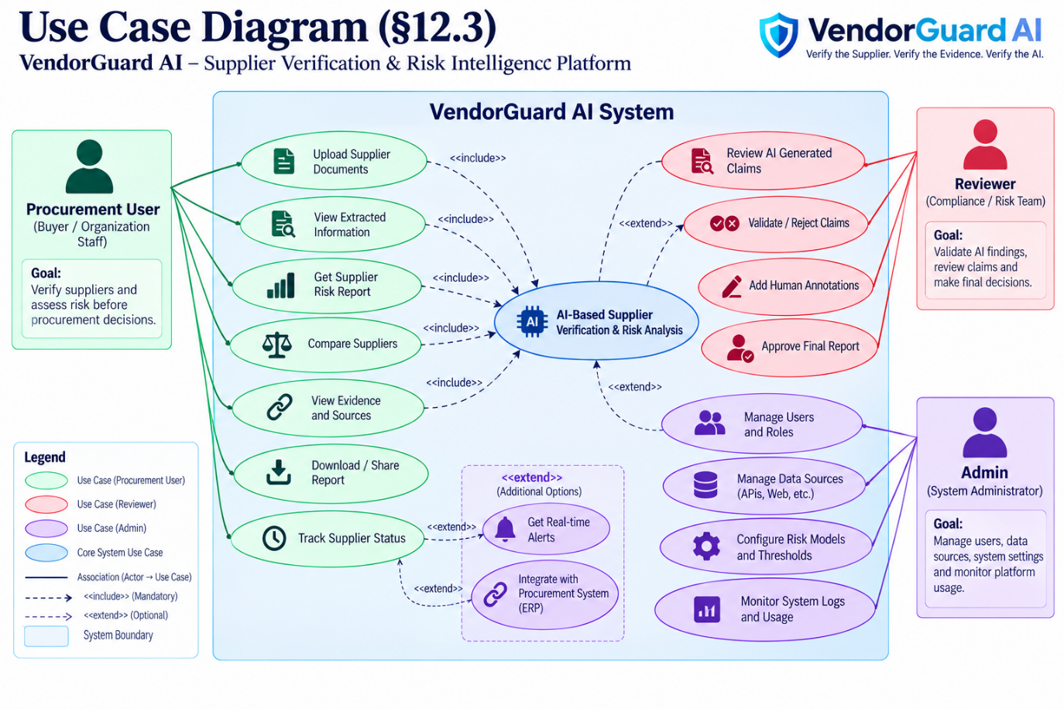
Figure 3: Use case diagram
- Procurement user: manage supplier, upload documents, run analysis, inspect report and compare suppliers.
- Reviewer: inspect evidence, resolve false matches and record review decision.
- Administrator: manage access, audit events and permitted source connectors.

12.4 Data Flow Diagram
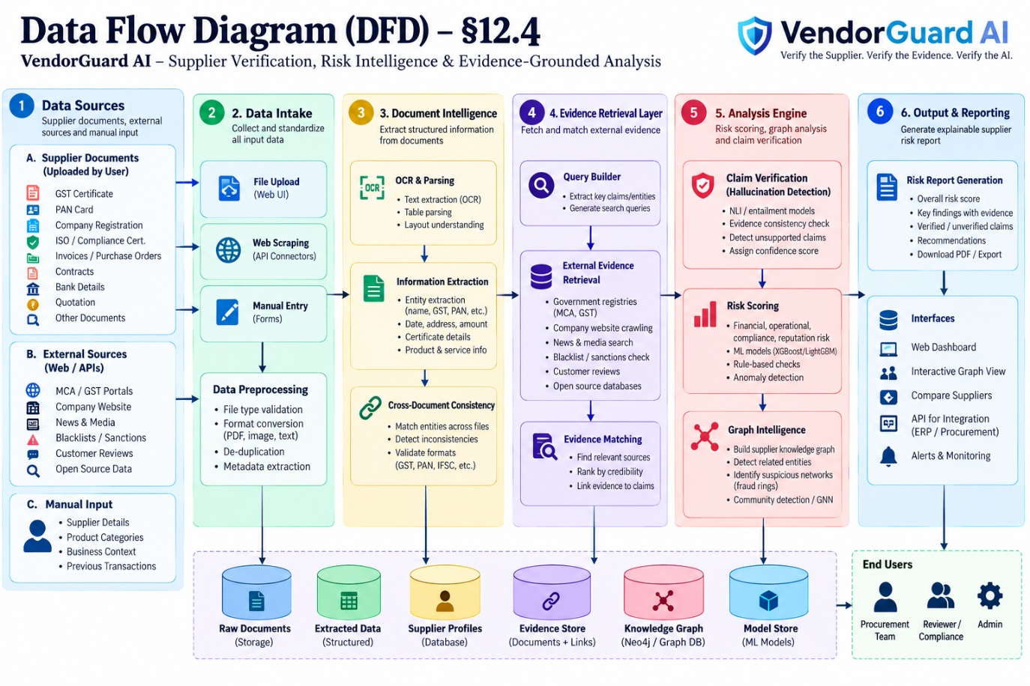
Figure 4: Data flow diagram
External inputs (documents, user-entered details, permitted sources) → intake/validation → extraction/normalization → supplier/evidence records → analysis modules → report/API output. Human corrections are stored separately and are not assumed to be ground truth.

12.5 ER Diagram (logical)
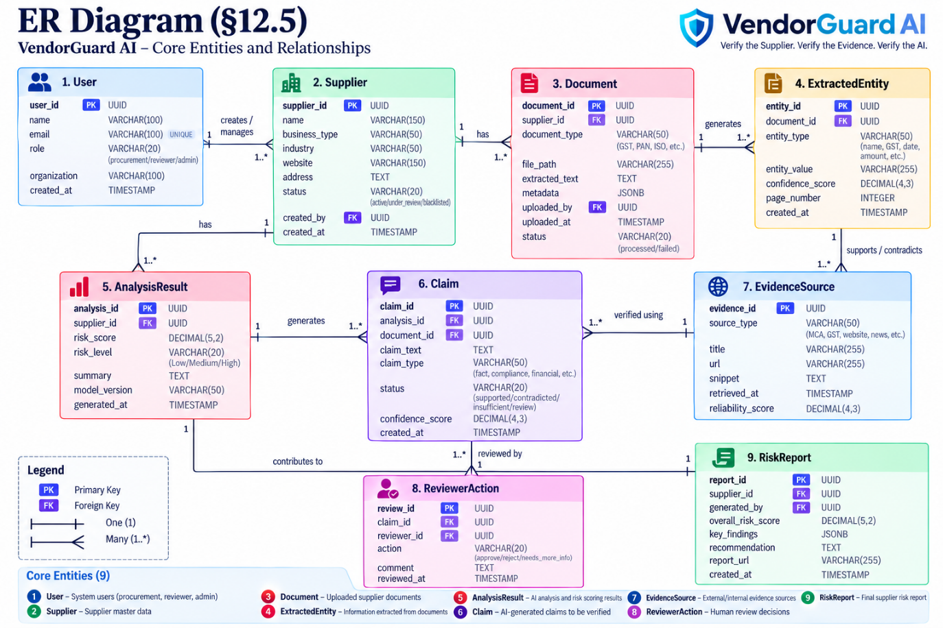
Figure 5: ER diagram – core entities and relationships
User 1:N Supplier (creates/manages); Supplier 1:N Document; Document 1:N ExtractedEntity; ExtractedEntity 1:N EvidenceSource (supports/contradicts); Supplier 1:N AnalysisResult; AnalysisResult 1:N Claim; Claim N:1 EvidenceSource (verified using); Claim 1:N ReviewerAction; AnalysisResult 1:1 RiskReport. Audit events and supplier-graph relationships are stored alongside these core tables.

12.6 Technical Workflow (summary)
User → supplier profile → document upload → validation/OCR → extraction → entity normalization → consistency checks → evidence retrieval → claim verification → risk/graph analysis → report → human review.

12.7 Work Architecture Diagram
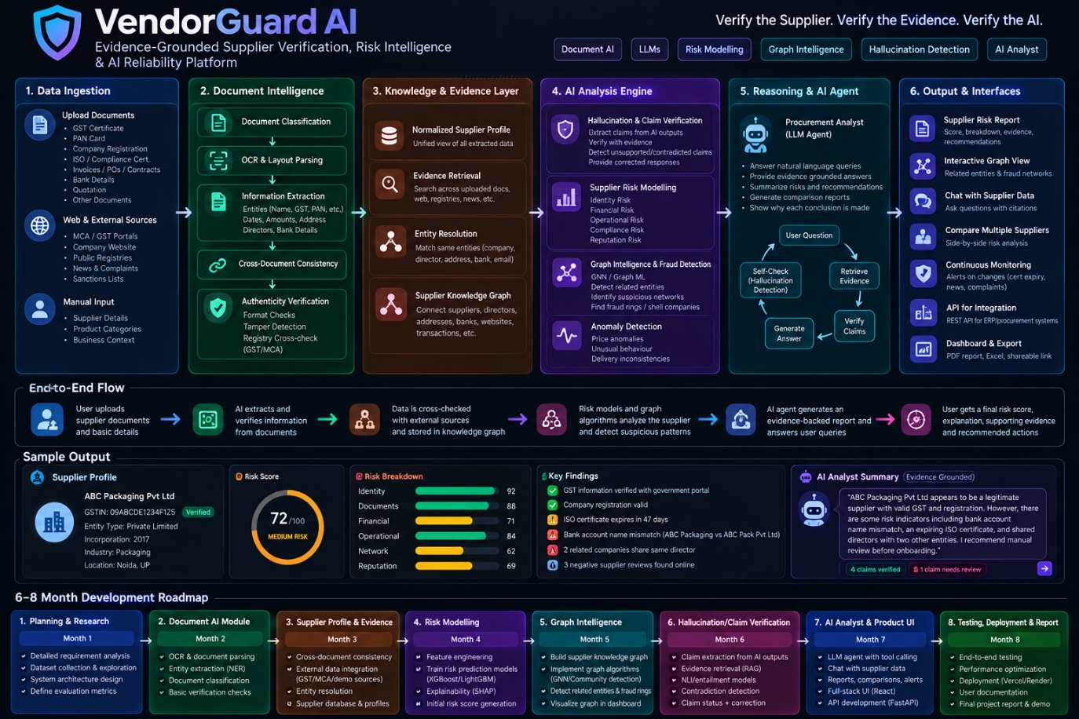
Figure 6: VendorGuard AI platform architecture, end-to-end flow and sample output
Start as a modular monolith with separated Python modules and API boundaries to reduce solo-developer overhead. Split services only if scale or deployment needs justify it. The platform overview above shows the six layers (data ingestion, document intelligence, knowledge & evidence, AI analysis engine, reasoning & AI agent, outputs & interfaces), the end-to-end flow and a sample supplier risk output.

13. Quality: NFRs and Testing

13.1 Non-functional requirements
Area | Requirement | Measurement
Reliability | Invalid/unsupported files fail safely. | Negative tests and logs
Performance | Measure processing latency and API p50/p95 on stated hardware. | Repeatable benchmark
Security | No committed secrets; authenticated access; validated uploads. | Scans and access tests
Traceability | Claims link to evidence or uncertainty state. | Automated report audit
Reproducibility | Pinned dependencies, data versions and documented commands. | Clean environment run
Maintainability | Modular code, schemas, README and tests. | Code checklist
Usability | Users can understand flagged conflicts and indicators. | Task-based feedback

13.2 Test plan
Area | Type/tools | Exit criteria
API | pytest, FastAPI TestClient | Critical scenarios pass
Document processing | Fixture-based and malformed-file tests | Supported files process; bad files fail safely
Extraction/entity resolution | Labelled fixtures and evaluation scripts | Metrics and error categories documented
Claim verification | Per-class metrics and adversarial cases | Confusion matrix and error analysis reported
Risk/graph | Baselines and planted-pattern tests | Data limitations clearly stated
Frontend | Manual and optional Playwright E2E | Core user journeys complete
Security | Authorization, upload validation and secret scan | No known critical demo issue left unresolved

13.3 Environments
Development: local Python environment and database. Test: synthetic/curated fixtures and isolated test database. Demo: Dockerized deployment if feasible. Production-grade operation requires further security, legal and operational review.

14. Security and Compliance

14.1 Threat model
Threat | Impact | Mitigation
Malicious uploaded file | Parser abuse or resource exhaustion | Type/size limits, timeouts, patched libraries, isolated processing where feasible
Unauthorized access | Supplier/business data exposure | Authentication, least privilege and authorization tests
Prompt injection in sources | Untrusted content affects model behaviour | Treat retrieved content as data; separate instructions and evidence; verify claims independently
Hallucinated explanation | Poor decision from unsupported claim | Evidence links, uncertainty labels, claim checks and human review
False entity match | Unrelated entities incorrectly linked | Conservative thresholds, explanation and manual review
Secret/data leakage | Credentials or private records exposed | No secrets in repo, minimal logs, protected storage and deletion process
Misleading feedback/data | Biased or unreliable model | Track provenance; version data; do not blindly train on feedback

14.2 AuthN/AuthZ
Implement secure authentication and API-level access checks. Roles may include user and reviewer/admin; access to documents and reports must be limited to authorized users.

14.3 Audit and logging
Record upload, analysis, report-access and review events while avoiding unnecessary raw document content or full sensitive identifiers.

14.4 Compliance and responsible use
This is an academic decision-support prototype. It is not a legal determination, guarantee of supplier reliability or substitute for human due diligence. Data must be used with permission and according to applicable terms.

15. Delivery and Operations

15.1 Release plan
Release | Scope | Exit criterion
Alpha | Profiles, intake, extraction and consistency checks | Upload-to-profile flow demonstrated
Beta | Evidence retrieval, claim verification, baseline risk indicators and report | Evidence-linked report and initial evaluation
Research release | Graph experiment, comparisons and error analysis | Reproducible evaluation documented
Final demo | Integrated UI/API, security checks, docs and presentation | Core acceptance criteria pass; limitations disclosed

15.2 CI/CD and rollback
Use GitHub for version control and optional GitHub Actions for linting/tests. Pin dependencies, document Docker builds, separate configuration from code and document rollback to a known-good version.

15.3 Monitoring and alerting
- Track processing failures, API errors, latency and job status.
- Record model/rule version and evidence timestamps for each assessment.
- Use basic logs for the academic demo; do not claim production monitoring until implemented.

15.4 Runbooks
Processing failure: Inspect error class, validate safely, and retry only when appropriate.
Poor extraction: Inspect OCR/source page and flag for manual correction.
Unsupported claim: Show insufficient evidence and request more sources or human review.
Unexpected risk spike: Inspect indicators, source freshness, model version and possible false matches.

15.5 Communication plan
Maintain a weekly progress log, mentor reviews, an updated GitHub backlog and milestone demonstrations.

16. Risks and Mitigations

16.1 Risk register
Risk | Likelihood/impact | Mitigation
No labelled fraud dataset | High/High | Data audit early; use clearly labelled synthetic benchmark; avoid unsupported predictive claims.
Scope too large for solo work | High/High | Build phases; defer GNN, integrations and monitoring if core flow slips.
OCR errors | High/Medium | Test varied quality; retain provenance; allow human review.
False entity match | Medium/High | Conservative thresholds and evidence-backed review; never label fraud from a shared attribute alone.
Verifier misses errors | Medium/High | Labelled evaluation, adversarial cases, uncertainty state and limitations.
Sources unavailable/restricted | Medium/Medium | Use permitted sources and user-provided docs; do not imply live verification.
Compute/deployment constraints | Medium/Medium | Local-first development, compact models and reproducible local demo.
Privacy/secret leakage | Low–Medium/High | Synthetic demo data, access controls, secret scanning and deletion process.

17. Research and Evaluation

17.1 Research questions
- How accurately can selected supplier fields be extracted from heterogeneous documents, and which fields are most error-prone?
- Do cross-document consistency checks improve detection of known discrepancies over isolated extraction?
- How well does claim-level verification distinguish supported, contradicted and insufficient-evidence claims?
- Can supplier graphs surface planted or labelled suspicious patterns with understandable false-positive rates?
- How does evidence-grounded generation compare with an unverified LLM answer in factual support and traceability?

17.2 Experimental design
- Document extraction: label permitted/synthetic documents; report per-field precision, recall, F1 and error categories.
- Consistency: create matching and controlled-conflict pairs; compare rule-only and normalized entity-resolution pipelines.
- Claim verification: label claims against evidence; compare baseline LLM/RAG with retrieval plus independent verification.
- Risk scoring: use supervised models only if labels/sample size are defensible; otherwise evaluate transparent rules without claiming predictive fraud accuracy.
- Graph analysis: use synthetic graphs with planted relationships if real labels are unavailable; report this limitation.
- Ablation: disable individual components to estimate their contribution to selected metrics.

17.3 Baselines and metrics
Potential baselines include rule/regex extraction, simple retrieval, unverified LLM summaries and standard tabular classifiers when suitable labels exist. Metrics include precision, recall, F1, confusion matrices, PR-AUC/ROC-AUC where appropriate, evidence coverage, false-positive rate, latency and reviewer findings.

17.4 Expected outcomes
- Working pipeline for document intake, profiles, extraction, consistency checks, evidence retrieval, claim verification and traceable reports.
- Documented risk-indicator framework and graph-analysis experiment.
- Reproducible evaluation with baselines, failure analysis and dataset limitations.
- GitHub repository with setup instructions, tests, synthetic examples, architecture and demo.

17.5 Limitations
Synthetic data cannot establish real-world fraud performance. Public data may be stale or misattributed; OCR/entity resolution can fail; NLI models can misjudge nuanced claims. A risk score is not a probability of fraud unless calibrated and validated on representative data. These limits will be reported.

17.6 Future scope
- Additional permitted registry/certification connectors.
- Monitoring for source changes and certificate expiry.
- Audited reviewer feedback and supplier response workflows.
- More languages and document types.
- ERP/procurement integrations and multi-tenant SaaS hardening after security and market validation.

18. Appendices

18.1 Glossary
Term | Meaning
OCR | Optical Character Recognition.
NLP | Natural Language Processing.
RAG | Retrieval-Augmented Generation.
NLI | Natural Language Inference.
Entity resolution | Determining whether records refer to the same real-world entity.
GNN | Graph Neural Network.
PR-AUC | Area under the precision–recall curve.
Evidence provenance | Origin, time and context of evidence used in an assessment.

Technology stack: Python, FastAPI, React, TypeScript, Tailwind CSS, PostgreSQL, PyMuPDF/pdfplumber, PaddleOCR or Tesseract, spaCy, Hugging Face Transformers, sentence-transformers, FAISS, Scikit-learn, optional XGBoost/LightGBM, NetworkX, optional PyTorch Geometric, pytest, Docker, Git and GitHub.
References: Starting points for the literature review; verify exact editions and add recent peer-reviewed work on supplier-risk prediction, document fraud, graph fraud detection, hallucination evaluation and NLI claim verification.
- Lewis, P. et al. (2020). Retrieval-Augmented Generation for Knowledge-Intensive NLP Tasks. NeurIPS.
- Thorne, J. et al. (2018). FEVER: a Large-scale Dataset for Fact Extraction and VERification. NAACL-HLT.
- Kipf, T. N., & Welling, M. (2017). Semi-Supervised Classification with Graph Convolutional Networks. ICLR.
- Vaswani, A. et al. (2017). Attention Is All You Need. NeurIPS.
- Scikit-learn official documentation: model evaluation, classification metrics and calibration.
- Hugging Face Transformers official documentation: text classification, token classification and inference.
- FastAPI official documentation: validation, file uploads, security and testing.
- NIST (2023). Artificial Intelligence Risk Management Framework (AI RMF 1.0).

