ICT ACADEMY OF KERALA
Summer Internship Report

Gather

College Event Registration and Attendance



Adithyan P B
Sahrdaya College of Engineering and Technology
24 October 2026

EXECUTIVE SUMMARY
Gather is a MERN application for college event registration and attendance. Students discover events, reserve a seat, cancel eligible bookings, and view their own tickets. Organizers create and publish events, monitor capacity, view participants, record check-in, and download attendance registers.
The application uses React and TypeScript, Express and Node.js, Mongoose and MongoDB. Twenty database-backed integration tests and a local browser walkthrough passed. Fictional schedules and identities demonstrate the workflow. The project does not claim institutional adoption or measured improvements in participation.

INTRODUCTION
Event announcements, registration lists and attendance sheets describe different stages of one student experience. Gather explores how these stages can be coordinated in one application, with clear roles, a consistent event lifecycle and a traceable reservation record.
The project is prepared by Adithyan P B for the full stack development course context at ICT Academy of Kerala and Sahrdaya College of Engineering and Technology. It is separate from the institution’s operational systems and uses no real attendance or student incident data.

OBJECTIVES
The objectives are to build an end-to-end event workflow, protect participant details, keep capacity correct under simultaneous requests, and make the implementation understandable through tests and documentation.
- Provide one place for event discovery, reservations and attendance.
- Protect student information and enforce capacity, lifecycle and role rules on the server.
- Verify the main flows and prepare reproducible documentation for review.

SCOPE AND DELIVERABLES
The first release includes student registration and sign-in, event discovery, category and literal search, pagination, seat reservation, owner cancellation, ticket references, organizer drafts and publication, cancellation and completion, attendee search, timed check-in, dashboard counts and CSV export.
Deliverables include the React frontend, Express API, MongoDB models, an SRS, this report, setup and API notes, automated integration tests, a learning guide, screenshots and a source archive.
Payments, QR scanning, password recovery, email verification, email notifications, calendar-provider synchronization, certificates and biometrics are excluded. Organizer roles share management of the single-campus catalogue; there are no separate club or college permission boundaries.

METHODOLOGY
Development proceeded through problem definition, role and lifecycle modelling, API implementation, interface construction, integration testing, browser verification and documentation. Coding assistance was used to prepare the implementation and report. The source and learning guide support student review and explanation.
React manages forms and screens through a shared authenticated app state. One API client handles requests and timeouts. Express routes delegate to controllers, middleware verifies sessions and roles, Zod validates input, and Mongoose models persist User and Event documents.
Registrations are embedded in a bounded Event record. A conditional single-document MongoDB update checks remaining capacity and duplicate ownership before reserving a seat. This avoids overselling the last seat without requiring a multi-document transaction. The maximum event capacity is 500.

PROJECT ACTIVITIES
Requirements and data design: defined Student and Organizer responsibilities, Draft/Published/Cancelled/Completed lifecycle rules, reservation eligibility, the attendance window, and the User, Event and embedded Registration records.
Backend implementation: created account, catalogue, reservation, attendance and export endpoints. Added strict validation, bcrypt hashing, signed cookie sessions, role checks, safe errors, origin protection, rate limits, pagination and optimistic concurrency.
Frontend implementation: built a distinct event-focused interface with event cards, category filters, search, ticket details, an organizer workspace, draft forms and attendance registers. Forms use labels and busy states; dialogs use native keyboard and focus behaviour.
Integration and review: exercised registration, booking, cancellation and rebooking, persistence after refresh, organizer sign-in, event creation and publication, attendance check-in, CSV download, search empty states, and responsive ticket views.
Packaging: documented installation, environment variables, API access, known limitations and demonstration steps. Generated local credentials stay outside Git. The public repository target is https://github.com/adityn09/gather-events. Cloud hosting requires the project owner’s authorized accounts.

RESULTS & FINDINGS
The production build completed and all 20 integration tests passed. Tests cover authentication, role escalation attempts, draft privacy, event validation, persisted reservations, duplicate prevention, simultaneous final-seat requests, cancellation ownership, check-in windows, lifecycle rules, CSV escaping, search, pagination, origin checks, logout, production cookies and SPA fallback.
The browser walkthrough confirmed the student-to-organizer flow and a downloaded attendance CSV. The student’s attended count changed to one after organizer check-in. At the 390 by 844 mobile test, document client width and scroll width both measured 375 CSS pixels, with no document-wide horizontal overflow. The desktop test used 1440 by 1000.
These results establish the tested local workflow, not institutional effectiveness, sustained cloud availability, concurrent-load performance or independent security certification. External production MongoDB, hosted acceptance and a verified live URL remain delivery tasks.

CONCLUSION
Gather joins event discovery, capacity-aware registration and manual attendance in a complete browser-to-database application. Atomic reservations protect capacity, while server roles keep attendee identities and check-in operations available only to organizers.
Before submission, Adithyan should review and explain the source, configure production hosting and database access, repeat the core workflow over HTTPS, and add the verified hosted URL. Future work could add verified college membership, notifications, calendar integration, controlled attendance corrections and larger-scale registration storage.

APPENDIX
Repository: https://github.com/adityn09/gather-events. Local preview: http://127.0.0.1:5174. A hosted application URL has not yet been created.
Supporting files: README.md, docs/Gather_SRS.docx, docs/API.md, docs/TEST_RESULTS.md, docs/LEARNING_GUIDE.md, docs/SUBMISSION_CHECKLIST.md, and server/test/api.test.js. Major views below show fictional local demonstration data captured at different stages of the walkthrough.
Figure 1 Student sign in and registration
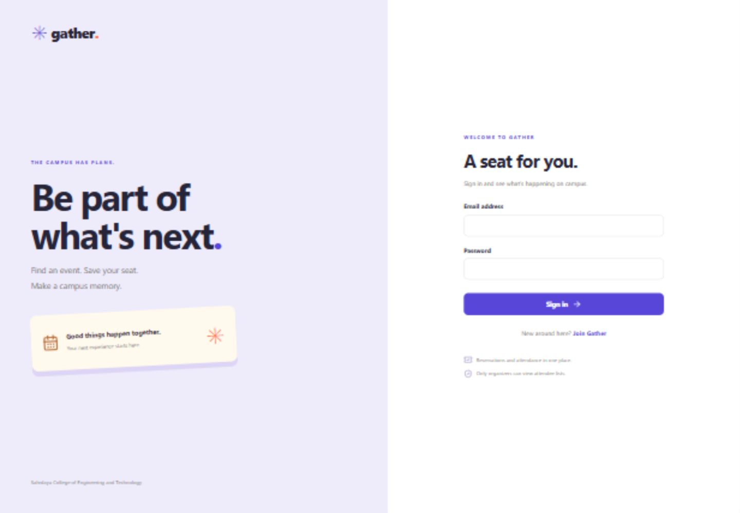
Figure 2 Campus event discovery overview
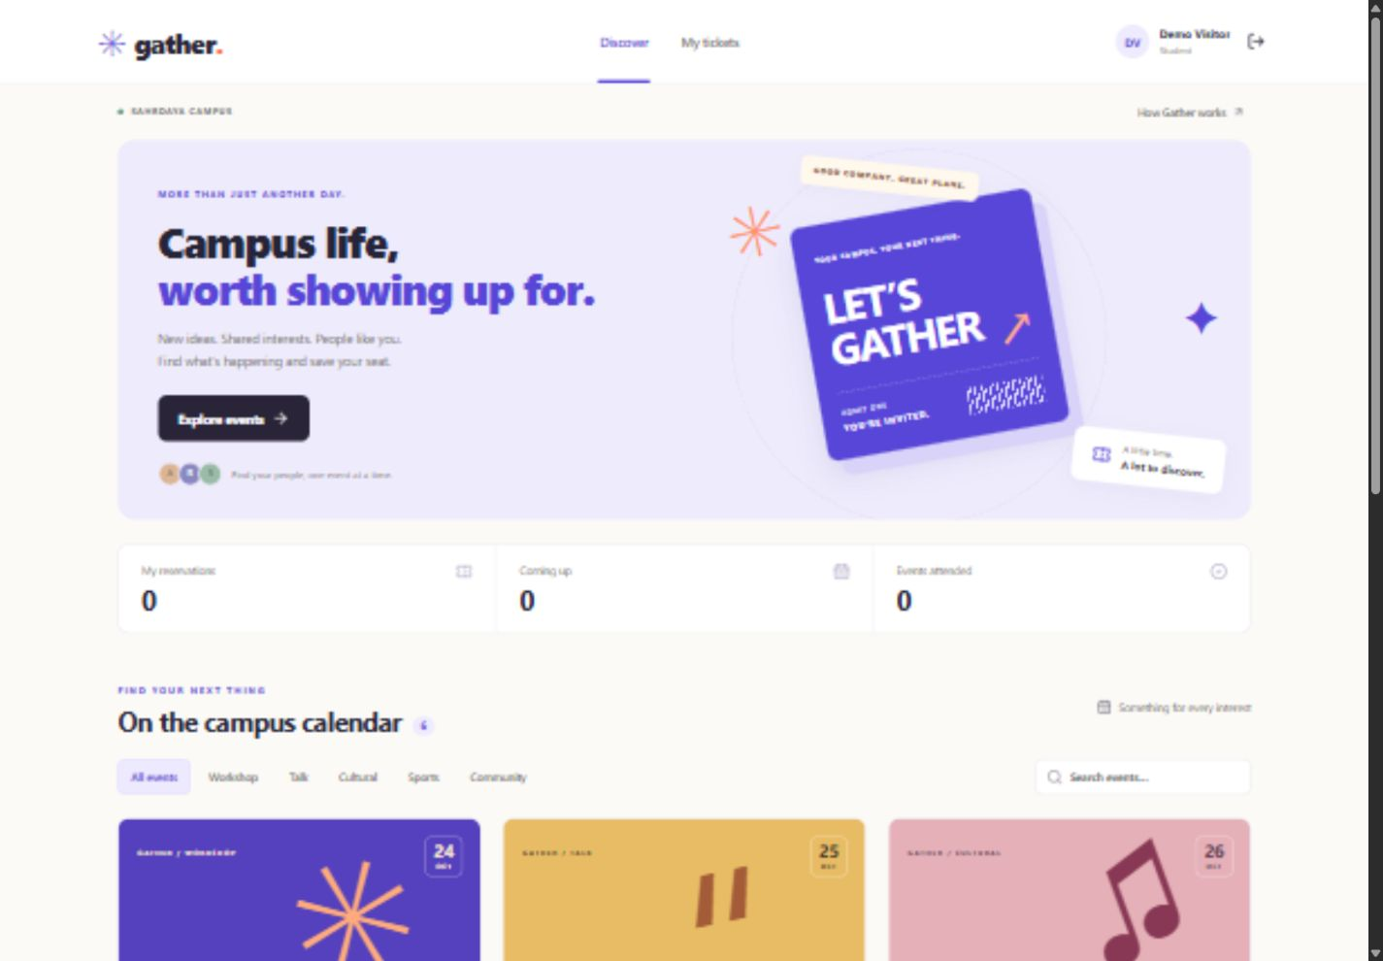
Figure 3 Event catalogue and category filters
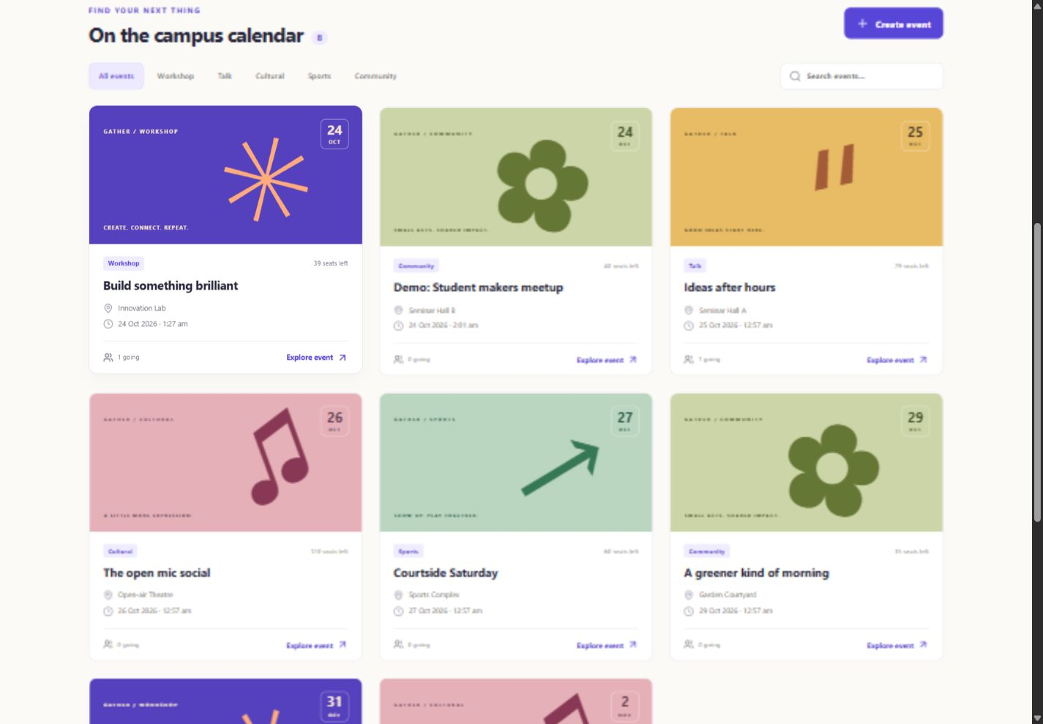
Figure 4 Student reservation reference
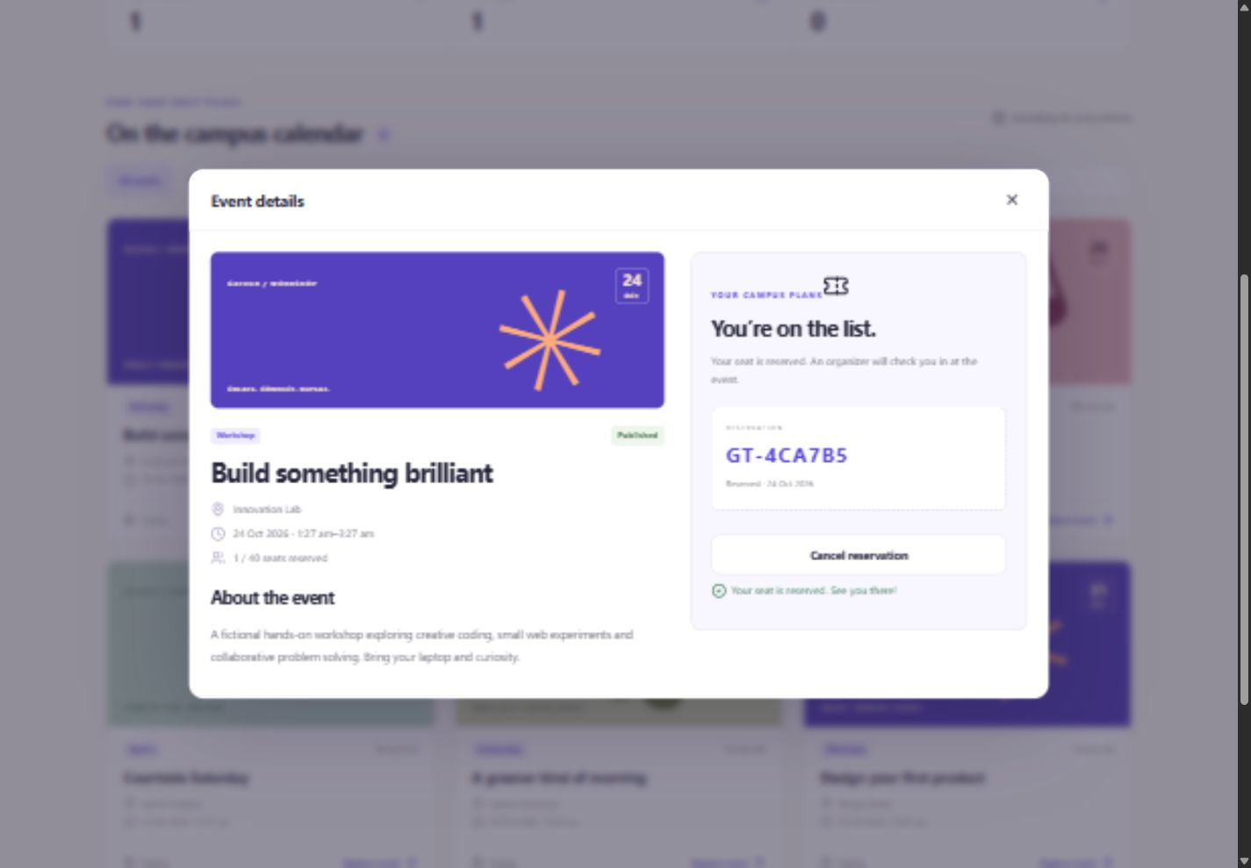
Figure 5 Organizer event creation form
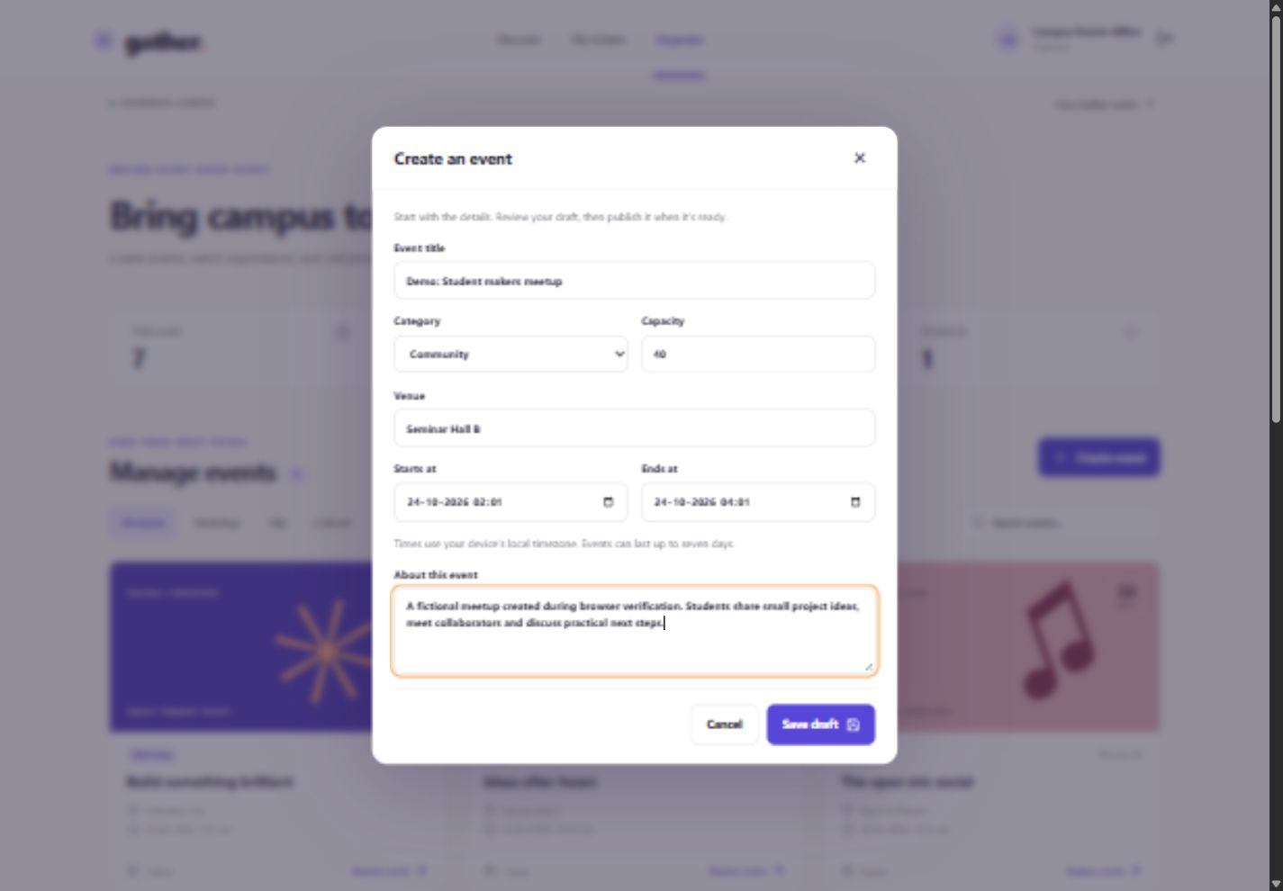
Figure 6 Organizer attendance and CSV export
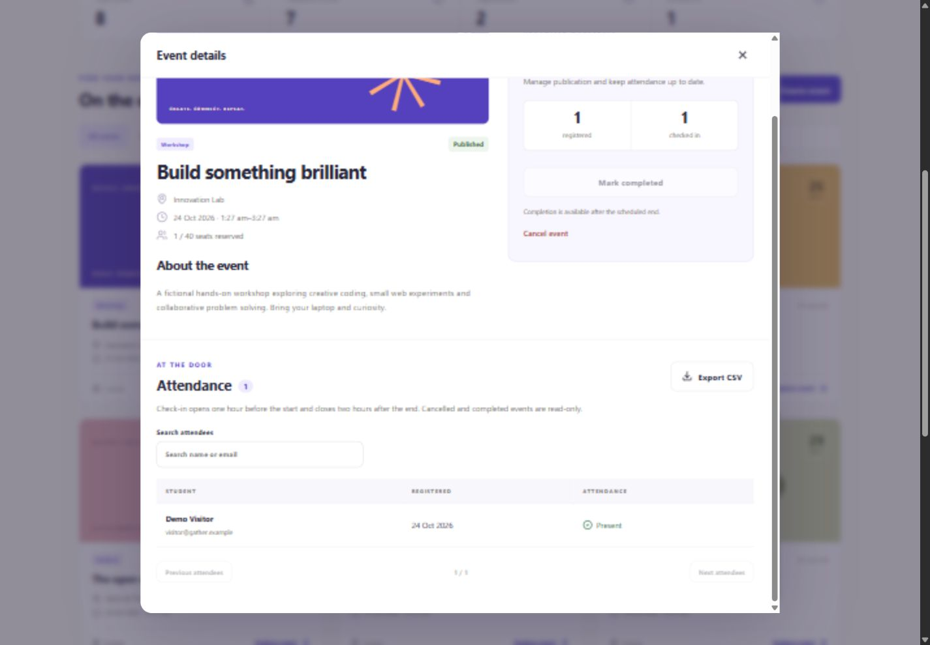
Figure 7 Student tickets at the mobile breakpoint
