SHRI RAMDEOBABA COLLEGE OF ENGINEERING AND MANAGEMENT, NAGPUR.



ELECTRONIC WORKSHOP LAB

MINI PROJECT REPORT

(6TH SEM, SESSION 2019-2020, ECP310)

**“GSM Based Home Automation”**

Submitted By

Ayushi Trivedi (Roll No.-02, Sec-B)

Riya Kathoke (Roll No.-06, Sec-B)

Abhijeet Jha (Roll No.-22, Sec-B)

Adivardhan Maheshwari (Roll No.-24, Sec-B)

**Department of Electronics and Communication Engineering**

1. **I****ntroduction:**

Day by day the concept of smart phone is rapidly increasing. Smart home is a concept which is termed as an appliance which can be controlled by the owner or a remote controller by a mobile app. The product focuses on comfort, security and benefit to its consumers.in home automation, devices are connected in a user-friendly manner allowing to communicate with the connected appliances which reduces human efforts. Some of the technologies used in home automation process are Bluetooth, WiMAX, Wireless LAN (Wi-Fi), Zigbee and Global System for Mobile Communication (GSM).

We live in the era of minute by minute developments in new technologies. The focus of engineering industries is to facilitate their customers with comfortable and secured living. In the last five years an enormous growth in the field of communication was observed. Rapid growth in mobile communication & its popularity makes us rethink about technological changes in fields of energy management, home automation and trying to merge it with a hand held device like mobile phone.

**Current scenario of Home Automation:**

The awareness of home automation is improving slowly in India. People are becoming more aware and adapting this technology & it’s potential. This is not the case in rural areas which is 70% of the population. Another aspect to think about is the cost. Even a basic led bulb which can be controlled is very expensive. Home automation systems must be affordable, reliable and effective. There are many complex systems which may be expensive and may not be affordable by everyone. There are individual automation systems based on the requirement.

**Need of Home Automation:**

Automated devices replace a good amount of human effort; moreover, human error can be avoided as an automated device works with diligence, versatility and almost zero error. It involves replacing human operators in tasks which involve tedious and monotonous work, dangerous environment like (space, nuclear facilities, fire etc.) performing the tasks which are beyond human capabilities involving size, weight, speed, endurance etc. Automation improves the economy of enterprises, society & most of humankind. For E.g. when an enterprise invests in automation technology & recovers its investment, or when a state or country increases its income due to automation like that of Germany or Japan which focuses on system involving hardware to control a variety of electrical and electronics.

The project we are building is a home automation system, where one can control the home appliances, using the simple GSM based phone, just by sending SMS through his phone. GSM phones will work to switch ON/OFF as well as control any home electronic appliances, from anywhere.

**Objectives of the Project:**

Change the status of the device upon receiving commands through SMS.

Display status of the devices in an LCD using a 16×2 LCD module.

1. **Block diagram and Functional description:**

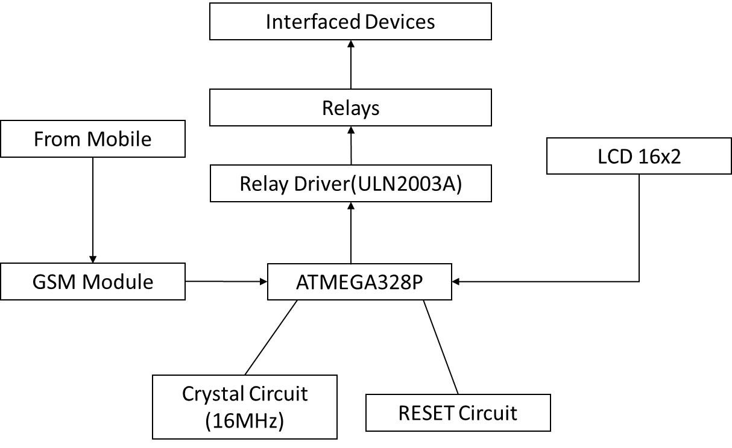

**GSM Module:**

It is used in many communication devices which are based on GSM (Global System for Mobile Communications) technology. It is used to interact with GSM network using a computer. GSM module only understands AT commands, and can respond accordingly.

**ATmega328P:**

The high-performance Microchip Pico Power 8-bit AVR RISC-based microcontroller combines 32KB ISP flash memory with read-while-write capabilities, 1024B EEPROM, 2KB SRAM, 23 general purpose I/O lines, 32 general purpose working registers, three flexible timer/counters with compare modes, internal and external interrupts, serial programmable USART, a byte-oriented 2-wire serial interface, SPI serial port, a 6-channel 10-bit A/D converter (8-channels in TQFP and QFN/MLF packages), programmable watchdog timer with internal oscillator, and five software selectable power saving modes. The device operates between 1.8-5.5 volts.

**16x2 LCD:**

LCD display is just an optional element in this project, to check if the correct command is being sent to GSM as well as being processed correctly by the microcontroller in this case atmega328p. This display is very useful in debugging process as well.

**ULN2003A:**

ULN2003A is a high voltage, high current Darlington arrays each containing seven open collector Darlington pairs with common emitters. Each channel rated at 500mA and can withstand peak currents of 600mA. Suppression diodes are included for inductive load driving and the inputs are pinned opposite the outputs to simplify board layout. These versatile devices are useful for driving a wide range of loads including solenoids, relays DC motors, LED displays filament lamps, thermal printheads and high-power buffers.

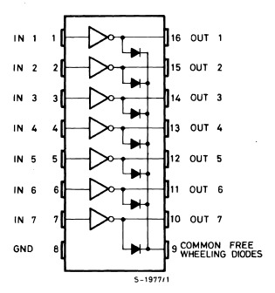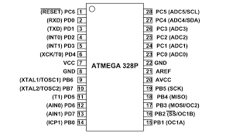

1. **Circuit diagram and it’s description:**

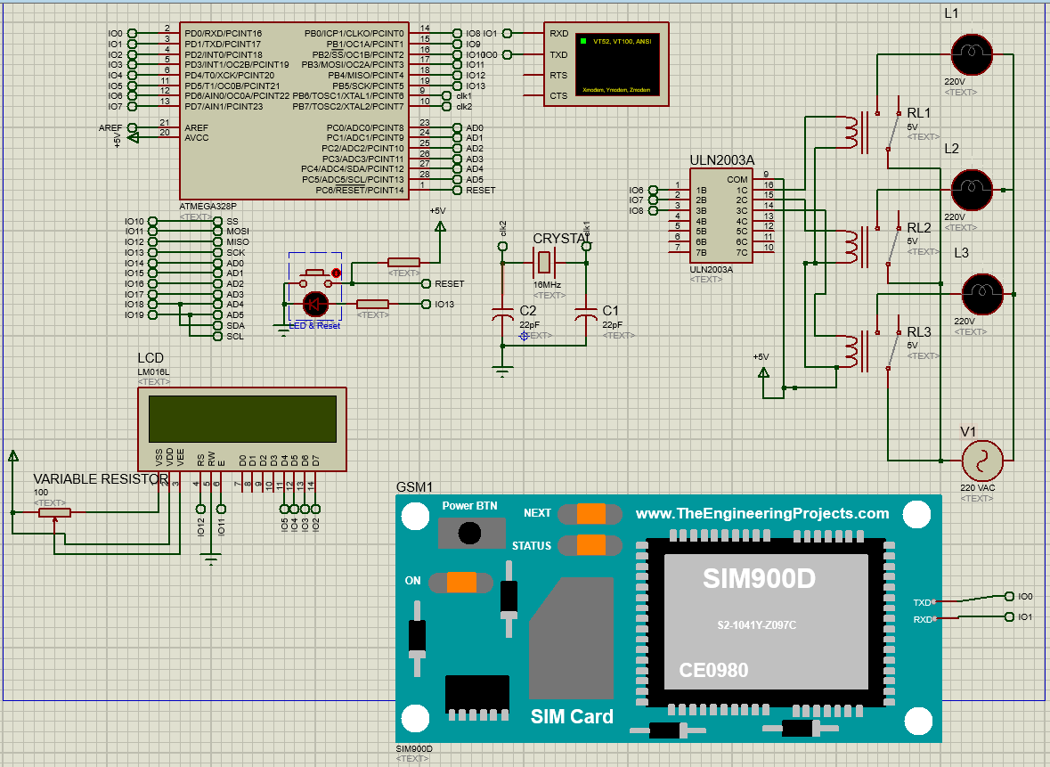

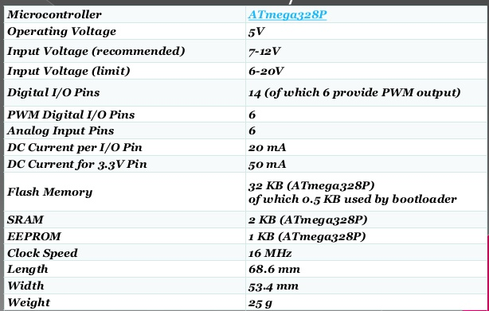

**Circuit components:**

ATmega328P

GSM Module

Relay 5 volt

ULN 2003

Bulb (used as load)

Connecting wires

Breadboard

16*2 LCD

Power supply

Cell phone

**Connections:**

Atmega328p is used here. A clock circuit with 16-megahertz crystal is required to run the Microcontroller. The Crystal is connected to 22 pF capacitor in parallel and connected to the controller at XTAL1 and XTAL2 which pin number 9 and 10. GSM module is interface at pin number 2 and 3 which have a dual function of acting as digital pin as well as serial communication. LCD display is interfaced at data pins 2,3,4 and 5 along with pin number 17 and 18 on microcontroller. Variable resistor resistor is required while connecting vss, vdd and vee to set the contrast as required.  Reset circuit is made by interfacing the reset pin of the microcontroller to + 5 volt and a push button connected to ground. Whenever the push button is pressed the reset pin gets zero volt instead of 5 volts and the microcontroller restarts. Uln2003a which is a driver IC which is interfaced at digital pins 6,7,8. The other side of the IC is interfaced with the relay board consisting of 5-volt relays which interface the load devices which in this case are 3 light bulbs.

1. **PCB layout and Artwork:**

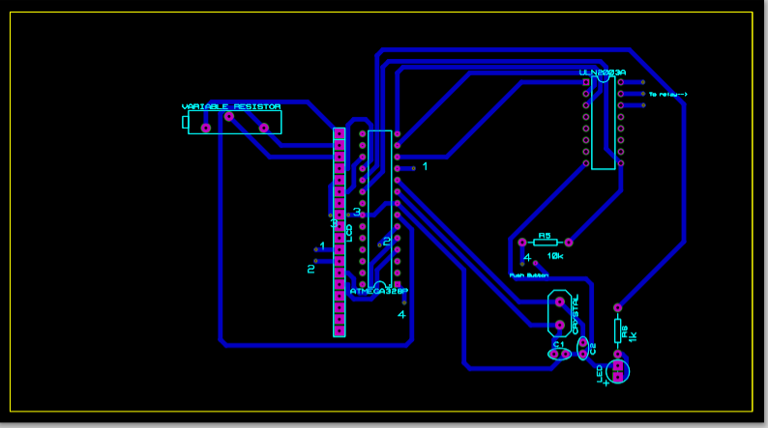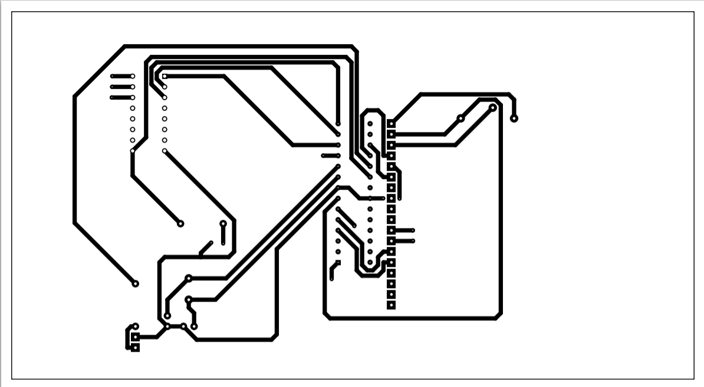

1. **Working of Project**

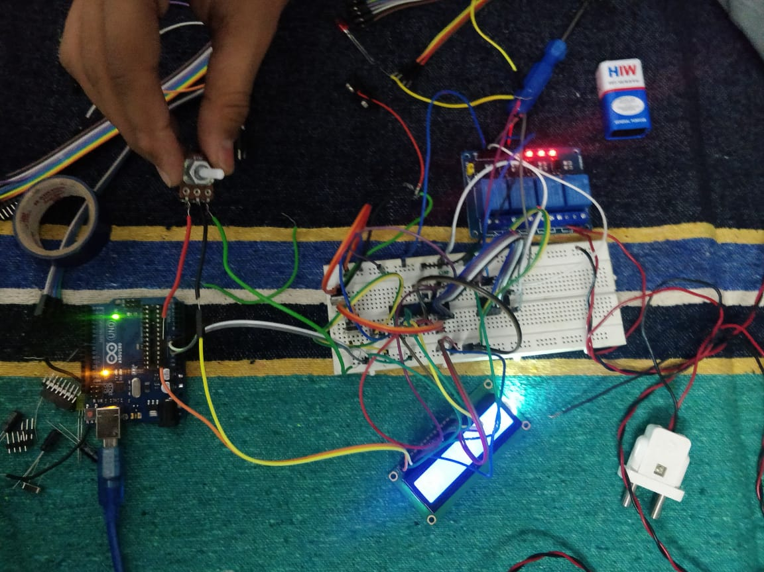

In this project, Atmega328P is used to control the whole process. The program is written such that when the GSM module sends the commands like " #Alight onA”, " #Alight offA", and so on the microcontroller accepts such commands. The prefix “#A” and the suffix “A” are unique strings which microcontroller helps to differ to any message and commands. This command is processed by the microcontroller which sets the particular pin connected to ULN2003A high. This in turn, will send signal to the Relay circuit. The switching on/ off the home appliances will be carried out by relays.

In the command, we have used a prefix - #A. This prefix indicates that, the main command is coming next to it and alongside we have also used the suffix "A" which indicates that the command has been ended.

Every message sent by to GSM module is forwarded to Atmega328P.

Atmega328P extracts the main command from the received message and stores it in a variable.

After this, the Arduino will compare the received message (extracted command from the message) with the predefined code. If it's a match then, the Arduino sends the signal to the relay circuit and the relay opens/closes the circuit accordingly.

For debugging purposes and to check which operation is being performed by the microcontroller, we have used an LED Display.

Another feature that has been added to the code is the password checking mechanism. A unique string is predefined in the code which has to be sent every time the microcontroller restarts. Only if the correct string is sent to the microcontroller, all the future operations are carried out else the LCD display will display wrong password for now.

Here in this project we have used 3 zero-watt bulb for demonstration which indicates Fan, Light and TV.

Below is the list of messages which we send via SMS, to turn On and Off the Fan, Light and TV:

|  |  |  |
| --- | --- | --- |
| S.no. | Message | Operation |
| 1 | #Afan onA | Fan ON |
| 2 | #Afan offA | Fan OFF |
| 3 | #Alight onA | Light ON |
| 4 | #Alight offA | Light OFF |
| 5 | #Atv onA | TV ON |
| 6 | #Atv offA | TV Off |
| 7 | #Aall onA | All ON |
| 8 | #Aall offA | All OFF |

1. **Result and Future Scope:**

**Result:**

A successful implementation of home automation project using a GSM module. We have interfaced only three devices for testing purposes but a maximum of 11 devices along with an LCD display and a maximum of 17 devices without LCD display can be interfaced. The working of the microcontroller can be seen on the LCD display along with the state of the devices.

**Future Scope:**

1. An app can be made to set automatic scheduling of various task as required by the user. In this case the customizability of this application increases greatly. For example, Let’s say user A has a small water tank and only need the water pump to operate for 20minutes whereas user B has a large water tank and needs 50mins to fill correctly. Such options could be set by the user on the mobile application and the mobile phone would automatically send the messages as scheduled.
2. The next step to this project can be unlimited expandability and interfacing of various devices (including and not limited to IR sensor to control TV and AC, alarms, air quality and moisture sensors, motion sensors and others.). An advanced version of this project which is already in development can perform communication using RF transmitter and receiver. Only one gsm module will be required to interface up to 128 devices using NRF24L01. Keeping expandability in mind, this project is not restricted to just automating and controlling home but can be used to control large warehouses and buildings.
3. In this project, the state of the device is not sent to the user. This can be resolved by making GSM module access the internet and feed the data to a directory which is then loaded by the mobile phone. If only a state of a particular device is required, it can be checked easily by making GSM module send the message to the user.